{TX|Multiple choice^2^^Filling blank^2}
{PZ|Left Brain^^Right Brain}
{KD|Left Brain^^Logical/mathematical^Linguistic/verbal}
{KD|Right Brain^^Spatial/visual}

[TX|Multiple choice][PZ|Right Brain][KD|Spatial/visual]

1. Which image is the least like the others?
A.  B.  C.  D. 
[答案]C

2. Which circle completes the analogy?
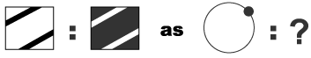
A.  B.  C. 
[答案]A

[PZ|Left Brain][KD|Logical/mathematical]

3. Which is heavier, the 3 green balls or the 8 purple balls laying in rows below the scales?
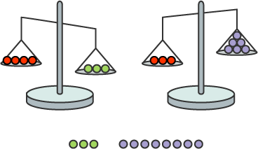
A. The green balls B. The purple balls C. They weigh the same D. It's impossible to know
[答案]A

4. If Moe likes oranges more than grapes, strawberries more than apples, and apples more than oranges, which of the following is NOT true?
A. He likes grapes more than strawberries B. He likes strawberries more than grapes C. He likes apples more than grapes D. He likes strawberries more than oranges
[答案]A

5. Which number comes next in the sequence?
0, 1, 1, 2, 3, 5, 8, ?
A. 9 B. 13 C. 15 D. 20
[答案]B

[KD|Linguistic/verbal]

6. If you saw a sign painted with the two words THINK ACT, what would you interpret it to mean?
A. Think but never act B. Don't act impulsively C. It's better to act than to think
[答案]B

[KD|Logical/mathematical]

7. Which is the shortest distance?
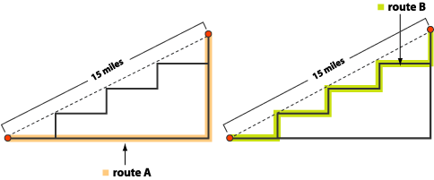
A. Route A B. Route B C. They are the same
[答案]C

[PZ|Right Brain][KD|Spatial/visual]

8. Which shape completes the analogy?

A.  B.  C.  D. 
[答案]B

[PZ|Left Brain][KD|Logical/mathematical]

9. Jack is going to randomly pick a day of the year for his wedding. Once he chooses the day, what is the least likely month it will be in?
A. January B. February C. March D. April
[答案]B

[PZ|Right Brain][KD|Spatial/visual]

10. Which image doesn't belong?
A.  B.  C.  D. 
[答案]D

[PZ|Left Brain][KD|Logical/mathematical]

11. A monster's middle name is based on its first name and the colour of its fur. Zachary has yellow fur and has the middle name Cay. Morton has purple fur and has the middle name Rop. Ted has red fur. What is his middle name?
A. Dep B. Der C. Rod D. Rot
[答案]B

12. Julie has two brothers, one sister, two aunts, and three uncles. How many children does Julie's mother have?
A. 2 B. 3 C. 4 D. 5
[答案]C

[PZ|Right Brain][KD|Spatial/visual]

13. Determine the next image in the series.

A.  B.  C.  D. 
[答案]A

[PZ|Left Brain][KD|Logical/mathematical]

14. Shelly asked Ben how much she owed him. In response he did 10 jumping jacks and 4 high kicks. But she thought she had borrowed £39.00 less than that, so she shook her head "No" and did 10 jumping jacks and 1 high kick to show him how much she thought she owed. If a jumping jack is worth £10, how much is a high kick worth?
A. £13 B. £17 C. £19 D. £175 E. It's impossible to tell
[答案]A

[PZ|Right Brain][KD|Spatial/visual]

15. Which tile belongs in the middle square to complete the pattern?
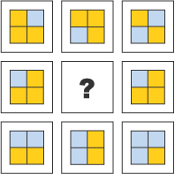
A.  B.  C.  D. 
[答案]A

[PZ|Left Brain][KD|Logical/mathematical]

16. Scott paid the cashier £6.30 in coins. He gave her an equal number of 20 pence, 10 pence and 5 pence coins. How many of each coin did he give her?
A. 5 B. 12 C. 18 D. 29 E. 31
[答案]C

[PZ|Right Brain][KD|Spatial/visual]

17. Which tile belongs in the missing square to complete the pattern?
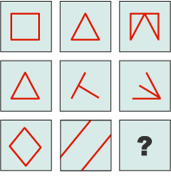
A.  B.  C.  D.  E. 
[答案]A

[PZ|Left Brain][KD|Logical/mathematical]

18. Five of Suzie's friends came to her party. Sky arrived before Sara. Ken arrived 30 minutes after Roger. Julia arrived after Roger, but before Sara. Sky arrived moments before Ken. Sara and Ken arrived at the same time. Who was the first to arrive?
A. Sky B. Sara C. Ken D. Roger E. Julia
[答案]D

[KD|Logical/mathematical^Spatial/visual]

19. What is the missing number?
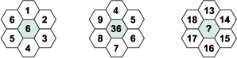
A. 35 B. 182 C. 234 D. 1314
[答案]C

[KD|Logical/mathematical]

20. Picture a bowl of sweets. All the sweets inside it are the same size. There are 6 cherry sweets, 11 raspberry sweets, 99 lemon sweets, and 16 orange sweets. If you reach in for one piece with your eyes closed, what are the chances of getting a raspberry sweet?
A. 1/10 B. 1/11 C. 1/12 D. 1/121
[答案]C

[PZ|Right Brain][KD|Spatial/visual^Logical/mathematical]

21. Determine the next star in the series.

A.  B.  C.  D.  E. 
[答案]D

[KD|Spatial/visual]

22. How many bricks are missing?
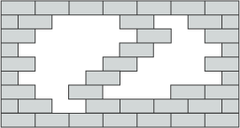
A. 19 B. 20 C. 23 D. 25 E. 27
[答案]D

[PZ|Left Brain][KD|Logical/mathematical]

23. Wednesday, but Wednesday is now 5 days before Monday. What happened to your weekend days?
A. Sunday is the day after Saturday B. Saturday is the day after Sunday C. They are one day apart D. They are two days apart
[答案]D

[PZ|Right Brain][KD|Spatial/visual]

24. Which image doesn't belong?
A.  B.  C.  D.  E. 
[答案]D

[PZ|Left Brain][KD|Logical/mathematical]

25. If the following is true:
Z:A+1
A:B+1
C:E+2
Then which of these is true?
A. D:E+2 B. Y:Z+1 C. K:M-1
[答案]B

[PZ|Right Brain][KD|Spatial/visual]

26. Which picture completes the analogy?
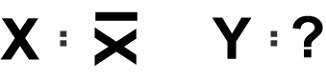
A.  B.  C. It's impossible to know
[答案]C

[PZ|Left Brain][KD|Logical/mathematical]

27. Josie is running at 5 miles per hour and her destination is 13 miles away. Billy is riding his bike at 12 miles per hour and his destination is 41 miles away. Stephen is walking at 1 mile per hour and his destination is 2.3 miles away. Who reaches their destination first?
A. Josie B. Billy C. Stephen
[答案]C

28. Chinese is to Asian as Italian is to
A. City B. African C. Country D. European
[答案]D

29. Which is the odd one out?
A. Mars B. Jupiter C. Comet D. Earth
[答案]C

30. Which city is the odd one out?
A. Paris B. Beijing C. Rome D. Berlin
[答案]B

31. Library is to book as book is to
A. Binding B. Copy C. Page D. Cover
[答案]C

[PZ|Right Brain][KD|Spatial/visual^Logical/mathematical]

32. Which of the patterns completes the series
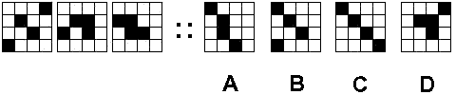
[答案]B

[KD|Spatial/visual]

33. Which is the odd one out?
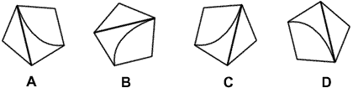
[答案]C

34. When the figure on the left is folded over which shape does it produce?
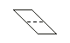 A.  B.  C. 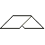 D. 
[答案]C

35. Which of the patterns completes the series?
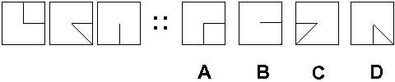
[答案]C

[KD|Spatial/visual^Logical/mathematical]

36. Which is the odd one out?
A.  B. C. 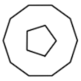 D. 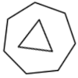
[答案]D

37. Which of the following cubes is similar to the unfolded cube?
(Note: the faces of the cube are non transparent)
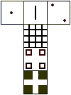 A.  B.  C.  D. 
[答案]A

[TX|Filling blank][PZ|Left Brain][KD|Linguistic/verbal]

38. "Either or find make we one a way will."
- Hannibal
After unscrambling the above statement, the 9th word is:
[答案]one

[PZ|Right Brain][KD|Spatial/visual]

39. How many squares of any size can be found in the figure below?
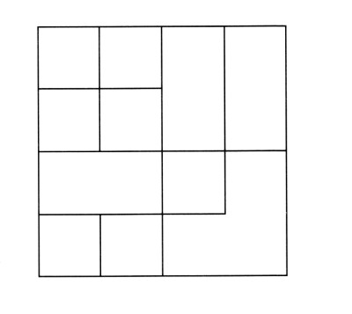
[答案]15

[PZ|Left Brain][KD|Logical/mathematical]

40. A certain logic has been followed in placing the numbers in the circles below. Complete the last circle
using the same logical progression.
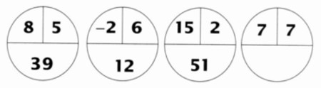
[答案]42

41. Below is a grid where a certain logic has been established to help you put the missing number in the empty box. What is the missing number?
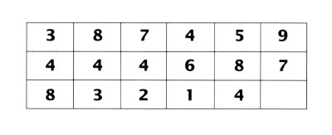
[答案]6

[KD|Linguistic/verbal]

42. Unscramble the letters below and supply the missing letter in the blank square, and you will find a common nine-letter word. What is the word?
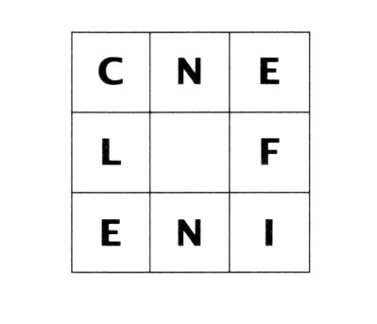
[答案]influence

[KD|Logical/mathematical]

43. Which number should come next in this series?
: 1, 4, 9, 16, 25,
[答案]36

44. Which number should come next in this series?
: 3,5,8,13,21,
[答案]34

45. If two typists can type two pages in two minutes, how many typists will it take to type 18 pages in six minutes?
[答案]6

46. What is the number that is one half of one quarter of one tenth of 400?
[答案]5

47. If you count from 1 to 100, how many 7"s will you pass on the way?
[答案]20

48. Two men, starting at the same point, walk in opposite directions for 4 meters, turn left and walk another 3 meters. What is the distance between them?
[答案]10

[KD|Linguistic/verbal]

49. What is the word coiled inside this circle?
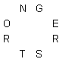
[答案]STRONGER

50. The same word can be added to the end of GRASS and the beginning of SCAPE to form two other English words?
[答案]LAND

