**Wireless Mesh Networking for Swarm Robotics**

Student Researcher: Cameron McCaskey

Advisor: Dr. Brian Trease

University of Toledo

Mechanical Industrial and Manufacturing Engineering

**Abstract**

Swarm robotics are robotics in which multiple robots are deployed, often with different sensor packages. In this case, the robotic swarm takes shape in the form of small boats that are deployed on Lake Erie to study harmful algae growth patterns. Swarm robotics are a complicated subject because any small increase in cost or complexity exponentially increases the cost or complexity of the entire robotic swarm. One of these key areas of interest is telemetry. Telemetry in the robotic swarm allows for the robots to be controlled from a central base station and also communicate with each other their exact location to avoid collisions.

**Project Objectives**

The objective of this research project is to use and adapt off the shelf wireless transceivers to implement the telemetry system for these swarm robotics. These off the shelf solutions allow for other labs to implement the same robotic swarm without investing in building custom electronic hardware.

Off the shelf radio transceivers are consistent, widely available, and significantly lower cost than developing custom radio hardware for a project. The radio modules being tested in this research are the Wemos D1 Mini Pro (ESP8266), LoRa 32u4 (SX1276), XBee Pro S1, and the XBee Pro S3B.

**Methodology Used**

Multiple range tests of each radio module were conducted. These range tests took place over a long straight length of road in front of the engineering college. In order to facilitate the range test, firmware was written for each radio module, that transmitted it’s current GPS coordinates available from a discrete GPS device. An identical radio module was held stationary in a parking area directly linear with the road. This receiving radio ran firmware the communicated the received GPS coordinates from the transmitter to a laptop computer where the results were recorded. The transmitter was driven down and back along the road to generate the GPS test data. This GPS data was later analyzed to calculate the range of the radio module being tested.

**Results Obtained**

The GPS data was ran through GPS Visualizer, a free utility that generates map data of GPS coordinates. This was a great tool for visualizing the collected GPS data. The distance of each test was then found using this map data shown in Figure 1.

**Figure 1:** Range Test Map

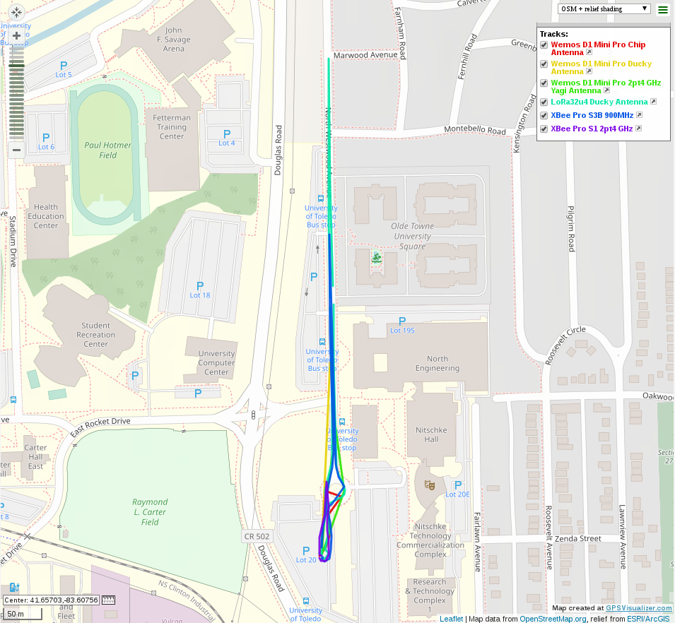

Figure 2 shows the range test data. The LoRa32u4 board offered the best range, followed by the XBee Pro S3B. This is no surprise since the transmit power and receiver sensitivity is similar for all of the modules, however the Lora32u4 board and XBee Pro S3B are 915 MHz and 900 MHz transmitters respectively. The Wemos D1 Mini Pro was the next best performing option especially with the ducky antenna. The Yagi antenna should have performed better than the ducky antenna due to the higher gain, however it is possible that the Yagi was not properly tuned to 2.4 GHz.

**Figure 2:** Range Test Data

It is important to choose the radio module that suits the need for its intended application. In cases where ease of use is supreme, the XBee Pro S3B is best. For low cost applications the Wemos D1 Mini Pro is a good choice. For best range, the LoRa SX1276 is a good choice. The Wemos D1 Mini Pro and LoRa SX1276 both require programming which is available on Github @3MDL. For swarm robotics, where many robots are built, the individual cost of each radio module rapidly adds up. Moving forward, due to the range and low cost the LoRa32u4 based on the SX1276 transceiver is a good choice for 3MDL especially compared to the XBee Pro S3B that are currently used.