Game Setup

Input schemes

Two views supports both keyboard input and controller input, for that you will need a mouse and keyboard or two controllers (currently supports PS4 and HORI controllers).

The default input is set to keyboard and mouse, however is it recommend to use controller for a better gameplay experience.

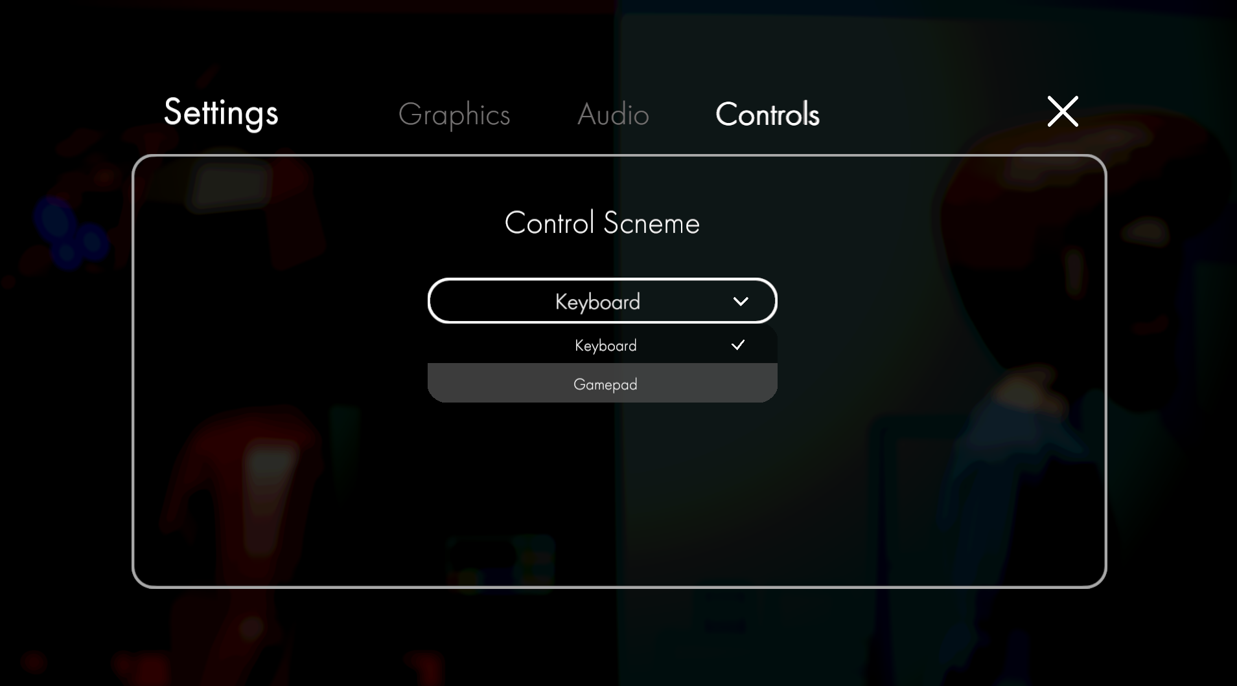

To change the input scheme, go to the setting option in the Main Menu, and then choose the controls tab, then select your choice of input. Note that it is not possible to change the control scheme in game. Please exit to the main menu in order to change controls

Controller setup

There is no special setup required for keyboard in game, however when choosing the controller input scheme, the game will ask you to input any key on your controller to join.

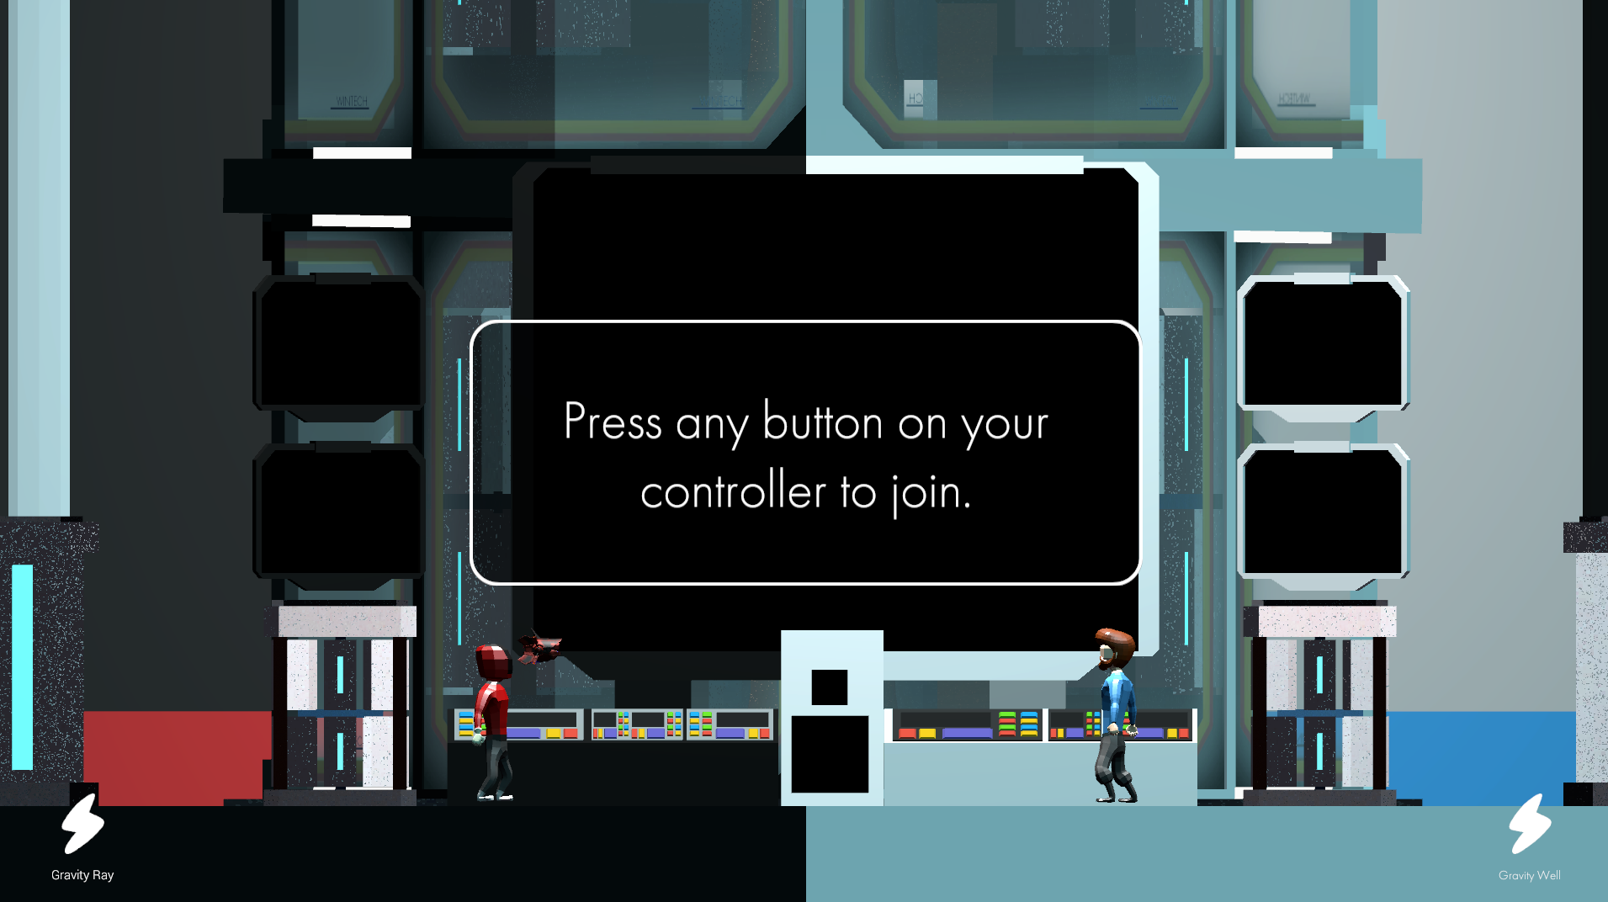

Make sure your controllers are plugged in and you may press a key on it to start controlling your characters.

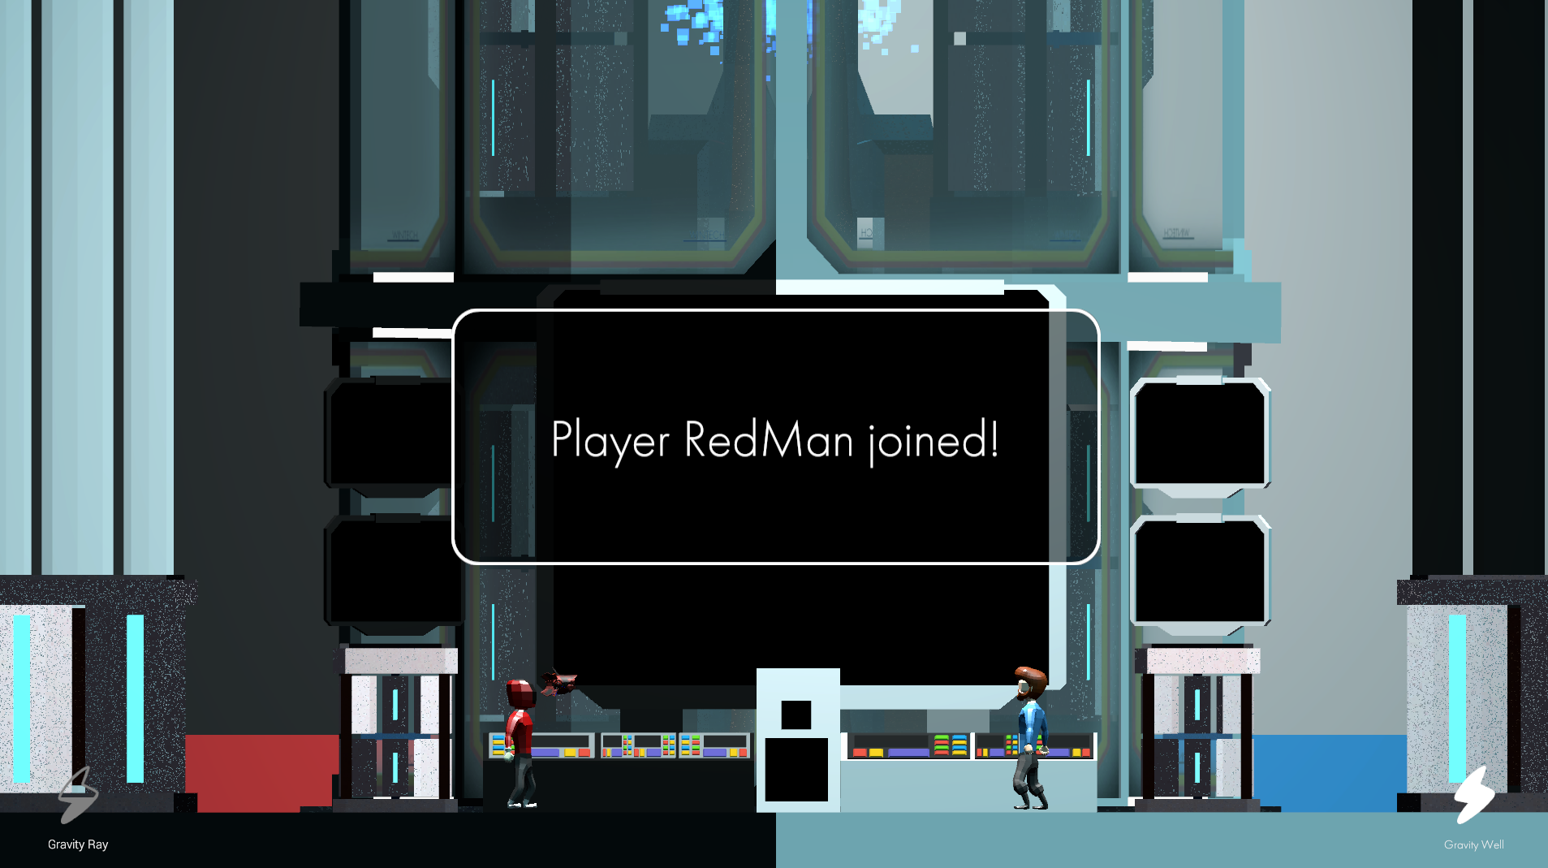

However if your controller does not work or want to switch back to the keyboard control scheme, you may press the ESC button and navigate back to the Main Menu.

The reload button

If you wish to re-do a part of a section or you believe the game is bugged, you may use the reset button to restart the level.

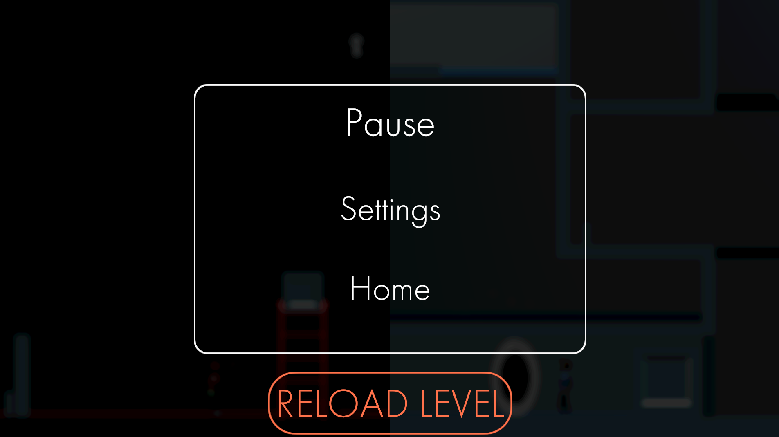

Please note that there is NO checkpoints in the level and your progress are NOT saved. So, it is recommended to only use the button when you really need to.

Game Play

Controls: Keyboard Input

**For Player Red:**

* _W_: Jump
* _A_: move left
* _D_: move right
* _S_: drop down (when on a one-way platform)
* _Q_: anchors view (move the view with A and D)
* _E_: interact
* _R_ (Hold): aim Gravity Ray (adjust the aim with W and S)
* _E_ (While holding R): cancel Gravity Ray
* _R_ (Release): shoot Gravity Ray
* _TAB_: open paused menu

**For Player Blue:**

* _P_: Jump
* _L_: move left
* _’_: move right
* _;_: drop down (when on a one-way platform)
* _O_: anchors view (move the view with A and D)
* _[_ interact
* _]_: activates Gravity Well

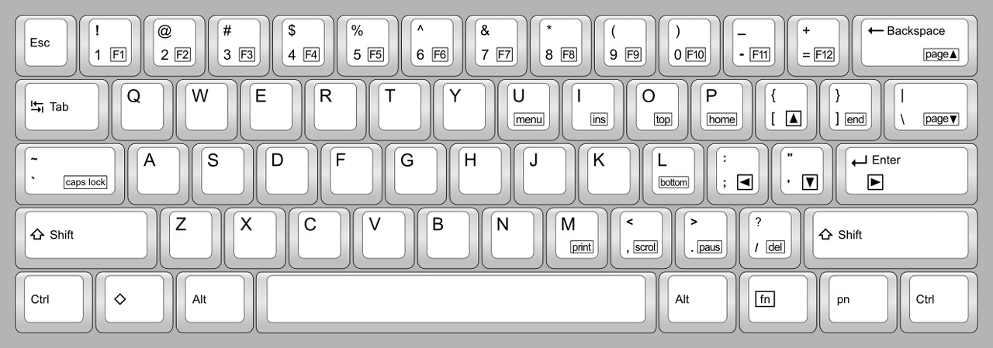

Controls: Controller Input

**For Player Red:**

* _A_: Jump
* _L-Stick (Left)_: move left
* _ L-Stick (Right)_: move right
* _ L-Stick (Down)_: drop down (when on a one-way platform)
* _X_: anchors view (move the view with L-Stick)
* _Y_: interact
* _B_ (Hold): aim Gravity Ray (adjust the aim L-Stick)
* _Y_ (While holding R): cancel Gravity Ray
* _B_ (Release): shoot Gravity Ray
* _START_: open paused menu

**For Player Blue:**

* _A_: Jump
* _L-Stick (Left)_: move left
* _ L-Stick (Right)_: move right
* _ L-Stick (Down)_: drop down (when on a one-way platform)
* _X_: anchors view (move the view with L-Stick)
* _Y_: interact
* _B_: activates Gravity Well

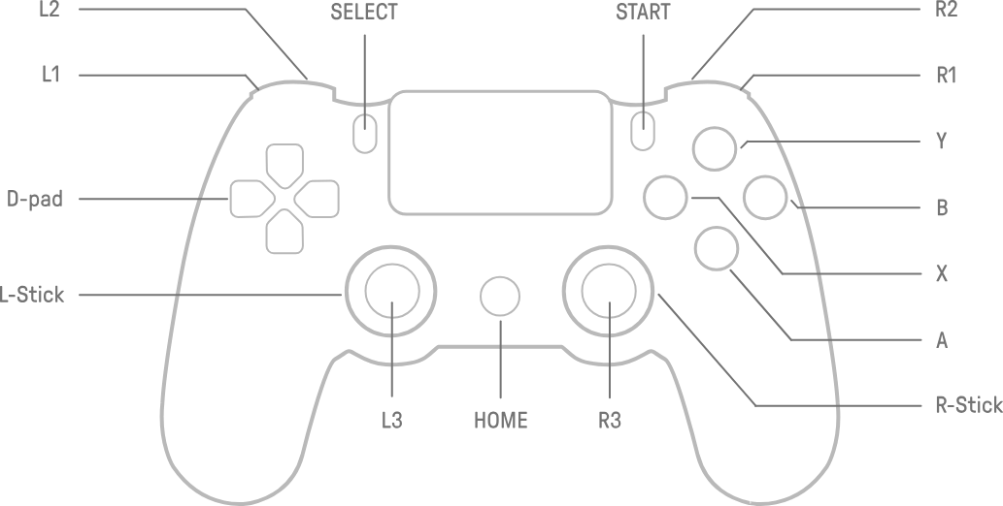

Player Skills:

**Gravity Ray (Red):**

Shoots a powerful beam of ray that alters gravity. Although it is a technology marvel, its capability is limited by its range and the property of the object. Some objects are too weak to withstand the strong gravity and will collapse and implode, some will be moved, but most often than not the objects in the facility will not be affected.

**Gravity Well (Blue):**

Alters the gravity around the user. The user will be able to jump higher and fall slower, also the weight of the object the user is carrying will also be affect, making it easier to carry it upwards. Despite being in a low gravity field, the user is able to maintain areal control due to the advanced calibration of the tech.

In Game UI:

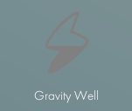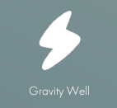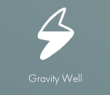

Skill ready Skill is active Skill is cooling down

Interactable Objects:

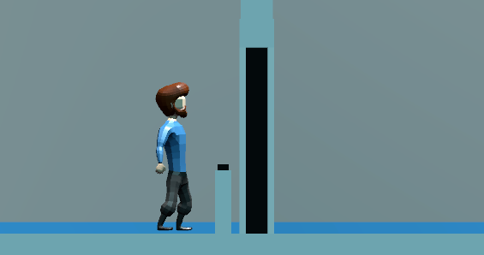

**Buttons:** Buttons are able to control doors, moving platforms or item respawners

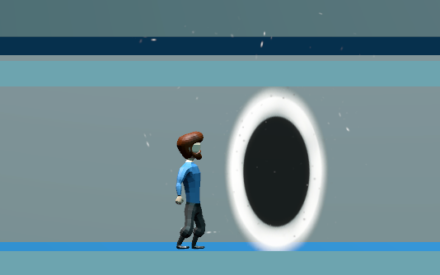

**Teleporter:** Teleporter can transport player instantly to a new location; however, it can only be activated when both teleporters are inside the player’s view.

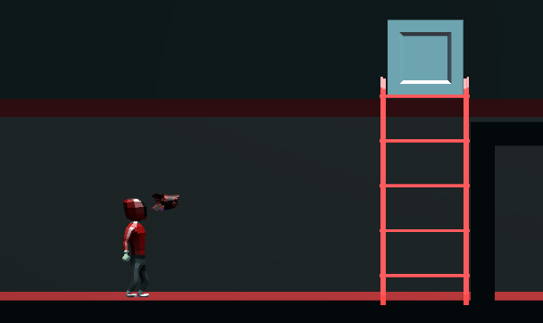

Gravity Objects: Gravity objects are highlighted in red in Red’s view, you can interact with them with your ability.

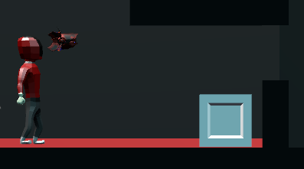

**Grabbable Objects**: Grabble objects are able to be Grabbed and move around. A grabbable object can be heavy, which will decrease your speed and jump height.

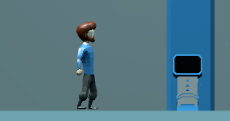

**Terminal**: Terminal can be interacted to inspect logs left by the scientists before the incident.

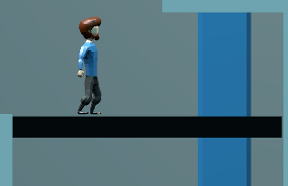

**One-way platforms:** One-way platforms can be jumped through from the bottom and fall through from the top. The platform will appear pure white in Red’s side.

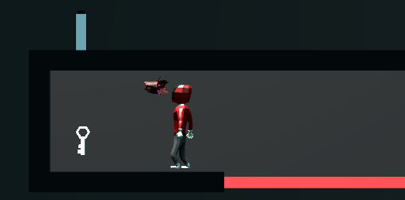

**Pickable Objects (Keys):** Pickable object spins around when active and can be picked up when interacted with. These objects usually act like a key item.

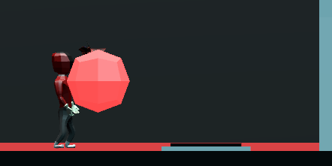

**Pressure Plates:**  Pressure plates can control doors or moving platforms, usually it is triggered by placing objects on top.