### **BOOTLOADER**

### Introduction:

A bootloader is a small program that is executed when a computer or embedded system is powered on or reset.

**For Embedded Systems**: Common MCU flashing methods if when we try to run a specific application on the MCU so that’s mean we need to flash the application to the MCU using the bootloader as the possible choice instead of the traditional ways like in-circuit Debugger which has a lot of issues like:

* **Connection Issues**

1. Loose or poor connections between the debugger and the target hardware can result in unreliable communication.
2. The debugger might not be compatible with all versions of the target microcontroller or development board.

* **Power Supply Problems**

Noise or fluctuations in the power supply can disrupt debugging operations.

* **Software Issues**

Problems integrating the debugger with the Integrated Development Environment (IDE) can hinder debugging efforts.

* **Hardware Limitations**:

The presence of the debugger can slow down the system being debugged, potentially masking timing-related issues.

* **Signal Integrity**:

1. High-frequency signals and electromagnetic interference (EMI) can affect the quality of communication between the debugger and the target device.
2. Incorrect timing of signals can cause the debugger to misinterpret data from the target device.

* **User Error**:

**Misinterpretation of Data**: Incorrectly interpreting data or signals from the debugger can lead to false conclusions about the system’s behavior.

When we say it has a lot of issues that’s mean we don’t use it absolutely not we can use mitigation strategies for the optimizations, it considers a crucial part of process of inserting a bootloader in an MCU for the first time and so on if we need to change the bootloader or update it. Therefore, we use bootloader to ease the process of the flushing. So again, bootloader is a software program in a MCU so we can update the current application already (primary application) in MCU.

Why we even need the bootloader in the MCU? (I know that I answer this above briefly but let’s try again)

* To answer this question let’s excite another question, does every unit need to be returned to the manufacturer every time the software is updated? what happens to these MCUs based products when millions of units shipped and a software ‘enhancement’ needs to be made?

The obvious answer to these questions is absolutely not and the primary reason why is that most systems ship with a bootloader on-board:

* A boot-loader is an application whose primary purpose is to allow a systems software to be updated without the use of specialized hardware (in-circuit Debugger).
* There are many different sizes and favors to embedded boot-loaders.
* 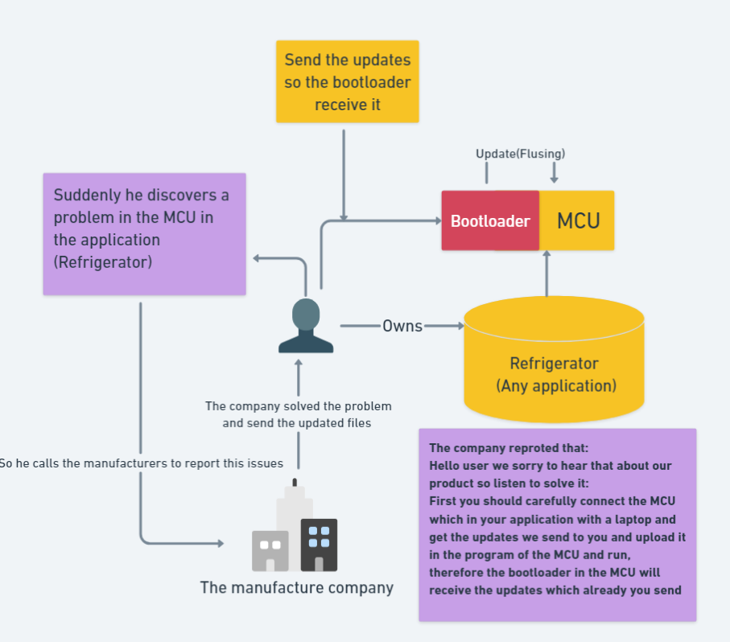They can communicate over variety of protocols such as USART, CAN, I2C, USB and the list goes on for as many protocols that exist.

Figure 1: An explanation of the flushing process

**For PC or laptops:** A bootloader is a program that is responsible for loading the operating system (OS) when a computer is turned on. The bootloader is typically stored in a special section of the computer's hard drive or other non-volatile storage device and is executed by the computer's BIOS (BIOS is the traditional firmware interface for PCs. It initializes hardware and loads the bootloader) or UEFI firmware (UEFI is designed to replace BIOS, offering enhanced features like faster boot times, larger disk support (beyond 2 TB), and better security). Without a bootloader, the computer would not be able to start up and run the operating system.

The bootloader performs several important tasks, including:

* Initializing and testing hardware components to ensure they are working properly.
* Starting the operating system kernel.
* Loading the operating system kernel into memory.

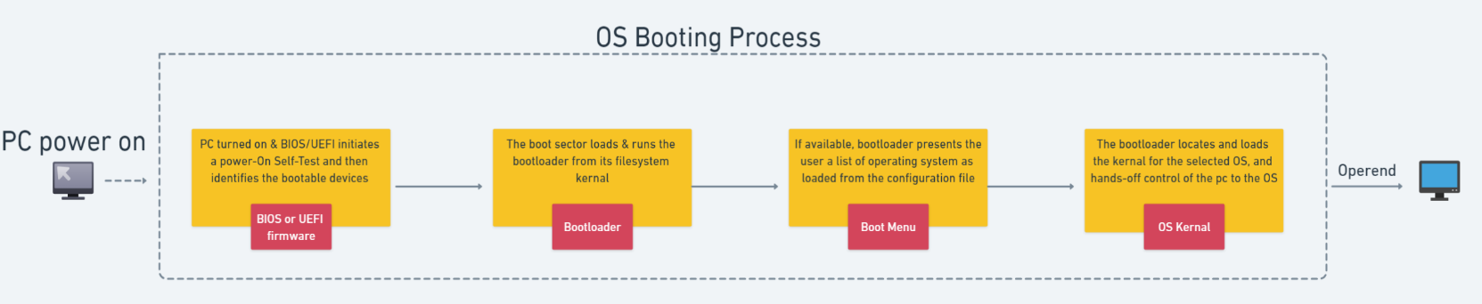Therefore, windows do require a bootloader in order to start up. When a Windows-based computer is turned on, the firmware first runs a small program called the Unified Extensible Firmware Interface (UEFI) or Basic Input/Output System (BIOS) that is responsible for identifying and initializing hardware components. The firmware then hands over control to the Windows bootloader, which loads the Windows kernel into memory and starts the operating system.

Figure 2: OS Booting process

As shown in figure 2 a simple description of the boot process in a modern computer is that when the machine is turned on, the first place the microprocessor looks for instructions on what to do to start is to go to the BIOS boot ROM. That minimal software loads some primitive drivers, and then sends it on to the bootloader software on the hard drive. The bootloader in turn loads the OS and software. All OS’s must have a bootloader to boot, including Windows, macOS, Linux.

**Functions of a Bootloader in PCs and Laptops:**

* The bootloader initializes system hardware, such as memory, CPU, and essential peripherals.
* It loads the operating system kernel into memory and transfers control to it.
* The bootloader can provide options to configure system parameters before the OS loads.
* It can perform basic system diagnostics and provide recovery options in case of errors.
* Modern bootloaders often support secure boot mechanisms to ensure only trusted software is loaded.

**Bootloaders Examples**:

* GRUB (GNU GRand Unified Bootloader): Commonly used in Linux systems, GRUB is a versatile bootloader that supports multiple operating systems.
* Windows Boot Manager: Used by Windows systems, it is responsible for loading the Windows OS.
* LILO (Linux Loader): An older Linux bootloader, largely replaced by GRUB.