Digital Egypt Pioneers Initiative
DEPI
Software Requirements Document
EduHub-Online Learning Platform

Team
Name | Depi-Code | Email
Omar Abdelsamad Hassan | 21168611 | omar2006khalil@gmail.com
Youssef Mostafa Salah | 21174670 | youssefsiam702@gmail.com
Ammar Hany Mahdy | 21170909 | ammarhany52@gmail.com
Abdullah Mohamed Abdelmawgood | 21150360 | abdullahmohamed  abdelmawgood@gmail.com
Mina Magdy Hanna | 21031941 | magdymena280@gmail.com

1. Project Planning & Management
Project Overview
EduHub is a comprehensive online learning platform built using a decoupled 3-Tier architecture and ASP.NET Core Web API. The backend uses Entity Framework Core (EF Core) for data access, separating the system into Presentation, Business Logic, and Data Access layers. It connects instructors who create and upload video-based courses, with students who enroll, track their progress, and earn automated PDF certificates upon completion. The platform differentiates itself by integrating AI-powered learning assistants, lesson summarization, and an automated customer support chatbot.

Project Objectives
- Establish a decoupled 3-Tier e-learning platform utilizing APIs and EF Core for robust data access.

- Integrate Azure Blob Storage for secure video streaming and Stripe for handling course enrollments.

- Automate the generation and verification of publicly verifiable PDF certificates for students upon course completion.

- Enhance the learning experience by providing AI-powered lesson summarization and an AI learning assistant.

- Provide an automated AI customer support chatbot to handle queries regarding registration and technical issues.

Project Scope
- In-Scope: ASP.NET Core Web API development, 3-Tier decoupling, EF Core database mappings, standalone frontend integration, Azure Blob video streaming, Stripe checkout, student progress tracking, PDF certificates, admin dashboards, and AI integrations (lesson summaries, learning assistant, support chatbot).
- Out-of-Scope: Real-time live streaming/webinars, native mobile applications, and subscription-based payment models.

Project Plan & Timeline
Phase | Duration | Dates | Milestones & Deliverables | Tech Focus
Phase 1: Architecture & DB | Week 1 | Oct 16 - 23 | Solution setup (API, Services, Data), EF Core DbContext creation, entity relationships, and initial migrations. | EF Core Code-First
Phase 2: Core Business Logic | Week 2 | Oct 24 - 31 | Course, Section, and Lesson CRUD implementations in the Service Layer, Azure Blob Storage integration. | 3-Tier Service decoupling
Phase 3: Web API & Endpoints | Week 3 | Nov 1 - 10 | Expose business logic via ASP.NET Core Web API controllers. Implement Swagger for API testing. | API Endpoints
Phase 4: Frontend & Features | Week 4 | Nov 11 - 21 | Connect standalone frontend UI. Integrate Stripe, PDF Certificates, and AI Chatbots. | UI Integration, AI
Phase 5: Testing & Deployment | Week 5 | Nov 21 - 30 | Integration testing of API endpoints, CORS configuration, deployment to Azure App Service. | Azure App Service

Risk Assessment & Mitigation Plan
Risk | Impact | Mitigation Strategy
Video Storage Limits | High | Compress videos before uploading and using Azure Blob Storage lifecycle management.
AI Cost Overruns & Hallucinations | High | Ground AI responses strictly in course materials and enforce configurable usage limits per user to manage costs.
Frontend-Backend Integration (CORS) | High | Configure proper Cross-Origin Resource Sharing (CORS) policies early in the Web API setup to allow the frontend to consume data securely.
Tight Schedule and Scope Creep | High | Prioritize core features first (authentication, courses, payments, progress), track milestones weekly, and defer optional features if a phase falls behind.
Unauthorized Access to Paid Content | High | Verify enrollment and role on every request and serve videos through time-limited secure access links from Azure Blob Storage.
Stripe Payment Failures or Mismatched Enrollments | Medium | Confirm payments through Stripe webhooks before enrolling students, handle failed or duplicate events safely, and test with Stripe test mode.

Key Performance Indicators (KPIs)
- Architecture Compliance: 100% of data access is encapsulated in EduHub.Data, and controllers in EduHub.API only contain endpoint routing and HTTP response logic.

- API Responsiveness: 95% of standard API requests must return within 2 seconds under test workloads (NFR-1).

- System Availability: Maintain 99.5% monthly availability, excluding planned maintenance windows (NFR-5).

- Security & Privacy: Secure endpoints using token-based authentication (e.g., JWT) with role-based access control and HTTPS enforcement (NFR-2).

3. Requirements Gathering
1- Functional Requirements
- FR-1: User Authentication and Authorization – The system shall allow users to register, log in, manage their profiles, and access features according to their roles (Student, Instructor, or Admin).
- FR-2: Course Browsing and Search – The system shall allow users to browse, search, filter, and sort published courses by title, category, price, difficulty level, and rating.
- FR-3: Course Management – The system shall allow instructors to create, edit, organize, and submit courses for approval, including sections, lessons, descriptions, thumbnails, and pricing.
- FR-4: Video Upload and Streaming – The system shall allow instructors to upload course videos to Azure Blob Storage and enable authorized students to stream them.
- FR-5: Course Enrollment and Payments – The system shall allow students to enroll in free courses and purchase paid courses through Stripe, including applicable coupons and discounts.
- FR-6: Student Learning and Progress Tracking – The system shall allow enrolled students to access lessons, track completed lessons, view course progress, bookmark content, and save personal notes.
- FR-7: Quiz and Assessment Management – The system shall allow instructors to create quizzes and students to complete assessments, receive scores, and check whether they meet the required passing score.
- FR-8: Course Reviews and Ratings – The system shall allow eligible students to submit course reviews and ratings and view the average rating of each course.
- FR-9: AI Lesson Summarization – The system shall generate AI-powered lesson summaries and key points from available lesson transcripts or text.
- FR-10: AI Learning Assistant – The system shall provide an AI chatbot that answers student questions about course content using relevant learning materials.
- FR-11: AI Customer Support Chatbot – The system shall provide an AI chatbot that answers common questions about registration, enrollment, payments, certificates, and technical support.
- FR-12: Notifications and Announcements – The system shall notify users about relevant events, including enrollments, payment results, course announcements, and learning milestones.
- FR-13: Certificate Generation and Verification – The system shall automatically generate downloadable PDF certificates for eligible students and provide a public certificate verification page.
- FR-14: Admin Management and Course Approval – The system shall allow administrators to manage users, approve or reject courses, manage categories, and configure platform settings.
- FR-15: Analytics and Reporting – The system shall provide dashboards displaying course enrollments, completion rates, instructor earnings, sales, and revenue trends.

2. Non-Functional Requirements
These are the main Non-Functional Requirements that EduHub must satisfy:
- NFR-1: Performance – The system should load standard pages within 3 seconds and return 95% of standard API requests within 2 seconds under the agreed test workload.
- NFR-2: Security and Privacy – The system shall protect user information, passwords, payments, and course content through HTTPS, secure password hashing, role-based authorization, and appropriate data protection measures.
- NFR-3: Scalability – The system shall support increasing numbers of users, courses, enrollments, video streams, and AI requests without significant performance degradation.
- NFR-4: Usability and Accessibility – The system shall provide a responsive, intuitive, and accessible interface that works across desktop, tablet, and mobile devices.
- NFR-5: Reliability and Availability – The system shall target 99.5% monthly availability, excluding agreed maintenance windows, and handle failures of external services without corrupting application data.
- NFR-6: Maintainability and Testability – The system shall follow N-Tier Architecture, use appropriate design patterns and Dependency Injection, and support unit and integration testing.
- NFR-7: Compatibility and Deployment – The system shall support major web browsers and be deployable to Microsoft Azure App Service, with Azure Blob Storage configured for course media.
- NFR-8: AI Quality and Cost Management – The AI features shall provide responses grounded in available course materials or approved support documentation, identify AI-generated content, and enforce configurable usage limits to manage costs.

3. User Stories
- User Story #1:
Field | Description
User Story ID | US #1
User Story Name | Users’ register
Actors | Student, Instructor
Description | As a user  I'd like to register  So that I can securely access features based on my role
Pre-condition | The user can access the EduHub platform
Post-condition | The user's account and profile are saved, and access is granted according to their role
Acceptance Criteria | Given I am on EduHub  When I fill in my information and credentials  Then the system saves my information and signs me in

- Scenarios
Normal Scenario:
Actor Action | System Response
1- User clicks sign up
 | 2- System displays sign up page
3- User enters their information
Pre-condition | 4- System verifies given information
Post-condition | 5- System saves the information in the database
6- User can use the app now

Exceptional Scenario:
Actor Action | System Response
1- User clicks sign up
 | 2- System displays sign up page
3- User enters an email that is already registered
Pre-condition | 4- System checks database and finds the email exists
Post-condition | 5- System displays an error message: "Email already registered"
6- User is prompted to log in or use a different email

- User Story #2:
Field | Description
User Story ID | US #2
User Story Name | Users' login
Actors | Student, Instructor, Admin
Description | As a user  I'd like to login  So that I can securely access features based on my role
Pre-condition | The user can access the EduHub platform
Post-condition | The user is authenticated, issued an access token (JWT), and redirected to their role-specific dashboard with authorized access to system features.
Acceptance Criteria | Given I’m a logged-out system user and I’m on the Sign-In page  When I fill in the “Username” and “Password” fields with my authentication credentials and I click the Sign-In button  Then the system signs me in

- Scenarios
Normal Scenario:
Actor Action | System Response
1- User clicks log in
 | 2- System displays log in page
3- User enters their credentials (username and password) and clicks sign in
Pre-condition | 4- System verifies the entered credentials against the database
Post-condition | 5- System generates an authentication token (JWT)
 | 6- System redirects user to their role-specific dashboard

Exceptional Scenario:
Actor Action | System Response
1- User clicks log in
 | 2- System displays log in page
3- User enters an email that does not exist in the database
Pre-condition | 4- System checks database and finds no user record
Post-condition | 5- System displays an error message: "Account does not exist"
6- User is prompted to register for a new account

- User Story #3:
Field | Description
User Story ID | US #3
User Story Name | Browse, Search, and Filter Courses
Actors | User
Description | As a user, I'd like to browse published courses and search or filter them by title, category, price, and other available criteria, so that I can quickly find courses that match my interests.
Pre-condition | Published courses are available on EduHub.
Post-condition | The published courses, or those matching the search term and selected filters, are displayed.
Acceptance Criteria | Given published courses are available, when I open the course catalog and optionally enter a title or select filters, then the system displays the published courses that match.

- Scenarios
Normal Scenario:
Actor Action | System Response
1- User opens the course catalog
 | 2- System retrieves and displays the published courses, the search field, and the available filters
3- User enters a course title and clicks Search, or selects a category or price filter
 | 4- System searches the published courses using the entered title and selected filters
 | 5- System displays the matching courses
6- User selects a course
 | 7- System displays the selected course details and description

Exceptional Scenario:
Actor Action | System Response
1- User opens the course catalog when no published courses exist
 | 2- System displays a message indicating that no courses are currently available
3- User enters a title or selects filters that match no course
 | 4- System displays a message indicating that no matching courses were found
5- User changes the search term or clears the filters
 | 6- System displays the matching or available courses again

- User Story #4:
Field | Description
User Story ID | US #4
User Story Name | Create and Edit Courses
Actors | Instructor
Description | As an instructor, I'd like to create new courses and edit my existing course details, so that I can share my knowledge and keep the course information accurate and up to date.
Pre-condition | The instructor is logged in and has permission to create or edit courses.
Post-condition | The new or updated course is saved in the system.
Acceptance Criteria | Given I am an authorized instructor, when I enter valid course details and submit them, then the system creates the course or updates the existing one.

- Scenarios
Normal Scenario:
Actor Action | System Response
1- Instructor opens the course management page
 | 2- System displays the instructor's courses and course management options
3- Instructor selects Create Course, or selects an existing course and clicks Edit
 | 4- System displays an empty course form, or the form with the current course details
5- Instructor enters or updates the course details and submits the form
 | 6- System validates the submitted information
 | 7- System saves the course and displays a confirmation message

Exceptional Scenario:
Actor Action | System Response
1- Instructor submits the form with missing required fields or invalid details
 | 2- System identifies the problem fields and displays validation messages
3- Instructor attempts to edit a course without permission
 | 4- System denies the action and displays an access-denied message
5- Instructor corrects the details and submits again
 | 6- System saves the course if the instructor is authorized and the information is valid

- User Story #5:
Field | Description
User Story ID | US #5
User Story Name | Upload Course Videos
Actors | Instructor
Description | As an instructor, I'd like to upload videos to my course, so that learners can access video-based lessons.
Pre-condition | The instructor is logged in and has permission to manage the course.
Post-condition | The uploaded videos are stored and linked to the course.
Acceptance Criteria | Given I have permission to manage a course, when I upload a valid video, then the system stores the video and associates it with the appropriate lesson.

- Scenarios
Normal Scenario:
Actor Action | System Response
1- Instructor opens a course lesson
 | 2- System displays the lesson management options
3- Instructor selects Upload Video and chooses a video file
 | 4- System checks the file type and size
5- Instructor confirms the upload
 | 6- System uploads and stores the video
 | 7- System links the video to the selected lesson

Exceptional Scenario:
Actor Action | System Response
1- Instructor selects an unsupported video format
 | 2- System identifies the unsupported format
 | 3- System displays an error message
4- Instructor selects a file that exceeds the allowed size
 | 5- System displays a message indicating that the file is too large
6- Instructor selects a valid video file and retries
 | 7- System uploads the video if it meets the requirements

- User Story #6:
Field | Description
User Story ID | US #6
User Story Name | Quiz Creation and Management
Actors | Instructor
Description | As an Instructor  I'd like to create, edit, and configure course quizzes and questions  So that I can test students' understanding of the course materials
Pre-condition | The instructor is logged in and authorized to manage the specific course.
Post-condition | The quiz details, questions, options, and passing score settings are saved in the database.
Acceptance Criteria | Given I am an authorized instructor managing a course  When I enter quiz settings, add questions with answer choices, and click save  Then the system validates and saves the quiz configuration.

- Scenarios
Normal Scenario:
Actor Action | System Response
1- Instructor opens the course management page
 | 2- System displays course sections and assessment options
3- Instructor selects "Create Quiz" and enters quiz title, passing score, and questions
 | 4- System validates the form fields and question data
5- Instructor clicks "Save Quiz"
 | 6- System persists the quiz and questions in the database and links them to the course

Exceptional Scenario:
Actor Action | System Response
1- Instructor opens the quiz creation form
 | 2- System displays the form
3- Instructor submits a quiz with missing required fields or no correct answer selected
 | 4- System validates the payload and identifies missing or invalid information
5- Instructor reviews the validation message
 | 6- System highlights invalid fields and asks the instructor to correct them before saving

- User Story #7:
Field | Description
User Story ID | US #7
User Story Name | Quiz Taking and Automated Grading
Actors | Student
Description | As an eligible student  I'd like to take course quizzes and submit my answers  So that I can assess my understanding of the material and view my automated score
Pre-condition | The student is logged in, enrolled in the course, and the quiz is published.
Post-condition | The student's quiz attempt and calculated score are saved in the database, and results are displayed.
Acceptance Criteria | Given I am an enrolled student opening a published quiz  When I answer the questions and submit the assessment  Then the system evaluates my answers, calculates my score, updates my records, and displays pass/fail feedback.

- Scenarios
Normal Scenario:
Actor Action | System Response
1- Student selects a quiz within an enrolled course
 | 2- System displays the quiz questions and submission form
3- Student completes all questions and clicks "Submit Quiz"
 | 4- System evaluates the answers against the correct choices stored in the database
 | 5- System saves the attempt score and completion status in the database
6- Student views their results
 | 7- System displays the score, detailed answer feedback, and indicates whether the passing score was met

Exceptional Scenario:
Actor Action | System Response
1- Student opens a quiz form
 | 2- System displays the active quiz questions
3- Student attempts to submit the quiz with unanswered required questions
 | 4- System detects incomplete answers
5- Student views the warning notification
 | 6- System prompts the student to complete all unanswered questions before final submission

- User Story #8:
Field | Description
User Story ID | US #8
User Story Name | Course Reviews and Ratings
Actors | Student
Description | As an eligible student  I'd like to submit a review and rating for a course and view the course's average rating  So that I can share my experience and help other users evaluate the course
Pre-condition | The student is logged in and meets the platform's eligibility requirements to review the course.
Post-condition | The review and rating are saved, and the course's average rating is updated and displayed.
Acceptance Criteria | Given I am logged in and eligible to review a course  When I submit a review and rating  Then The system saves my review and updates the course's average rating.

- Scenarios
Normal Scenario:
Actor Action | System Response
1- Student opens an eligible course page
 | 2- System displays the course details and available review options
3- Student enters a review and selects a rating
 | 4- System validates the submitted review and rating
5- Student submits the review
 | 6- System saves the review and updates the average course rating
7- Student views the course page
 | 8- System displays the course's average rating

Exceptional Scenario:
Actor Action | System Response
1- Student opens the course review section
 | 2- System checks the student's eligibility
3- Student is not eligible to submit a review
 | 4- System prevents the review submission
5- Student sees the eligibility message
 | 6- System explains that only eligible students can submit course reviews and ratings

- User Story #9:
Field | Description
User Story ID | US #9
User Story Name | AI Lesson Summarization
Actors | Student
Description | As an eligible student  I'd like to generate a summary and key points from a lesson's available transcript or text  So that I can review the main ideas quickly and understand the lesson more easily
Pre-condition | The student can access a lesson that has an available transcript or text.
Post-condition | The system generates and displays an AI-powered lesson summary and key points based on the available lesson text.
Acceptance Criteria | Given I am viewing a lesson with an available transcript or text  When I request an AI summary  Then The system generates and displays the lesson summary and key points.

- Scenarios
Normal Scenario:
Actor Action | System Response
1- Student opens a lesson
 | 2- System displays the lesson content and summary option
3- Student selects the option to generate a summary
 | 4- System retrieves the available lesson transcript or text
5- Student waits for the summary
 | 6- System generates and displays the summary and key points

Exceptional Scenario:
Actor Action | System Response
1- Student requests a summary for a lesson
 | 2- System checks whether lesson transcript or text is available
3- No transcript or text is available
 | 4- System cannot generate a content-based summary
5- Student receives a message explaining the issue
 | 6- System asks the student to try again when lesson text is available

- User Story #10:
Field | Description
User Story ID | US #10
User Story Name | AI Learning Assistant
Actors | Student
Description | As an eligible student  I'd like to ask an AI chatbot questions about course content  So that I can get help understanding the learning materials while studying
Pre-condition | The student is logged in and can access the relevant course learning materials.
Post-condition | The system displays an answer grounded in relevant available course materials.
Acceptance Criteria | Given I am studying a course on EduHub  When I ask the AI learning assistant a question about the course content  Then The chatbot provides an answer based on relevant learning materials.

- Scenarios
Normal Scenario:
Actor Action | System Response
1- Student opens the AI learning assistant
 | 2- System displays the chat interface
3- Student enters a question about the course
 | 4- System identifies relevant available learning materials
5- Student submits the question
 | 6- System generates and displays an answer based on the relevant course materials

Exceptional Scenario:
Actor Action | System Response
1- Student asks the AI assistant a course-related question
 | 2- System searches the available course materials for relevant information
3- No relevant information is found in the available materials
 | 4- System cannot provide a grounded answer from the course materials
5- Student receives a response explaining the limitation
 | 6- System indicates that the available course materials do not provide enough information to answer

- User Story #11:
Field | Description
User Story ID | US #11
User Story Name | Enroll in Courses (Free or Paid)
Actors | User
Description | As a user, I'd like to enroll in free courses directly and purchase paid courses securely, optionally using a coupon, so that I can access the learning materials after enrolling or completing payment.
Pre-condition | The user is logged in and the course is available for enrollment.
Post-condition | The user is enrolled in the course (after successful payment for paid courses) and can access its materials.
Acceptance Criteria | Given I am logged in and have selected a course, when I enroll in it (completing payment if it is paid), then the system enrolls me and grants access to the course.

- Scenarios
Normal Scenario:
Actor Action | System Response
1- User logs in and opens a course
 | 2- System displays the course details, the price (or Free), and the enrollment option
3- User clicks Enroll
 | 4- System verifies that the course is available; for a free course, the system enrolls the user and grants access without payment
 | 5- For a paid course, the system displays the checkout page and total price
6- For a paid course, the user optionally enters a coupon code and clicks Apply
 | 7- System validates the coupon, applies the discount, and displays the updated total
8- For a paid course, the user enters payment details and confirms payment
 | 9- System sends the payment request to the payment provider (Stripe) and receives the payment confirmation
 | 10- System records the purchase and enrolls the user
11- User opens the enrolled course
 | 12- System grants access to the course materials

Exceptional Scenario:
Actor Action | System Response
1- User attempts to enroll without logging in
 | 2- System requests authentication
3- User attempts to enroll in an unavailable course
 | 4- System displays a message indicating that enrollment is unavailable
5- User enters an invalid or expired coupon code
 | 6- System rejects the coupon, displays a message, and keeps the original total
7- User submits an unsuccessful payment or invalid payment details
 | 8- System displays a payment failure message and does not enroll the user
9- User retries with valid payment details
 | 10- System processes the payment and grants access only after successful confirmation

- User Story #12:
Field | Description
User Story ID | US #12
User Story Name | Stream Course Videos
Actors | Student
Description | As an enrolled student, I'd like to stream course videos, so that I can learn from lessons without downloading them.
Pre-condition | The student is logged in, enrolled in the course, and the lesson has an uploaded video.
Post-condition | The lesson video streams securely from Azure Blob Storage to the authorized student.
Acceptance Criteria | Given I am enrolled in a course, when I open a lesson that has a video, then the system streams the video and lets me play, pause, and resume it.

- Scenarios
Normal Scenario:
Actor Action | System Response
1- Student opens a lesson that contains a video
 | 2- System verifies that the student is enrolled in the course
 | 3- System retrieves secure access to the video stored in Azure Blob Storage
 | 4- System displays the video player and starts streaming
5- Student plays, pauses, or resumes the video
 | 6- System continues streaming from the selected position

Exceptional Scenario:
Actor Action | System Response
1- Student who is not enrolled tries to open a paid lesson video
 | 2- System denies access and prompts the student to enroll
3- Student opens a lesson whose video fails to load
 | 4- System displays an error message and a Retry option
5- Student clicks Retry
 | 6- System attempts to stream the video again

- User Story #13:
Field | Description
User Story ID | US #13
User Story Name | Track Lesson Completion and Course Progress
Actors | Student
Description | As an enrolled student, I'd like to mark lessons as completed and see my course progress, so that I know how much of the course I have finished.
Pre-condition | The student is logged in and enrolled in the course.
Post-condition | The completed lesson is saved and the course progress percentage is updated.
Acceptance Criteria | Given I am enrolled in a course, when I complete a lesson, then the system records it and updates my progress percentage.

- Scenarios
Normal Scenario:
Actor Action | System Response
1- Student finishes a lesson and marks it as completed
 | 2- System validates that the student is enrolled in the course
 | 3- System saves the lesson completion
 | 4- System recalculates the course progress percentage
5- Student opens the My Courses page
 | 6- System displays the updated progress for each enrolled course

Exceptional Scenario:
Actor Action | System Response
1- Student tries to mark a lesson as completed in a course they are not enrolled in
 | 2- System denies the action and displays an access-denied message
3- Student marks a lesson as completed while the server is unreachable
 | 4- System displays an error message and keeps the previous progress unchanged
5- Student retries later
 | 6- System saves the completion and updates the progress

- User Story #14:
Field | Description
User Story ID | US #14
User Story Name | Bookmark Lessons and Save Notes
Actors | Student
Description | As an enrolled student, I'd like to bookmark lessons and save personal notes, so that I can quickly return to important content and keep my own study notes.
Pre-condition | The student is logged in and enrolled in the course.
Post-condition | The bookmark or note is saved and linked to the student and the lesson.
Acceptance Criteria | Given I am viewing a lesson in an enrolled course, when I bookmark it or save a note, then the system stores it and shows it in my bookmarks and notes.

- Scenarios
Normal Scenario:
Actor Action | System Response
1- Student opens a lesson
 | 2- System displays the lesson with Bookmark and Add Note options
3- Student clicks Bookmark and writes a personal note
4- Student clicks Save
 | 5- System validates the note content
 | 6- System saves the bookmark and the note linked to the lesson
7- Student opens the bookmarks and notes page
 | 8- System displays the saved bookmarks and notes

Exceptional Scenario:
Actor Action | System Response
1- Student tries to save an empty note
 | 2- System displays a validation message asking for note content
3- Student enters the note text and saves again
 | 4- System saves the note if the content is valid

- User Story #15:
Field | Description
User Story ID | US #15
User Story Name | Manage Profile
Actors | Student, Instructor, Admin
Description | As a user, I'd like to view and update my profile information, so that my account details stay accurate.
Pre-condition | The user is logged in.
Post-condition | The updated profile information is saved.
Acceptance Criteria | Given I am logged in, when I edit my profile details and save, then the system validates and saves the changes.

- Scenarios
Normal Scenario:
Actor Action | System Response
1- User opens the profile page
 | 2- System displays the current profile information
3- User edits the profile details and clicks Save
 | 4- System validates the submitted information
 | 5- System saves the changes
 | 6- System displays a confirmation message

Exceptional Scenario:
Actor Action | System Response
1- User submits invalid profile details (for example, a malformed email)
 | 2- System identifies the invalid fields and displays validation messages
3- User corrects the details and saves again
 | 4- System saves the changes if all information is valid

- User Story #16:
Field | Description
User Story ID | US #16
User Story Name | Submit Course for Approval
Actors | Instructor
Description | As an instructor, I'd like to submit my completed course for approval, so that it can be reviewed and published on the platform.
Pre-condition | The instructor is logged in and owns a course that contains the required details, at least one section, and at least one lesson.
Post-condition | The course status changes to Pending Approval and is visible to administrators for review.
Acceptance Criteria | Given I own a complete draft course, when I click Submit for Approval, then the system marks the course as pending approval.

- Scenarios
Normal Scenario:
Actor Action | System Response
1- Instructor opens a draft course in the course management page
 | 2- System displays the course details and the Submit for Approval option
3- Instructor clicks Submit for Approval
 | 4- System checks that the course meets the submission requirements
 | 5- System changes the course status to Pending Approval
 | 6- System displays a confirmation message and notifies the administrators

Exceptional Scenario:
Actor Action | System Response
1- Instructor submits a course that is missing required content (for example, no lessons, price, or thumbnail)
 | 2- System blocks the submission and lists the missing items
3- Instructor completes the missing items and submits again
 | 4- System accepts the submission if all requirements are met

- User Story #17:
Field | Description
User Story ID | US #17
User Story Name | Approve or Reject Courses
Actors | Admin
Description | As an administrator, I'd like to review submitted courses and approve or reject them, so that only quality courses are published on the platform.
Pre-condition | The administrator is logged in and at least one course is pending approval.
Post-condition | The course is published if approved, or returned to the instructor with a reason if rejected, and the instructor is notified.
Acceptance Criteria | Given a course is pending approval, when I approve or reject it, then the system updates the course status and notifies the instructor.

- Scenarios
Normal Scenario:
Actor Action | System Response
1- Admin opens the pending courses list
 | 2- System displays the courses awaiting approval
3- Admin selects a course and reviews its content
 | 4- System displays the course details, sections, and lessons
5- Admin clicks Approve
 | 6- System publishes the course and makes it visible in the catalog
 | 7- System notifies the instructor of the decision

Exceptional Scenario:
Actor Action | System Response
1- Admin clicks Reject without entering a rejection reason
 | 2- System requires a reason before completing the rejection
3- Admin enters the reason and confirms the rejection
 | 4- System sets the course status to Rejected and sends the reason to the instructor

- User Story #18:
Field | Description
User Story ID | US #18
User Story Name | Manage Users, Categories, and Platform Settings
Actors | Admin
Description | As an administrator, I'd like to manage users, course categories, and platform settings, so that I can keep the platform organized and under control.
Pre-condition | The administrator is logged in.
Post-condition | The requested user, category, or setting change is saved and takes effect.
Acceptance Criteria | Given I am logged in as an administrator, when I change a user's status, a category, or a platform setting and save, then the system applies the change.

- Scenarios
Normal Scenario:
Actor Action | System Response
1- Admin opens the admin dashboard
 | 2- System displays the user, category, and settings management options
3- Admin selects an option (for example, deactivating a user or adding a category)
 | 4- System displays the relevant form or list
5- Admin makes the change and confirms
 | 6- System validates and saves the change
 | 7- System displays a confirmation message

Exceptional Scenario:
Actor Action | System Response
1- Admin submits an invalid value (for example, a duplicate category name)
 | 2- System rejects the change and displays a validation message
3- Admin enters a valid value and confirms
 | 4- System saves the change

- User Story #19:
Field | Description
User Story ID | US #19
User Story Name | AI Customer Support Chatbot
Actors | User
Description | As a user, I'd like to ask a support chatbot about registration, enrollment, payments, certificates, and technical issues, so that I get quick help without waiting for a human agent.
Pre-condition | The EduHub platform is accessible and the support documentation is available to the chatbot.
Post-condition | The chatbot displays an answer based on the approved support documentation.
Acceptance Criteria | Given I need help on EduHub, when I ask the support chatbot a question, then the system answers based on the approved support documentation and identifies the answer as AI-generated.

- Scenarios
Normal Scenario:
Actor Action | System Response
1- User opens the support chatbot
 | 2- System displays the chat interface
3- User enters a question about registration, payments, certificates, or technical issues
 | 4- System searches the approved support documentation for relevant information
 | 5- System generates and displays an answer labeled as AI-generated

Exceptional Scenario:
Actor Action | System Response
1- User asks a question that is outside the supported topics or not covered by the documentation
 | 2- System cannot find relevant information
 | 3- System informs the user that it cannot answer and suggests contacting platform support
4- User reaches the configured AI usage limit
 | 5- System displays a message that the limit has been reached and asks the user to try again later

- User Story #20:
Field | Description
User Story ID | US #20
User Story Name | Receive Notifications
Actors | Student, Instructor, Admin
Description | As a user, I'd like to receive notifications about enrollments, payment results, course announcements, and learning milestones, so that I stay informed about important events.
Pre-condition | The user is logged in.
Post-condition | Relevant notifications are displayed and can be marked as read.
Acceptance Criteria | Given an event relevant to me occurs, when I open my notifications, then the system displays the notification and lets me mark it as read.

- Scenarios
Normal Scenario:
Actor Action | System Response
 | 1- System detects a relevant event (for example, a successful enrollment or payment)
 | 2- System creates a notification for the affected user
3- User opens the notifications panel
 | 4- System displays the notifications, with unread ones highlighted
5- User opens a notification
 | 6- System marks it as read and navigates to the related content

Exceptional Scenario:
Actor Action | System Response
1- User opens the notifications panel when there are no notifications
 | 2- System displays a message indicating that there are no notifications

- User Story #21:
Field | Description
User Story ID | US #21
User Story Name | Publish Course Announcements
Actors | Instructor
Description | As an instructor, I'd like to publish announcements to the students enrolled in my course, so that I can share updates and important information.
Pre-condition | The instructor is logged in, owns the course, and the course has enrolled students.
Post-condition | The announcement is saved and a notification is sent to the enrolled students.
Acceptance Criteria | Given I own a course, when I publish an announcement, then the system notifies all students enrolled in that course.

- Scenarios
Normal Scenario:
Actor Action | System Response
1- Instructor opens the announcements page of a course
 | 2- System displays the announcement form
3- Instructor enters the title and message and clicks Publish
 | 4- System validates the announcement
 | 5- System saves the announcement
 | 6- System sends a notification to the enrolled students

Exceptional Scenario:
Actor Action | System Response
1- Instructor submits an announcement with an empty message
 | 2- System displays a validation message
3- Instructor enters the message and publishes again
 | 4- System saves the announcement and notifies the students

- User Story #22:
Field | Description
User Story ID | US #22
User Story Name | Generate and Download Certificate
Actors | Student
Description | As a student, I'd like to receive a downloadable PDF certificate after completing a course, so that I can prove my achievement.
Pre-condition | The student is logged in, enrolled in the course, has completed all required lessons, and has met the required passing score on the course quizzes.
Post-condition | A PDF certificate with a unique verification code is generated, saved, and available for download.
Acceptance Criteria | Given I have completed all course requirements, when I request my certificate, then the system generates a PDF certificate that I can download.

- Scenarios
Normal Scenario:
Actor Action | System Response
 | 1- System detects that the student has completed all course requirements
 | 2- System generates a PDF certificate with the student name, course name, completion date, and a unique verification code
 | 3- System saves the certificate and notifies the student
4- Student opens the My Certificates page
 | 5- System displays the available certificates
6- Student clicks Download
 | 7- System provides the PDF certificate file

Exceptional Scenario:
Actor Action | System Response
1- Student requests a certificate for a course that is not yet completed
 | 2- System denies the request
 | 3- System displays the remaining requirements (for example, incomplete lessons or a failed quiz)
4- Student completes the remaining requirements
 | 5- System generates the certificate

- User Story #23:
Field | Description
User Story ID | US #23
User Story Name | Verify Certificate Publicly
Actors | User (no login required)
Description | As anyone with a certificate, I'd like to verify its authenticity on a public page, so that employers and others can trust it.
Pre-condition | The public certificate verification page is accessible.
Post-condition | The system displays whether the certificate is valid and its details.
Acceptance Criteria | Given I have a certificate verification code, when I enter it on the verification page, then the system shows whether the certificate is valid and displays its details.

- Scenarios
Normal Scenario:
Actor Action | System Response
1- User opens the public certificate verification page
 | 2- System displays the verification form
3- User enters the certificate verification code and clicks Verify
 | 4- System looks up the certificate in the database
 | 5- System displays the certificate as valid, with the student name, course name, and issue date

Exceptional Scenario:
Actor Action | System Response
1- User enters a verification code that does not exist
 | 2- System finds no matching certificate
 | 3- System displays a message that the certificate could not be verified
4- User re-enters the correct code
 | 5- System displays the certificate details if found

- User Story #24:
Field | Description
User Story ID | US #24
User Story Name | View Analytics and Reports
Actors | Instructor, Admin
Description | As an instructor or administrator, I'd like to view analytics dashboards, so that I can track enrollments, completion rates, sales, earnings, and revenue trends for my courses or for the whole platform.
Pre-condition | The instructor or administrator is logged in.
Post-condition | The dashboard displays the data the user is authorized to see: the instructor's own courses or the platform-wide metrics.
Acceptance Criteria | Given I am a logged-in instructor or administrator, when I open the analytics dashboard and select a course or period, then the system displays the relevant enrollments, completion rates, and earnings or revenue.

- Scenarios
Normal Scenario:
Actor Action | System Response
1- User opens the analytics dashboard
 | 2- System retrieves the data for the user's role (the instructor's own courses, or platform-wide data for an administrator)
 | 3- System displays enrollments, completion rates, sales, and earnings or revenue trends
4- User selects a course or a reporting period
 | 5- System updates the charts and figures accordingly

Exceptional Scenario:
Actor Action | System Response
1- User opens the dashboard or selects a period with no recorded activity
 | 2- System finds no data to display
 | 3- System displays a message that no data is available

4. Stakeholder Analysis: Identifying Key Stakeholders and Their Needs
1. Students (Learners)
- Role / Description: Primary end-users who consume course content, take quizzes, and earn certificates.
- Key Needs & Expectations: An intuitive and accessible interface to browse courses and stream videos securely. They need automated tools to track their course progress, save personal study notes, and generate publicly verifiable PDF certificates upon completion. They also expect instant study help via the AI Learning Assistant.
- Primary Pain Points Addressed: Getting stuck on difficult concepts without immediate help (solved by the AI Learning Assistant and AI Lesson Summarization) and losing track of their learning progress (solved by automated progress tracking).

2. Instructors (Creators)
- Role / Description: Subject matter experts who build courses, upload video content, and manage student assessments.
- Key Needs & Expectations: A seamless, secure upload process for video content using Azure Blob Storage. They need easy-to-use tools for building quizzes, organizing course sections, and publishing announcements. They also require analytics dashboards to track student enrollments and their personal earnings.
- Primary Pain Points Addressed: Unauthorized downloading or sharing of their premium video content (solved by secure Azure streaming), and the time-consuming process of manual grading (solved by automated quiz grading).

3. Platform Administrators
- Role / Description: System managers responsible for quality control, user management, and overall platform health.
- Key Needs & Expectations: A centralized dashboard to carefully review, approve, or reject submitted courses before they go live. They need tools to manage user roles, configure course categories, and view comprehensive platform-wide analytics for revenue and system usage.
- Primary Pain Points Addressed: Low-quality or inappropriate courses being published to the public (solved by the mandatory admin approval workflow), and spending too much time managing basic user support tickets (solved by the automated AI Customer Support Chatbot).

4. Visitors (Guests)
- Role / Description: Unregistered users exploring the platform to see what it offers, or employers looking to verify a student's credentials.
- Key Needs & Expectations: The ability to easily search, filter, and browse the public course catalog before committing to creating an account. Employers need a frictionless, public verification page to confirm the authenticity of student certificates. Guests also need quick answers to basic registration or payment questions.
- Primary Pain Points Addressed: Uncertainty about the platform's course offerings before signing up, and the difficulty of trusting self-reported online certificates (solved by the unique public verification code system).

5. DEPI Supervisors & Evaluators
- Role / Description: The academic and program stakeholders who will review, grade, and approve the final project for graduation.
- Key Needs & Expectations: Strict adherence to the Decoupled 3-Tier Architecture and ASP.NET Core Web API development standards. They expect clean database relationships using EF Core, well-structured API endpoints, and complete, traceable documentation (such as this Software Requirements Document).
- Primary Pain Points Addressed: Unstructured code or monolithic application designs and missing functional requirements during the final project presentation (solved by the comprehensive Requirements Traceability Matrix mapping).

6. External Services (Stripe, Azure, AI Providers)
- Role / Description: Third-party cloud systems and APIs integrated into the platform's backend infrastructure.
- Key Needs & Expectations: Secure API key management, proper token exchange, and adherence to their specific integration protocols. The system must also respect rate limits and constraints, especially regarding AI generation and data storage.
- Primary Pain Points Addressed: Accidental high cloud costs and resource exhaustion (solved by implementing strict usage limits and utilizing Azure Blob lifecycle management).

5 Use Case Diagrams
The following five UML views describe how users and external services interact with EduHub. Together they cover the 24 user stories and 15 functional requirements in this document. The existing stories and normal and exceptional scenarios remain the detailed behavioral specification.
5.1 Actors and Model Conventions
Actor | Responsibilities
Visitor or Guest | Browse the public catalog, register, request support, and verify certificates.
Student | Enroll, learn, take quizzes, review courses, use AI learning tools, and obtain certificates.
Instructor | Manage authorized courses and assessments, publish announcements, and view own-course analytics.
Admin | Review courses, manage users and categories, configure settings, and view platform analytics.
Stripe | Confirm payments for paid course enrollment.
Azure Blob Storage | Store instructor video uploads and serve authorized student streams.
AI Provider | Generate lesson summaries, learning assistance, and support answers.

Account Holder in the shared account view represents Student, Instructor, or Admin. Student in the enrollment view denotes a user acting as a learner. Public browsing, support, and certificate verification also remain available to account holders. Registering a new account does not create an Admin role.
Each ellipse has a UC identifier and references its source user story and functional requirement. US01 corresponds to US #1, and FR01 corresponds to FR-1. Solid lines show participation. A dashed include arrow points to required behavior; an extend arrow points to the base use case and states its optional condition. Hollow triangles point to a general use case from its specialized free or paid variant.
Authentication, role checks, course ownership, and enrollment are access preconditions rather than a requirement to log in again for every action. Non-functional requirements such as security, performance, accessibility, and AI usage limits constrain these behaviors and are not separate user goals.

5.2 Public Access and Accounts
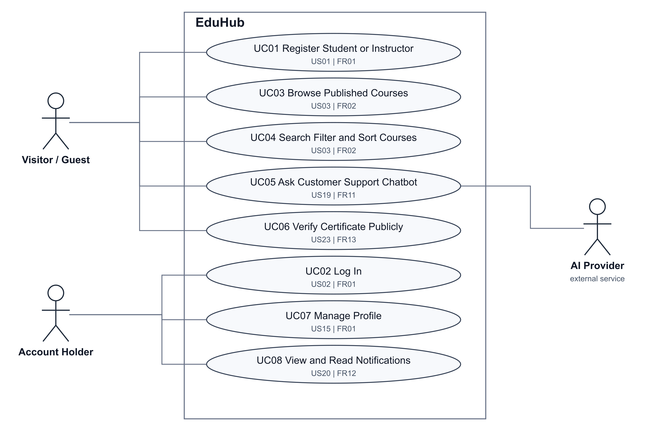
Figure 1 Public Access and Accounts
Account holder means Student, Instructor, or Admin. Registration creates Student or Instructor accounts only. Public certificate verification requires no login.

5.3 Enrollment Payments and Certificates
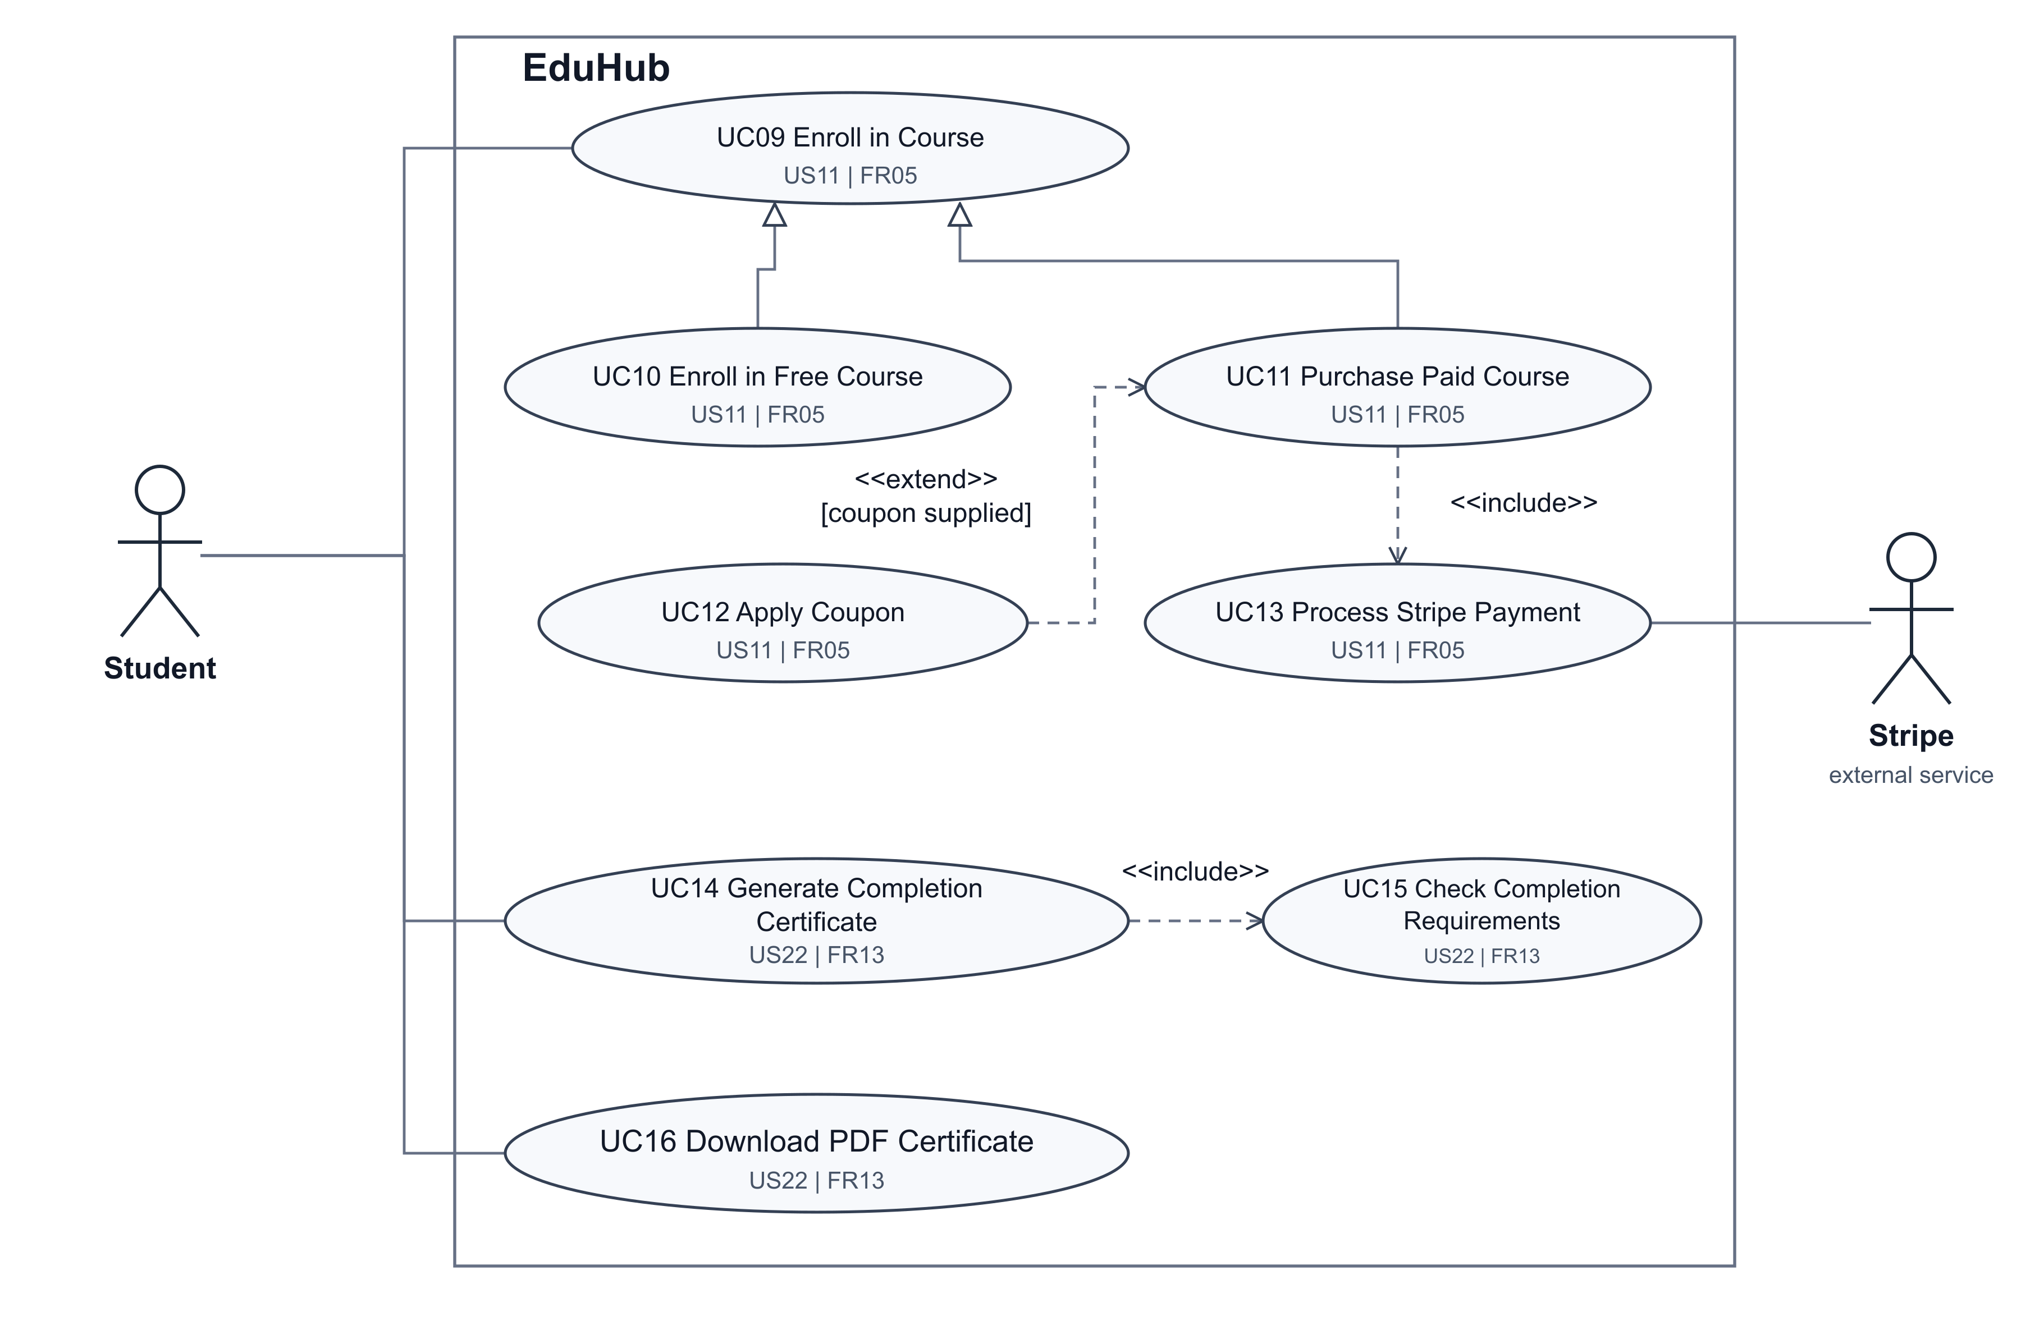
Figure 2 Enrollment Payments and Certificates
Free and paid enrollment specialize the same enrollment goal. Failed payments never grant enrollment. Certificate generation is triggered by course completion; downloading an existing certificate does not regenerate it.

5.4 Student Learning
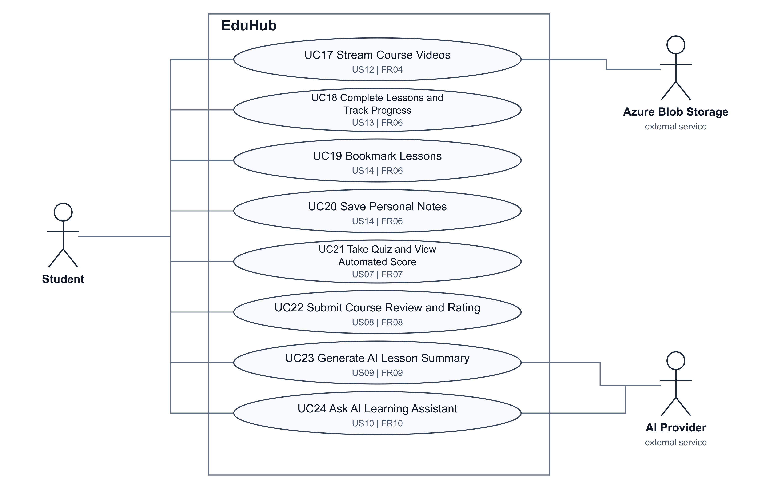
Figure 3 Student Learning
Course content requires authorized access. Reviews require the configured eligibility rules. AI summaries need lesson text or transcripts; AI answers use accessible course materials and follow the configured usage limits.

5.5 Instructor Course Management
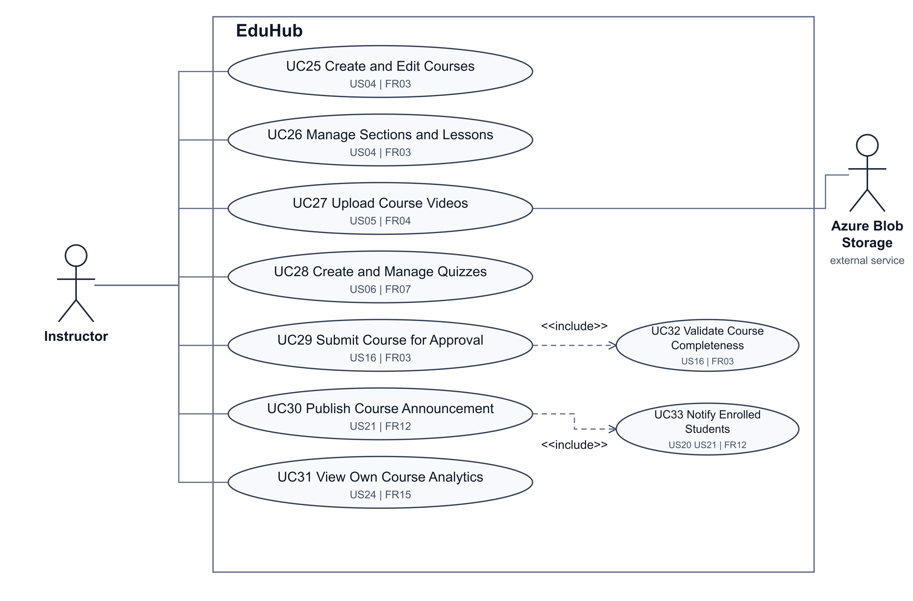
Figure 4 Instructor Course Management
Quiz management includes questions, answer options, and passing scores. Course management includes descriptions, thumbnails, and pricing. Instructors can change only courses they own or are authorized to manage.

5.6 Platform Administration
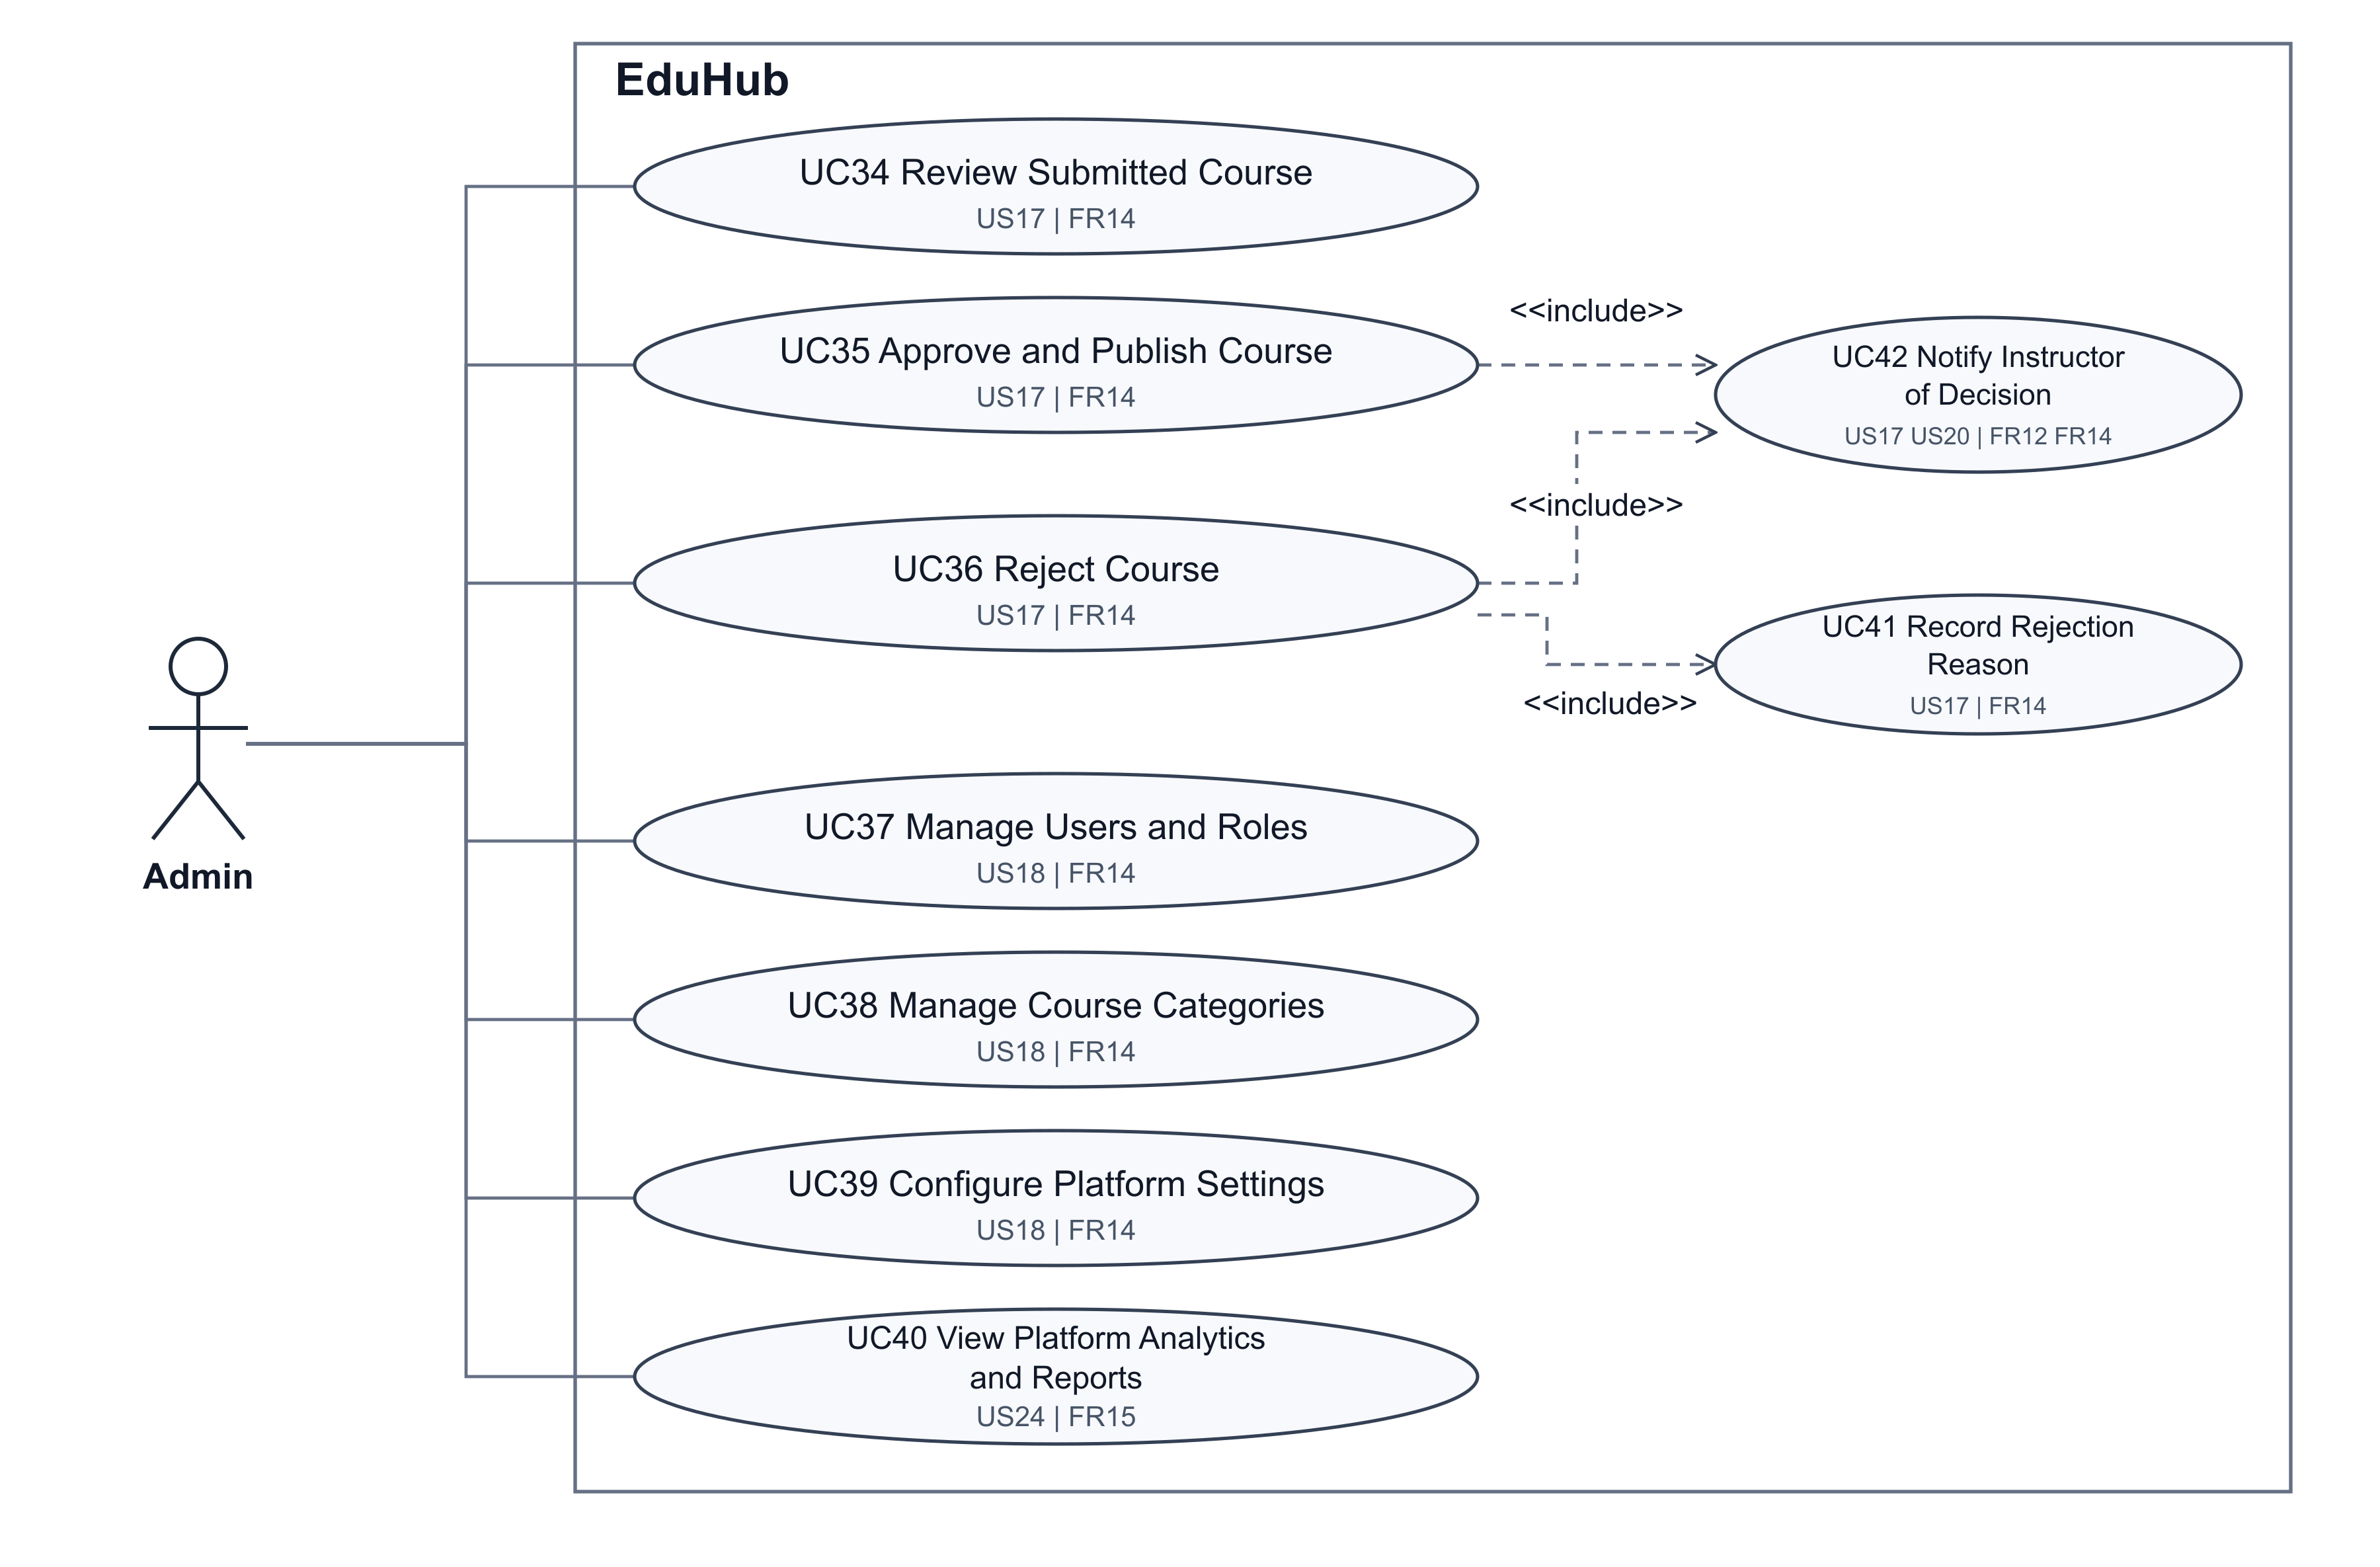
Figure 5 Platform Administration
Approval publishes the course in the catalog. Rejection requires a recorded reason and returns the decision to the instructor. Administrative operations require an authorized Admin account.

5.7 User Story Coverage
Every user story is linked below to at least one use case. A story can be represented by several related goals or required subfunctions. Figure numbers match the preceding five diagram pages.
Story | User story | Figure | Use cases
US #1 | Users’ register | 1 | UC01
US #2 | Users' login | 1 | UC02
US #3 | Browse, Search, and Filter Courses | 1 | UC03, UC04
US #4 | Create and Edit Courses | 4 | UC25, UC26
US #5 | Upload Course Videos | 4 | UC27
US #6 | Quiz Creation and Management | 4 | UC28
US #7 | Quiz Taking and Automated Grading | 3 | UC21
US #8 | Course Reviews and Ratings | 3 | UC22
US #9 | AI Lesson Summarization | 3 | UC23
US #10 | AI Learning Assistant | 3 | UC24
US #11 | Enroll in Courses (Free or Paid) | 2 | UC09, UC10, UC11, UC12, UC13
US #12 | Stream Course Videos | 3 | UC17

5.7 User Story Coverage Continued
Story | User story | Figure | Use cases
US #13 | Track Lesson Completion and Course Progress | 3 | UC18
US #14 | Bookmark Lessons and Save Notes | 3 | UC19, UC20
US #15 | Manage Profile | 1 | UC07
US #16 | Submit Course for Approval | 4 | UC29, UC32
US #17 | Approve or Reject Courses | 5 | UC34, UC35, UC36, UC41, UC42
US #18 | Manage Users, Categories, and Platform Settings | 5 | UC37, UC38, UC39
US #19 | AI Customer Support Chatbot | 1 | UC05
US #20 | Receive Notifications | 1, 4, 5 | UC08, UC33, UC42
US #21 | Publish Course Announcements | 4 | UC30, UC33
US #22 | Generate and Download Certificate | 2 | UC14, UC15, UC16
US #23 | Verify Certificate Publicly | 1 | UC06
US #24 | View Analytics and Reports | 4, 5 | UC31, UC40

5.8 Functional Requirement Coverage
Req | Feature | Figure | Use cases
FR-1 | Authentication and authorization | 1 | UC01, UC02, UC07
FR-2 | Course browsing and search | 1 | UC03, UC04
FR-3 | Course management | 4 | UC25, UC26, UC29, UC32
FR-4 | Video upload and streaming | 3, 4 | UC17, UC27
FR-5 | Enrollment and payments | 2 | UC09, UC10, UC11, UC12, UC13
FR-6 | Learning and progress tracking | 3 | UC18, UC19, UC20
FR-7 | Quizzes and assessment | 3, 4 | UC21, UC28
FR-8 | Course reviews and ratings | 3 | UC22
FR-9 | AI lesson summarization | 3 | UC23
FR-10 | AI learning assistant | 3 | UC24
FR-11 | AI support chatbot | 1 | UC05
FR-12 | Notifications and announcements | 1, 4, 5 | UC08, UC30, UC33, UC42
FR-13 | Certificates and public verification | 1, 2 | UC06, UC14, UC15, UC16
FR-14 | Admin management and approval | 5 | UC34, UC35, UC36, UC37, UC38, UC39, UC41, UC42
FR-15 | Analytics and reporting | 4, 5 | UC31, UC40

5.9 Feature Coverage Details
Course discovery includes title, category, price, difficulty level, and rating criteria, with sorting as stated in FR-2. Course management includes descriptions, thumbnails, pricing, sections, and lessons. UC26 explicitly covers sections and lessons under FR-3 and expands the course management goal described in US #4.
Free enrollment grants access without payment. Paid enrollment grants access only after successful Stripe confirmation, including the confirmed-payment handling described in the risk mitigation plan. A coupon is optional, and an invalid coupon does not replace the original price. Payment failures do not create an enrollment.
Lesson completion updates the saved course progress. Quiz management includes questions, answer options, and passing scores; a student submission stores the attempt and automatically calculates and displays the score. Eligible course reviews update the displayed average rating. Bookmarks and personal notes are saved for the student and lesson.
AI lesson summaries use available lesson text or transcripts. The learning assistant uses accessible course materials, while the support chatbot uses approved support documentation. AI responses and availability follow the quality, grounding, labeling, and usage-limit constraints in the existing requirements; unsupported questions retain the specified limitation response.
Notifications cover enrollments, payment results, announcements, and learning milestones. Students, instructors, and administrators can read relevant notifications. Course approval and rejection notify the instructor, while announcements notify enrolled students. Rejection requires a reason, and approval publishes the course.
Completion certificates are generated automatically after all required lessons and required quiz passing scores are satisfied. The PDF includes a unique verification code and can be downloaded later. Public verification accepts the code without login. Instructor analytics is restricted to authorized own-course data; administrators can view platform-wide enrollments, completion rates, sales, earnings, and revenue trends.
The diagrams visualize the existing functional scope. Validation errors, invalid coupons, unavailable videos, denied access, failed payments, and unavailable AI responses continue to follow the normal and exceptional scenarios already documented. The excluded live-streaming, native mobile application, and subscription-payment features are not added to this model.

