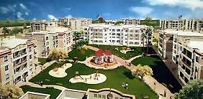

**Al Khama'el Residential Buildings –**

**Cairo – Egypt**

**Client:** variable

**Main Consultant**: Space Engineering Consultancy

**Scope:** MEP for some units

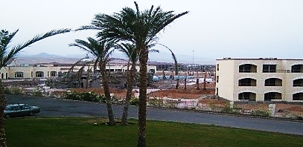

**Al Raouf Hotels Project**

**- Egypt**

**Client:** Al Raouf Hotels

**Main Consultant**: Architecture art

**Scope:** MEP Systems

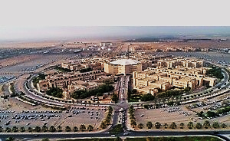

**Science Faculty, Girls Campus,**

**Al Qaseem University**

**Client:** Ben laden

**Main Consultant**: DAR Al handasah

**Scope:** MEP Infrastructure networks and Utilities

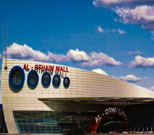

**Al Rabwa(2) Mall**

**(AL Othaim Group) – KSA**

**Client:** Al Othaim Commercial group

**Main Consultant**: DPME

**Scope:** MEP Systems

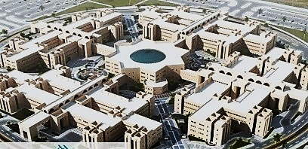

**Faculties Layout, Girls Campus,**

**Al Qaseem University Buraydah, KSA**

**Client:** Ben laden

**Main Consultant**: DAR Al handasah

**Scope:** Mechanical Systems

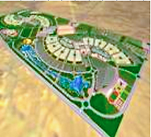

**Faculty of Society (Al Baha) – KSA**

**Client:** Ben laden

**Main Consultant**: DAR Al handasah

**Scope:** Full MEP work

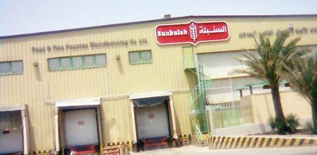

**Al Sonbollah Factory**

**Client:** Al Sonbollah

**Main Consultant**: Integrated consultant office

**Scope:** Full MEP Systems

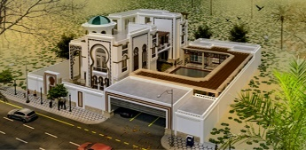

**Residential Villa (G+F)**

**Main Consultant:** Al-ITTIFAQ Engineering Consultants

**Scope:** Full MEP Work

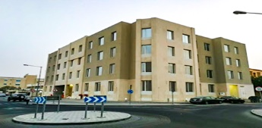

**Residential Building (B+G+3) - Old Aiport**

**Main Consultant:** Al-ITTIFAQ Engineering Consultants

**Scope:** Full MEP Work