Class: CS-5520 Mobile Application Development

Project: Contact Tracing App

Team Members: Marjan Moshfegh Gohari, Thitikorn Pongmorrakot, Tianyi Chen, Shu Hong Chan

**Background**

In order to slowing the spread of COVIS-19, people should take proactive action (such as do the COVID-19 testing) if who have come into close contact with someone diagnosed with COVID-19. The purpose of this App is helping people to record the location they have visited, such as restaurants, shops, theatres…

**How it works**

* Scan the QR-code or record the GPS coordinate (e.g. Postcode) when arrive the venue (e.g. restaurant)
* Location record with the timestamp will be stored in mobile devices
* A Public Location List which record all the venues with confirmed cases (i.e. someone diagnosed with COVID-19 have visited these venues in the past 14 days) is available on website for download
* App will get this Public Location List from website regularly and do the matching
* Once the record match, user will get the notification and the advice for the COVID-19 testing.

**Functions**

1. Capture the QR-code and save to local file with timestamp
2. Get the postcode information through Google Place API and save the information to local file with timestamp
3. Get the Public Location List and do the matching in the past 14 days
4. If match, push the notification message

Additional functions:

1. Store the Vaccine Card image for easy access (get the image from camera roll)

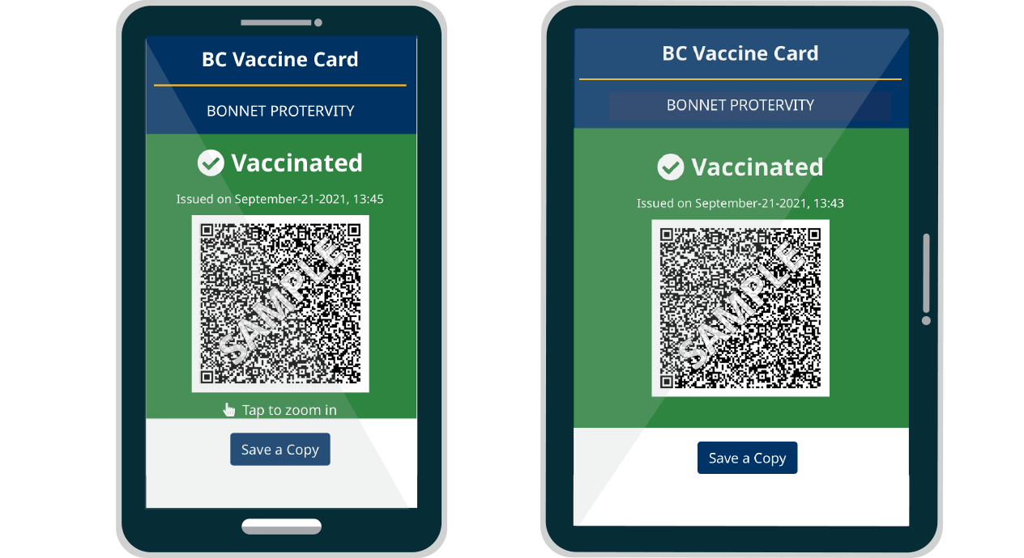

1. COVID-19 Information: redirect to B.C. COVID-19 website (<https://www2.gov.bc.ca/gov/content/covid-19/info/response>)

**Screen Draft**

Record Location

Vaccine

Card

COVID-19

Information

Database last update:

10-Nov-2021

***Contact Tracing***

Matching

Check

Screen 1 (Home)

< Home

Screen

QR-code

Location

Capture

OR

Screen 2

Screen 2

Home

< Home

Screen 4

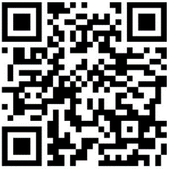

Location: V6B 5A6

OK

Screen 3

Screen 6

Screen 9

Redirect to B.C. COVID-19 website

Screen 5

< Home

Screen 3



Please scan the location QR code

When success, Screen 4

< Home

Screen 5

Location: V6B 5A6

OK

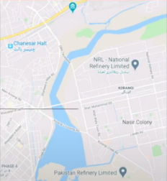

Home

< Home

Screen 8

**Please Note!**

The venue you have visited was also visited by a COVID-19 infected patient.

Date: 12-Oct-2021

Location: V6B 5A6

You can arrange COVID-19 testing by yourself. Please seek medical advice promptly when feeling unwell and proactively make a request to your doctor for testing.

More information

< Home

Screen 6

Matching check is carried out automatically; you will be notified if matched. However, you can also do it manually.

Check now

If match

Home

Redirect to B.C. COVID-19 website

([*https://www2.gov.bc.ca/gov/content/covid-19/info/response*](https://www2.gov.bc.ca/gov/content/covid-19/info/response))

< Home

Screen 7

**SAFE**

No match record.

OK

If no match record

Record Location

Vaccine

Card

COVID-19

Information

Database last update:

10-Nov-2021

***Contact Tracing***

Matching

Check

Screen 1 (Home)

If the Vaccine Card image was imported

< Home

Screen 9

Location: V6B 5A6

Update



Cancel

< Home

Import the Vaccine Card image

Screen 10

< Home

Screen 12

Location: V6B 5A6

Confirm



< Home

Screen 11

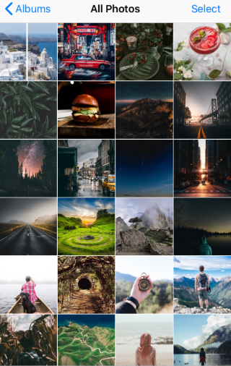

Screen 12

Screen 11

If the Vaccine Card image is not import yet, Screen 11

Home

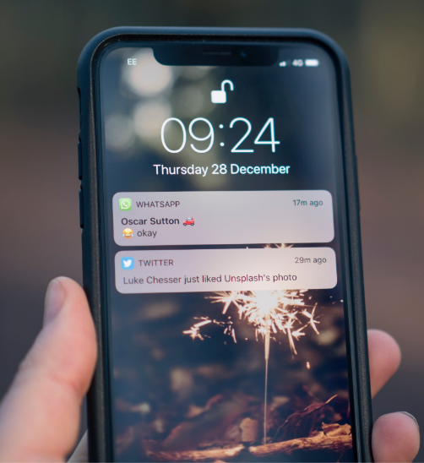

Download the Public Location List every two hours

Background Process

If matching found, show notification

Do the matching

When click on the message, go to the screen 8