Level 1 - Interview Feedback Form

Date of Interview:

Candidate Information

|  |  |
| --- | --- |
| Candidate Name | Chandra Sekhar Anil Chintakindi |
| Years of Experience | 6 |
| Skill | Javascript, React JS |

1. Candidate working screenshot

Scoring - The numerical rating system is based on the following: 5 - Exceptional, 4 - Satisfactory, 3 - Above Average, 2 - Average, 1 – Unsatisfactory

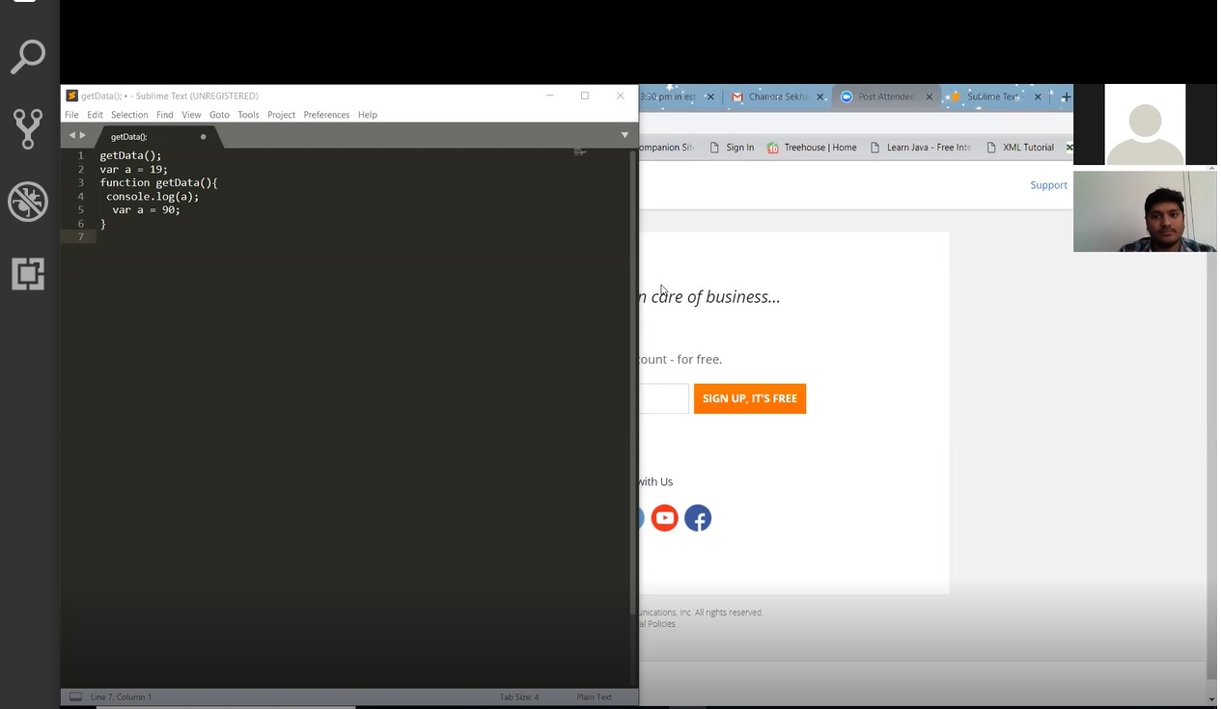

Interviewer Feedback

|  |  |
| --- | --- |
| Recommended for next Level | Selected/Rejected/Borderline |

2. Knowledge of Previous Projects

|  |  |  |
| --- | --- | --- |
| Previous Projects | Interviewer comments | Competency (1 – 5) |
| United Airlines, Houston Texas | NA | 1 |

3. Technical/ Techno functional skills Evaluation

**Questions Covered**

1. **JavaScript basics**

Rating 1/5

Video Time 05 : 00 – 14:05

1) How would you check if a number is an integer or float

2) console.log(y);   
let y =5;

Console.log(y);

var y=5;

3)

var a = 19;

function getData(){

console.log(a);

var a = 90;

}

getData();

4) console.log(5+2-"2")

console.log(3+5+"7")

1. **This Context**

Rating 1/5

Video Time 20 : 00 – 29:16

#1) var obj = {

myval:10,

getMyVal:function(){

console.log(this.myval)

}

}

console.log(obj.getMyVal());

var j = obj.getMyVal;

console.log(j());

#2) Call bind Apply & asked to give example

1. **Prototype & Inheritance**

Rating 1/5

Video Time 29:18 –33:35

#1) What is prototype in JavaScript & asked for writing the code for prototypal inheritance

1. **Array**

Rating 1/5

Video Time 34:18 –38:10

#1) [1,2,3,4,5] asked to insert the value between 3 ,5

#2) Difference between Slice & Splice

1. **HTML/CSS**

Rating 1/5

Video Time 43:27 –45:00

#1)Event Bubbling and capturing

1. **Logical**

Rating 0/5

Video Time 45:27 –46:19

#) write the logic to generate the Fibonacci series between 1-100;

1. **React -Redux**

Rating 2/5

Video Time 49:27 – 52:19

#1) Life cycle Methods

#) Redux Flow

#) HOC

4. General Aptitude

|  |  |  |
| --- | --- | --- |
| General Aptitude | Interviewer comments | Competency (1 – 5) |
| Communication | Good In Communication | 2 |
| Logic | Poor in Logic, Asked logic for fibbonaci series ,he didn't try |  |
|  |  |  |

5. Learning Capability

|  |  |  |
| --- | --- | --- |
| Competencies | Interviewer comments | Competency (1 – 5) |
| Self Starter * | NO |  |
| Quick / Self Learner * | NO |  |

6. Overall assessment

|  |
| --- |
| He has only Theoretical Knowledge not practical, he unable to answer the basic questions. |

7. Your message to next interviewer, if any (to be filled in after the interview)

|  |
| --- |
| As he don’t have good knowledge of JavaScript ,can’t consider for L2. |

8. PROCTORING REPORT

|  |  |
| --- | --- |
| Proctoring Report | |
| Areas | Number of Red Flags |
| 1. Eyes Movement | 0 |
| a. At the time of code writing or theoretical questions explanations where the eyes are | 1 |
| b. Zoom the candidate to see how many lights reflection in her eyes | 0 |
| 2. Head movement | 0 |
| a. At the time of code writing or theoretical questions explanations where the head is | 0 |
| 3. Lips movement | 0 |
| a. Using overhead light | 0 |
| b. Dark light in the room or on the face | 0 |
| c. Using Headphone in front of Lips | 0 |
| 4. Latency check or Jitter report to see for the packet loss | See pic |
| 5. Candidate desktop | 0 |
| a. External suspicious applications (screen mirroring app/ remote desktops) open or devices connected; we can see the toolbar | 0 |
| b. Sharing screen but not desktop | 0 |
| 6. Voice Impostering | 0 |
| a. Using speaker or audio splitter to communicate, so that the voice can be heard on phone c-nference and answer can be given on phone | 0 |
| b. Voice tone and expressions are not in sync- flat voice | 0 |
| c. Non-satisfactory answers for personal questions from the resume | 0 |
| d. Suspicious voice- any notifcations, pings, other voices | 0 |
| 7. Linkedin Photo Verification |  |
|  |  |