**index.html**

<!DOCTYPE html>

<html lang="en">

<head>

<meta charset="UTF-8">

<meta name="viewport" content="width=device-width, initial-scale=1.0">

<meta http-equiv="X-UA-Compatible" content="ie=edge">

<title>Title</title>

</head>

<body>

<h1>Home</h1>

<a href="./">Home</a>

<a href="./images.html">Images</a>

<a href="./tables.html">Tables</a>

</body>

</html>

**images.html**

<!DOCTYPE html>

<html lang="en">

<head>

<meta charset="UTF-8">

<meta name="viewport" content="width=device-width, initial-scale=1.0">

<meta http-equiv="X-UA-Compatible" content="ie=edge">

<title>Images</title>

</head>

<body>

<h1>Images</h1>

<a href="./">Home</a>

<a href="./images.html">Images</a>

<a href="./tables.html">Tables</a>

<hr>

<img src="http://lorempixel.com/400/300/" alt="Stock Image">

<img src="http://lorempixel.com/400/400/" alt="Stock Image">

<img src="http://lorempixel.com/250/250/" alt="Stock Image">

<img src="http://lorempixel.com/50/50/" alt="Stock Image">

</body>

</html>

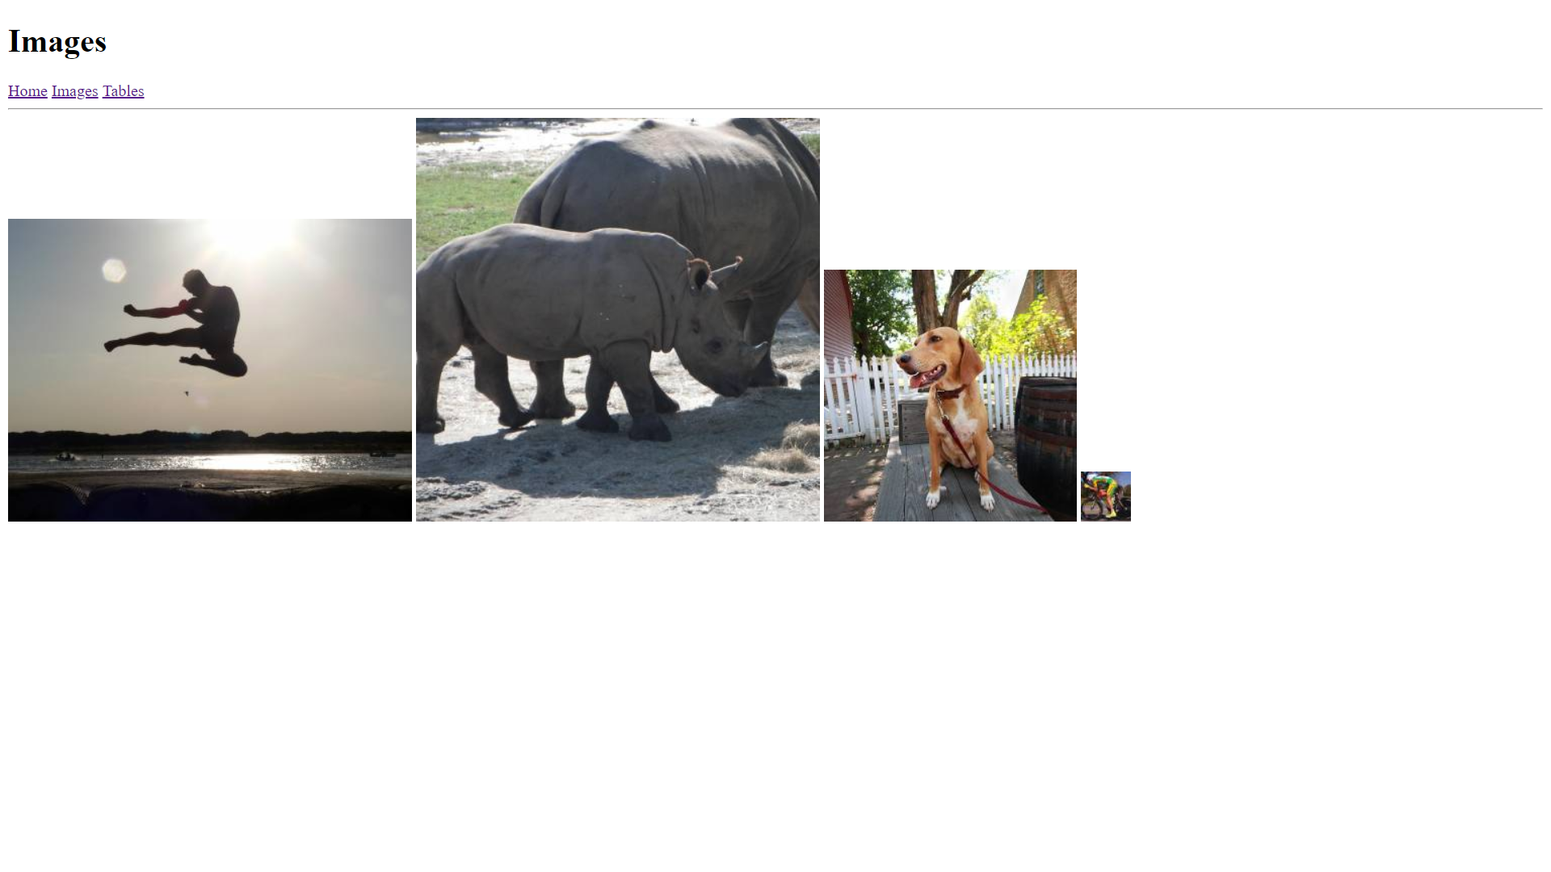**tables.html**

<!DOCTYPE html>

<html lang="en">

<head>

<meta charset="UTF-8">

<meta name="viewport" content="width=device-width, initial-scale=1.0">

<meta http-equiv="X-UA-Compatible" content="ie=edge">

<title>Tables</title>

</head>

<body>

<h1>Tables</h1>

<a href="./">Home</a>

<a href="./images.html">Images</a>

<a href="./tables.html">Tables</a>

<hr>

<table border="1">

<tr>

<th>Entry Header 1</th>

<th>Entry Header 2</th>

<th>Entry Header 3</th>

<th>Entry Header 4</th>

</tr>

<tr>

<td>Entry First Line 1</td>

<td>Entry First Line 2</td>

<td>Entry First Line 3</td>

<td>Entry First Line 4</td>

</tr>

<tr>

<td>Entry Line 1</td>

<td>Entry Line 2</td>

<td>Entry Line 3</td>

<td>Entry Line 4</td>

</tr>

<tr>

<td>Entry Last Line 1</td>

<td>Entry Last Line 2</td>

<td>Entry Last Line 3</td>

<td>Entry Last Line 4</td>

</tr>

</table>

</body>

</html>

