**index.html**

<!DOCTYPE html>

<html lang="en">

<head>

<meta charset="UTF-8">

<meta name="viewport" content="width=device-width, initial-scale=1.0">

<meta http-equiv="X-UA-Compatible" content="ie=edge">

<title>CSS Formats</title>

<link rel="stylesheet" href="style.css">

<style>

p {

margin-left: 3%;

color: blue;

}

</style>

</head>

<body>

<h1>Using CSS Forms</h1>

<hr>

<h2>Inline CSS</h2>

<p style="color: red">

Lorem ipsum dolor sit amet consectetur adipisicing elit. Nesciunt atque non

maiores autem hic! Odit quos quam fugiat repudiandae voluptatem incidunt non!

Nulla quas voluptatum laudantium, maxime ad voluptatibus harum!

</p>

<hr>

<h2>Internal CSS</h2>

<p>

Lorem ipsum dolor sit amet consectetur adipisicing elit. Nesciunt atque non

maiores autem hic! Odit quos quam fugiat repudiandae voluptatem incidunt non!

Nulla quas voluptatum laudantium, maxime ad voluptatibus harum!

</p>

<hr>

<h2>External CSS</h2>

<p>

Lorem ipsum dolor sit amet consectetur adipisicing elit. Nesciunt atque non

maiores autem hic! Odit quos quam fugiat repudiandae voluptatem incidunt non!

Nulla quas voluptatum laudantium, maxime ad voluptatibus harum!

</p>

<hr>

</body>

</html>

**style.css**

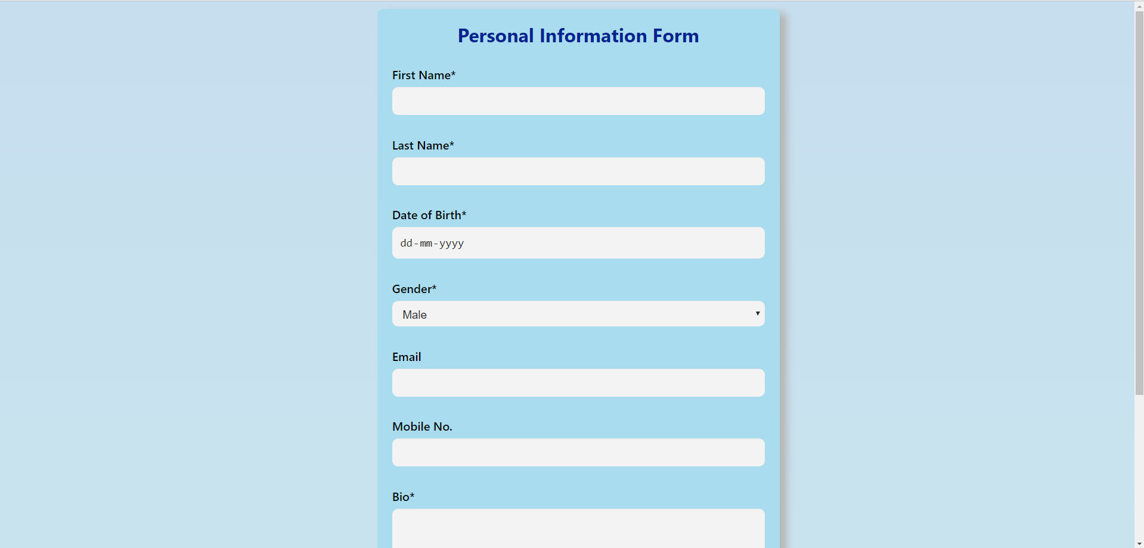

html {

font-family: 'Segoe UI', Tahoma, Geneva, Verdana, sans-serif;

background: linear-gradient(90deg, rgba(240,171,171,1) 0%, rgba(174,200,233,1) 100%);

}

h1 {

text-align: center;

color: #00156b;

}

h2 {

color: #4f00aa;

}

p {

color: #00d60b;

}

hr {

background-color: white;

border: 1px solid white;

}