

**Faculty of engineering - Shoubra**

**Benha University**

**Name:** **Abdelrahman Hamza Mokhtar Hamza**

**B.N: 445**

**Date: 10\5\2020**

**Topic:** programming language

**Github link :**

[**https://github.com/3bdelrahman-hamza/ece001**](https://github.com/3bdelrahman-hamza/ece001)

**Website link :**

[**https://3bdelrahman-hamza.github.io/ece001/**](https://3bdelrahman-hamza.github.io/ece001/)

**Application brief :**

**In my research I wrote about programming languages because it’s a very important topic nowadays and everyone now should learn and know about programming language because programming is the future and the programming languages are now beginning to be used in almost all fields, such as industrial, medical, engineering and many other. The most important types of programming languages that I discussed in this research are (Java, C++ and Python).**

**Screenshots:**

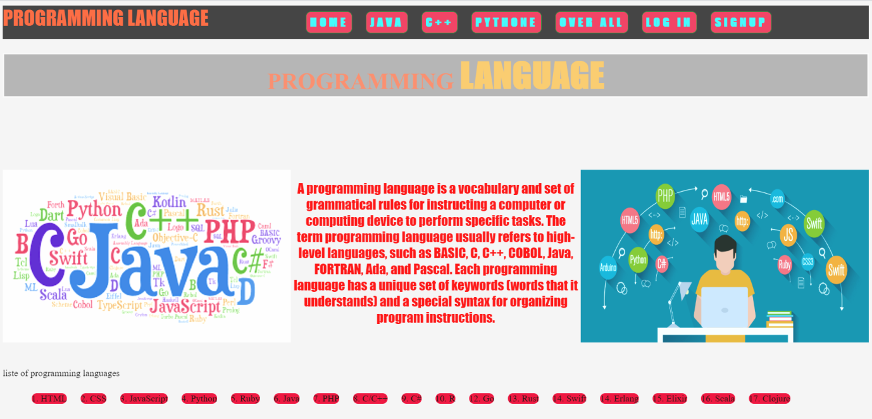1- Home page : 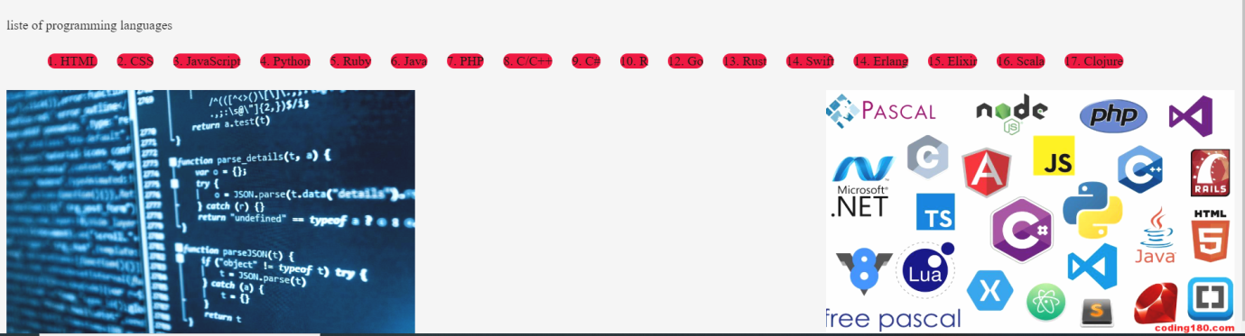

2- Java page :

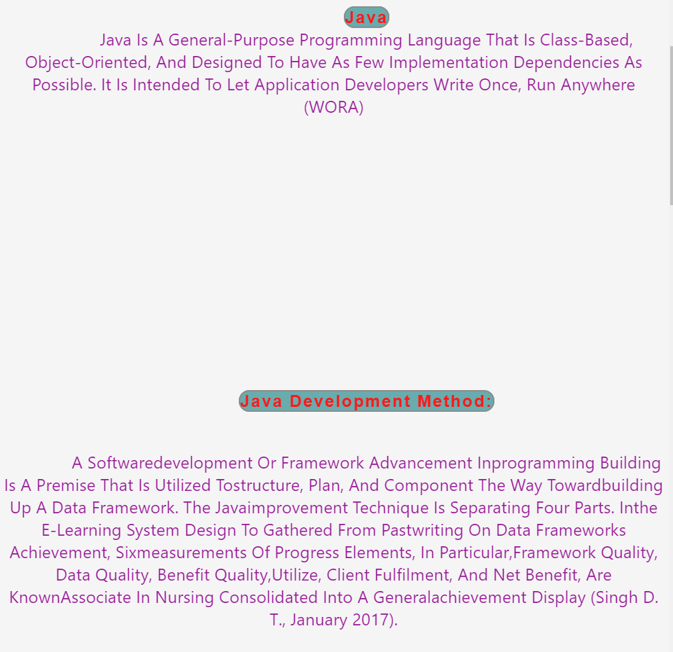

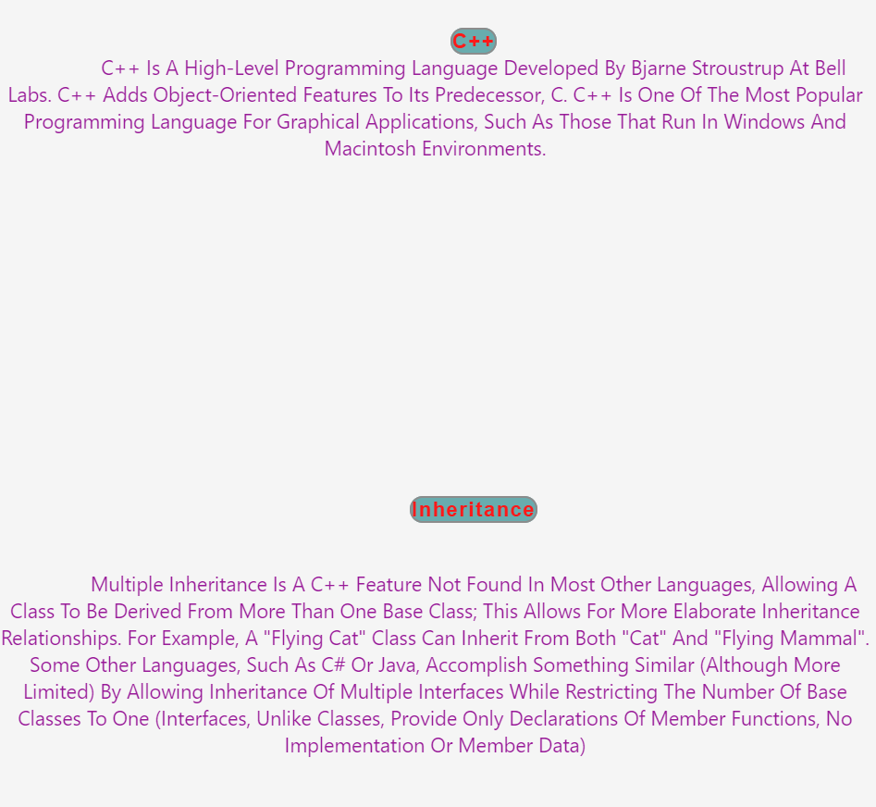3- C++ page :

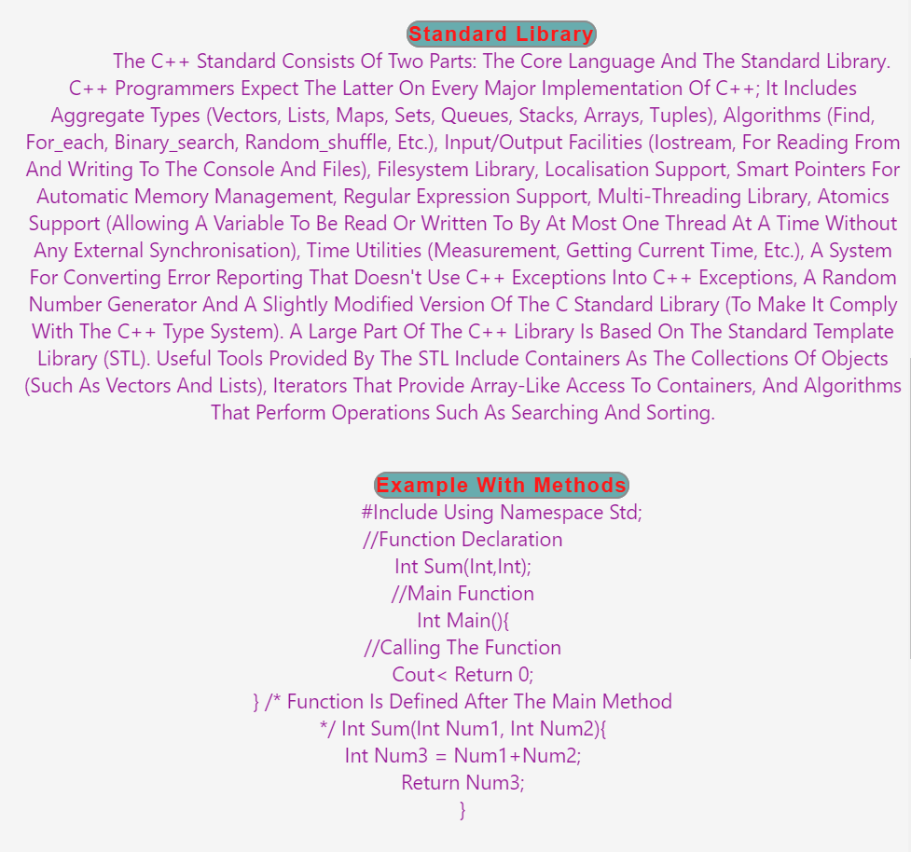

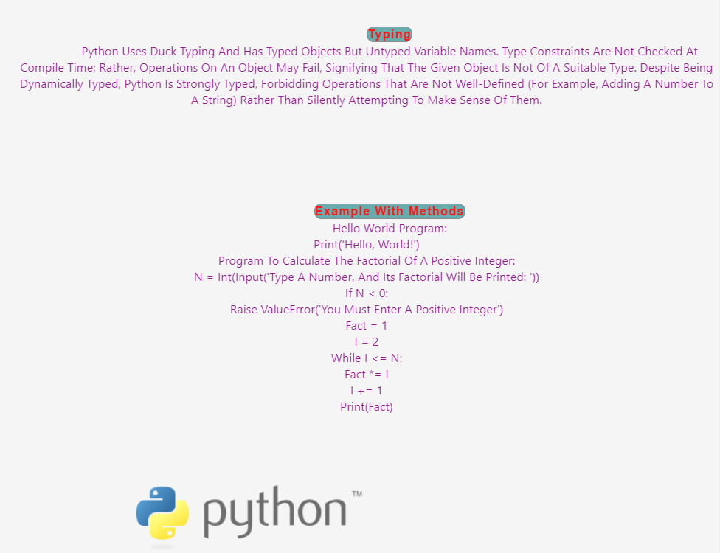4- Python page: 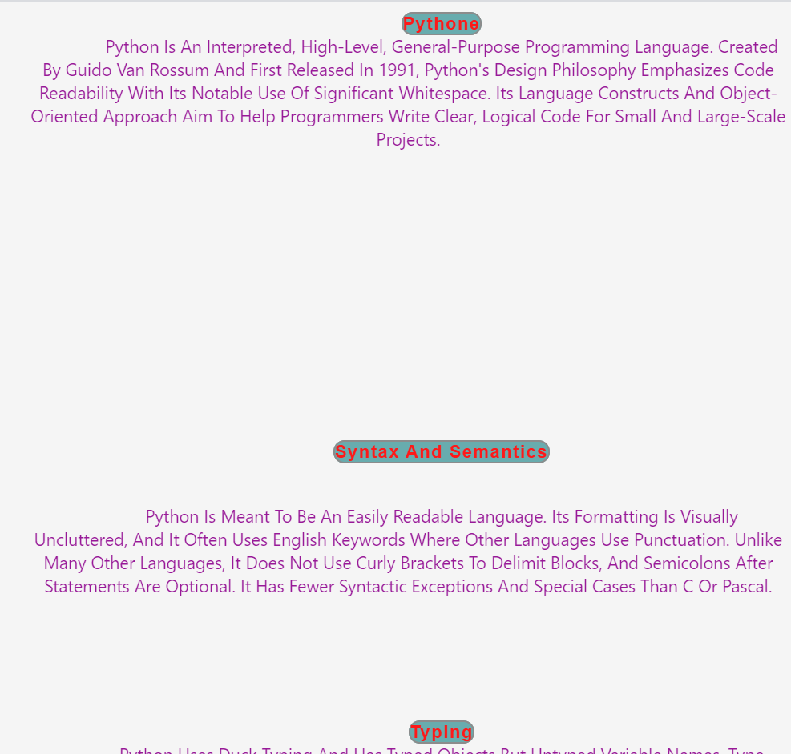

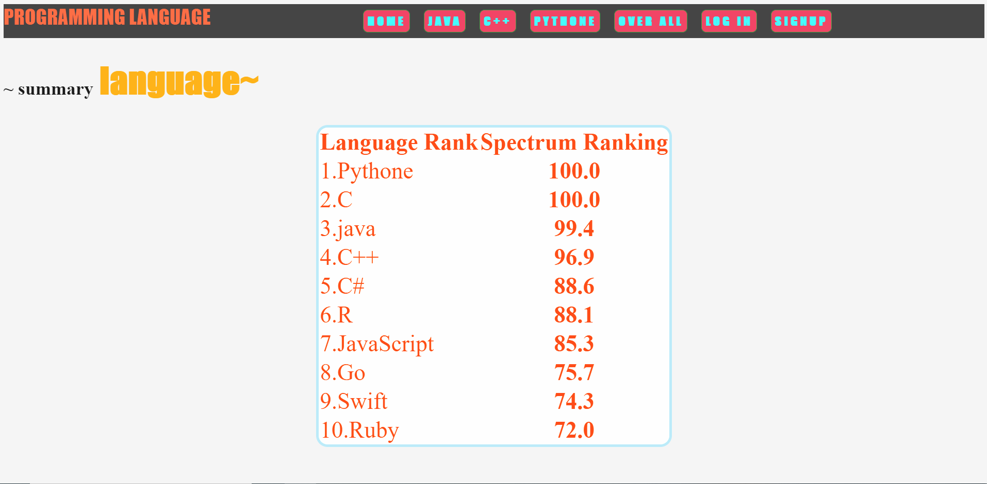5- Overall page :

6- Login page:

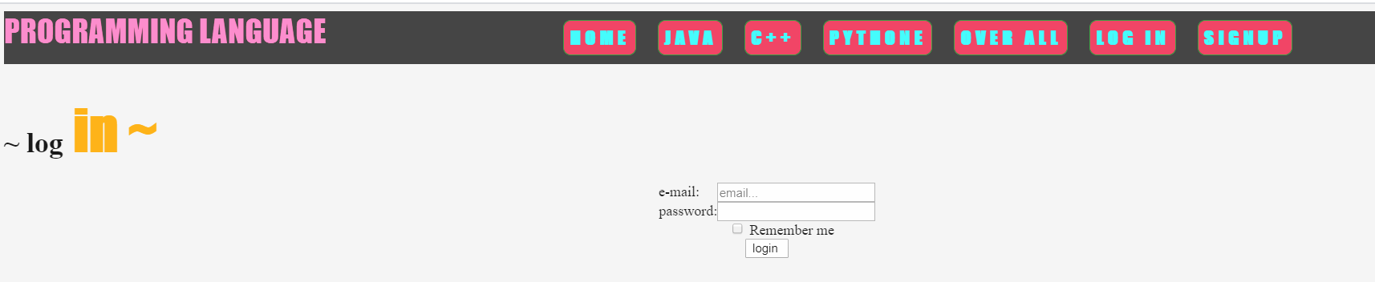

7- Signup page:

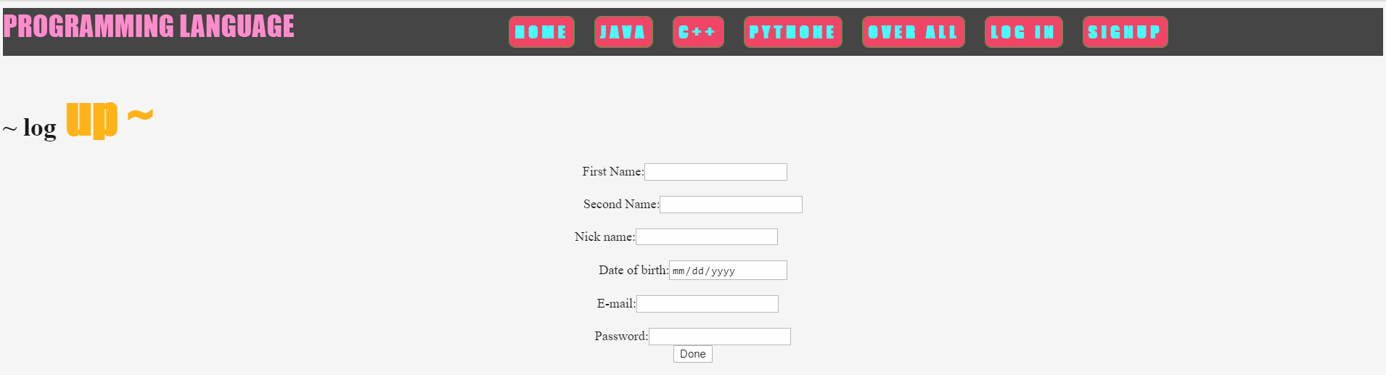

**Source code:**

1-Home page:

<!DOCTYPE html>

<html>

<head>

<title>Abood webpage </title>

<link rel="stylesheet" href="css/style.css">

<link rel="stylesheet" href="css/style1.css">

<link rel="stylesheet" href="css/style3.css">

<link rel="stylesheet" href="css/style5.css">

<link rel="stylesheet" href="css/styleteam.css">

<link rel="stylesheet" href="css/stylesignup.css">

<link rel="stylesheet" href="css/stylemap.css">

<link rel="stylesheet" href="css/news.css">

</head>

<body>

<nav>

<ul>

<div id="logo"><a href="../DONE/home.html">Programming Language<p style="font-size: 15px;"></p></a></div>

<li><a href="../DONE/home.html">home</a></li>

<li><a href="../DONE/java.html">java</a></li>

<li><a href="../DONE/c++.html">c++</a></li>

<li><a href="../DONE/pythone.html">pythone</a></li>

<li><a href="../DONE/all.html">over all</a></li>

<li><a href="../DONE/sign.html" >log in </a></li>

<li><a href="../DONE/signup.html">signup</a></li>

</ul>

</nav>

<br>

<br>

<br>

<div class="head">

<h1> Programming <span style="color: orange;font-family: fantasy;font-size: 60px;"> Language </span></h1>

</div>

<br>

<br>

<br>

<br>

<!-- /////////////////\\\\\\\\\\\\\\\\\\\\\\\\\\\\\\\\\\\\\\\\\\\\\\\\\\\\\\\\\\\\\\\\\\\\\\\\\\\\\\\\\\\\\\\\\\\\\\\\\\\\\\\\\\\\\\\\ -->

<!-- section 1 -->

<section class="num1">

<div class="q">

<img src="first.png" width="500" height="300" >

</div>

<div class="w">

<img src="second.jpeg" width="500" height="300">

</div>

<!-- section 1 end -->

<div class="e">

<br> <span style="color: red;font-family: fantasy;font-size: 23px;"> A programming language is a vocabulary and set of grammatical rules for instructing a computer or computing device to perform specific tasks. The term programming language usually refers to high-level languages, such as BASIC, C, C++, COBOL, Java, FORTRAN, Ada, and Pascal.

Each programming language has a unique set of keywords (words that it understands) and a special syntax for organizing program instructions. </span><br>

<br>

<br>

<br>

</div>

<br>

<h> liste of programming languages</h>

<ol>

<li> 1. HTML</li>

<li> 2. CSS</li>

<li> 3. JavaScript</li>

<li> 4. Python</li>

<li> 5. Ruby</li>

<li> 6. Java</li>

<li> 7. PHP</li>

<li> 8. C/C++</li>

<li> 9. C#</li>

<li> 10. R</li>

<li> 12. Go</li>

<li> 13. Rust</li>

<li> 14. Swift</li>

<li> 14. Erlang</li>

<li> 15. Elixir</li>

<li> 16. Scala</li>

<li> 17. Clojure</li>

</ol>

</section>

<!-- section 2 -->

<!-- section 2 -->

<section class="num2">

<div class="r">

<img src="third.jpg" width="500" height="300">

</div>

<div class="t">

<img src="four.jpeg" width="500" height="300">

</div>

</body>

</html>

2- Java page :

<!DOCTYPE html>

<html>

<head>

<title>java </title>

<link rel="stylesheet" href="css/news.css">

</head>

<body>

<nav>

<ul>

<div id="logo"><a href="../DONE/home.html">Programming Language<p style="font-size: 15px;"></p></a></div>

<li><a href="../DONE/home.html">home</a></li>

<li><a href="../DONE/java.html">java</a></li>

<li><a href="../DONE/c++.html">c++</a></li>

<li><a href="../DONE/pythone.html">pythone</a></li>

<li><a href="../DONE/all.html">over all</a></li>

<li><a href="../DONE/sign.html" >log in </a></li>

<li><a href="../DONE/signup.html">signup</a></li>

</ul>

</nav>

<br>

<br>

<br>

<br>

<br>

<br>

<div class="p">

<p>

<br>

<br>

<center><strong style="color: red; font-family:; letter-spacing: 2px;border: 2px solid grey;border-radius: 20px; background-color:cadetblue;">Java</strong>

</center>

<center>

<span style="color:darkmagenta; font-family:Segoe UI;">Java is a general-purpose programming language that is class-based, object-oriented, and designed to have as few implementation dependencies as possible. It is intended to let application developers write once, run anywhere (WORA)</span></center>

<br>

<br>

<br>

<br>

<br><br>

<br>

<br>

<br>

<br>

<br>

<br>

<br>

<br>

<center><strong style="color: red; font-family:; letter-spacing: 2px;border: 2px solid grey;border-radius: 20px; background-color:cadetblue;">Java Development Method:</strong>

<br>

<br>

<br>

</center>

<center>

<span style="color:darkmagenta; font-family:Segoe UI;">A softwaredevelopment or framework advancement inprogramming building is a premise that is utilized tostructure, plan, and component the way towardbuilding up a data framework. The Javaimprovement technique is separating four parts. Inthe e-learning system design to gathered from pastwriting on data frameworks achievement, sixmeasurements of progress elements, in particular,framework quality, data quality, benefit quality,utilize, client fulfilment, and net benefit, are knownAssociate in Nursing consolidated into a generalachievement display (Singh D. T., January 2017).

</span></center><br><br>

<br>

<br>

<br>

<br>

<center><strong style="color: red; font-family:; letter-spacing: 2px;border: 2px solid grey;border-radius: 20px; background-color:cadetblue;">Java Security Method: </strong>

<center>

<span style="color:darkmagenta; font-family:Segoe UI;">In this day and age wherePC organizing assumes a vital part in the regular dayto day existence, PC lawbreakers cause destructionin basic or vital system conditions. A typicalcriminal exercise includes: tapping systemmovement, altering databases, adjusting sitescrippling administrations and data robbery.

</span></center>

<br>

<br>

<br>

<br>

<br>

<br><br>

<center><strong style="color: red; font-family:; letter-spacing: 2px;border: 2px solid grey;border-radius: 20px; background-color:cadetblue;">Example with methods</strong>

</center>

<center>

<span style="color:darkmagenta; font-family:Segoe UI;">// This is an example of a single line comment using two slashes

/*<br>

* This is an example of a multiple line comment using the slash and asterisk.

* This type of comment can be used to hold a lot of information or deactivate

* code, but it is very important to remember to close the comment.

*/<br>

package fibsandlies;<br>

import java.util.Map;<br>

import java.util.HashMap;<br>

/**<br>

* This is an example of a Javadoc comment; Javadoc can compile documentation<br>

* from this text. Javadoc comments must immediately precede the class, method,<br>

* or field being documented.

*/<br>

public class FibCalculator extends Fibonacci implements Calculator {<br>

private static Map<Integer, Integer> memoized = new HashMap<>();<br>

/*

* The main method written as follows is used by the JVM as a starting point<br>

* for the program.<br>

*/<br>

public static void main(String[] args) {<br>

memoized.put(1, 1);<br>

memoized.put(2, 1);<br>

System.out.println(fibonacci(12)); // Get the 12th Fibonacci number and print to console

}<br>

/**<br>

* An example of a method written in Java, wrapped in a class.

* Given a non-negative number FIBINDEX, returns

* the Nth Fibonacci number, where N equals FIBINDEX.

* <br>

* @param fibIndex The index of the Fibonacci number

* @return the Fibonacci number

*/<br>

public static int fibonacci(int fibIndex) {<br>

if (memoized.containsKey(fibIndex)) return memoized.get(fibIndex);<br>

else {<br>

int answer = fibonacci(fibIndex - 1) + fibonacci(fibIndex - 2);<br>

memoized.put(fibIndex, answer);<br>

return answer;<br>

}

}

}

release on March 27, 2018<br></span></center>

<br>

<br>

<br>

<br>

<br>

<div id="f">

<img src="java1.png" style="width:500px; height: 500;">

</body>

</html>

- C++ page :3

<!DOCTYPE html>

<html>

<head>

<title>c++ </title>

<link rel="stylesheet" href="css/news.css">

</head>

<body>

<nav>

<ul>

<div id<div id="logo"><a href="../DONE/home.html">Programming Language<p style="font-size: 15px;"></p></a></div>

<li><a href="../DONE/home.html">home</a></li>

<li><a href="../DONE/java.html">java</a></li>

<li><a href="../DONE/c++.html">c++</a></li>

<li><a href="../DONE/pythone.html">pythone</a></li>

<li><a href="../DONE/all.html">over all</a></li>

<li><a href="../DONE/sign.html" >log in </a></li>

<li><a href="../DONE/signup.html">signup</a></li>

</ul>

</nav>

<br>

<br>

<br>

<br>

<br>

<br>

<div class="p">

<p>

<br>

<br>

<center><strong style="color: red; font-family:; letter-spacing: 2px;border: 2px solid grey;border-radius: 20px; background-color:cadetblue;">C++</strong>

</center>

<center>

<span style="color:darkmagenta; font-family:Segoe UI;">C++ is a high-level programming language developed by Bjarne Stroustrup at Bell Labs. C++ adds object-oriented features to its predecessor, C. C++ is one of the most popular programming language for graphical applications, such as those that run in Windows and Macintosh environments.</span></center>

<br>

<br>

<br>

<br>

<br><br>

<br>

<br>

<br>

<br>

<br>

<br>

<br>

<br>

<center><strong style="color: red; font-family:; letter-spacing: 2px;border: 2px solid grey;border-radius: 20px; background-color:cadetblue;">Inheritance</strong>

<br>

<br>

<br>

</center>

<center>

<span style="color:darkmagenta; font-family:Segoe UI;">Multiple inheritance is a C++ feature not found in most other languages, allowing a class to be derived from more than one base class; this allows for more elaborate inheritance relationships. For example, a "Flying Cat" class can inherit from both "Cat" and "Flying Mammal". Some other languages, such as C# or Java, accomplish something similar (although more limited) by allowing inheritance of multiple interfaces while restricting the number of base classes to one (interfaces, unlike classes, provide only declarations of member functions, no implementation or member data)

</span></center><br><br>

<br>

<br>

<br>

<br>

<center><strong style="color: red; font-family:; letter-spacing: 2px;border: 2px solid grey;border-radius: 20px; background-color:cadetblue;">Standard library </strong>

<center>

<span style="color:darkmagenta; font-family:Segoe UI;">The C++ standard consists of two parts: the core language and the standard library. C++ programmers expect the latter on every major implementation of C++; it includes aggregate types (vectors, lists, maps, sets, queues, stacks, arrays, tuples), algorithms (find, for_each, binary_search, random_shuffle, etc.), input/output facilities (iostream, for reading from and writing to the console and files), filesystem library, localisation support, smart pointers for automatic memory management, regular expression support, multi-threading library, atomics support (allowing a variable to be read or written to by at most one thread at a time without any external synchronisation), time utilities (measurement, getting current time, etc.), a system for converting error reporting that doesn't use C++ exceptions into C++ exceptions, a random number generator and a slightly modified version of the C standard library (to make it comply with the C++ type system).

A large part of the C++ library is based on the Standard Template Library (STL). Useful tools provided by the STL include containers as the collections of objects (such as vectors and lists), iterators that provide array-like access to containers, and algorithms that perform operations such as searching and sorting.</span></center>

<br>

<br>

<center><strong style="color: red; font-family:; letter-spacing: 2px;border: 2px solid grey;border-radius: 20px; background-color:cadetblue;">Example with methods</strong>

</center>

<center>

<span style="color:darkmagenta; font-family:Segoe UI;">#include <iostream>

using namespace std; <br>

//Function declaration<br>

int sum(int,int);<br>

//Main function<br>

int main(){<br>

//Calling the function<br>

cout<<sum(1,99);<br>

return 0;<br>

}

/* Function is defined after the main method <br>

*/

int sum(int num1, int num2){<br>

int num3 = num1+num2;<br>

return num3;<br>

}</span></center><br>

<br>

<br>

<br>

<br>

<br>

<div id="f">

<img src="c++.png" style="width: 500px; height: 500;">

</body>

</html>

4- Python page:

<!DOCTYPE html>

<html>

<head>

<title>pythone </title>

<link rel="stylesheet" href="css/news.css">

</head>

<body>

<nav>

<ul>

<div id="logo"><a href="../DONE/index.html">Programming Language<p style="font-size: 15px;"></p></a></div>

<li><a href="../DONE/home.html">home</a></li>

<li><a href="../DONE/java.html">java</a></li>

<li><a href="../DONE/c++.html">c++</a></li>

<li><a href="../DONE/pythone.html">pythone</a></li>

<li><a href="../DONE/all.html">over all</a></li>

<li><a href="../DONE/sign.html" >log in </a></li>

<li><a href="../DONE/signup.html">signup</a></li>

</ul>

</nav>

<br>

<br>

<br>

<br>

<br>

<br>

<div class="p">

<p>

<br>

<br>

<center><strong style="color: red; font-family:; letter-spacing: 2px;border: 2px solid grey;border-radius: 20px; background-color:cadetblue;">pythone</strong>

</center>

<center>

<span style="color:darkmagenta; font-family:Segoe UI;">Python is an interpreted, high-level, general-purpose programming language. Created by Guido van Rossum and first released in 1991, Python's design philosophy emphasizes code readability with its notable use of significant whitespace. Its language constructs and object-oriented approach aim to help programmers write clear, logical code for small and large-scale projects.</span></center>

<br>

<br>

<br>

<br>

<br><br>

<br>

<br>

<br>

<br>

<br>

<br>

<br>

<br>

<center><strong style="color: red; font-family:; letter-spacing: 2px;border: 2px solid grey;border-radius: 20px; background-color:cadetblue;">Syntax and semantics</strong>

<br>

<br>

<br>

</center>

<center>

<span style="color:darkmagenta; font-family:Segoe UI;">Python is meant to be an easily readable language. Its formatting is visually uncluttered, and it often uses English keywords where other languages use punctuation. Unlike many other languages, it does not use curly brackets to delimit blocks, and semicolons after statements are optional. It has fewer syntactic exceptions and special cases than C or Pascal.</span></center><br><br>

<br>

<br>

<br>

<br>

<center><strong style="color: red; font-family:; letter-spacing: 2px;border: 2px solid grey;border-radius: 20px; background-color:cadetblue;">Typing</strong>

<center>

<span style="color:darkmagenta; font-family:Segoe UI;">Python uses duck typing and has typed objects but untyped variable names. Type constraints are not checked at compile time; rather, operations on an object may fail, signifying that the given object is not of a suitable type. Despite being dynamically typed, Python is strongly typed, forbidding operations that are not well-defined (for example, adding a number to a string) rather than silently attempting to make sense of them.</span></center>

<br>

<br>

<br>

<br>

<br>

<br><br>

<center><strong style="color: red; font-family:; letter-spacing: 2px;border: 2px solid grey;border-radius: 20px; background-color:cadetblue;">Example with methods</strong>

</center>

<center>

<span style="color:darkmagenta; font-family:Segoe UI;">Hello world program:<br>

print('Hello, world!')<br>

Program to calculate the factorial of a positive integer:<br>

n = int(input('Type a number, and its factorial will be printed: '))<br>

if n < 0:<br>

raise ValueError('You must enter a positive integer')<br>

fact = 1<br>

i = 2<br>

while i <= n:<br>

fact *= i<br>

i += 1<br>

print(fact) <br></span></center>

<br>

<br>

<br>

<br>

<br>

<div id="f">

<img src="pythone.png" style="width:500px; height: 500;">

</body>

</html>

- Overall page :5

<!DOCTYPE html>

<html>

<head>

<title>ALL </title>

<link rel="stylesheet" href="css/news.css">

</head>

<body>

<nav>

<ul>

<div id="logo"><a href="../DONE/home.html">Programming Language<p style="font-size: 15px;"></p></a></div>

<li><a href="../DONE/home.html">home</a></li>

<li><a href="../DONE/java.html">java</a></li>

<li><a href="../DONE/c++.html">c++</a></li>

<li><a href="../DONE/pythone.html">pythone</a></li>

<li><a href="../DONE/all.html">over all</a></li>

<li><a href="../DONE/sign.html" >log in </a></li>

<li><a href="../DONE/signup.html">signup</a></li>

</ul>

</nav>

<br>

<br>

<br>

<br>

<h1> ~ summary<span style="color: orange;font-family: fantasy;font-size: 60px;"> language~ </span></h1>

<section class="num1">

</div>

</section>

<center>

<table style="border: 4px solid lightblue; color: orangered; font-size: 40px; border-radius: 20px; background-color: azure; ">

<tr>

<th>Language Rank</th> &nbsp;&nbsp;&nbsp;&nbsp <th>Spectrum Ranking</th>

</tr>

<tr>

<td>1.Pythone</td><th>100.0</th>

</tr>

<tr>

<td>2.C</td><th>100.0</th>

</tr>

<tr>

<td>3.java</td> <th>99.4</th>

</tr>

<tr>

<td>4.C++</td> <th>96.9</th>

</tr>

<tr>

<td>5.C#</td> <th>88.6</th>

</tr>

<tr>

<td>6.R</td> <th>88.1</th>

</tr>

<tr>

<td>7.JavaScript</td> <th>85.3</th>

</tr>

<tr>

<td>8.Go</td> <th>75.7</th>

</tr>

<tr>

<td>9.Swift</td> <th>74.3</th>

</tr>

<tr>

<td>10.Ruby</td> <th>72.0</th>

</tr>

</table>

</center>

</body>

</html>