**Abdulrahman Mohammed Muhanna**

**60101806**

**Gym Management System**

**Entities**

**Member table**

**Session Table**

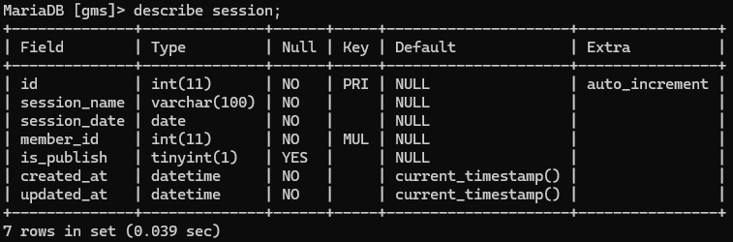

**Member_session table**

**GET method for members.**

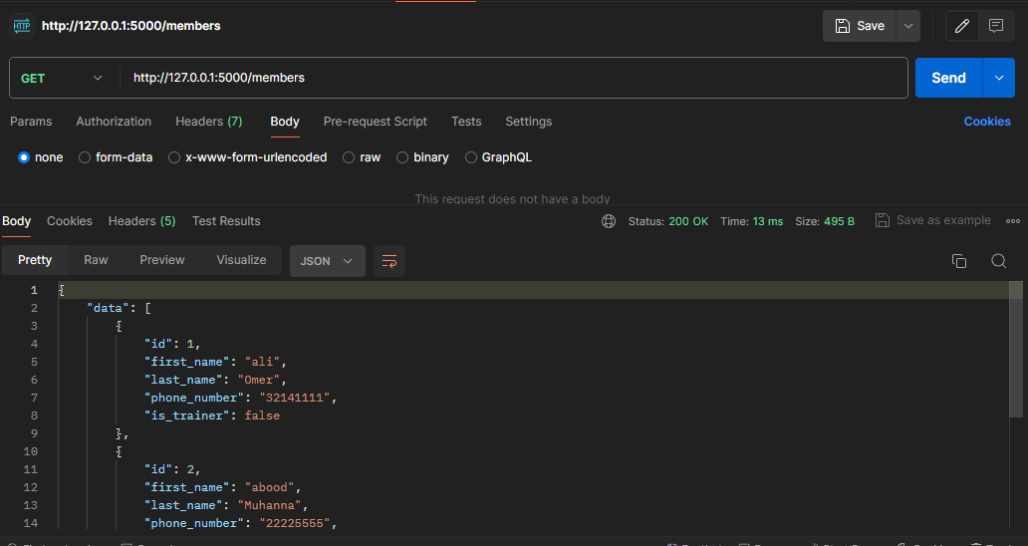

**Get method for sessions that are published.**

**GET method for member_session.**

**POST method for members.**

**Member table before creating a normal member.**

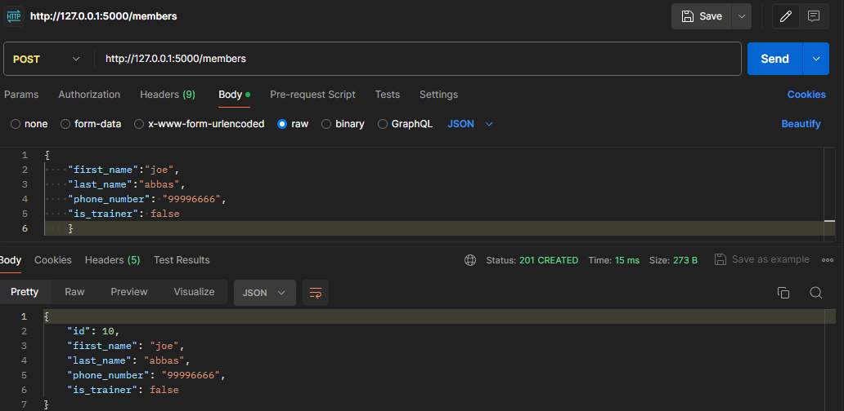

**Member table before creating a new trainer.**

**Member table after creating a new member.**

**Member table after creating a new trainer.**

**POST method for sessions.**

**Session table before creating a new session.**

**Session table after creating a new session.**

**POST method for member_session.**

**I got this error message because I didn’t publish the new session.**

**Publishing the new session.**

**After publishing the new session.**

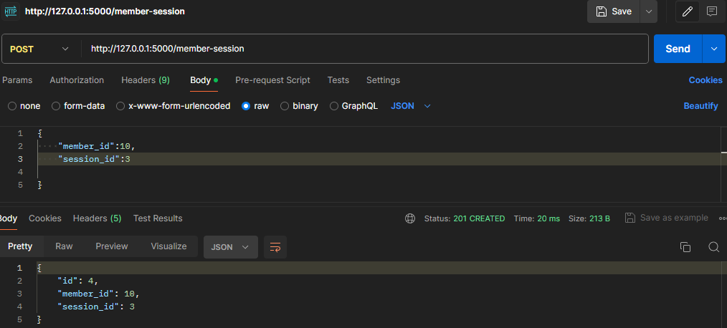

**UPDATE method for members.**

**Member table before updating the name**

**Member table after updating the name.**

**UPDATE method for sessions.**

**Session table before updating the session date.**

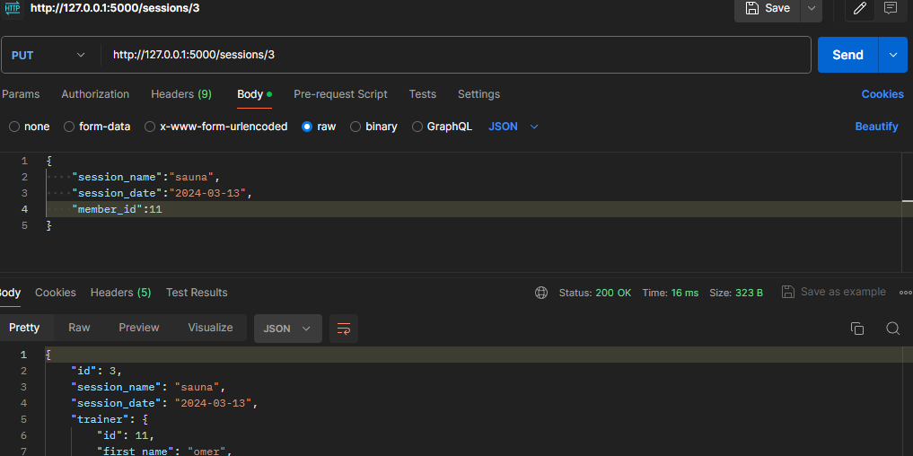

**Session table after updating the session date.**

**DELETE method for members.**

**Member table before deleting a member.**

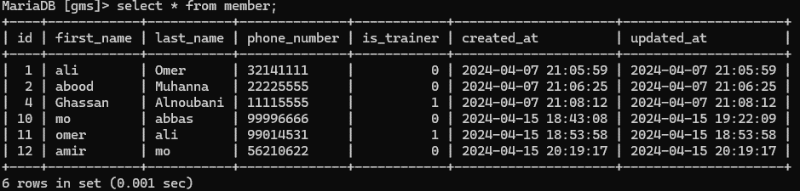

**Member table after deleting a member.**

**DELETE method for sessions.**

**Session table before deleting a session.**

**Session table after deleting a session.**

