

Midterm Project - Multimodal Sign Language Translation System

Abdullah Hani Abdellatif Al-Shobaki - 2284612
Due To: 17 Dec 2025
Course: AIN4311 - Special Topics in Artificial Intelligence Engineering I
Instructor: Dr. Avşar Asan
Table of Contents
1. Motivation 3
2. System Overview 3
Stage 1 — Vision 3
Stage 2 — Text 3
Stage 3 — Audio 3
Pipeline Diagram 3
3. Implementation Steps 4
Step 1 — Data Collection 4
Step 2 — Training the Classifier 4
Step 3 — Sentence Generation 5
Step 4 — Audio Output 5
Step 5 — Real-Time System (run_live) 5
4. Technical Information 6
MediaPipe Hands 6
MLP Classifier 6
FLAN-T5-Large 6
gTTS 6
5. Problems Faced and Troubleshooting 7
Problem 1 — MediaPipe did not install 7
Problem 2 — NumPy binary error 7
Problem 3 — OpenCV window freezing on macOS 7
Problem 4 — Sentence generation failures 7
Problem 5 — Overfitting risk 7
6. Results 7
Gesture Recognition 7
Sentence Generation 7
Audio Output 8
7. Conclusion and Improvements 8
Possible improvements 8
8. Inputs Used 8
9. Demonstration Video 9

1. Motivation

This project presents a multimodal AI solution that recognizes sign language gestures and translates them to English. The main goal is to understand and show how Vision, Text, and Audio can all connect inside one functional pipeline.

The system use a computer vision algorithm to detect the hand and a machine-learning (ML) classifier to recognize the gesture. Likewise, a language model creates an English sentence to be used afterwords with a text-to-speech model.

The motivation is both educational and practical:
- To learn multimodal AI practically in a project.
- AI has the potential to aid in communication and accessibility.
- To create a functioning system for the interaction of AI models.

2. System Overview

The system has three stages:

Stage 1 — Vision
- A camera captures the user’s hand.
- MediaPipe Hands extracts 21 hand landmarks (each has x, y, z).
- This creates a 63-value feature vector.

Stage 2 — Text
- An MLP classifier predicts the gesture label.
- FLAN-T5-Large creates a short, natural English sentence that uses the gesture meaning.

Stage 3 — Audio
- The gTTS model turns the sentence into an audio file.
- The MP3 file plays when clicked.

Pipeline Diagram
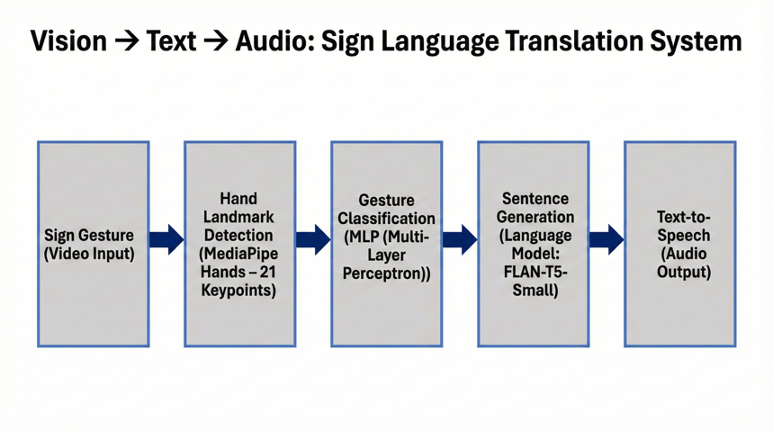

3. Implementation Steps

Step 1 — Data Collection

I collected 40 samples for each gesture using the webcam:
- HELLO
- YES
- NO
- THANK YOU

Every sample has 63 values of 21 landmarks of MediaPipe. The fucntion used for this step is collect_data(), which:
- Opens the webcam
- Detects the hand landmarks
- Saves the landmark values along with the label
- Shows progress made on the screen

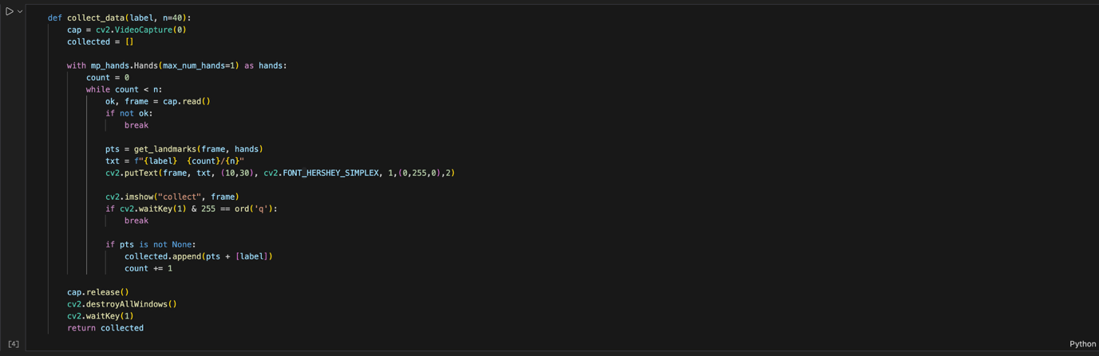

Step 2 — Training the Classifier

After collecting all samples, the data is saved in a CSV file.

I trained an MLPClassifier using scikit-learn. In which the important parts of this step:
- Input size = 63 features
- Hidden layers = (64, 32)
- Maximum iterations = 500
- Train/test split = 80/20

The MLP learns how the landmark patterns match each gesture.

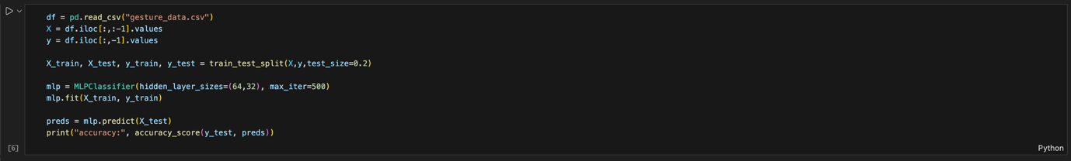

Step 3 — Sentence Generation

Initially, I used FLAN-T5-Small, but it was weak and inconsistent. Then I tried FLAN-T5-Base, which still made errors. I’ve finally brought FLAN-T5-Large successfully to produce stable, natural English sentences.

The make_sentence() function:
- Predicts gestures and responses such as 'hello', 'yes', 'no', 'thank you'.
- Uses a custom prompt.
- Make a 6-12 word sentence in English that is natural.
- The gesture is verified with the meaning of the sentence.
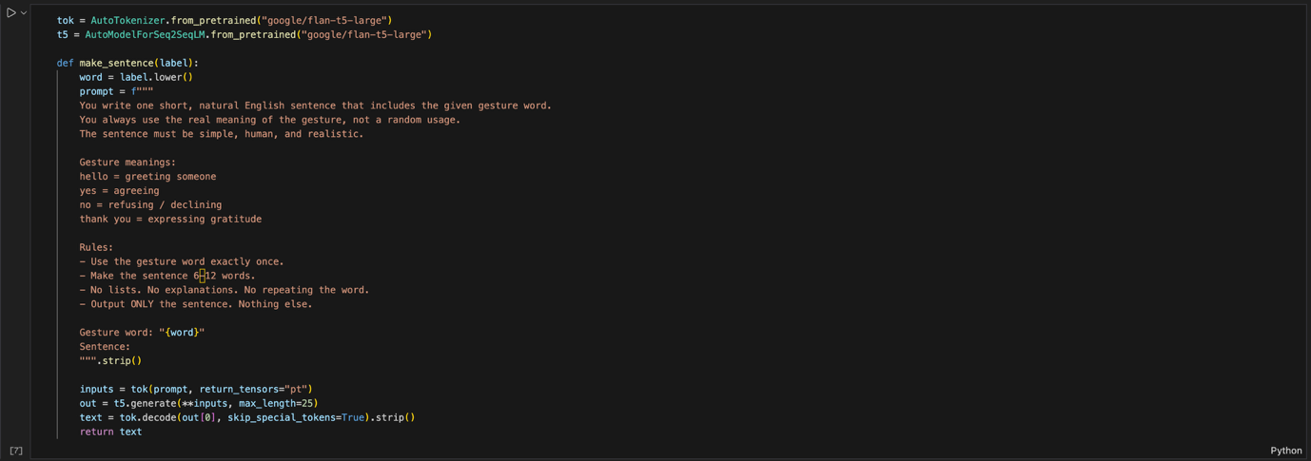

Step 4 — Audio Output

The speak() function converts text to speech using gTTS.

Steps performed:
- Receives the English sentence generated.
- Creates an MP3 file.
- It plays when you click it inside notebook.

Step 5 — Real-Time System (run_live)

The final system puts everything together, run_live():
- Opens the webcam
- Real-time detection of hand landmarks is done.
- Predicts the gesture
- Displays the result
- The program will generate and speak the sentence when pressing “s”
- Exits when pressing “q”

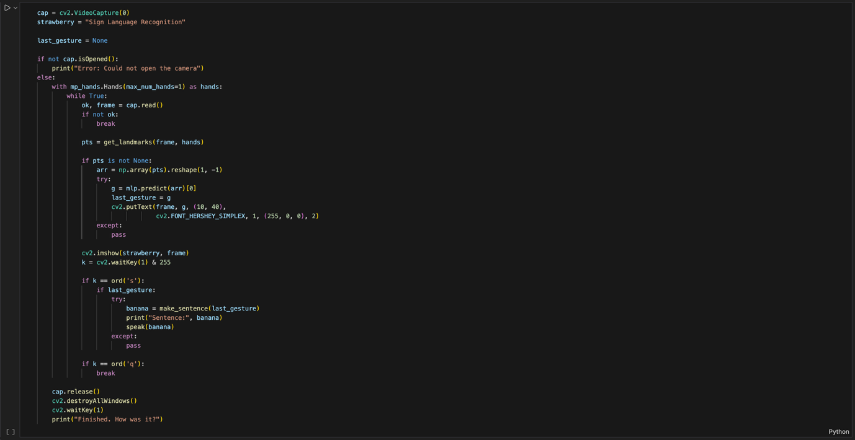

4. Technical Information

MediaPipe Hands
- Detects 21 hand landmarks
- Each landmark has coordinates of x, y, z.
- Creates 63-feature input vector
- It works well in real-time video.

MLP Classifier
- The input layer size is 63, and the hidden layers are 64 → 32. The output has four gesture classes.
- Trained on 160 samples.

FLAN-T5-Large
Reason for choosing large version:
- Best sentence accuracy
- Smaller versions ignored instructions
- The large model adheres to the rules of a prompt well.

gTTS
- Takes English text
- Produces smooth audio
- Very simple to use
- Works well for real-time playback

5. Problems Faced and Troubleshooting

Problem 1 — MediaPipe did not install

MediaPipe does not support Python 3.13. To solve such problem, I set up a new environment with Python 3.10.11.

Problem 2 — NumPy binary error

Error: “dtype size changed”. To solve such problem, I install numpy again in the 3.10 environment.

Problem 3 — OpenCV window freezing on macOS

Added cv2.waitKey(1) added to destroy window to avoid freezing

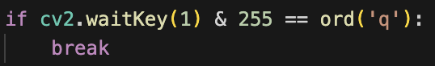

Problem 4 — Sentence generation failures

FLAN-T5-Small and Base produced bad sentences. To solve this problem, I used the FLAN-T5-Large model with a custom prompt.

Problem 5 — Overfitting risk

The small size of the dataset (160 samples) was a problem and to prevent overfitting:
- Samples have been gathered from different places and lighting.
- Train/test split used
- Accuracy remained stable

6. Results

Gesture Recognition

MLP model was able to identify all four gestures well with real-time prediction as well.

Sentence Generation

FLAN-T5-Large generates stable, clear sentences such as:
- “I said yes to the idea.”
- “Thank you for your help today.”
- “The man said hello to the woman.”
- “I’m not going to do that.”

Audio Output

gTTS produces:
- Clear voice
- Correct pronunciation
- Fast processing time

In general, the complete pipeline works correctly and gives the expected multimodal output.

7. Conclusion and Improvements

This project successfully displays integration of Vision, Text, and Audio in a single system.
Gesture → Sentence → Speech works end-to-end.

Possible improvements

- Add more gestures
- Collect more training samples
- Replace MLP out for a deep neural network
- Use a faster model utilizing a GPU.
- Add reverse translation (speech to sign)
- Create a more user-friendly user interface

8. Inputs Used

- There are a total of 160 gesture samples recorded with the webcam
- Four gesture classes
- Custom T5 prompt text
- Audio files generated through gTTS in MP3 format
- Full code in Jupyter Notebook .ipynb

9. Demonstration Video
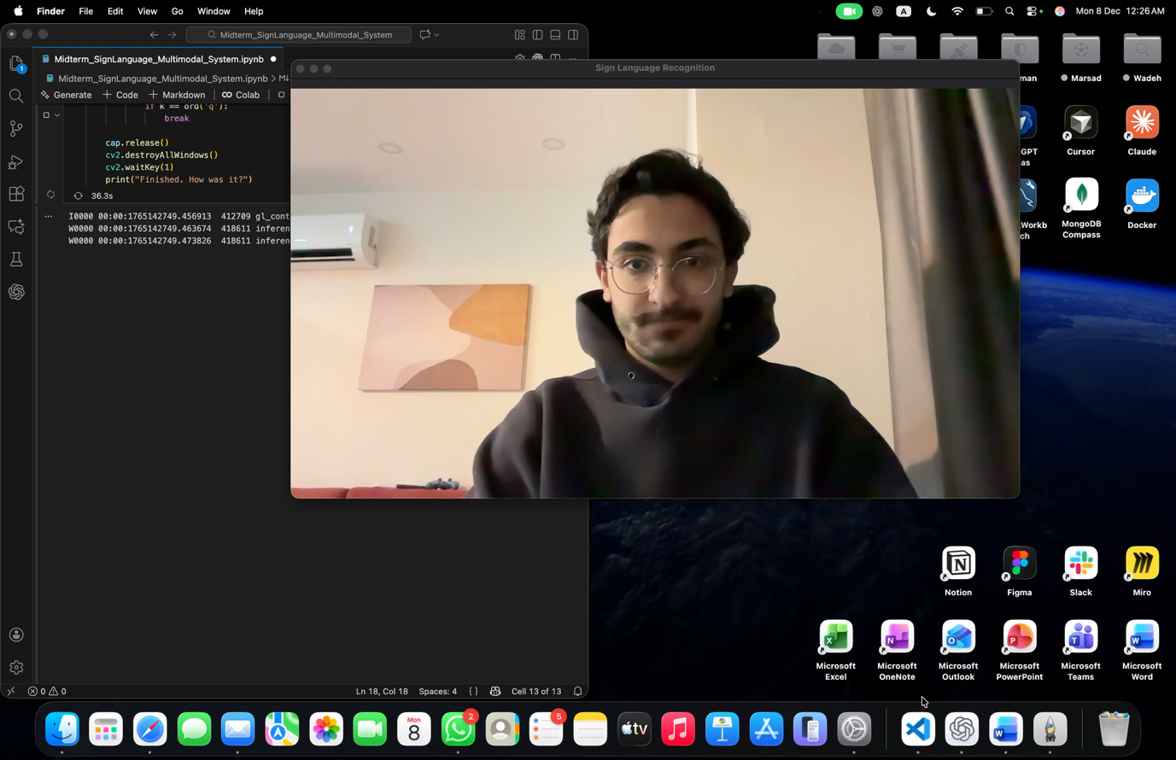
Note: In case the video does not show in the PDF, please open the actual Word document of the report. Also, a copy of the demo video is included in the project folder /images/demo_video/.

