Start Time: 1:00 PM - 7:00 PM Date :27 – 11 -2025
Task Completed – Backend && Frontend
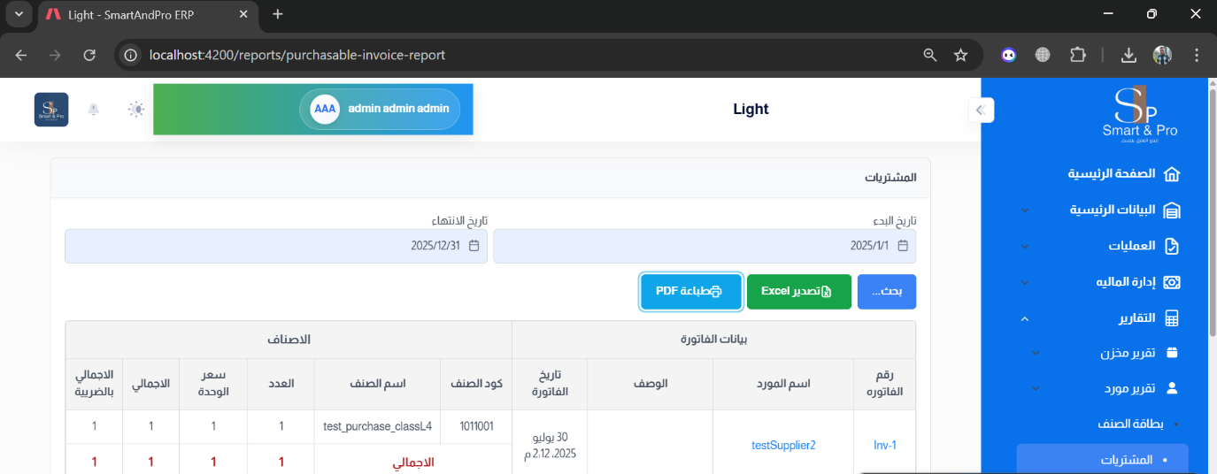
Add print pdf and in purchase report
