3D City Database for CityGML

Texture Atlas Creator Version 1.0.0

30 June 2011

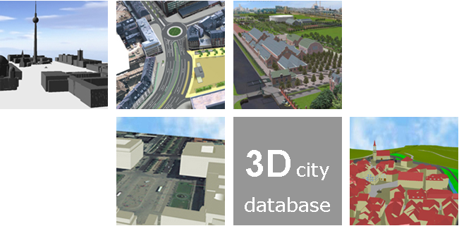

Institute for Geodesy and Geoinformation Science
Technische Universität Berlin
Babak Naderi
Javier Herreruela
Thomas H. Kolbe
(Page intentionally left blank)
Content
1 DISCLAIMER 4
2 Texture Atlas Creator Program 5
2.1 Definition 5
2.2 How to Use It 5
2.2.1 Main Features 7
3 REQUIREMENTS 7
4 APPENDIXES 8
Appendix A: Example 8
Appendix B: Sample Texture Atlases 11
5 REFERENCES 14

DISCLAIMER
The Texture Atlas Creator version 1.0.0 program developed by the Institute for Geodesy and Geoinformation Science (IGG) at the Technische Universität Berlin is free software under the GNU Lesser General Public License Version 3.0. See the file LICENSE shipped together with the software for more details. For a copy of the GNU Lesser General Public License see the files COPYING and COPYING.LESSER or visit http://www.gnu.org/licenses/.
THE SOFTWARE IS PROVIDED BY IGG "AS IS" AND "WITH ALL FAULTS." IGG MAKES NO REPRESENTATIONS OR WARRANTIES OF ANY KIND CONCERNING THE QUALITY, SAFETY OR SUITABILITY OF THE SOFTWARE, EITHER EXPRESSED OR IMPLIED, INCLUDING WITHOUT LIMITATION ANY IMPLIED WARRANTIES OF MERCHANTABILITY, FITNESS FOR A PARTICULAR PURPOSE, OR NON-INFRINGEMENT.
IGG MAKES NO REPRESENTATIONS OR WARRANTIES AS TO THE TRUTH, ACCURACY OR COMPLETENESS OF ANY STATEMENTS, INFORMATION OR MATERIALS CONCERNING THE SOFTWARE THAT IS CONTAINED ON AND WITHIN ANY OF THE WEBSITES OWNED AND OPERATED BY IGG.
IN NO EVENT WILL IGG BE LIABLE FOR ANY INDIRECT, PUNITIVE, SPECIAL, INCIDENTAL OR CONSEQUENTIAL DAMAGES HOWEVER THEY MAY ARISE AND EVEN IF IGG HAVE BEEN PREVIOUSLY ADVISED OF THE POSSIBILITY OF SUCH DAMAGES.

Texture Atlas Creator Program

Definition
The Texture Atlas Creator program is a standalone tool for modifying CityGML files and making texture atlases for all entire buildings. A texture atlas is a large image contains many smaller sub-images, each of them is a texture for some part of a 3D building object The Texture Atlas Creator program will automatically compact several (as much as possible) texture images of a building together into one or several atlases (depending on atlas' size settings) and adapt texture coordinates accordingly. As a result the overall size of the resources (both CityGML and texture image files) will be significantly decreased. In addition, using texture atlases will considerably decrease the loading time of modified CityGML files in viewers. For more information about textures in CityGML specification please see [1].

How to Use It
The Texture Atlas Creator program must be executed from the shell. It does not have a graphical user interface. The command line syntax is:
java [options] -jar TAC.jar [/A <algorithm>] [/W <max_width> /H <max_height>] <input> <output>

It is also possible to use a Batch file for executing the program. The command line syntax is:
TAC [/A <algorithm>] [/W <max_width> /H <max_height>] <input> <output>

In the following lines command’s options are explained:
- <algorithm> (optional): points to a packing algorithm should be used during atlas creation. The selected algorithm will manage position of each texture in atlases during packing process. Default algorithm is set to be TPIM. In case that it is not specified in shell command the default value will be used. Following algorithms are available in the Texture Atlas Creator program:
  - TPIM: It is a customized version of the Touching Perimeter algorithm as a heuristic two-dimensional bin packing with support of rotation. During tests 83.35% of result atlas was occupied. This algorithm is based on source code developed and released to the public by Jukka Jylänki.
TPIM starts by sorting the items according to non-increasing area and their normal orientation. It initializes a bin with maximum acceptable size and packs one item at a time. In the case that it is not possible to add a new item to the current bin, a new bin will be initialized. The first item packed in a bin is always placed in the bottom left corner. However in the result atlas the origin will be in the top left corner. Each item is packed in a way that its bottom and left edges touching either the bin or the edge of another item.
Each potential position for the new item will be scored as the amount of its touching edges. Touching the bin edges is more valuable to avoid inhomogeneous shape of bin. For each candidate (position) the score will be calculated twice (normal orientation and 90 degree rotated) and the highest value will be taken. For more information about Touching Perimeter algorithm please refer to [2].
  - TPIM_WOR: TPIM_WITHOUT_ROTATION is an extension of TPIM algorithm which does not rotate textures.
  - SLEA: Sleator's algorithm is a two-dimensional bin packing. It starts by packing all the items which has a width greater than half of the bin's width on top of each other. Then the remaining items will be sorted according to non-increasing height. The bin will be split to two halves. Next items will be placed from left to right in the left half and when it can not accommodate, the left half will be close and items will be placed in right half. Next level of halves will be started with different bottom height according to maximum height in previous level of left and right side. For more information please refer to [3].
  - NFDH: The Next-Fit Decreasing Height (NFDH) algorithm starts by sorting items according to non-increasing height. Then it packs a next item, left side, on the current level if it fits. Otherwise, the level will be closed, and a new level will be created (as a horizontal line drawn on the top of the tallest item packed on the current level), and the item is packed, left justified, on it [4].
  - FFDH: The First-Fit Decreasing Height (FFDH) algorithm starts by sorting items according to non-increasing height. It packs the next item, left justified, on the first level where it fits. If there is not any level to accommodate it, a new level is created as in NFDH [4].
- <max_width> (optional) specifies maximum acceptable width of output texture atlases. Default value is 2048. In case that this field is not specified in shell command the default value will be used.
- <max_height> (optional) specifies maximum acceptable height of output texture atlases. Default value is 2048. In case that this field is not specified in shell command the default value will be used.
- <input> points to an input CityGML file or a folder. In the case of using folder, all sub folders will be parsed recursively and all founded CityGML files will be modified.
- <output> points to an output CityGML file or a folder. In the case of using folder structure of the input folder will be reproduced in the output folder.

Main Features
In the following lines main features of the Texture Atlas Creator program are listed
- Program will group textures have similar properties for each building and then create one or more texture atlases from each group. Transparency of image is one of the factors considering for grouping textures based on them.
- Maximum atlas size can be specified as an input argument. The program will guaranty that the generated texture atlases have a size equal or less than the specified argument. In the case that a texture’s size is larger than the maximum atlas size, the texture will be resized to follow the condition of maximum atlas size.
- A folder may be specified as an input. As a result it will be parsed recursively and program will automatically run on all valid CityGML files founded in sub-folders.
- Detailed output will be shown in console.
- The SGI RGB Image format is supported by this program. An encoder is developed based on file format specification version 1.00 written by Paul Haeberli from Silicon Graphics Computer Systems. The encoder supports most of RGB images, but not all of them. For more information about the file format please refer to [5]. In addition to RGB, more image formats are also supported for input like JPEG and PNG.
- Texture atlases will be created in two image format depends of transparency of entire images. If the input CityGML file refers to a texture file which is not well-known by the Texture Atlas Creator program, the file will be copy exactly in corresponding place in output folder.
Notes:
- Textures with wrapping coordinates (have a coordinate out of the range [0,1]) will not be modified.
- TexCoordGen and GeoreferencedTexture of CityGML specification are not supported.
- Input CityGML files MUST be well-formed and validated based on its official schema.

REQUIREMENTS
Java JRE or JDK version 1.5 or later is needed. In case of using the batch file for executing the program 1GB main memory is needed. If the amount of memory is not available use the pure java syntax (first method) or modify the batch file by changing -Xms1024m and -Xmx1024m to maximum possible size depending on your system.

APPENDIXES

Appendix A: Example
Here is a step by step guide for running the Texture Atlas Creator program.
- Open a shell window and write the following command:
TAC /A TPIM /W 2048 /H 2048 c:/test_case c:/results

- Figure 1 is a shell snapshot of the Texture Atlas Creator program running. At first the program will recursively pars the input folder (path: “c:/test_case”) to find all available CityGML files. Then it will start to modify them one by one.
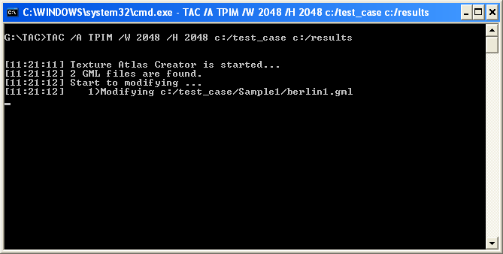
Figure 1: Shell snapshot of the Texture Atlas Creator program running.

- Figure 2 shows a snapshot of the next step. The program is modifying buildings included in the first CityGML file one by one. As a result one or more texture atlases will be created for each building.
- Figure 3 shows a snapshot of the console when some textures with wrapping coordinates are detected. In this case program will show an information message on console and skip the texture.
- Figure 3 also shows a snapshot of the console when the modification of first CityGML file is finished. The modified file is written in output folder and same procedure is started for next second found CityGML file in input directory.
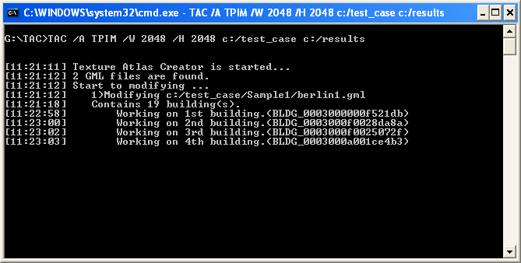
Figure 2: Shell snapshot of the Texture Atlas Creator program running. During modification of each CityGML file, building will be modified one by one and one or more texture atlases will be created for each of them.

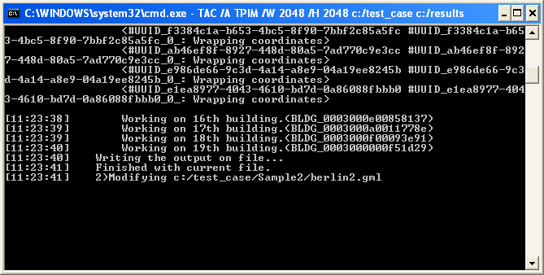
Figure 3: Shell snapshot of the Texture Atlas Creator program running. If any wrapping coordinates are founded, corresponding message will be shown in the console. By finishing the modification of all buildings included in first file, modified CityGML file will be written in output folder. Then same procedure will be start for the next CityGML file.

- After modifying the second CityGML file the program is finished by all found input files and finished automatically (Figure 4). By look at the output folder, same structure as the input folder will be seen. Textures are replaced with texture atlases and CityGML files are modified.
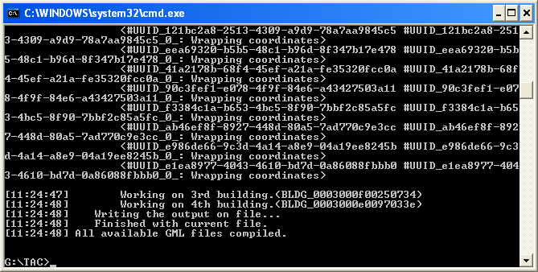
Figure 4: Shell snapshot of the Texture Atlas Creator program running. The program is finished.

Appendix B: Sample Texture Atlases
In the following sample texture atlases generated by different algorithms are shown:
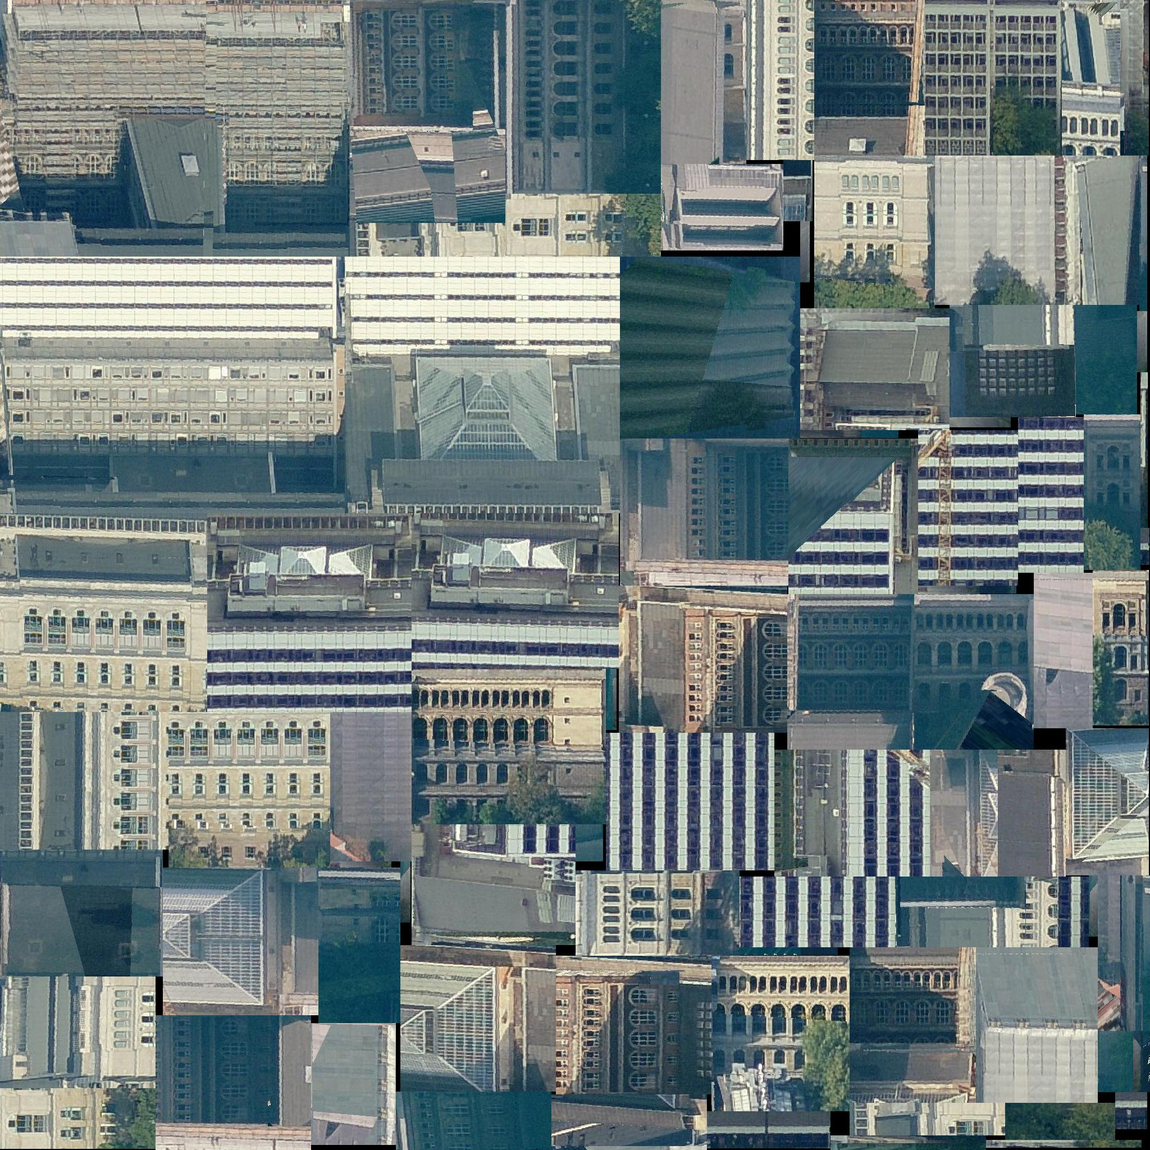
Figure 5 A texture atlas created by TPIM algorithm.
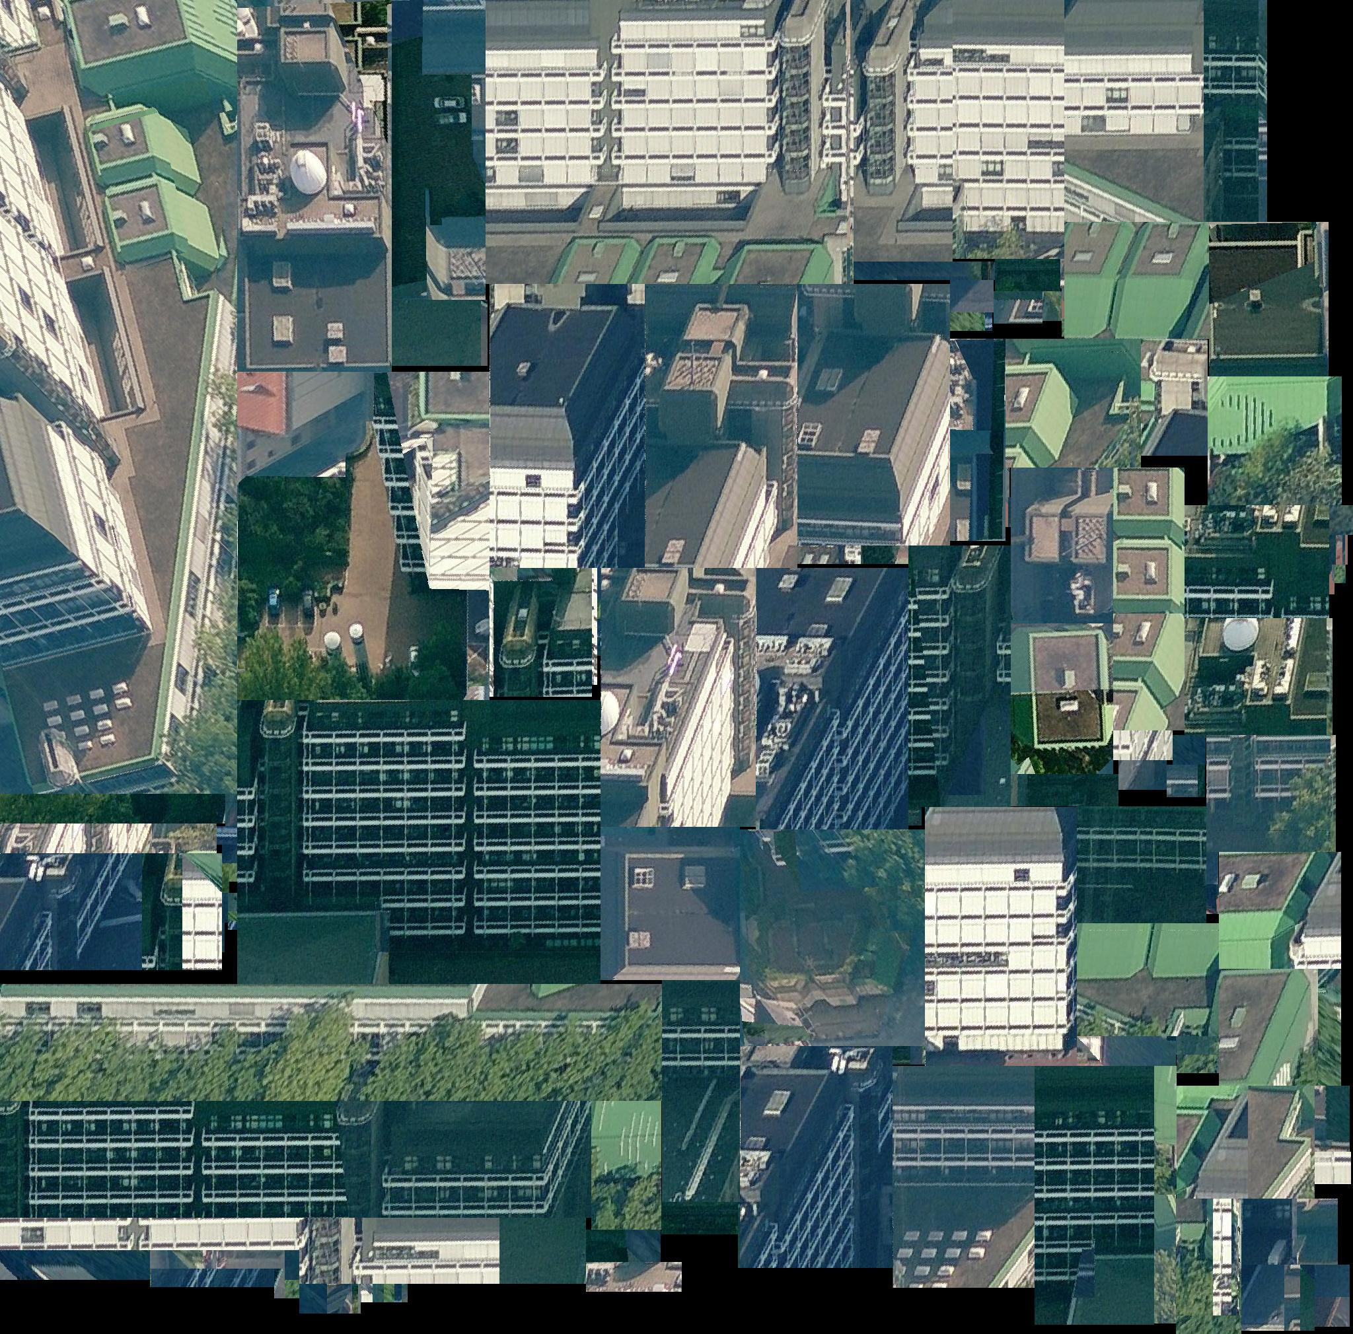
Figure 6 A texture atlas created by TPIM_WOR algorithm.

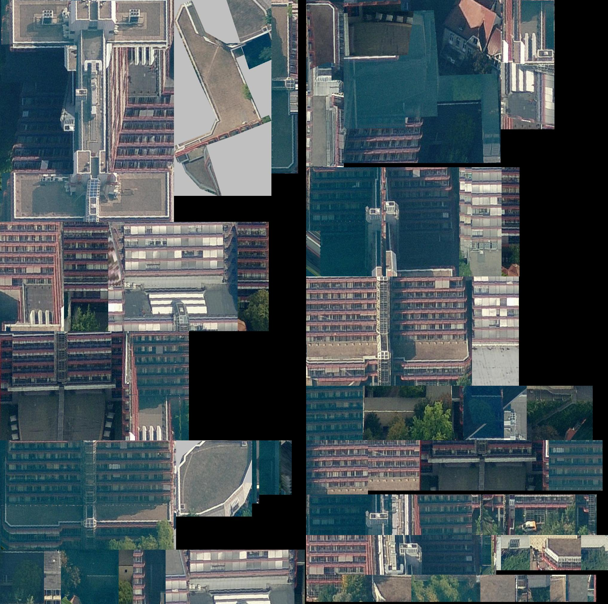
Figure 7 A texture atlas created by SLEA algorithm.
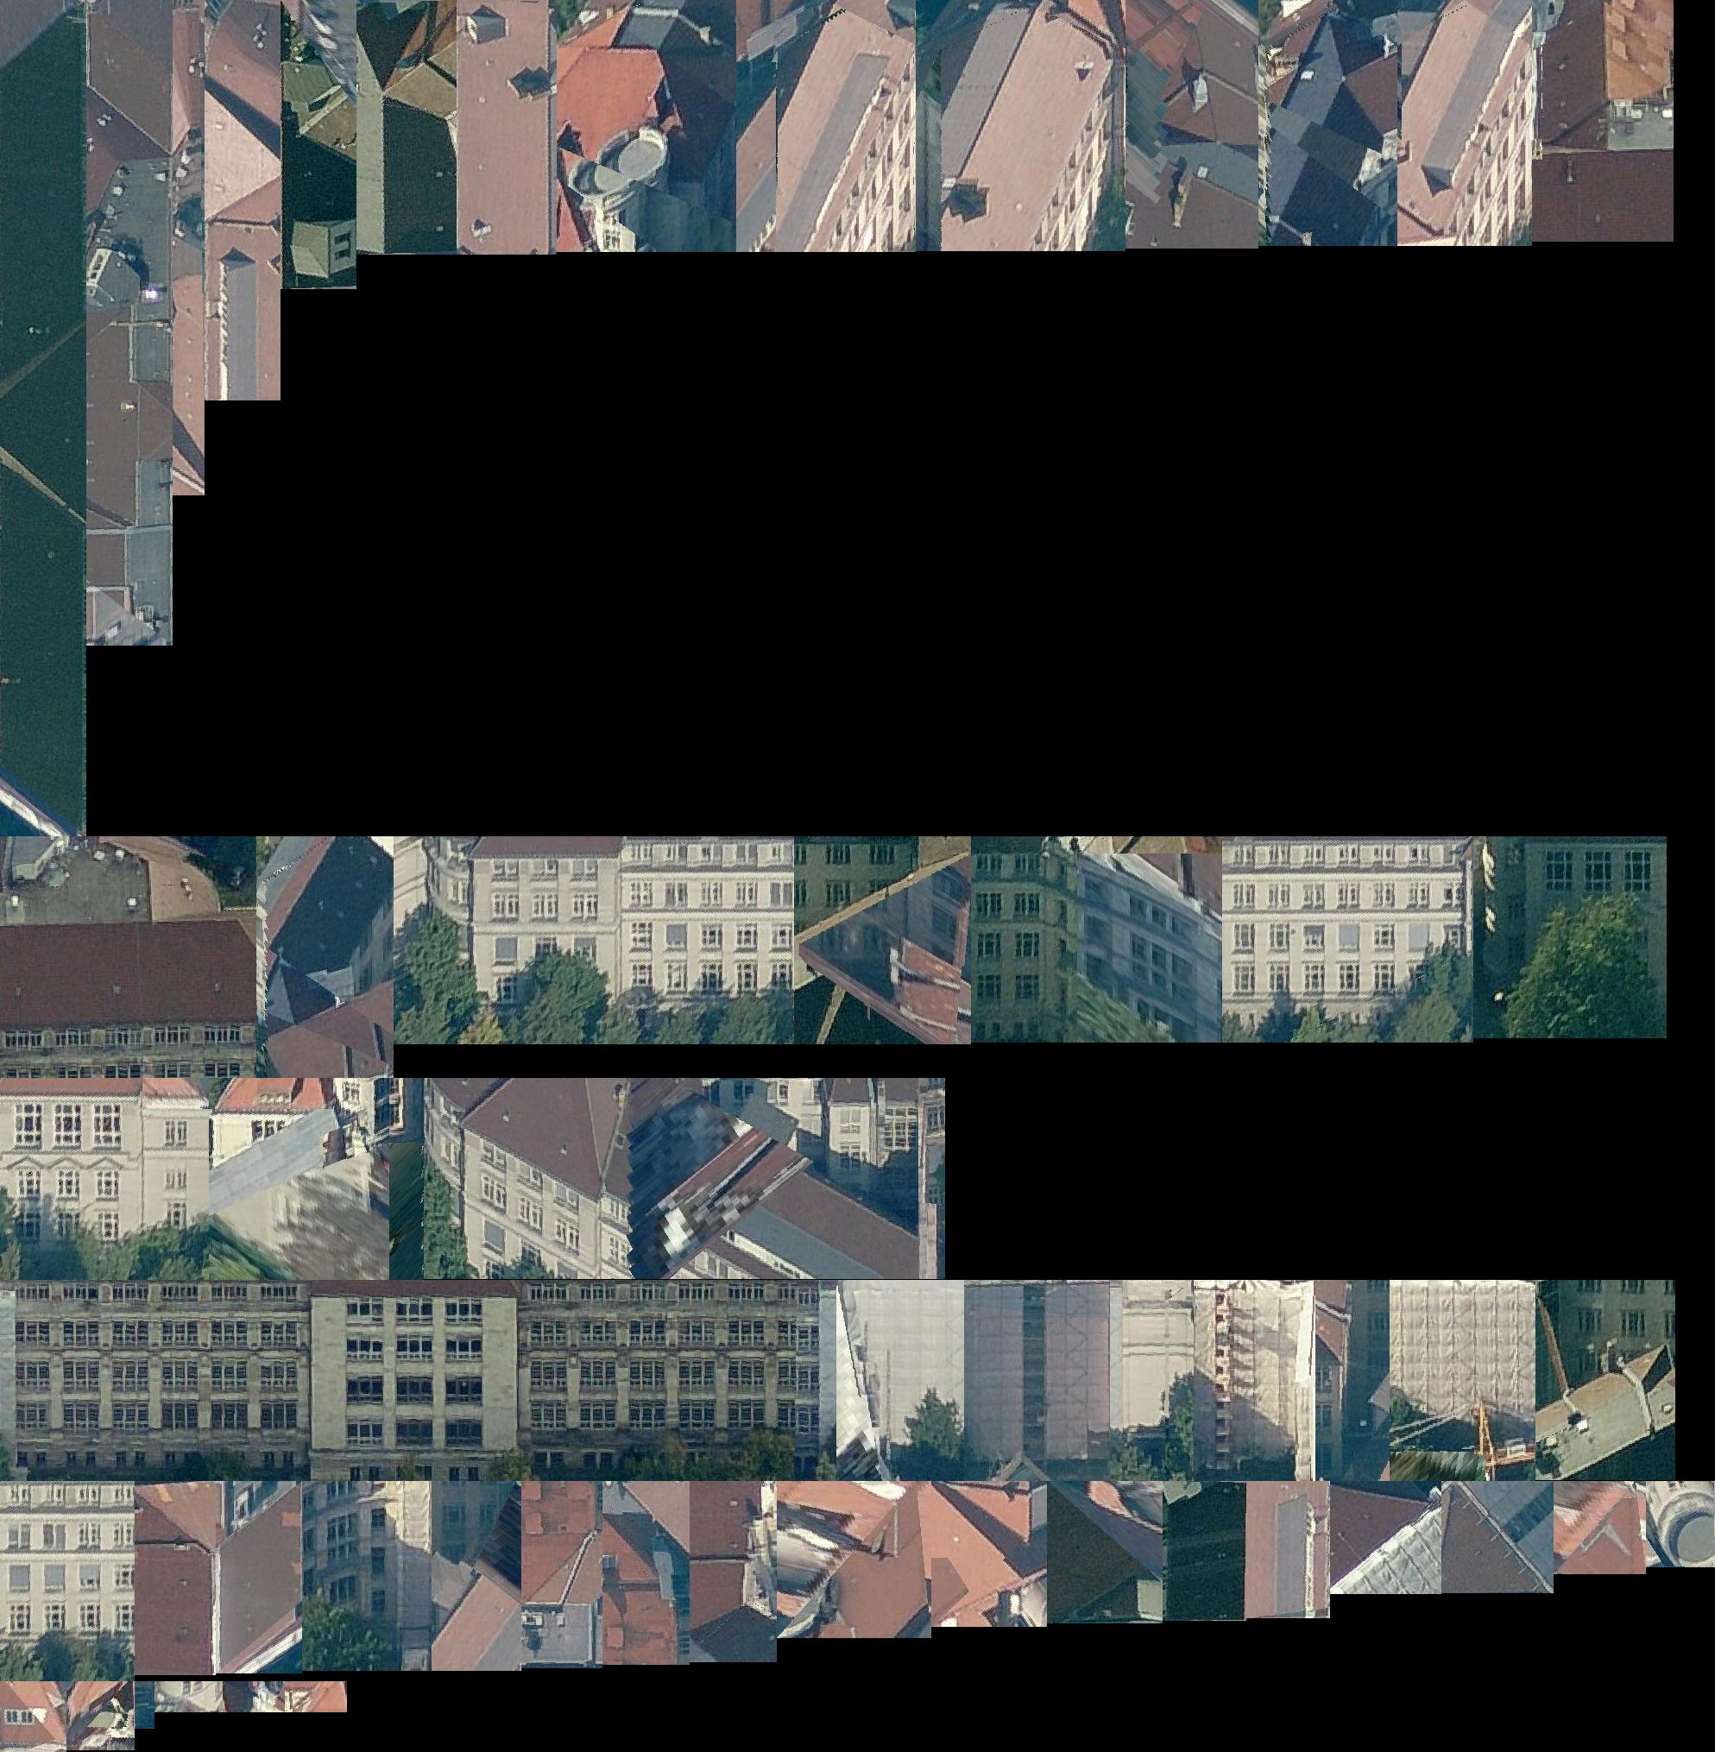
Figure 8 A texture atlas created by NFDH algorithm.

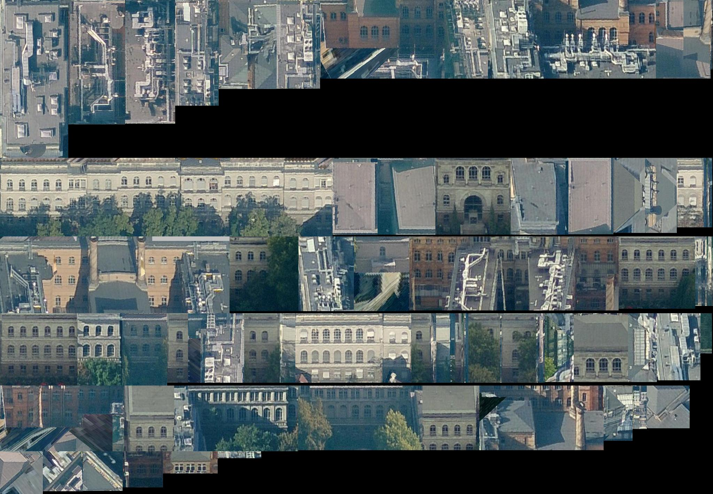
Figure 9 A texture atlas created by FFDH algorithm.

REFERENCES
[1] | Kolbe, T. H.; König, G.; Nagel, C.; Stadler, A. (2009): 3D-Geo-Database for CityGML, Version 2.0.1, Documentation, April 24th. http://www.3dcitydb.net
[2] | Lodi A, Martello S, Vigo D (1999): Heuristic and Metaheuristic Approaches for a Class of Two-Dimensional Bin Packing Problems. INFORMS J on Computing;11:345-357.
[3] | D. Sleator (1980): A 2.5 times optimal algorithm for packing in two dimensions. Information Processing Letters 10, pp. 37-40.
[4] | Lodi, Andrea, Martello, Silvano and Monaci, Michele (2002): Two-dimensional packing problems: A survey, European Journal of Operational Research, 141, issue 2, p. 241-252.
[5] | The SGI RGB Image format, Weblink (accessed February 2012): http://paulbourke.net/dataformats/sgirgb/sgiversion.html

