**BUILDING YOUR OWN PC**

# **Introduction**

**Building a Personal Computer can sometimes seem like a very tedious and daunting task. However, with the right guidance and tools, you will experience the reward of pressing the power button. Before jumping in, we must first discuss a few things that will keep you and your newly purchased computer parts safe.**

**IMPORTANT NOTE: PLEASE READ THIS SECTION FIRST BEFORE STARTING!**

## **BEFORE WE BEGIN**

**Before we begin, we must prepare the workspace. It is very important to have a clean an organized work area when working with computer components. Your computer parts are made up of materials that if not handled carefully, you can turn a $200 part into a $200 paper weight.**

* **Be sure to keep all parts in their static resistant packaging until ready to use.**
* **Make sure you are working on a clean table with your static matt in place and your parts are neatly laid out.**
* **Place your ATX case flat on the static matt with covers removed.**
* **GROUND YOURSELF: Make sure you are wearing your antistatic bracelet. Connect the clip to your ATX case. This will cause you to be grounded and prevent any static charges from your body from frying any components. Yes, this can happen. THIS IS A VERY IMPORTANT STEP!**

# **Lets get started**

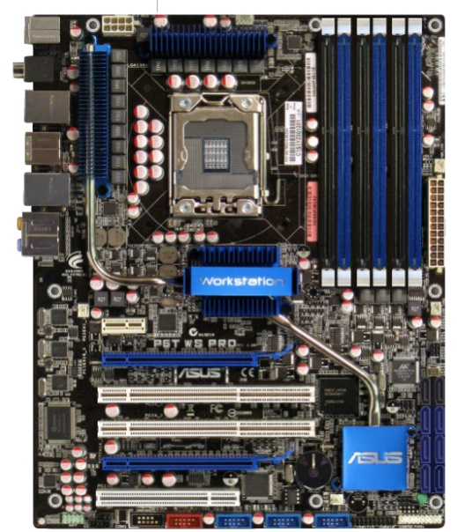[1]

## **Motherboard Installation**

**For this setup, we will be using the socket 1366 motherboard**

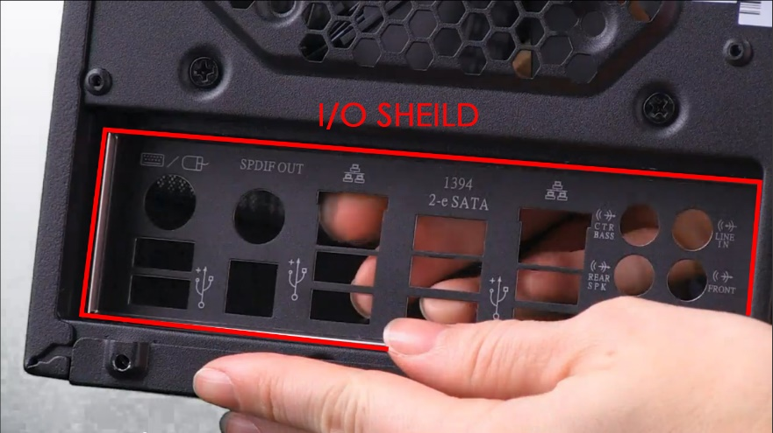**[2]**

### **iNSTALL i/o shield- When placing i/o shield push firmly until it snaps into place.**

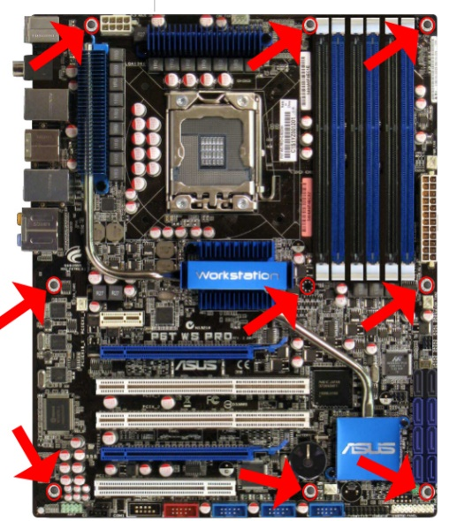**[1]**

### **2. Review the oreintation of the screw wholes on the mother board- You will need to know this so that you can place the standoff screws in the correct orientation.**

**3. HAND TIGHTEN THE STAND OFF SCREWS IN CORRECT OREINTATION ACCORDING TO THE SCREW HOLES ON THE MOTHERBOARD. - It may help to hold the motherboard above the mounting area to help you to identify the correct holes.**

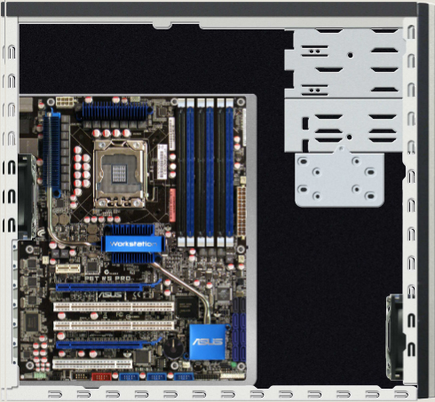[1]

**4. MOUNT THE MOTHER BOARD- Using a hand screwdriver, securely mount the motherboard to the standoff screws that have been placed. Be sure to tighten just enough to hold the motherboard firmly in place. Do not over tighten to avoid damaging the motherboard.**

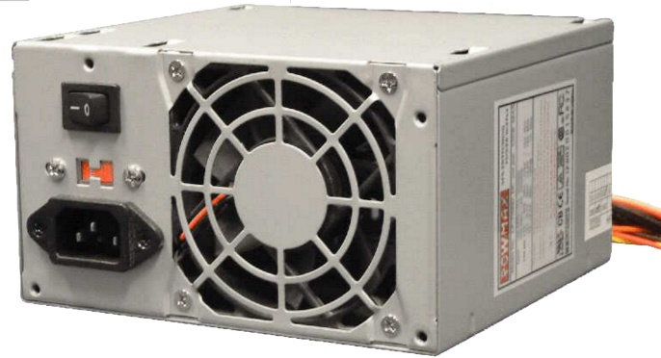**[1]**

## **INSTALL THE POWER SUPPLY**

**For this setup, we are using a ATX Power Supply with 20+4 pin power connector and PCIe connector.**

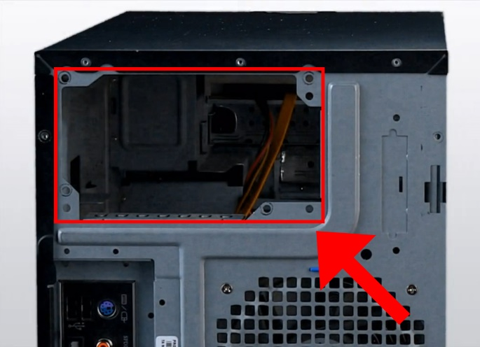[3]

### **1. Locate area to install power supply**

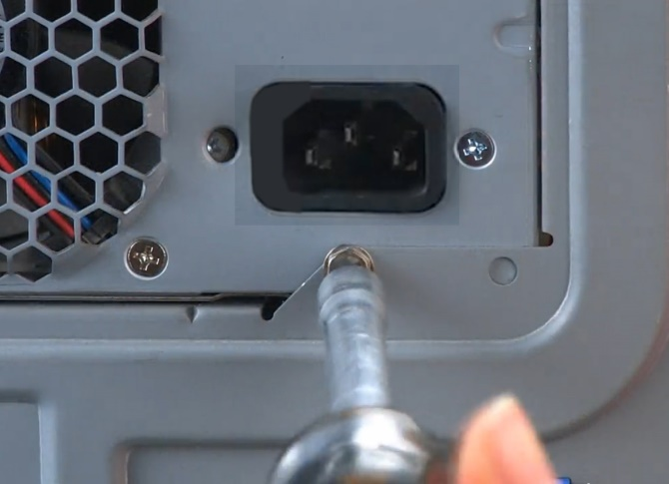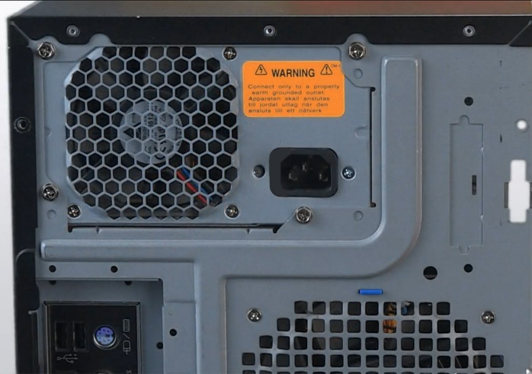**[3]**

**2. PUT POWER SUPPLY IN PLACE AND SECURE WITH SCREWS**

## **CONNECT POWER SUPPLY TO MOTHERBOARD**

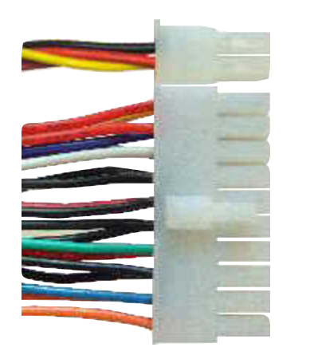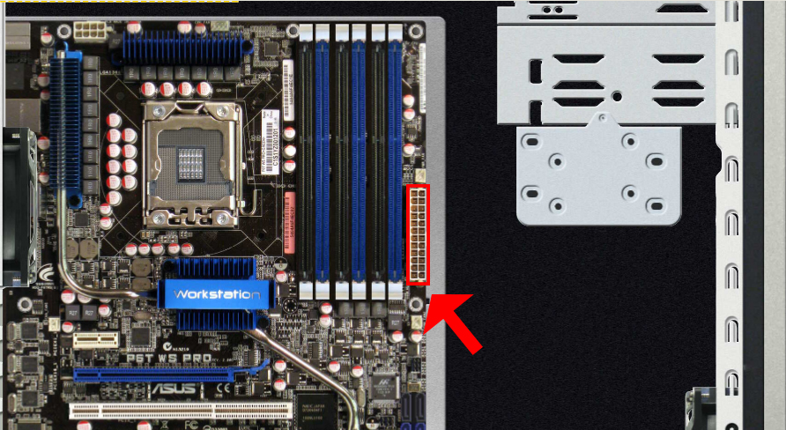**[1]**

### **1. Locate the 20+4 pin connector ON THE POWER SUPPLY and connect it to the motherboard.**

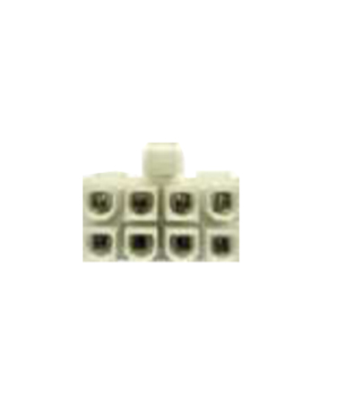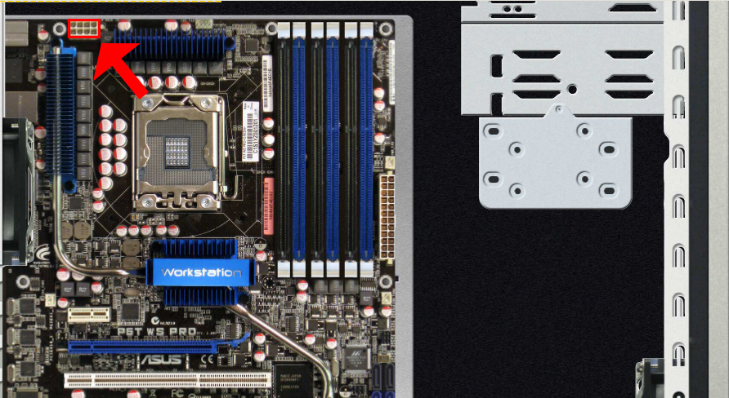**[1]**

**2. LOCATE THE 8-PIN CPU POWER CONNECTOR ON THE POWER SUPPLY AND CONNECT IT TO THE MOTHERBOARD.**

**Make sure all Power Supply connection are firmly connected. You do not want any loose connections as this could cause components to not work correctly or cause serious damage.**

**NOTE: IF YOU SEE A LOT OF LEFT OVER CONNECTORS, DON’T WORRY. WE WILL CONNECT SOME OF THEM LATER. NOT ALL CONNECTORS WILL BE NEEDED.**

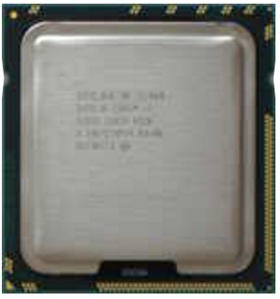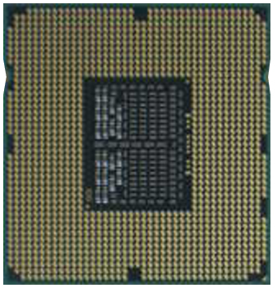**[1]**

## **INSTALL THE CPU**

**CAUTION: IT IS VERY IMPORTANT THAT YOU WEAR AN ANTISTATIC BRACELET FOR THIS STEP. NOT DOING SO COULD RISK DAMAGING THE CPU BEYOND REPAIR.**

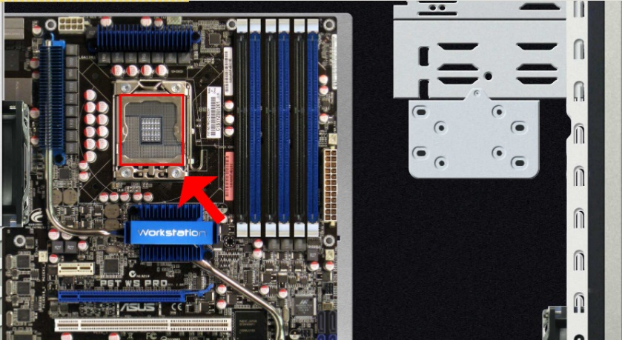[1]

### **locate CPU socket on the mother- This socket is only compatible with certain CPUs. Be sure to always review the motherboard manual and the CPU manual and verify that they are compatible before installing. For this setup, you should be using the Intel i7-960 3.20 GHZ, LGA1366 socket CPU.**

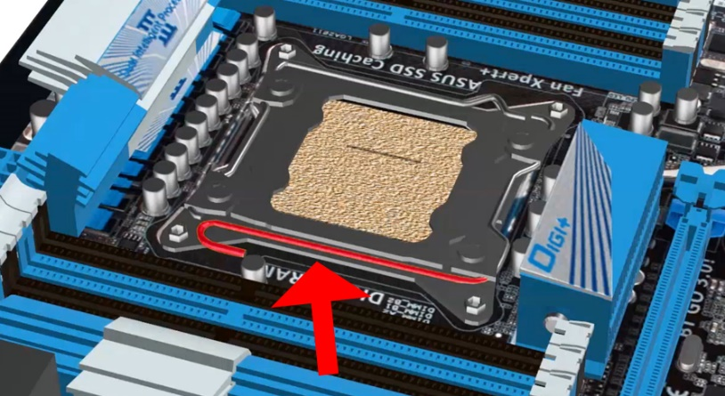**[4]**

### **Lift lever- To install the CPU, you must first lift the lever located on the side of the CPU socket, as shown in the image above. This will lift the socket cover, opening a space to place the CPU.**

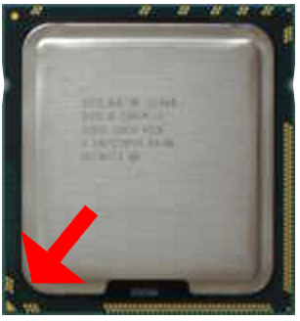 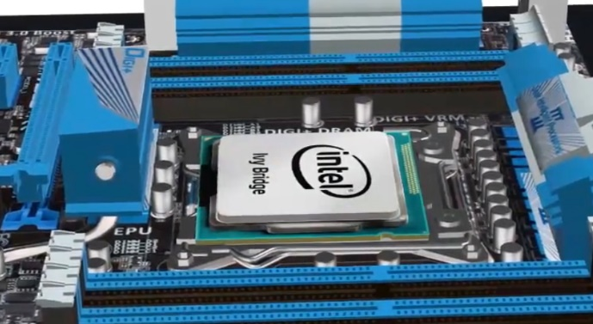**[4]**

### **install CPU- Now it is time to mount the CPU.**

* **LOOK FOR THE CORNER OF THE CPU WITH THE GOLD TIP**
* **ALIGN THE GOLD TIP UP WITH THE MARKING ON THE CPU SOCKET- This insure that the CPU is properly aligned. The CPU will only fit in one orientation.**
* **PLACE THE CPU SO THAT IT EASILY FITS- If there is any resistance, DO NOT FORCE THE CPU. This usually means that the CPU is not correctly oriented.**
* **SECURE THE CPU- Once the CPU is properly in place, pull the lever down to secure the CPU.**

### **appLY THERMAL PASTE- Your CPU will generate a lot of heat when it is in operation. Therefore, you will need the proper cooling system to accommodate for the excessive heat. After your CPU is secure, you need to apply thermal paste. This will allow efficient heat transfer from the CPU to the heat sink and fan which we will install next.**

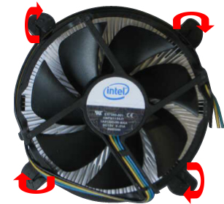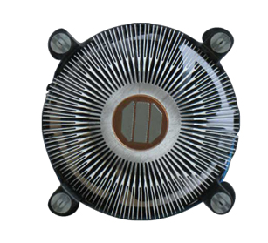**[1]**

### **INSTALL CPU FAN AND HEATSINK- Before installing the CPU cooling fan and heatsink, locate each of the 4 tabs on the fan and turn them each 90° clockwise.**

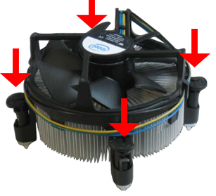 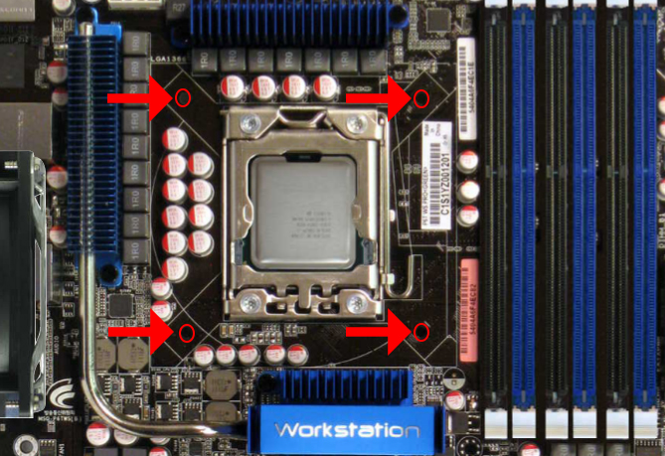**[1]**

### **Secure cooling fan- Once tabs are set, place the cooling system on top of the CPU. Be sure that the tabs are lined up with the 4 holes surrounding the CPU. Press down on each tab until you hear a “click”. Lightly tug on the cooling fan to ensure that the fan is secure**

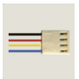 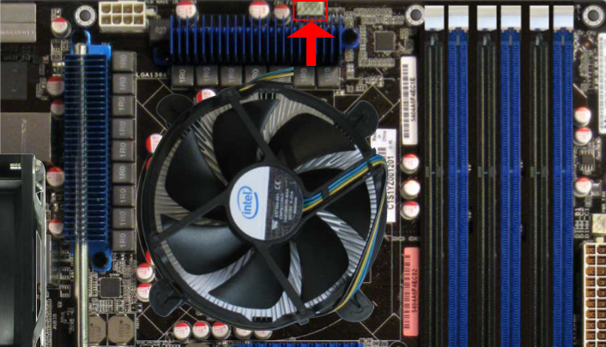**[1]**

### **Connect the 4-pin cpu fan connector to the motherboard- This connector will be attached to the fan. it will allow the fan to receive power. Be sure that you have a secure connection.**

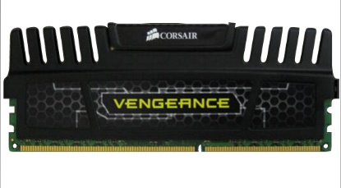**[1]**

## **installing Memory**

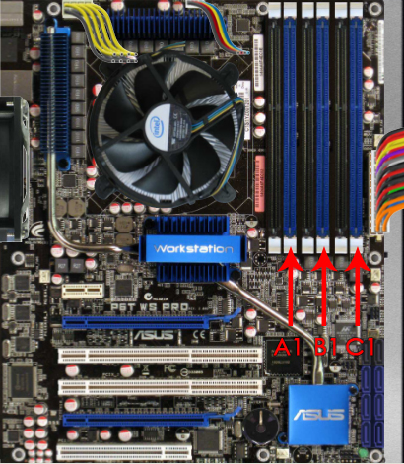**[1]**

### **triple channel configuration- For this system we will setup your memory configuration for triple channel operation. This will allow a total of three, 2GB DDR3 RAM to be installed, which will give the system a total of 6GB of memory. Setting up the ram in the wrong configuration will not allow you to use all the ram installed on your system. We will be installing the RAM in the three slots indicated in the image above. These are slots A1, B1, and C1. This will ensure triple channel operation.**

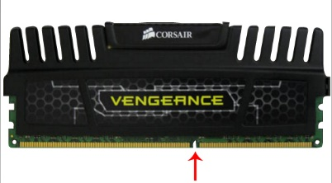 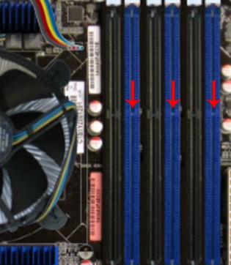**[1]**

### **install the ram- Your motherboard is designed to fit DDR3 ram. This is indicated by the notches shown in the images above. To install the RAM, you must align these notches and firmly push the ram down into the slot until the white tabs on the end of the slots snap into place. If you feel it is too hard to push down, then make sure the RAM is correctly oriented. You shouldn’t have to apply to much pressure to insert the RAM.**

**If done successfully, the ram should be securely seated into the ram slots, locked in by the white tabs on the end.**

# References

[1] TestOut, *Screenshots retrieved from LabSim 13.1 Build A Computer From Scratch*. 2016.

[2] TestOut, *Screenshots retrieved from 3.3.3 Installing A Mother Board Video*. 2016.

[3] TestOut, *Screenshots retrieved from 3.2.4 Changing the Power Supply*. 2016.

[4] TestOut, *Screenshot retrieved from 3.5.5 Installing a Processor*. 2016.