# C:\Users\Messom\Desktop\Monash.jpg

# FIT5032 Design Report

# Major Application Development

# {Credit/Distinction/High Distinction}

# APPLICATION NAME

STUDENT NAME:ID

INSTRUCTIONS: Substitute all RED text with your information. DELETE all BLUE instructions before final submission (in PDF format). Feel free to edit the format of the document to improve presentation

**Contents Page**

**Your design report must include the following:**

**Credit Level**

1. Web application title and description
2. User stories and a Use case diagram
3. Block/Functional diagram
4. Your selected approach when constructing the application

**Additional Distinction Level (the above and the following)**

1. Class Diagram or Entity Relation Diagram
2. Mockup prototypes and Implementation
3. Data dictionary
4. Usability Design Review

**Additional High Distinction Level (the above and the following)**

1. Development Methodology
2. Versioning
3. Checklist of site functionality.

**Your design report must include the following (Pass Level and Above):**

1. **Web Application Title and Description**

Include a title of the web application you are creating. Be creative! Include enough details along with goals so that anyone understand what this web application will do.

MedConnect

1. **User stories and Use case diagram**

Include user stories and a use case diagram of your web application with two roles and three or more Business Requirements outlined in the Assignment Portfolio Specification

1. **Block/Functional diagram**

Include a high-level block/functional diagram of your web application outlining the functionalities (three or more levels) of your web application.

User Stories for use case diagram {TODO}:

1. **Your selected approach when constructing the application.**

Discuss your selected approach (Model First, Code First or Database First) with justification.

**Additional Distinction Level (the above and the following)**

1. **Class Diagram or Entity Relation Diagram**

Include Class diagram or Entity Relationship diagram of your web application that addresses three or more Business Requirements outlined in the Assignment Portfolio Specification. (If you are using the Model First or Code First approach, you will need to provide a class diagram. An Entity Relationship Diagram (ERD using Crows Feet or Chen Notation) should be provided if you decide to use the Database First methodology.

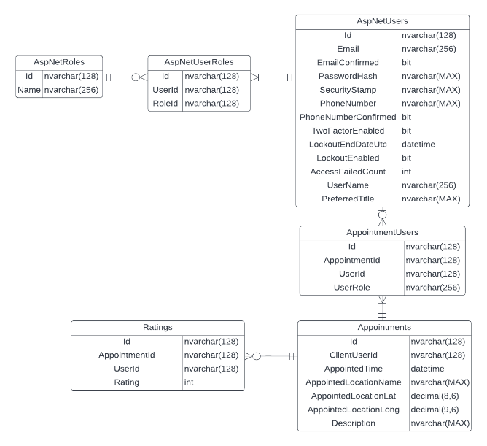

1. **Data dictionary**

Include the justification of the data types which you use.

1. **Mockup prototypes and implementation with user registration and authentication**

Include unambiguous mockup prototypes of three or more Business Requirements outlined in the Assignment Portfolio Specification, or if implemented.

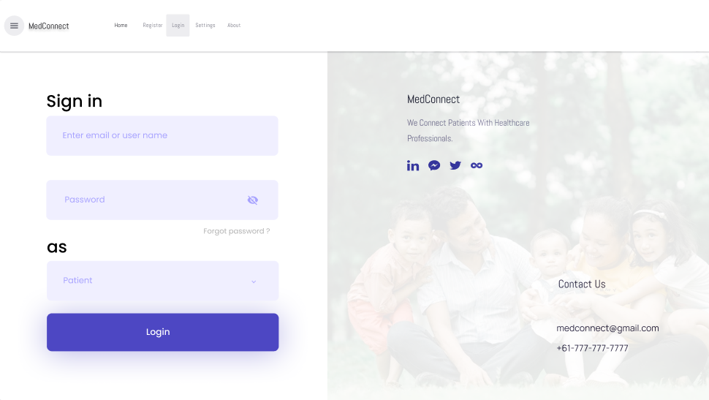

*Figure 3: Mock-up for Role based Authentication (BR B.1)*

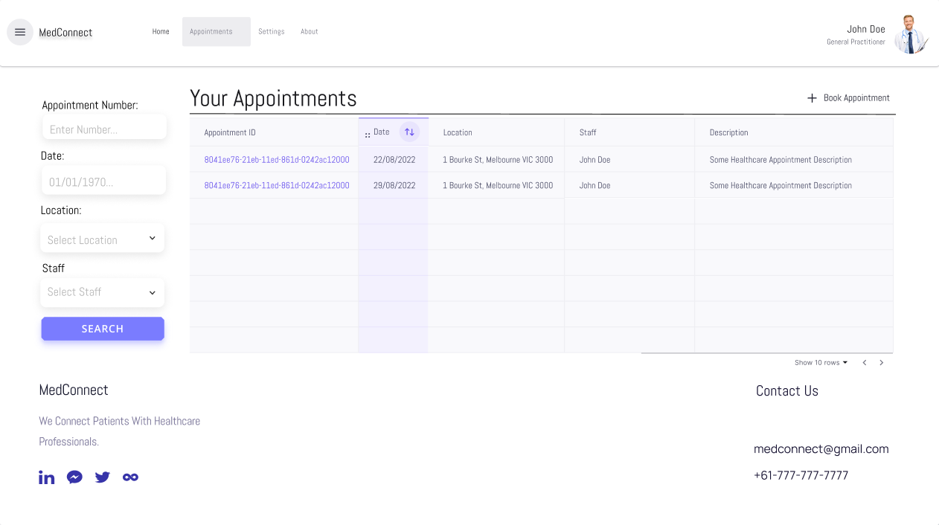

*Figure 4: Mock-up for Interactive Table Data (BR C.3)*

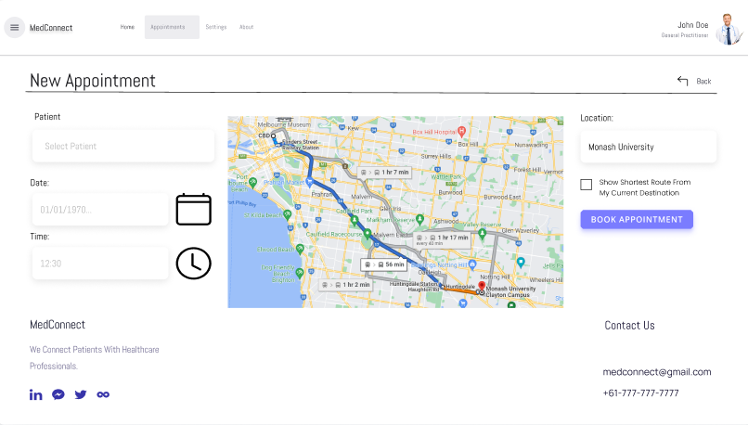

*Figure 5: Mock-up for Geo-Location Map to Record down Appointment locations (BR E.1)*

*Note: Please don’t consider these to be super high-fidelity so take it with a grain of salt. Some of these Mock-ups have less than ideal icons (couldn’t find anything better in Figma) as button like the date & clock icons for date & time field in figure 5.*

Implementation with user registration and authentication. Include code URL and screenshots of HomeController implementation with user registration and authentication with validations of your web application.

The default controller providing authentication in my current project is AccountController. Which simply handles the authentication via MS Identity.

Link (I’m not taking a screenshot, as it’s too long to fit in a single screenshot):

<https://github.com/3drdsh3in/FIT5032/blob/master/assignments/portfolio/FIT5032_Assignment_Portfolio/FIT5032_Assignment_Portfolio/Controllers/AccountController.cs>

*Figure 2: Registration Form*

*Figure 3: Logging In*

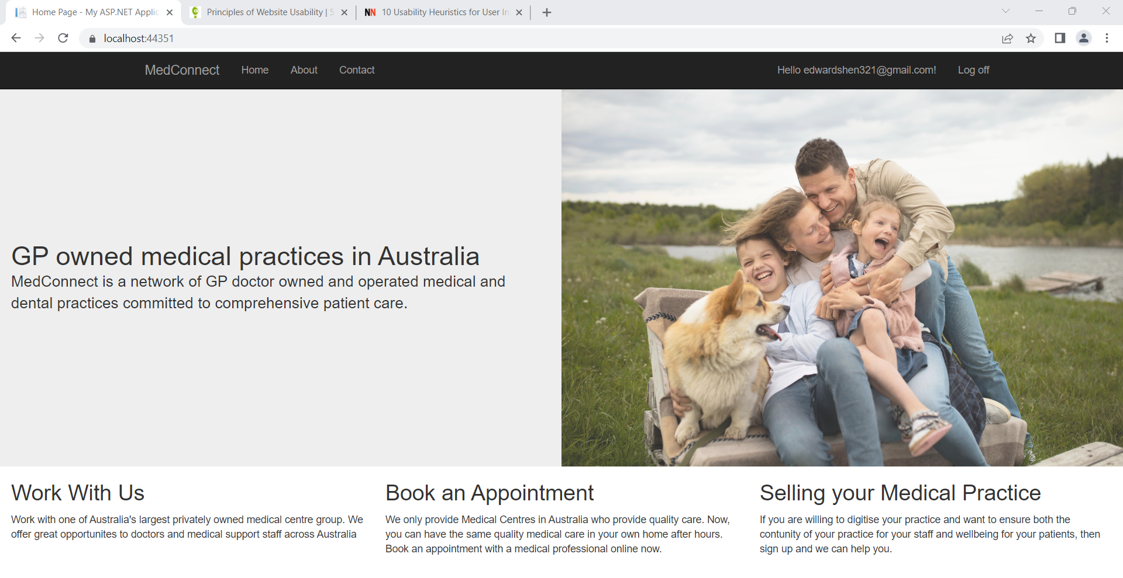

*Figure 4: Log in Screen upon clicking Create or Login.*

1. **Usability Design Review**

Include usability evaluation of your web application. Use Flow Bohl, Donald Norman or other referenced UX evaluation criteria for this purpose.

**Additional High Distinction Level (the above and the following)**

1. **Development Methodology**

A description of your development methodology for this portfolio submission. (For example, did you approach the portfolio submission using a Code and Fix method or using a Test Driven Development). Most students are expected to use the Code & Fix model. (This is completely normal for all assignments)

1. **Versioning**

Description of how you handled the versioning of your project. For example, if you have used [Git](https://www.atlassian.com/git/tutorials/what-is-git), [Mercurial](https://www.mercurial-scm.org/), [CVS](https://en.wikipedia.org/wiki/Concurrent_Versions_System), or [SVN](https://subversion.apache.org/). Please provide evidence of your repository if you have done so. (If you did not use it, justify why). It is not a requirement to use these tools but if you have done so, please state it.

1. **Innovation and Research**

Describe how the new Web Application has been implemented any one innovative feature aimed at improving User Experience (Note that implemented innovation feature may be significant enhancements to existing features). A separate research section with recommendation for future upgrades (Please fill out all sections of Research Report_Template).

1. **Checklist of site functionality**

|  |  |
| --- | --- |
| **1. (Layout Page)** | **TICK**  **if complete** |
| Good Design |  |
| Stylesheet |  |
| JavaScript |  |
| Menu |  |
|  |  |
| **2. (Home page)** |  |
| Design and content |  |
| Banner Image |  |
|  |  |
| **3. (User Log in)** |  |
| Web form and validation controls |  |
| Formatted data entry display |  |
| Overall page design |  |
|  |  |
| **4. (Customised Views and Controllers)** |  |
| Customised Views |  |
| Customised Controllers |  |
| Other customisations |  |
|  |  |
| **5. (Documentation)** |  |
| Code Comments |  |
| Attribution of Source of any code used |  |
|  |  |
| **6 Business Requirements** |  |
| **BR(A1): for P** |  |
| **BR(A2): for P** |  |
| **BR(B1): for C to C+** |  |
| **BR(B2): for C to C+** |  |
| **BR(C1): for C+ to C++** |  |
| **BR(C2): for C+ to C++** |  |
| **BR(C3): for C+ to C++** |  |
| **BR(C4): for C+ to C++** |  |
| **BR(D1): for D to D++** |  |
| **BR(D2): for D to D++** |  |
| **BR(D3): for D to D++** |  |
| **BR(D4): for D to D++** |  |
| **BR(E1): for HD to HD+** |  |
| **BR(E2): for HD to HD+** |  |
| **BR(F1): for HD+ to HD++** |  |
|  |  |
| **Audit** |  |
| No breaking of copyright |  |