Five Different IDES:

1. Visual Studio (C#)
2. IntelliJ (Java)
3. Pycharm (Python)
4. XCode (Swift)
5. Webstorm (JavaScript)

Visual Studio Community Edition Features (Discussion & Screenshots):

Feature 1: Fast Code Execution

The IDE provides the ability to run or debug the code of the entire web application at the click of a button (Highlighted in red below) as opposed to having to compile & run code via command line.

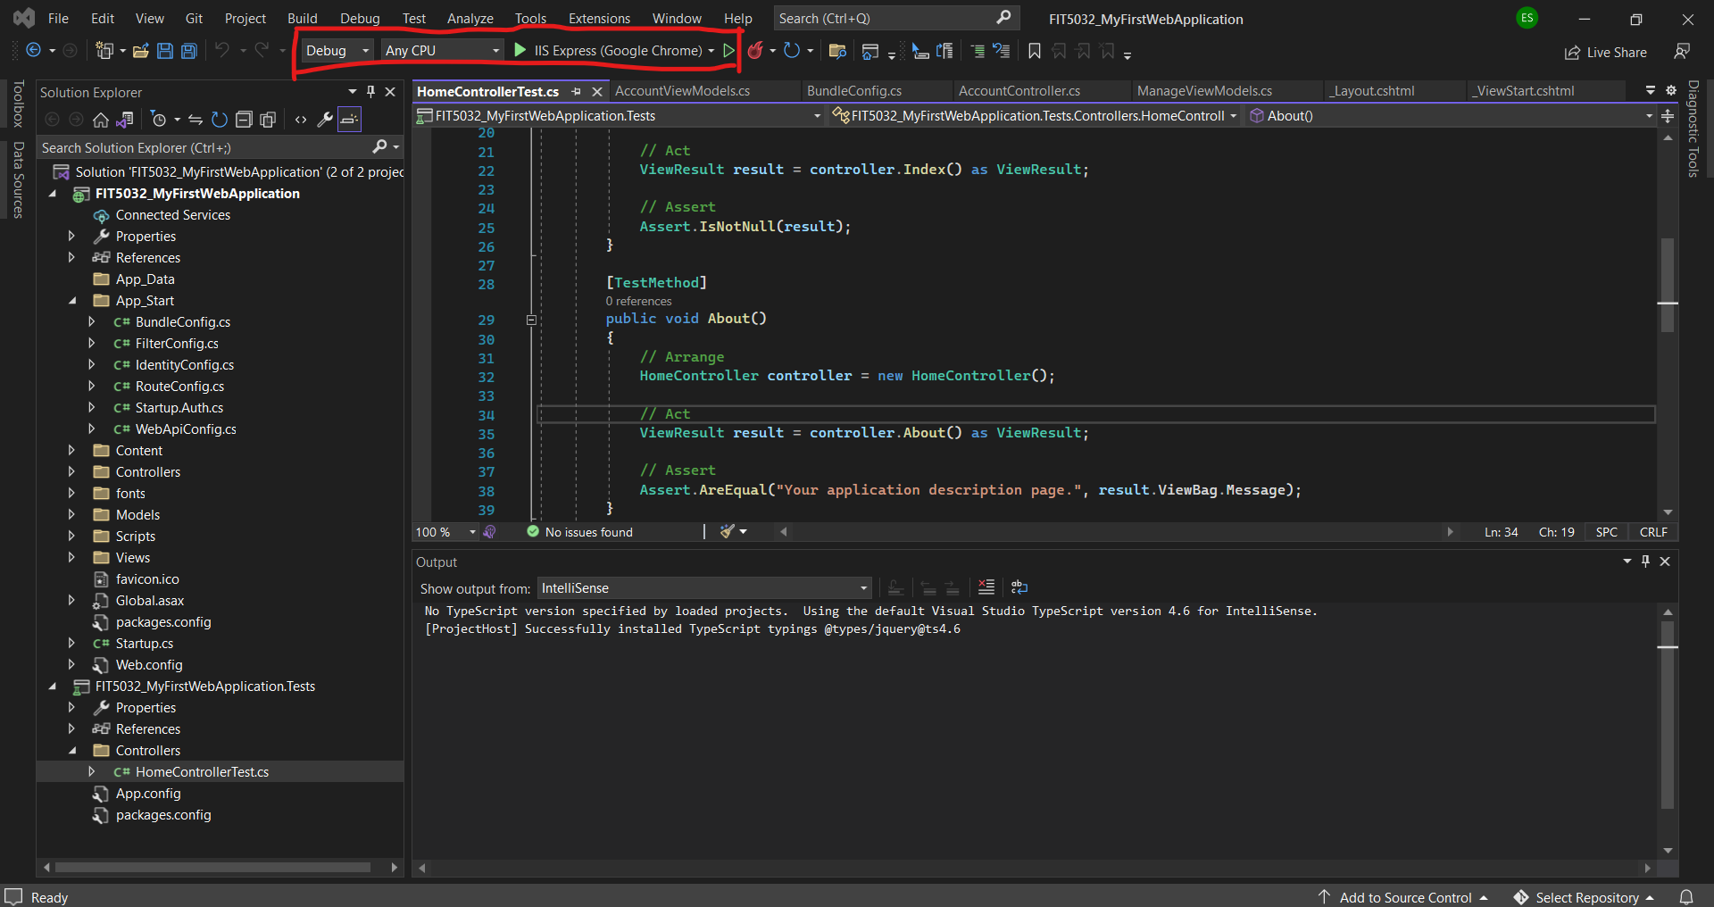

Feature 2: Built-In Debugger

Visual Studio Code has a built-in debugger that allows you to add/remove breakpoints, view function stacks etc. This is a very useful code feature & enables us to fix code quicker.

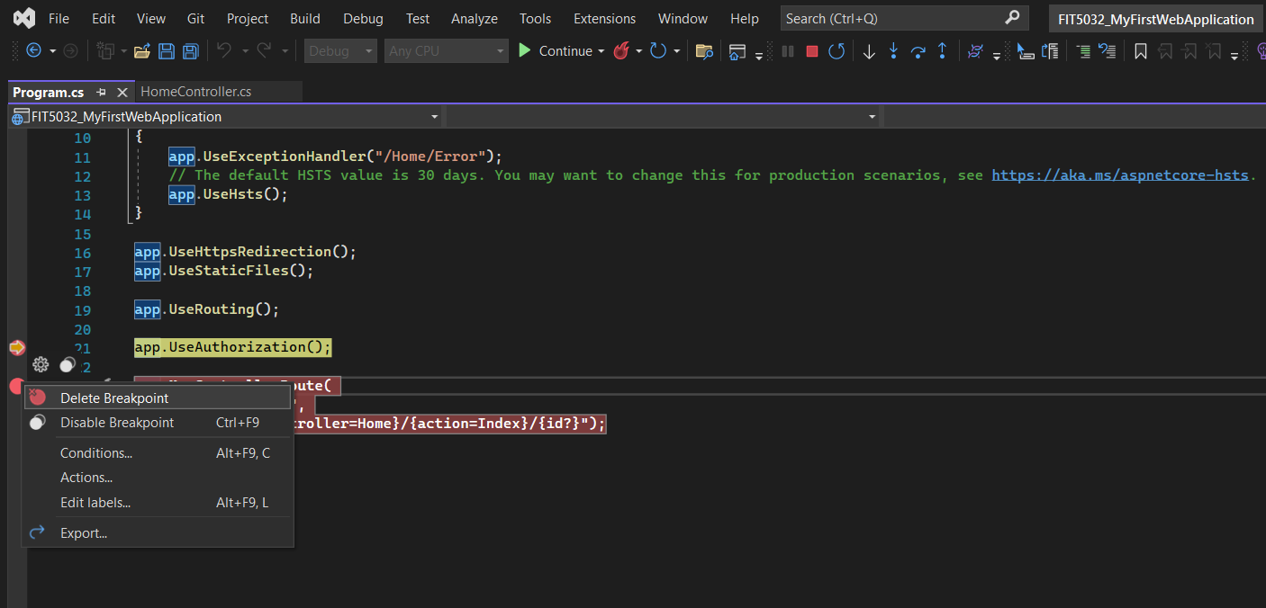

Feature 3: Syntax Checks & IntelliSense

The IDE provides IntelliSense and will alert you whenever you have made a syntactics error when writing code for C# (or other) related programs. It will provide you suggestions on how to fix the error when hovering over as show below.

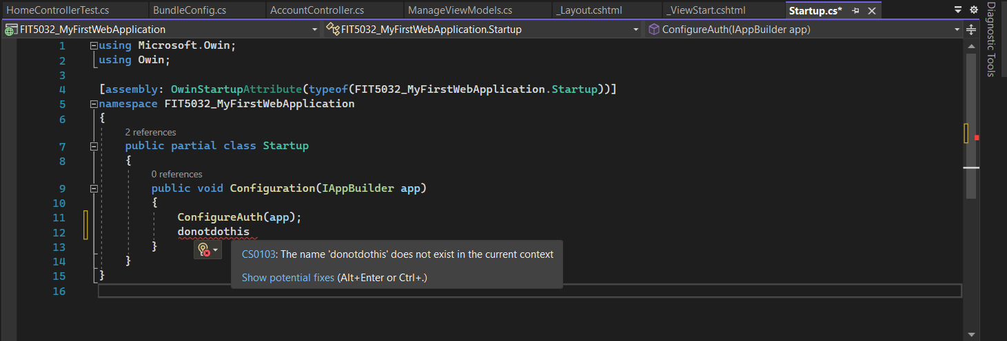

Feature 4: Code completion

Visual Studio Code provides the ability to autocomplete incompletely written code lines for example below. When it is difficult to remember every method (or classes & objects) available to you this can help speed up development. It also provides immediate access to coding documentation:

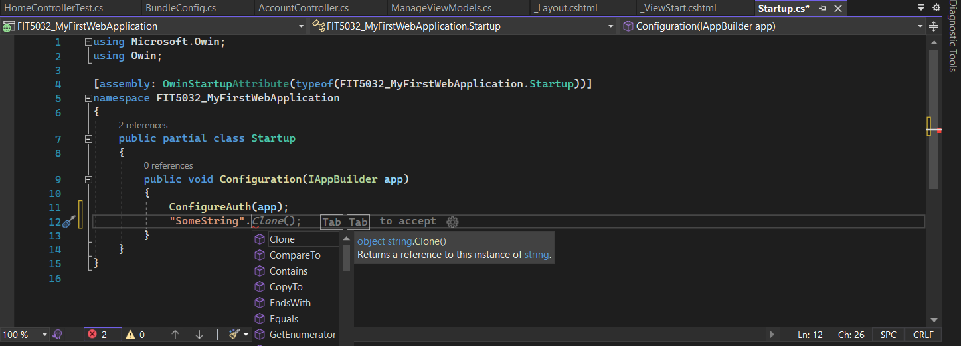

Feature 5: Git Integration

The IDE itself provides an interface to collaborate with others on code via a built-in IDE (No need to worry too much about learning command line or downloading other applications to manage the code).

