FIT5032: Internet Applications Development

Studio Assessment Task 1: Studio #1 & #2

Name: Edward Shen

Student Id: 30594863

Date of submission: 4th August 2022

Self-Evaluation: High Distinction

Task 1.1 (Demonstrating a successful setup)

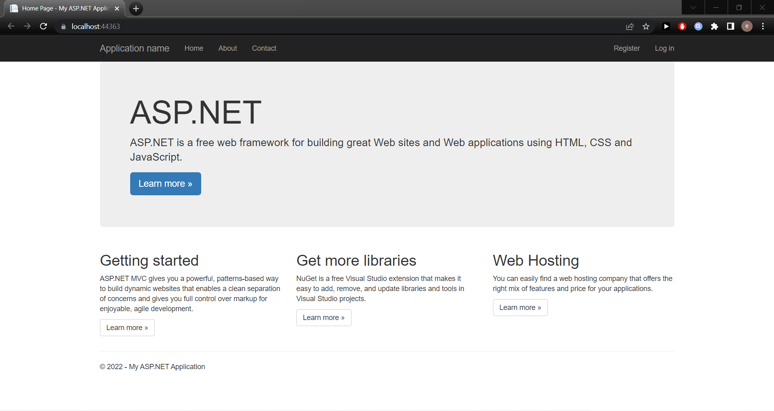

Figure 1.1: IIS localhost screenshot

Task 1.2 (5 Different IDES and brief description on useful Visual Studio Community features):

**Five Different IDES:**

1. Visual Studio (C#)
2. IntelliJ (Java)
3. Pycharm (Python)
4. XCode (Swift)
5. Webstorm (JavaScript)

**Visual Studio Community Edition Features (Discussion & Screenshots):**

**Feature 1: Fast Code Execution**

The IDE provides the ability to run or debug the code of the entire web application at the click of a button (Highlighted in red below) as opposed to having to compile & run code via command line.

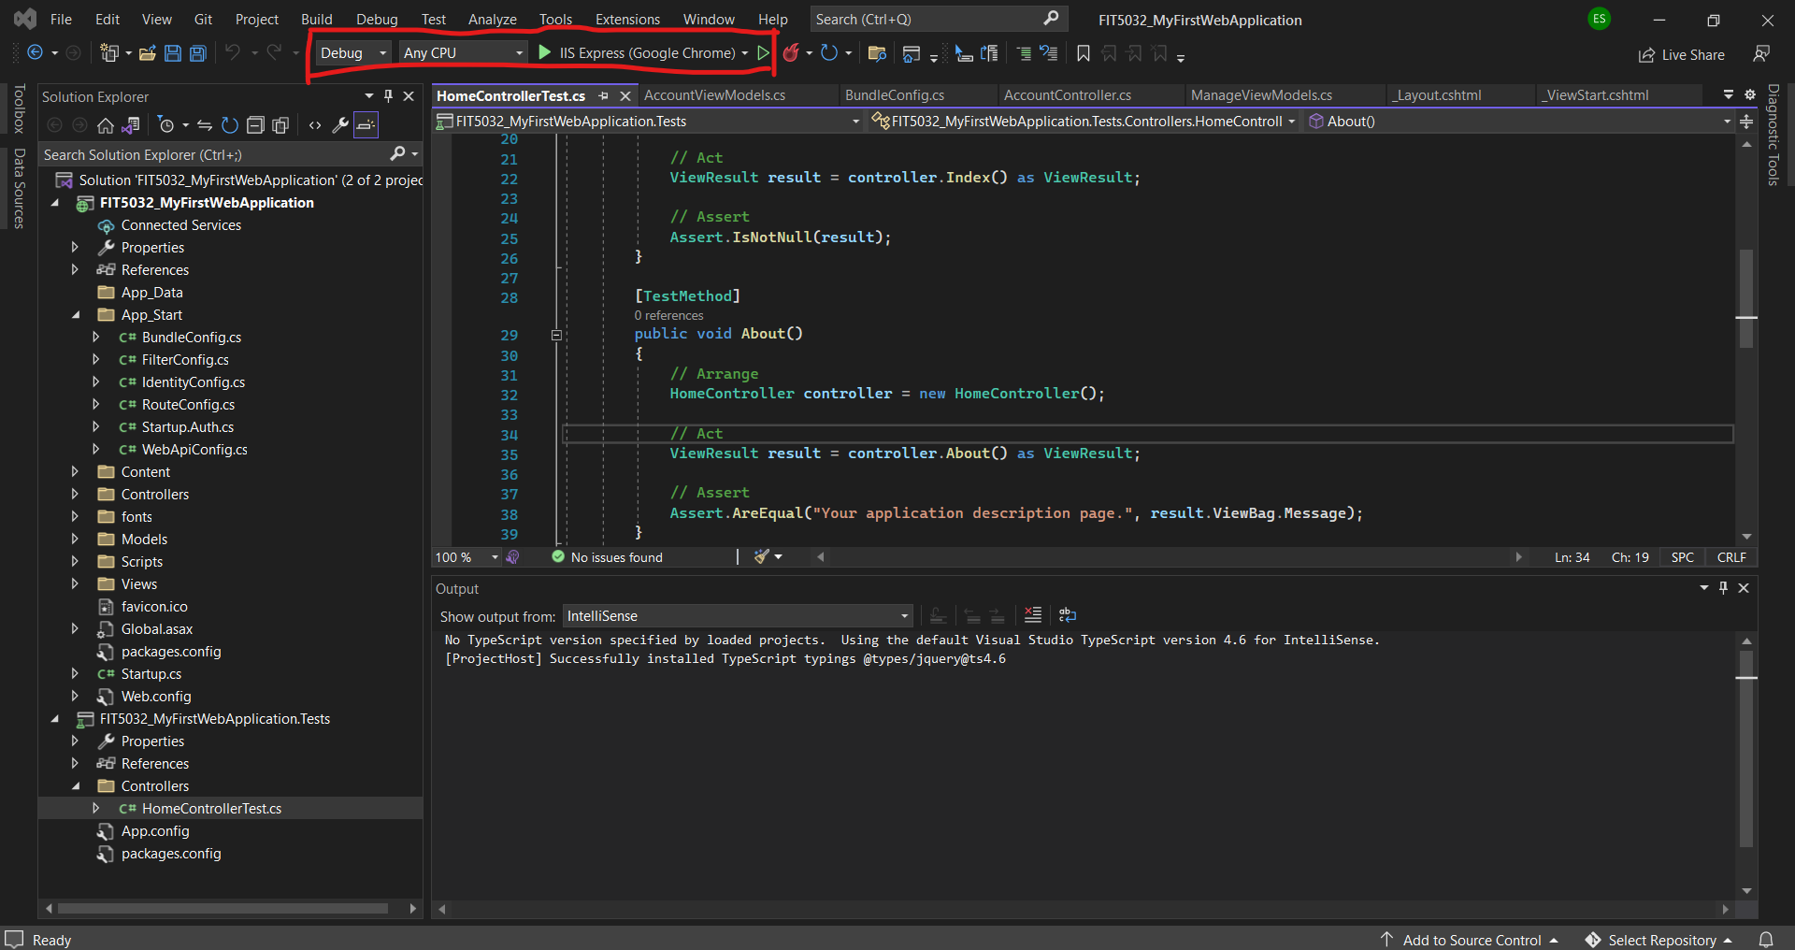

Figure 1.2.1: You can start the entire web application at the click of a button

**Feature 2: Built-In Debugger**

Visual Studio Code has a built-in debugger that allows you to add/remove breakpoints, view function stacks etc. This is a very useful code feature & enables us to fix code quicker.

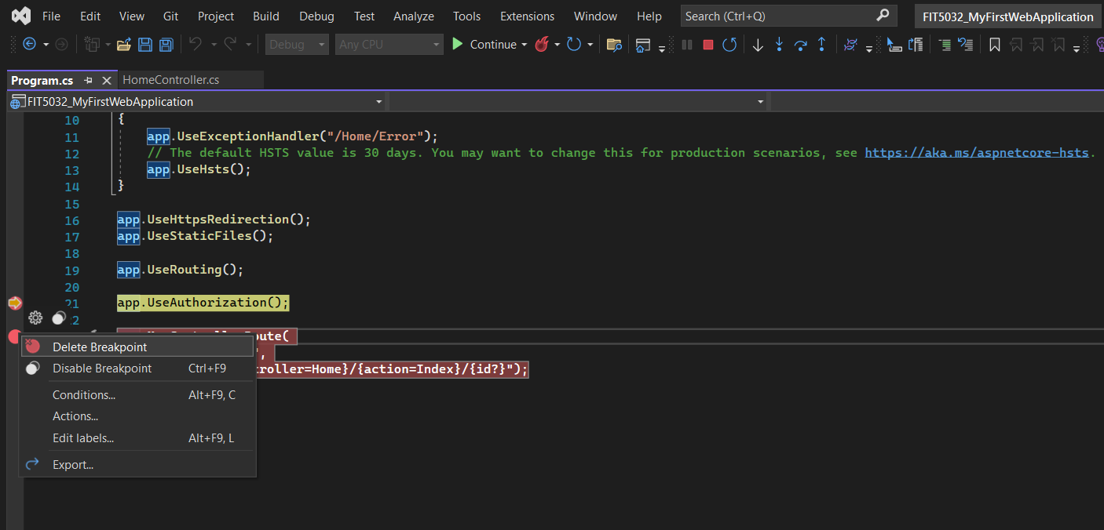

Figure 1.2.2: Setting breakpoints for debugging in the IDE

**Feature 3: Syntax Checks & IntelliSense**

The IDE provides IntelliSense and will alert you whenever you have made a syntactics error when writing code for C# (or other) related programs. It will provide you suggestions on how to fix the error when hovering over as show below.

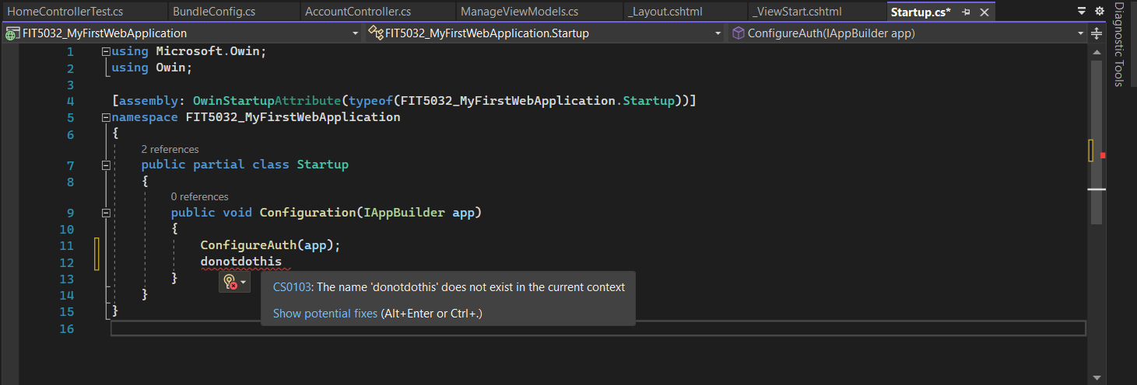

Figure 1.2.3: Automatic underlining/detection of invalid C# code.

**Feature 4: Code completion**

Visual Studio Code provides the ability to autocomplete incompletely written code lines for example below. When it is difficult to remember every method (or classes & objects) available to you this can help speed up development. It also provides immediate access to coding documentation:

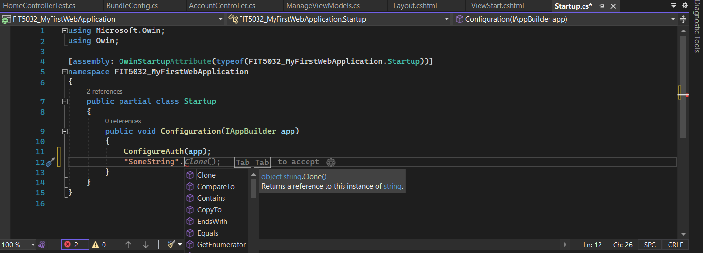

Figure 1.2.4: Without writing any method of a string. Visual Studio provides automatic code completion for methods within the String Object of C#.

**Feature 5: Git Integration**

The IDE itself provides an interface to collaborate with others on code via a built-in IDE (No need to worry too much about learning command line or downloading other applications to manage the code).

Figure 1.2.5: We can create a git repository for our C# project all in visual studio (No command line etc).

Task 2.1 (Writing CSS like a psychopath & demonstrating web page responsiveness):

Figure 2.1.1: HTML of the about page (which we will for our example).

Figure 2.1.2: CSS of the classes for the about page (which we will for our example).

Figure 2.1.3: Larger Viewport View (are your eyes bleeding yet?).

Figure 2.1.4: Smaller Viewport to demonstrate that bootstrap responsiveness (since bootstrap grid elements are written to be responsive by default). On mobile viewports elements on the same column (from the desktop viewports) will instead be displayed on separate rows.

Task 2.2 (Making sure the web app works with a simple database):

Figure 2.2.1: StudentController.cs and the database running w/ the Student & Unit tables.

Figure 2.2.2: The Web app after entering the table a student’s entry from the web app.

Figure 2.2.3: The database after adding the student “Edward Shen” via the web app.