Efolio Task 3.1:

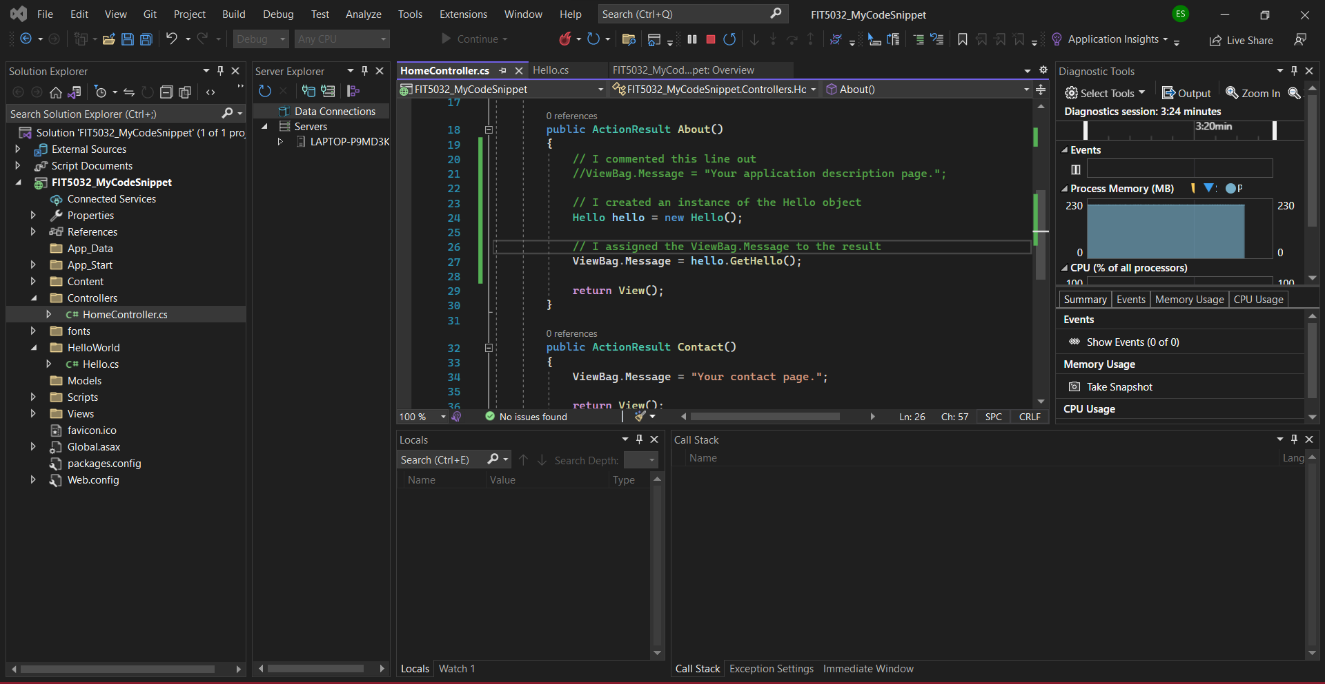

Code from IDE because I think it proves I (actually) did it a bit better.

Efolio Task 3.2:

(Remember to ask during lab to give tutors access to the repository.)

https://github.com/3drdsh3in/FIT5032_W3