FIT5032: Internet Applications Development

Studio Assessment Task 1: Studio #5 & #6

Name: Edward Shen

Student Id: 30594863

Date of submission: 21st August 2022

Self-Evaluation: High Distinction

Task 5.1:

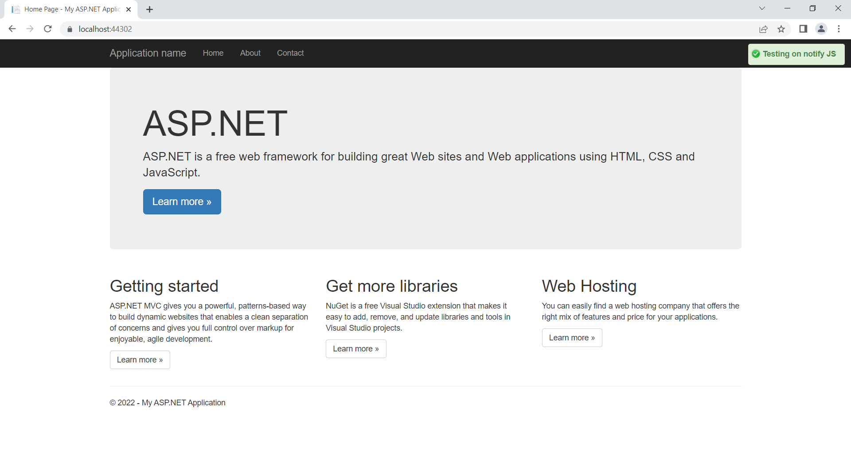

*Figure 1: Page with the working notify plugin script*

Difference Between Defer and Async:

<script src=”~/SomeJS.js” async></script>

Will begin by parsing the HTML file, will then schedule a separate process (asynchronously) to begin download and load in the JavaScript file. Note that It may pause the HTML from parsing while it begins executing the corresponding JavaScript file.

<script src=”~/SomeJS.js” defer></script>

Also begins by parsing the HTML file, also schedules a separate process process to asynchronously download the SomeJS.js file, however defer will forcefully defer the actual execution of the SomeJS.js file until the HTML has completely finished parsing.

Task 5.2:

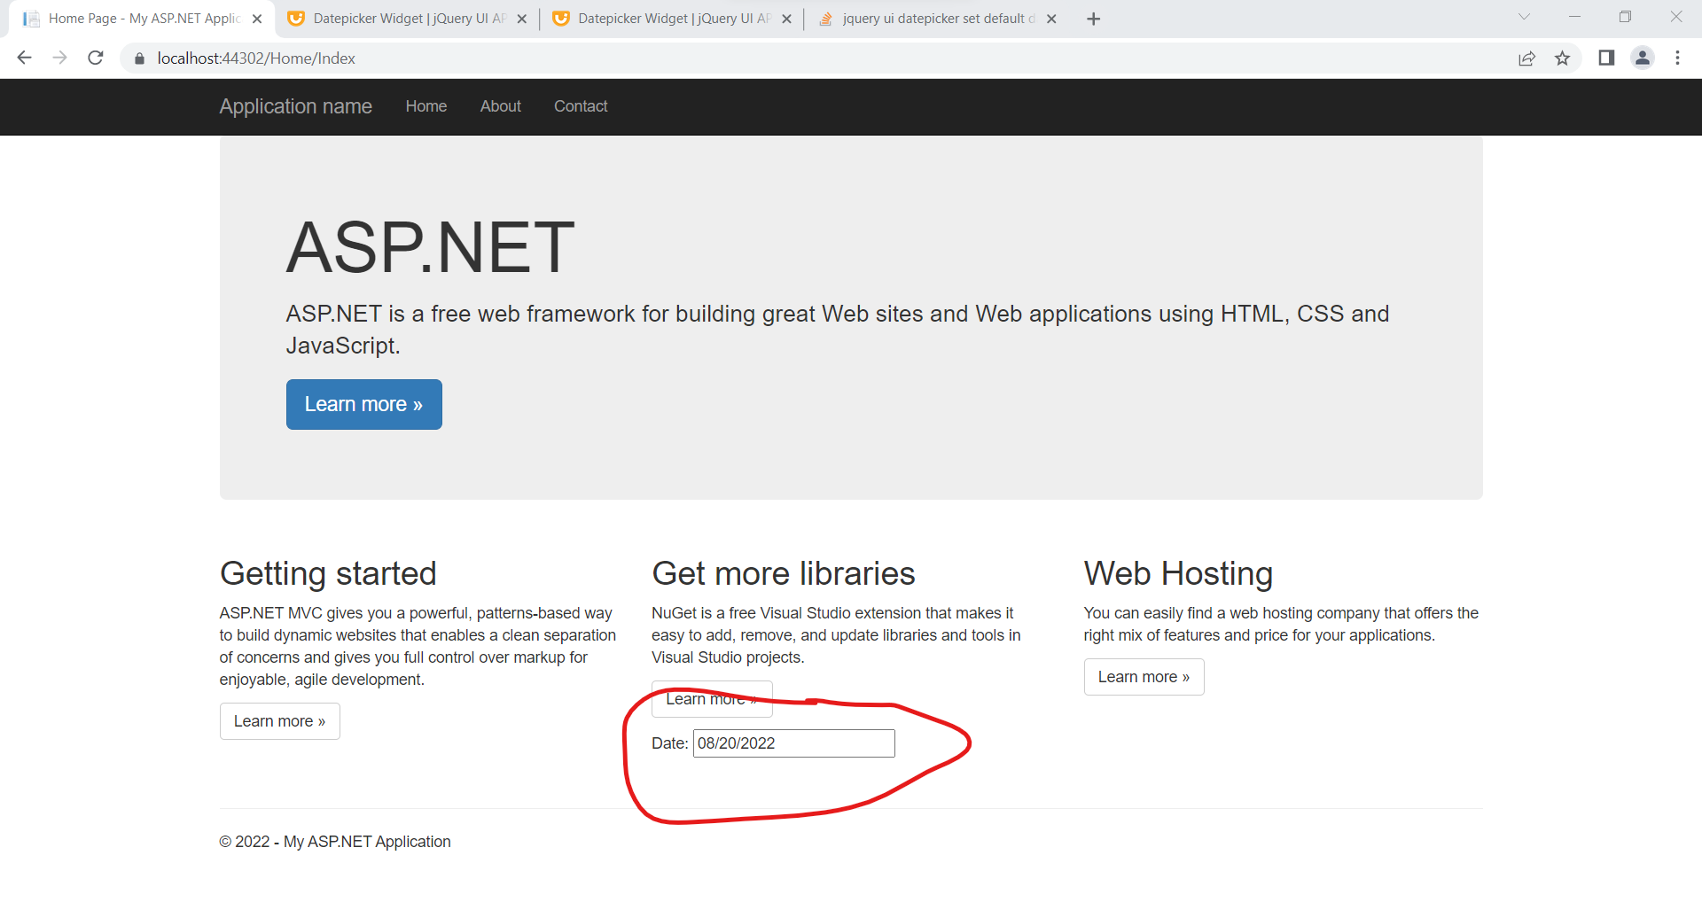

*Figure 2: Date Picker Functionality.*

Github link of jQuery source code: