FIT5032: Internet Applications Development

Studio Assessment Task 1

Name: Edward Shen

Student Id: 30594863

Date of submission: 26th August 2022

Self-Evaluation: High Distinction

# Web Application Title and Description:

“MedConnect” will be a web application that aims to enable doctors to connect with patients so that they can schedule and manage appointments with one another (as its core functionality). To ensure that these requirements are met to a respectable standard (regarding security) a corresponding authentication system for patients (known as clients in the system) and staff will to be established. The web application will feature innovative user experience by enabling users to book their appointments in via a geographical mapping system (as opposed to having to manually type in an address) which aims at ensuring an intuitive user interaction experience. In addition to this a modern response table management system will be implemented to view, search, and manage users along with allowing staff members to book appointments with potential client. An emailing system will be used to help user confirm any updates to their user profiles or corresponding appointments.

In this system staff members (general practitioners, specialists, etc.) will be associated with (created & deleted by) an Admin user (which will be synonymous with the manager of a healthcare business or hospital system) that is used to manage them.

# High Level Functional/Block Diagram:

The functional diagram I have created for this system is divided into 3 parts, one for each type of user (Client, Staff, Admin) whom each interact with the system differently.

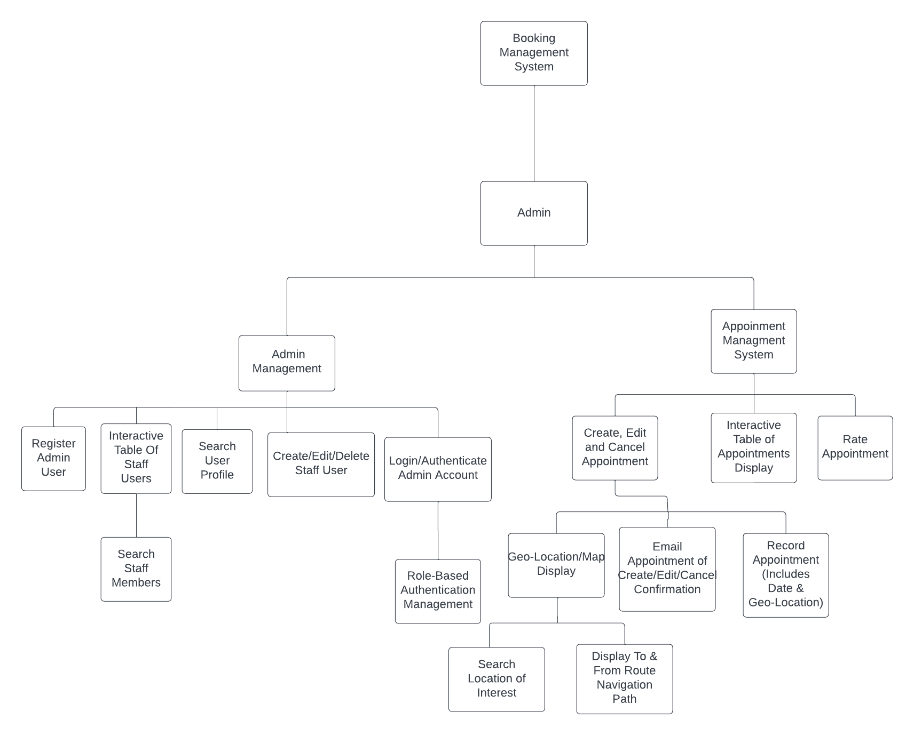

*Figure 1: Functional/Block Diagram for Admin User*

*

*Figure 2: Functional/Block Diagram for Staff User*

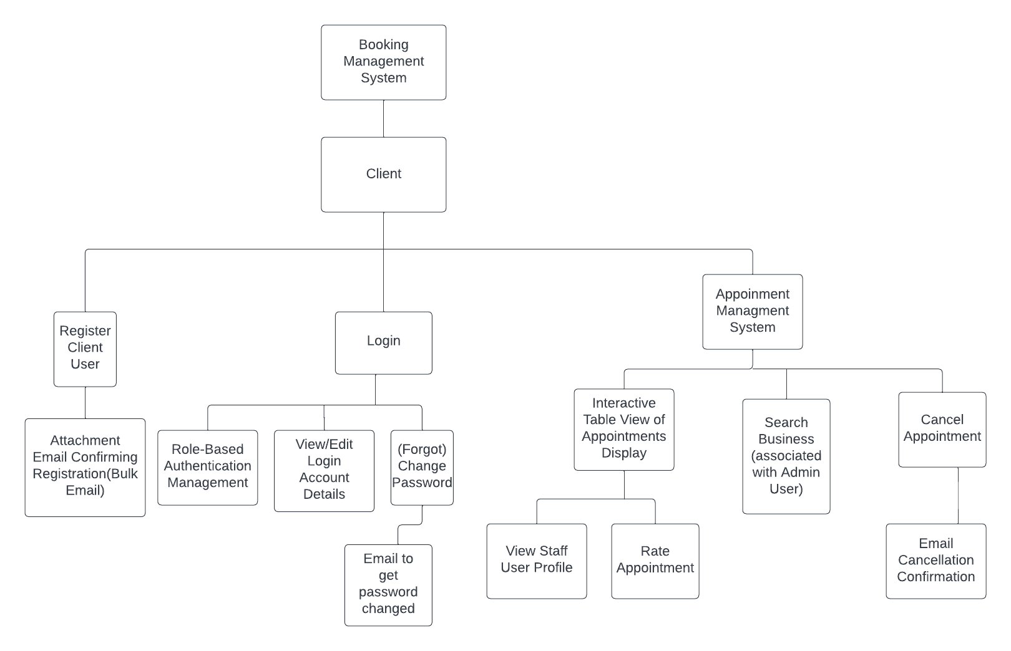

*Figure 3: Functional/Block Diagram for Client User*

# Use case Diagram:

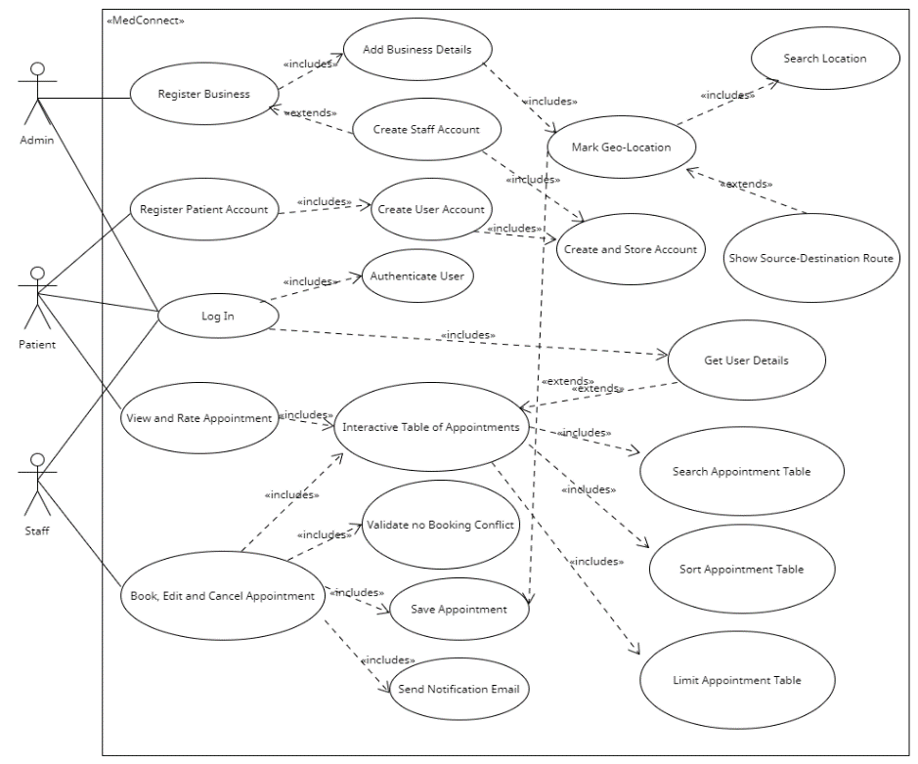

*Figure 2: Use case diagram*

# Validations:

**Role-Based Authentication (BR B.1):**

Successful Validation of completion will involve (sequentially) being able to retrieve the user’s account details from what was filled out in the login form and providing their client a user account access token (validating the session) before bringing the user to their personal Appointments screen showing what their upcoming appointments are. If either the user data or authentication token cannot be retrieved an error message “Could Not Find User Details” or “Failed to Authenticate User” will be displayed (potentially with a bootstrap modal).

**Interactive Table Data (BR C.3):**

The successful validation of completion for this business requirement (for this web application) involves being able to view the appointment data, being able to search, sort and limit the number of appointments. Hence, any failures whilst retrieving the appointment data, searching, sorting, or limiting (note each of these events are separate from one another) of the appointments will need to be handled with corresponding error messages along the lines of “Failed to retrieve, search, sort or limit the appointment data”.

**Interactive Table Data (BR E.1):**

The successful validation of completion for this business requirement (for this web application) involves being able to successfully Select Patient, Date, Time, and Location through Map Location Search (along with enabling user to show routes between their current location and selected destination) and submit the form. These are all separate events and will be handled with separate error messages if issues were found during submission. Additionally, a more dynamic (potentially via JavaScript) approach to handling invalid fields by highlighting the invalid data in red will be adopted to ensure that the user entered valid fields into each field in the first place (which will block the UI from sending the “Book Appointment” request if a single field is invalid).

Mock-up Prototypes Design:

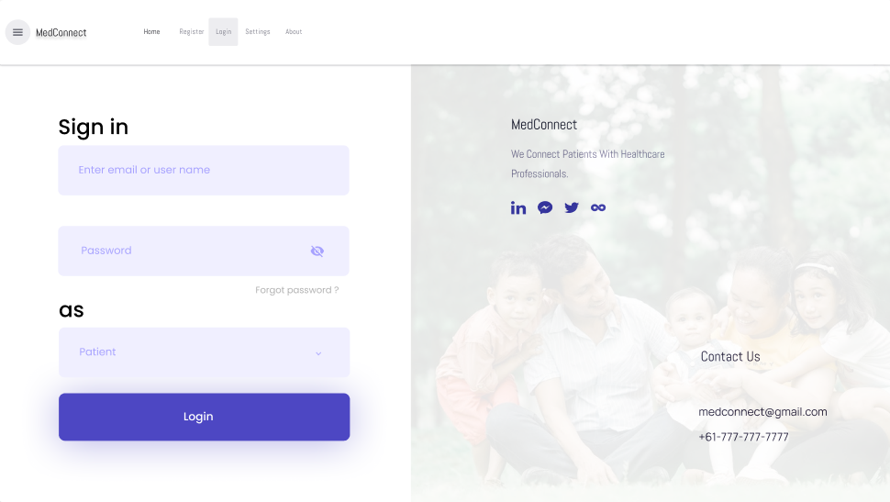

*Figure 3: Mock-up for Role based Authentication (BR B.1)*

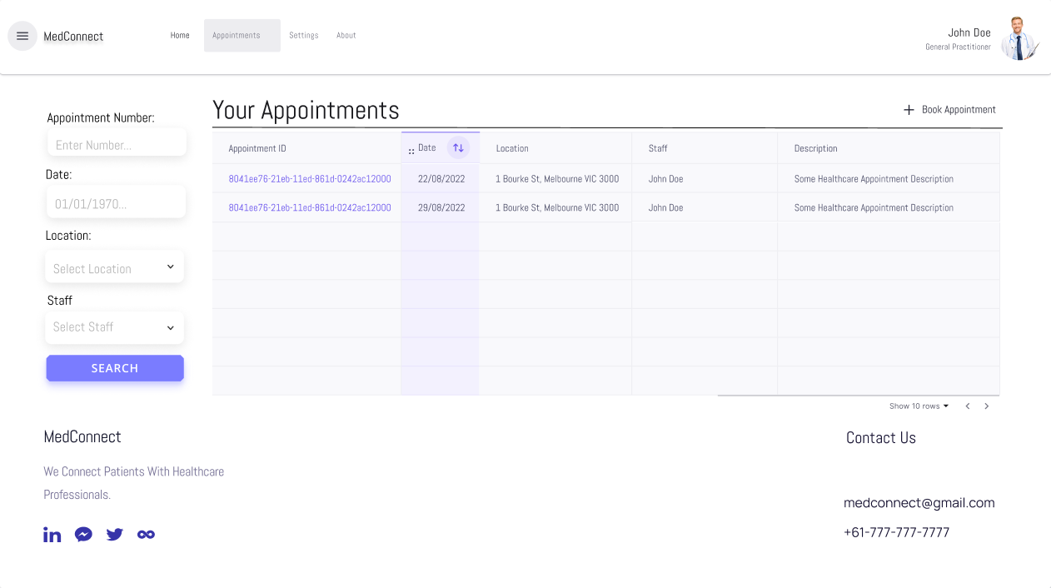

*Figure 4: Mock-up for Interactive Table Data (BR C.3)*

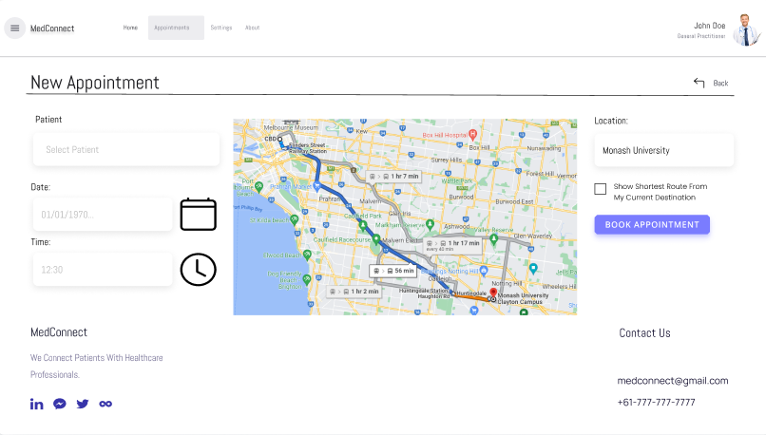

*Figure 5: Mock-up for Geo-Location Map to Record down Appointment locations (BR E.1)*

*Note: Please don’t consider these to be super high-fidelity so take it with a grain of salt. Some of these Mock-ups have less than ideal icons (couldn’t find anything better in Figma) as button like the date & clock icons for date & time field in figure 5.*