Implementation of file upload and email with attachment

Link:

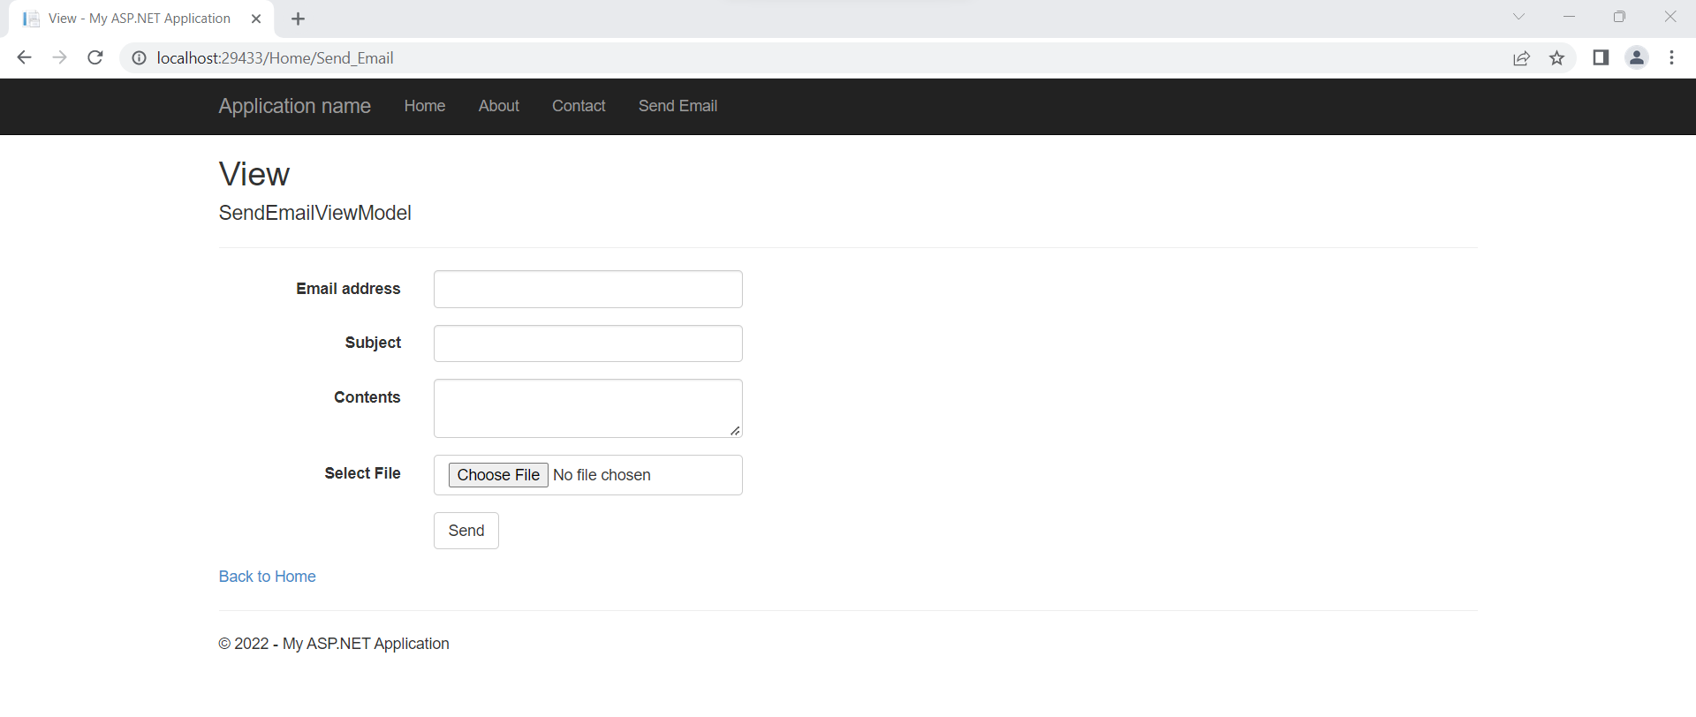

Figure 1: Send Email View

Figure 2: Email Contents

Figure 3: Email Sent

Figure 4: The Corresponding Email:

Implementation of any one innovative feature aimed at improving User Experience (UX)