CSML1020 Assignment Bonus Marks Attempt

Notes on experiments with model performance in the Nvidia Fundamentals of Deep Learning Certificate.

Pete Gray, YorkU #217653247, ptgray@my.yorku.ca

Certificate link: https://courses.nvidia.com/certificates/b2ec399b8f9946d4a7912239b665377c
---------------------------------------------------------------------------------------------------------------------------

For my first attempt at setting up a whale face classifier in DIGITS for the Nvidia certificate, I used 3 epochs of training, and the default presets for everything else. This resulted in a model with 97.97% accuracy and validation loss of 0.066. This performance was enough to score the certificate once the code to be submitted had been sorted out. Experiments were done once I'd already graduated.

When I went back to try to improve the performance of the model, the first thing I did was to run it through 30 epochs, which was the default value in that interface, and the only one I changed the first time through. Took a big 6 minutes or so to crunch. For thousands of images, through 30 epochs! This resulted in a model with 99.34% accuracy and a validation loss of 0.026. Much better!

Next, I tried some different “solvers” than the default Stochastic Gradient Descent. RMSProp performed abysmally – like a dummy classifier. Maybe I didn't set something up right for use with that. Then I tried ADAGrade. It was a little better than a dummy classifier, but way worse than SGD, with accuracy at 64.35% and a validation loss of 0.65. Ouch!

Finally, I experimented with different base learning rates, back in good old SGD, of course, and different types of learning rate decay. Decreasing the base learning rate caused the model to be less accurate, increasing it lead to a variety of results that were difficult to interpret. Using a fixed, but high, learning rate lead to very bouncy results. I found improved results using sigmoid decay for the learning rate, rather than a step-wise decay.

The best results I was able to achieve was using 30 epochs, stochastic gradient descent, a base learning rate of 0.015, and a sigmoid learning rate decay with gamma set to 0.8. Defaults on all other settings. This resulted in accuracy of 99.52% and a validation loss of 0.022. Here's a screenshot of that:

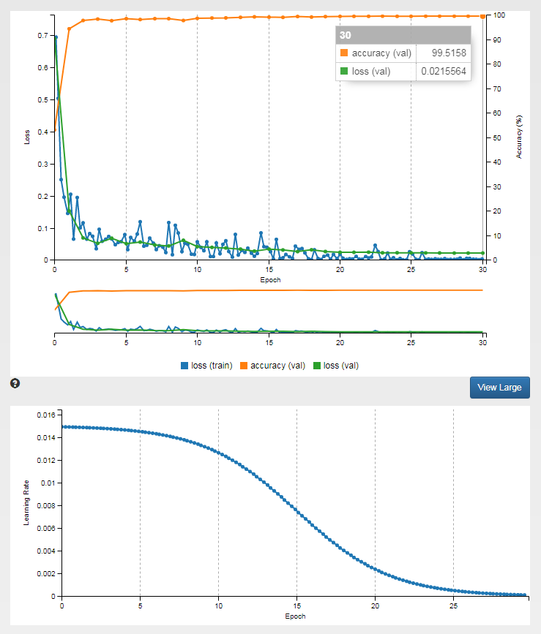
This concludes my experiments with the whale face classifier in the Nvidia Certificate.

Quite the interface, that DIGITS – seeing the young algorithms growing up while I wasn't in code mindset almost felt more like a biology or chemistry lab than an exercise in math. I think it's helped broaden my nascent intuitions. Cool.

