CSML1020 Assignment – Word Counting

MapReduce and Performance of Word Counting Programs, local, Colab, and GCP.

Pete Gray, YorkU #217653247, ptgray@my.yorku.ca

Code and Data used:
Code and setup of GCP: https://cloud.google.com/composer/docs/tutorials/hadoop-wordcount-job
Code for Local and Colab: http://www.analytics.business/word-counter-jupyter-notebooks/
Texts: http://www.gutenberg.org/wiki/Main_Page
206kB — Albert Einstein, Relativity: The Special and General Theory, http://www.gutenberg.org/ebooks/30155
332kB — Planet of the Damned, Harry Harrison, http://www.gutenberg.org/ebooks/21873
1.2MB — Moby Dick; Or, The Whale by Herman Melville, http://www.gutenberg.org/ebooks/2701
3.2MB — War and Peace by graf Leo Tolstoy, http://www.gutenberg.org/ebooks/2600

To begin, I wanted to start with the familiar frustration, futility and failure of trying to crunch respectable amounts of data on some of my local computers, and I was not disappointed!

Though, I didn't know this code from Gutenberg, and once I got to know it a little better, I realized I had to ransack it for performance before I even had a reasonable benchmark. I was able to crunch 1000 times as much stuff locally, just by swapping a few lines of code. Read on for the gory details.

I started with the code cited above, and Moby Dick, at 1.2MB. And I started in my desktop, with a Jupyter Notebook. After about 5 minutes, the whole computer was dead, dead, dead as a doornail and had to be restarted the hard way. So I thought, maybe this would play out better in Colab? Afraid not.
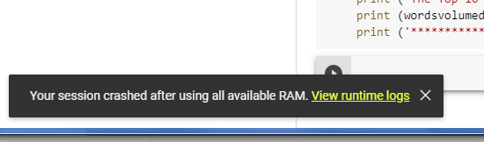
A couple of times, it offered me a runtime with more RAM. Tried a few times – still just crashes. It doesn't always explain, or understand, why. But unlike when I crash locally, at least I can grab a screenshot.

I was finally able to get the code to run locally, using Einstein's Special and General Theory of Relativity as input, which weighs in at a mere 206KB.
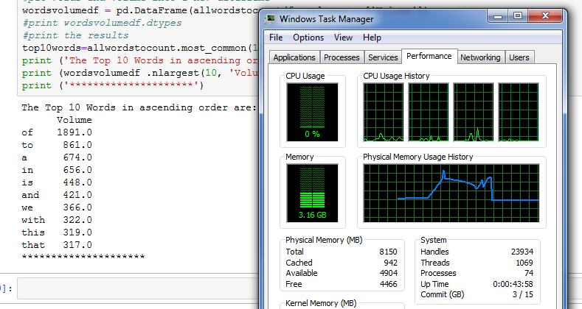
Note the memory usage spike in the Task Manager – that's getting pretty close to maxing out. And sure enough, I tried it again with Harry Harrison's Planet of the Damned, at 332kB, roughly 50% bigger. I watched as that memory usage line crept up towards the top, and then sure enough, as soon as it was there – dead, dead, dead as a doornail, no screenshots for me, back to 10 seconds on the power switch. Cool.

This seemed like a pathetically small chunk of data to be thwarting any sort of machinery at all. I started looking into the code, seeing how far it made it, and where it choked, and came to the conclusion it was blowing up doing something that wasn't even counting words. It was making dataframes it didn't really need.

I replaced this:

allwordstocountdf = wordsdf.word.apply(lambda x: pd.value_counts(x.split(" "))).sum(axis = 0)
#put words and volume into a new dataframe
wordsvolumedf = pd.DataFrame(allwordstocountdf, columns = ['Volume'])
top10words=allwordstocount.most_common(10) # find ten most common words and their counts
print ('The Top 10 Words in ascending order are:')

with this:

Counter = Counter(words)
most_occur = Counter.most_common(5)
print(most_occur)

And hooray! War and Peace, at 3.32MB, returned some nice results in about 4 seconds in the Colab:
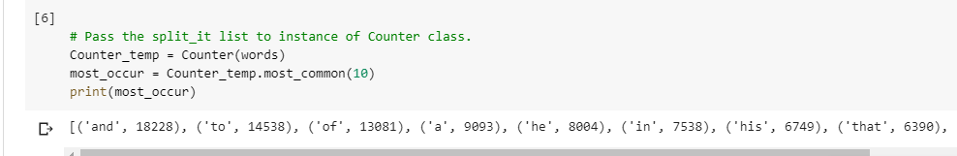
With this staggering improvement in hand, I went back to local, to see if I could get something more reasonable for a benchmark. War and Peace was a breeze. I started concatenating copies after copies after copies of War and Peace together. It worked not bad for 200. Most of the time, about 5 minutes, was spent on the concatenation. The counting itself executed in 21 seconds.

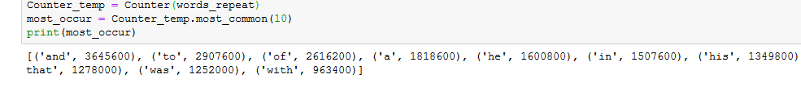
This certainly gives us something meaty to compare against on the Colab.

I was able to do 200 copies of War and Peace in about half the time it took on my desktop, 2 minutes to concatenate, 12 seconds or so for the count.

For a final run before moving on to MapReduce, I had it run in Colab with 500 copies of War and Peace. While it took somewhere between 15 and 20 minutes just to tack them all together, it was able to execute the Counter in 37 seconds.

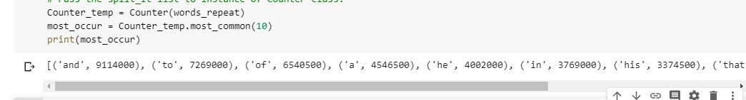
So there's my benchmarks, moving into the GCP – 200 copies of War and Peace in 21 seconds on my desktop — 500 copies of War and Peace in 37 seconds, in the Colab.

I had started with 1,891 as the count of the most frequent word – Now I'm up to 9,114,000. That feels like about as far as I'm going to be able to take it, with code changes and non-GCP runtimes.

So now we're off to the GCP, to try some MapReduce, and see how much better it is.

The first thing I note is the “overhead” involved with setting up a cloud environment. To do as above, either local or Colab, one is up and running in under a minute. We commit to at least 20 minutes of spinning just to take the first steps in the cloud.

