**JCFeather For Arnold**

Email : jerrychinse@163.com

<http://www.jerrykon.com>

Special Thanks to [Wei Xiong](http://www.linkedin.com/pub/wei-xiong/70/b82/b84)

**1. Old method:**

Render feather mesh with one single texture.

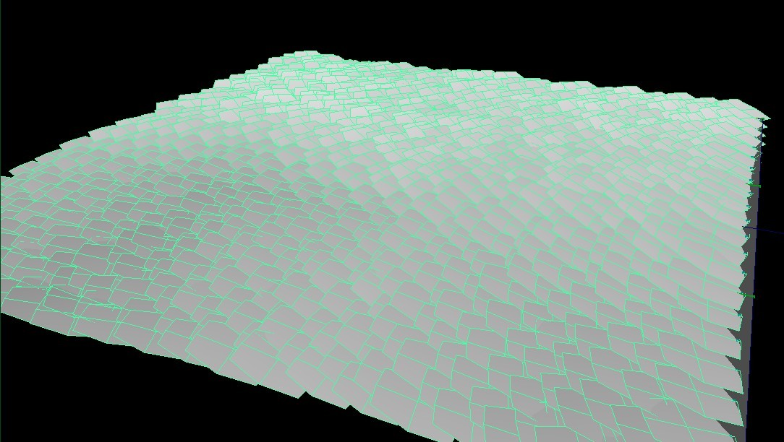

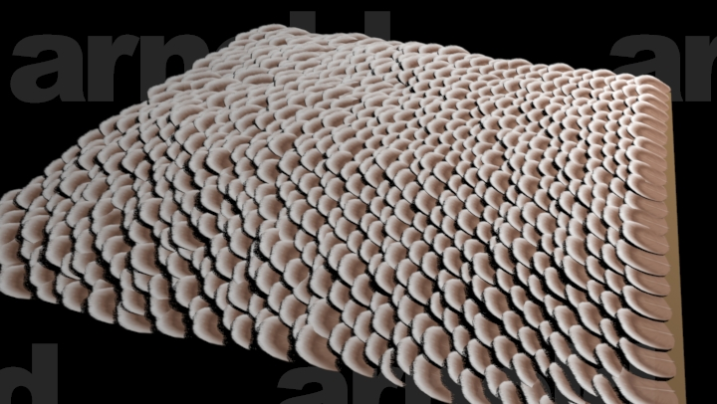

**2. My method:**

(1) 3 textures.

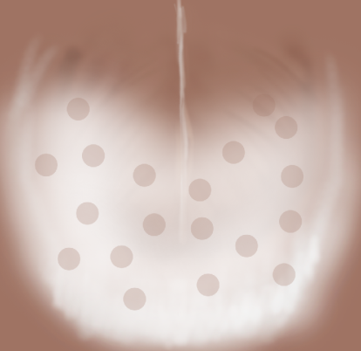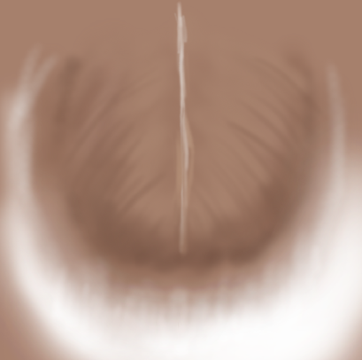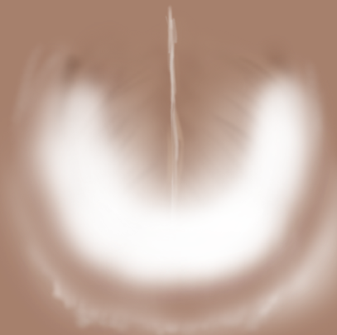

(2)Paint a texture, different textures will be located at different colors.

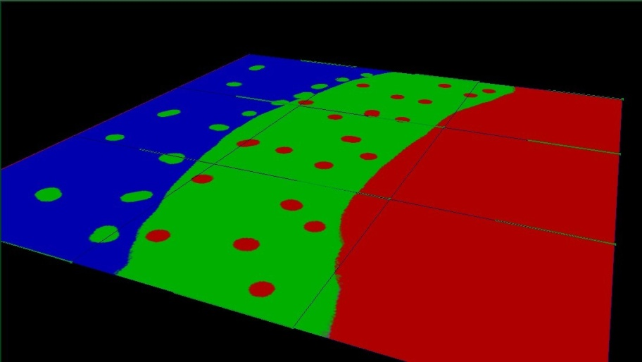

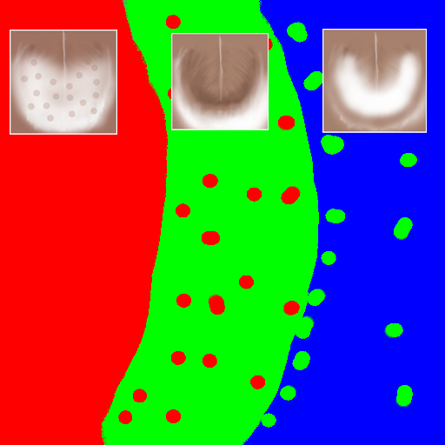

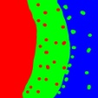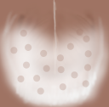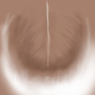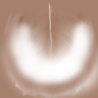(3)Connect 3 textures to one Arnold shader.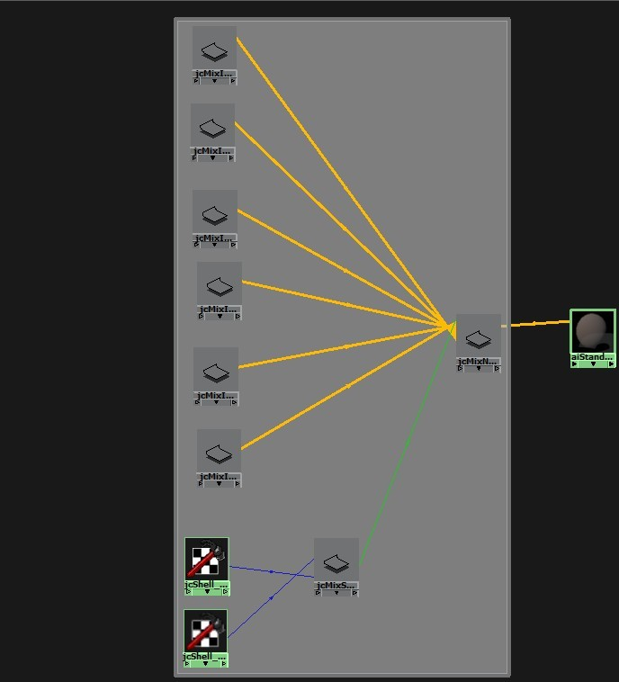

(4) Assign the shader to feather mesh and render. Notice that different textures at different color locations.

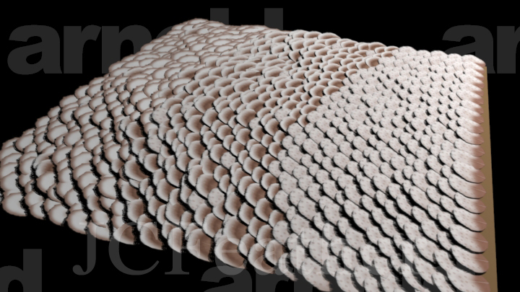

(5)Add a simple ramp texture with a little noise.

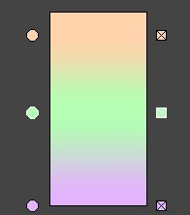

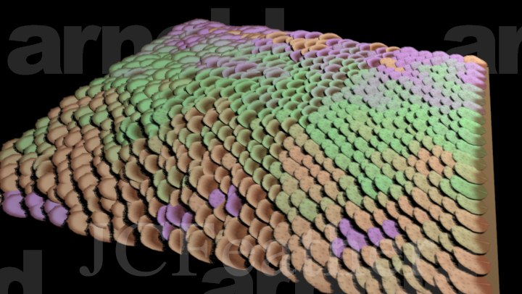

**3. Steps:**

(1) Make a feather coat mesh.

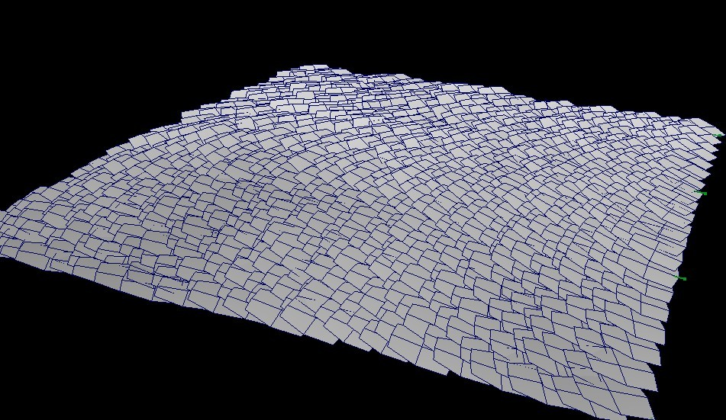

(2)Select feather coat mesh and create jcFeatherComponentArray.

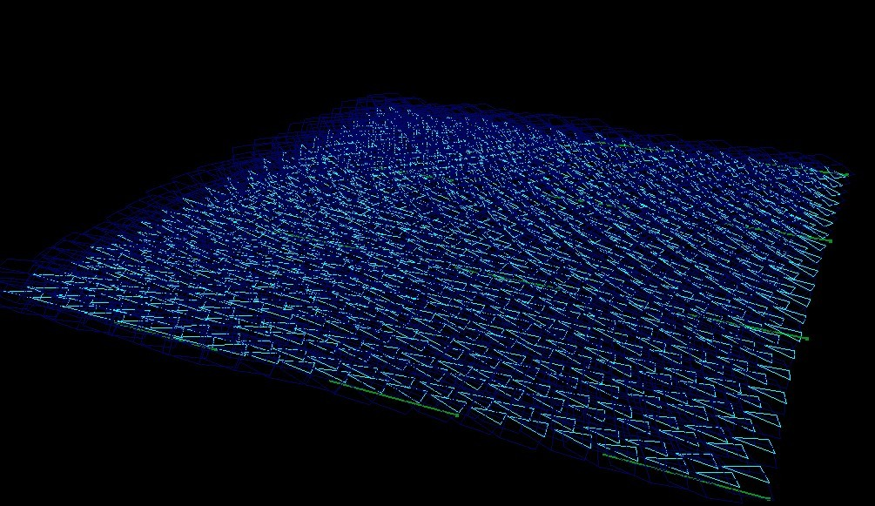

(3)Set the "vertexGroup" and "uvType" attribute of jcFeatherComponentArray.

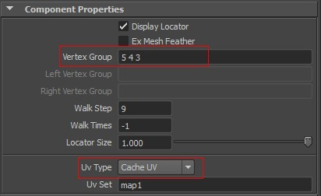

(4)Select the plane under the feather and the jcFeatherComponentArray node to transfer uv data to each single feather by clicking shelf button updateComUV.png

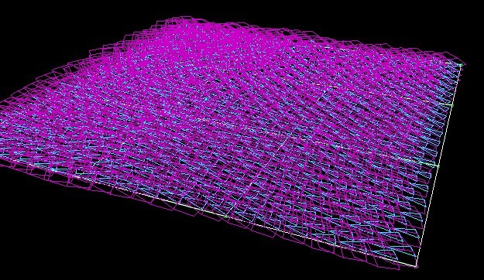

(5) Select the plane and use 3dPaintTools to paint a texture like this.

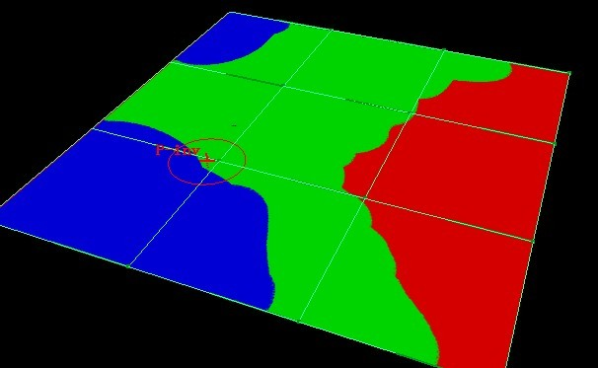

(6) Open jcFeatherTools UI featherTools.png. Select jcFeatherComponentArray node and click button "Update Shell Attributes" to add Mtoa attributes for Arnold.

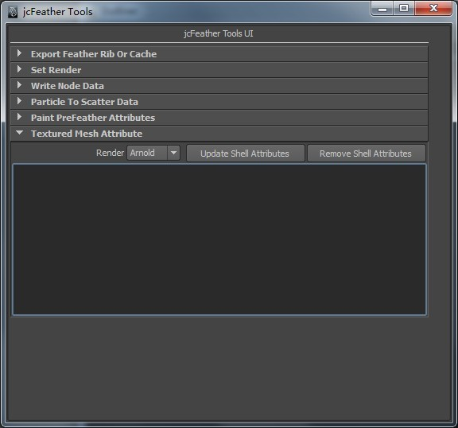

(7)Add feather images to scroll list. Select images and click "Create Arnold Shaders".

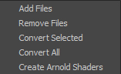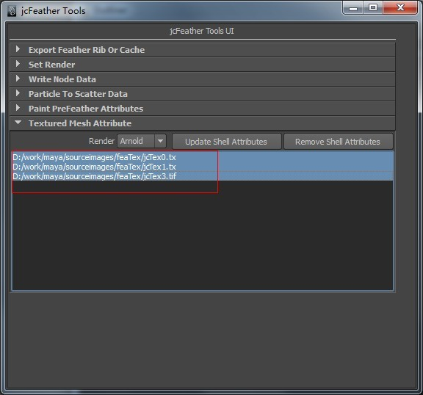

(8)Open Hypershader, browse the texture to painted sample texture for aiImage and connect jcFeatherTexMix to the feather coat mesh shader.

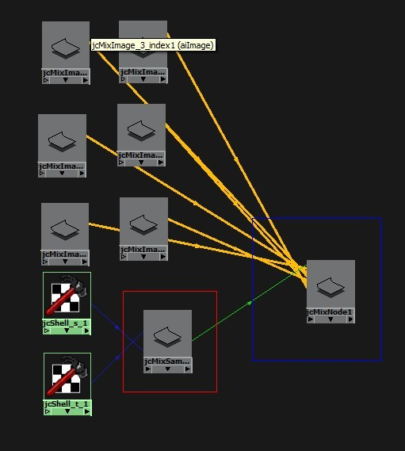

(9)Click render.

(10) If the topology of the feather coat mesh changes, you need redo step 4 and 6.

**4. Reference**

jcFeatherTexMix is an Arnold shader which is designed to sample a texture's color hue value in hsv to pick a texture from 6 connected feather textures and output the color and alpha of that texture. It's designed for feather rendering, but you can use it in many other fields.

Inside jcFeatherTexMix, it works something like this.

Take a look at the following image. You put six feather textures at different locations of the color ring. And give the jcFeatherTexMix a texture(We call it **SampleTexture**) like the one in **step 5**. jcFeatherTexMix will get the hue value of color hsv at the spicified uv point on the **SampleTexture** and get the distance between this hue value and the one of **SampleColor#**(Here # means 0 1 2 3 4 5). Pick the nearest **TexColor#** texture and output its color and alpha if **SampleEnable#** is enabled. jcFeatherTexMix will search for the nearest texture in the order of 0,1,2,3,4,5. Once it get the one whose distance is in the range of **HueTolerance**, it returns the result. If **jcFeatherTexMix** cannot find the nearest texture from the six guys, the **DefaultColor** and **DefaultAlpha** will be used. So please connect the best texture to the default guy.

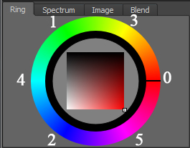

The aiImage nodes connected to the attributes **TexColor#** and **TexAlpha#** of **jcFeatherTexMix** should not use the default uvCoordinate. Two **aiUserDataFloat** nodes are used to sample the uvCoordinate. Anold supports constant, uniform, varying attributes for mesh, so jcFeather adds **mtoa_uniform_jcshells** and **mtoa_uniform_jcshellt** attributes to the feather coat mesh. Then it stores a special uv data for each polygon face so that users can use **aiUserDataFloat** node to get the data at render time for complex feather rendering. The **step 7** do the attribute adding and data setting.

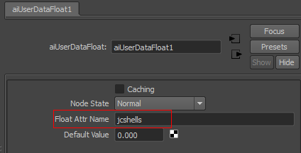 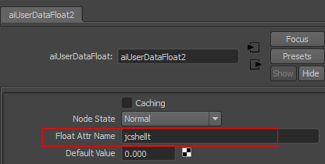

|  |  |  |  |
| --- | --- | --- | --- |
| Attribute Name | Type | Defualt Value | Detail |
| Enable | Bool | True | Enable the shader or not. |
| SampleTexture | Color |  | This attribute should be connected to a painted texture whose color should be with |
| HueTolerance | Float | 10 | The tolerance for the hue distance. |
| MultiplyColor | Color |  | Multiply this color to the input **SampleColor#** |
| MultiplyAlpha | Float |  | Multiply this alpha to the input **SampleAlpha#** |
| DefaultColor | Color |  | This color will be used if the shader cannot find the nearest texture in the range of HueTolearnce. |
| DefaultAlpha | Float |  | This alpha will be used if the shader cannot find the nearest texture in the range of HueTolearnce. |
| SampleEnable# | Bool | True | Enable this texture or not. |
| SampleColor# | Color |  | The hue value of this color will be used to measure the distance. S and V are ignored. |
| TexColor# | Color |  | The output color of the index#.  Usually it should be connected to the outColor of an aiImage node. |
| TexAlpha# | float |  | The ouput alpha of the index#.  Usually it should be connected to the outAlpha of an aiImage node. |