**Problem 1: Computational Graphs and Backpropagation**

**Q1.** Construct the computational graph.

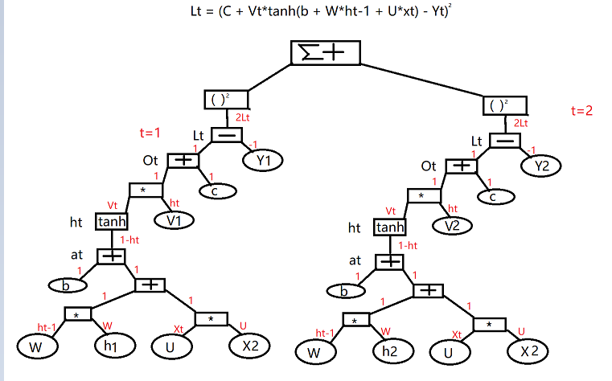

**Q2.** What are the model parameters to be learned?

The parameters of b, W, U, c and V will be learned.

**Q3.**

**See below**

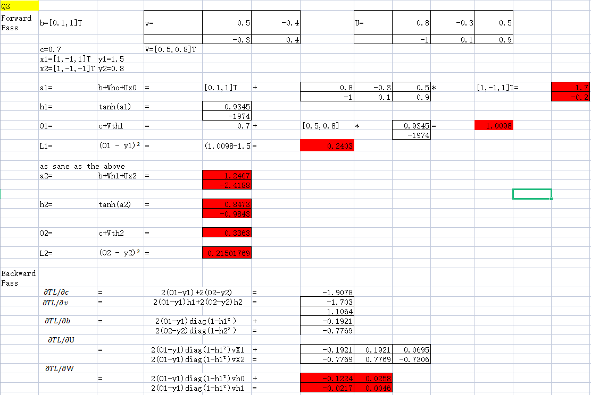

**Problem 2: Na¨ıve Bayes Classififier**

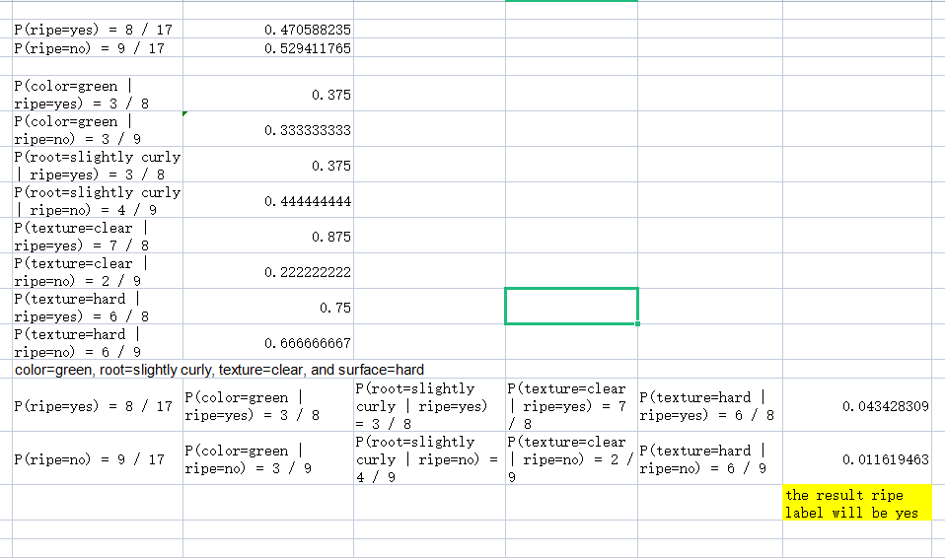

The prediction label will be Yes

**Problem 3: Bayesian Networks**

**Q1.**

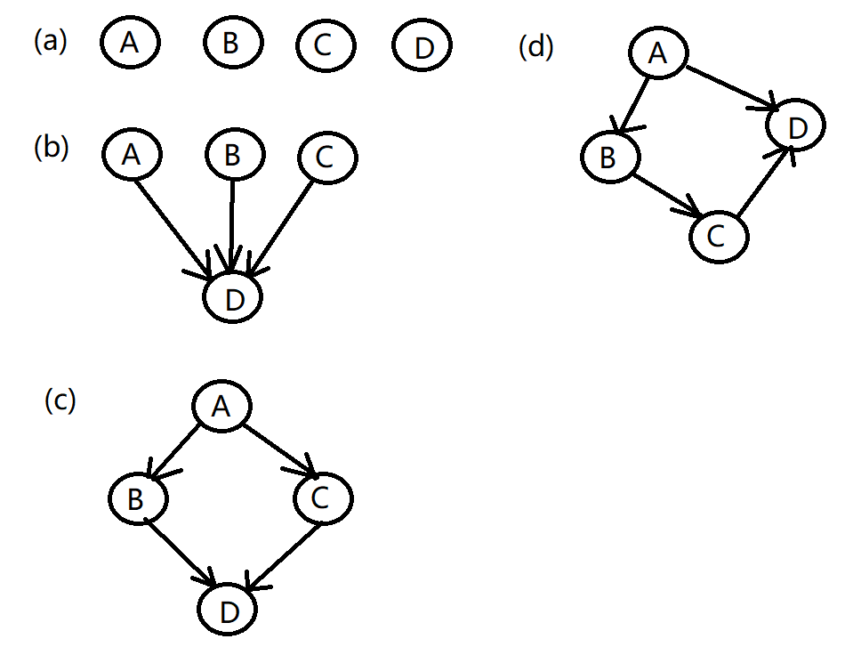

**Q2.**

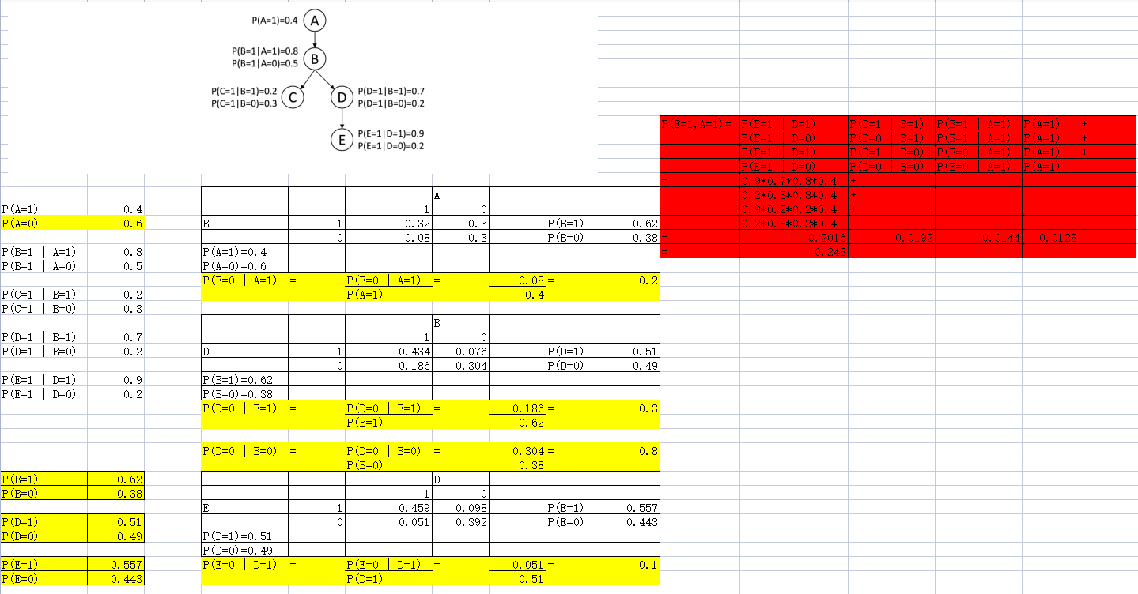

**P(E=1,A=1) = 0.248**

**Problem 4: Reinforcement Learning**

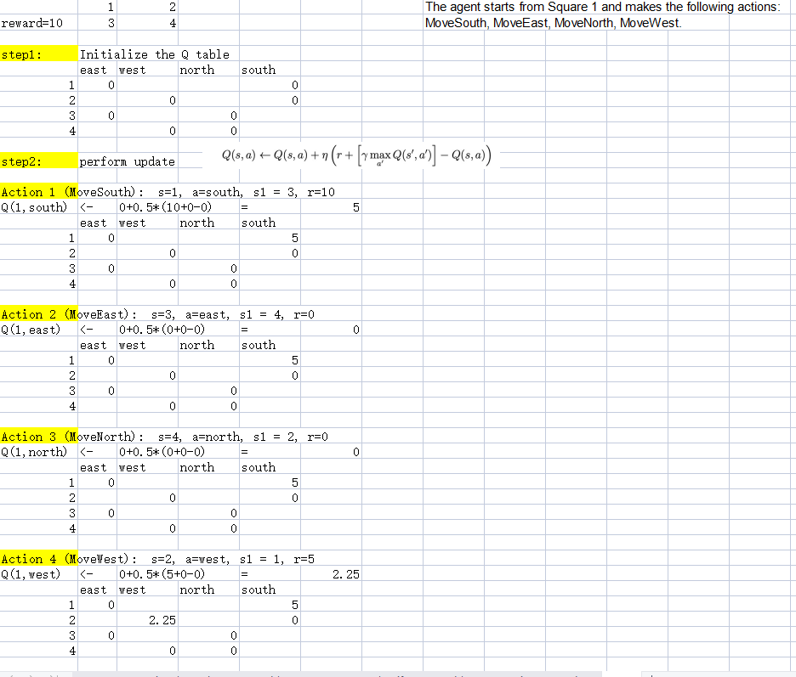

The final state will be

East west north south

1 0 5

2 0 2.25 0

3 0 0

4 0 0