from sklearn import datasets

from sklearn.model_selection import train_test_split

from sklearn.metrics import accuracy_score

from sklearn import preprocessing,svm

from sklearn.decomposition import PCA

# import some data to play with

digits = datasets.load_digits()

X_digits = digits.data

y_digits = digits.target

print(X_digits.shape)

print(y_digits.shape)

# 1 Split the Digits Dataset (load_digits) into training and testing sets with ratio 9:1

Xtrain, Xtest, ytrain, ytest = train_test_split(X_digits, y_digits,test_size=0.1)

# 2 Standardize the data for each dimension

scaler = preprocessing.StandardScaler().fit(Xtrain)

Xtrain_new = scaler.transform(Xtrain)

Xtest_new = scaler.transform(Xtest)

# 3 Reduce the dimension to 32 using PCA

pca = PCA(32)

pca.fit(Xtrain_new)

Xtrain_new = pca.transform(Xtrain_new)

Xtest_new = pca.transform(Xtest_new)

print(Xtrain_new.shape)

# 4 Train a SVM classifier

model = svm.SVC()

model.fit(Xtrain_new, ytrain)

y_pred = model.predict(Xtest_new)

print(accuracy_score(y_pred,ytest))

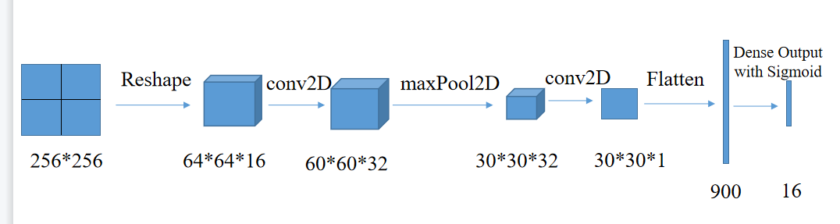

from keras.models import Sequential

from keras.layers import Dense,Conv2D,MaxPool2D,Input,Reshape,Flatten

import keras

import numpy as np

layers = [Input(shape=(256,256,1)),

      Reshape((64,64,-1)),

      Conv2D(filters=32,kernel_size=5),

      MaxPool2D(2),

      Conv2D(filters=1,kernel_size=1),

      Flatten(),

      Dense(16,activation='sigmoid')]

model = Sequential(layers)

model.summary()

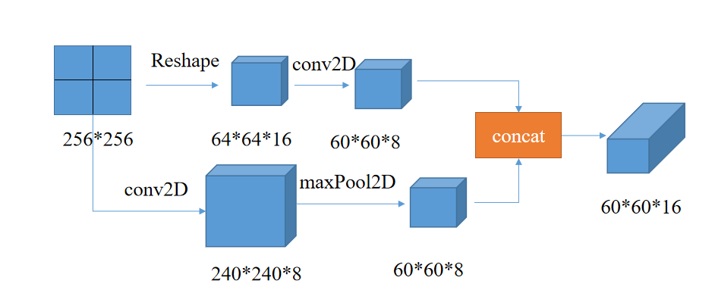

def my_model():

  # define layers

    input_tensor = Input(shape=(256,256,1))

    reshape_layer = Reshape((64,64,-1))

    conv2d_1 = Conv2D(filters=8,kernel_size=5)

    conv2d_2 = Conv2D(filters=8,kernel_size=17)

    max_pool_layer = MaxPool2D(4)

    input_tensor_reshape = reshape_layer(input_tensor)

    conv1_out = conv2d_1(input_tensor_reshape)

    conv2_out = conv2d_2(input_tensor)

    max_pool_out = max_pool_layer(conv2_out)

    cat_out = concatenate([conv1_out,max_pool_out],axis=-1)

    model = Model(inputs=input_tensor, outputs=cat_out)

    return model

my_model = my_model()

my_model.summary()

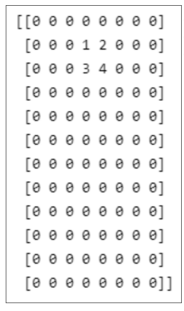import numpy as np

a = [[1, 2], [3, 4]]

print(a)

a_pad = np.pad(a, ((1, 9), (3, 3)), 'constant')

print(a_pad)

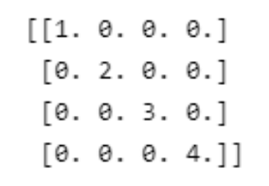

import numpy as np

a=np.zeros([4,4])

for i in range(4):

    a[i,i]=i+1

print(a)

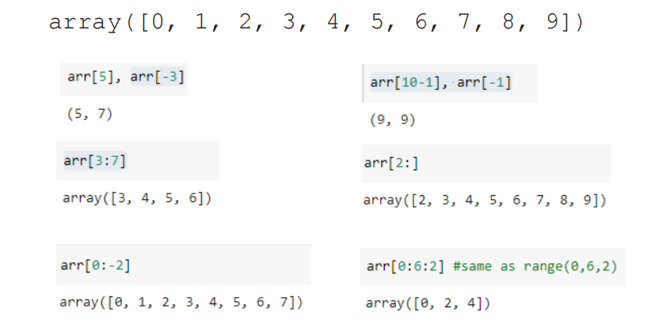

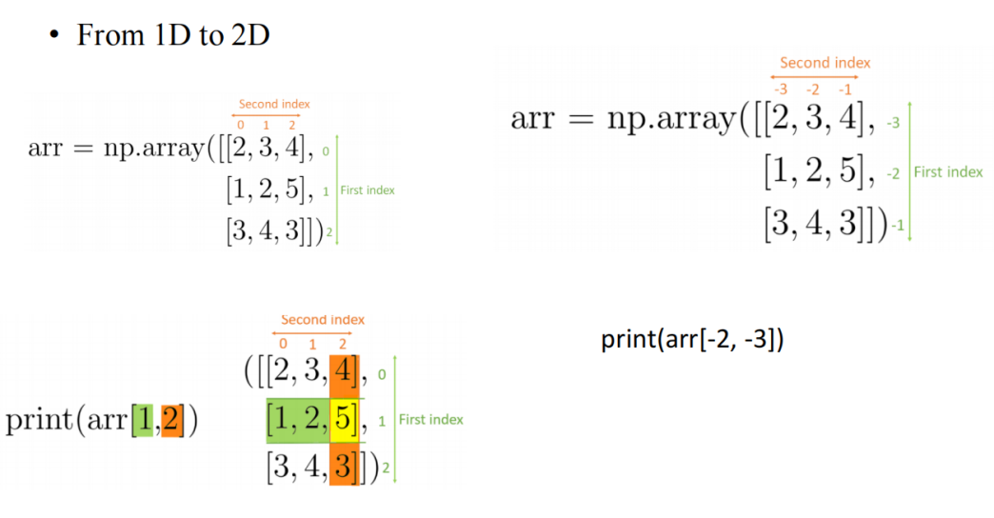

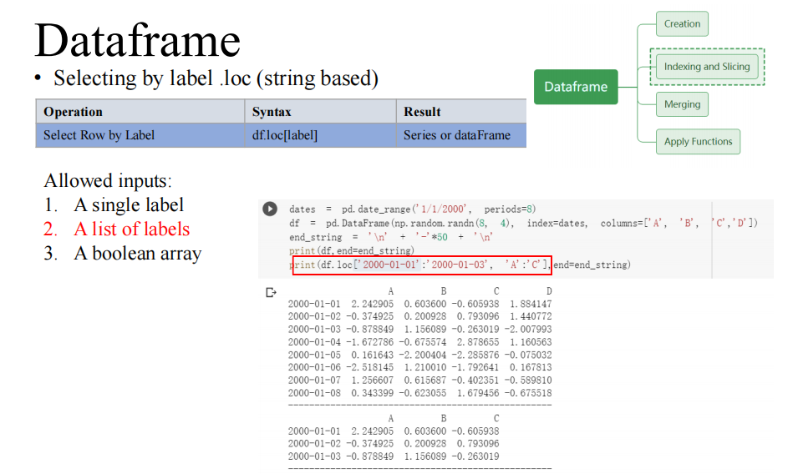

df.loc[行，列]

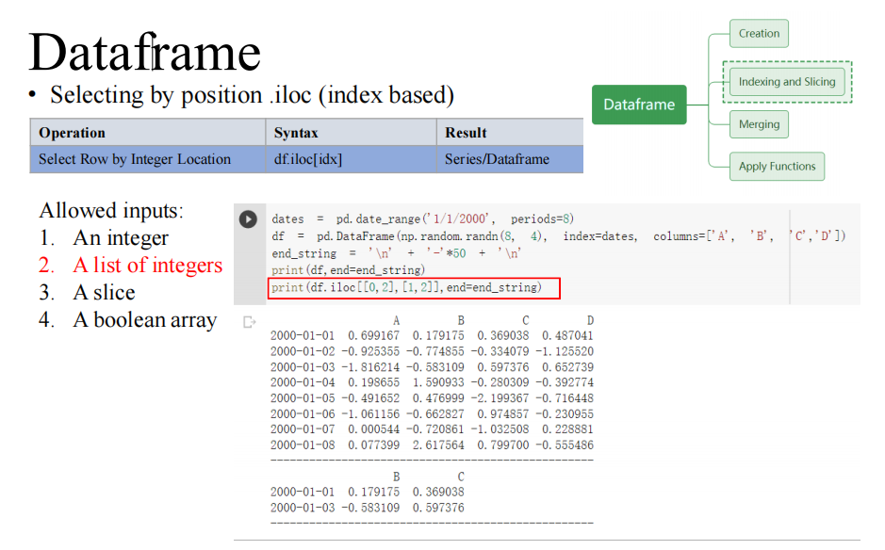

df.iloc[rowIndex, columnIndex]

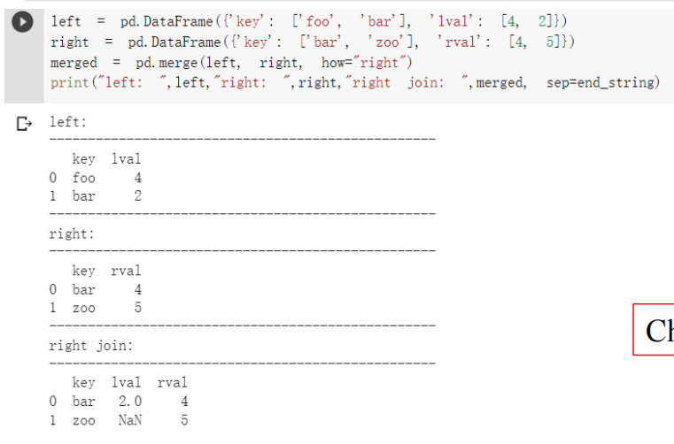

pd.merge(left,right,how=’right’), 自动找可以连起来的键

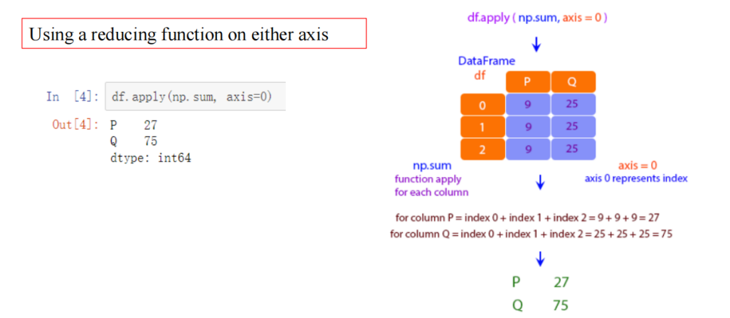

df.apply(function, axis=0列，axis=1行),可以通过loc.apply配合实现我们的逻辑

aRowColumnMax = df.loc[‘a’].apply(thisRowColumnMax)

Data visualization

