判断Convex function

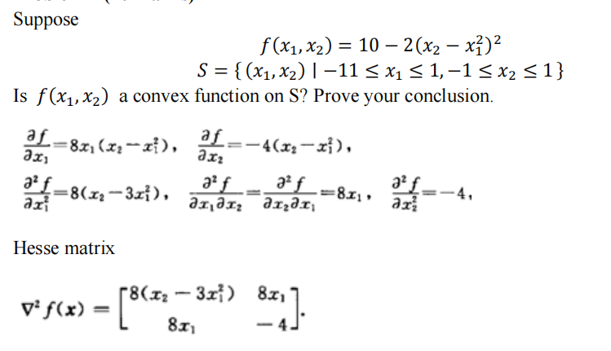

[ A B

C D]

根据定义域/值域判断，And A > 0 & AC - >=0 x1 = 1, x2=1,不符合条件

AX = λX

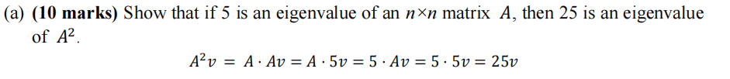





PCA

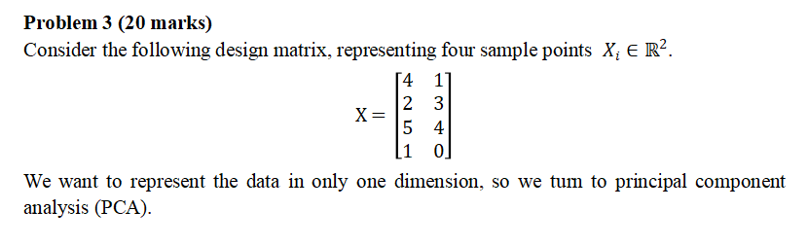

先把X矩阵转置，然后求每一行的中心点，(4+2+5+1) / 4 = 3, (1+3+4+0) / 3 = 2

然后把 X和Xt 相乘得到一个特征方程

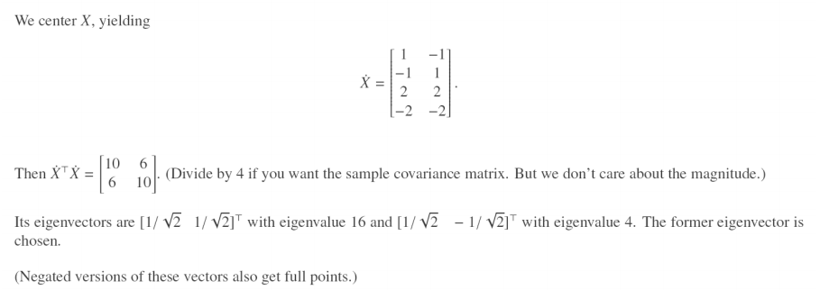

[10-λ, 6

6, 10-λ] (10-λ)² - 36 = 0, λ1 = 4，λ2=16

λ1 = 4

[10, 6 [4, 0 [6, 6 [6,6 [1 , 1

6, 10] - 0 , 4] = 6, 6] r2-r1 = 0, 0] 1/6r1 = 0, 0] => x1=x2

X1 =X2= 1/√2 , X1 = X2 等于根号2分之一

λ1 = 16

[1 ,- 1

0, 0] => X1=-X2

X1 = 1/√2, X2= -1/√2,

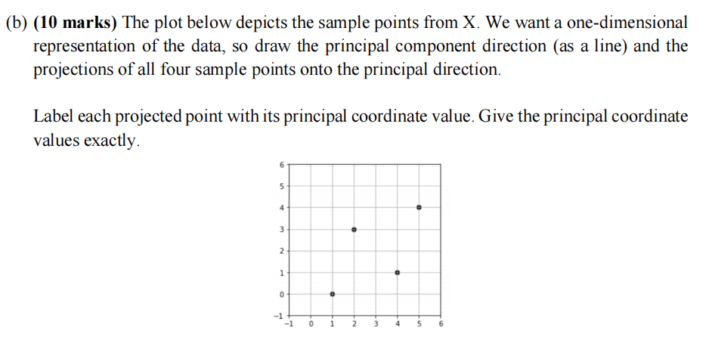

P = [1,0] * [1/√2, 1/√2] T = 1/√2

P = [2,3] * [1/√2, 1/√2] T = 5/√2

把图中的坐标带进特征向量里面去，就可以画出一条直线

Project Matrix

**P**1 and **P**2 are projection matrices, so we have **P**1² = **P**1 and **P**2² = **P**2 .

• (a) Assume that **P**1 has the eigenvalues , then **P**1 **x** = **x.**

• For **P**1² , we have **P**1² **x** = **P**1**P**1 **x = P**1**ax = aP**1 **x = a*ax = a**² **x**

• Since **P**1² = **P**1 , we have a²=a(a-1)=0 => a=0 or a=1

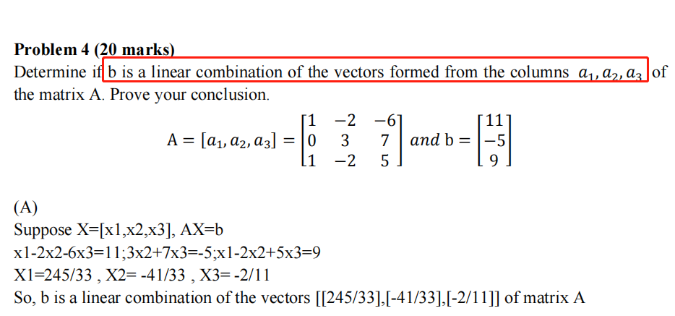

可用高斯消融，或者解方程的形式算出来，算的出来就是线性组合，Ax=b

可以用初等行变换算出来Rank，如果是rank=3，就一定能表示为线性组合,Ax=b

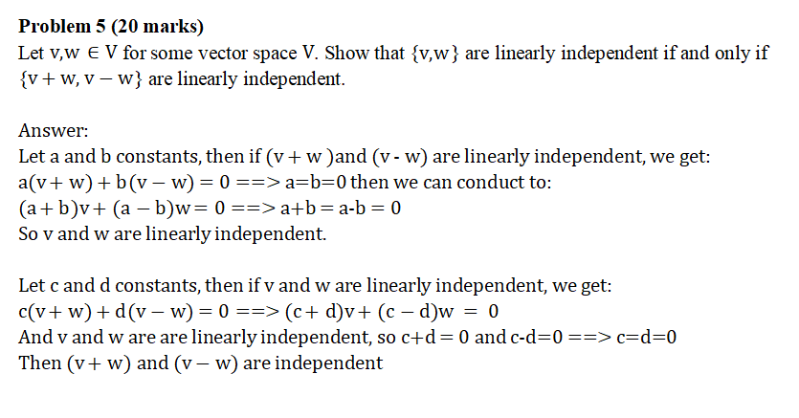

假设V+W, V-W 线性独立，就可以证明 V 和 W线性独立

假设V, W线性独立，就可以证明 V+W 和 V-W线性独立。

Suppose 0 is a 5 by 10 matrix with average grades for 5 courses over 10 years.

1. .How to create the centered matrix *A* and the sample covariance matrix S  
   每一行元素减去改行的平均值，subtract the average in every row, then it produces the matrix centered A The sample covariance matrix is S = 1/9 AAT

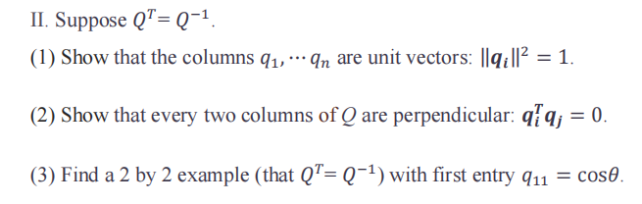

Let Q = identity matrix [10;01] then prove the question

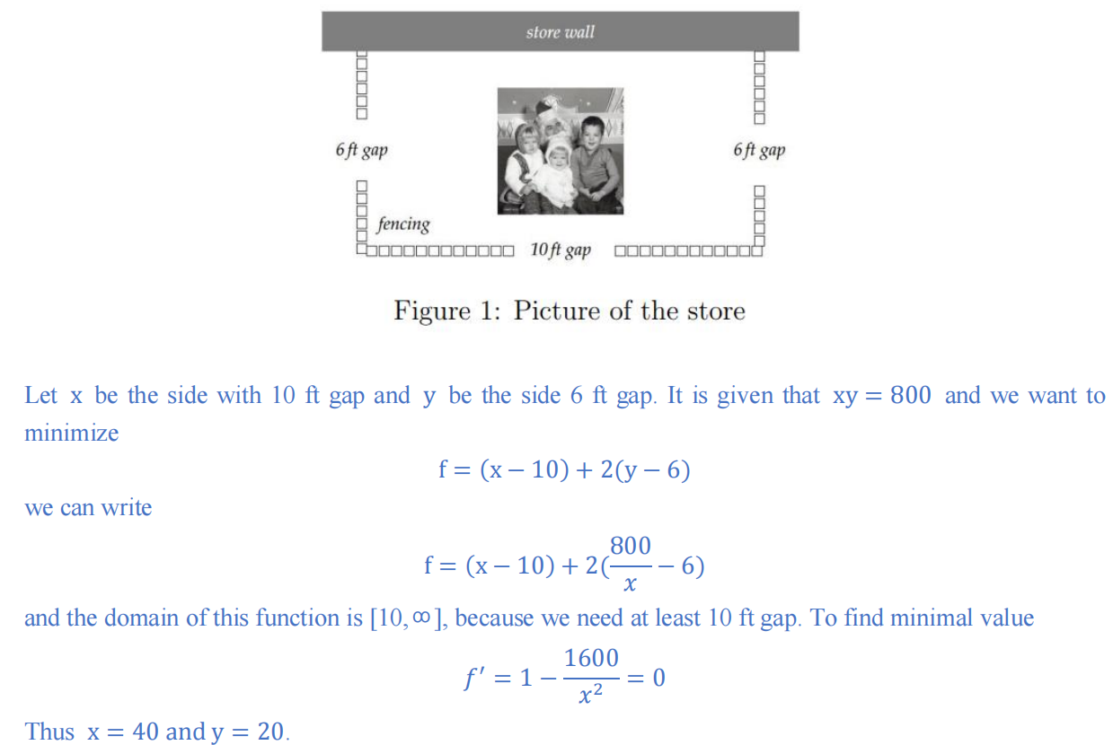

离散型变量，概率密度函数

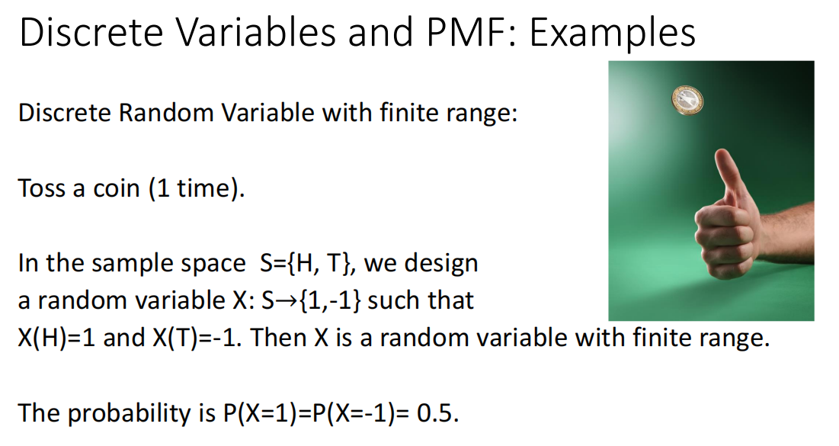

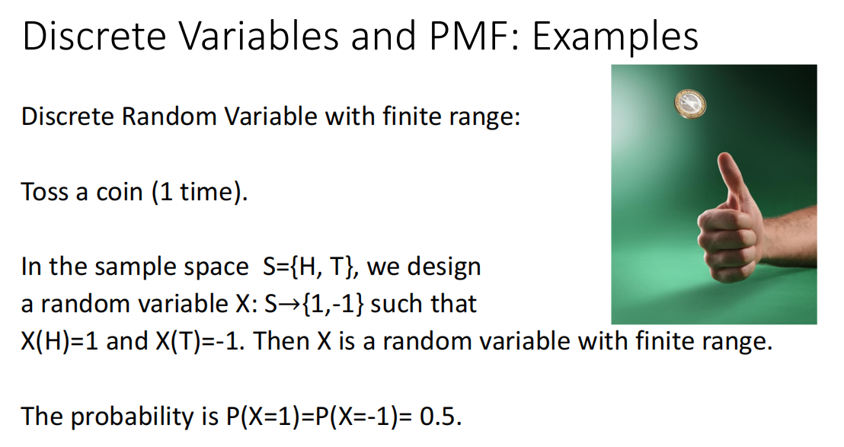

Bayes’ Rule

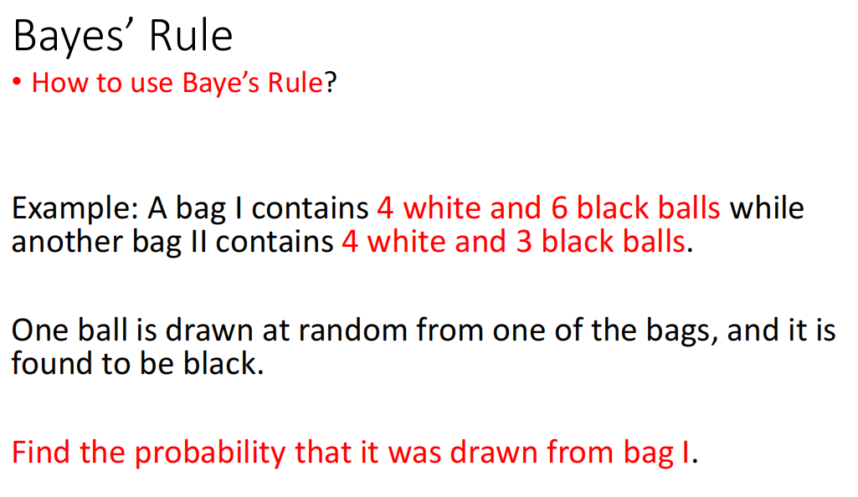

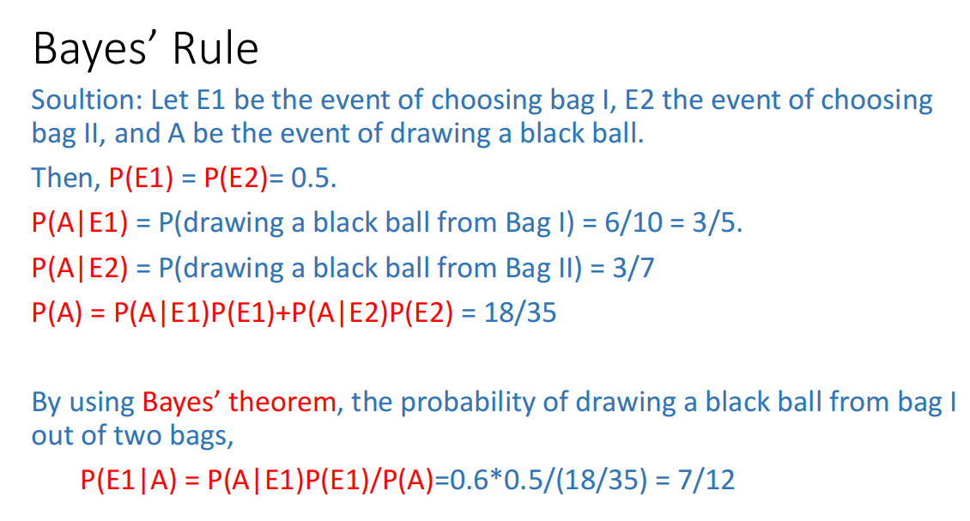

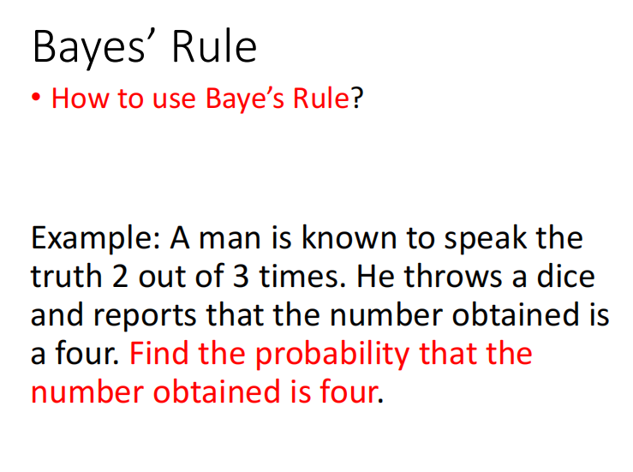

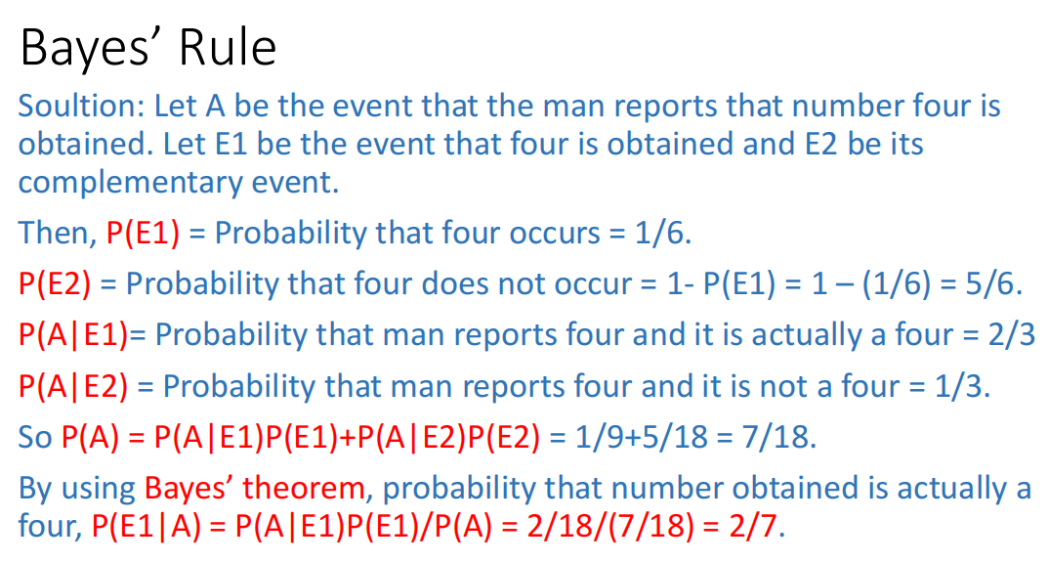

方差，协方差

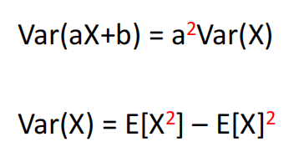

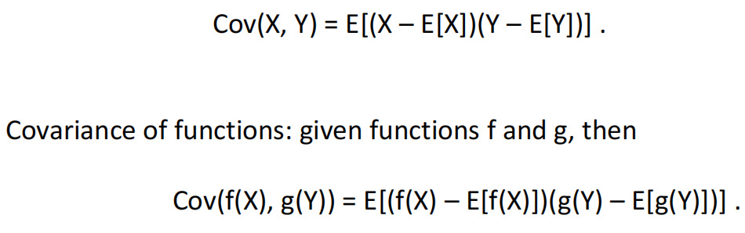

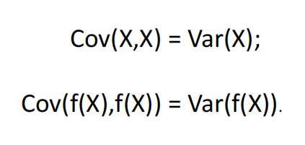

Gaussian Distribution (Normal Distribution)

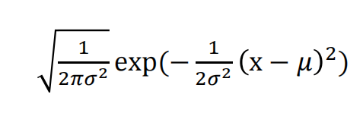

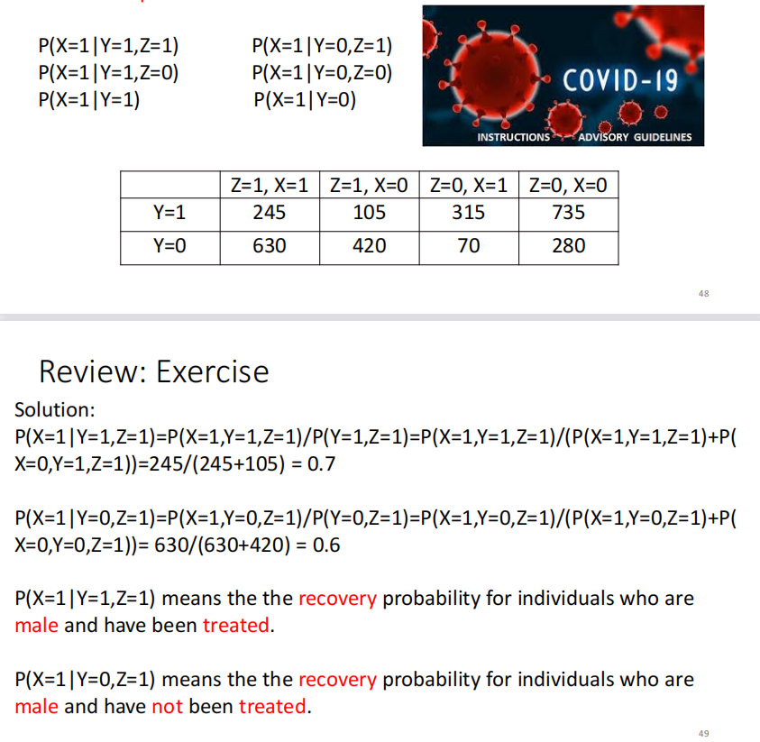

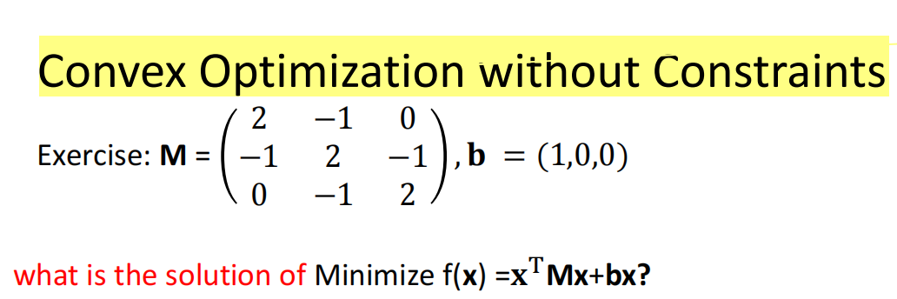

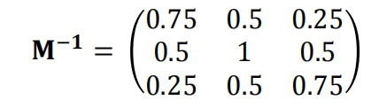

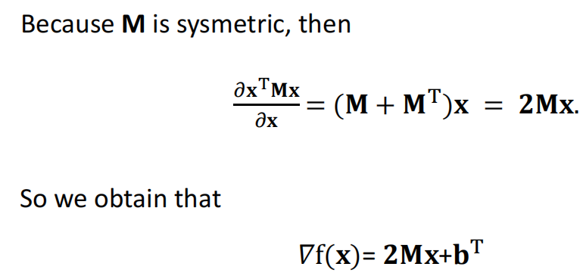

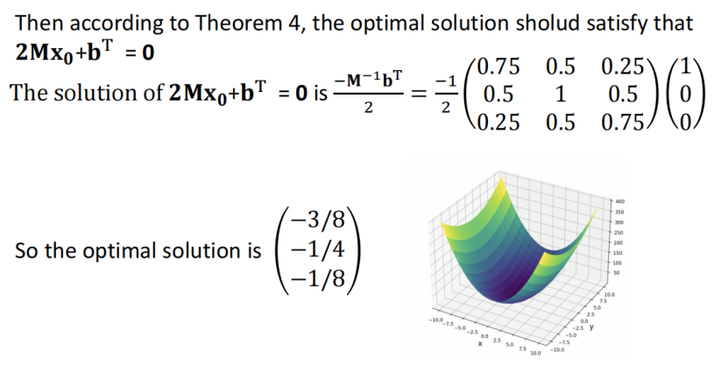

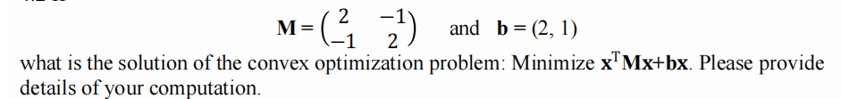

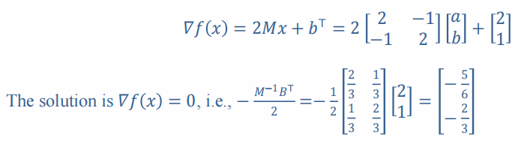

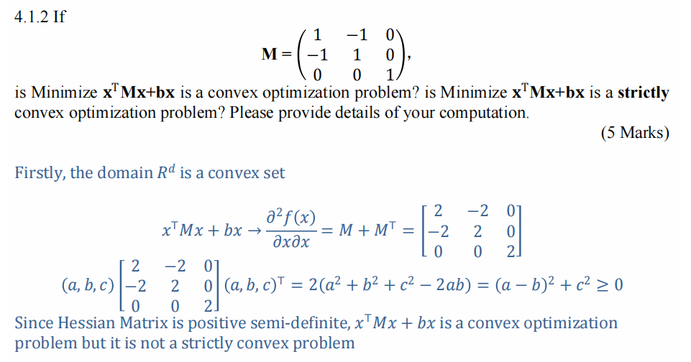

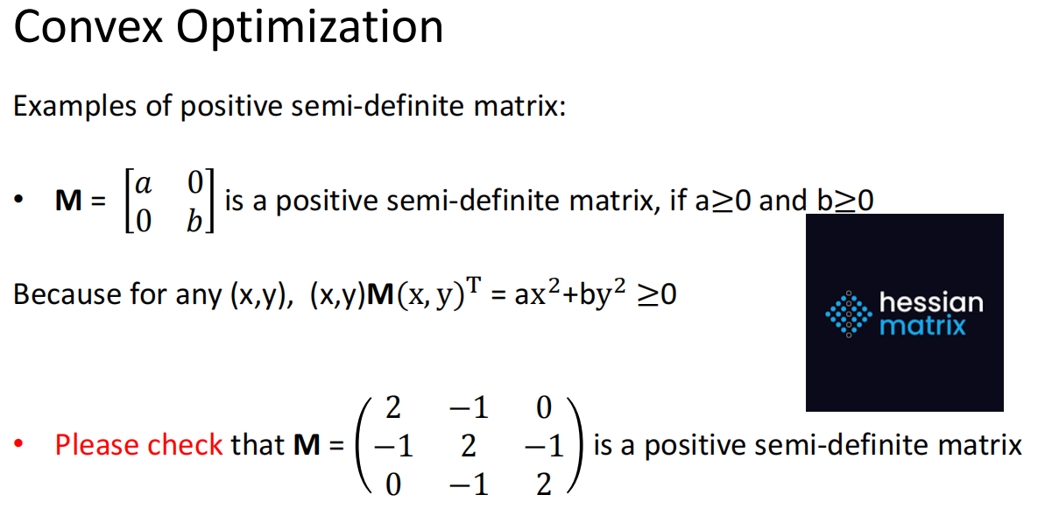

如果(x,y)M(x,y)t >= 0 就是半正定的矩阵，推出是凸函数，如果是>0就是严格的凸函数

给了b的值Convex Optimization without Constraints就是没有限制。要求M的逆矩阵

