Pheonix stack-two write-up

### **Intro**

This level is pretty much the same as the previous one. The goal is to bypass the “if” check . The only difference between this level and the previous one is that in this level we are expected to use an environment variable to store our input instead inserting it directly as an argument.

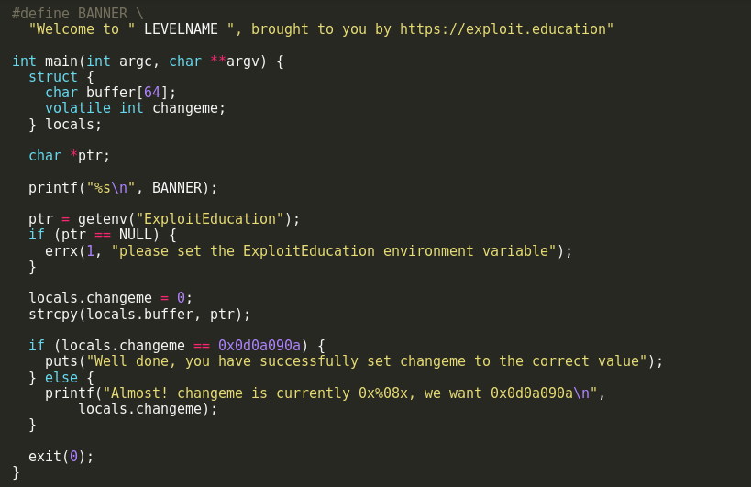

Solution

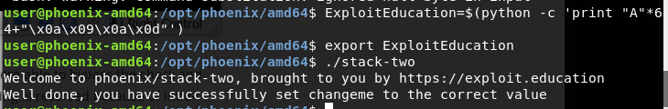

we used the same approach as described in the previous write-up **note here the little endian architecture** I hope you enjoyed my write-up any comment or suggest is appreciated you can contact me via my e-mail address: omaroobaniessa@gmail.com