Apex P Snapshot Gallery
Source: tests/ragger/snapshots/apex_p
Images are grouped by top-level folder name and ordered lexicographically.
test_approve_erc20
6 image(s)
test_approve_erc20
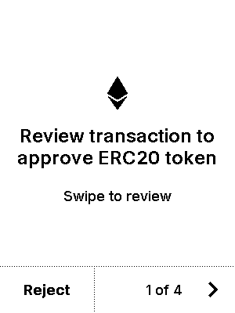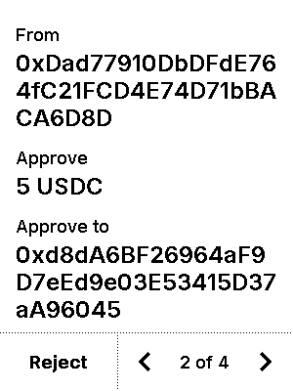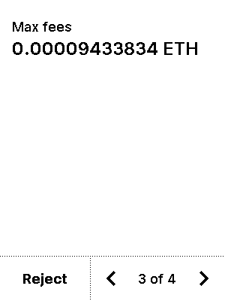
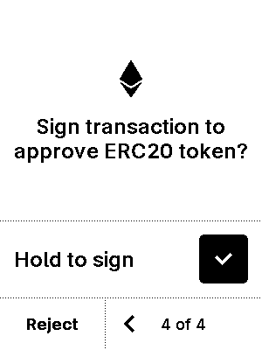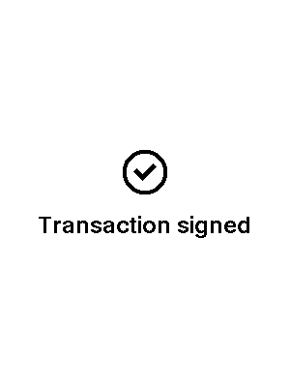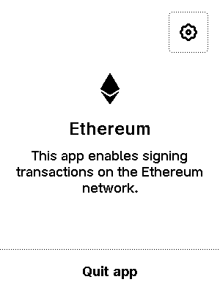

test_approve_erc20_extra_data
6 image(s)
test_approve_erc20_extra_data
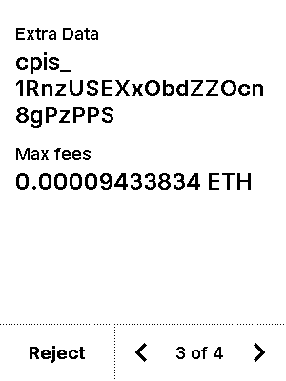


test_approve_erc20_extra_data_nonascii
6 image(s)
test_approve_erc20_extra_data_nonascii
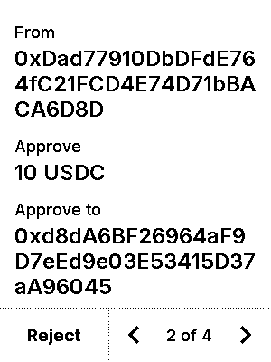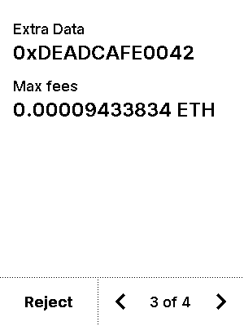


test_blind_sign
7 image(s)
test_blind_sign
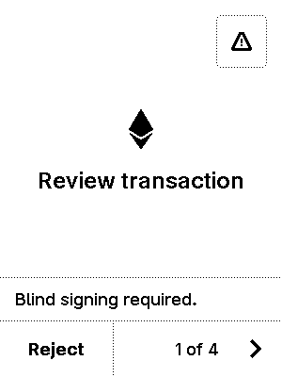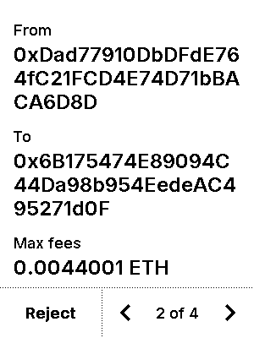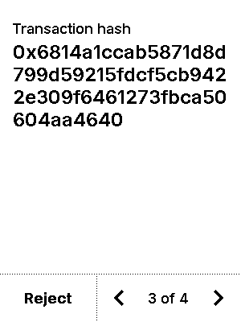
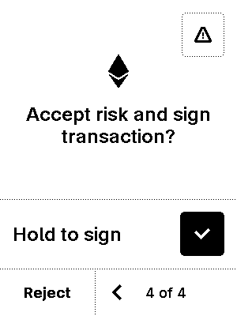
warning
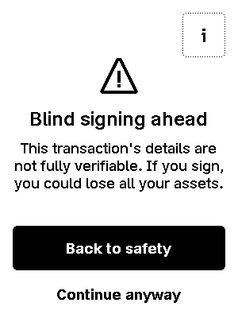

test_blind_sign_nonce_nonzero
7 image(s)
test_blind_sign_nonce_nonzero
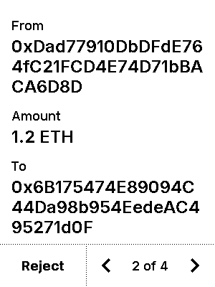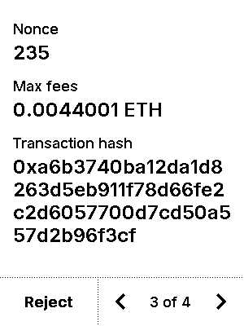

warning


test_blind_sign_nonzero
7 image(s)
test_blind_sign_nonzero
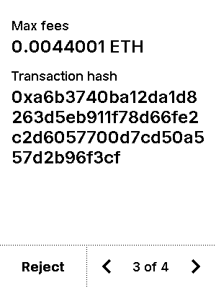

warning


test_blind_sign_not_enabled_error
2 image(s)
test_blind_sign_not_enabled_error
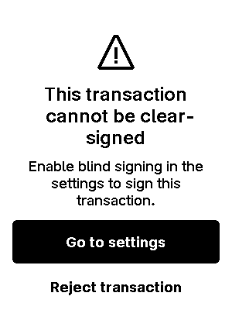

test_blind_sign_rejected
8 image(s)
test_blind_sign_rejected

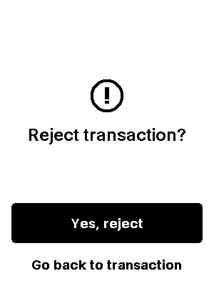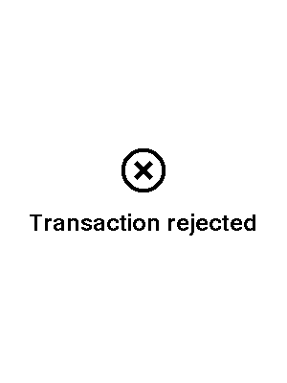

warning


test_clone_thundercore
6 image(s)
test_clone_thundercore
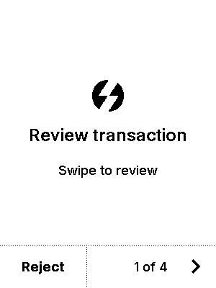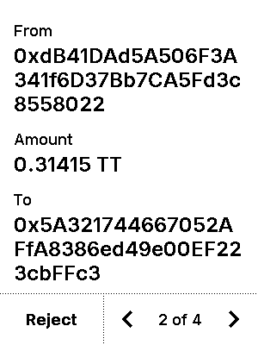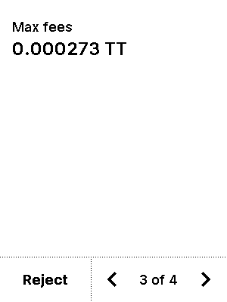
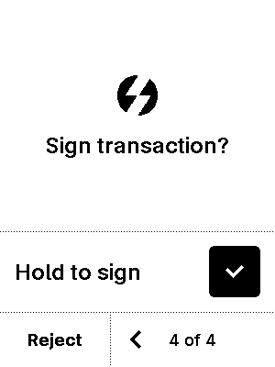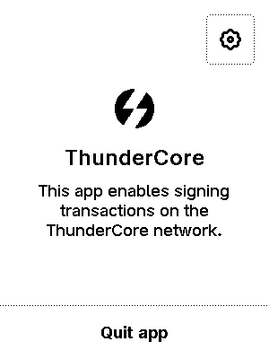

test_eip7002_exit
6 image(s)
test_eip7002_exit
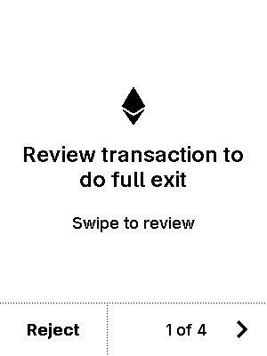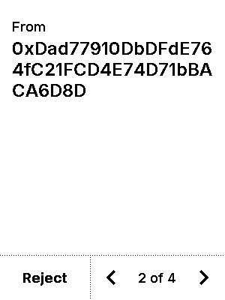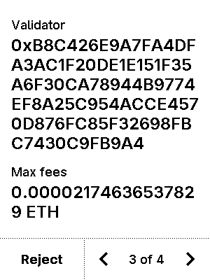
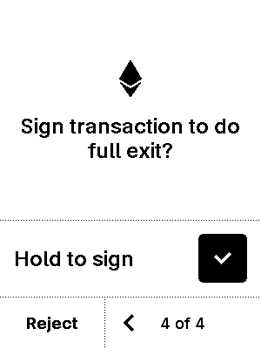

test_eip7002_partial_withdrawal
7 image(s)
test_eip7002_partial_withdrawal
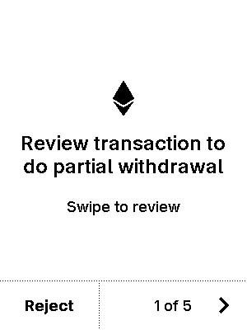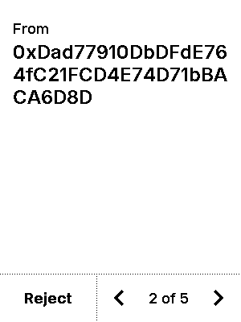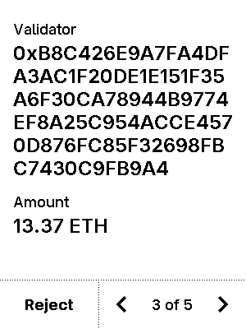
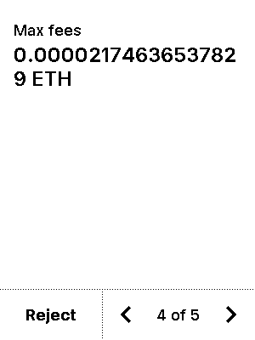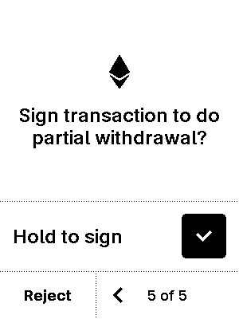


test_eip712_advanced_filtering
6 image(s)
test_eip712_advanced_filtering
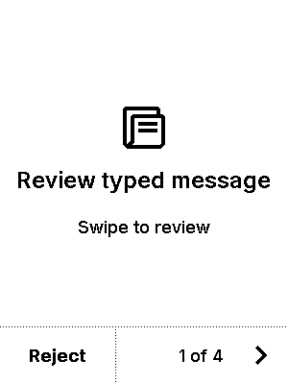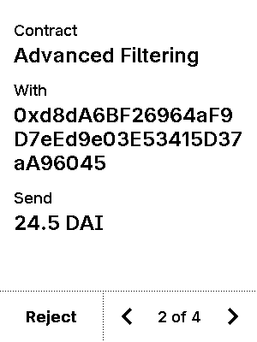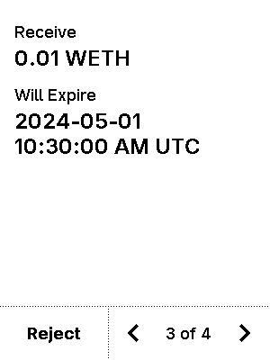
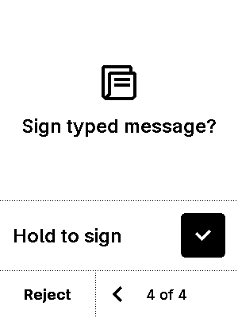

test_eip712_advanced_filtering-verbose
7 image(s)
test_eip712_advanced_filtering-verbose
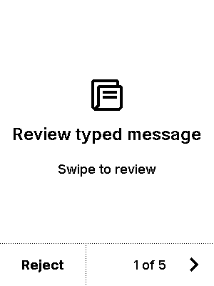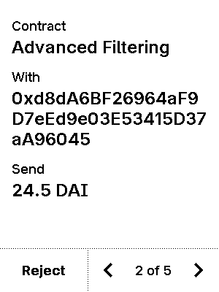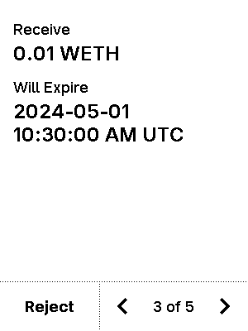
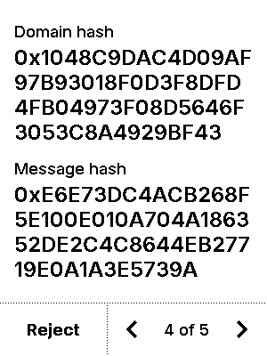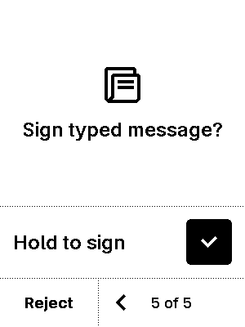


test_eip712_advanced_filtering_permit
5 image(s)
test_eip712_advanced_filtering_permit
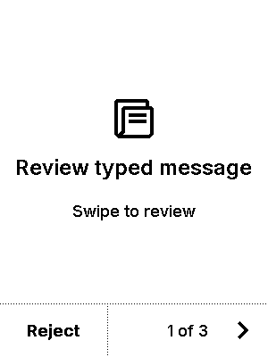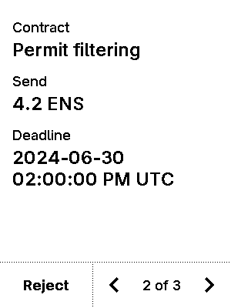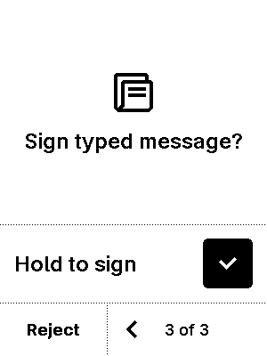


test_eip712_advanced_filtering_unlimited
5 image(s)
test_eip712_advanced_filtering_unlimited
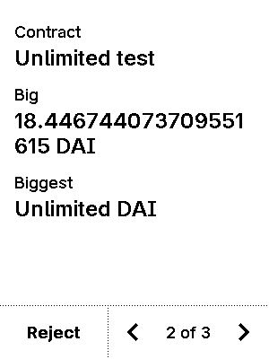


test_eip712_advanced_missing_token-False-True
5 image(s)
test_eip712_advanced_missing_token-False-True
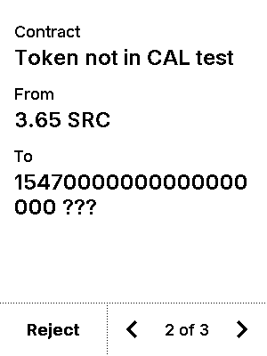


test_eip712_advanced_missing_token-True-False
5 image(s)
test_eip712_advanced_missing_token-True-False
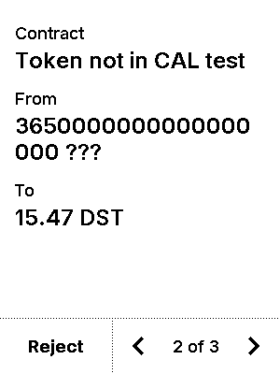


test_eip712_advanced_trusted_name_account_with_account
5 image(s)
test_eip712_advanced_trusted_name_account_with_account
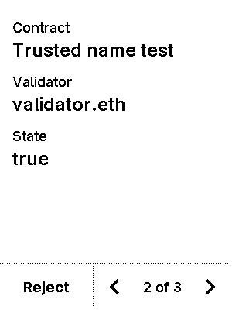


test_eip712_advanced_trusted_name_account_with_account_contract
5 image(s)
test_eip712_advanced_trusted_name_account_with_account_contract



test_eip712_advanced_trusted_name_account_with_contract
5 image(s)
test_eip712_advanced_trusted_name_account_with_contract
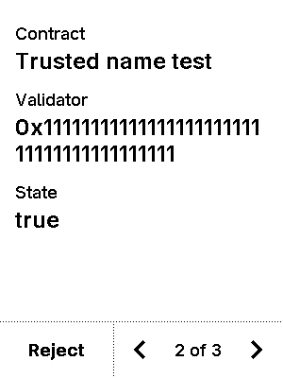


test_eip712_advanced_trusted_name_account_with_contract_account
5 image(s)
test_eip712_advanced_trusted_name_account_with_contract_account



test_eip712_advanced_trusted_name_contract_with_account
5 image(s)
test_eip712_advanced_trusted_name_contract_with_account



test_eip712_advanced_trusted_name_contract_with_account_contract
5 image(s)
test_eip712_advanced_trusted_name_contract_with_account_contract
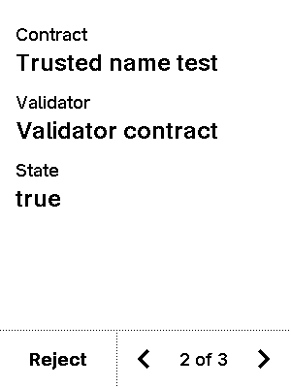


test_eip712_advanced_trusted_name_contract_with_contract
5 image(s)
test_eip712_advanced_trusted_name_contract_with_contract



test_eip712_advanced_trusted_name_contract_with_contract_account
5 image(s)
test_eip712_advanced_trusted_name_contract_with_contract_account



test_eip712_batch
11 image(s)
test_eip712_batch
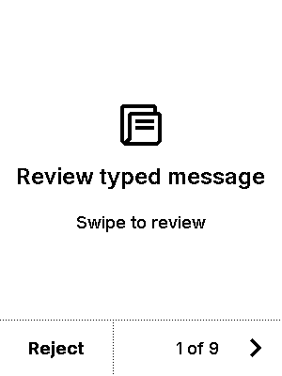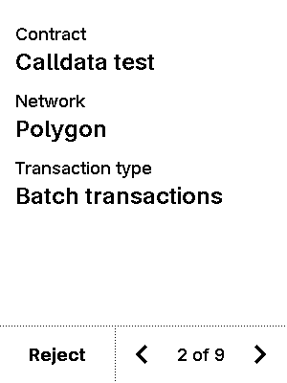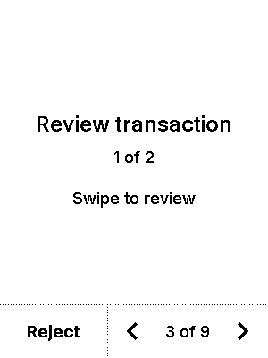
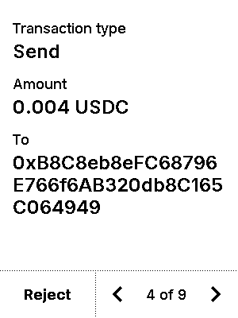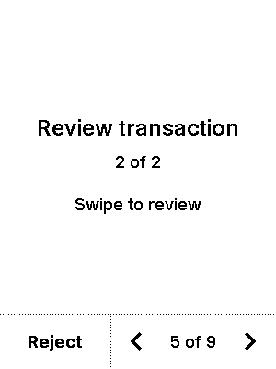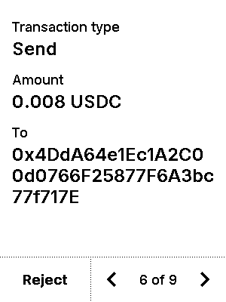
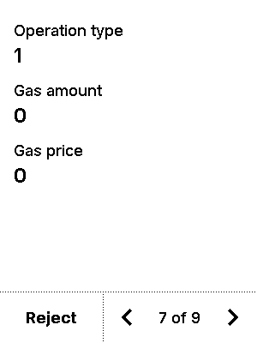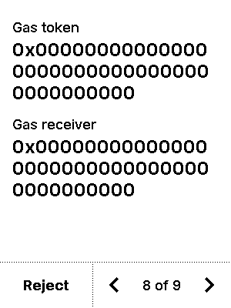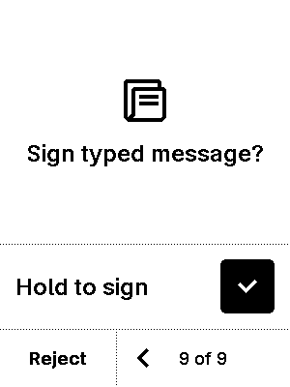


test_eip712_calldata
5 image(s)
test_eip712_calldata
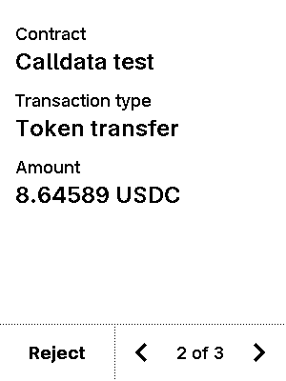


test_eip712_calldata_empty_send
5 image(s)
test_eip712_calldata_empty_send
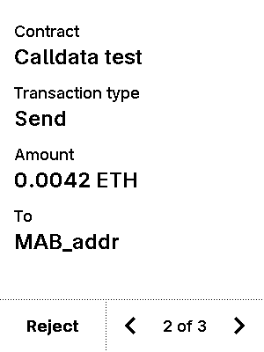


test_eip712_calldata_no_param
5 image(s)
test_eip712_calldata_no_param
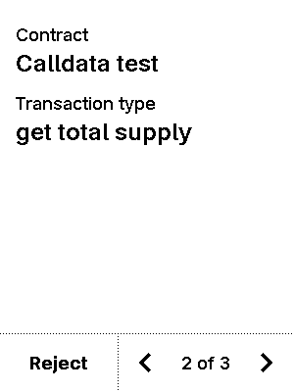


test_eip712_filtering_empty_array
5 image(s)
test_eip712_filtering_empty_array
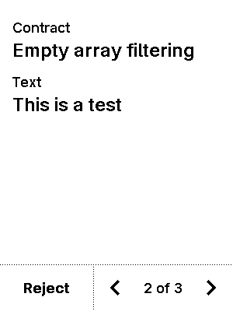


test_eip712_new-00-simple_mail-data-False-False
11 image(s)
test_eip712_new-00-simple_mail-data-False-False
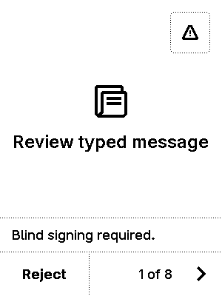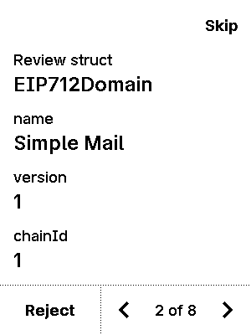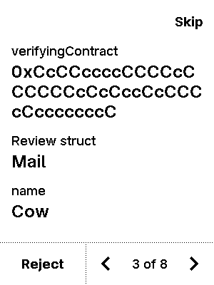
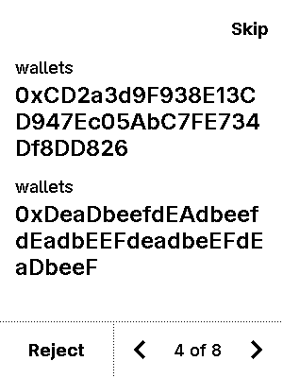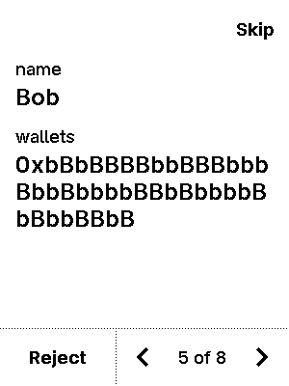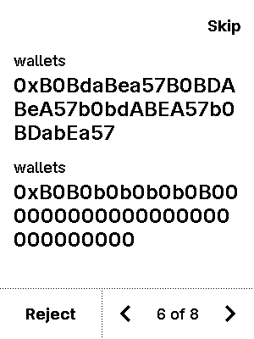
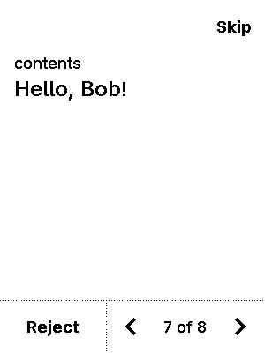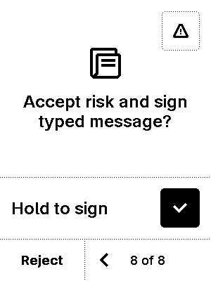

warning


test_eip712_new-00-simple_mail-data-False-True
5 image(s)
test_eip712_new-00-simple_mail-data-False-True
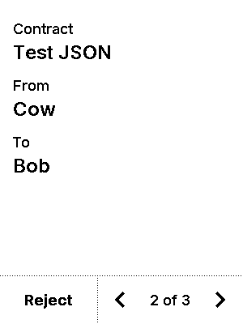


test_eip712_new-00-simple_mail-data-True-False
11 image(s)
test_eip712_new-00-simple_mail-data-True-False




warning


test_eip712_new-00-simple_mail-data-True-True
11 image(s)
test_eip712_new-00-simple_mail-data-True-True




warning


test_eip712_new-01-addresses_array_mail-data-False-False
9 image(s)
test_eip712_new-01-addresses_array_mail-data-False-False
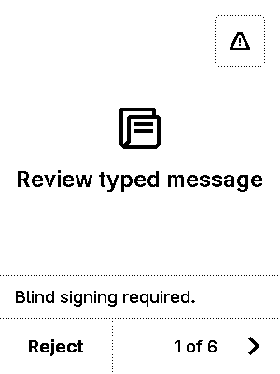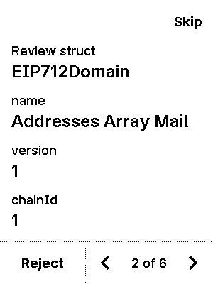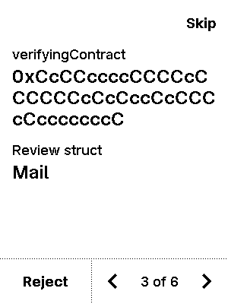
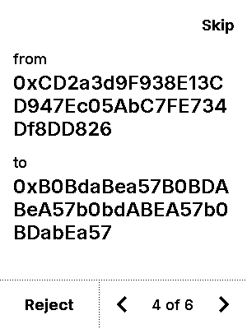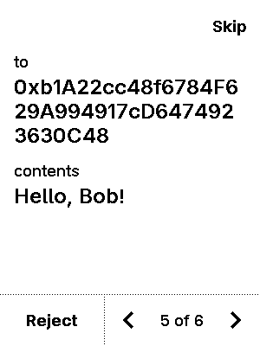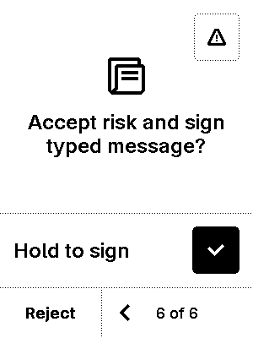

warning


test_eip712_new-01-addresses_array_mail-data-True-False
9 image(s)
test_eip712_new-01-addresses_array_mail-data-True-False



warning


test_eip712_new-02-recipients_array_mail-data-False-False
11 image(s)
test_eip712_new-02-recipients_array_mail-data-False-False
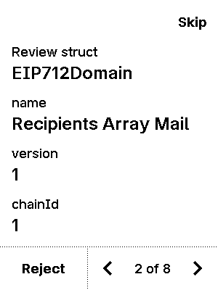
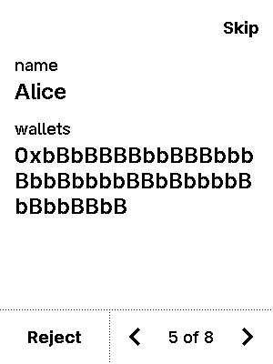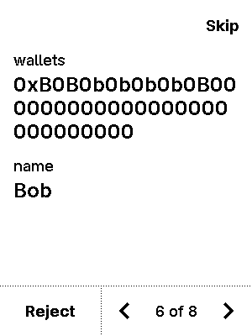
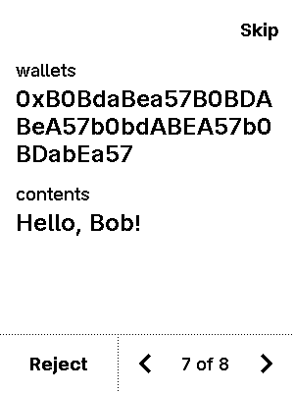

warning


test_eip712_new-02-recipients_array_mail-data-True-False
11 image(s)
test_eip712_new-02-recipients_array_mail-data-True-False




warning


test_eip712_new-03-long_string-data-False-False
11 image(s)
test_eip712_new-03-long_string-data-False-False
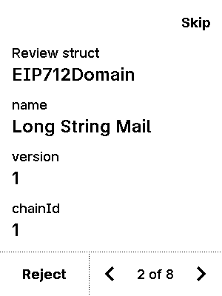

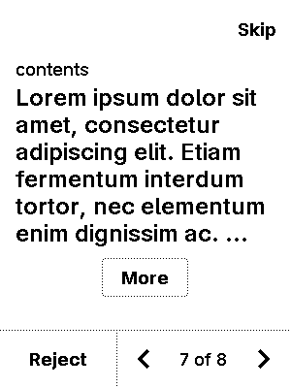

warning


test_eip712_new-03-long_string-data-True-False
11 image(s)
test_eip712_new-03-long_string-data-True-False




warning


test_eip712_new-04-long_bytes-data-False-False
11 image(s)
test_eip712_new-04-long_bytes-data-False-False
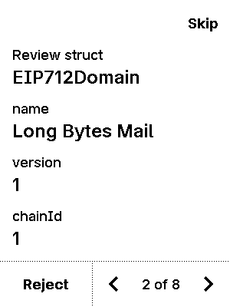

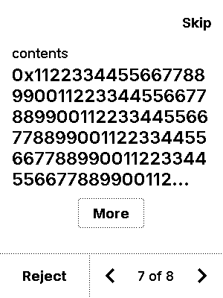

warning


test_eip712_new-04-long_bytes-data-True-False
11 image(s)
test_eip712_new-04-long_bytes-data-True-False




warning


test_eip712_new-05-signed_ints-data-False-False
10 image(s)
test_eip712_new-05-signed_ints-data-False-False
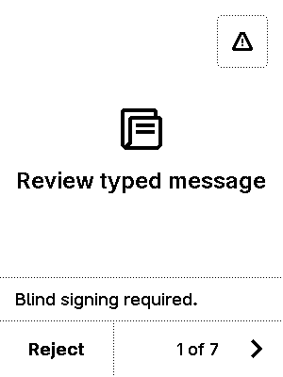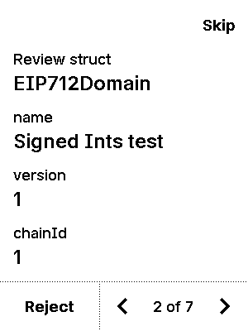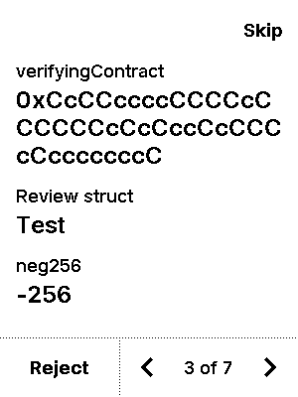
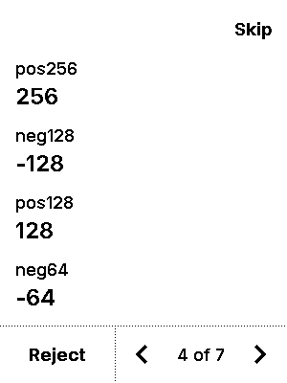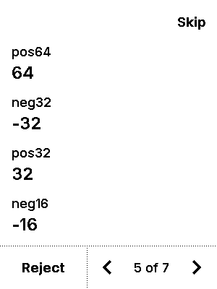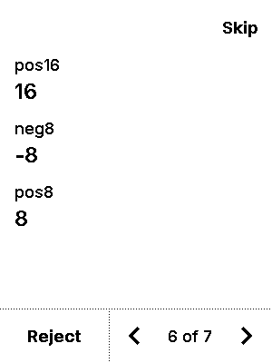
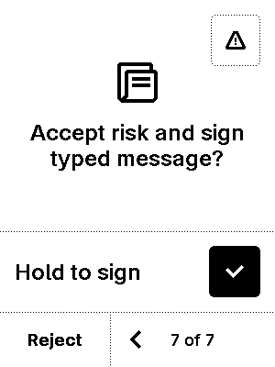
warning


test_eip712_new-05-signed_ints-data-True-False
10 image(s)
test_eip712_new-05-signed_ints-data-True-False



warning


test_eip712_new-06-boolean-data-False-False
8 image(s)
test_eip712_new-06-boolean-data-False-False
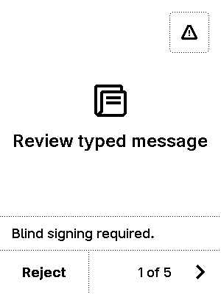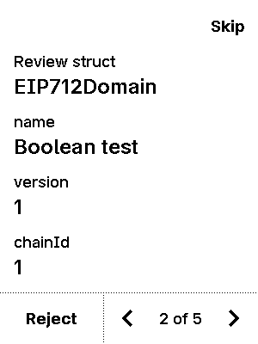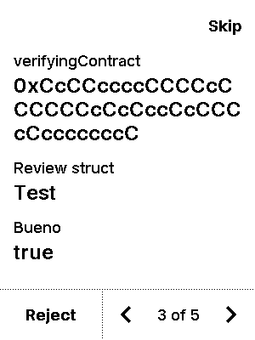
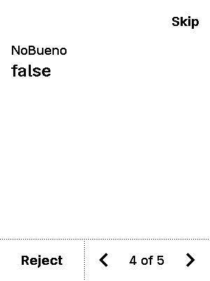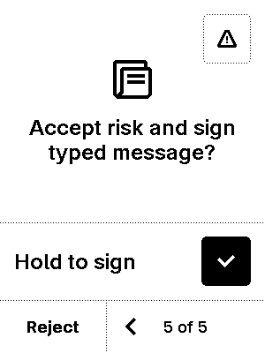

warning


test_eip712_new-06-boolean-data-True-False
8 image(s)
test_eip712_new-06-boolean-data-True-False



warning


test_eip712_new-07-fixed_bytes-data-False-False
9 image(s)
test_eip712_new-07-fixed_bytes-data-False-False
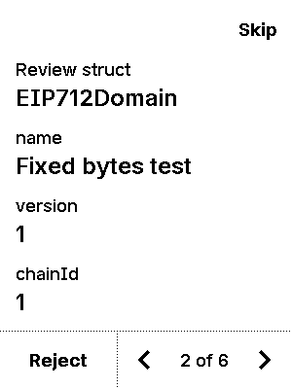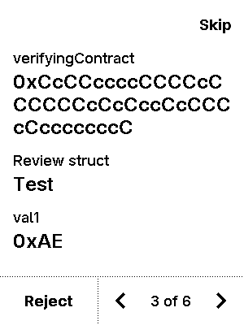
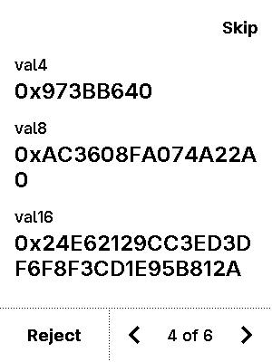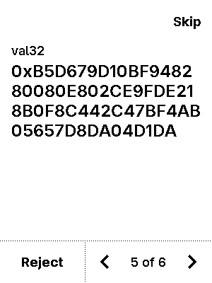

warning


test_eip712_new-07-fixed_bytes-data-True-False
9 image(s)
test_eip712_new-07-fixed_bytes-data-True-False



warning


test_eip712_new-08-opensea-data-False-False
18 image(s)
test_eip712_new-08-opensea-data-False-False
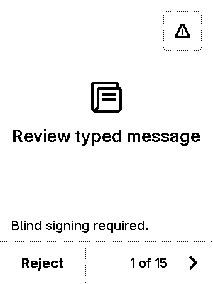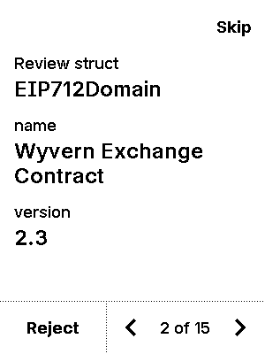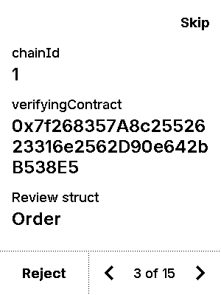
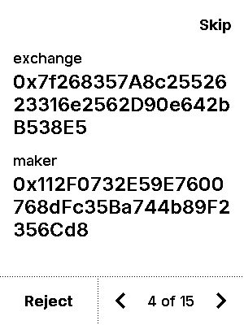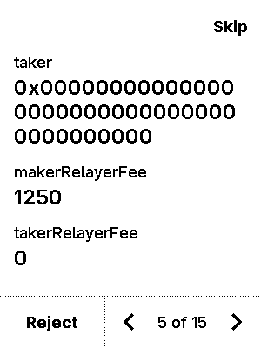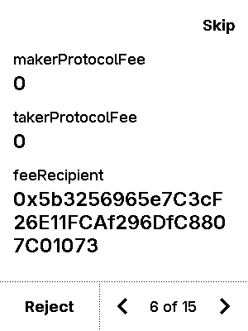
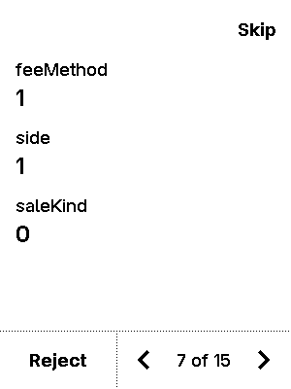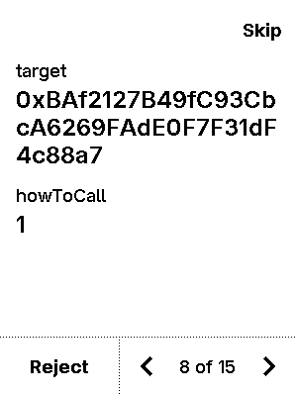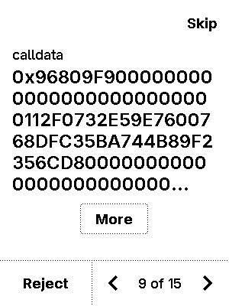
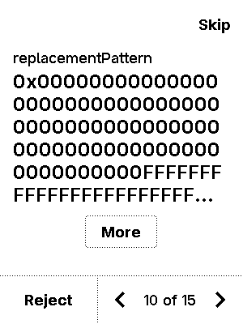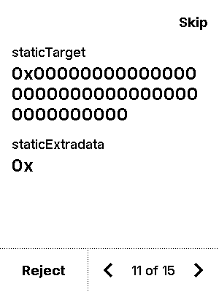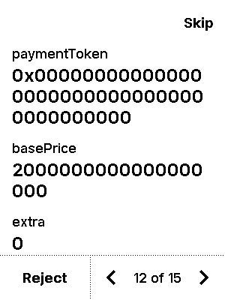
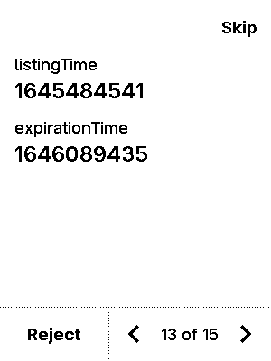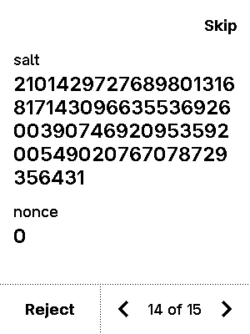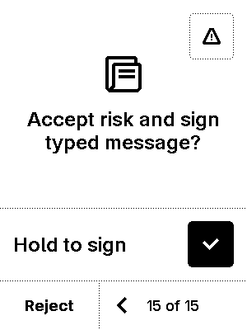

warning


test_eip712_new-08-opensea-data-False-True
6 image(s)
test_eip712_new-08-opensea-data-False-True
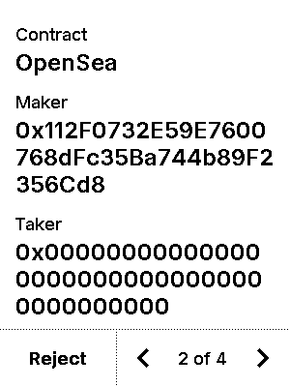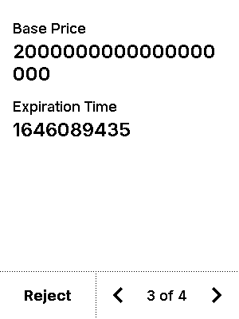


test_eip712_new-08-opensea-data-True-False
18 image(s)
test_eip712_new-08-opensea-data-True-False






warning


test_eip712_new-08-opensea-data-True-True
18 image(s)
test_eip712_new-08-opensea-data-True-True






warning


test_eip712_new-09-rarible-data-False-False
14 image(s)
test_eip712_new-09-rarible-data-False-False
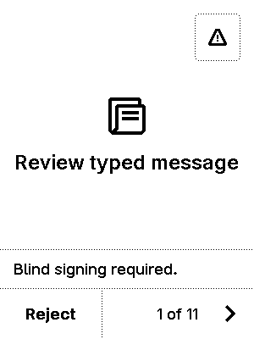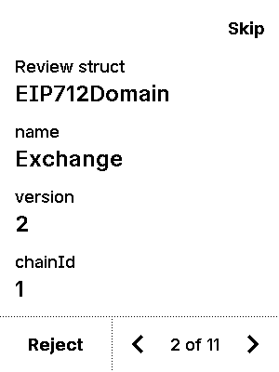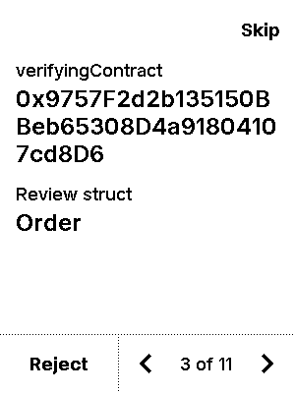
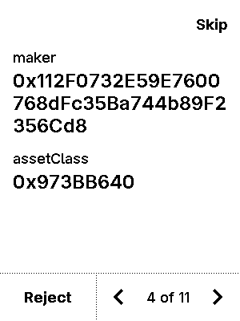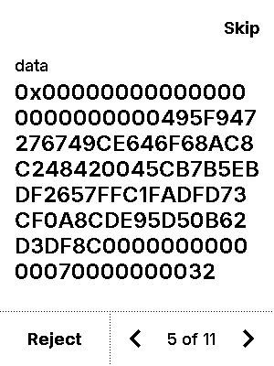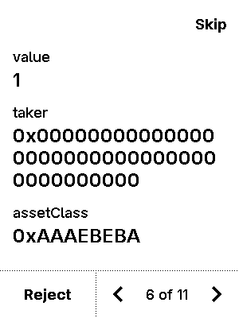
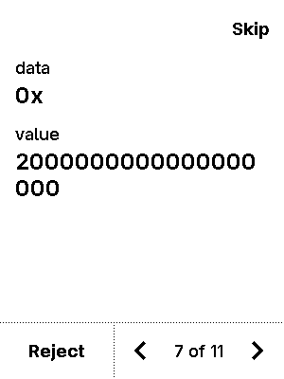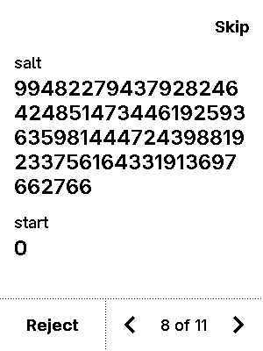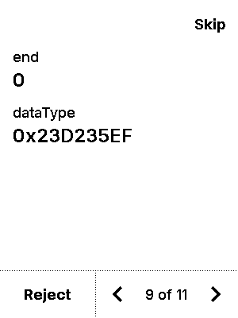
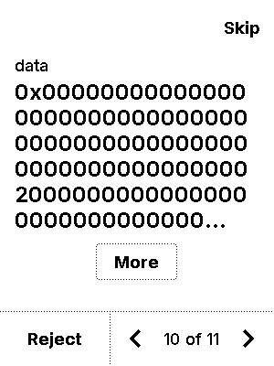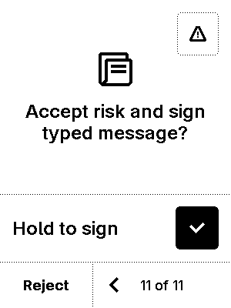

warning


test_eip712_new-09-rarible-data-True-False
14 image(s)
test_eip712_new-09-rarible-data-True-False





warning


test_eip712_new-10-multidimensional_arrays-data-False-False
9 image(s)
test_eip712_new-10-multidimensional_arrays-data-False-False
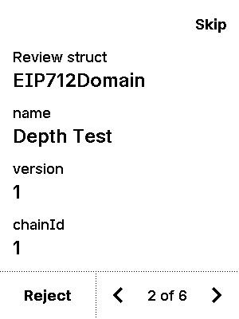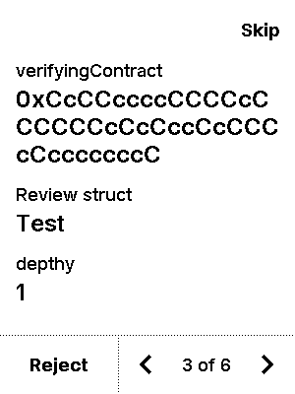
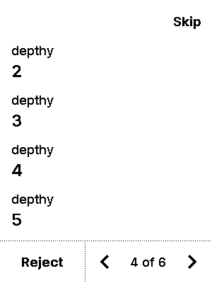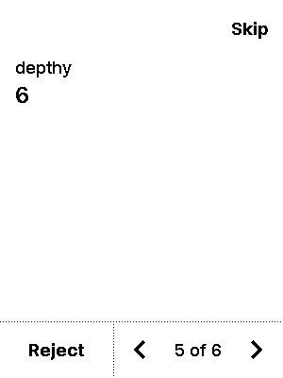

warning


test_eip712_new-10-multidimensional_arrays-data-True-False
9 image(s)
test_eip712_new-10-multidimensional_arrays-data-True-False



warning


test_eip712_new-11-complex_structs-data-False-False
12 image(s)
test_eip712_new-11-complex_structs-data-False-False
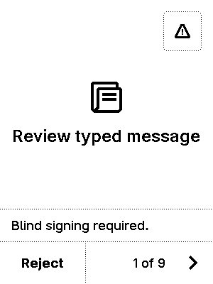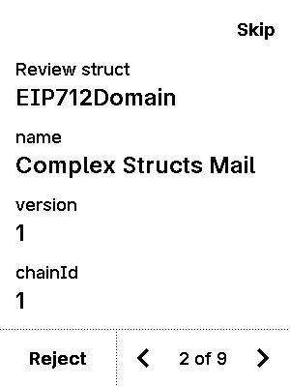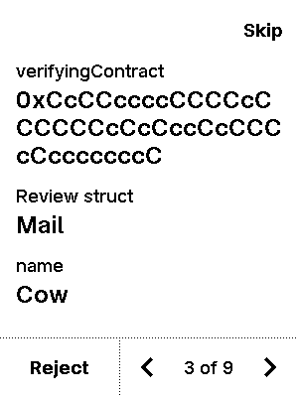
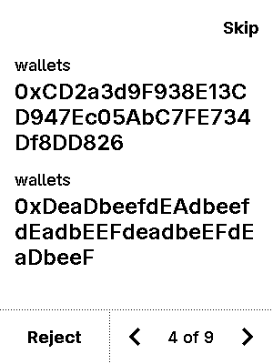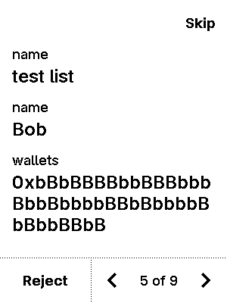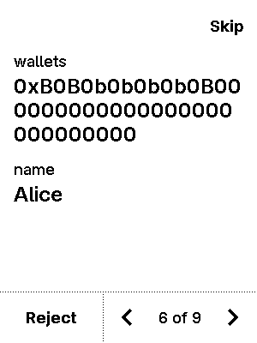
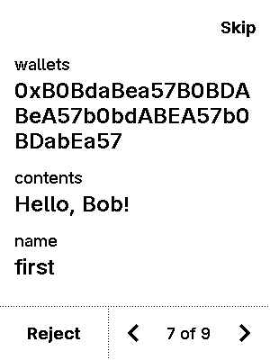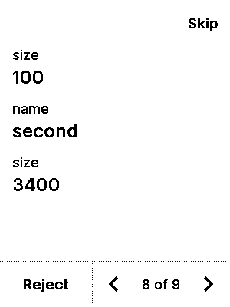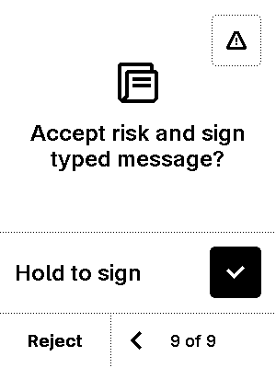

warning


test_eip712_new-11-complex_structs-data-False-True
6 image(s)
test_eip712_new-11-complex_structs-data-False-True
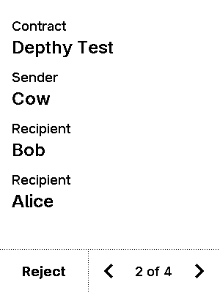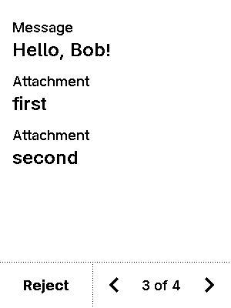


test_eip712_new-11-complex_structs-data-True-False
12 image(s)
test_eip712_new-11-complex_structs-data-True-False




warning


test_eip712_new-11-complex_structs-data-True-True
12 image(s)
test_eip712_new-11-complex_structs-data-True-True




warning


test_eip712_new-12-sign_in-data-False-False
7 image(s)
test_eip712_new-12-sign_in-data-False-False
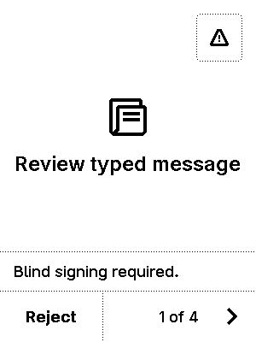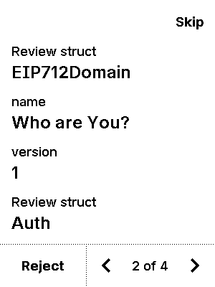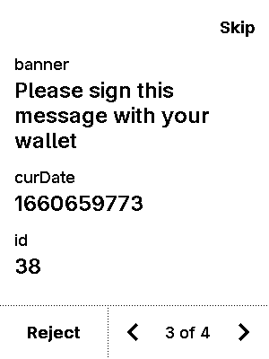
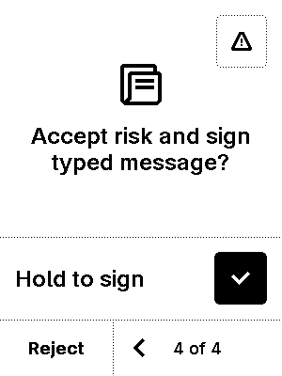
warning


test_eip712_new-12-sign_in-data-False-True
5 image(s)
test_eip712_new-12-sign_in-data-False-True
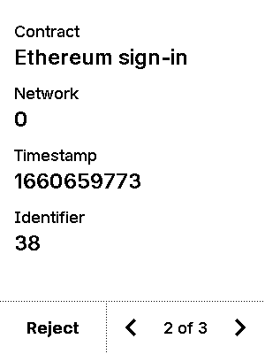


test_eip712_new-12-sign_in-data-True-False
7 image(s)
test_eip712_new-12-sign_in-data-True-False


warning


test_eip712_new-12-sign_in-data-True-True
7 image(s)
test_eip712_new-12-sign_in-data-True-True


warning


test_eip712_new-13-empty_arrays-data-False-False
9 image(s)
test_eip712_new-13-empty_arrays-data-False-False
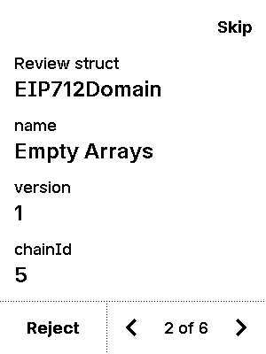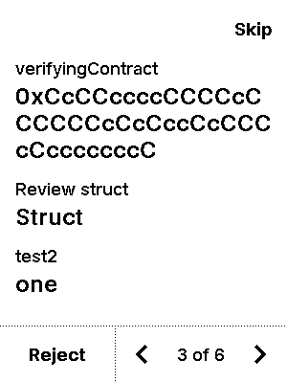
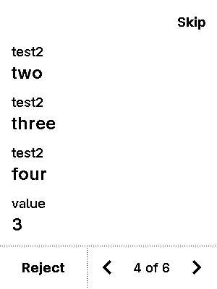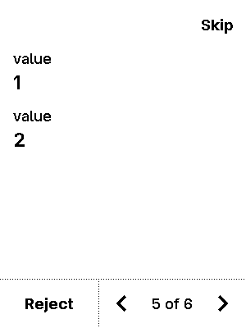

warning


test_eip712_new-13-empty_arrays-data-True-False
9 image(s)
test_eip712_new-13-empty_arrays-data-True-False



warning


test_eip712_new-14-rabby_bug-data-False-False
12 image(s)
test_eip712_new-14-rabby_bug-data-False-False
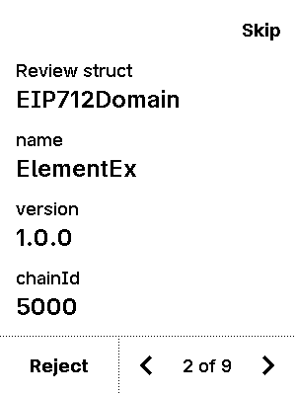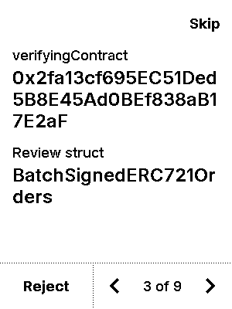
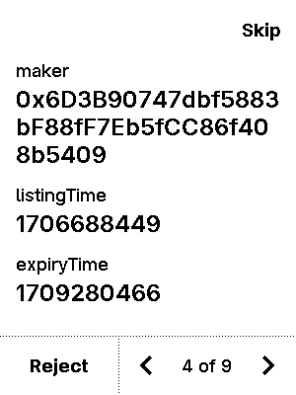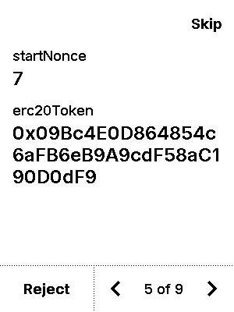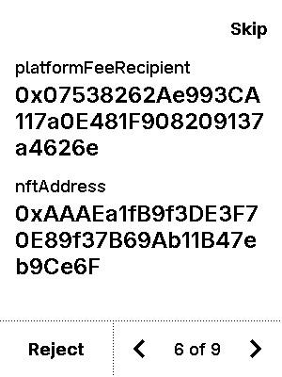
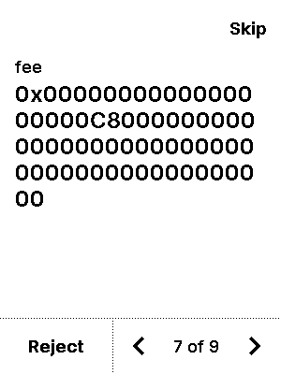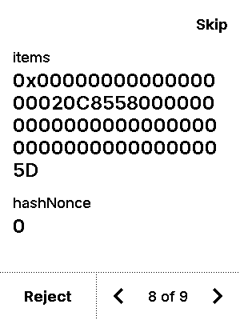

warning


test_eip712_new-14-rabby_bug-data-True-False
12 image(s)
test_eip712_new-14-rabby_bug-data-True-False




warning


test_eip7251_compound
6 image(s)
test_eip7251_compound
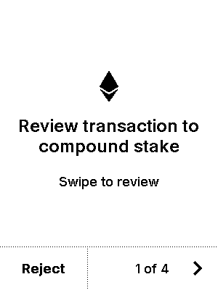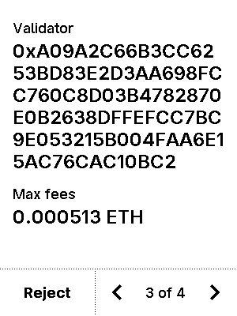
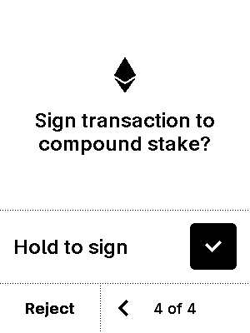

test_eip7251_consolidate
7 image(s)
test_eip7251_consolidate
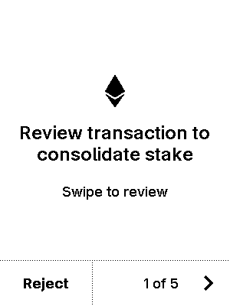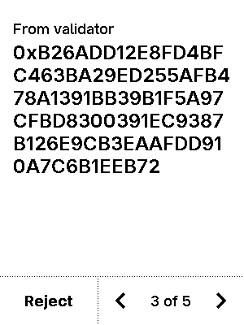
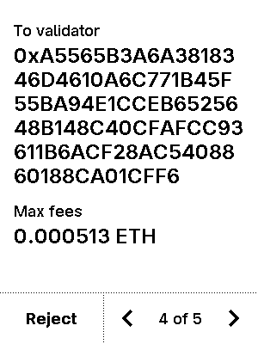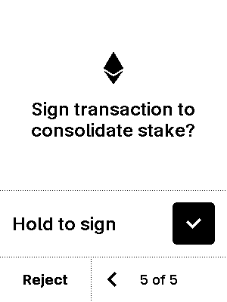


test_eip7702_in_whitelist
5 image(s)
test_eip7702_in_whitelist
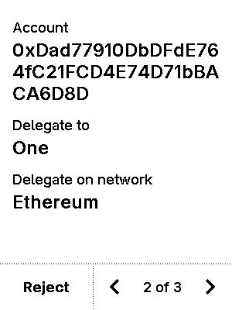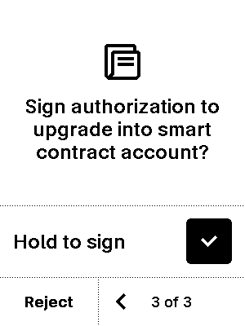


test_eip7702_in_whitelist_all_chain_param
5 image(s)
test_eip7702_in_whitelist_all_chain_param
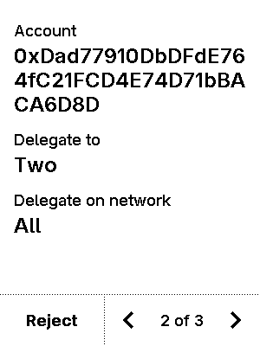


test_eip7702_in_whitelist_all_chain_whitelisted
5 image(s)
test_eip7702_in_whitelist_all_chain_whitelisted
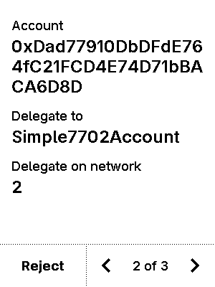


test_eip7702_in_whitelist_max
5 image(s)
test_eip7702_in_whitelist_max
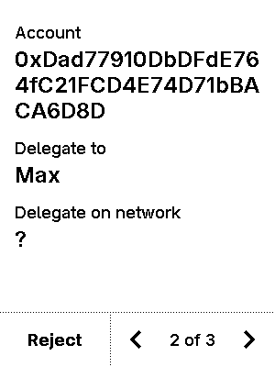


test_eip7702_in_whitelist_wrong_chain
2 image(s)
test_eip7702_in_whitelist_wrong_chain


test_eip7702_not_enabled
2 image(s)
test_eip7702_not_enabled
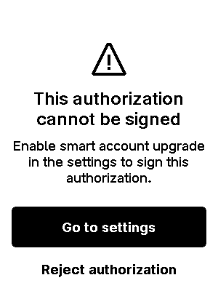

test_eip7702_not_in_whitelist
2 image(s)
test_eip7702_not_in_whitelist


test_eip7702_revocation
5 image(s)
test_eip7702_revocation
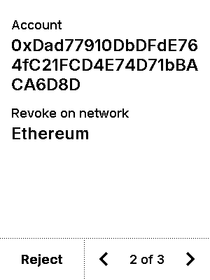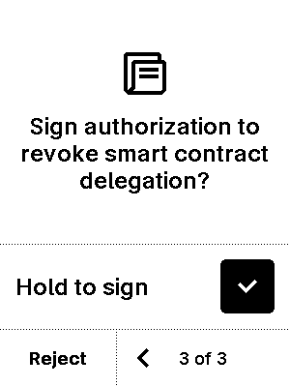


test_eth2_deposit
6 image(s)
test_eth2_deposit
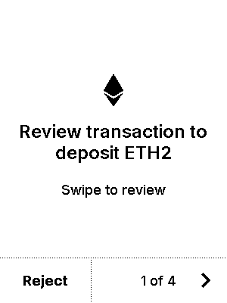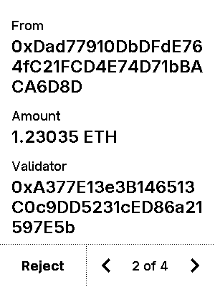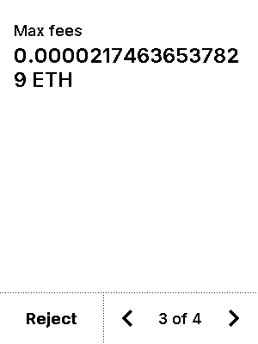
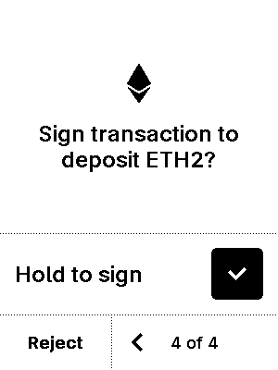

test_gating_blind_signing
8 image(s)
test_gating_blind_signing


warning
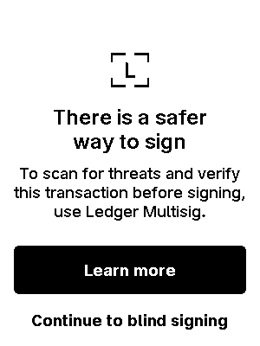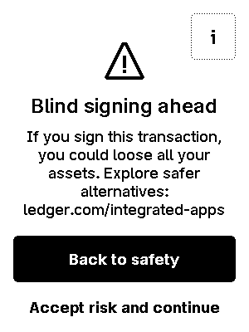

test_gating_blind_signing_with_proxy
8 image(s)
test_gating_blind_signing_with_proxy
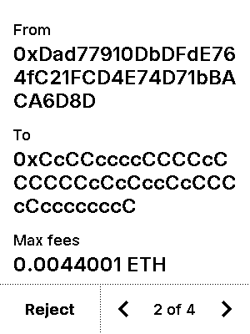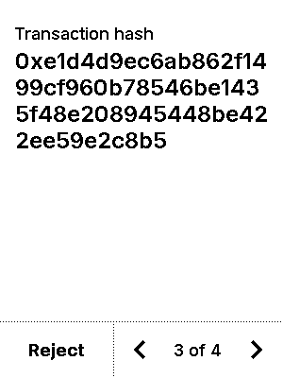

warning


test_gating_eip712
12 image(s)
test_gating_eip712




warning


test_gcs_1inch
6 image(s)
test_gcs_1inch
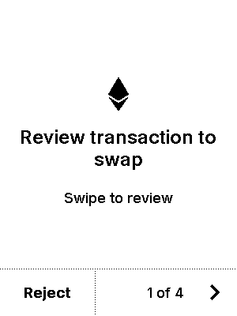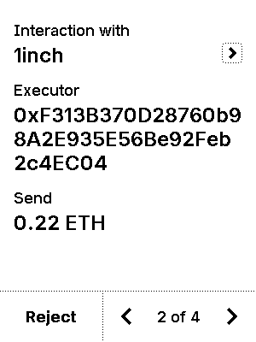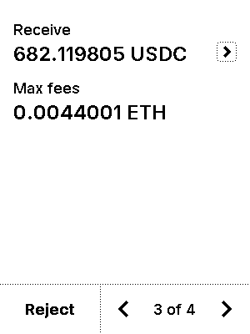
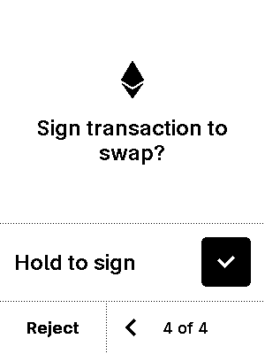

test_gcs_4226
6 image(s)
test_gcs_4226
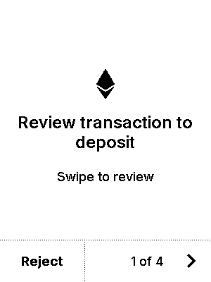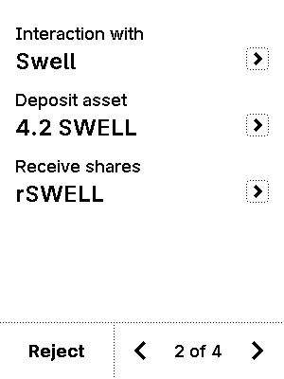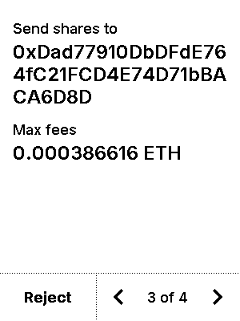
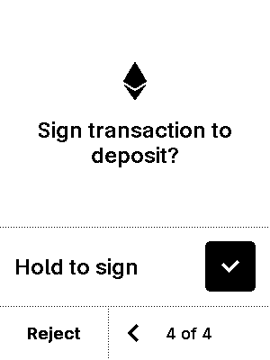

test_gcs_batch
10 image(s)
test_gcs_batch
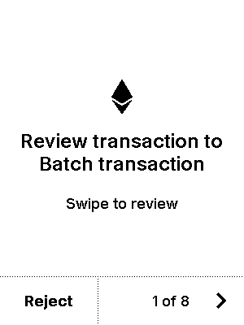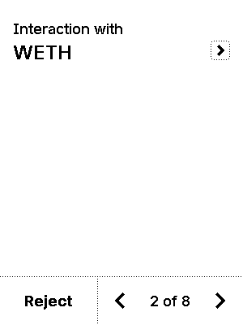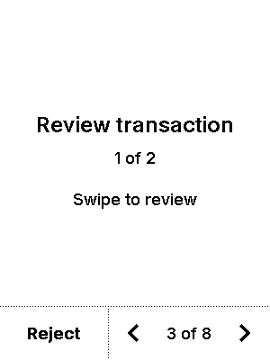
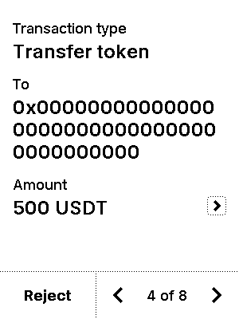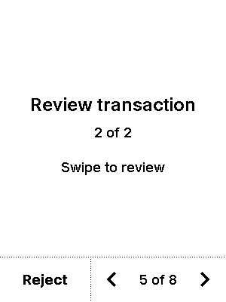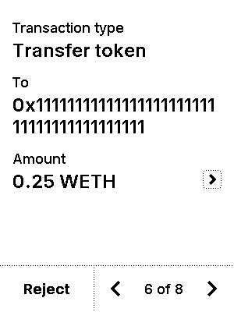
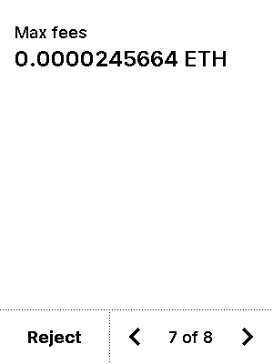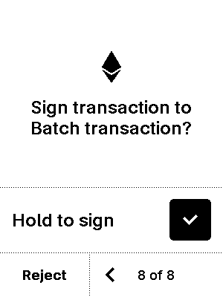


test_gcs_batch_2
12 image(s)
test_gcs_batch_2
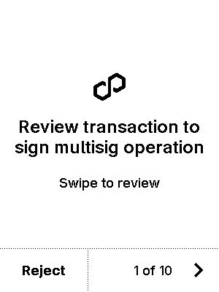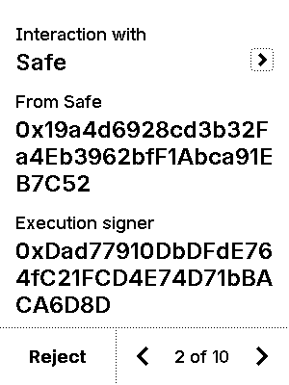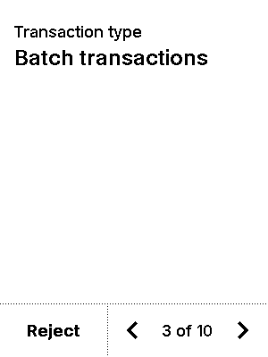
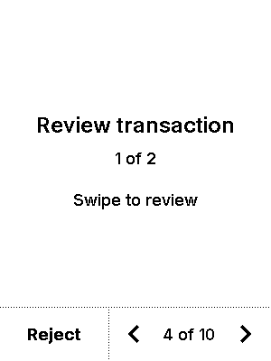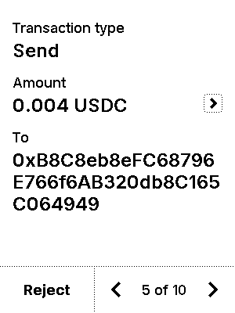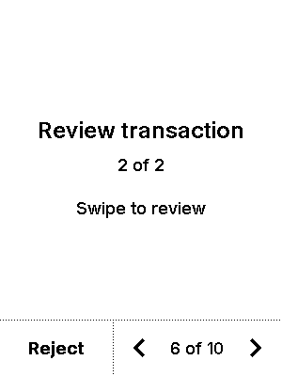
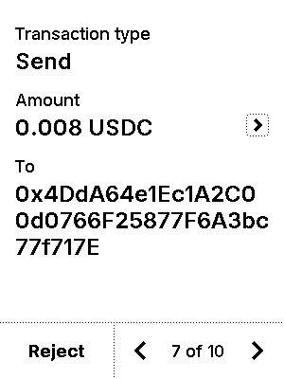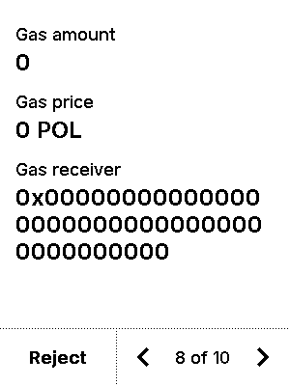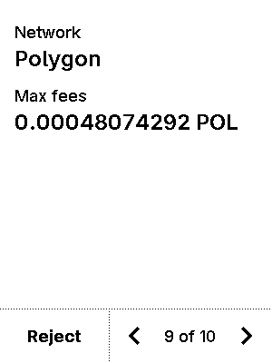
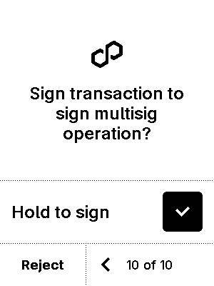

test_gcs_batch_complex
18 image(s)
test_gcs_batch_complex
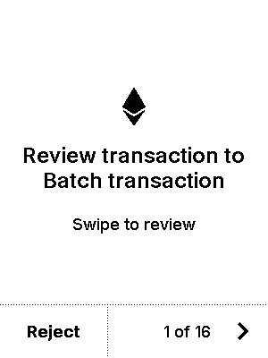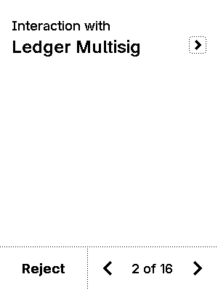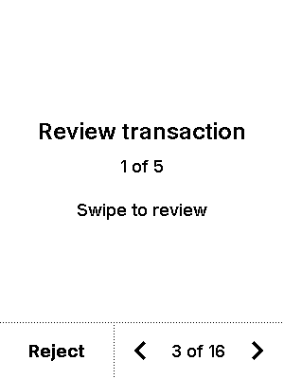
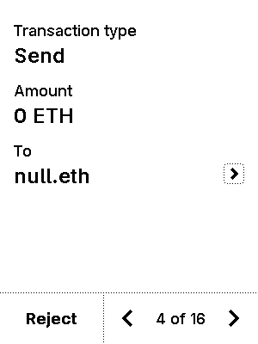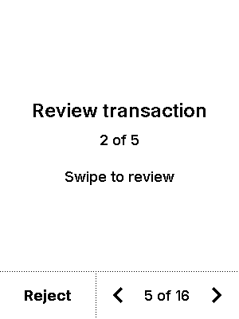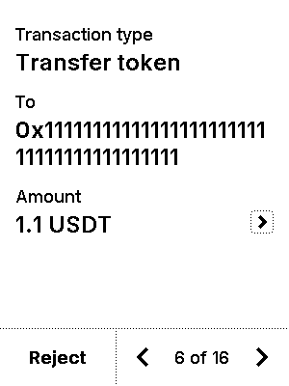
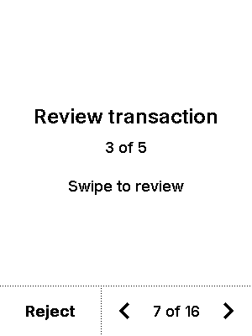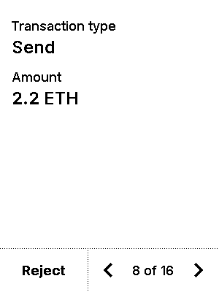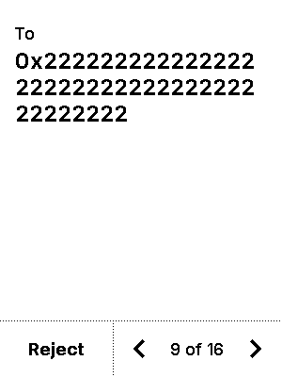
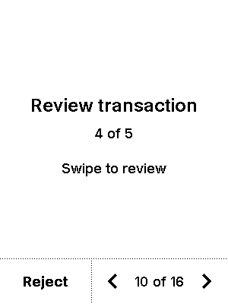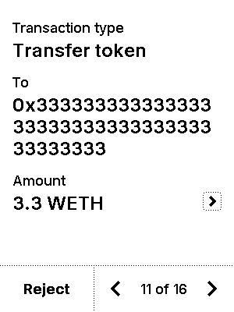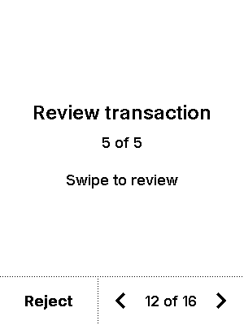
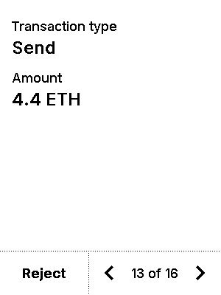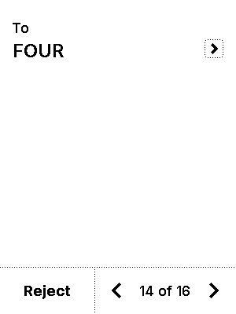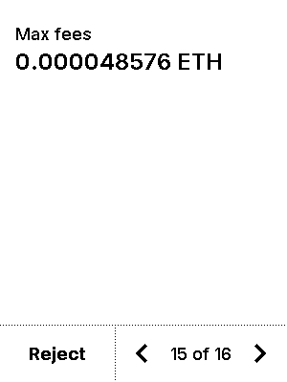
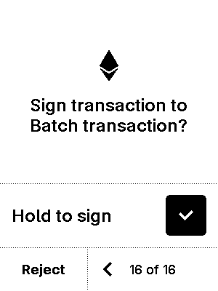

test_gcs_batch_empty_tx
6 image(s)
test_gcs_batch_empty_tx
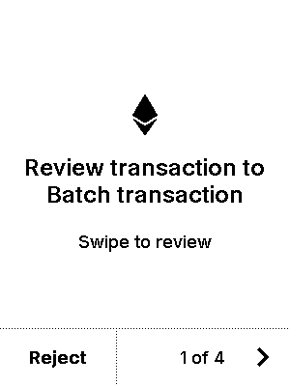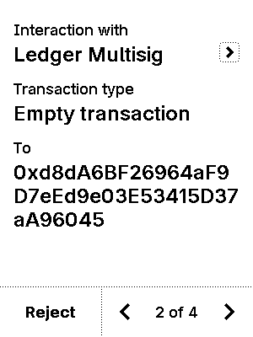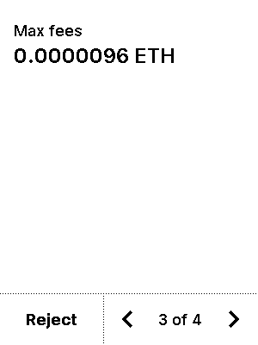
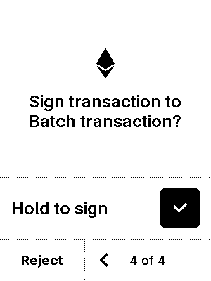

test_gcs_constraints_if_not_0
7 image(s)
test_gcs_constraints_if_not_0
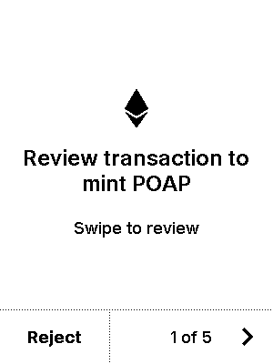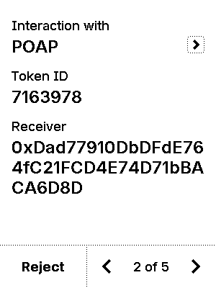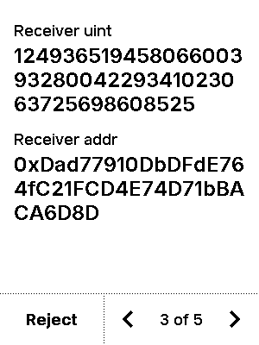
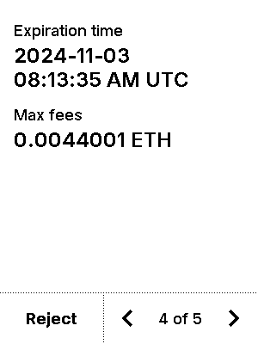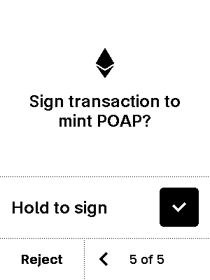


test_gcs_constraints_if_not_addr
5 image(s)
test_gcs_constraints_if_not_addr
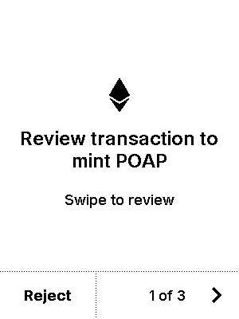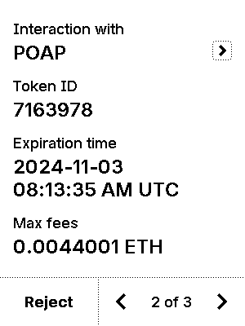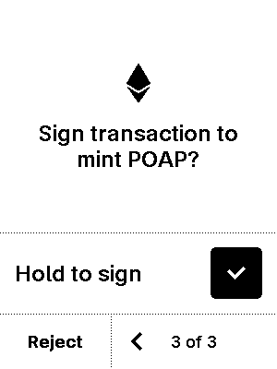


test_gcs_constraints_must_be_addr
5 image(s)
test_gcs_constraints_must_be_addr



test_gcs_formatter_chain_id
6 image(s)
test_gcs_formatter_chain_id
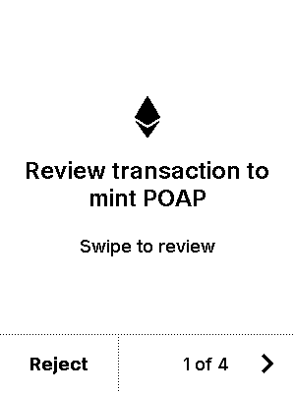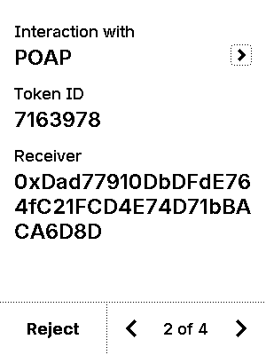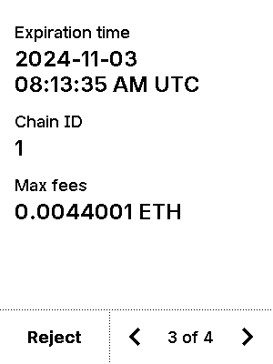
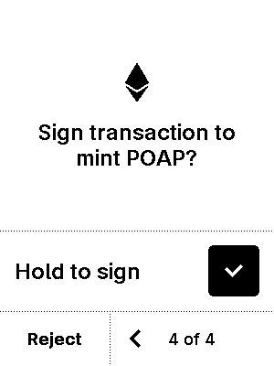

test_gcs_formatter_network
6 image(s)
test_gcs_formatter_network
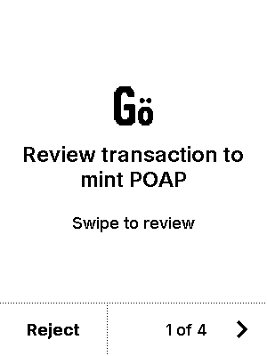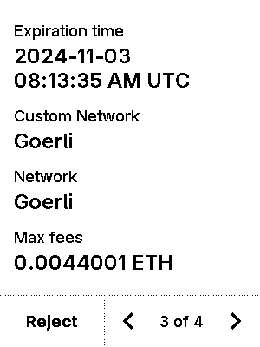
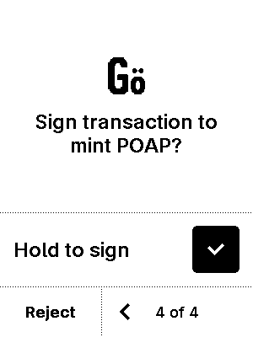

test_gcs_nested_createProxyWithNonce
9 image(s)
test_gcs_nested_createProxyWithNonce
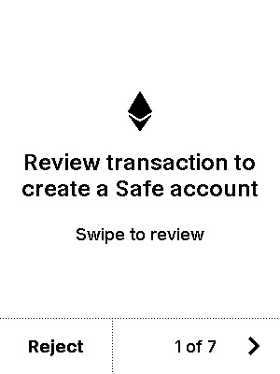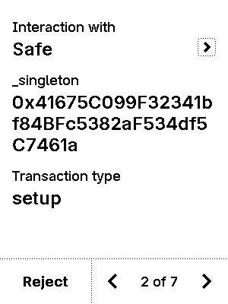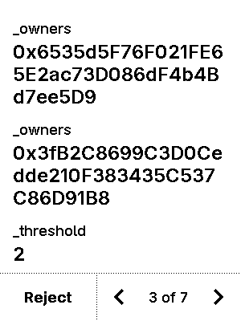
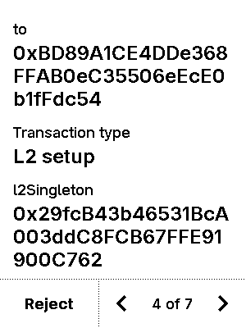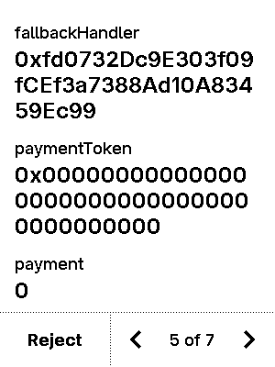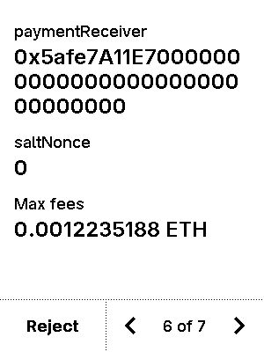
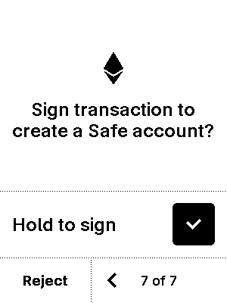

test_gcs_nested_execTransaction_addOwnerWithThreshold
10 image(s)
test_gcs_nested_execTransaction_addOwnerWithThreshold
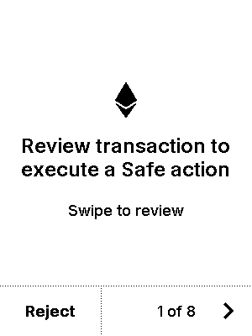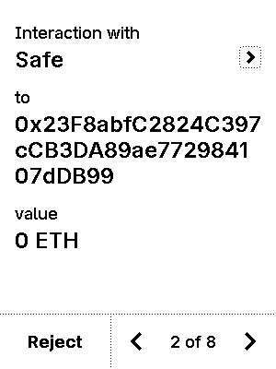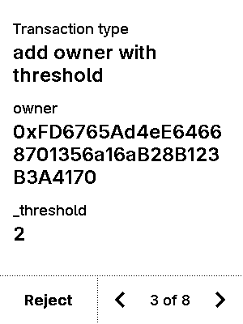
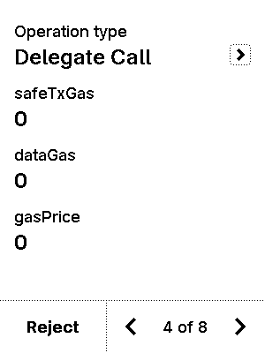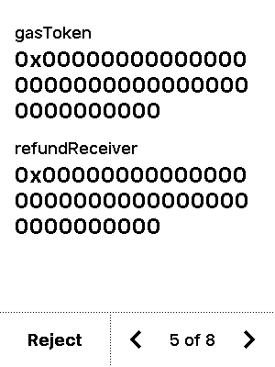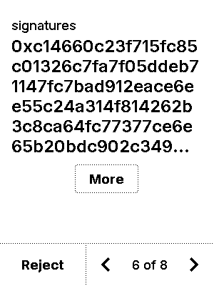
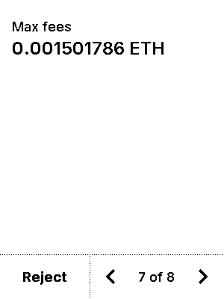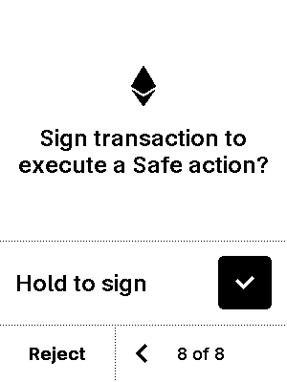


test_gcs_nested_execTransaction_changeThreshold
10 image(s)
test_gcs_nested_execTransaction_changeThreshold
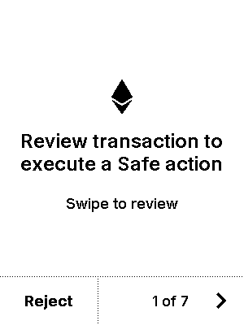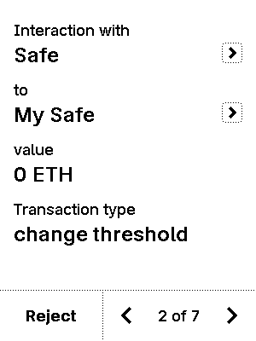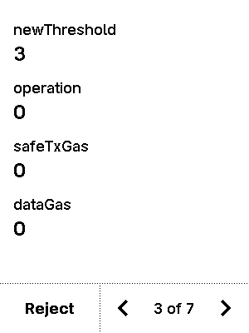
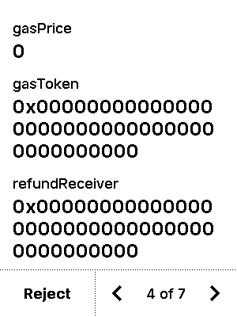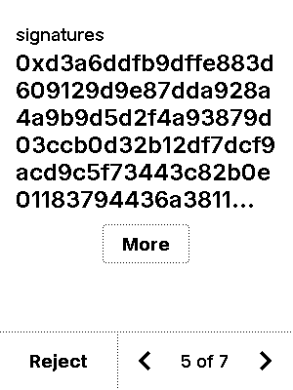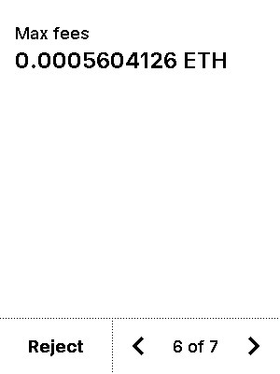
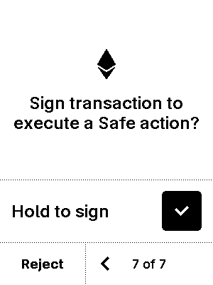


test_gcs_nested_execTransaction_send
6 image(s)
test_gcs_nested_execTransaction_send
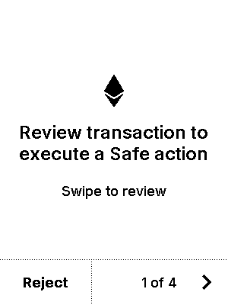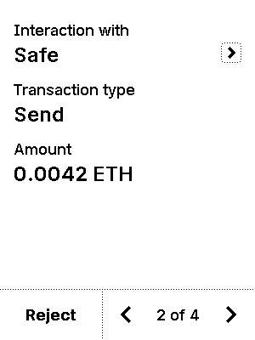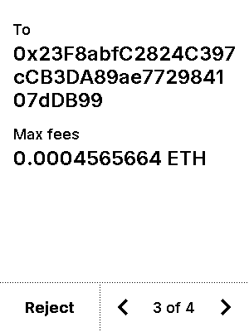
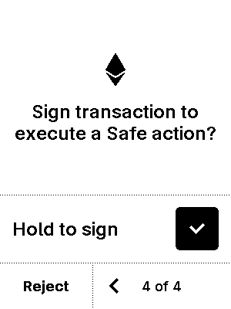

test_gcs_nested_no_param
5 image(s)
test_gcs_nested_no_param
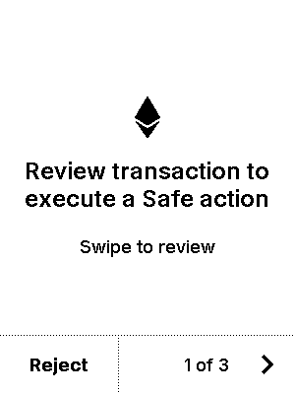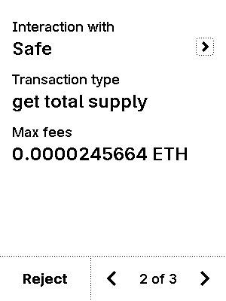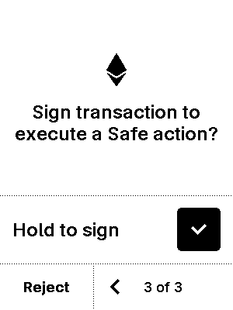


test_gcs_nft
8 image(s)
test_gcs_nft
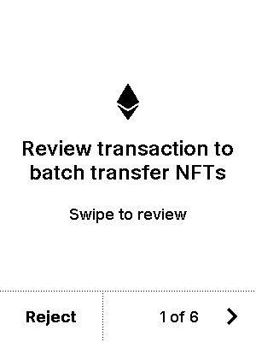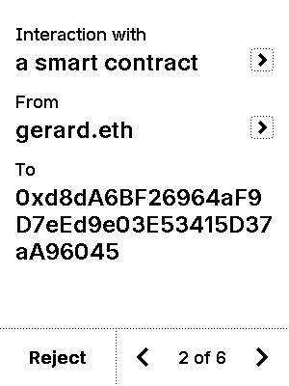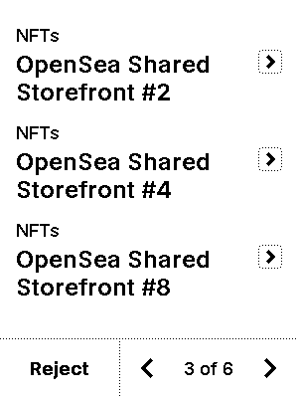
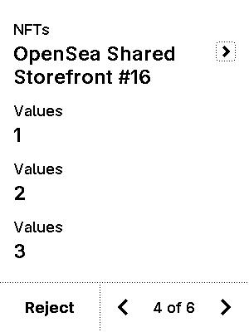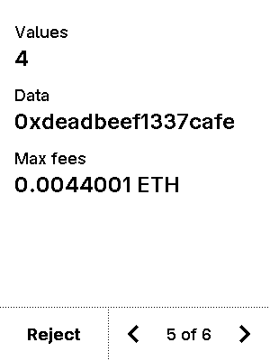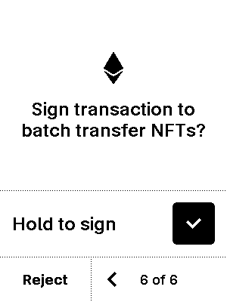


test_gcs_no_param
5 image(s)
test_gcs_no_param
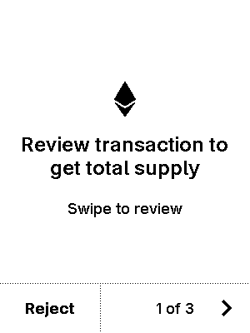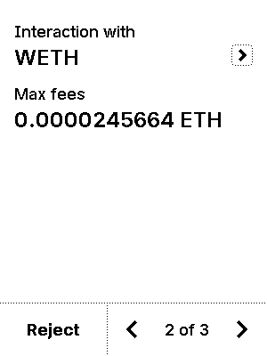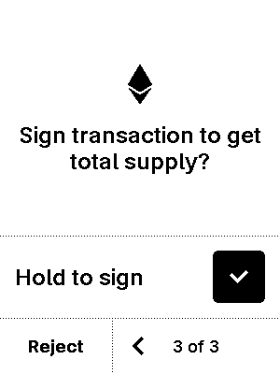


test_gcs_poap
8 image(s)
test_gcs_poap
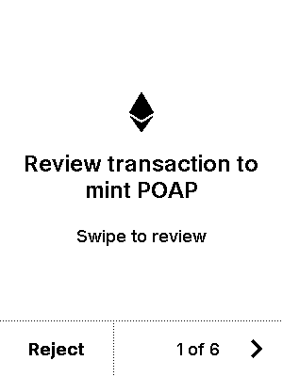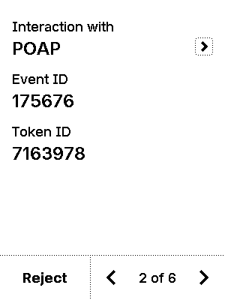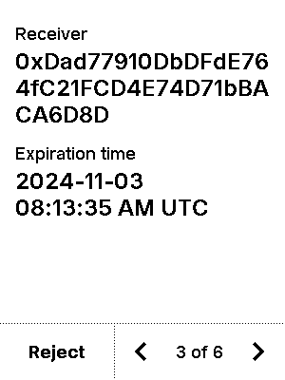
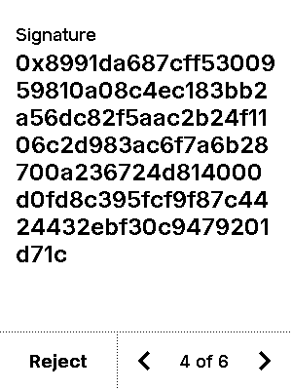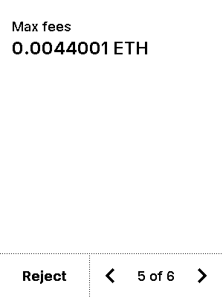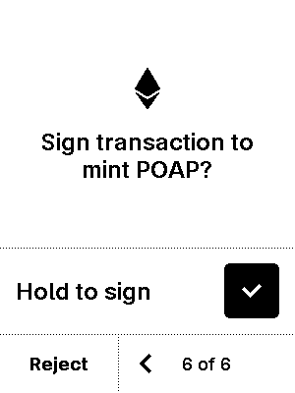


test_gcs_proxy
5 image(s)
test_gcs_proxy
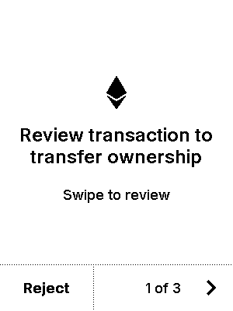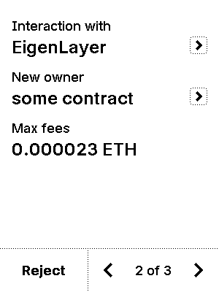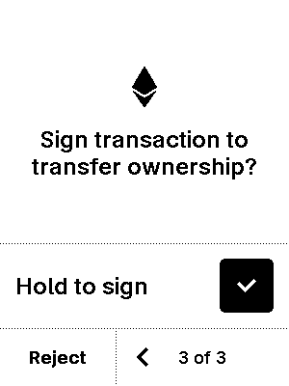


test_gcs_trusted_name_token
5 image(s)
test_gcs_trusted_name_token
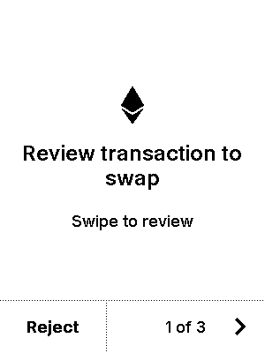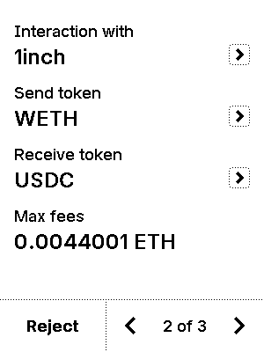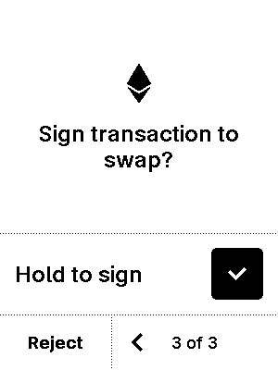


test_get_eth2_pk
4 image(s)
test_get_eth2_pk
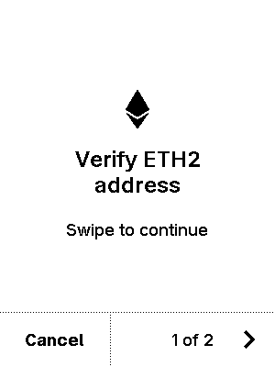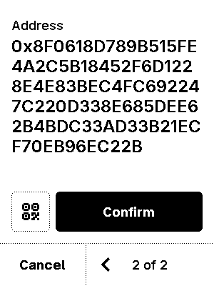


test_get_pk_1
4 image(s)
test_get_pk_1
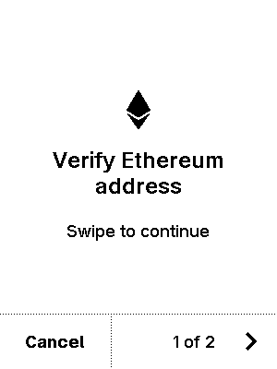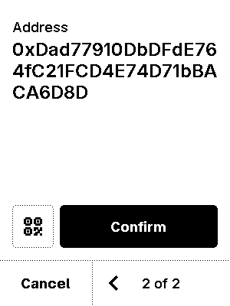


test_get_pk_137
4 image(s)
test_get_pk_137
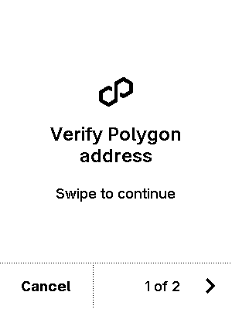


test_get_pk_2
4 image(s)
test_get_pk_2
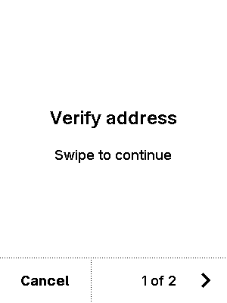


test_get_pk_5
4 image(s)
test_get_pk_5
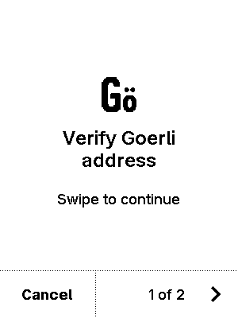


test_get_pk_None
4 image(s)
test_get_pk_None



test_get_pk_rejected
4 image(s)
test_get_pk_rejected



test_nft_erc1155_reject_safeTransferFrom_1
8 image(s)
test_nft_erc1155_reject_safeTransferFrom_1
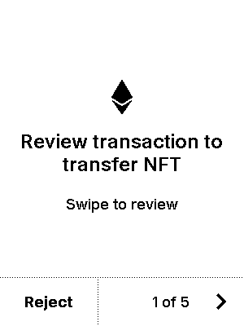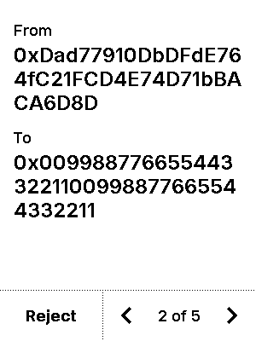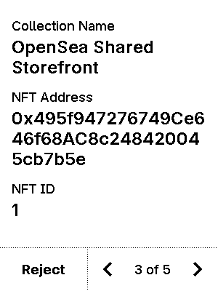
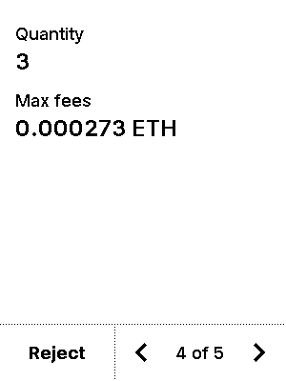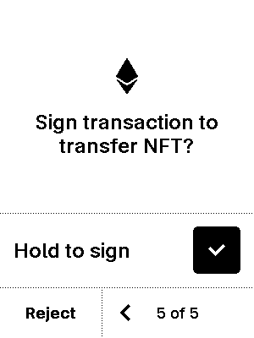


test_nft_erc1155_safeBatchTransferFrom_1
7 image(s)
test_nft_erc1155_safeBatchTransferFrom_1
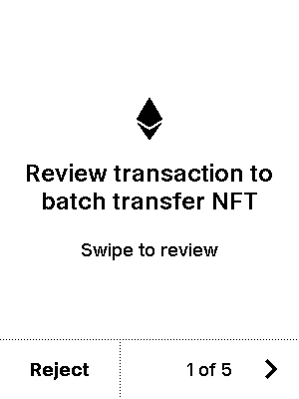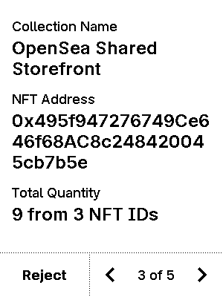
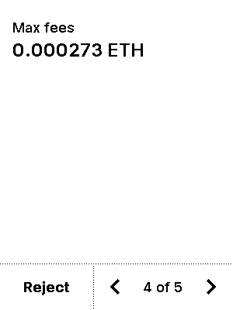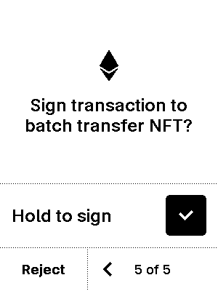


test_nft_erc1155_safeBatchTransferFrom_137
7 image(s)
test_nft_erc1155_safeBatchTransferFrom_137
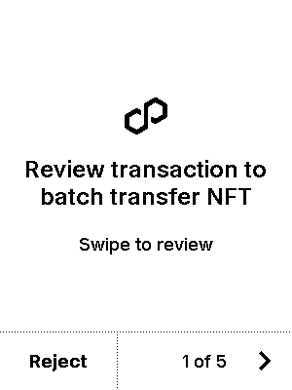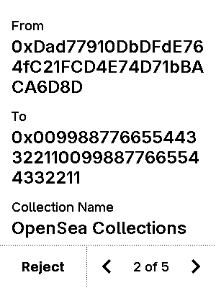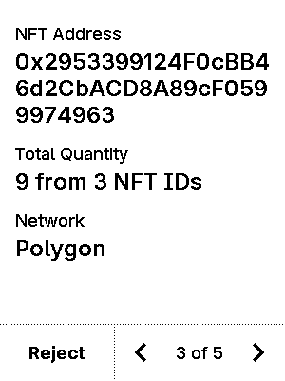
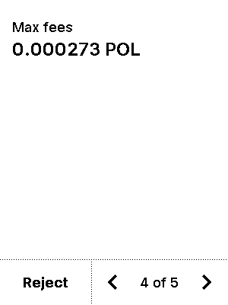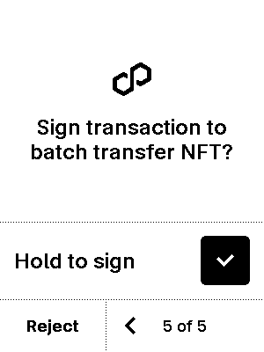


test_nft_erc1155_safeBatchTransferFrom_5
7 image(s)
test_nft_erc1155_safeBatchTransferFrom_5
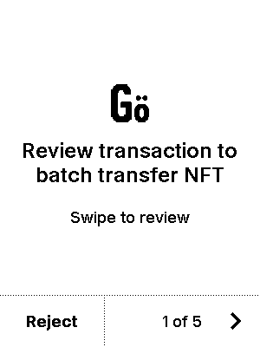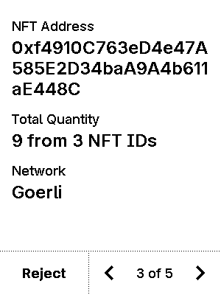
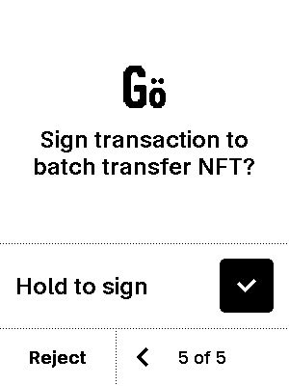


test_nft_erc1155_safeTransferFrom_1
7 image(s)
test_nft_erc1155_safeTransferFrom_1




test_nft_erc1155_safeTransferFrom_137
7 image(s)
test_nft_erc1155_safeTransferFrom_137
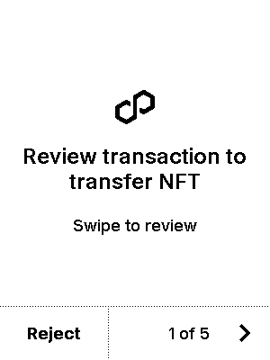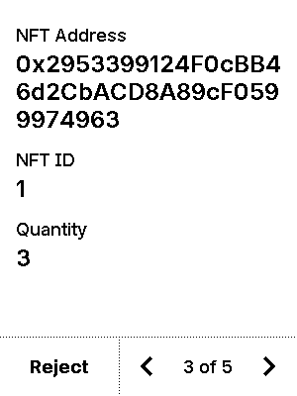
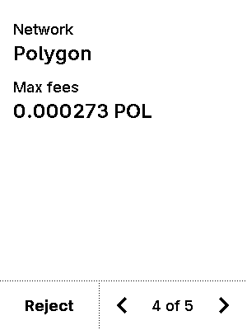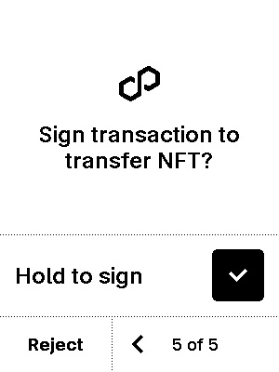


test_nft_erc1155_safeTransferFrom_5
7 image(s)
test_nft_erc1155_safeTransferFrom_5
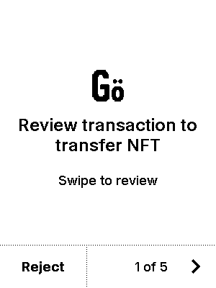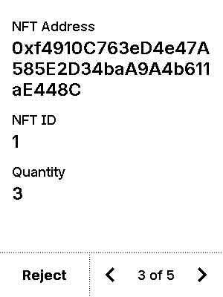
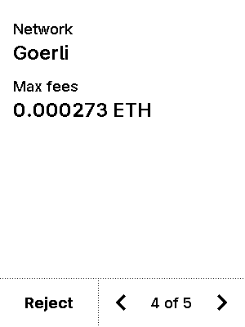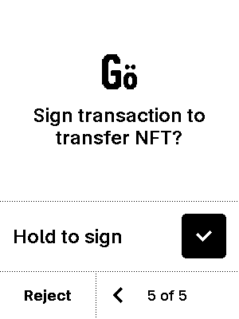


test_nft_erc1155_setApprovalForAll_1
6 image(s)
test_nft_erc1155_setApprovalForAll_1
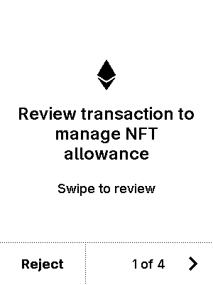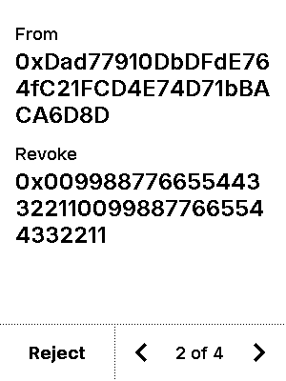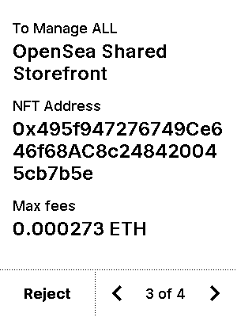
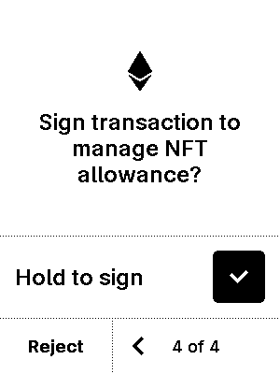

test_nft_erc1155_setApprovalForAll_137
6 image(s)
test_nft_erc1155_setApprovalForAll_137
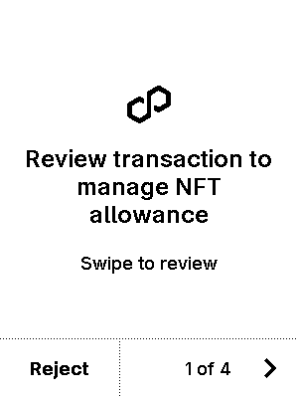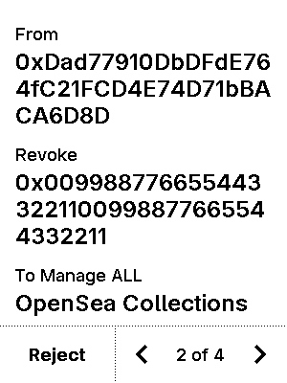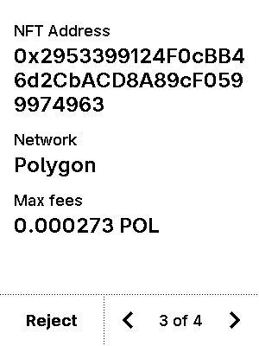
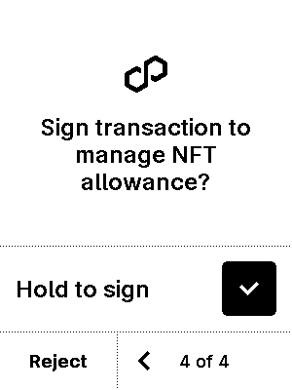

test_nft_erc1155_setApprovalForAll_5
6 image(s)
test_nft_erc1155_setApprovalForAll_5
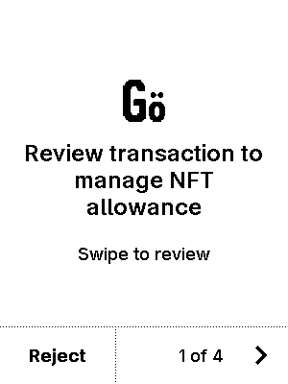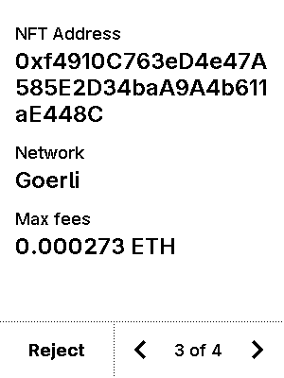
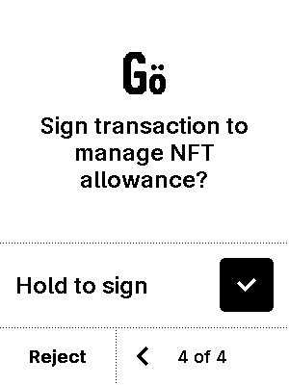

test_nft_erc721_approve_1
6 image(s)
test_nft_erc721_approve_1
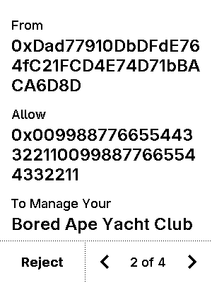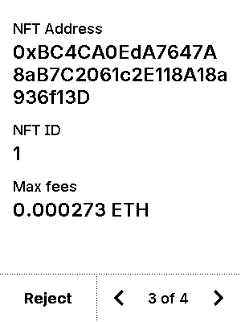


test_nft_erc721_approve_137
7 image(s)
test_nft_erc721_approve_137
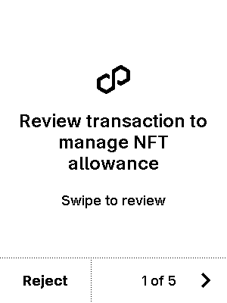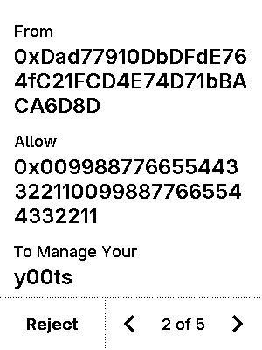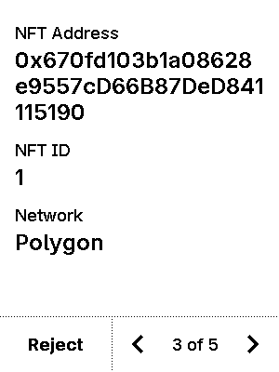
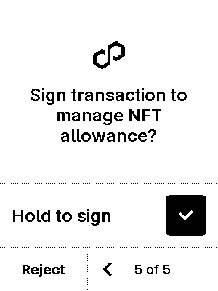


test_nft_erc721_approve_5
7 image(s)
test_nft_erc721_approve_5
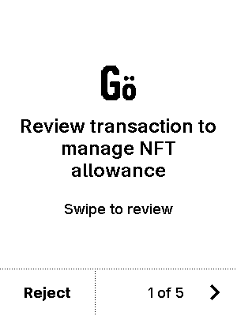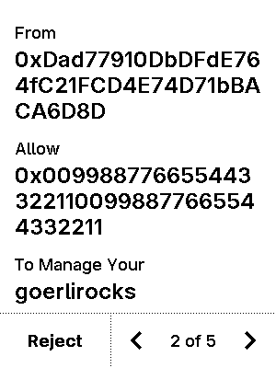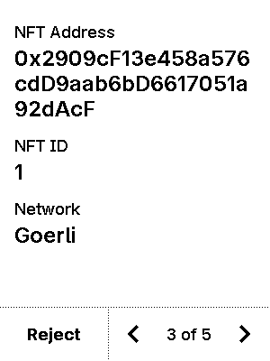
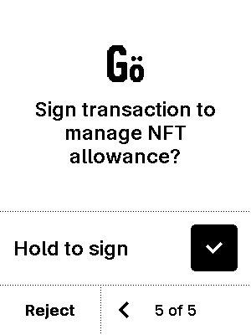


test_nft_erc721_reject_safeTransferFrom_1
7 image(s)
test_nft_erc721_reject_safeTransferFrom_1
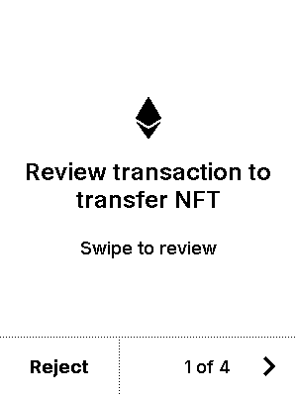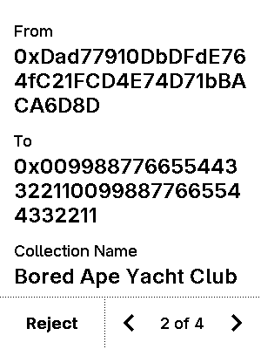
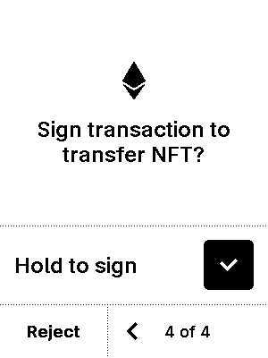


test_nft_erc721_safeTransferFrom_1
6 image(s)
test_nft_erc721_safeTransferFrom_1



test_nft_erc721_safeTransferFrom_137
7 image(s)
test_nft_erc721_safeTransferFrom_137
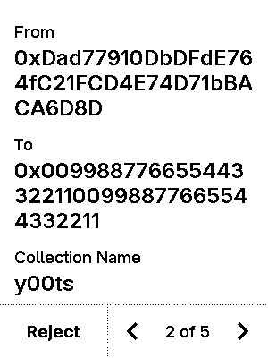



test_nft_erc721_safeTransferFrom_5
7 image(s)
test_nft_erc721_safeTransferFrom_5
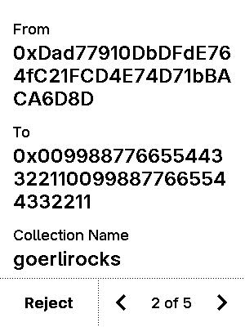



test_nft_erc721_setApprovalForAll_1
6 image(s)
test_nft_erc721_setApprovalForAll_1
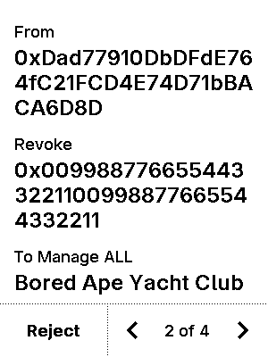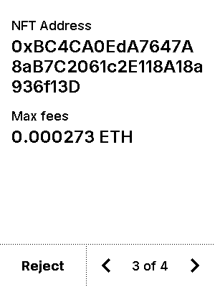


test_nft_erc721_setApprovalForAll_137
6 image(s)
test_nft_erc721_setApprovalForAll_137
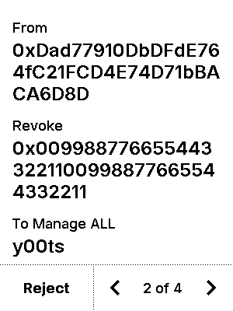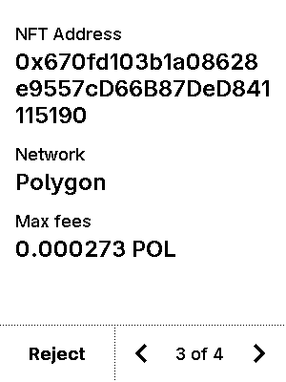


test_nft_erc721_setApprovalForAll_5
6 image(s)
test_nft_erc721_setApprovalForAll_5
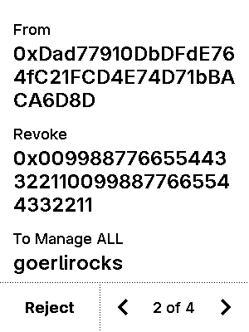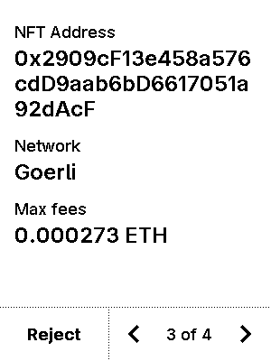


test_nft_erc721_transferFrom_1
6 image(s)
test_nft_erc721_transferFrom_1



test_nft_erc721_transferFrom_137
7 image(s)
test_nft_erc721_transferFrom_137




test_nft_erc721_transferFrom_5
7 image(s)
test_nft_erc721_transferFrom_5




test_personal_sign_metamask
5 image(s)
test_personal_sign_metamask
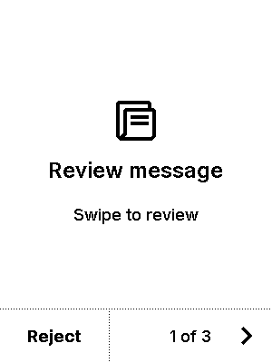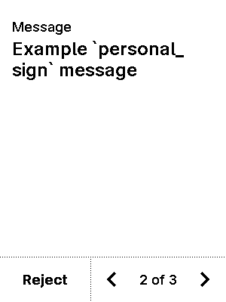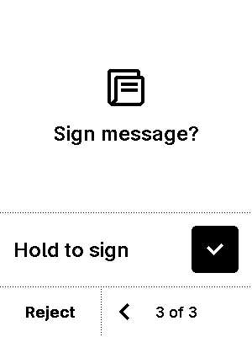


test_personal_sign_non_ascii
5 image(s)
test_personal_sign_non_ascii
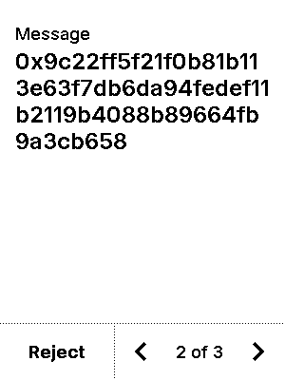


test_personal_sign_opensea
5 image(s)
test_personal_sign_opensea



test_personal_sign_reject
6 image(s)
test_personal_sign_reject
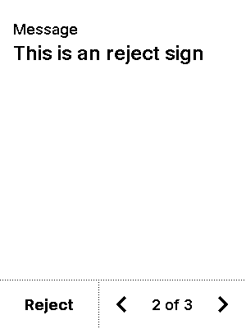
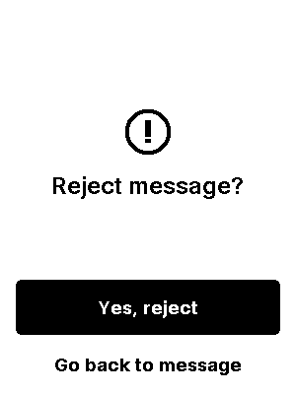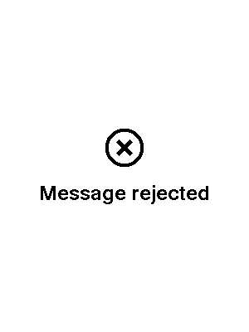

test_safe_descriptor
5 image(s)
test_safe_descriptor
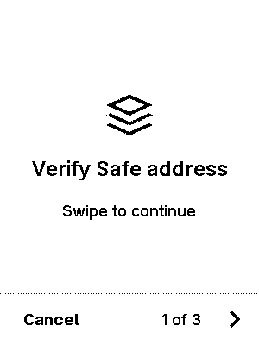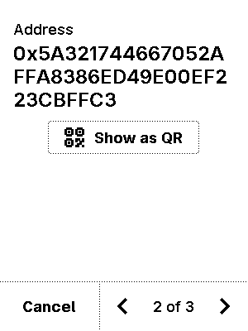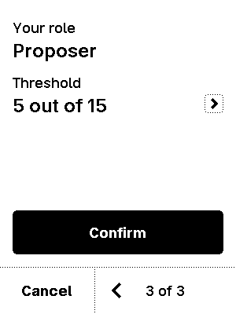
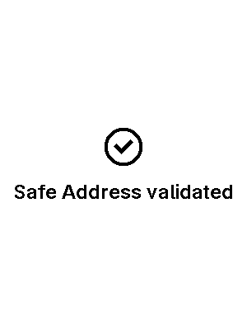

test_settings
53 image(s)
blind_sign
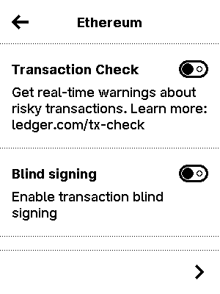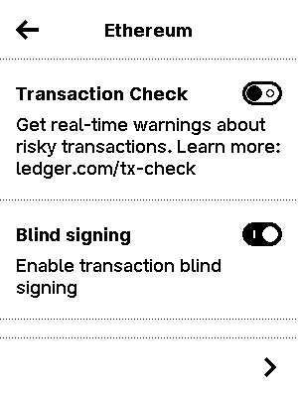

debug_token
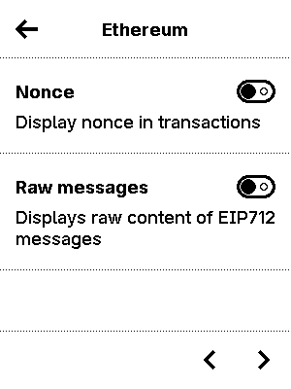
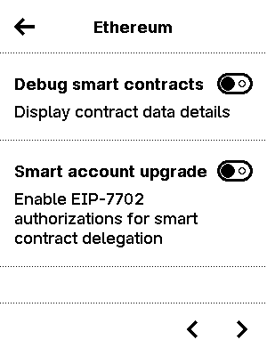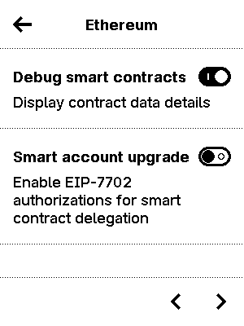
eip712_token

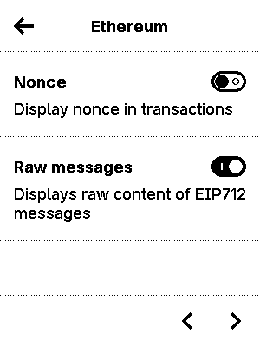
hash

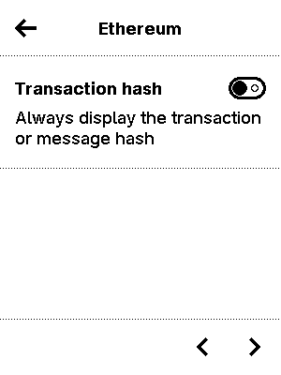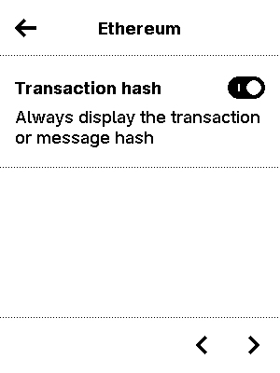

multiple1



multiple2


multiple3
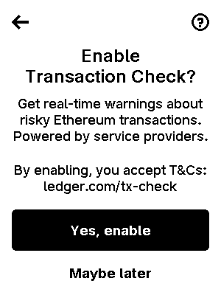
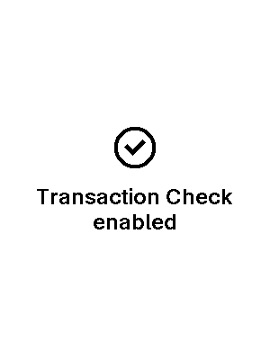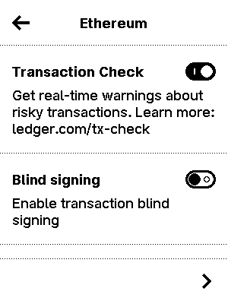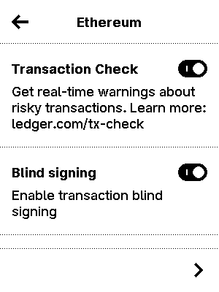

nonce

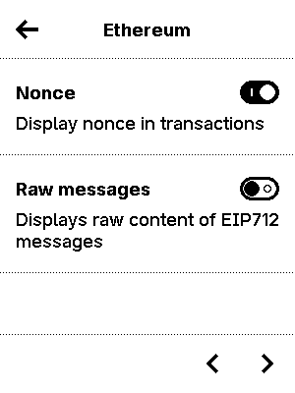
tx_checks



test_sign_eip_2930
6 image(s)
test_sign_eip_2930
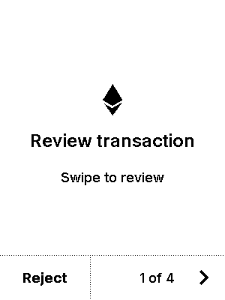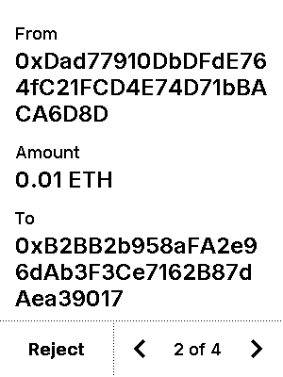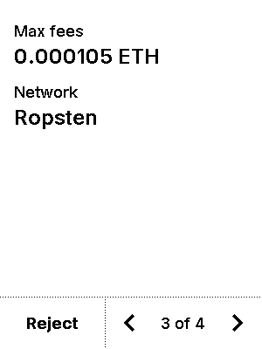
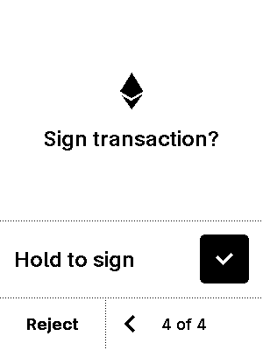

test_sign_eip_7702
6 image(s)
test_sign_eip_7702
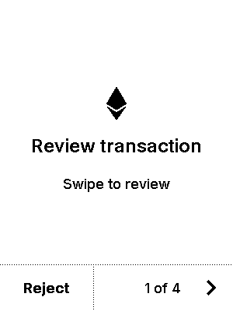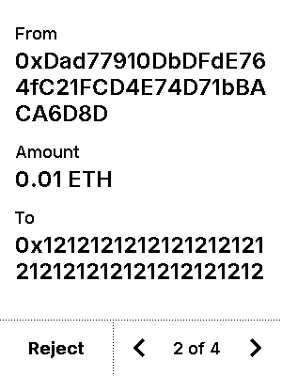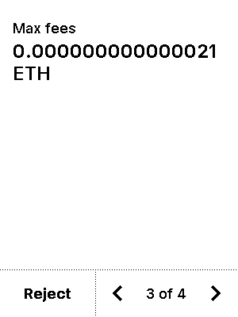
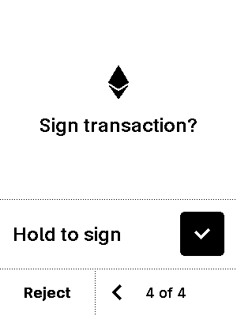

test_sign_legacy_chainid
6 image(s)
test_sign_legacy_chainid
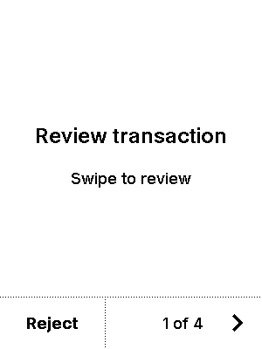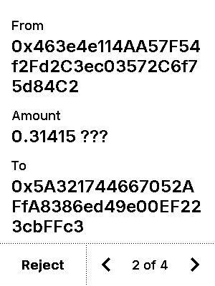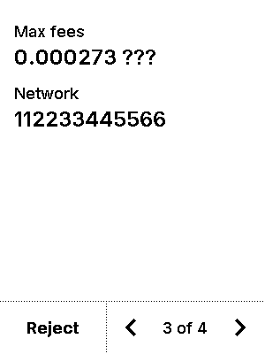
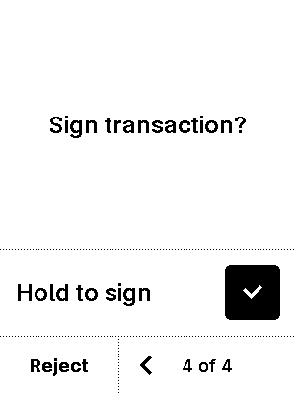

test_sign_legacy_send_bsc
6 image(s)
test_sign_legacy_send_bsc
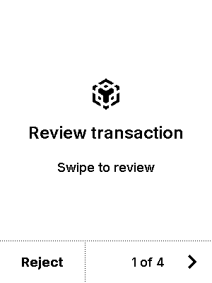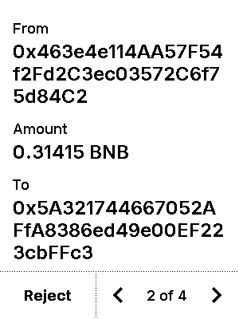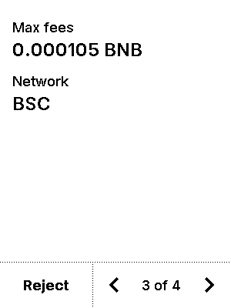
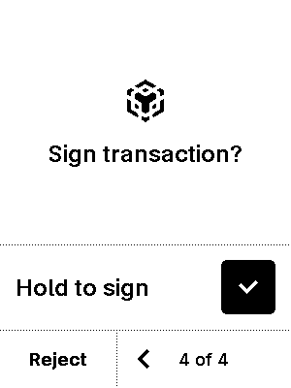

test_sign_limit_nonce
6 image(s)
test_sign_limit_nonce
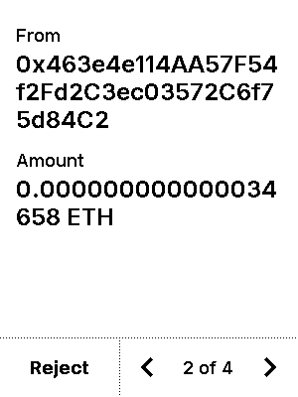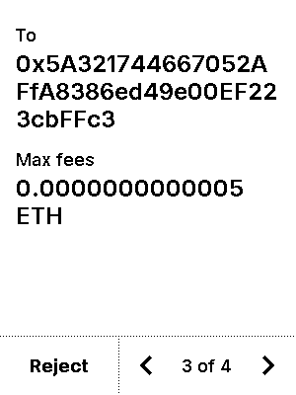


test_sign_nonce_display
6 image(s)
test_sign_nonce_display
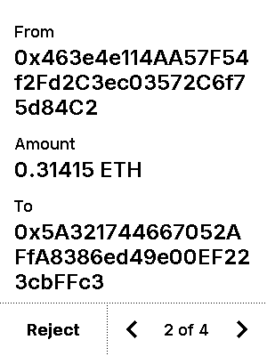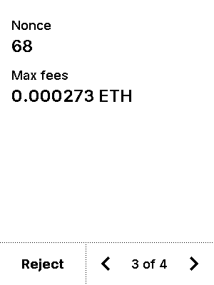


test_sign_parameter_selector
12 image(s)
test_sign_parameter_selector
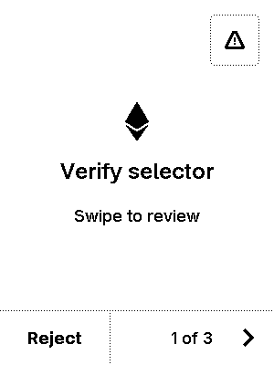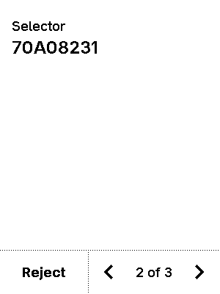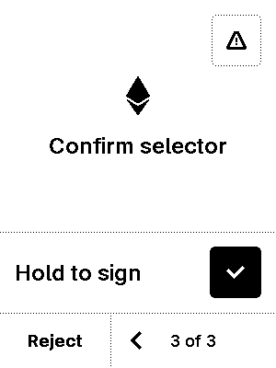
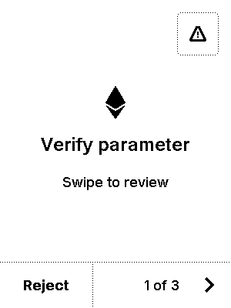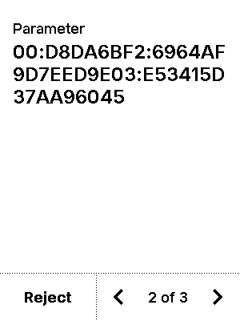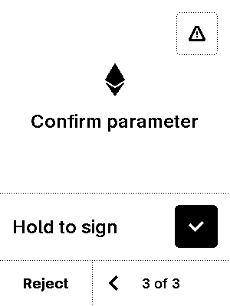



test_sign_reject
7 image(s)
test_sign_reject
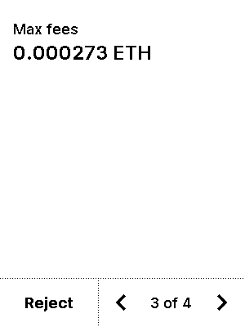



test_sign_simple
6 image(s)
test_sign_simple



test_sign_simple_display_hash
6 image(s)
test_sign_simple_display_hash
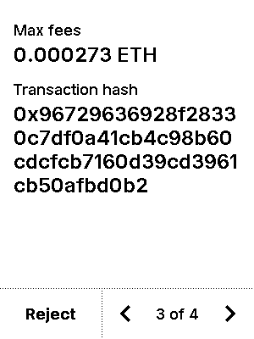


test_transfer_erc20
6 image(s)
test_transfer_erc20
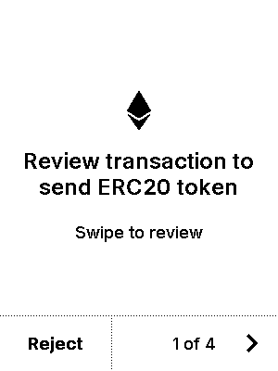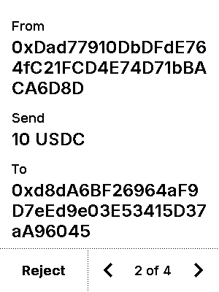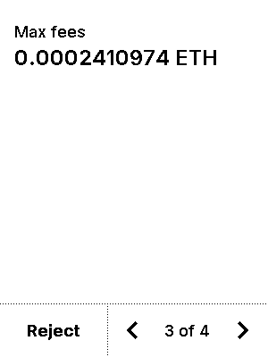
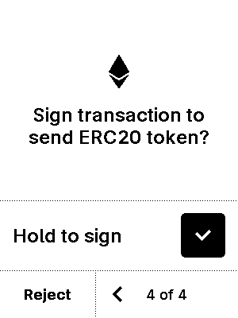

test_transfer_erc20_extra_data
6 image(s)
test_transfer_erc20_extra_data
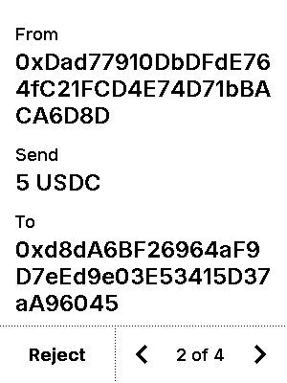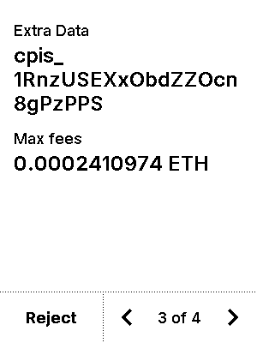


test_transfer_erc20_extra_data_nonascii
6 image(s)
test_transfer_erc20_extra_data_nonascii
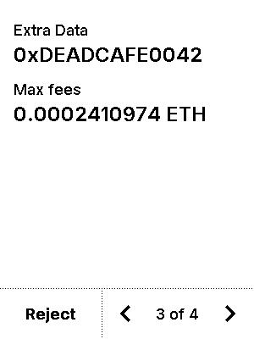


test_transfer_erc20_extra_data_nonascii_truncated
6 image(s)
test_transfer_erc20_extra_data_nonascii_truncated
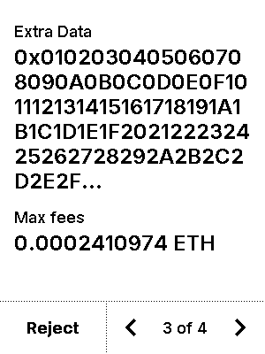


test_trusted_name_v1
6 image(s)
test_trusted_name_v1
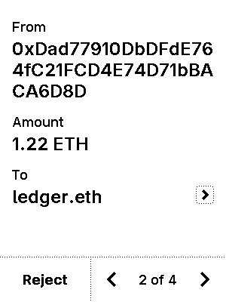


test_trusted_name_v1_non_mainnet
6 image(s)
test_trusted_name_v1_non_mainnet
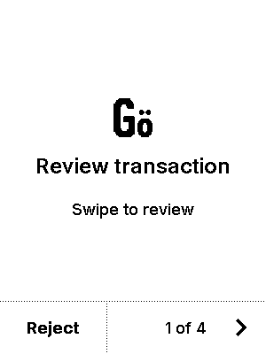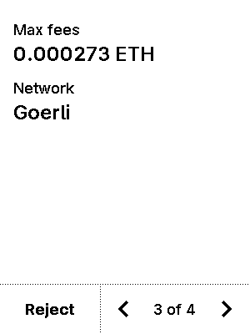
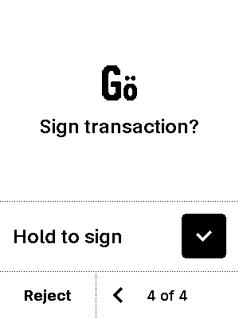

test_trusted_name_v1_unknown_chain
6 image(s)
test_trusted_name_v1_unknown_chain
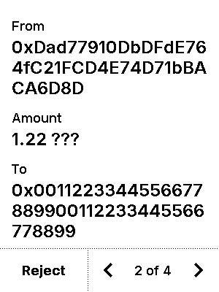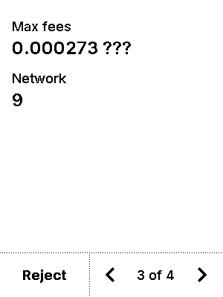


test_trusted_name_v1_verbose
8 image(s)
part1
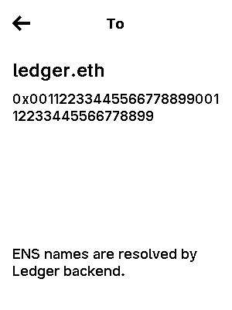
part2



test_trusted_name_v1_wrong_addr
6 image(s)
test_trusted_name_v1_wrong_addr
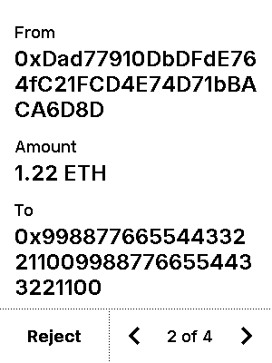


test_trusted_name_v2
6 image(s)
test_trusted_name_v2



test_trusted_name_v2_wrong_chainid
6 image(s)
test_trusted_name_v2_wrong_chainid
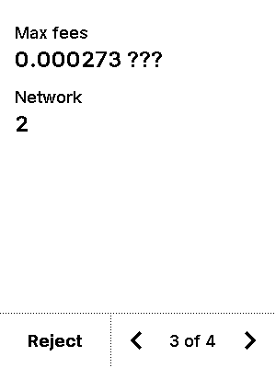


test_tx_simulation_blind_sign_benign
7 image(s)
test_tx_simulation_blind_sign_benign
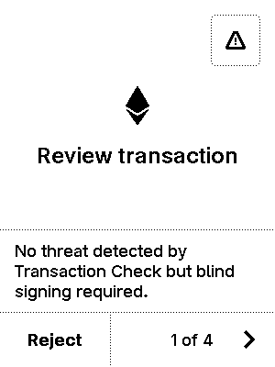

warning


test_tx_simulation_blind_sign_issue
7 image(s)
test_tx_simulation_blind_sign_issue
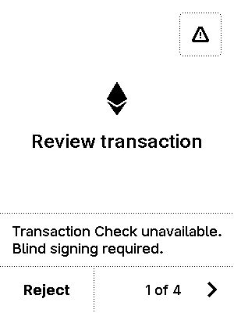

warning


test_tx_simulation_blind_sign_threat
7 image(s)
test_tx_simulation_blind_sign_threat
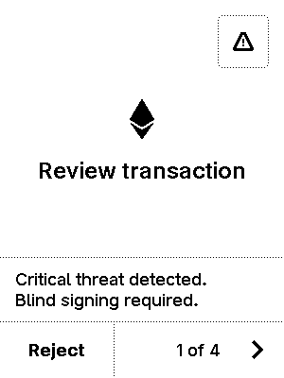
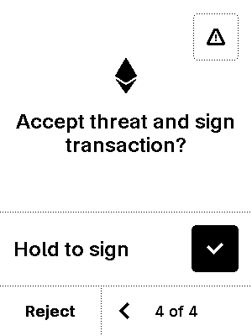
warning
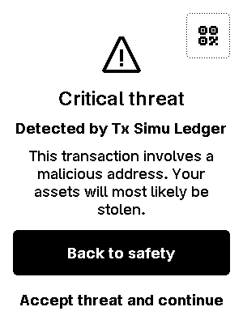

test_tx_simulation_blind_sign_warning
7 image(s)
test_tx_simulation_blind_sign_warning
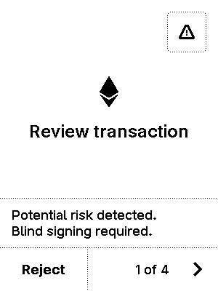

warning
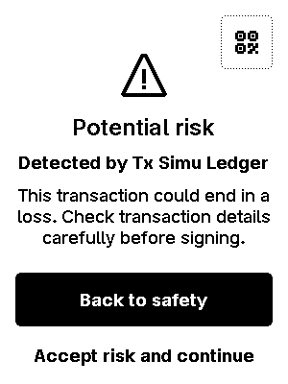

test_tx_simulation_eip712
6 image(s)
test_tx_simulation_eip712
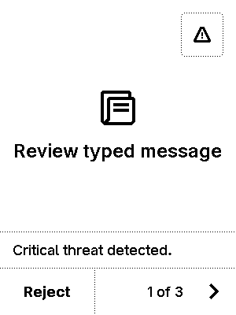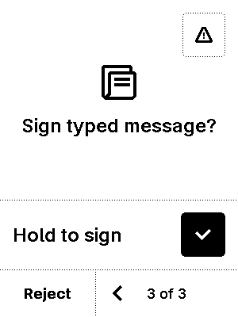

warning


test_tx_simulation_gcs
9 image(s)
test_tx_simulation_gcs
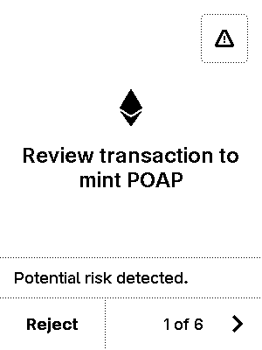
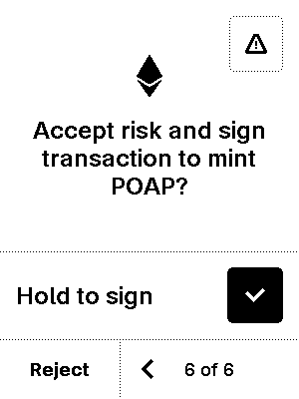

warning


test_tx_simulation_nft_safeTransferFrom_1
7 image(s)
test_tx_simulation_nft_safeTransferFrom_1
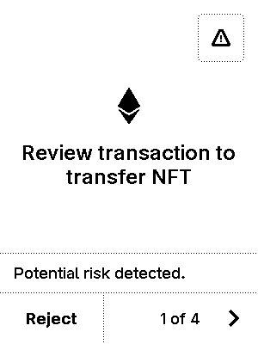
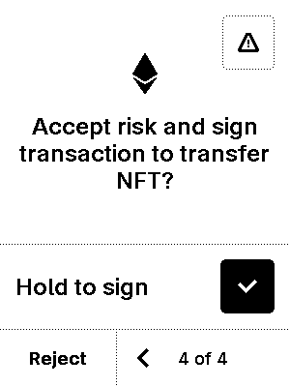
warning


test_tx_simulation_no_simu
6 image(s)
test_tx_simulation_no_simu
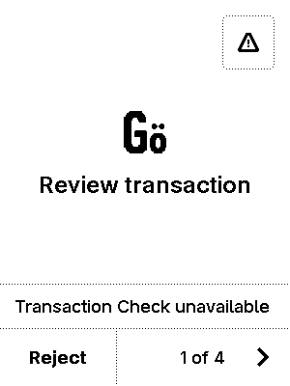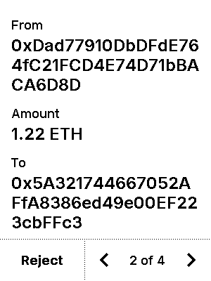
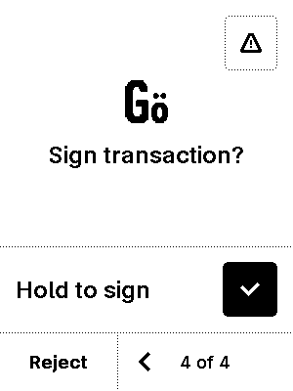

test_tx_simulation_opt_in
2 image(s)
test_tx_simulation_opt_in


test_tx_simulation_sign_benign
6 image(s)
test_tx_simulation_sign_benign
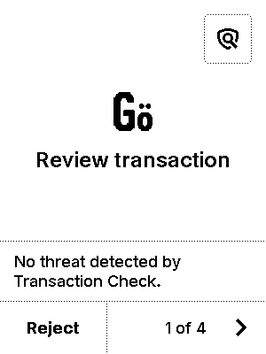
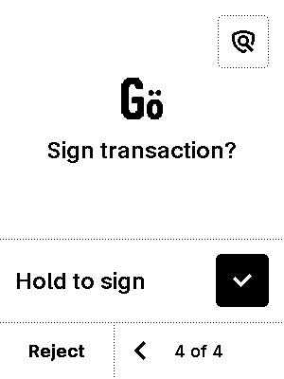

test_tx_simulation_sign_issue
6 image(s)
test_tx_simulation_sign_issue



test_tx_simulation_sign_threat
7 image(s)
test_tx_simulation_sign_threat
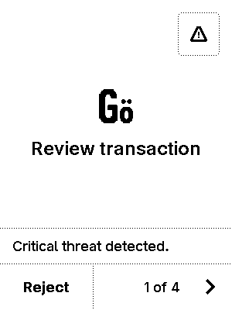
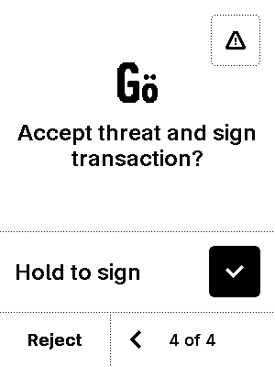
warning


test_tx_simulation_sign_warning
7 image(s)
test_tx_simulation_sign_warning
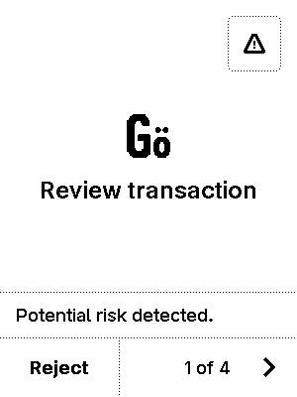
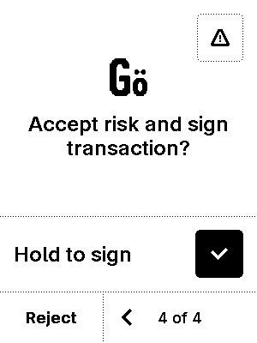
warning


