Nano S Plus Snapshot Gallery
Source: tests/ragger/snapshots/nanosp
Images are grouped by top-level folder name and ordered lexicographically.
test_gating_transaction
5 image(s)
test_gating_transaction
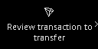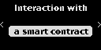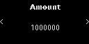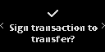
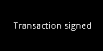

test_gating_transaction_with_proxy
5 image(s)
test_gating_transaction_with_proxy
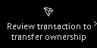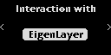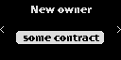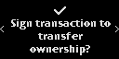


test_gcs_1inch
7 image(s)
test_gcs_1inch
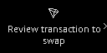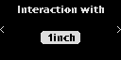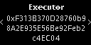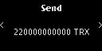
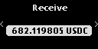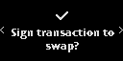

test_gcs_4226
7 image(s)
test_gcs_4226
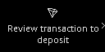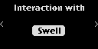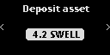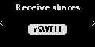
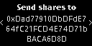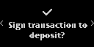

test_gcs_amount_decimals
5 image(s)
test_gcs_amount_decimals
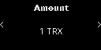


test_gcs_batch
12 image(s)
test_gcs_batch
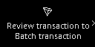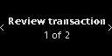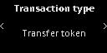
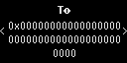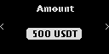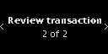
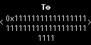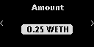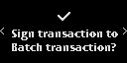

test_gcs_batch_2
18 image(s)
test_gcs_batch_2
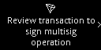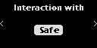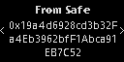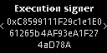
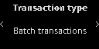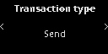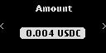
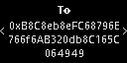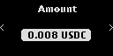
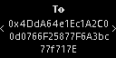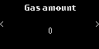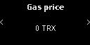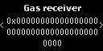
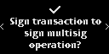

test_gcs_batch_complex
24 image(s)
test_gcs_batch_complex
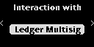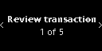
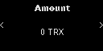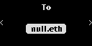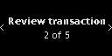
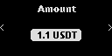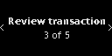
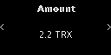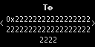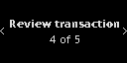
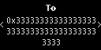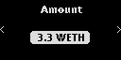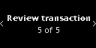
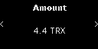

test_gcs_batch_empty_tx
6 image(s)
test_gcs_batch_empty_tx
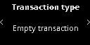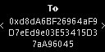


test_gcs_burn_long_calldata
7 image(s)
test_gcs_burn_long_calldata
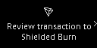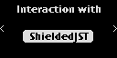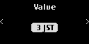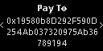
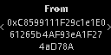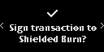

test_gcs_constraints_if_not_0
9 image(s)
test_gcs_constraints_if_not_0
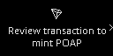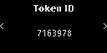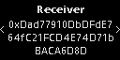
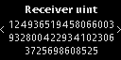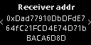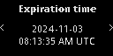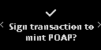


test_gcs_constraints_if_not_addr
6 image(s)
test_gcs_constraints_if_not_addr



test_gcs_constraints_must_be_addr
6 image(s)
test_gcs_constraints_must_be_addr



test_gcs_datetime
5 image(s)
test_gcs_datetime
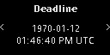


test_gcs_enum
5 image(s)
test_gcs_enum
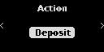


test_gcs_formatter_chain_id
8 image(s)
test_gcs_formatter_chain_id

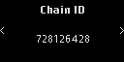

test_gcs_formatter_network
8 image(s)
test_gcs_formatter_network

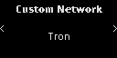

test_gcs_mint_long_calldata
6 image(s)
test_gcs_mint_long_calldata
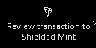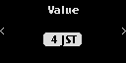
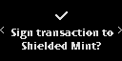

test_gcs_nested_createProxyWithNonce
17 image(s)
test_gcs_nested_createProxyWithNonce
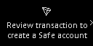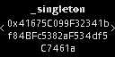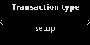
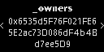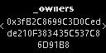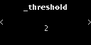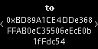
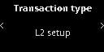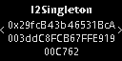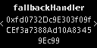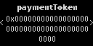
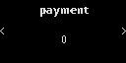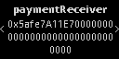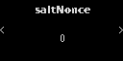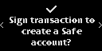


test_gcs_nested_execTransaction_addOwnerWithThreshold
20 image(s)
test_gcs_nested_execTransaction_addOwnerWithThreshold
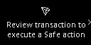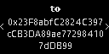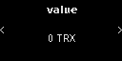
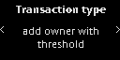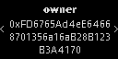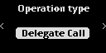
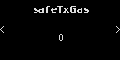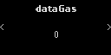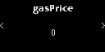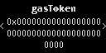
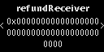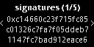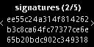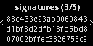
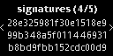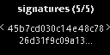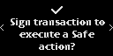

test_gcs_nested_execTransaction_changeThreshold
19 image(s)
test_gcs_nested_execTransaction_changeThreshold
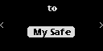
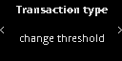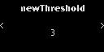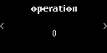

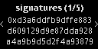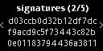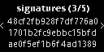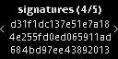
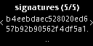

test_gcs_nested_execTransaction_send
7 image(s)
test_gcs_nested_execTransaction_send
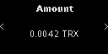
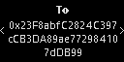

test_gcs_nested_no_param
5 image(s)
test_gcs_nested_no_param
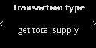


test_gcs_nft
15 image(s)
test_gcs_nft
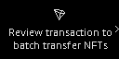
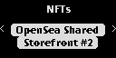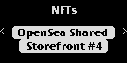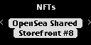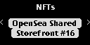
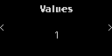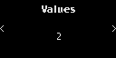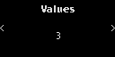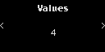
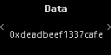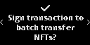

test_gcs_no_param
4 image(s)
test_gcs_no_param
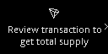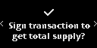

test_gcs_poap
11 image(s)
test_gcs_poap
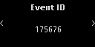
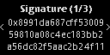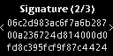
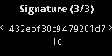

test_gcs_proxy
5 image(s)
test_gcs_proxy



test_gcs_sign
5 image(s)
test_gcs_sign



test_gcs_token_amount
5 image(s)
test_gcs_token_amount
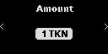


test_gcs_transfer_long_calldata
5 image(s)
test_gcs_transfer_long_calldata
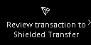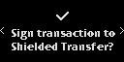


test_gcs_trusted_name
5 image(s)
test_gcs_trusted_name



test_gcs_trusted_name_token
6 image(s)
test_gcs_trusted_name_token
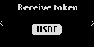


test_get_public_key_confirm_accepted
4 image(s)
test_get_public_key_confirm_accepted
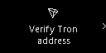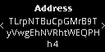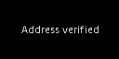

test_get_public_key_confirm_refused
5 image(s)
test_get_public_key_confirm_refused

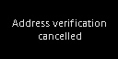

test_personal_sign_metamask
4 image(s)
test_personal_sign_metamask
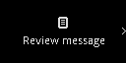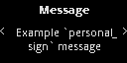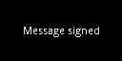

test_personal_sign_non_ascii
5 image(s)
test_personal_sign_non_ascii
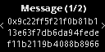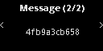


test_personal_sign_opensea
10 image(s)
test_personal_sign_opensea
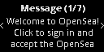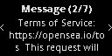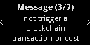
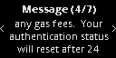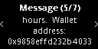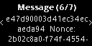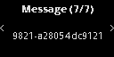


test_personal_sign_reject
5 image(s)
test_personal_sign_reject
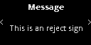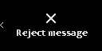
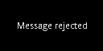

test_settings
91 image(s)
blind_sign
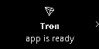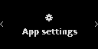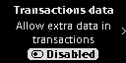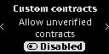
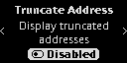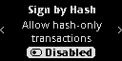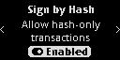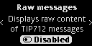
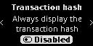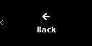
custom_contract

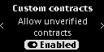

data_allowed
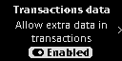


display_hash


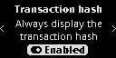
multiple1


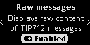
multiple2



multiple3



tip712_token




test_trusted_name_v1
7 image(s)
test_trusted_name_v1
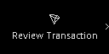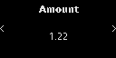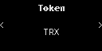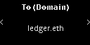
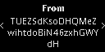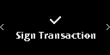

test_trusted_name_v1_non_mainnet
7 image(s)
test_trusted_name_v1_non_mainnet



test_trusted_name_v1_unknown_chain
7 image(s)
test_trusted_name_v1_unknown_chain



test_trusted_name_v1_wrong_addr
7 image(s)
test_trusted_name_v1_wrong_addr
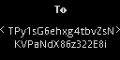


test_trusted_name_v2
7 image(s)
test_trusted_name_v2



test_trusted_name_v2_wrong_chainid
7 image(s)
test_trusted_name_v2_wrong_chainid



test_trx_account_permission_update
6 image(s)
test_trx_account_permission_update
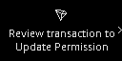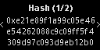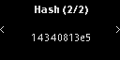
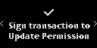

test_trx_account_update
6 image(s)
test_trx_account_update
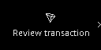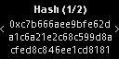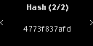
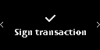

test_trx_create_witness
5 image(s)
test_trx_create_witness
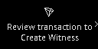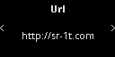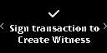


test_trx_custom_contract
11 image(s)
part1

part2
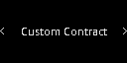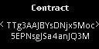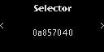
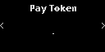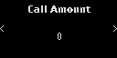


test_trx_delegate_resource
8 image(s)
test_trx_delegate_resource
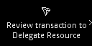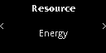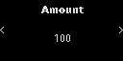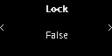
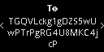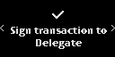

test_trx_ecdh_key
5 image(s)
test_trx_ecdh_key
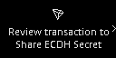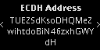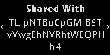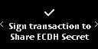


test_trx_exchange_create
8 image(s)
test_trx_exchange_create
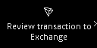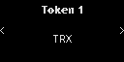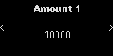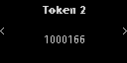
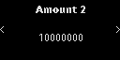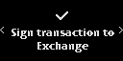

test_trx_exchange_create_with_token_name
8 image(s)
test_trx_exchange_create_with_token_name
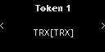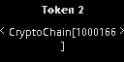


test_trx_exchange_inject
8 image(s)
test_trx_exchange_inject
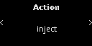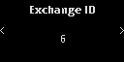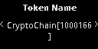
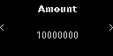

test_trx_exchange_transaction
8 image(s)
test_trx_exchange_transaction
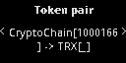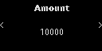
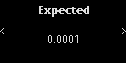

test_trx_exchange_withdraw
8 image(s)
test_trx_exchange_withdraw
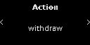


test_trx_freezeV2_balance
7 image(s)
test_trx_freezeV2_balance
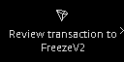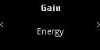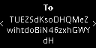
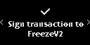

test_trx_freeze_balance_bw
7 image(s)
test_trx_freeze_balance_bw
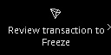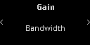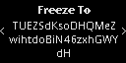
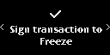

test_trx_freeze_balance_delegate_energy
7 image(s)
test_trx_freeze_balance_delegate_energy
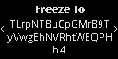


test_trx_freeze_balance_energy
7 image(s)
test_trx_freeze_balance_energy



test_trx_proposal_approve
6 image(s)
test_trx_proposal_approve
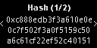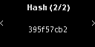


test_trx_proposal_create
6 image(s)
test_trx_proposal_create
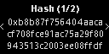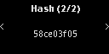


test_trx_proposal_delete
6 image(s)
test_trx_proposal_delete
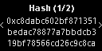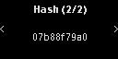


test_trx_send
7 image(s)
test_trx_send
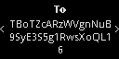


test_trx_send_asset_with_name
7 image(s)
test_trx_send_asset_with_name
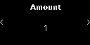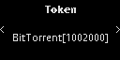


test_trx_send_asset_without_name
7 image(s)
test_trx_send_asset_without_name
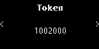


test_trx_send_display_hash
9 image(s)
test_trx_send_display_hash

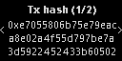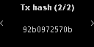


test_trx_send_permissioned
8 image(s)
test_trx_send_permissioned

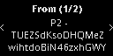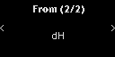

test_trx_send_with_data_field
9 image(s)
part1

part2



test_trx_send_wrong_path
7 image(s)
test_trx_send_wrong_path



test_trx_sign_hash
6 image(s)
test_trx_sign_hash
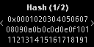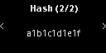


test_trx_sign_message
6 image(s)
test_trx_sign_message
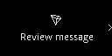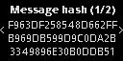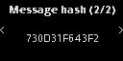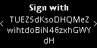


test_trx_sign_personal_message
8 image(s)
test_trx_sign_personal_message
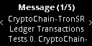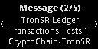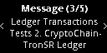
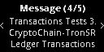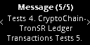

test_trx_sign_tip712
7 image(s)
test_trx_sign_tip712
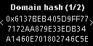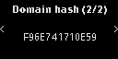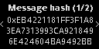
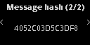

test_trx_tip712_advanced_filtering
8 image(s)
test_trx_tip712_advanced_filtering
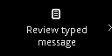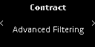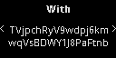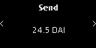
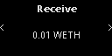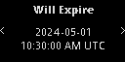

test_trx_tip712_advanced_filtering_permit
6 image(s)
test_trx_tip712_advanced_filtering_permit
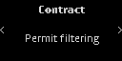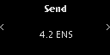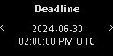


test_trx_tip712_advanced_filtering_unlimited
6 image(s)
test_trx_tip712_advanced_filtering_unlimited
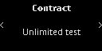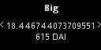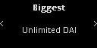


test_trx_tip712_advanced_missing_token-False-True
6 image(s)
test_trx_tip712_advanced_missing_token-False-True
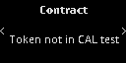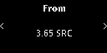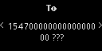


test_trx_tip712_advanced_missing_token-True-False
6 image(s)
test_trx_tip712_advanced_missing_token-True-False
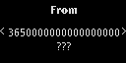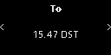


test_trx_tip712_advanced_trusted_name_account_with_account
6 image(s)
test_trx_tip712_advanced_trusted_name_account_with_account
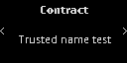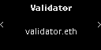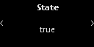


test_trx_tip712_advanced_trusted_name_account_with_account_contract
6 image(s)
test_trx_tip712_advanced_trusted_name_account_with_account_contract



test_trx_tip712_advanced_trusted_name_account_with_contract
6 image(s)
test_trx_tip712_advanced_trusted_name_account_with_contract
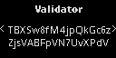


test_trx_tip712_advanced_trusted_name_account_with_contract_account
6 image(s)
test_trx_tip712_advanced_trusted_name_account_with_contract_account



test_trx_tip712_advanced_trusted_name_contract_with_account
6 image(s)
test_trx_tip712_advanced_trusted_name_contract_with_account



test_trx_tip712_advanced_trusted_name_contract_with_account_contract
6 image(s)
test_trx_tip712_advanced_trusted_name_contract_with_account_contract
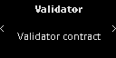


test_trx_tip712_advanced_trusted_name_contract_with_contract
6 image(s)
test_trx_tip712_advanced_trusted_name_contract_with_contract



test_trx_tip712_advanced_trusted_name_contract_with_contract_account
6 image(s)
test_trx_tip712_advanced_trusted_name_contract_with_contract_account



test_trx_tip712_batch
18 image(s)
test_trx_tip712_batch
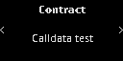
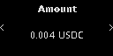
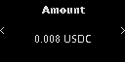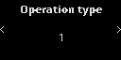
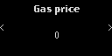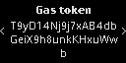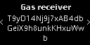


test_trx_tip712_calldata
6 image(s)
test_trx_tip712_calldata
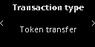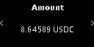


test_trx_tip712_calldata_empty_send
7 image(s)
test_trx_tip712_calldata_empty_send
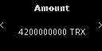
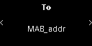

test_trx_tip712_calldata_no_param
5 image(s)
test_trx_tip712_calldata_no_param



test_trx_tip712_filtering_empty_array
5 image(s)
test_trx_tip712_filtering_empty_array
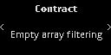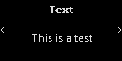


test_trx_tip712_gondi
11 image(s)
part1
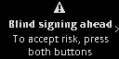
part2
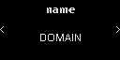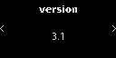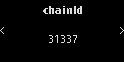
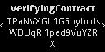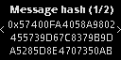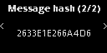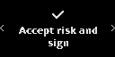


test_trx_tip712_new-00-simple_mail-data-False-False
11 image(s)
part1

part2
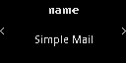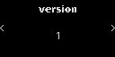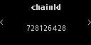
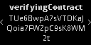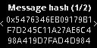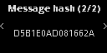


test_trx_tip712_new-00-simple_mail-data-False-True
6 image(s)
test_trx_tip712_new-00-simple_mail-data-False-True
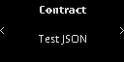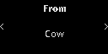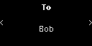


test_trx_tip712_new-00-simple_mail-data-True-False
19 image(s)
part1

part2
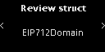
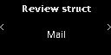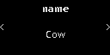
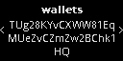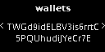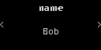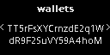
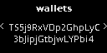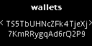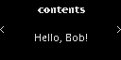


test_trx_tip712_new-00-simple_mail-data-True-True
19 image(s)
part1

part2






test_trx_tip712_new-01-addresses_array_mail-data-False-False
11 image(s)
part1

part2
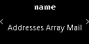
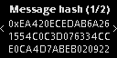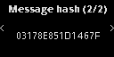


test_trx_tip712_new-01-addresses_array_mail-data-True-False
15 image(s)
part1

part2

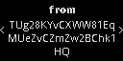
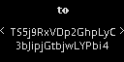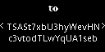


test_trx_tip712_new-02-recipients_array_mail-data-False-False
11 image(s)
part1

part2
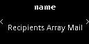
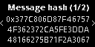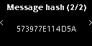


test_trx_tip712_new-02-recipients_array_mail-data-True-False
20 image(s)
part1

part2


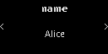



test_trx_tip712_new-03-long_string-data-False-False
11 image(s)
part1

part2
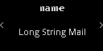
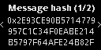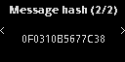


test_trx_tip712_new-03-long_string-data-True-False
36 image(s)
part1

part2



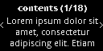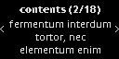
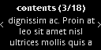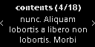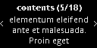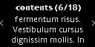
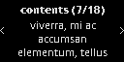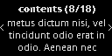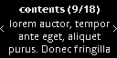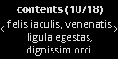
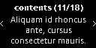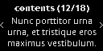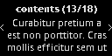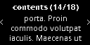
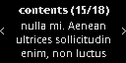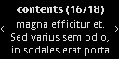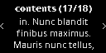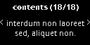


test_trx_tip712_new-04-long_bytes-data-False-False
11 image(s)
part1

part2
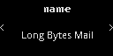
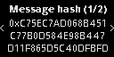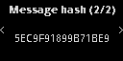


test_trx_tip712_new-04-long_bytes-data-True-False
23 image(s)
part1

part2



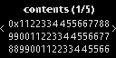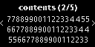
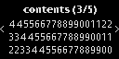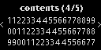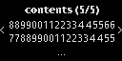


test_trx_tip712_new-05-signed_ints-data-False-False
11 image(s)
part1

part2
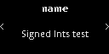
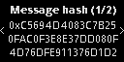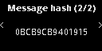


test_trx_tip712_new-05-signed_ints-data-True-False
23 image(s)
part1

part2

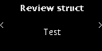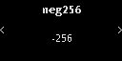
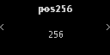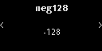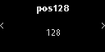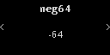
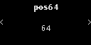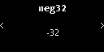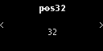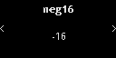
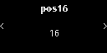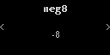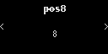


test_trx_tip712_new-06-boolean-data-False-False
11 image(s)
part1

part2
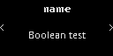
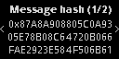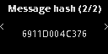


test_trx_tip712_new-06-boolean-data-True-False
13 image(s)
part1

part2

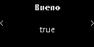
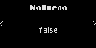

test_trx_tip712_new-07-fixed_bytes-data-False-False
11 image(s)
part1

part2
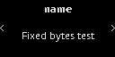
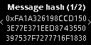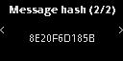


test_trx_tip712_new-07-fixed_bytes-data-True-False
17 image(s)
part1

part2

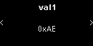
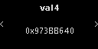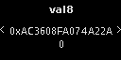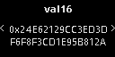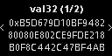
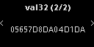

test_trx_tip712_new-08-opensea-data-False-False
11 image(s)
part1

part2
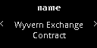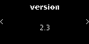
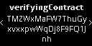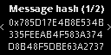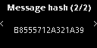


test_trx_tip712_new-08-opensea-data-False-True
8 image(s)
test_trx_tip712_new-08-opensea-data-False-True
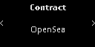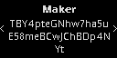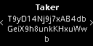
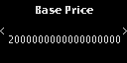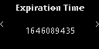

test_trx_tip712_new-08-opensea-data-True-False
44 image(s)
part1

part2

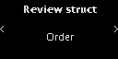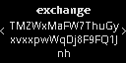
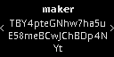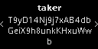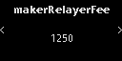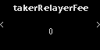
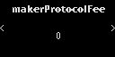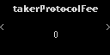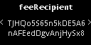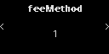
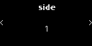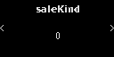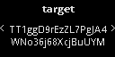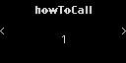
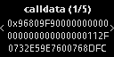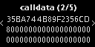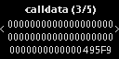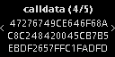
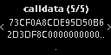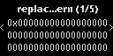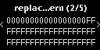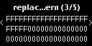
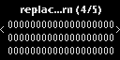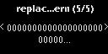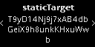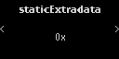
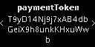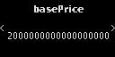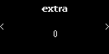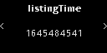
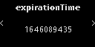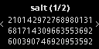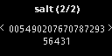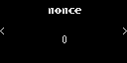


test_trx_tip712_new-08-opensea-data-True-True
44 image(s)
part1

part2












test_trx_tip712_new-09-rarible-data-False-False
11 image(s)
part1

part2
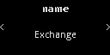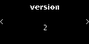
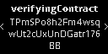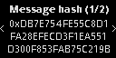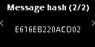


test_trx_tip712_new-09-rarible-data-True-False
31 image(s)
part1

part2


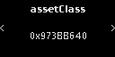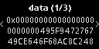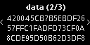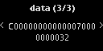
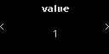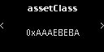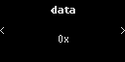
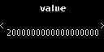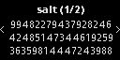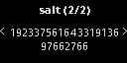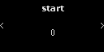
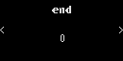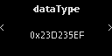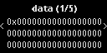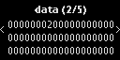
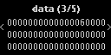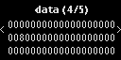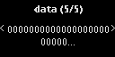


test_trx_tip712_new-10-multidimensional_arrays-data-False-False
11 image(s)
part1

part2
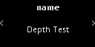
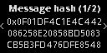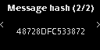


test_trx_tip712_new-10-multidimensional_arrays-data-True-False
17 image(s)
part1

part2

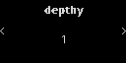
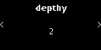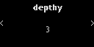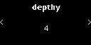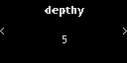
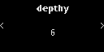

test_trx_tip712_new-11-complex_structs-data-False-False
11 image(s)
part1

part2
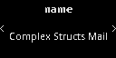
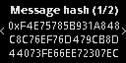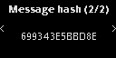


test_trx_tip712_new-11-complex_structs-data-False-True
10 image(s)
test_trx_tip712_new-11-complex_structs-data-False-True
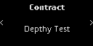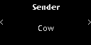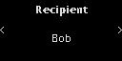
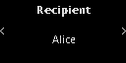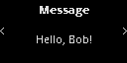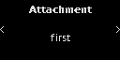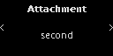


test_trx_tip712_new-11-complex_structs-data-True-False
25 image(s)
part1

part2


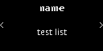

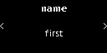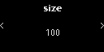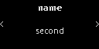
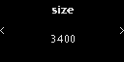

test_trx_tip712_new-11-complex_structs-data-True-True
25 image(s)
part1

part2







test_trx_tip712_new-12-sign_in-data-False-False
9 image(s)
part1

part2
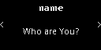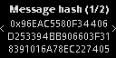
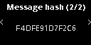

test_trx_tip712_new-12-sign_in-data-False-True
7 image(s)
test_trx_tip712_new-12-sign_in-data-False-True
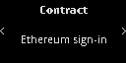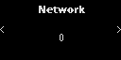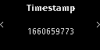
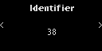

test_trx_tip712_new-12-sign_in-data-True-False
12 image(s)
part1

part2

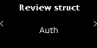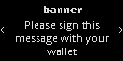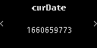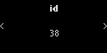


test_trx_tip712_new-12-sign_in-data-True-True
12 image(s)
part1

part2




test_trx_tip712_new-13-empty_arrays-data-False-False
11 image(s)
part1

part2
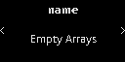
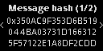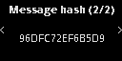


test_trx_tip712_new-13-empty_arrays-data-True-False
18 image(s)
part1

part2

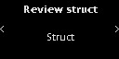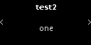
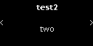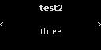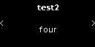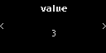
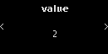

test_trx_tip712_new-14-rabby_bug-data-False-False
11 image(s)
part1

part2
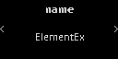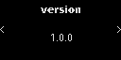
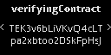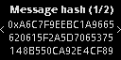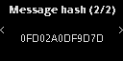


test_trx_tip712_new-14-rabby_bug-data-True-False
23 image(s)
part1

part2

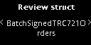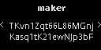
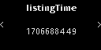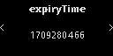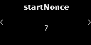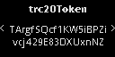
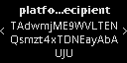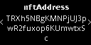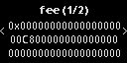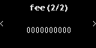
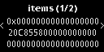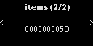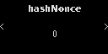


test_trx_tip712_new-15-opensea_bulkorder-data-False-False
11 image(s)
part1

part2
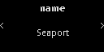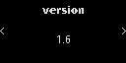
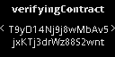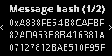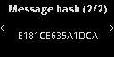


test_trx_tip712_new-15-opensea_bulkorder-data-True-False
81 image(s)
part1

part2

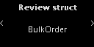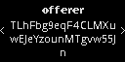
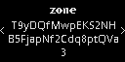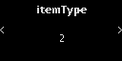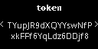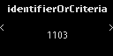
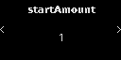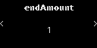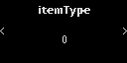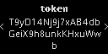
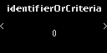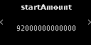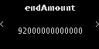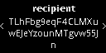
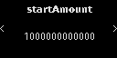
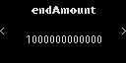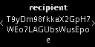
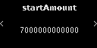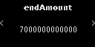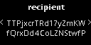
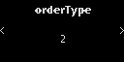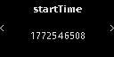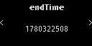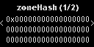
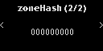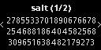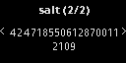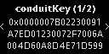
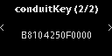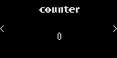
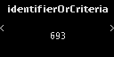






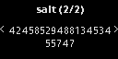


test_trx_tip712_new-16-trctoken-data-False-False
12 image(s)
part1

part2
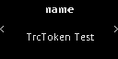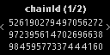
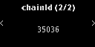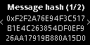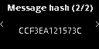


test_trx_tip712_new-16-trctoken-data-True-False
25 image(s)
part1

part2


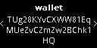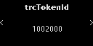
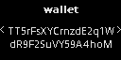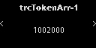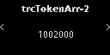
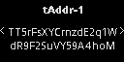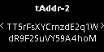


test_trx_tip712_new-17-trctoken-new-data-False-False
11 image(s)
part1

part2
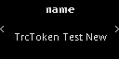



test_trx_tip712_new-17-trctoken-new-data-True-False
24 image(s)
part1

part2







test_trx_tip712_proxy
6 image(s)
test_trx_tip712_proxy
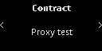


test_trx_trc20_approve
7 image(s)
test_trx_trc20_approve
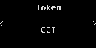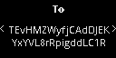


test_trx_trc20_send
7 image(s)
test_trx_trc20_send



test_trx_trc20_send_e20_amount
7 image(s)
test_trx_trc20_send_e20_amount
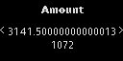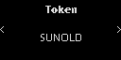


test_trx_trc20_send_zero_amount
7 image(s)
test_trx_trc20_send_zero_amount
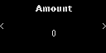


test_trx_undelegate_resource
7 image(s)
test_trx_undelegate_resource
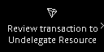
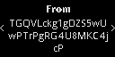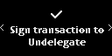

test_trx_unfreezeV2_balance
7 image(s)
test_trx_unfreezeV2_balance
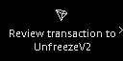
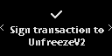

test_trx_unfreeze_balance_bw
6 image(s)
test_trx_unfreeze_balance_bw
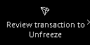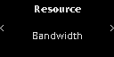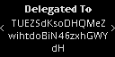
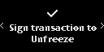

test_trx_unfreeze_balance_delegate_energy
6 image(s)
test_trx_unfreeze_balance_delegate_energy
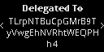


test_trx_unknown_trc20_send
11 image(s)
part1

part2
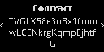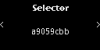



test_trx_vote_witness
9 image(s)
test_trx_vote_witness
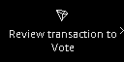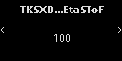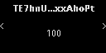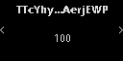
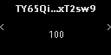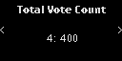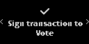


test_trx_withdraw_balance
4 image(s)
test_trx_withdraw_balance
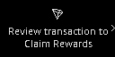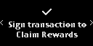

test_trx_withdraw_unfreeze
4 image(s)
test_trx_withdraw_unfreeze
