Stax Snapshot Gallery
Source: tests/ragger/snapshots/stax
Images are grouped by top-level folder name and ordered lexicographically.
test_blind_sign
7 image(s)
test_blind_sign
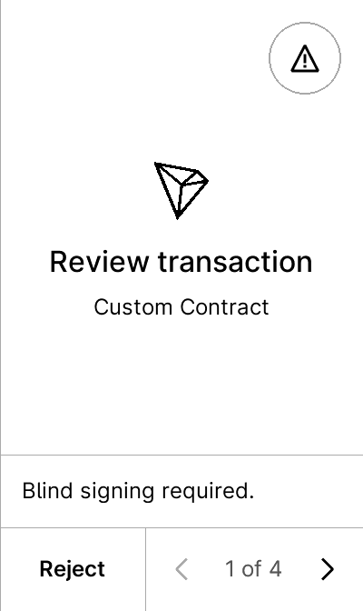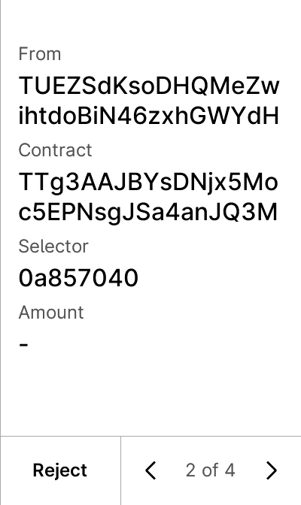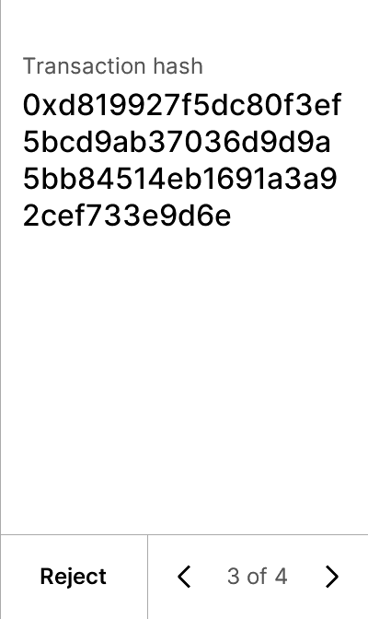
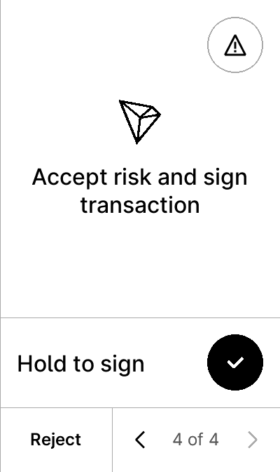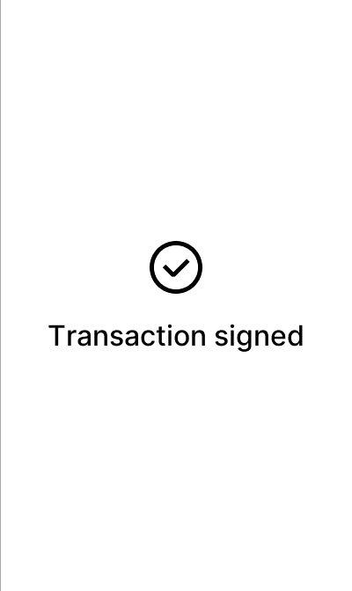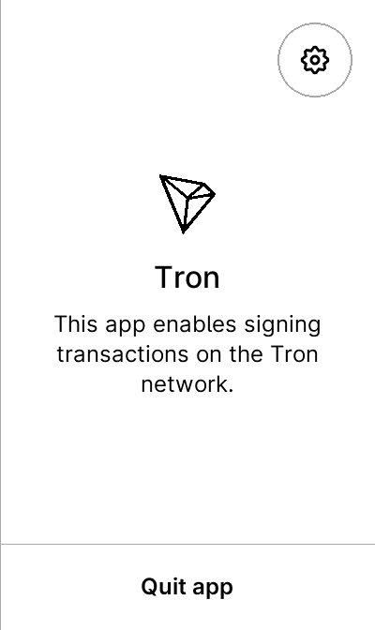
warning
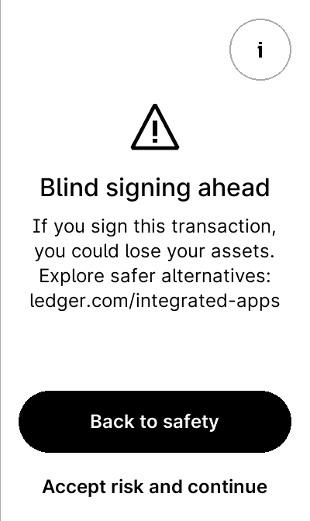

test_blind_sign_nonzero
7 image(s)
test_blind_sign_nonzero
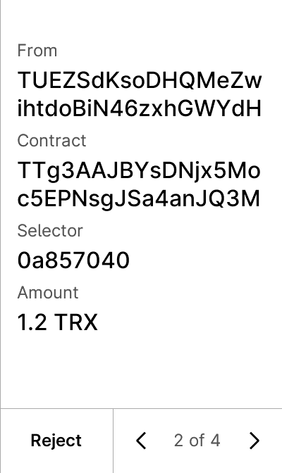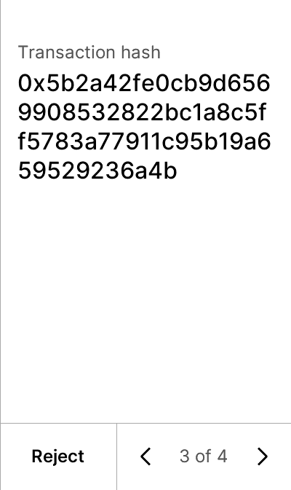

warning


test_blind_sign_not_enabled_error
2 image(s)
test_blind_sign_not_enabled_error
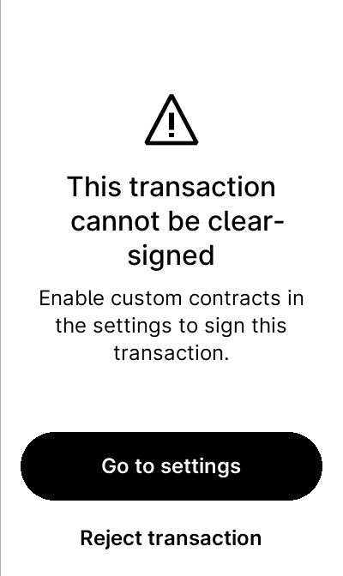

test_blind_sign_rejected
8 image(s)
test_blind_sign_rejected

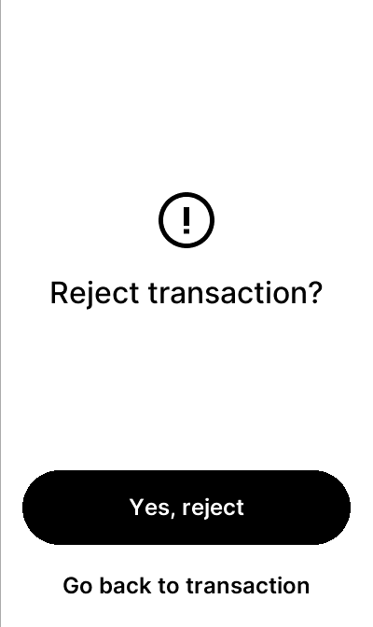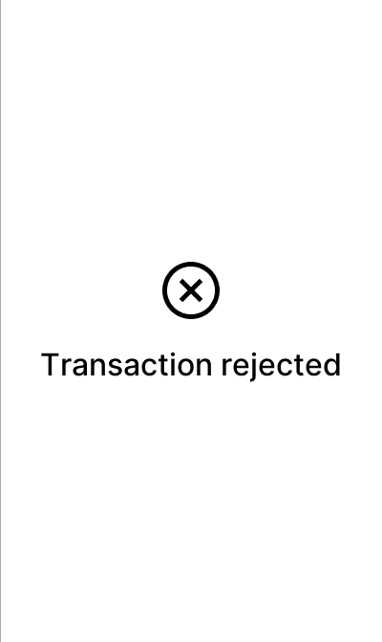

warning


test_gating_blind_signing
8 image(s)
test_gating_blind_signing


warning
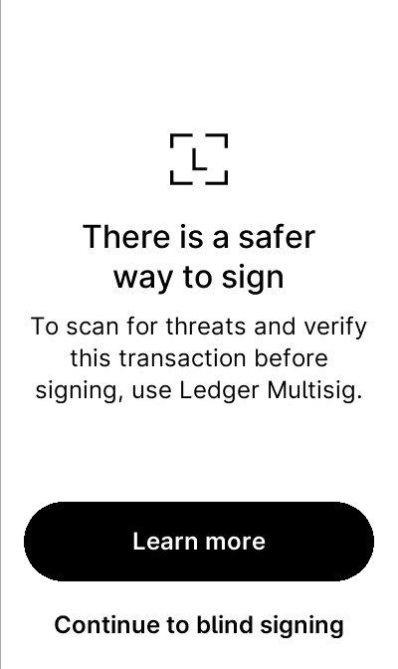

test_gating_blind_signing_with_proxy
8 image(s)
test_gating_blind_signing_with_proxy


warning


test_gating_tip712
10 image(s)
test_gating_tip712
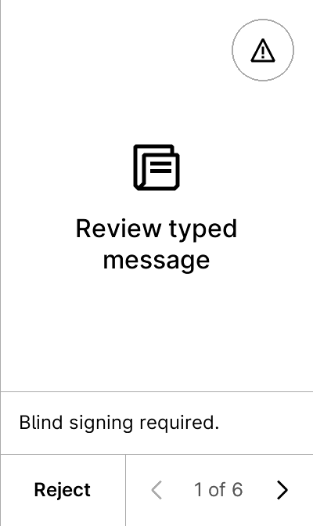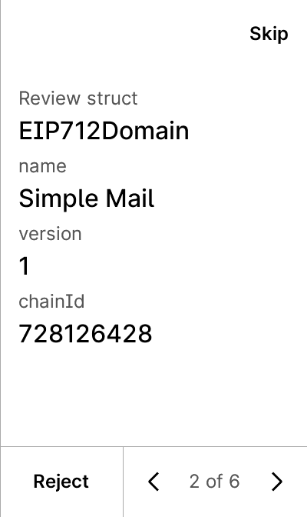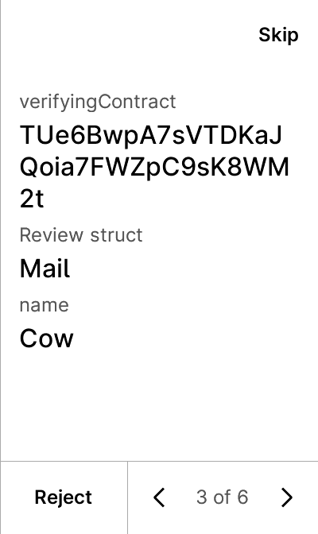
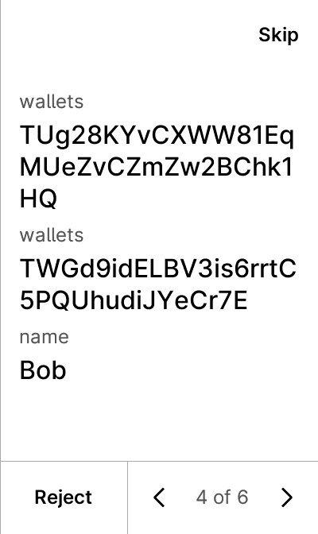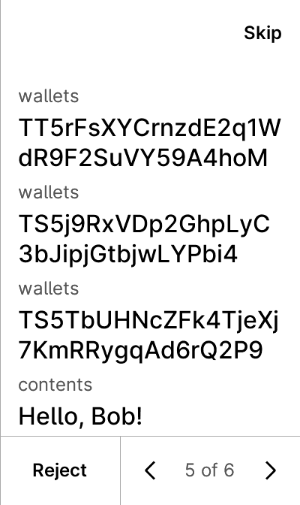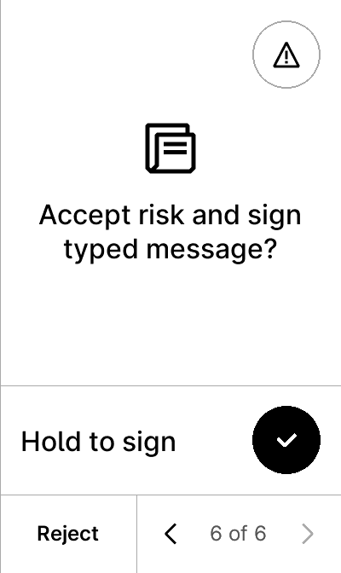
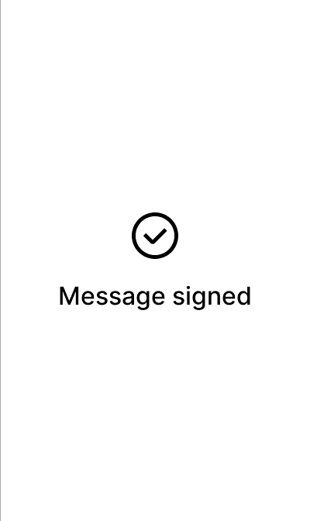
warning


test_gcs_1inch
5 image(s)
test_gcs_1inch
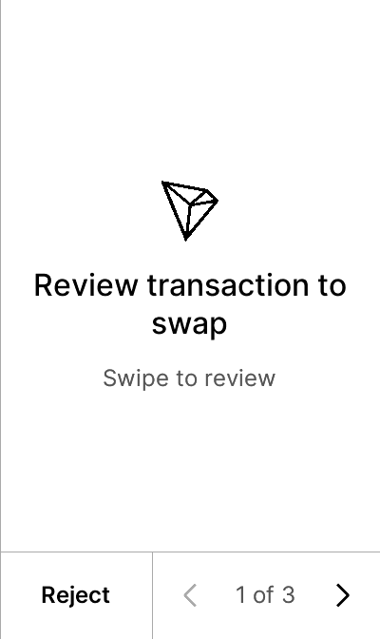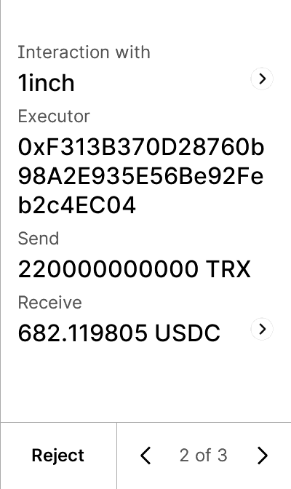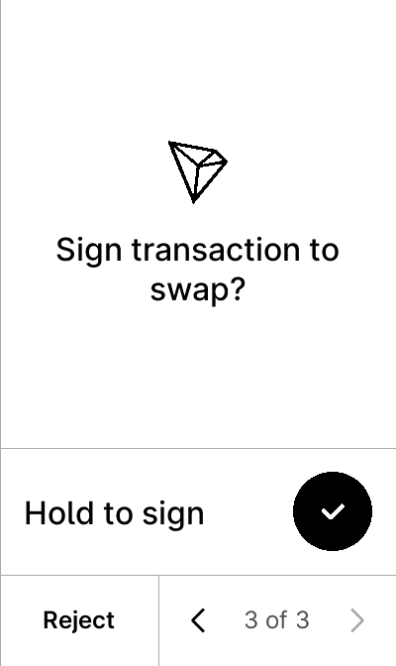


test_gcs_4226
5 image(s)
test_gcs_4226
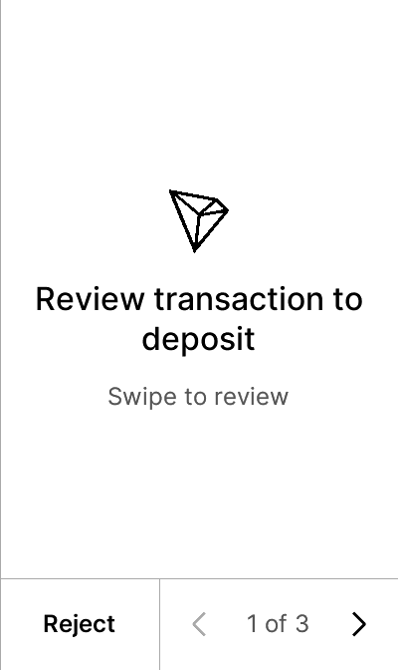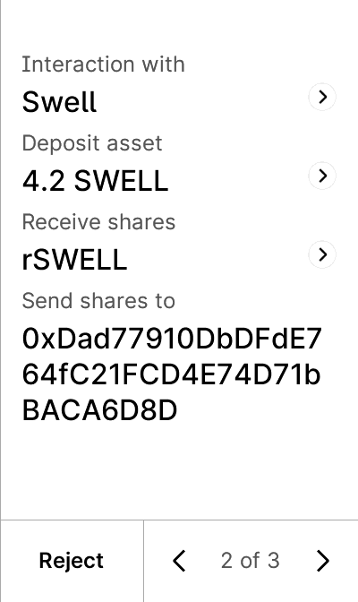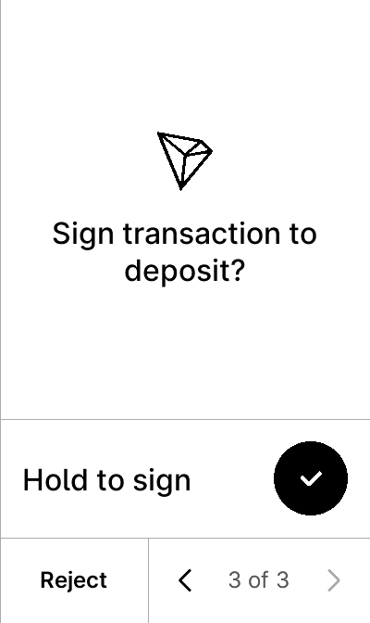


test_gcs_amount_decimals
5 image(s)
test_gcs_amount_decimals
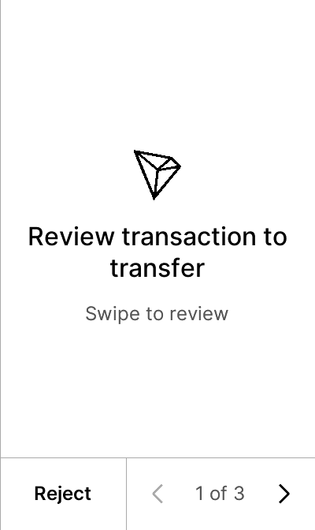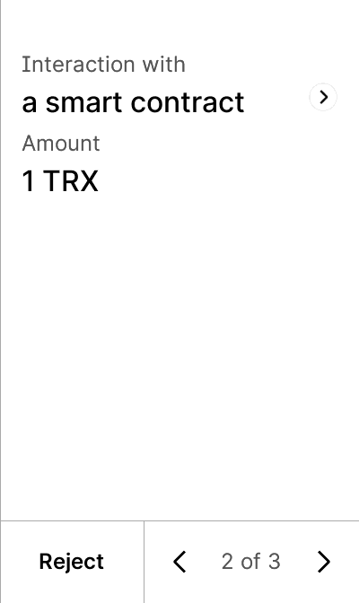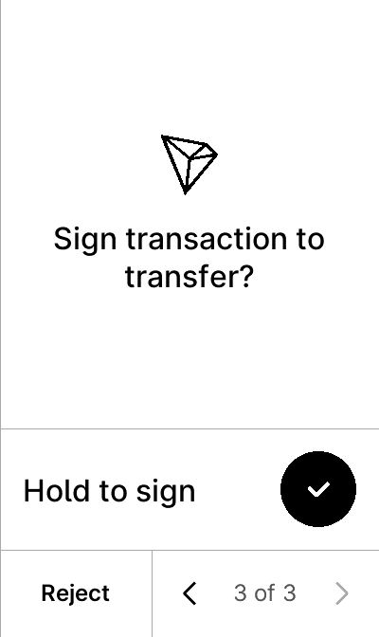


test_gcs_batch
9 image(s)
test_gcs_batch
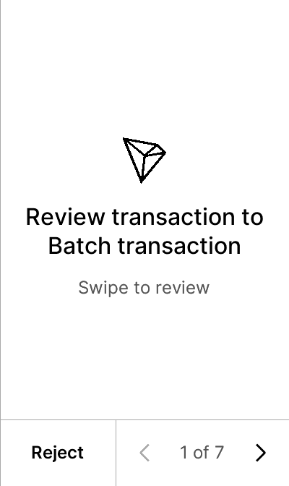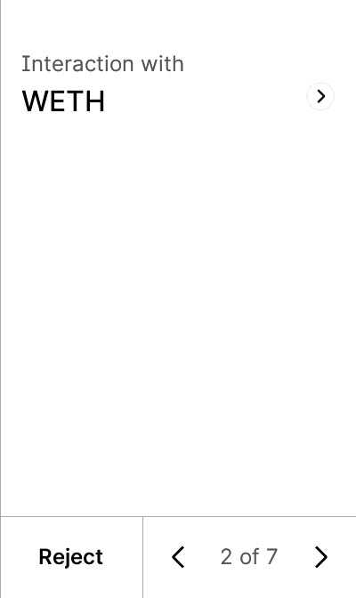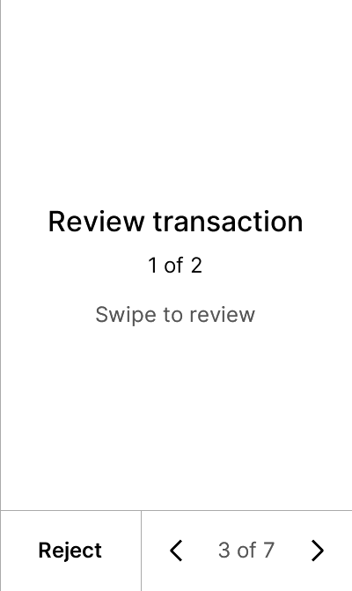
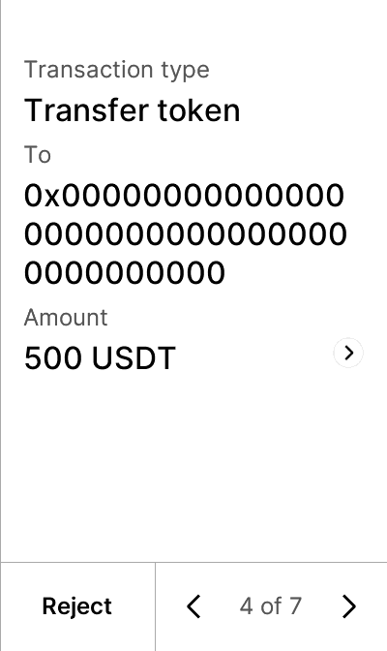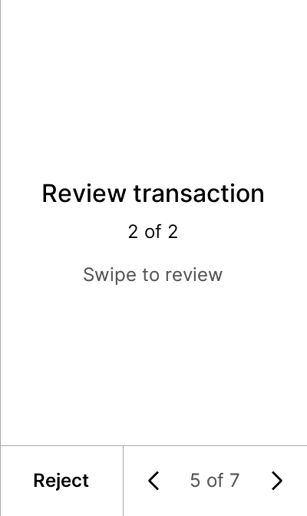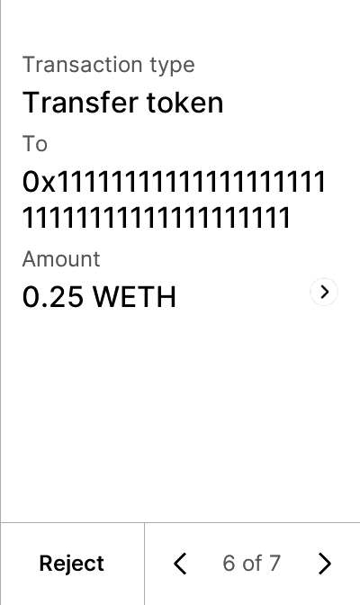
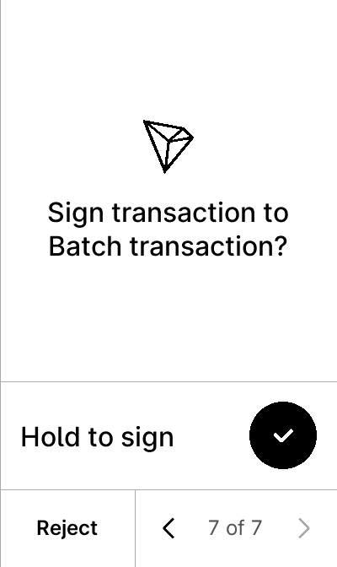

test_gcs_batch_2
10 image(s)
test_gcs_batch_2
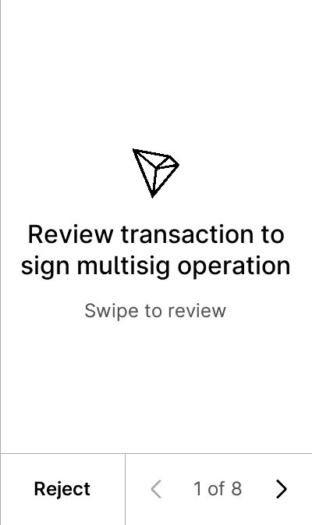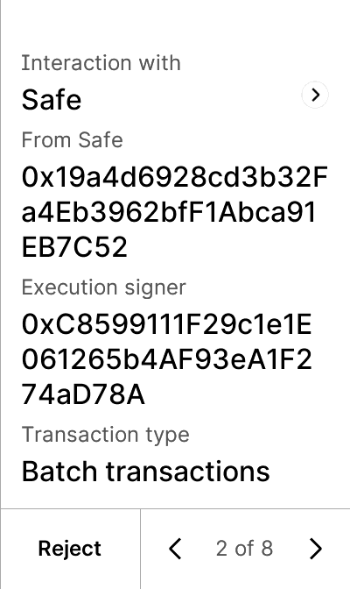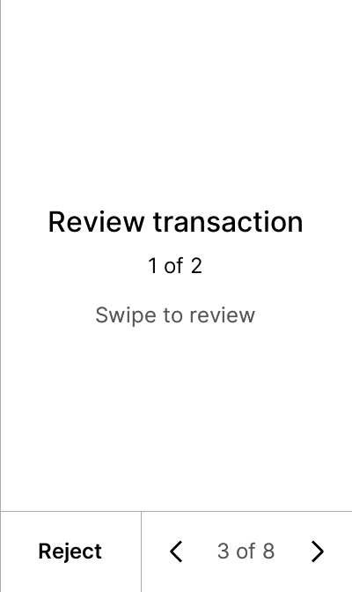
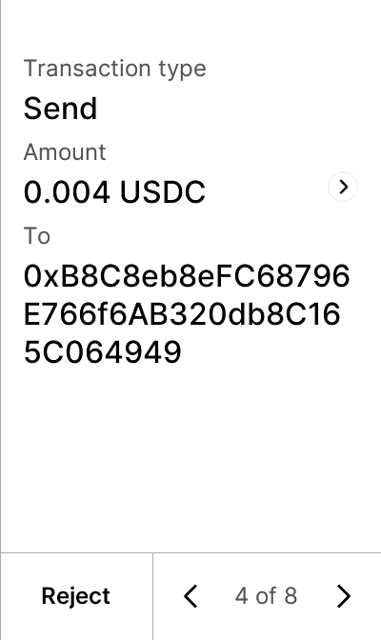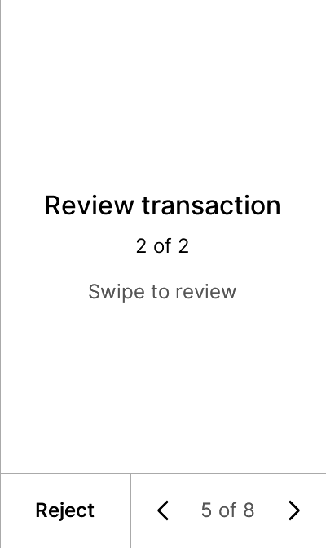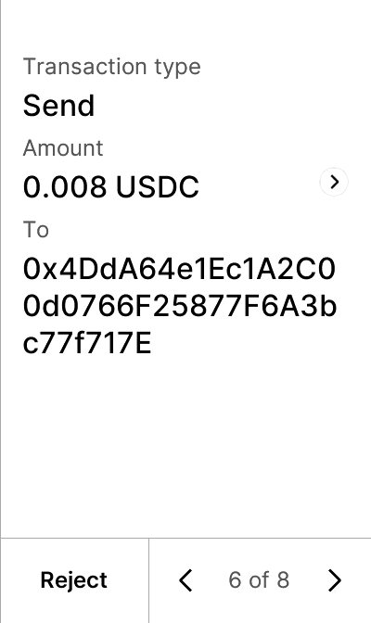
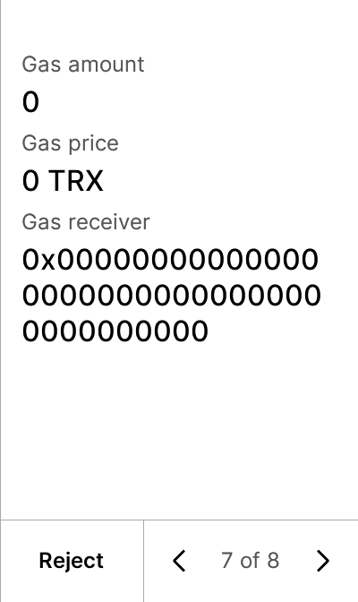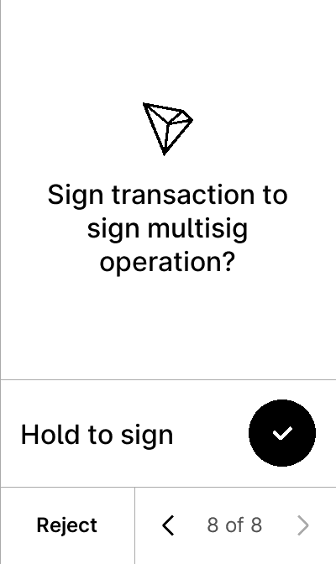


test_gcs_batch_complex
17 image(s)
test_gcs_batch_complex
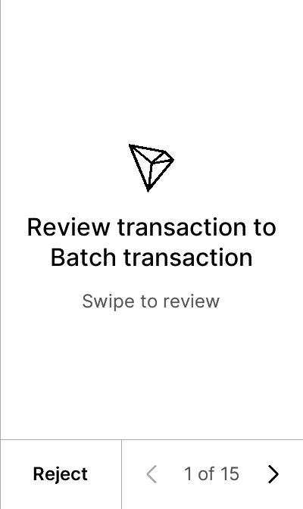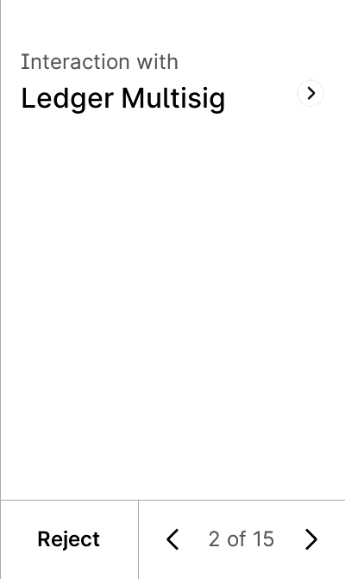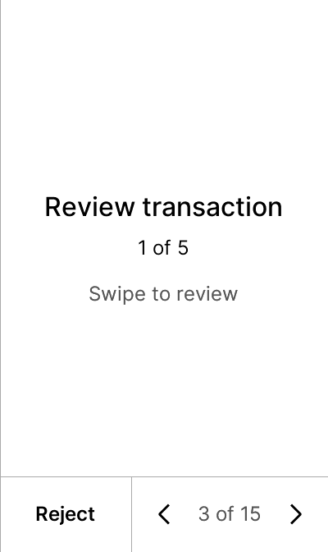
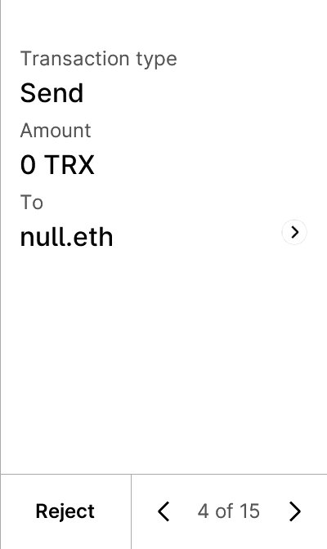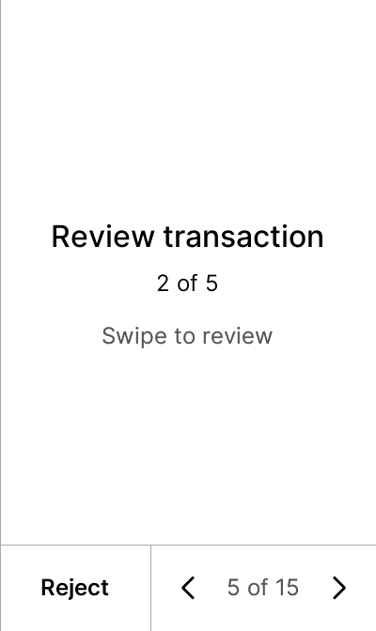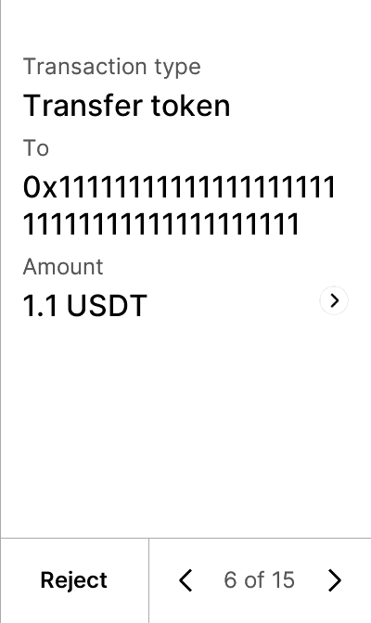
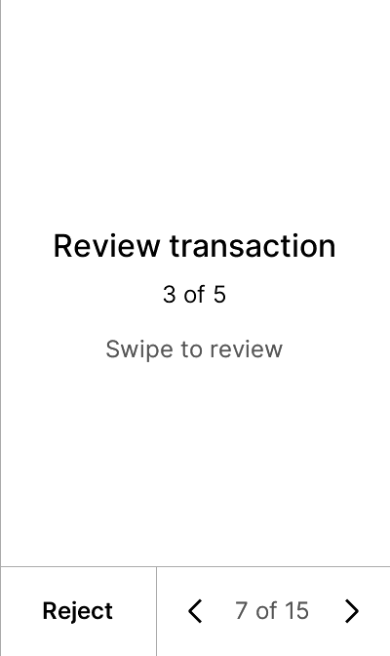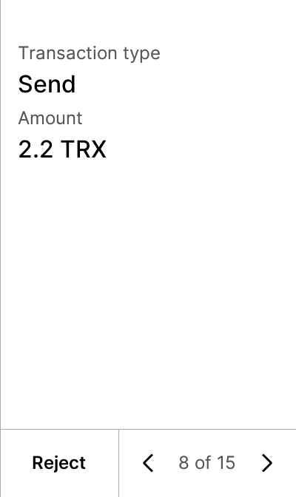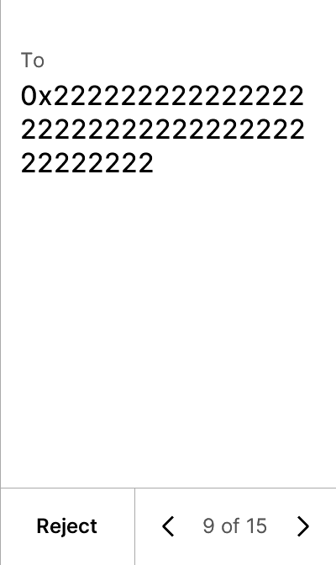
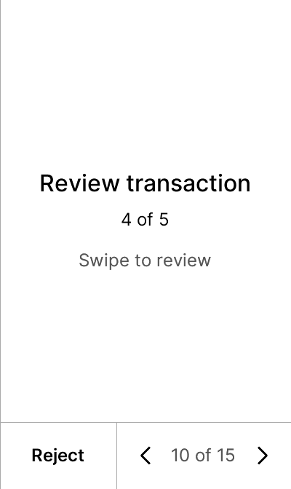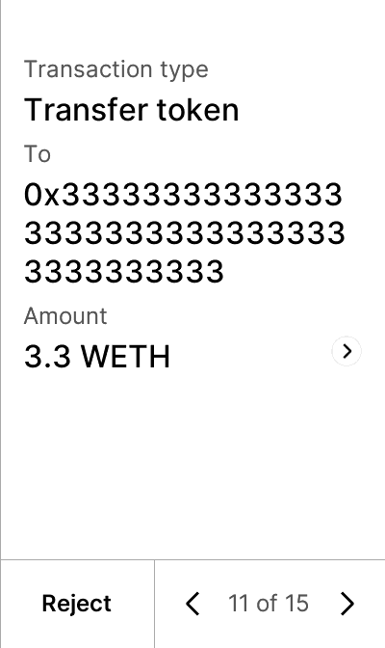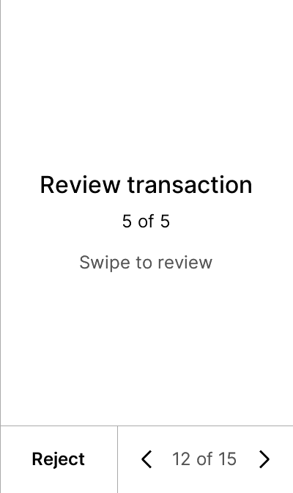
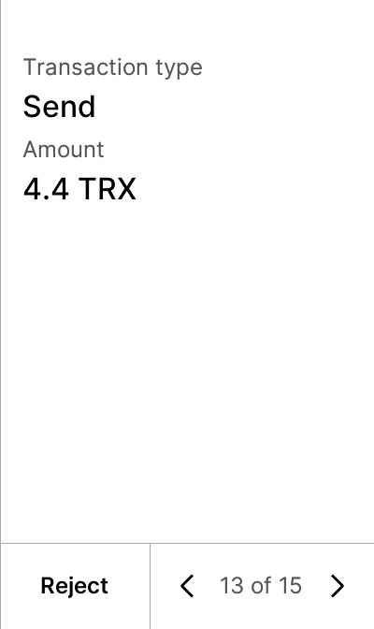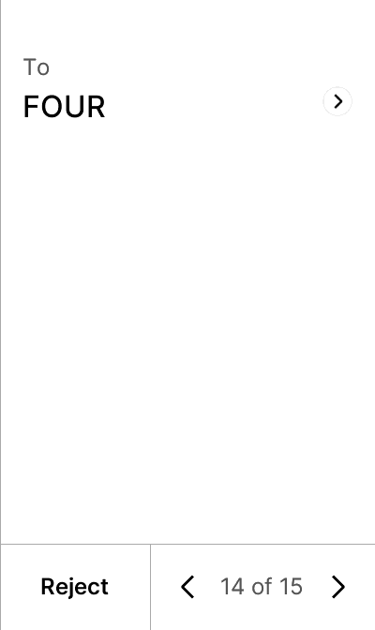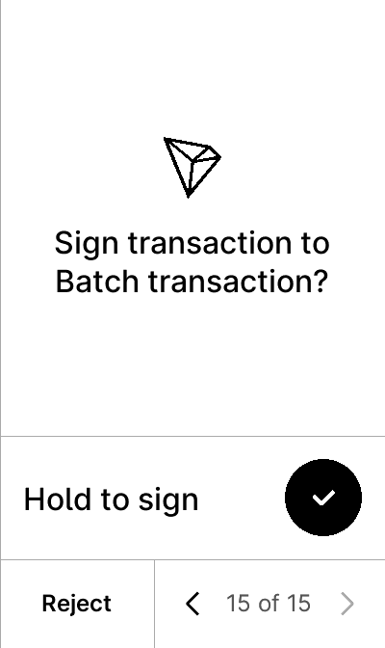


test_gcs_batch_empty_tx
5 image(s)
test_gcs_batch_empty_tx
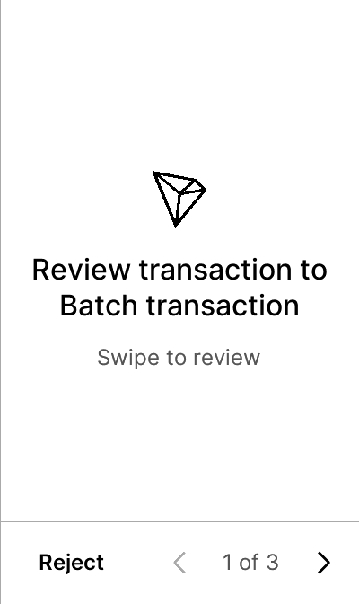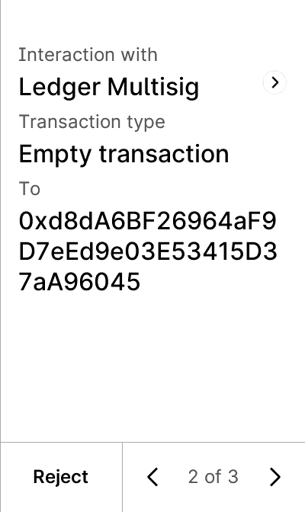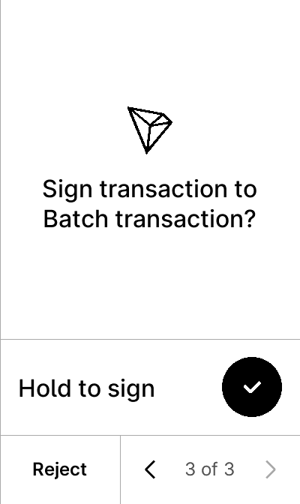


test_gcs_burn_long_calldata
5 image(s)
test_gcs_burn_long_calldata
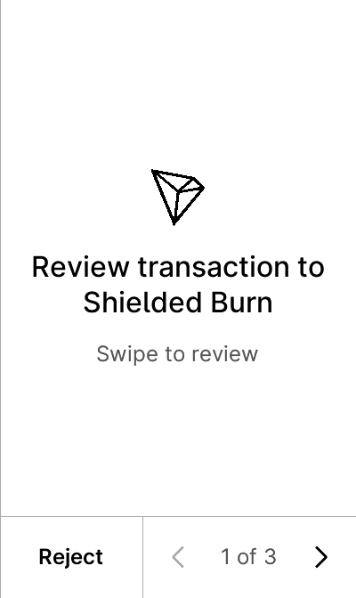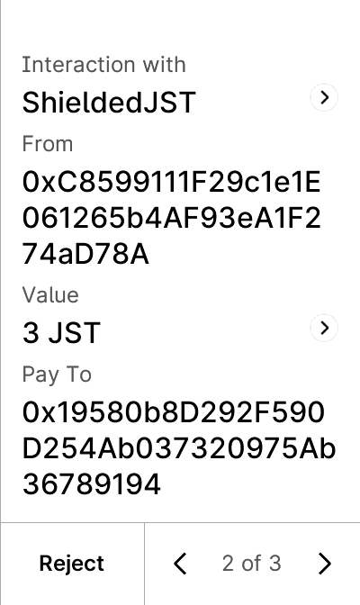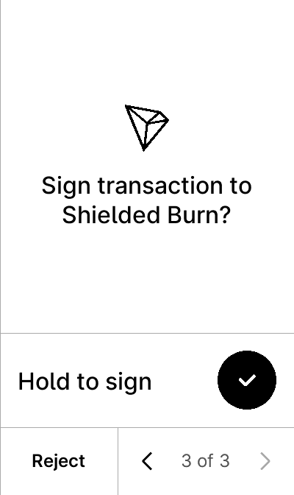


test_gcs_constraints_if_not_0
6 image(s)
test_gcs_constraints_if_not_0
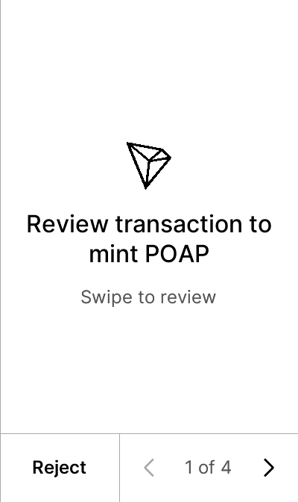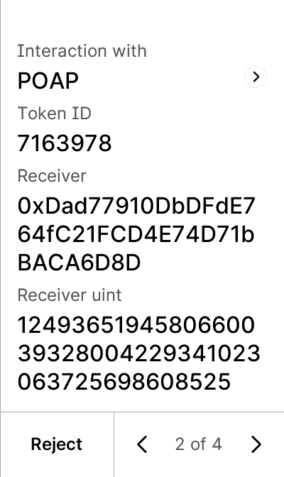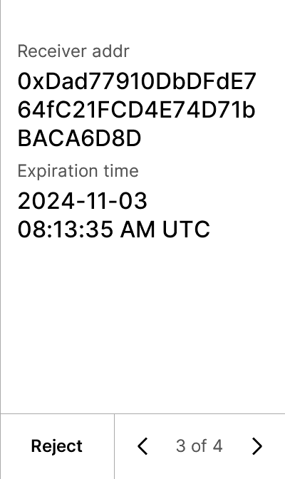
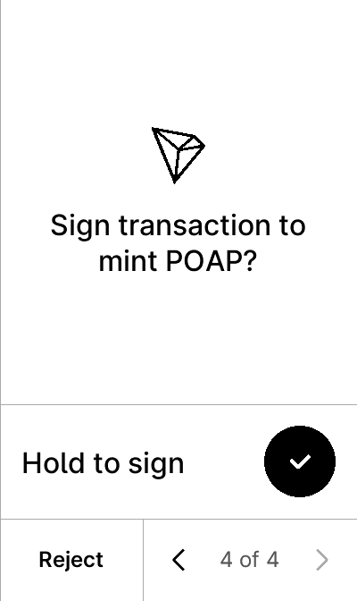

test_gcs_constraints_if_not_addr
5 image(s)
test_gcs_constraints_if_not_addr
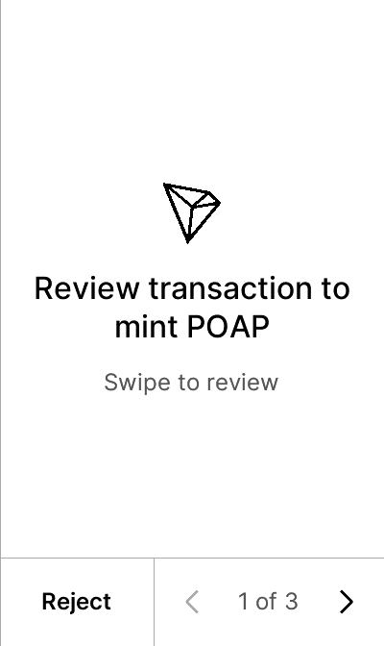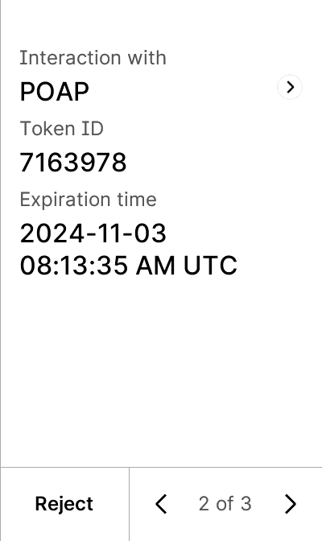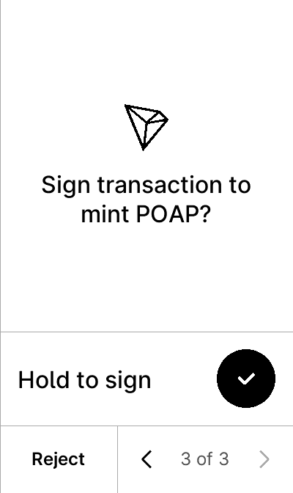


test_gcs_constraints_must_be_addr
5 image(s)
test_gcs_constraints_must_be_addr



test_gcs_datetime
5 image(s)
test_gcs_datetime
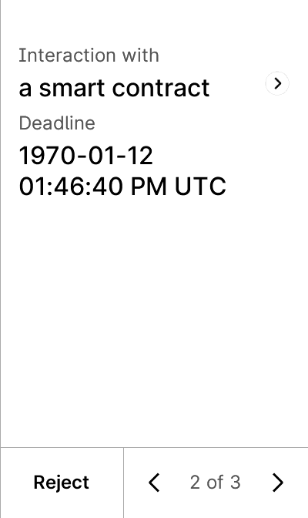


test_gcs_enum
5 image(s)
test_gcs_enum
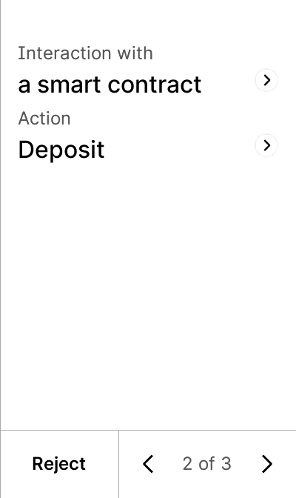


test_gcs_formatter_chain_id
6 image(s)
test_gcs_formatter_chain_id
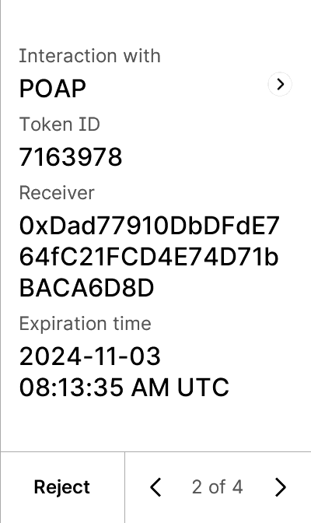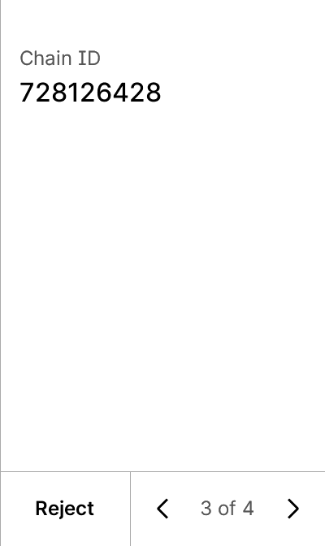


test_gcs_formatter_network
6 image(s)
test_gcs_formatter_network
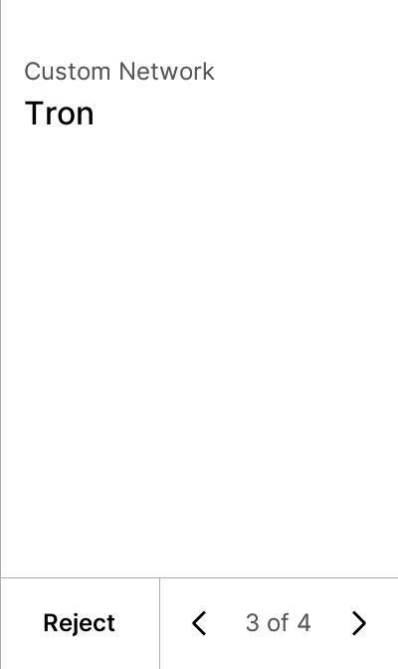


test_gcs_mint_long_calldata
5 image(s)
test_gcs_mint_long_calldata
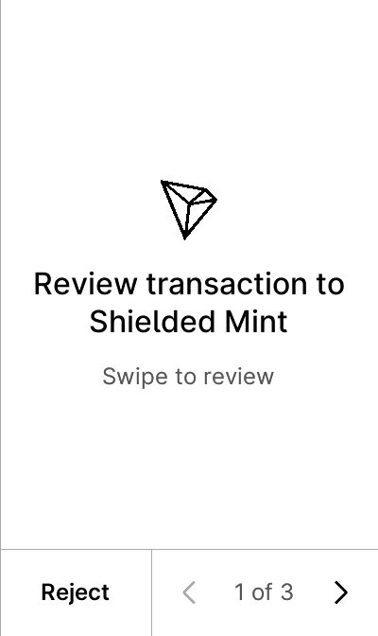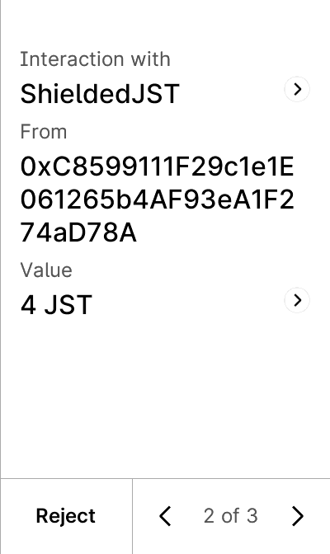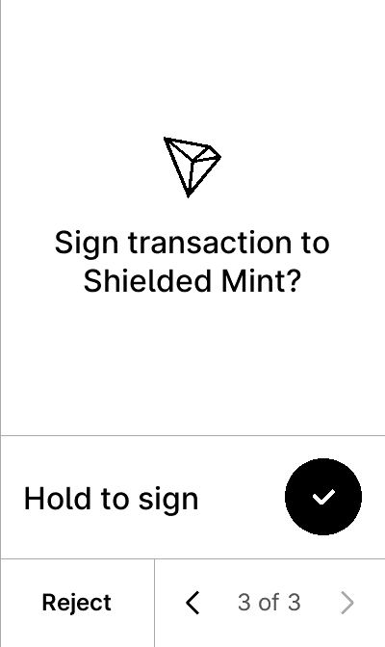


test_gcs_nested_createProxyWithNonce
8 image(s)
test_gcs_nested_createProxyWithNonce
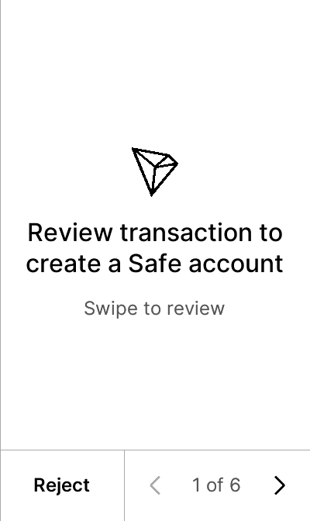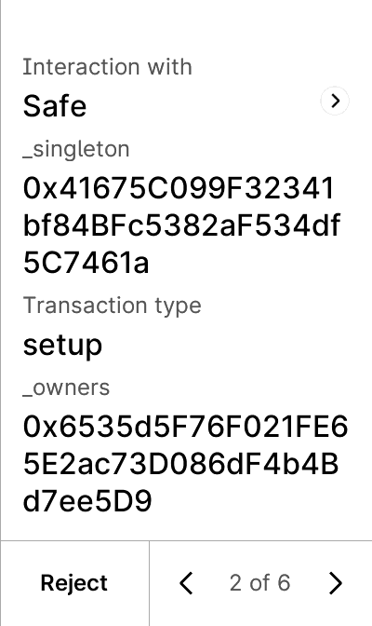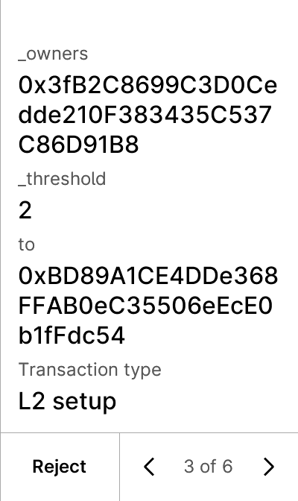
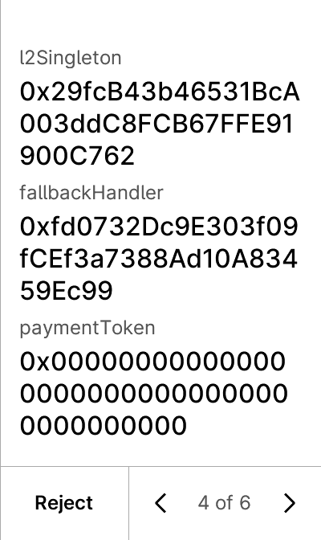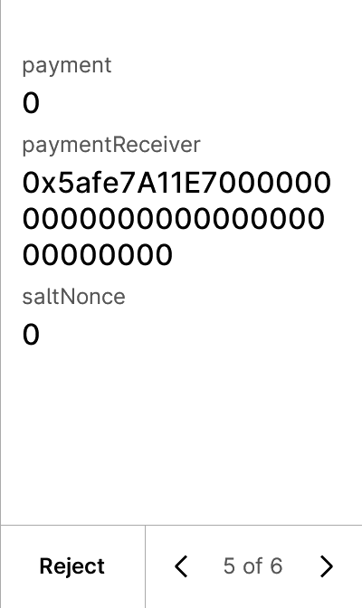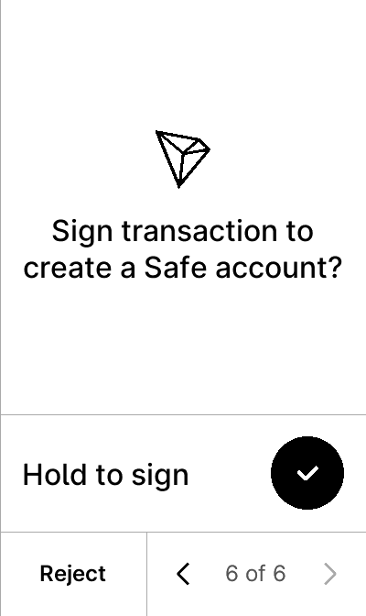


test_gcs_nested_execTransaction_addOwnerWithThreshold
8 image(s)
test_gcs_nested_execTransaction_addOwnerWithThreshold
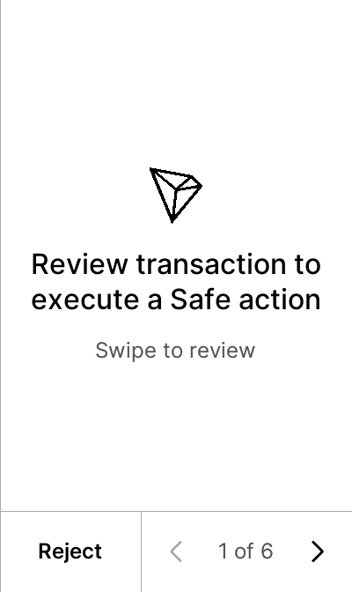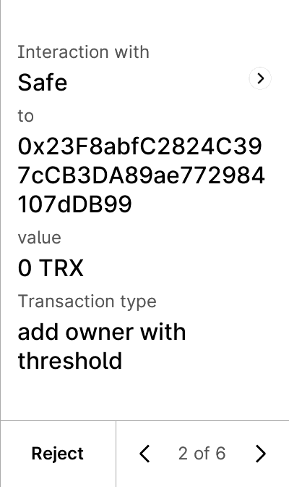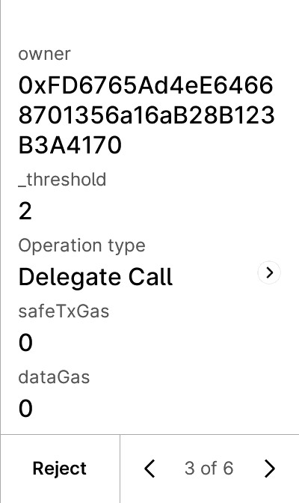
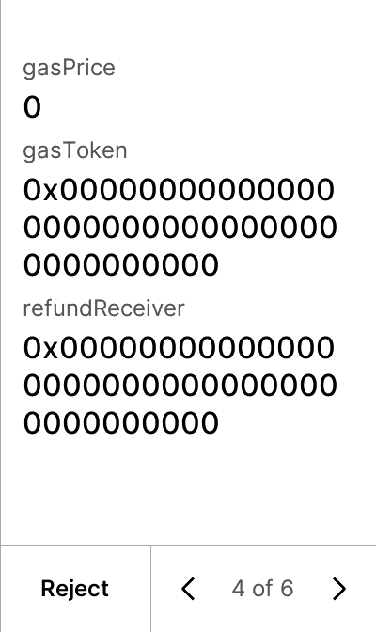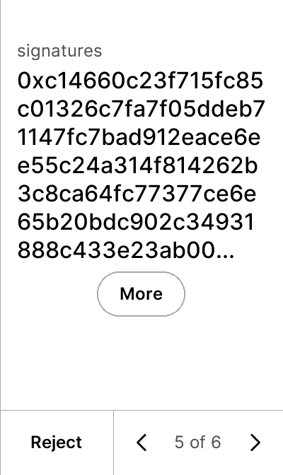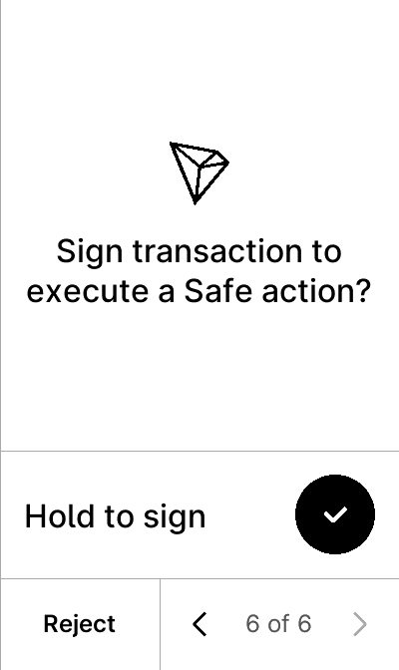


test_gcs_nested_execTransaction_changeThreshold
8 image(s)
test_gcs_nested_execTransaction_changeThreshold
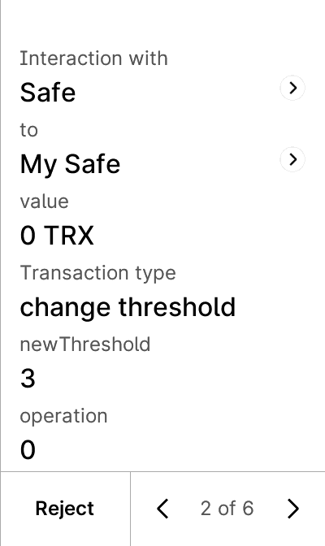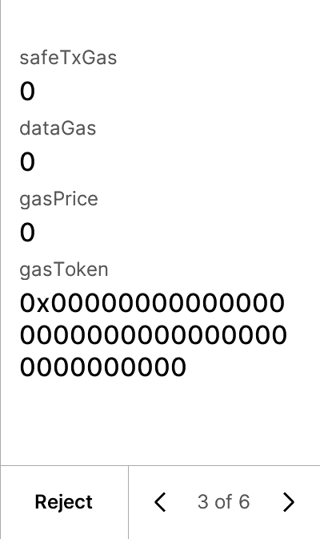
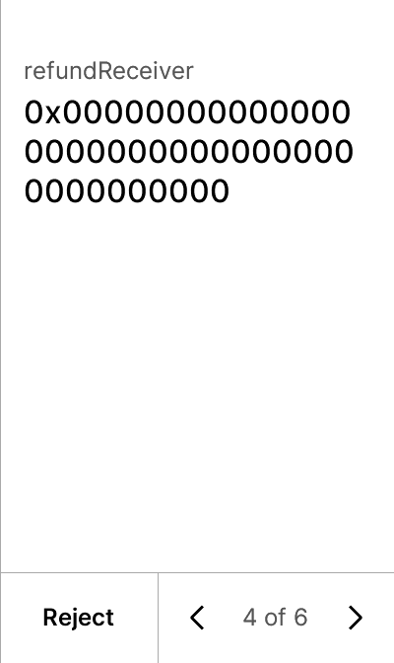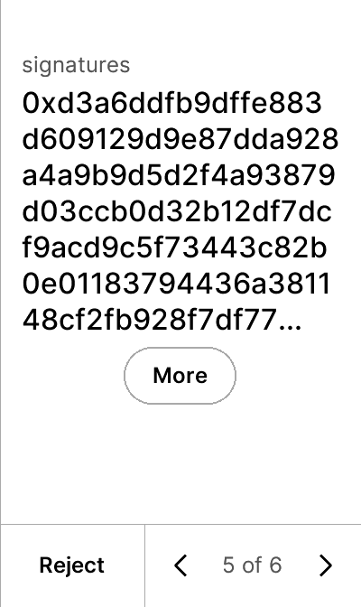


test_gcs_nested_execTransaction_send
5 image(s)
test_gcs_nested_execTransaction_send
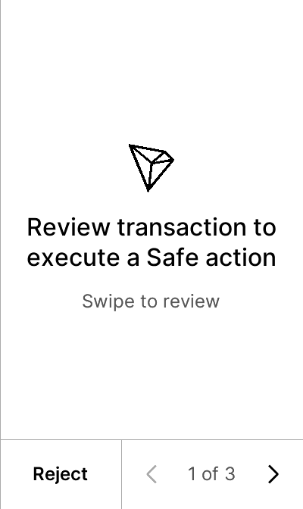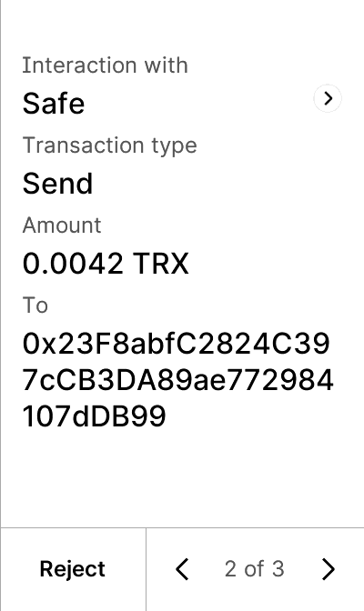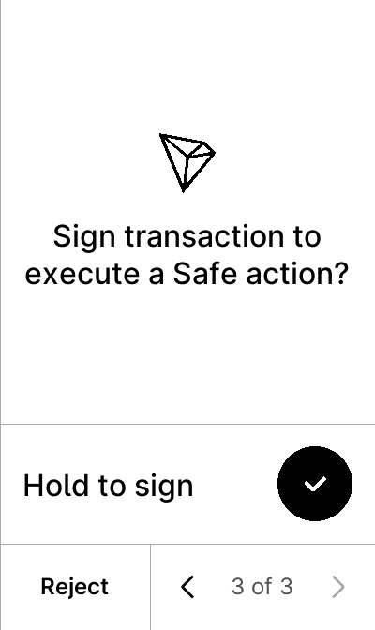


test_gcs_nested_no_param
5 image(s)
test_gcs_nested_no_param
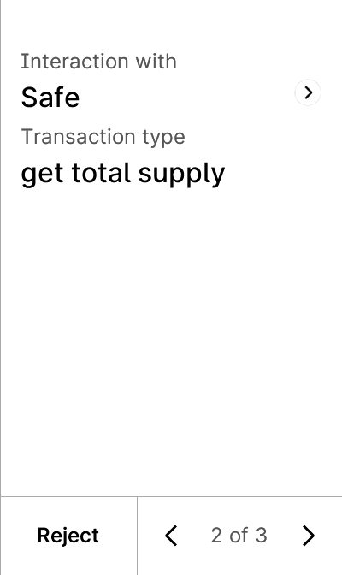


test_gcs_nft
7 image(s)
test_gcs_nft
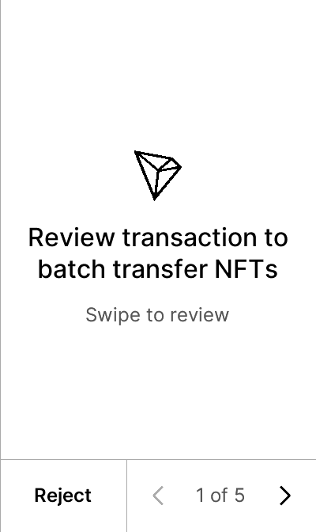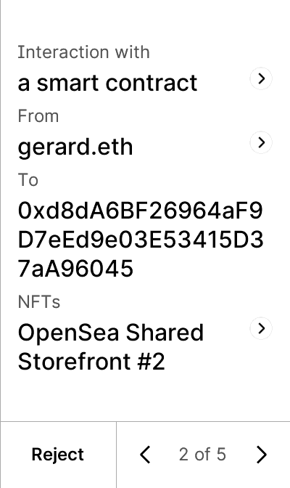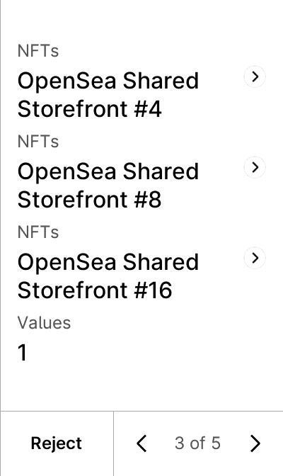
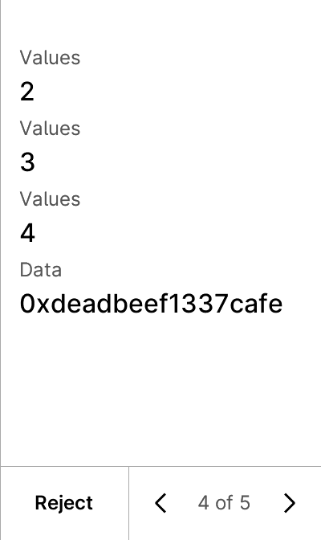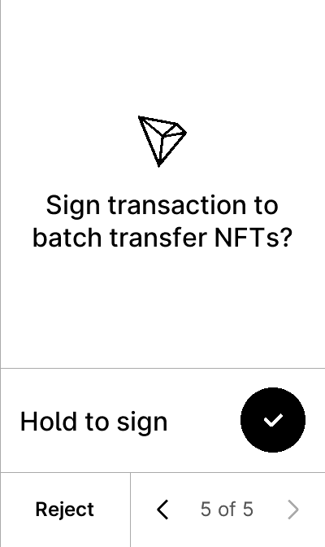


test_gcs_no_param
5 image(s)
test_gcs_no_param
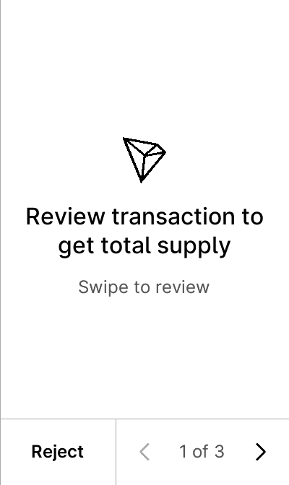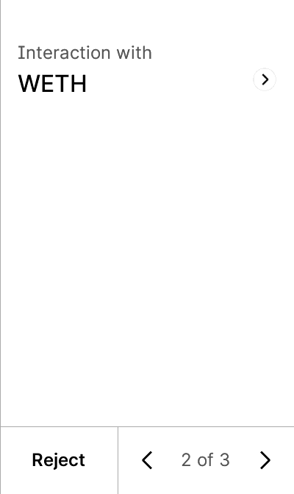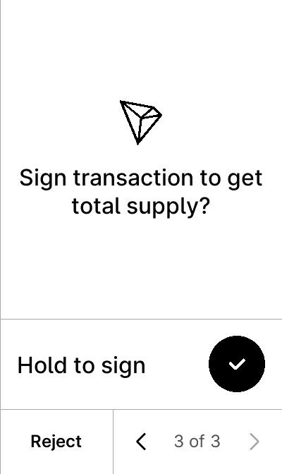


test_gcs_poap
6 image(s)
test_gcs_poap
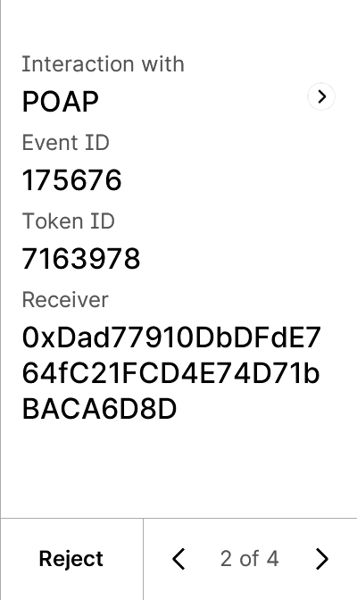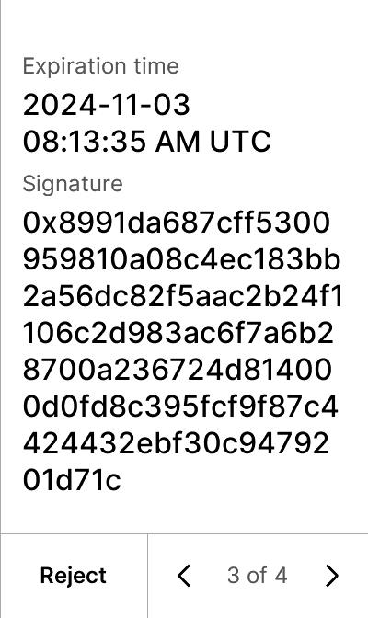


test_gcs_proxy
5 image(s)
test_gcs_proxy
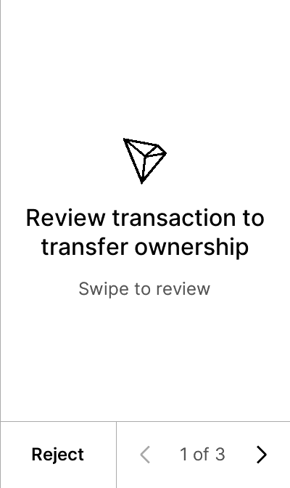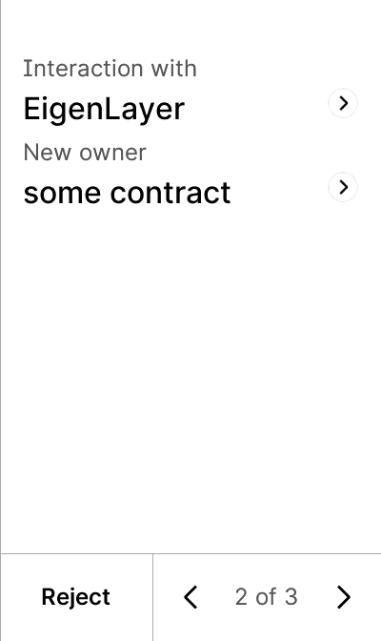


test_gcs_sign
5 image(s)
test_gcs_sign
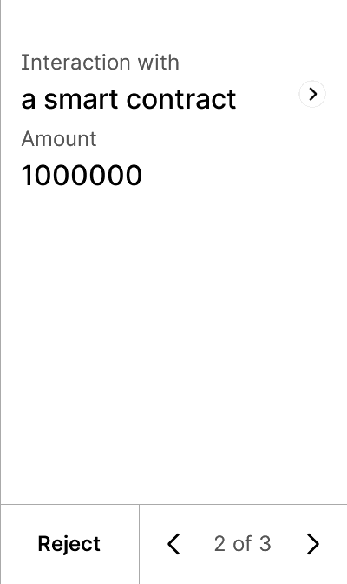


test_gcs_token_amount
5 image(s)
test_gcs_token_amount
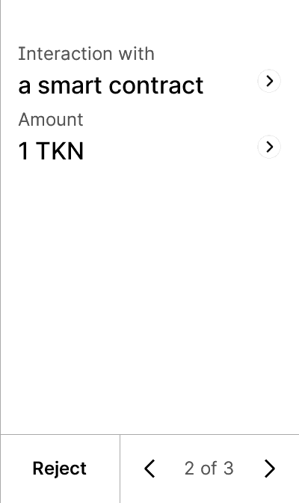


test_gcs_transfer_long_calldata
5 image(s)
test_gcs_transfer_long_calldata
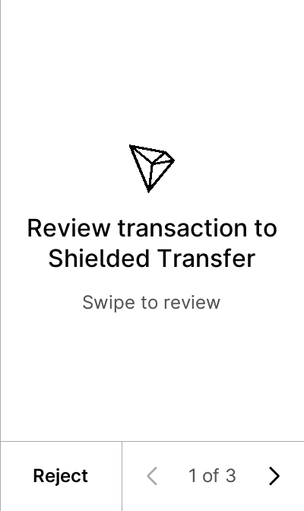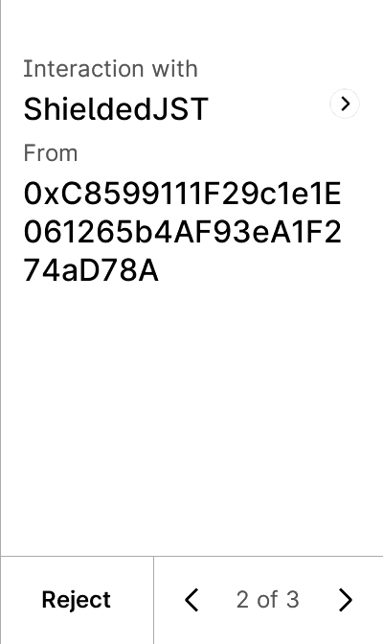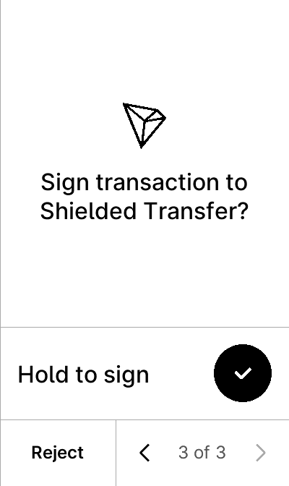


test_gcs_trctoken
5 image(s)
test_gcs_trctoken
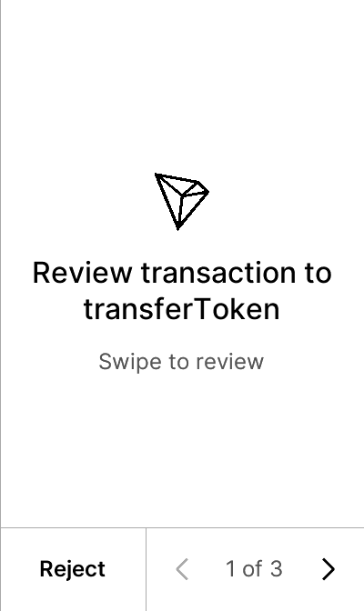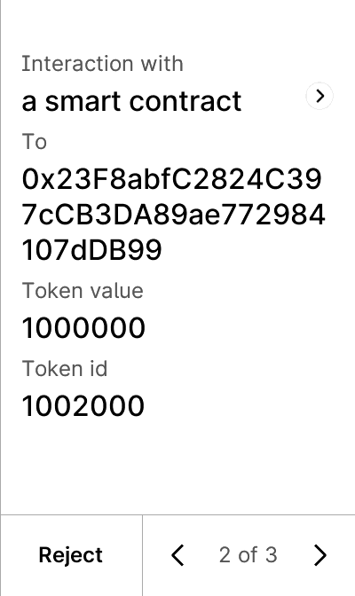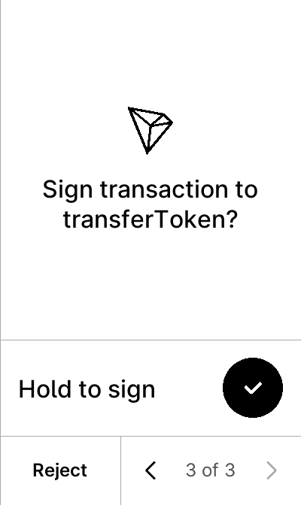


test_gcs_trusted_name
5 image(s)
test_gcs_trusted_name
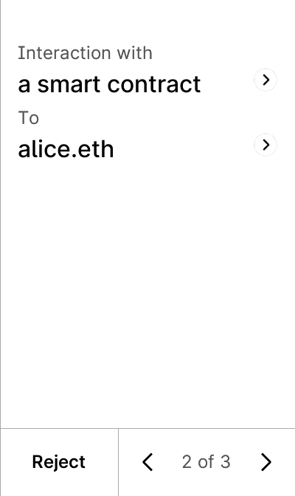


test_gcs_trusted_name_token
5 image(s)
test_gcs_trusted_name_token
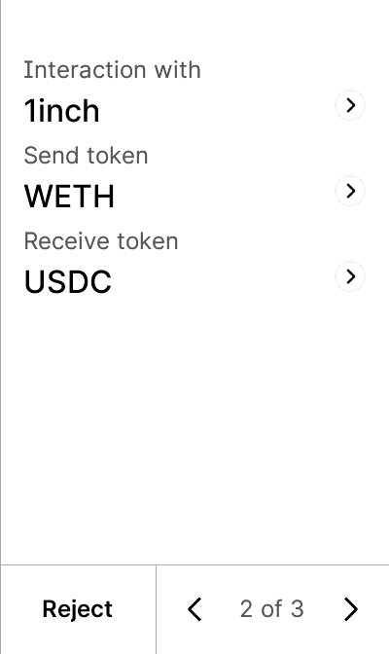


test_get_public_key_confirm_accepted
4 image(s)
test_get_public_key_confirm_accepted
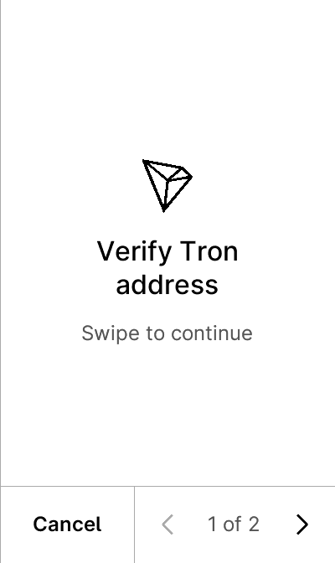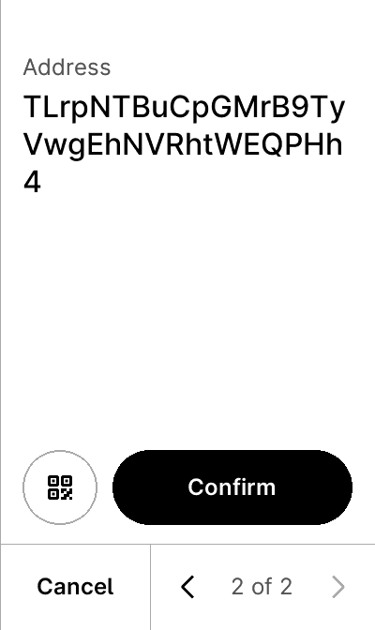


test_get_public_key_confirm_refused
4 image(s)
test_get_public_key_confirm_refused
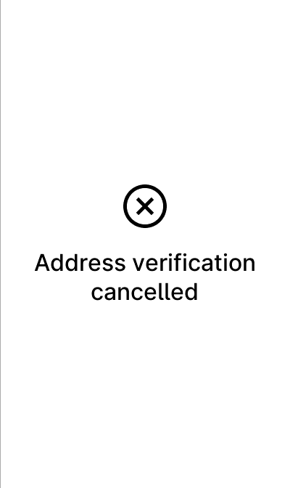


test_personal_sign_metamask
5 image(s)
test_personal_sign_metamask
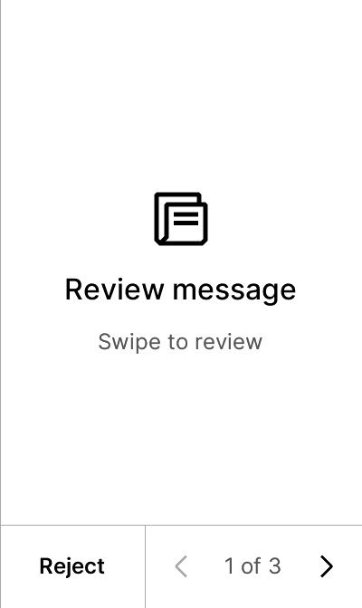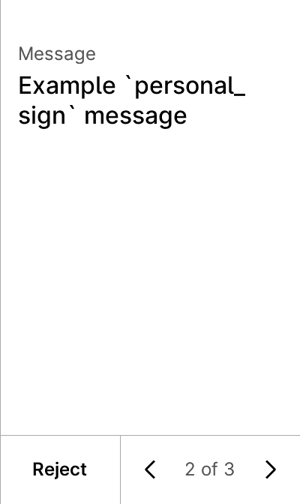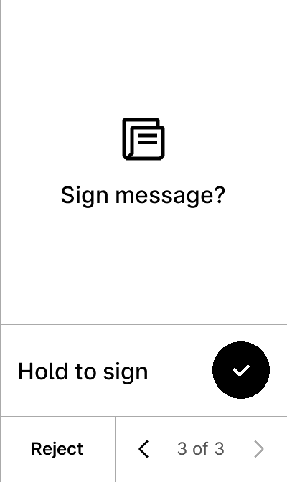


test_personal_sign_non_ascii
5 image(s)
test_personal_sign_non_ascii
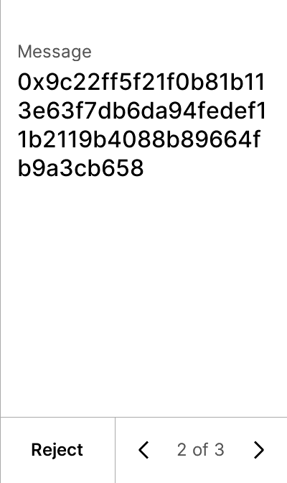


test_personal_sign_opensea
5 image(s)
test_personal_sign_opensea
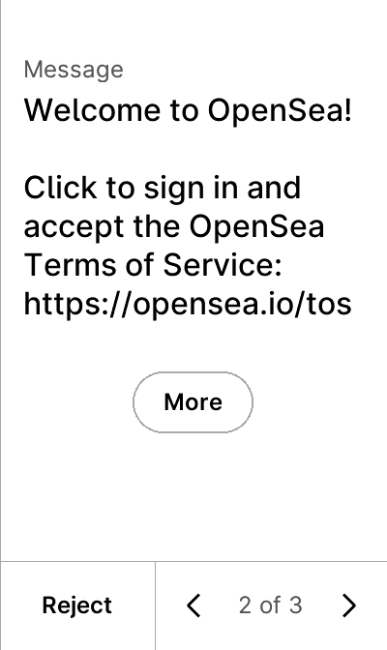


test_personal_sign_reject
6 image(s)
test_personal_sign_reject
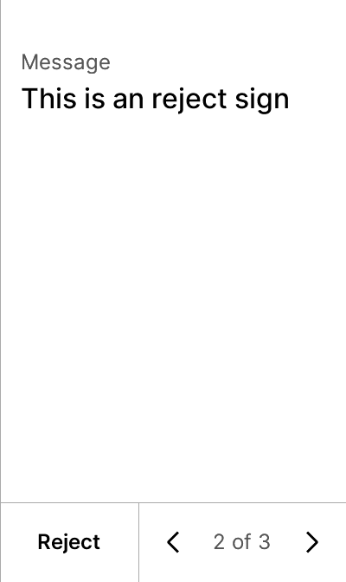
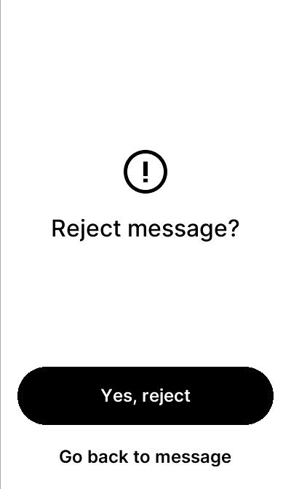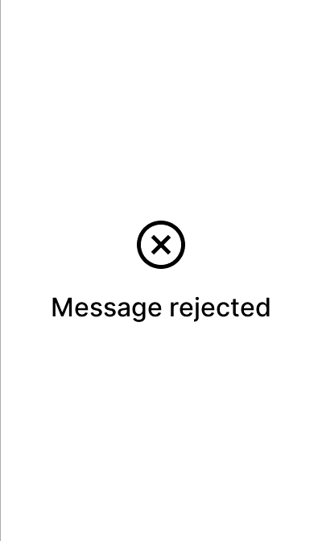

test_settings
38 image(s)
blind_sign
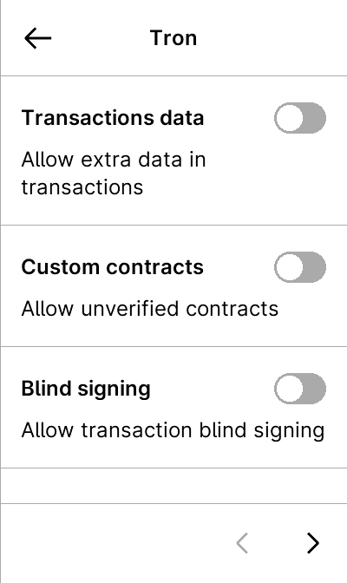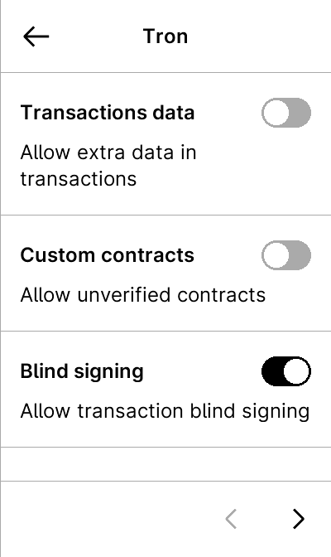

custom_contract
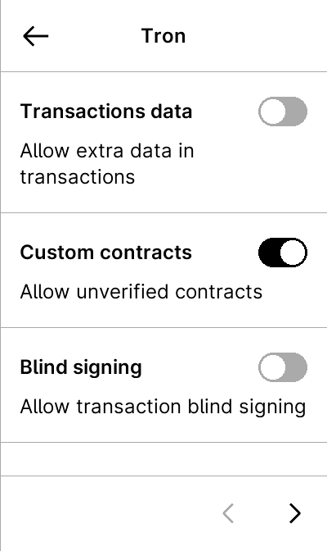

data_allowed
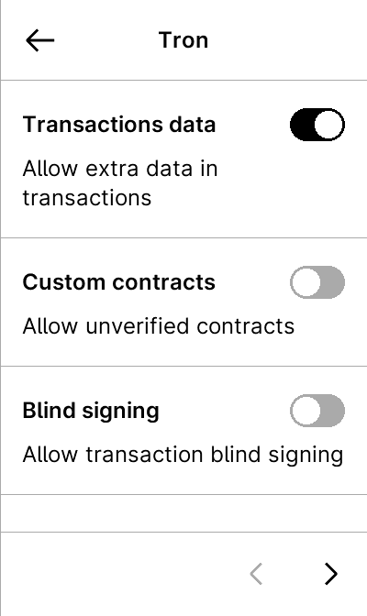

display_hash
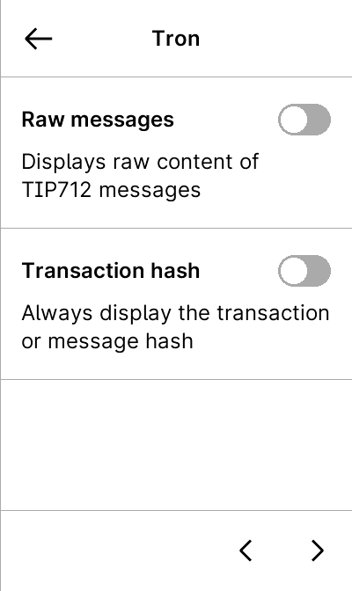
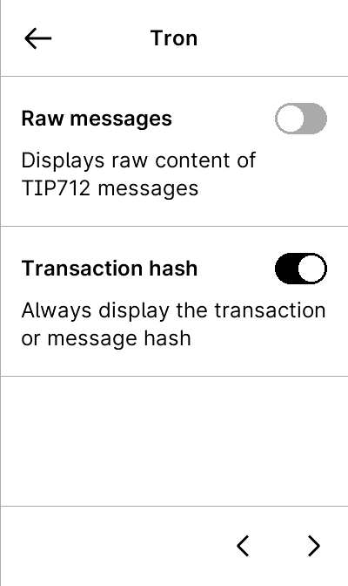
multiple1

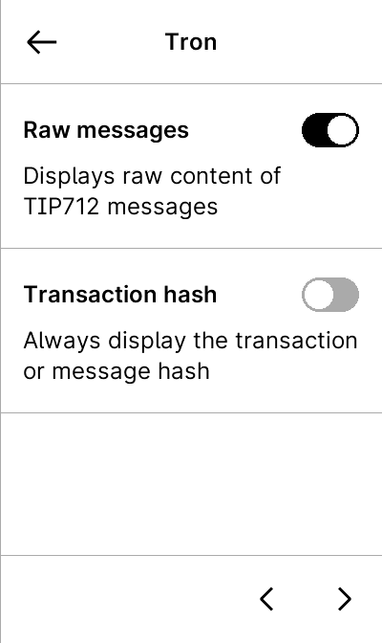
multiple2

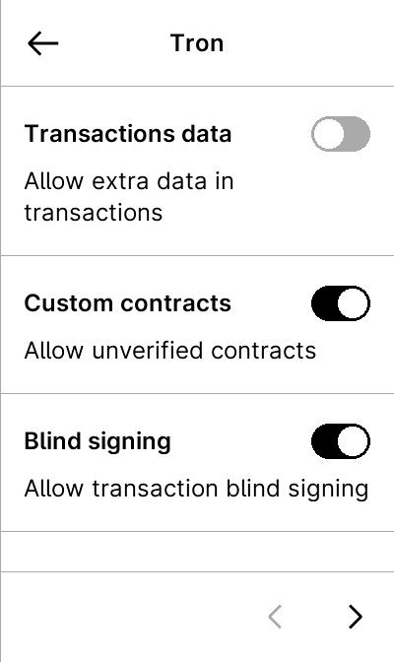
multiple3

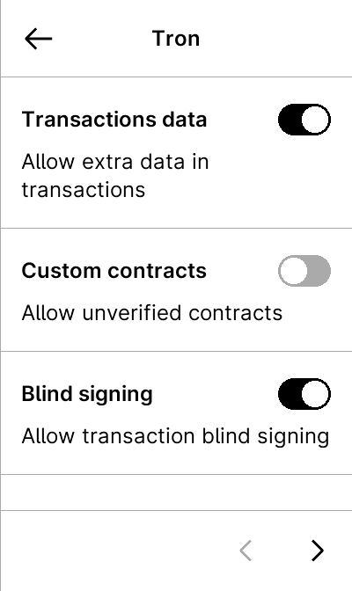
tip712_token



test_tip712_advanced_filtering
5 image(s)
test_tip712_advanced_filtering
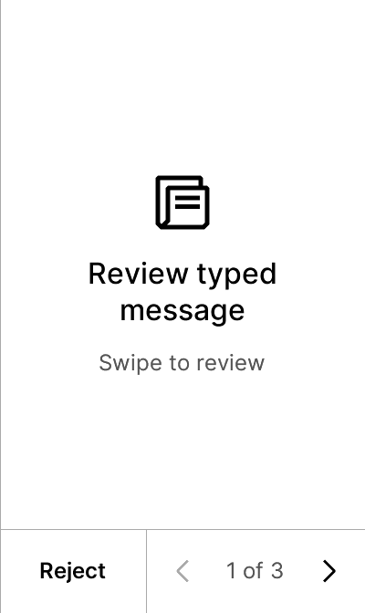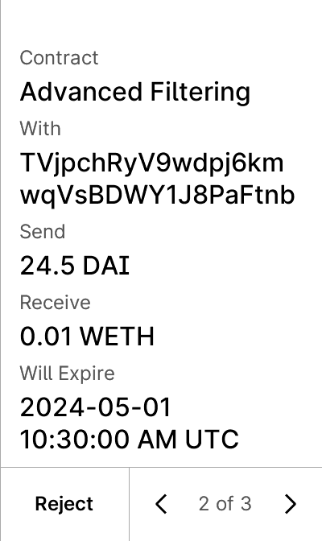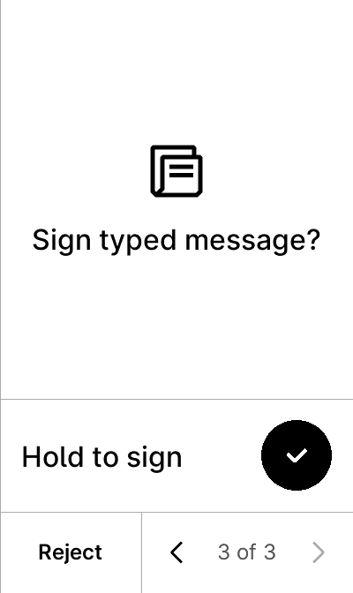


test_tip712_advanced_filtering-verbose
6 image(s)
test_tip712_advanced_filtering-verbose
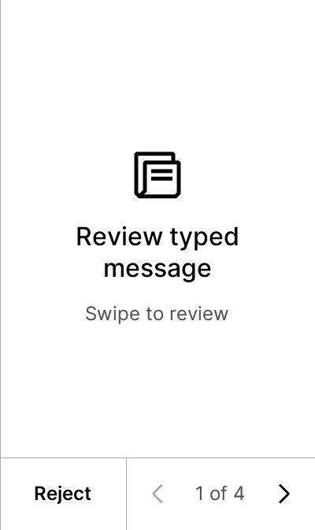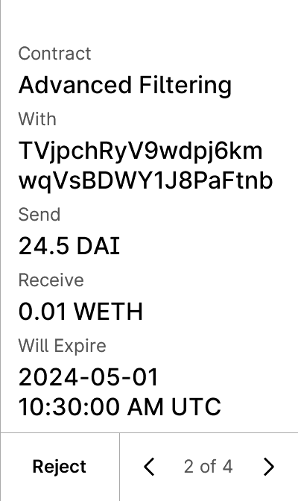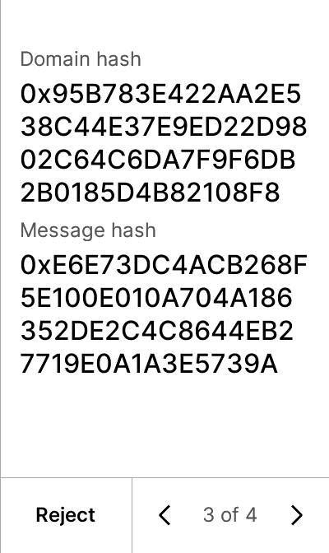
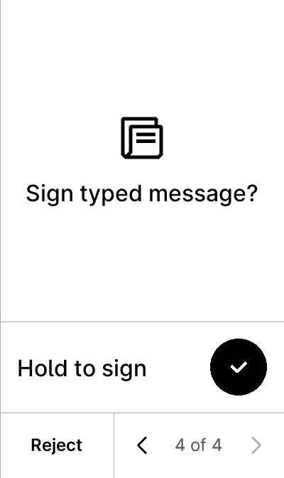

test_tip712_advanced_filtering_permit
5 image(s)
test_tip712_advanced_filtering_permit
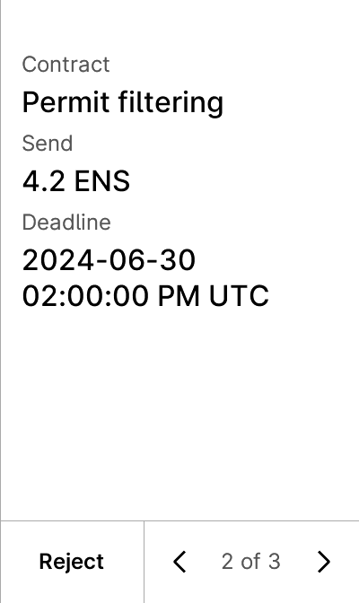


test_tip712_advanced_filtering_unlimited
5 image(s)
test_tip712_advanced_filtering_unlimited
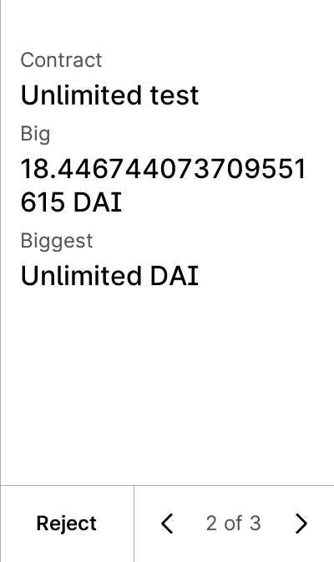


test_tip712_advanced_missing_token-False-True
5 image(s)
test_tip712_advanced_missing_token-False-True
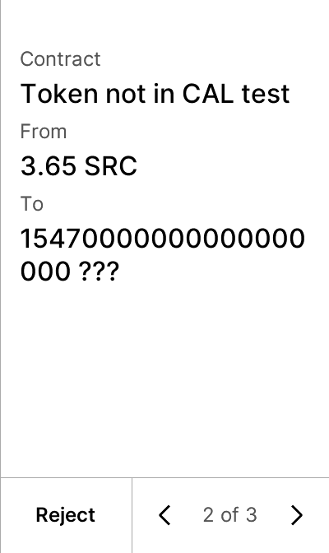


test_tip712_advanced_missing_token-True-False
5 image(s)
test_tip712_advanced_missing_token-True-False
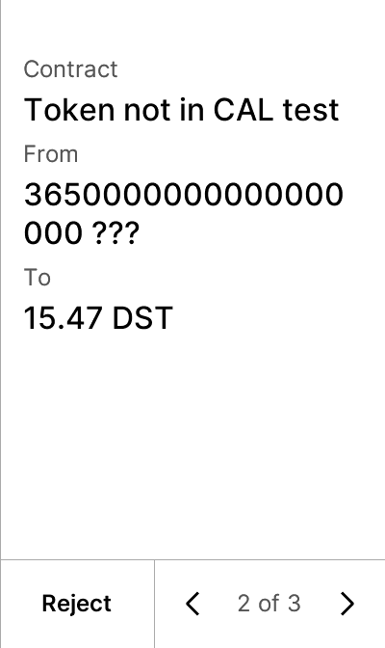


test_tip712_advanced_trusted_name_account_with_account
5 image(s)
test_tip712_advanced_trusted_name_account_with_account
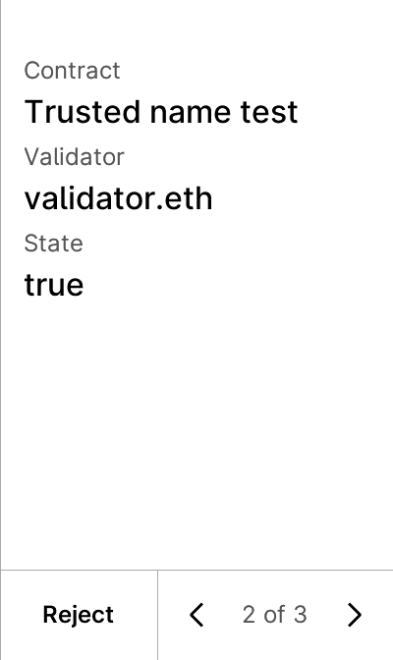


test_tip712_advanced_trusted_name_account_with_account_contract
5 image(s)
test_tip712_advanced_trusted_name_account_with_account_contract



test_tip712_advanced_trusted_name_account_with_contract
5 image(s)
test_tip712_advanced_trusted_name_account_with_contract
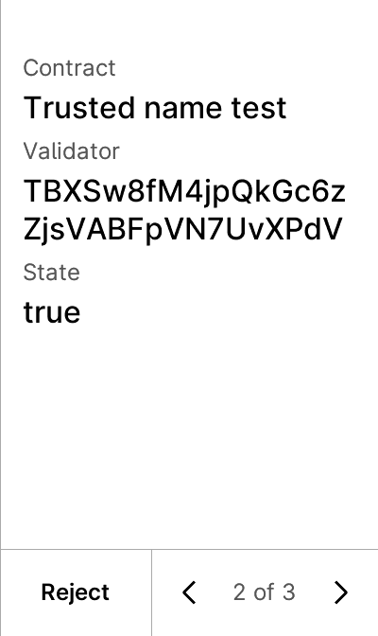


test_tip712_advanced_trusted_name_account_with_contract_account
5 image(s)
test_tip712_advanced_trusted_name_account_with_contract_account



test_tip712_advanced_trusted_name_contract_with_account
5 image(s)
test_tip712_advanced_trusted_name_contract_with_account



test_tip712_advanced_trusted_name_contract_with_account_contract
5 image(s)
test_tip712_advanced_trusted_name_contract_with_account_contract
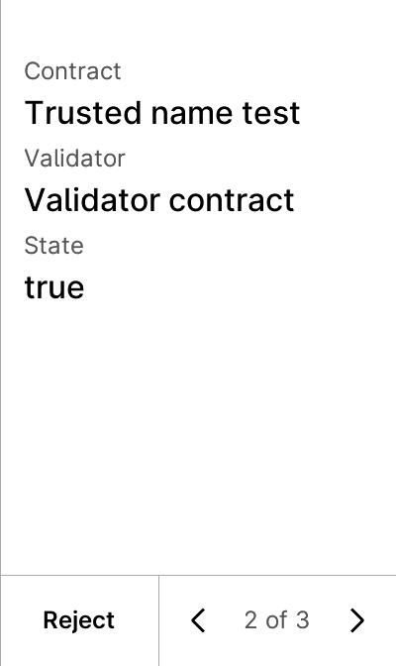


test_tip712_advanced_trusted_name_contract_with_contract
5 image(s)
test_tip712_advanced_trusted_name_contract_with_contract



test_tip712_advanced_trusted_name_contract_with_contract_account
5 image(s)
test_tip712_advanced_trusted_name_contract_with_contract_account



test_tip712_batch
10 image(s)
test_tip712_batch
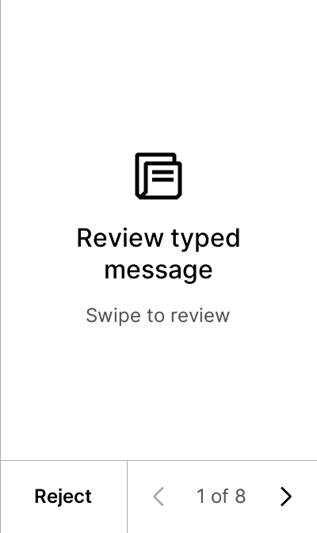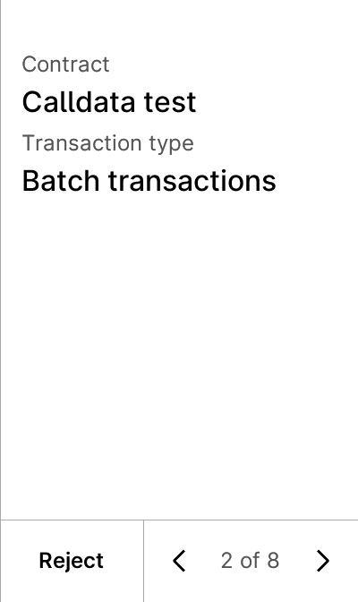
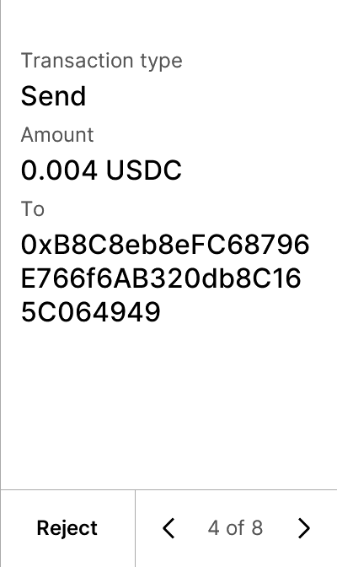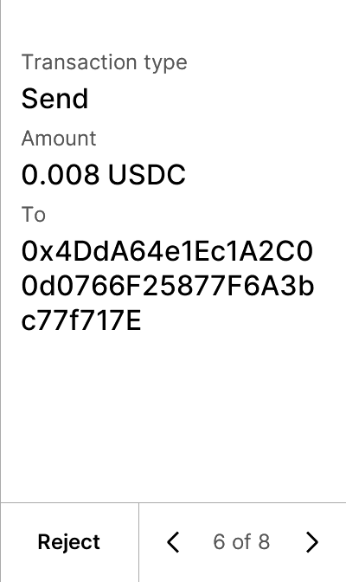
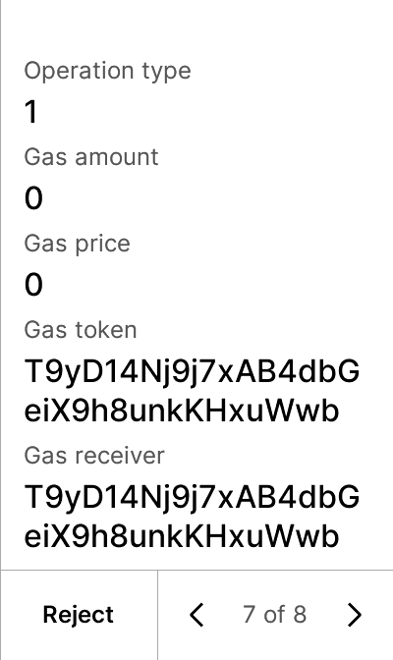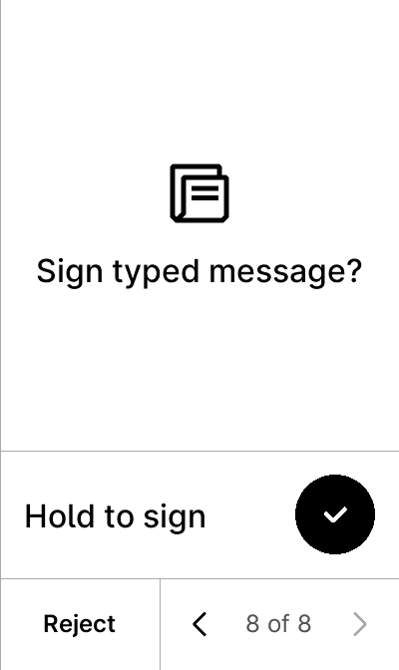


test_tip712_calldata
5 image(s)
test_tip712_calldata
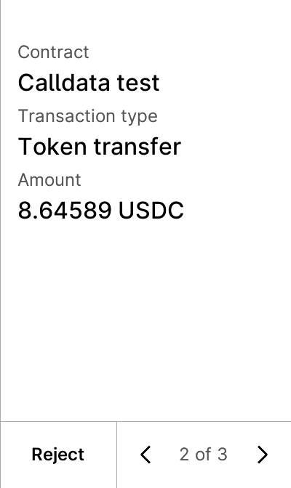


test_tip712_calldata_empty_send
5 image(s)
test_tip712_calldata_empty_send
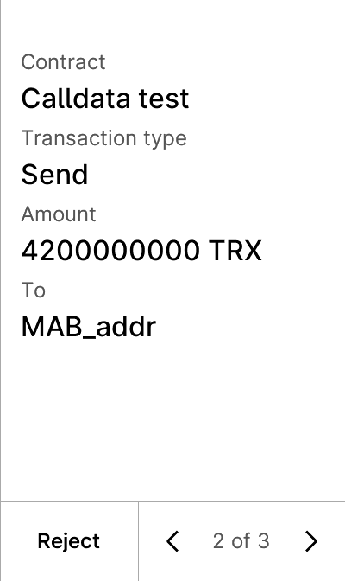


test_tip712_calldata_no_param
5 image(s)
test_tip712_calldata_no_param
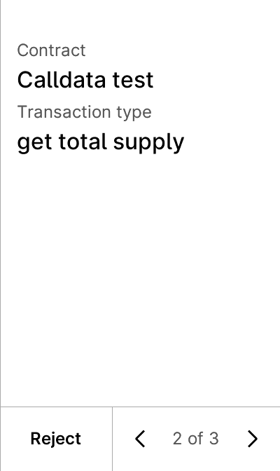


test_tip712_calldata_trctoken
5 image(s)
test_tip712_calldata_trctoken
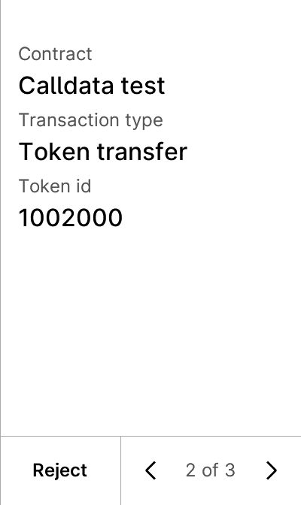


test_tip712_filtering_empty_array
5 image(s)
test_tip712_filtering_empty_array
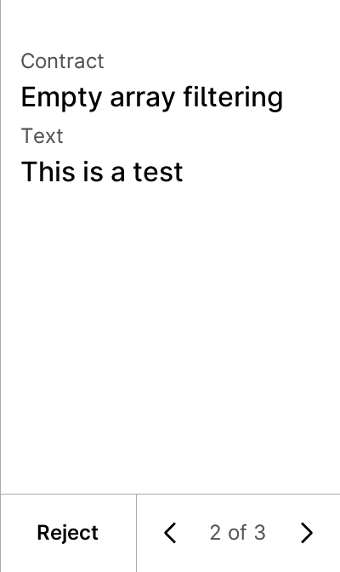


test_tip712_gondi
7 image(s)
test_tip712_gondi
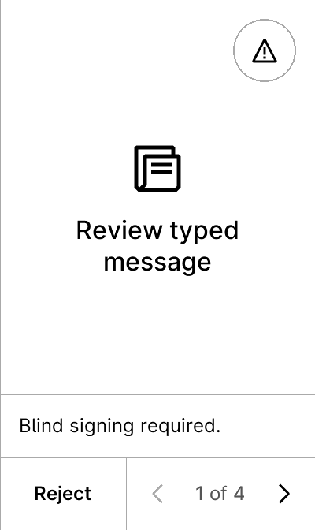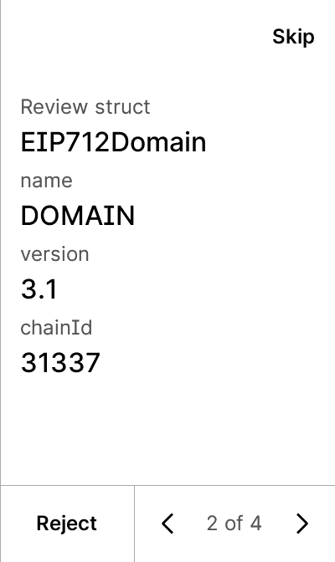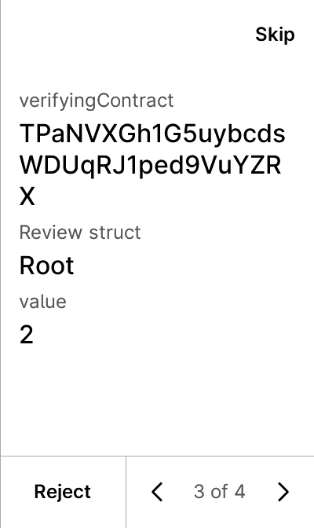
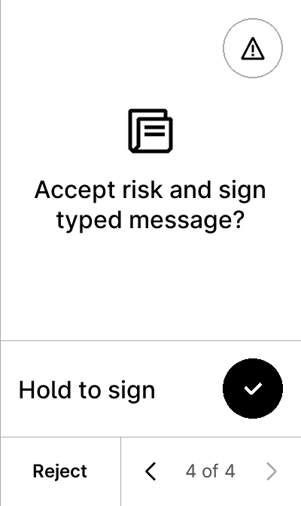
warning


test_tip712_new-00-simple_mail-data-False-False
9 image(s)
test_tip712_new-00-simple_mail-data-False-False



warning


test_tip712_new-00-simple_mail-data-False-True
5 image(s)
test_tip712_new-00-simple_mail-data-False-True
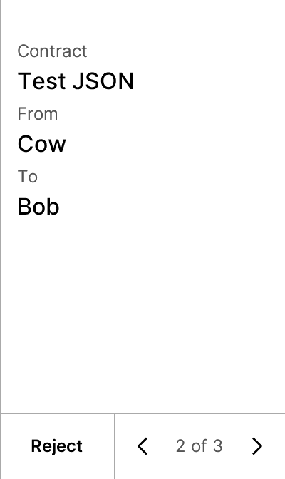


test_tip712_new-00-simple_mail-data-True-False
9 image(s)
test_tip712_new-00-simple_mail-data-True-False



warning


test_tip712_new-00-simple_mail-data-True-True
9 image(s)
test_tip712_new-00-simple_mail-data-True-True



warning


test_tip712_new-01-addresses_array_mail-data-False-False
8 image(s)
test_tip712_new-01-addresses_array_mail-data-False-False
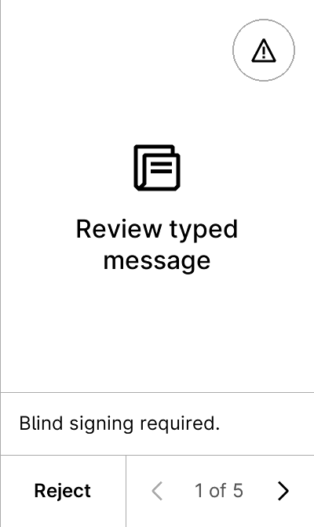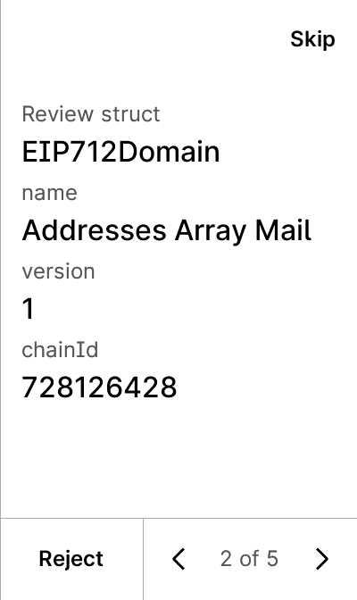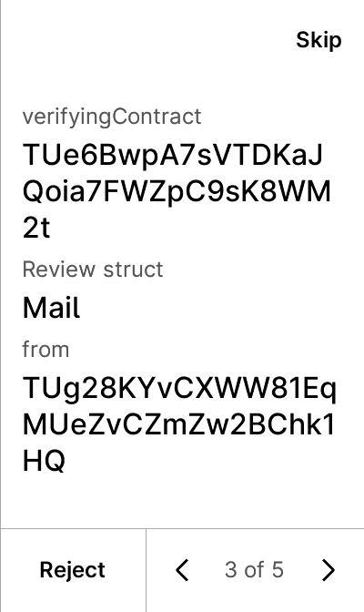
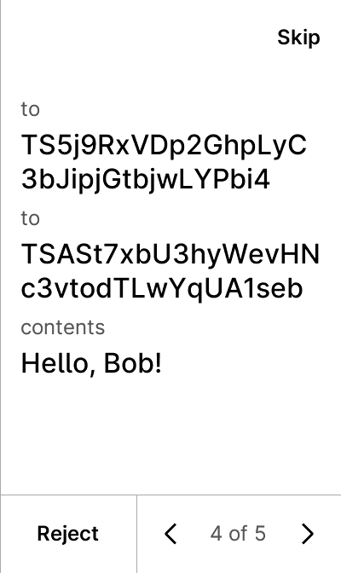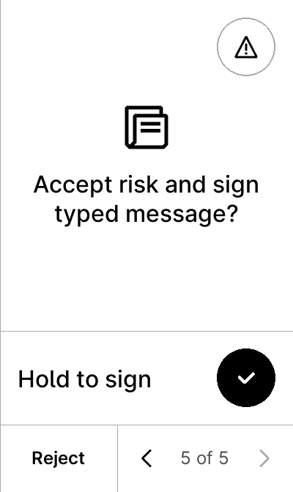

warning


test_tip712_new-01-addresses_array_mail-data-True-False
8 image(s)
test_tip712_new-01-addresses_array_mail-data-True-False



warning


test_tip712_new-02-recipients_array_mail-data-False-False
10 image(s)
test_tip712_new-02-recipients_array_mail-data-False-False
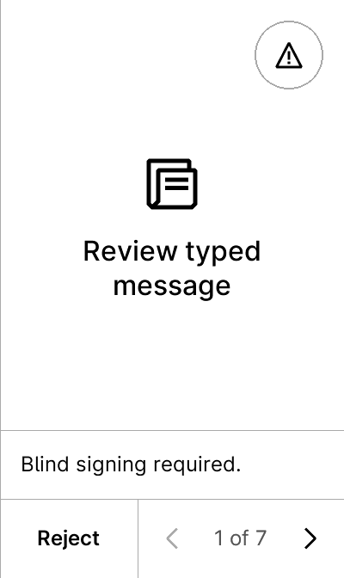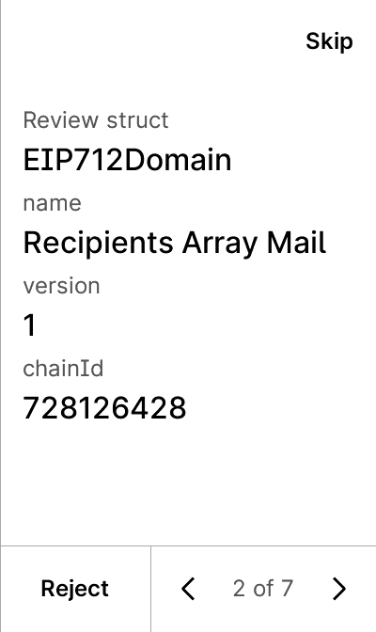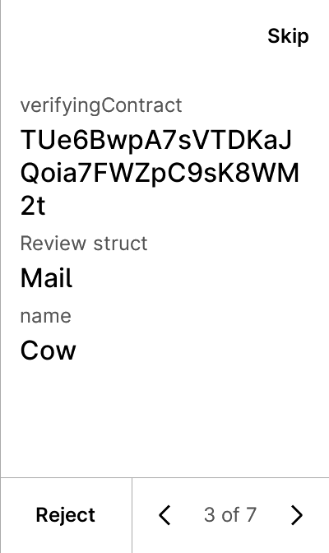
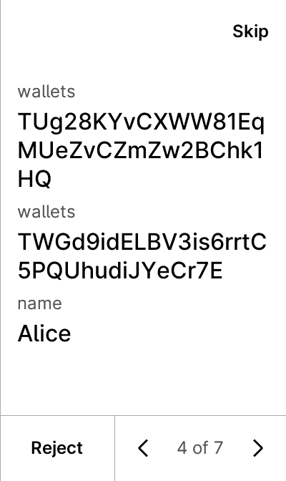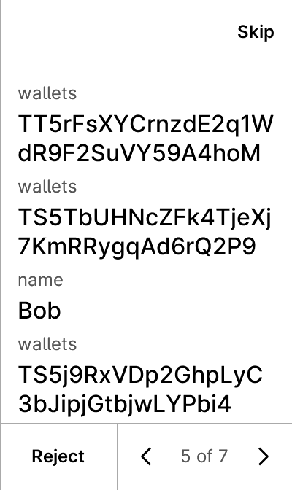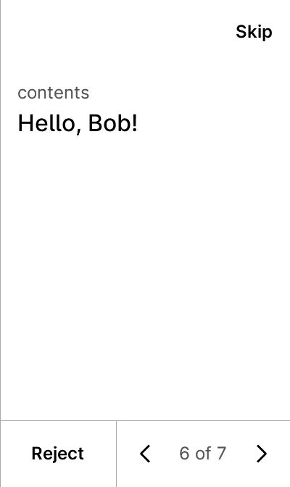
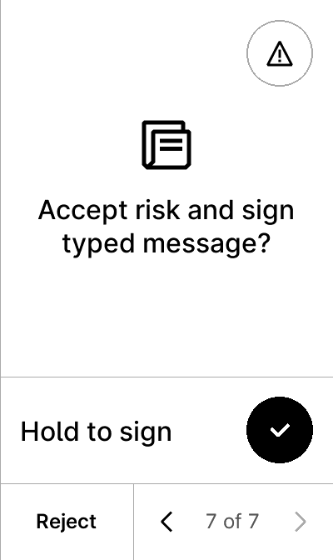
warning


test_tip712_new-02-recipients_array_mail-data-True-False
10 image(s)
test_tip712_new-02-recipients_array_mail-data-True-False



warning


test_tip712_new-03-long_string-data-False-False
10 image(s)
test_tip712_new-03-long_string-data-False-False
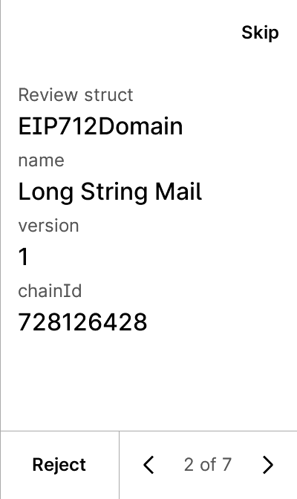
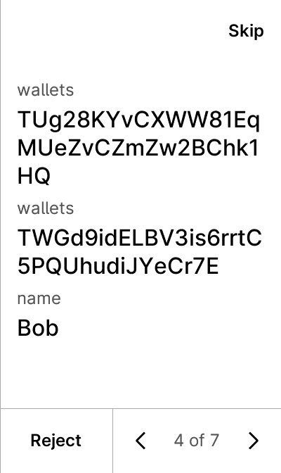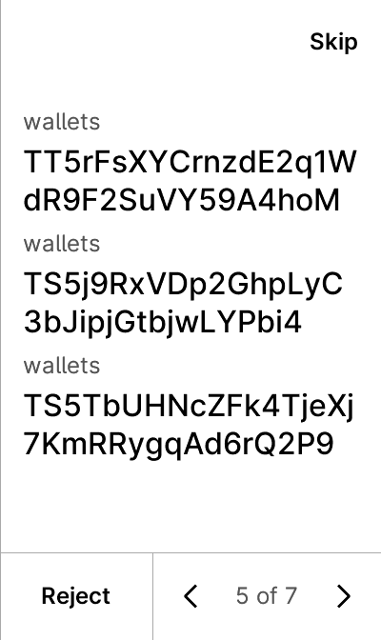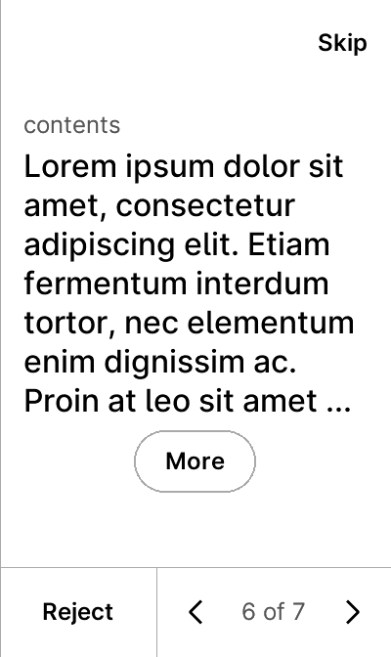

warning


test_tip712_new-03-long_string-data-True-False
10 image(s)
test_tip712_new-03-long_string-data-True-False



warning


test_tip712_new-04-long_bytes-data-False-False
10 image(s)
test_tip712_new-04-long_bytes-data-False-False
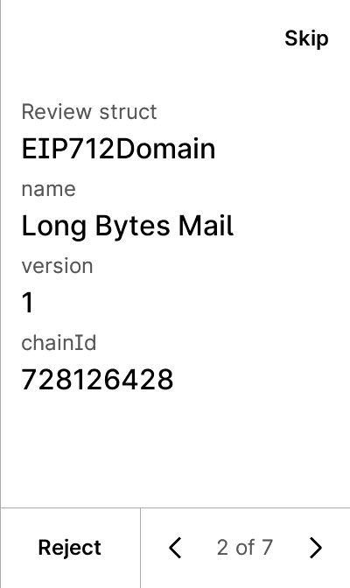
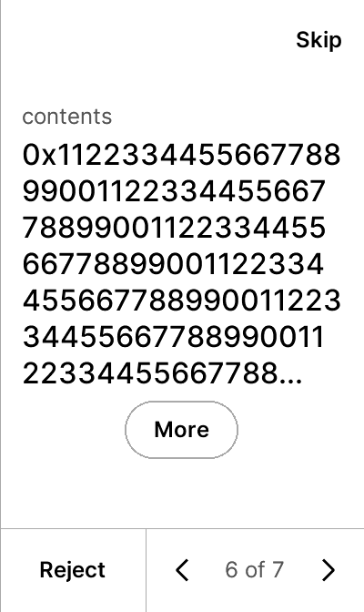

warning


test_tip712_new-04-long_bytes-data-True-False
10 image(s)
test_tip712_new-04-long_bytes-data-True-False



warning


test_tip712_new-05-signed_ints-data-False-False
9 image(s)
test_tip712_new-05-signed_ints-data-False-False
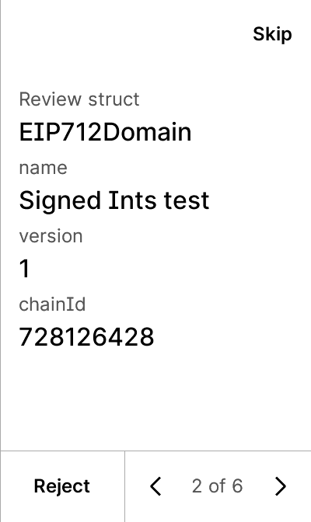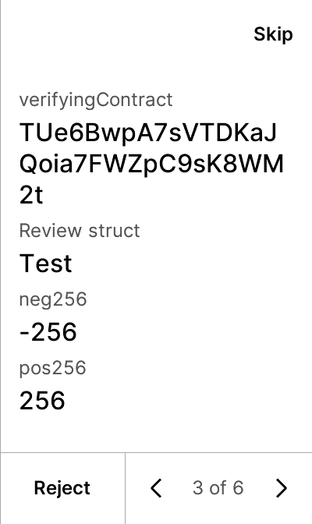
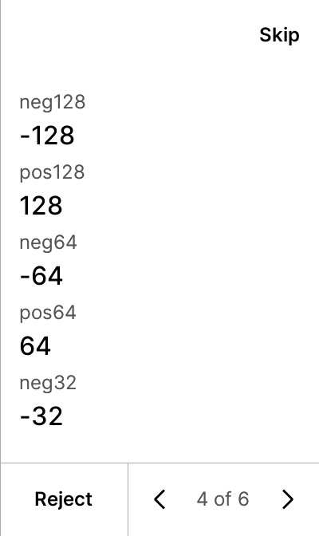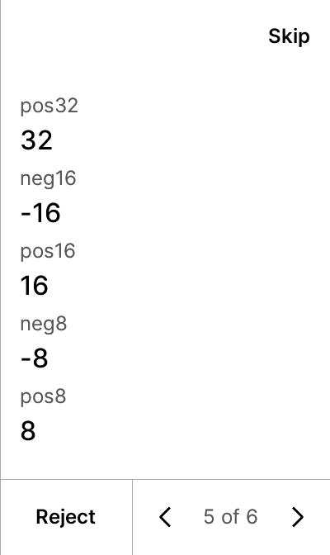

warning


test_tip712_new-05-signed_ints-data-True-False
9 image(s)
test_tip712_new-05-signed_ints-data-True-False



warning


test_tip712_new-06-boolean-data-False-False
7 image(s)
test_tip712_new-06-boolean-data-False-False
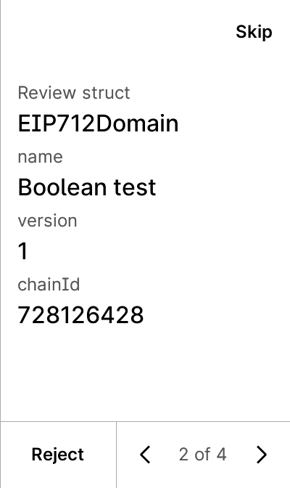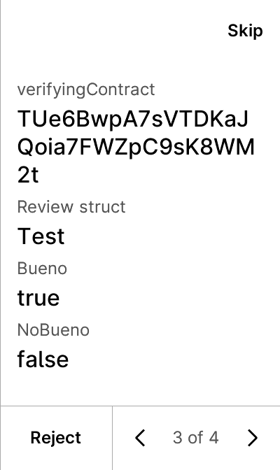

warning


test_tip712_new-06-boolean-data-True-False
7 image(s)
test_tip712_new-06-boolean-data-True-False


warning


test_tip712_new-07-fixed_bytes-data-False-False
8 image(s)
test_tip712_new-07-fixed_bytes-data-False-False
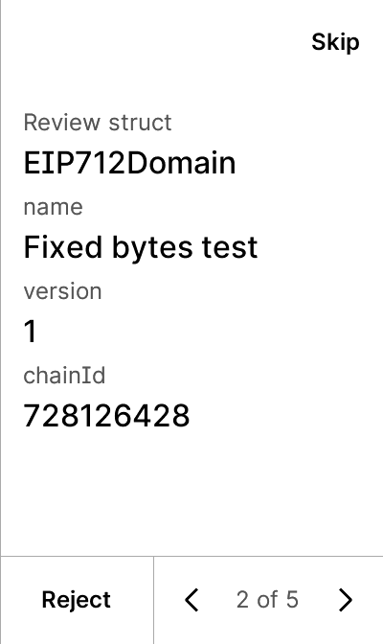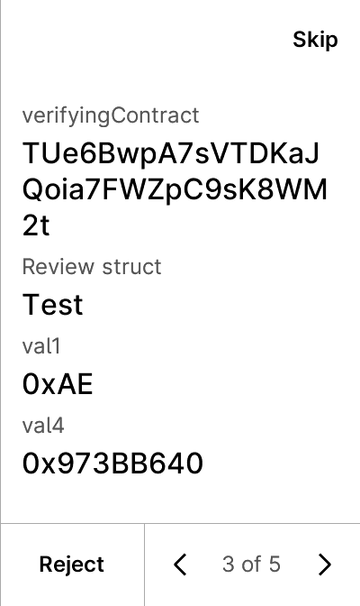
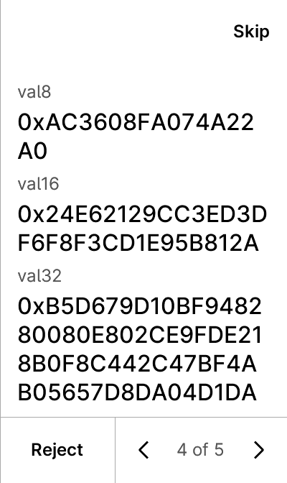

warning


test_tip712_new-07-fixed_bytes-data-True-False
8 image(s)
test_tip712_new-07-fixed_bytes-data-True-False



warning


test_tip712_new-08-opensea-data-False-False
15 image(s)
test_tip712_new-08-opensea-data-False-False
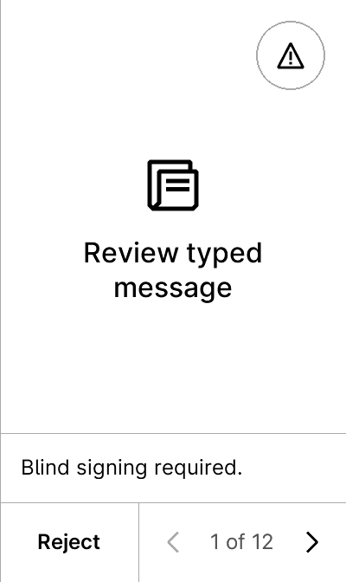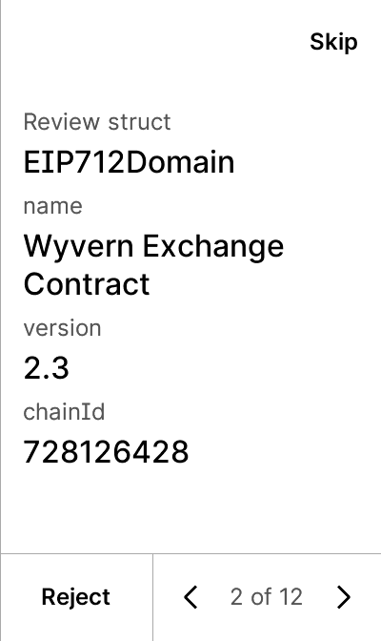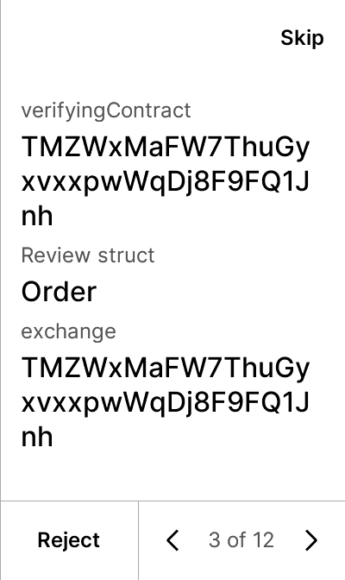
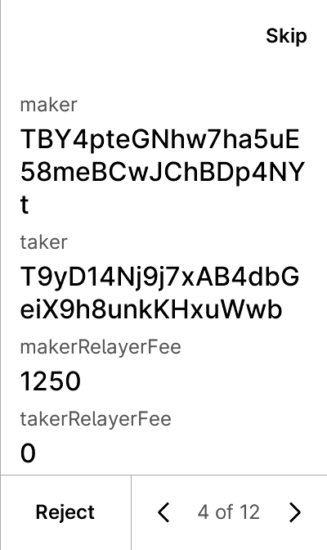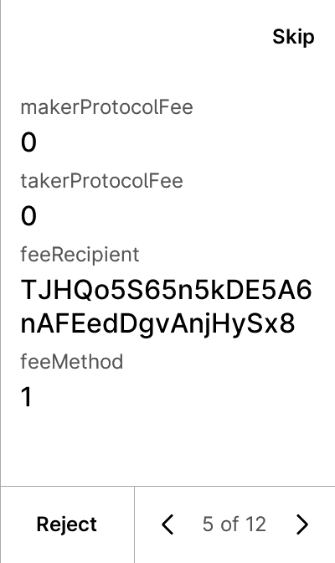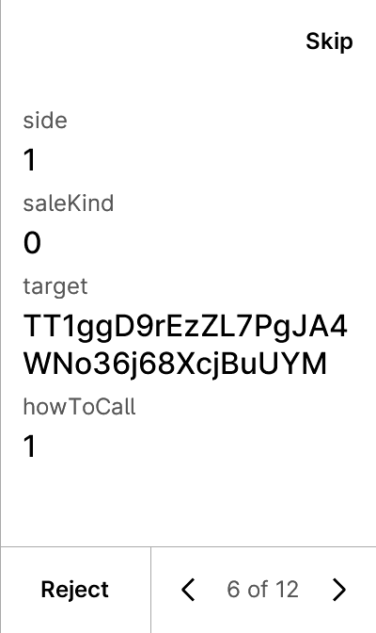
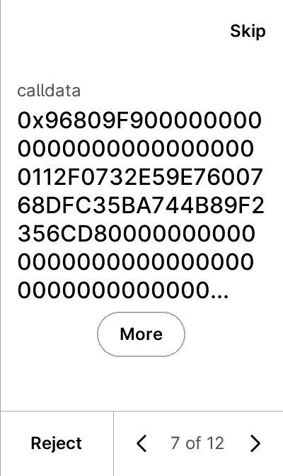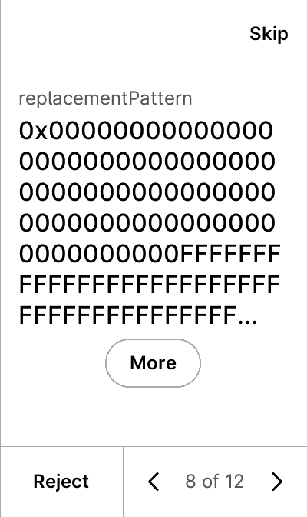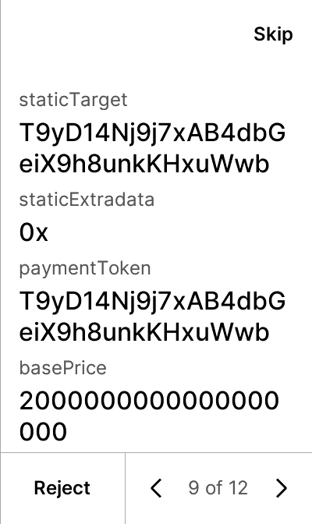
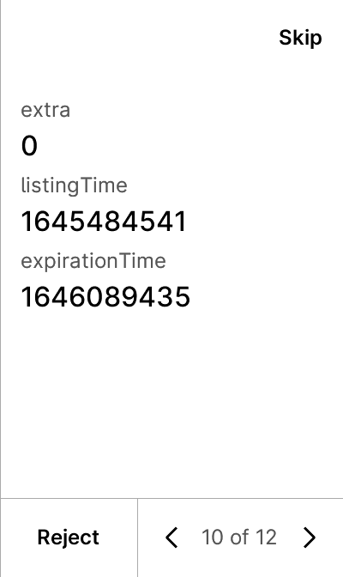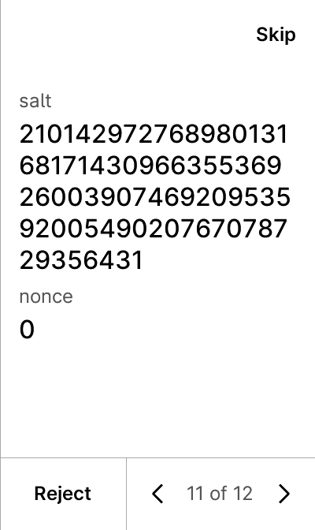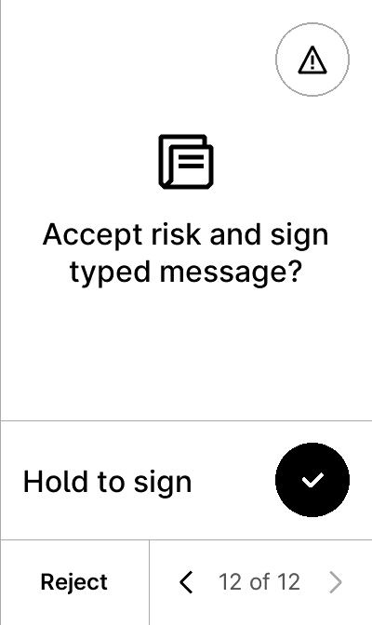

warning


test_tip712_new-08-opensea-data-False-True
6 image(s)
test_tip712_new-08-opensea-data-False-True
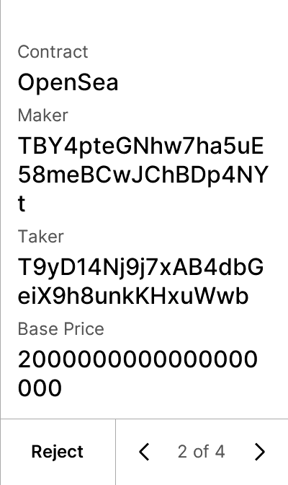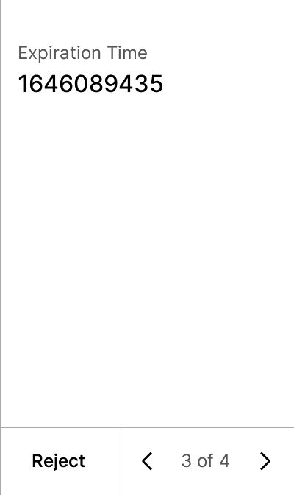


test_tip712_new-08-opensea-data-True-False
15 image(s)
test_tip712_new-08-opensea-data-True-False





warning


test_tip712_new-08-opensea-data-True-True
15 image(s)
test_tip712_new-08-opensea-data-True-True





warning


test_tip712_new-09-rarible-data-False-False
12 image(s)
test_tip712_new-09-rarible-data-False-False
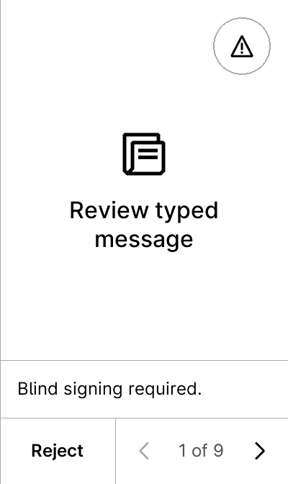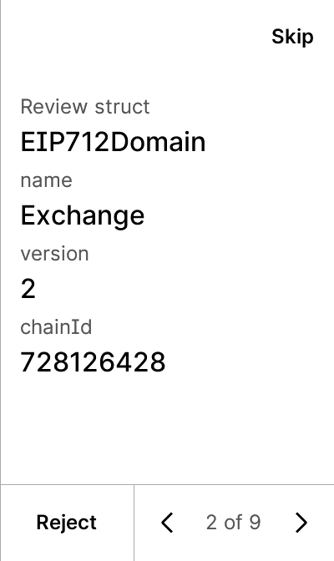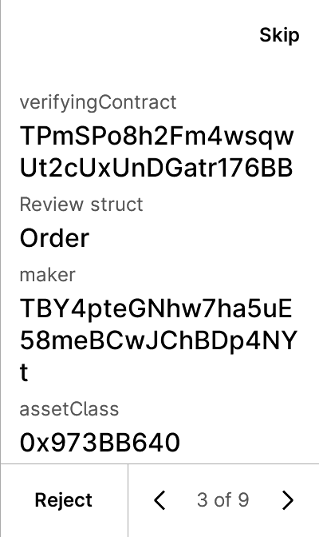
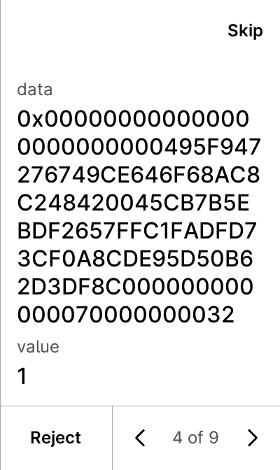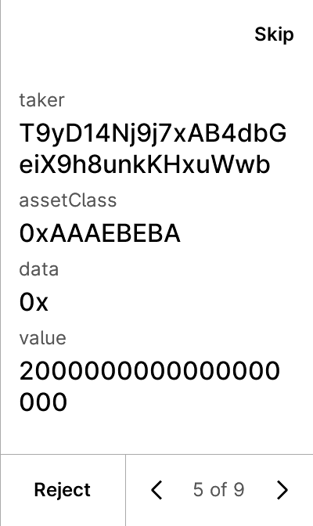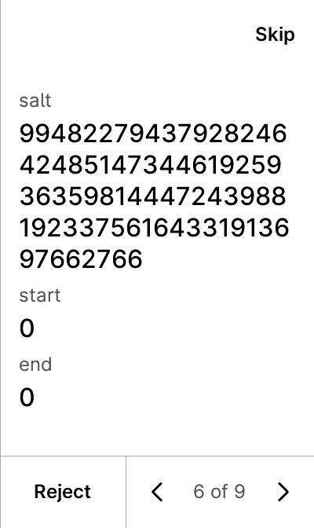
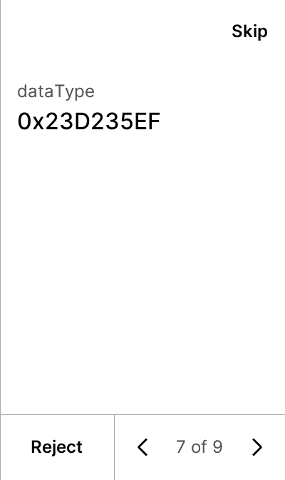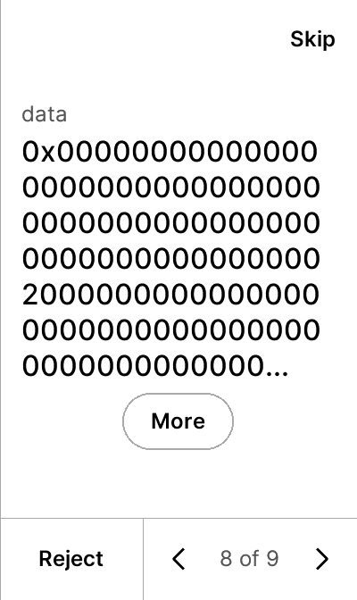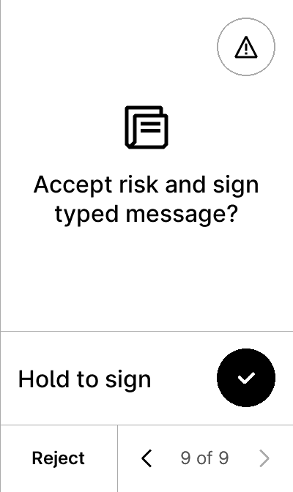

warning


test_tip712_new-09-rarible-data-True-False
12 image(s)
test_tip712_new-09-rarible-data-True-False




warning


test_tip712_new-10-multidimensional_arrays-data-False-False
8 image(s)
test_tip712_new-10-multidimensional_arrays-data-False-False
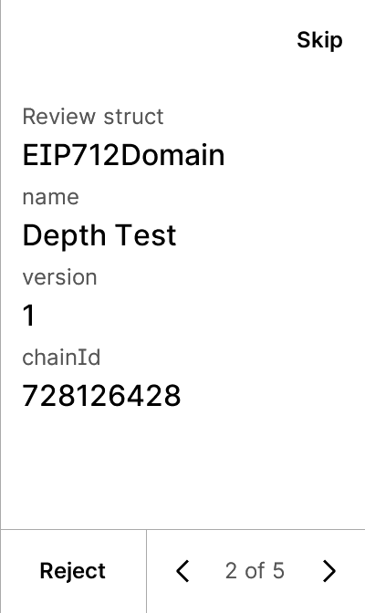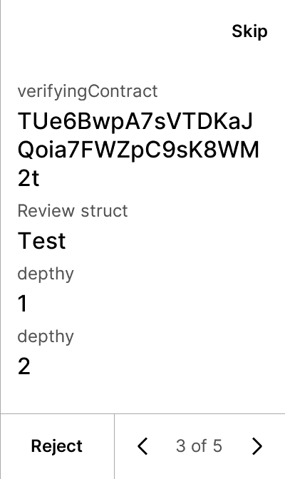
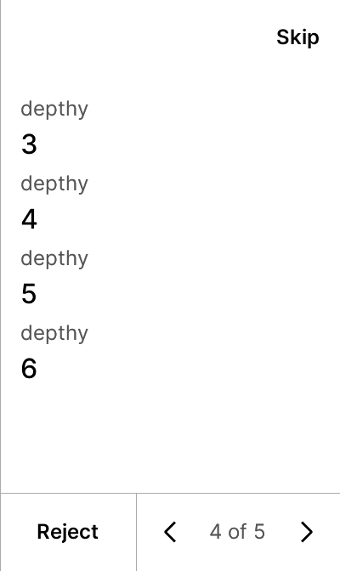

warning


test_tip712_new-10-multidimensional_arrays-data-True-False
8 image(s)
test_tip712_new-10-multidimensional_arrays-data-True-False



warning


test_tip712_new-11-complex_structs-data-False-False
10 image(s)
test_tip712_new-11-complex_structs-data-False-False
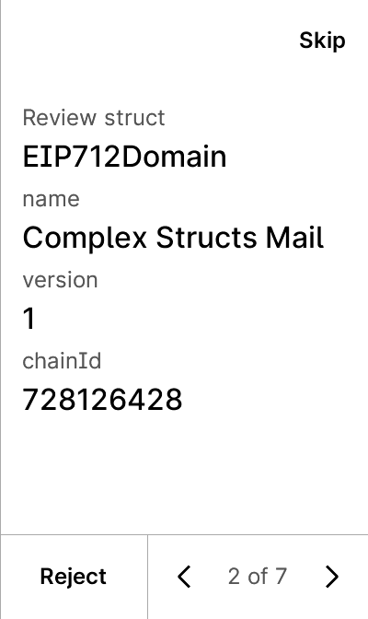
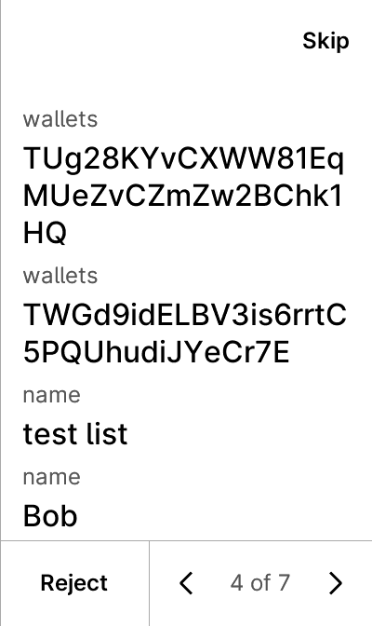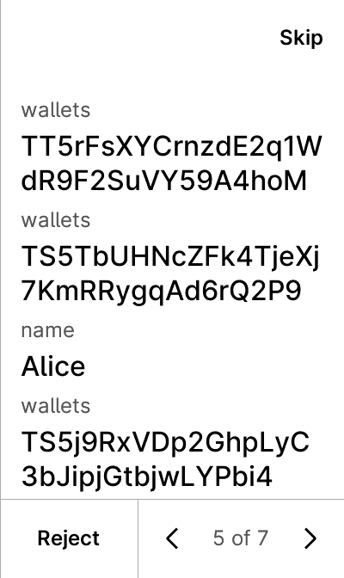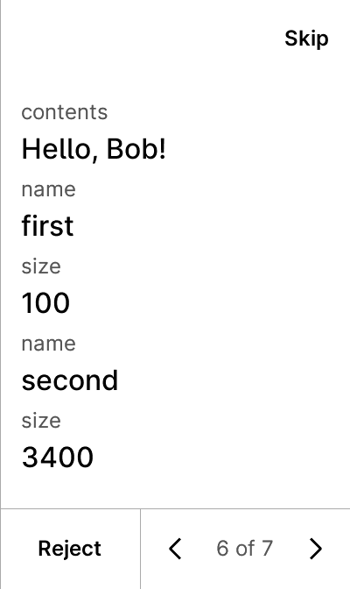

warning


test_tip712_new-11-complex_structs-data-False-True
6 image(s)
test_tip712_new-11-complex_structs-data-False-True
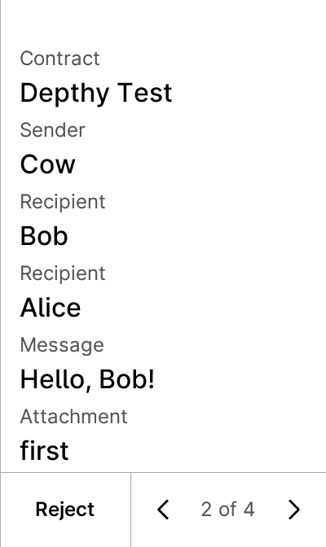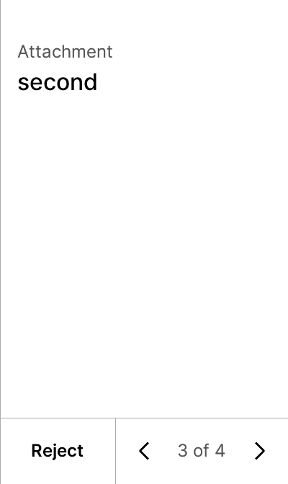


test_tip712_new-11-complex_structs-data-True-False
10 image(s)
test_tip712_new-11-complex_structs-data-True-False



warning


test_tip712_new-11-complex_structs-data-True-True
10 image(s)
test_tip712_new-11-complex_structs-data-True-True



warning


test_tip712_new-12-sign_in-data-False-False
7 image(s)
test_tip712_new-12-sign_in-data-False-False
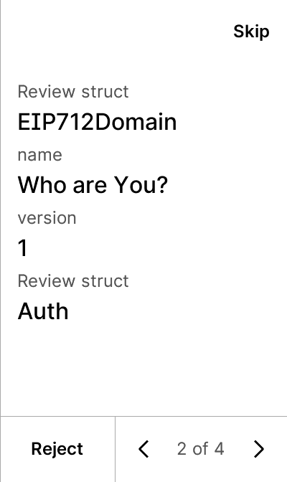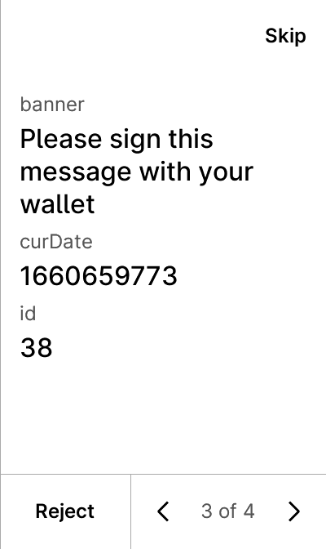

warning


test_tip712_new-12-sign_in-data-False-True
5 image(s)
test_tip712_new-12-sign_in-data-False-True
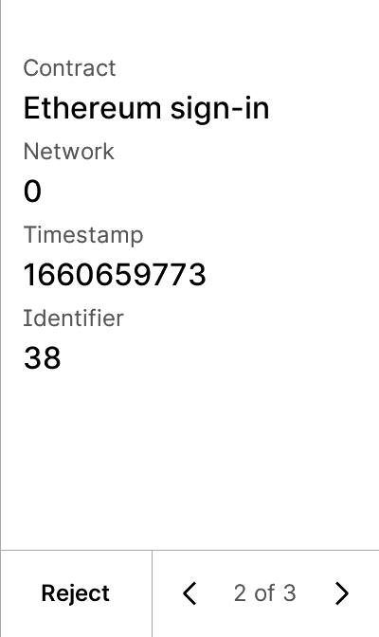


test_tip712_new-12-sign_in-data-True-False
7 image(s)
test_tip712_new-12-sign_in-data-True-False


warning


test_tip712_new-12-sign_in-data-True-True
7 image(s)
test_tip712_new-12-sign_in-data-True-True


warning


test_tip712_new-13-empty_arrays-data-False-False
8 image(s)
test_tip712_new-13-empty_arrays-data-False-False
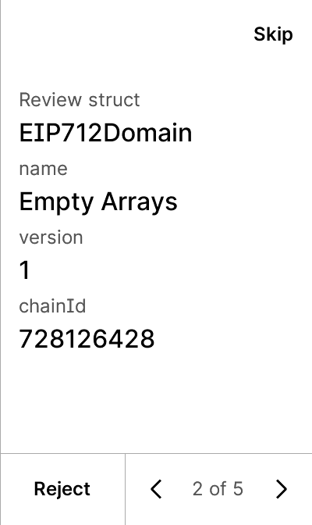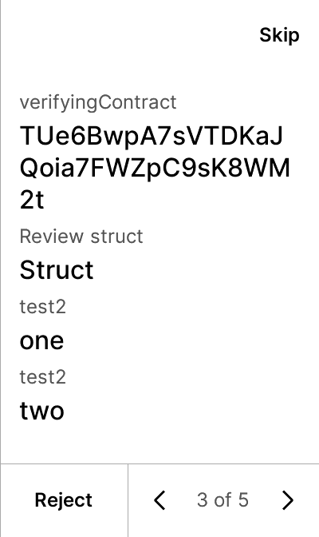
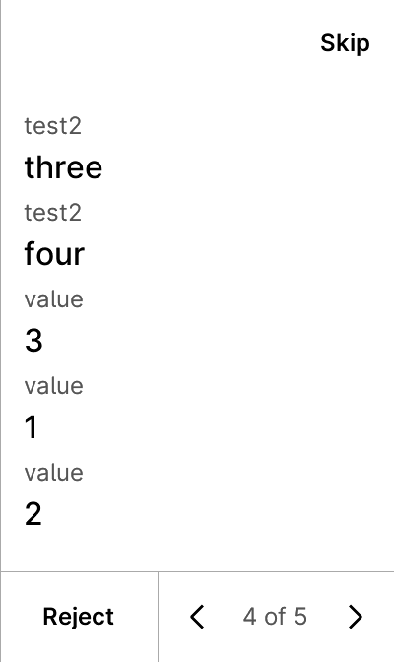

warning


test_tip712_new-13-empty_arrays-data-True-False
8 image(s)
test_tip712_new-13-empty_arrays-data-True-False



warning


test_tip712_new-14-rabby_bug-data-False-False
10 image(s)
test_tip712_new-14-rabby_bug-data-False-False
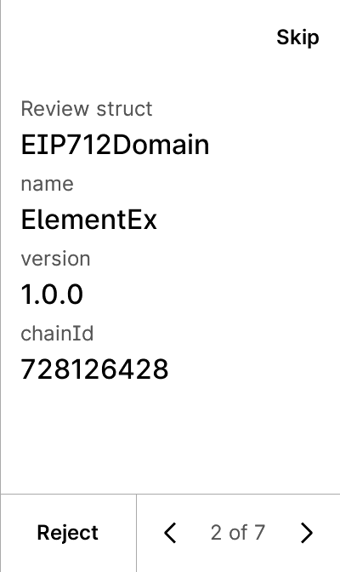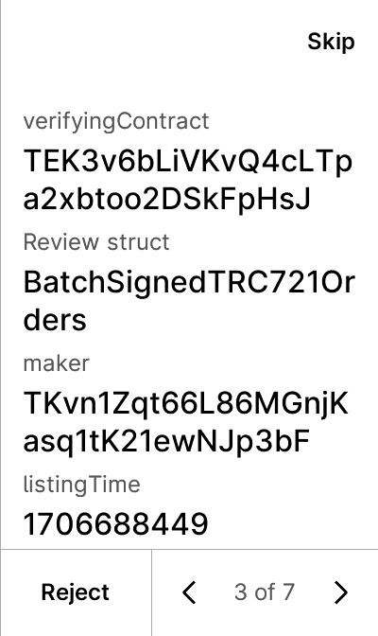
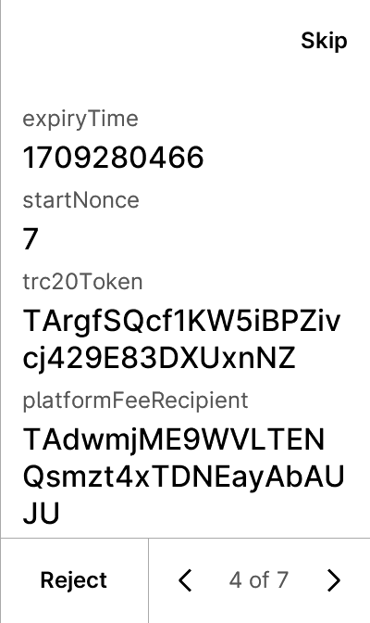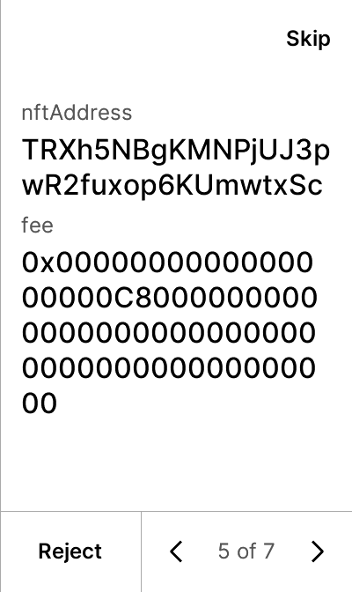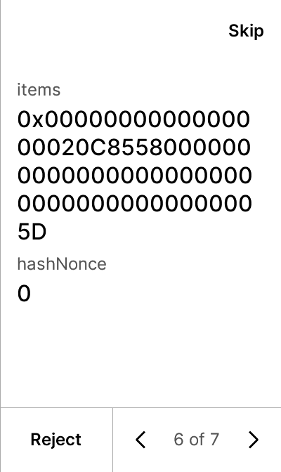

warning


test_tip712_new-14-rabby_bug-data-True-False
10 image(s)
test_tip712_new-14-rabby_bug-data-True-False



warning


test_tip712_new-15-opensea_bulkorder-data-False-False
26 image(s)
test_tip712_new-15-opensea_bulkorder-data-False-False
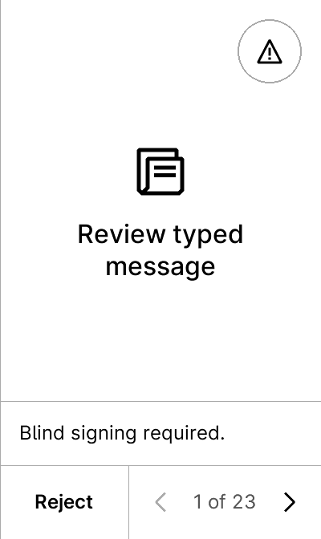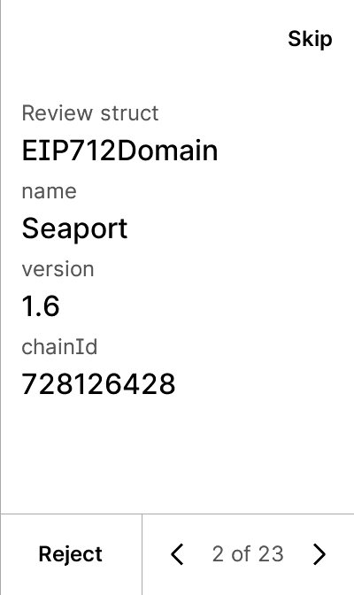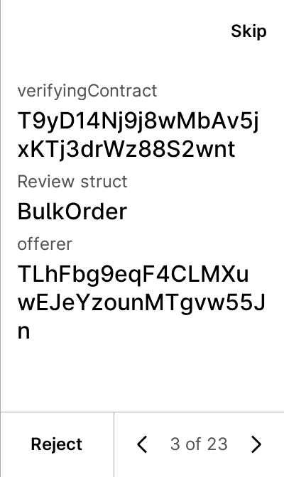
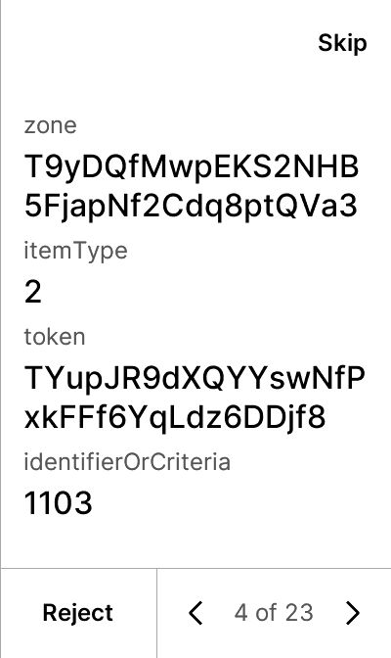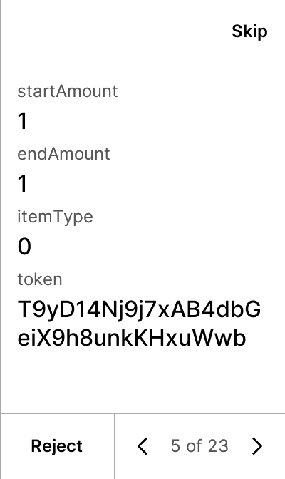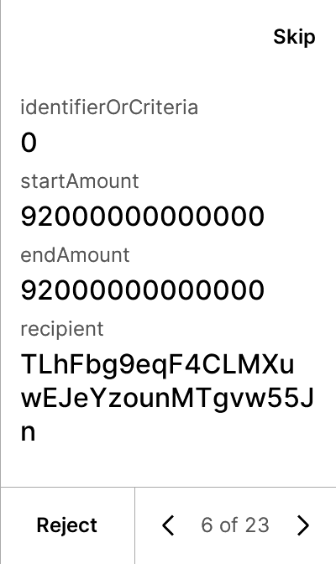
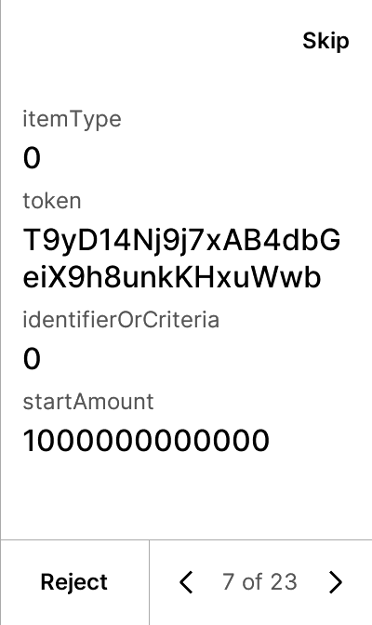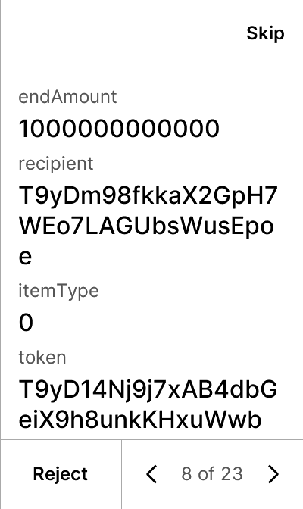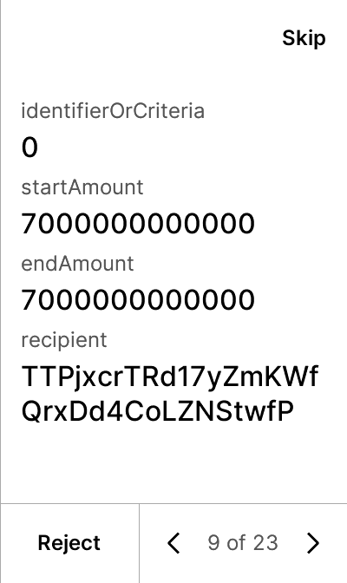
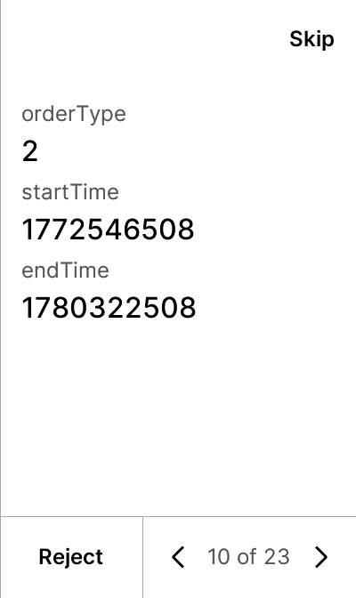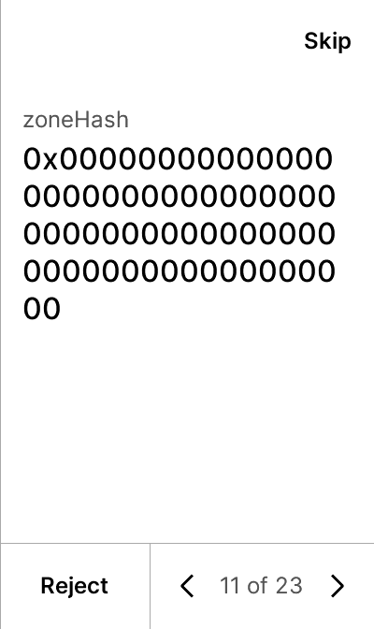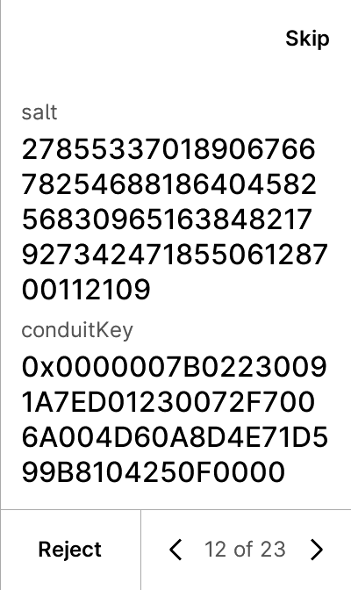
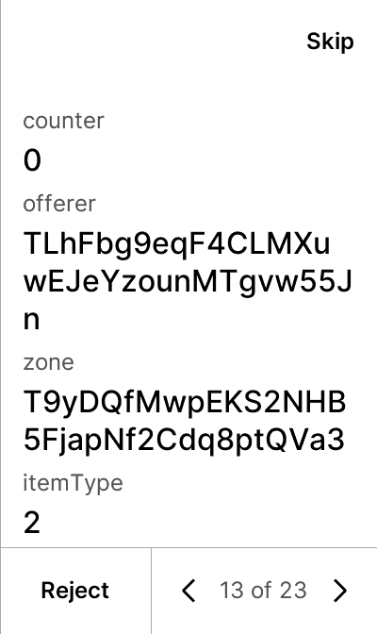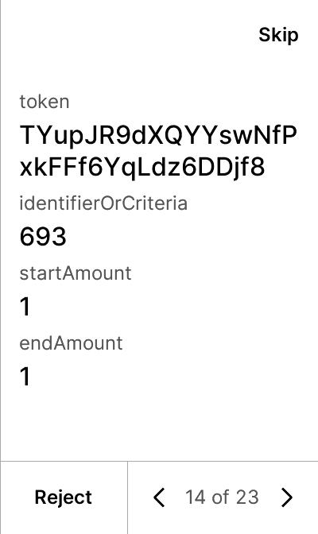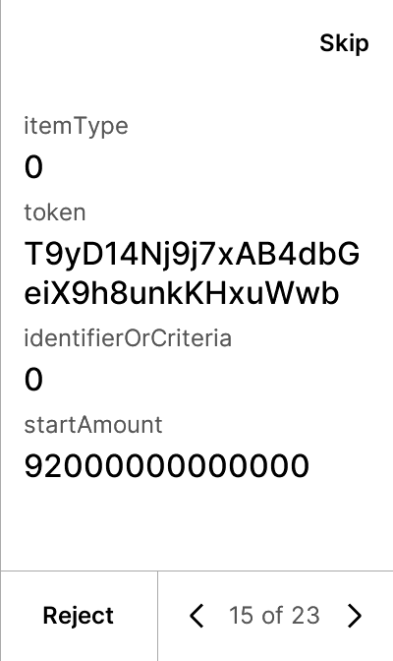
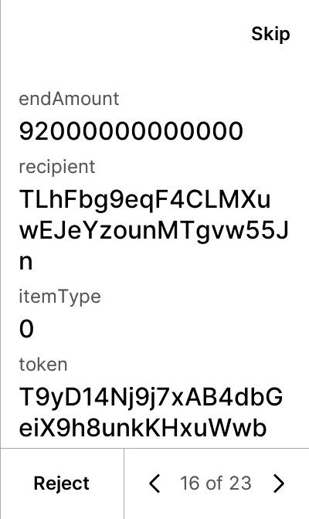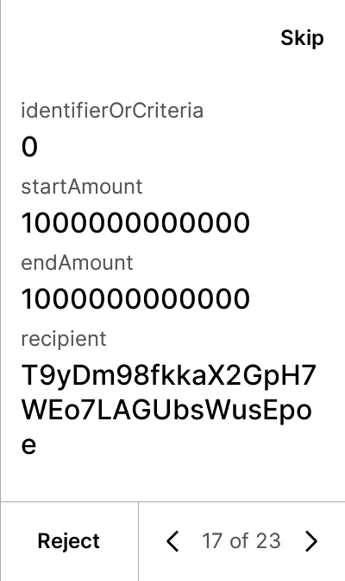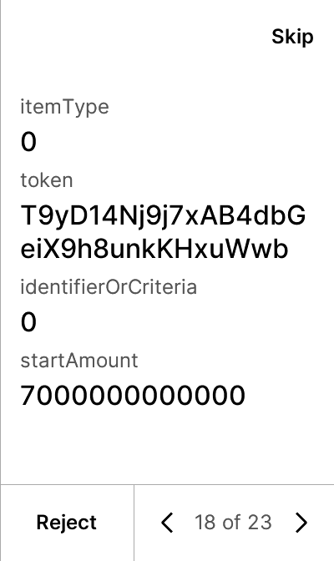
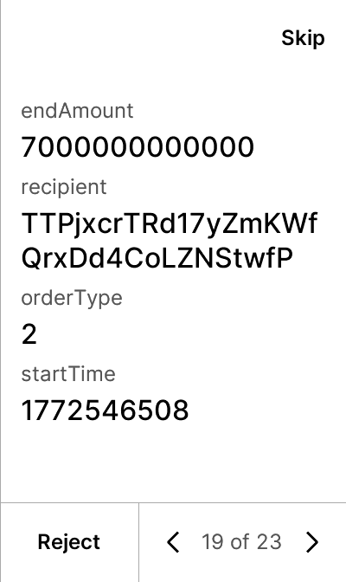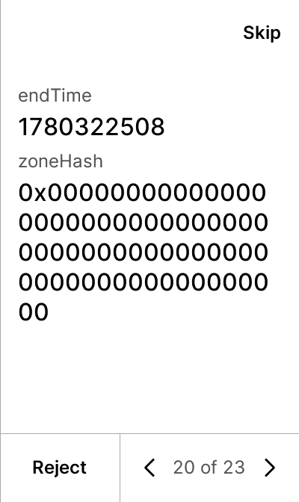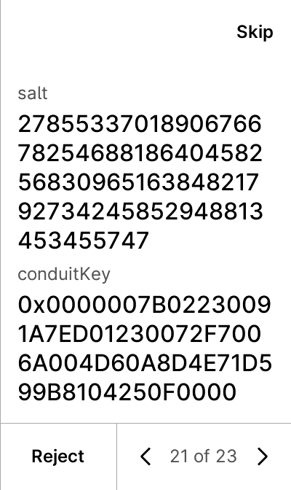
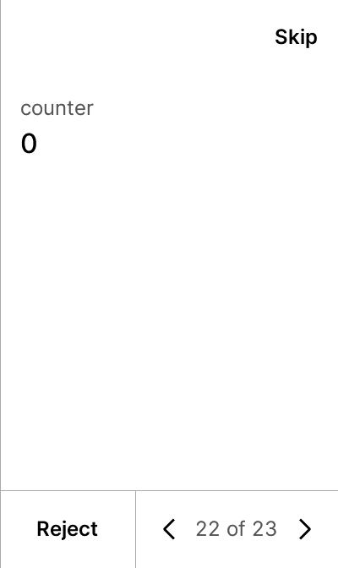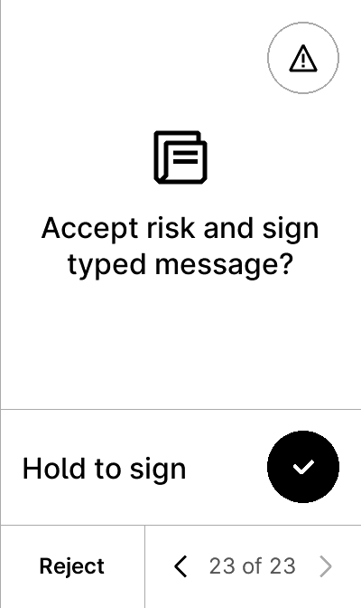

warning


test_tip712_new-15-opensea_bulkorder-data-True-False
26 image(s)
test_tip712_new-15-opensea_bulkorder-data-True-False









warning


test_tip712_new-16-trctoken-data-False-False
10 image(s)
test_tip712_new-16-trctoken-data-False-False
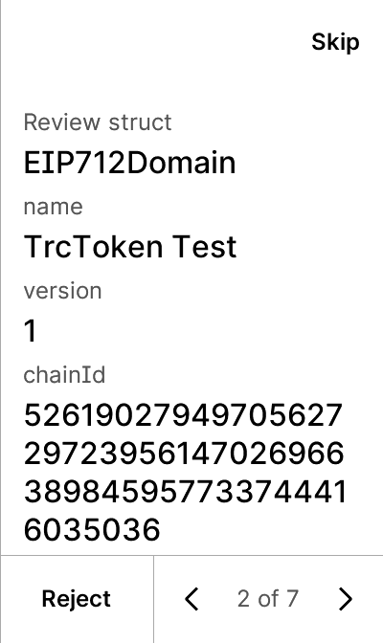
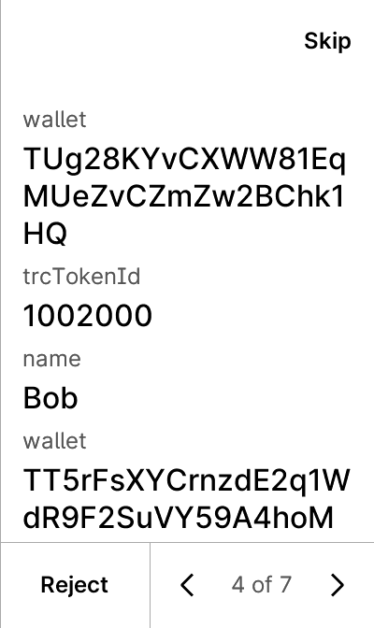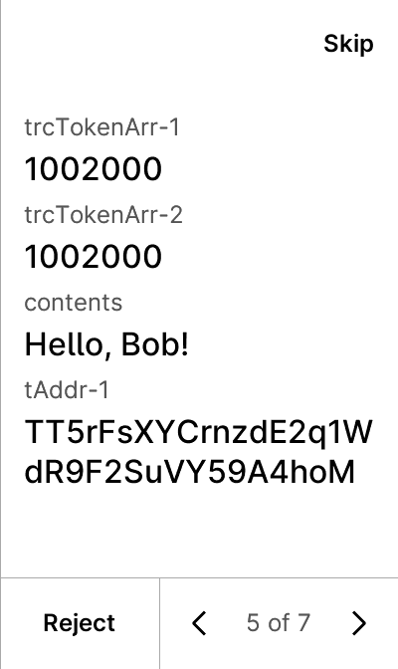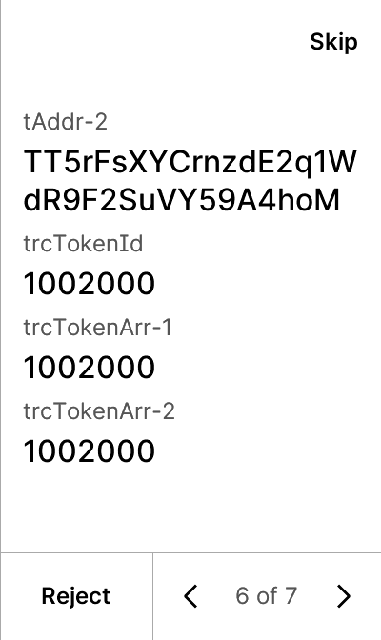

warning


test_tip712_new-16-trctoken-data-True-False
10 image(s)
test_tip712_new-16-trctoken-data-True-False



warning


test_tip712_new-17-trctoken-new-data-False-False
10 image(s)
test_tip712_new-17-trctoken-new-data-False-False
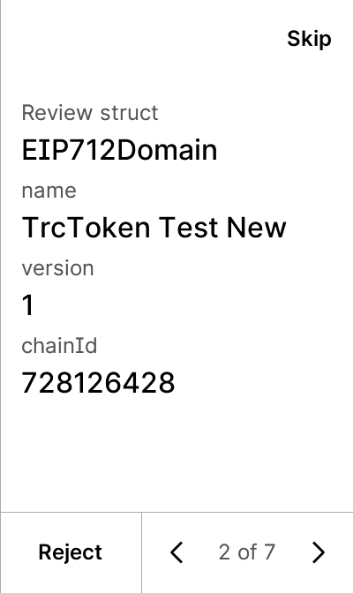


warning


test_tip712_new-17-trctoken-new-data-True-False
10 image(s)
test_tip712_new-17-trctoken-new-data-True-False



warning


test_tip712_proxy
5 image(s)
test_tip712_proxy
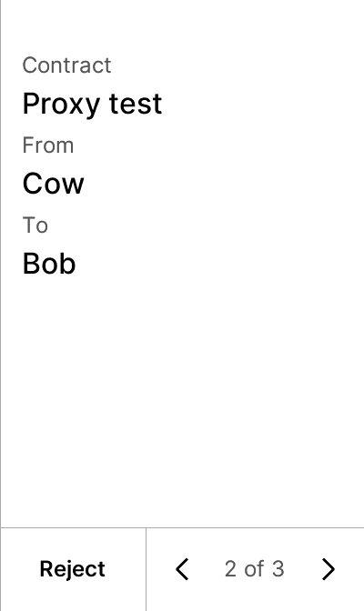


test_trusted_name_v1
5 image(s)
test_trusted_name_v1
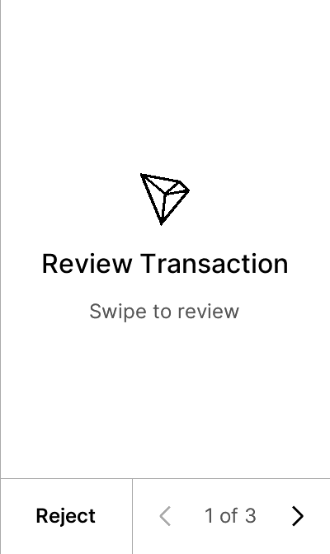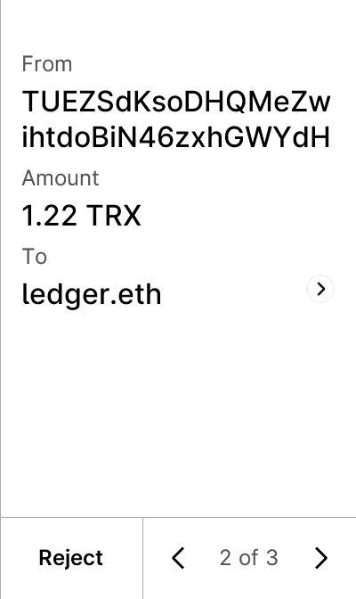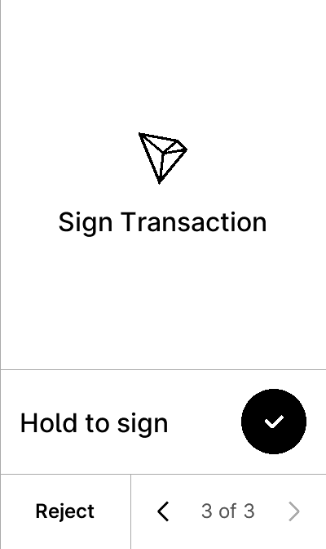


test_trusted_name_v1_non_mainnet
5 image(s)
test_trusted_name_v1_non_mainnet



test_trusted_name_v1_unknown_chain
5 image(s)
test_trusted_name_v1_unknown_chain



test_trusted_name_v1_verbose
7 image(s)
part1
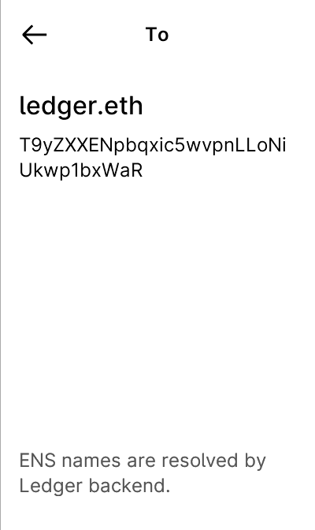
part2



test_trusted_name_v1_wrong_addr
5 image(s)
test_trusted_name_v1_wrong_addr
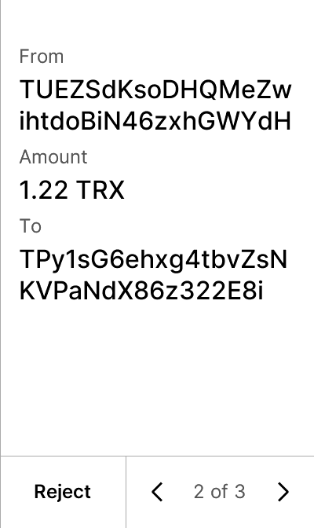


test_trusted_name_v2
5 image(s)
test_trusted_name_v2



test_trusted_name_v2_wrong_chainid
5 image(s)
test_trusted_name_v2_wrong_chainid



test_trx_account_permission_update
5 image(s)
test_trx_account_permission_update
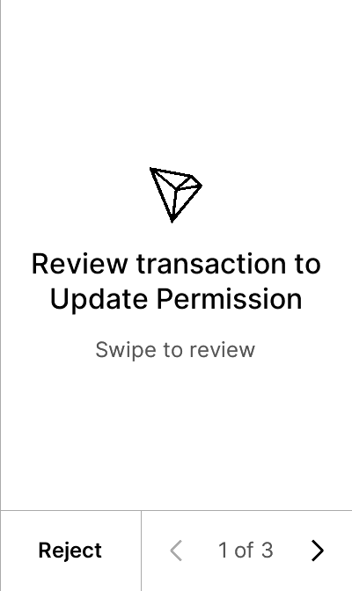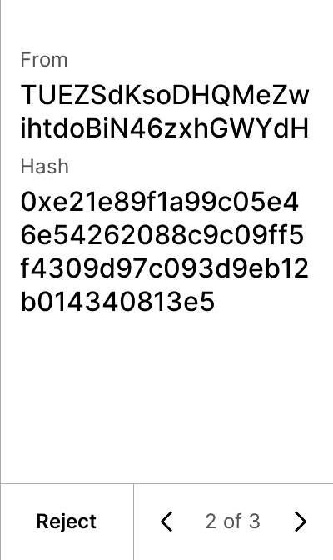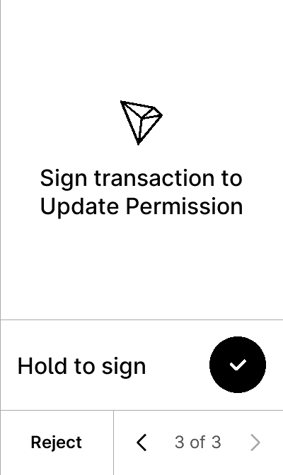


test_trx_account_update
5 image(s)
test_trx_account_update
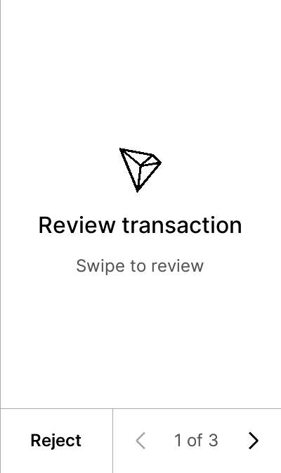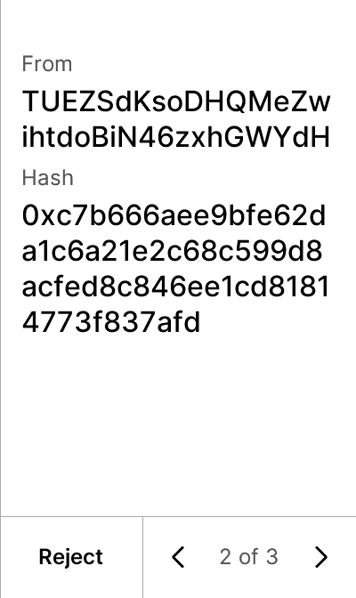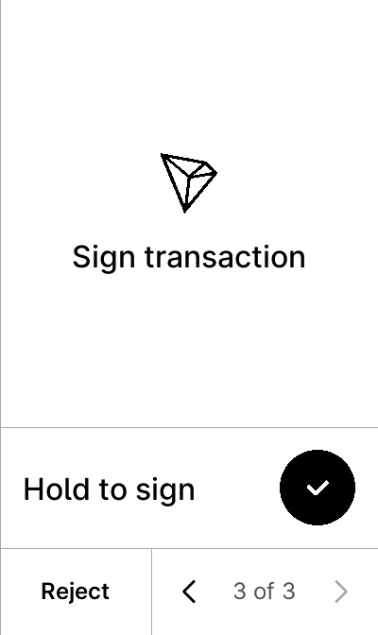


test_trx_create_witness
5 image(s)
test_trx_create_witness
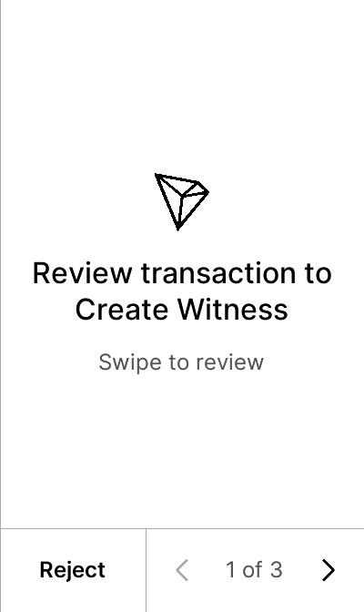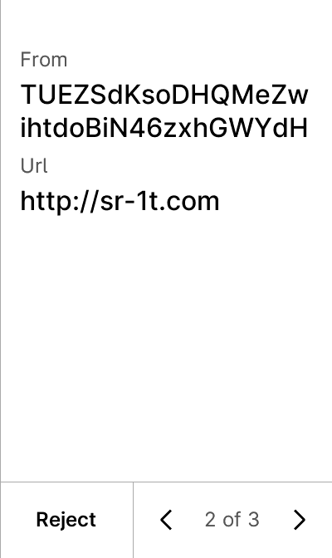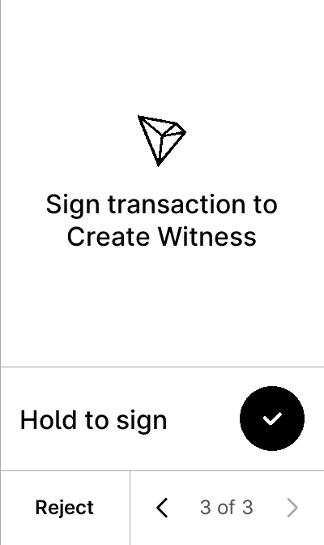


test_trx_custom_contract
7 image(s)
test_trx_custom_contract


warning


test_trx_delegate_resource
6 image(s)
test_trx_delegate_resource
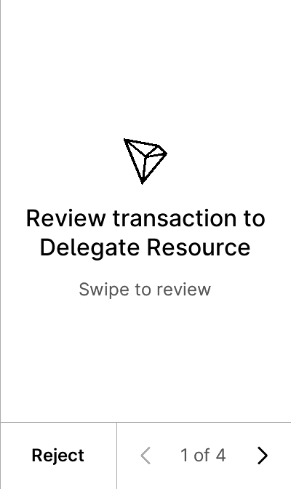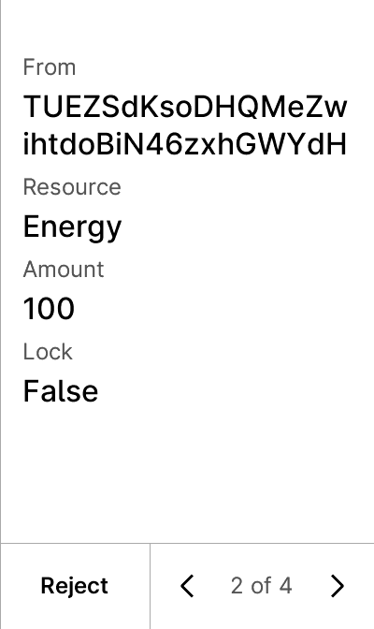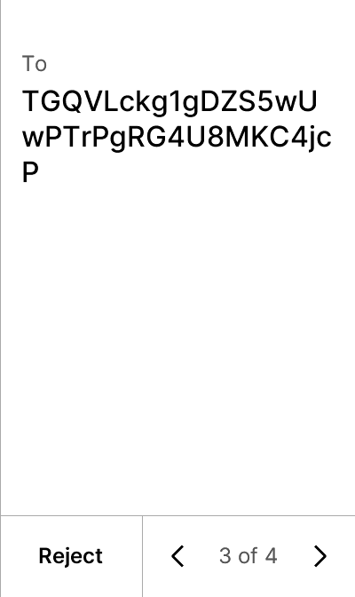
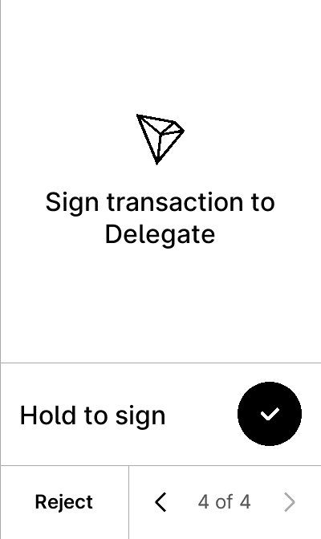

test_trx_ecdh_key
5 image(s)
test_trx_ecdh_key
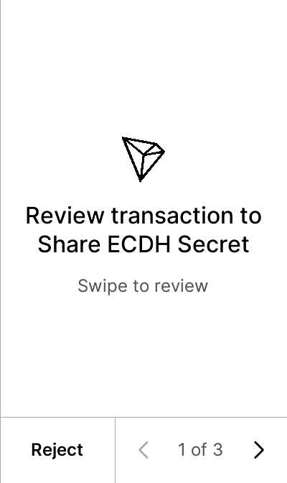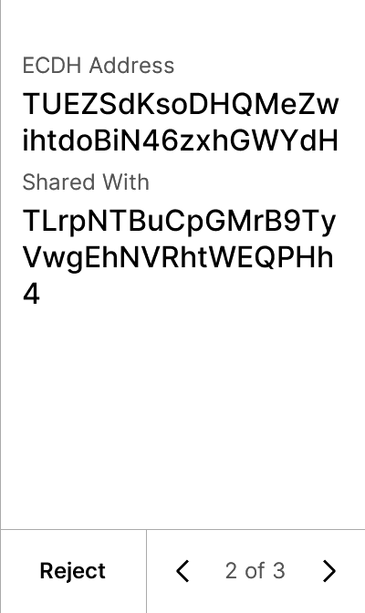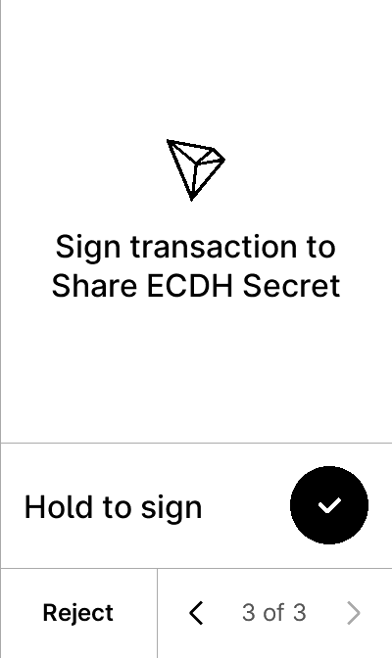


test_trx_exchange_create
5 image(s)
test_trx_exchange_create
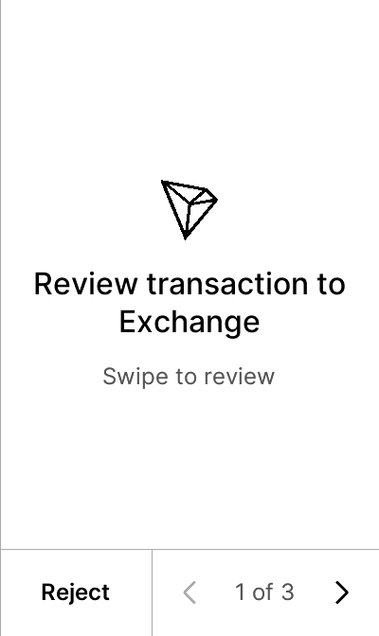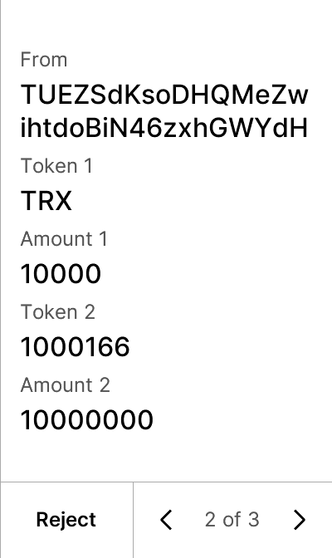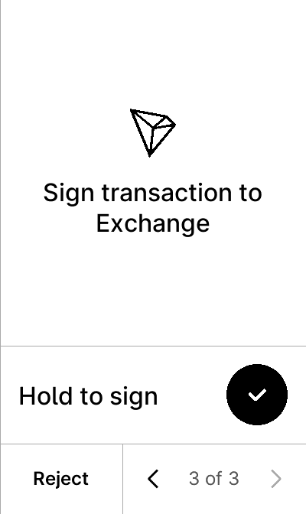


test_trx_exchange_create_with_token_name
5 image(s)
test_trx_exchange_create_with_token_name
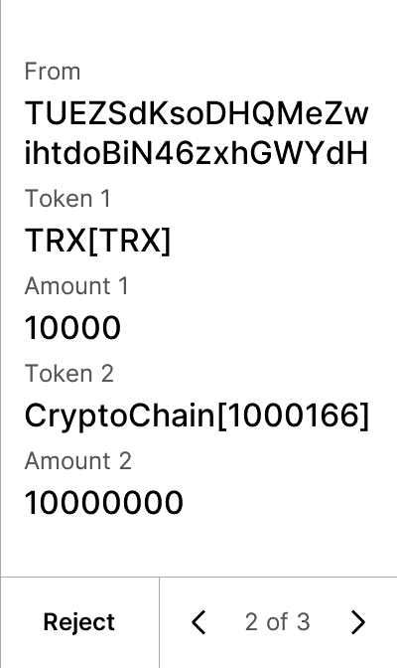


test_trx_exchange_inject
5 image(s)
test_trx_exchange_inject
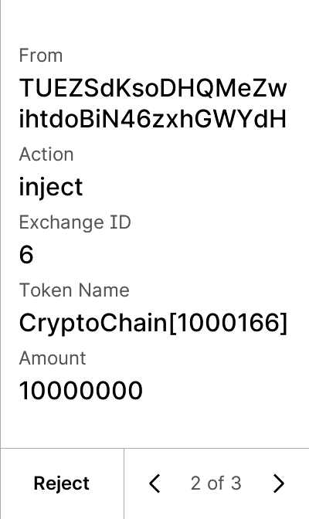


test_trx_exchange_transaction
5 image(s)
test_trx_exchange_transaction
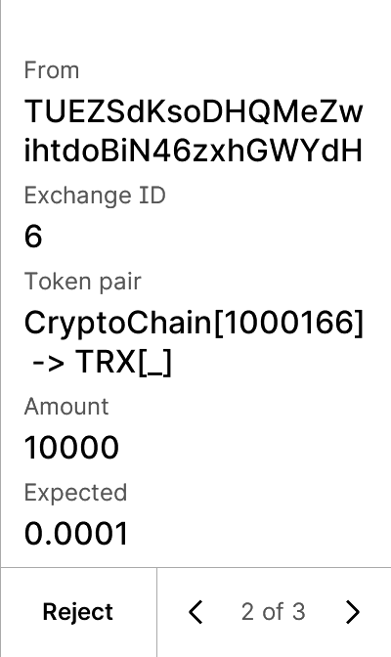


test_trx_exchange_withdraw
5 image(s)
test_trx_exchange_withdraw
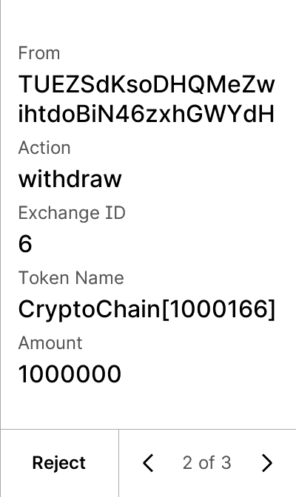


test_trx_freezeV2_balance
5 image(s)
test_trx_freezeV2_balance
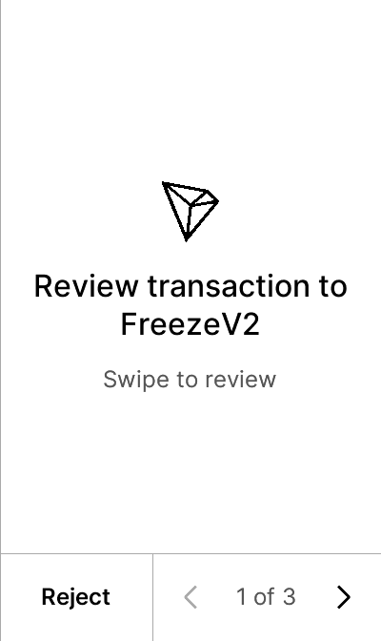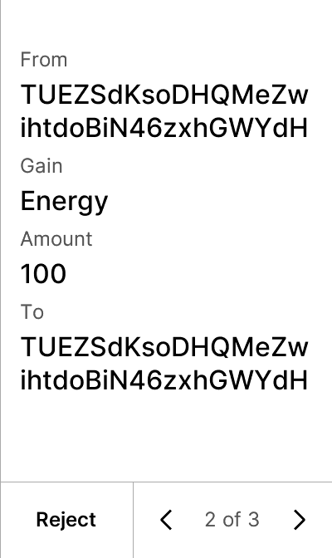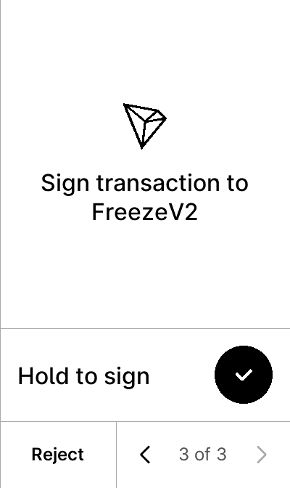


test_trx_freeze_balance_bw
5 image(s)
test_trx_freeze_balance_bw
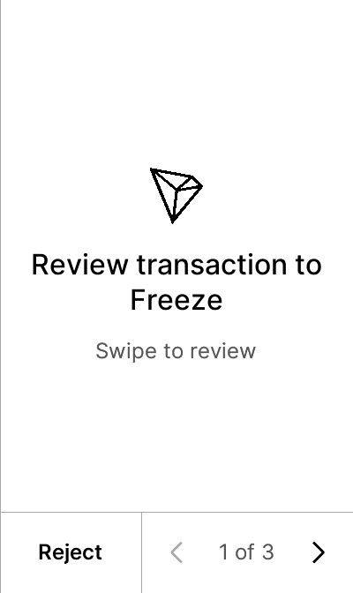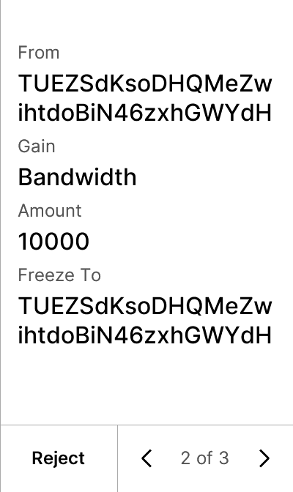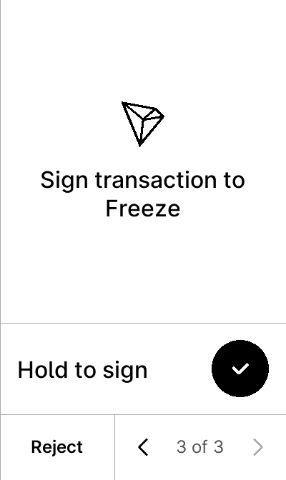


test_trx_freeze_balance_delegate_energy
5 image(s)
test_trx_freeze_balance_delegate_energy
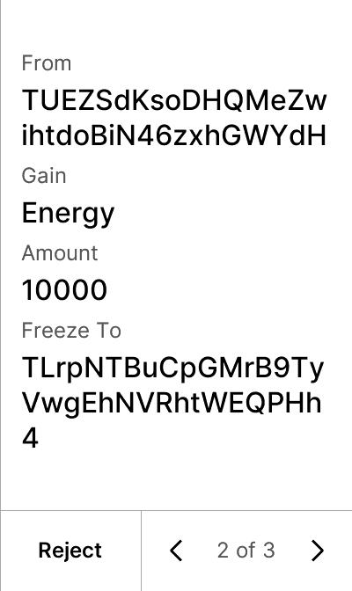


test_trx_freeze_balance_energy
5 image(s)
test_trx_freeze_balance_energy
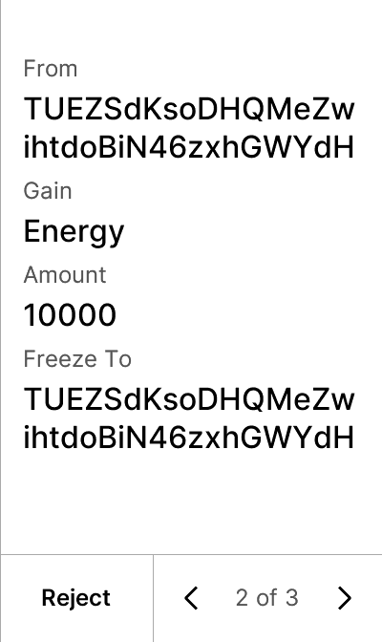


test_trx_proposal_approve
5 image(s)
test_trx_proposal_approve
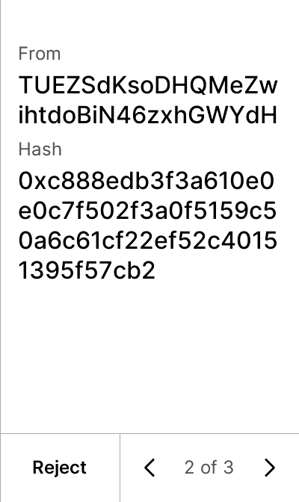


test_trx_proposal_create
5 image(s)
test_trx_proposal_create
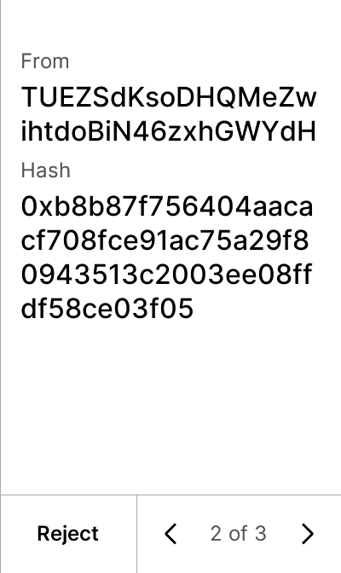


test_trx_proposal_delete
5 image(s)
test_trx_proposal_delete
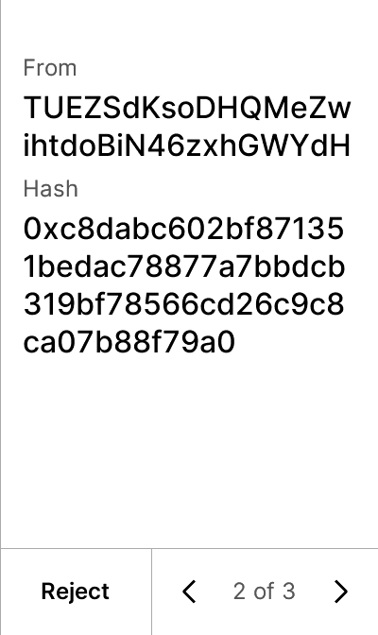


test_trx_send
5 image(s)
test_trx_send
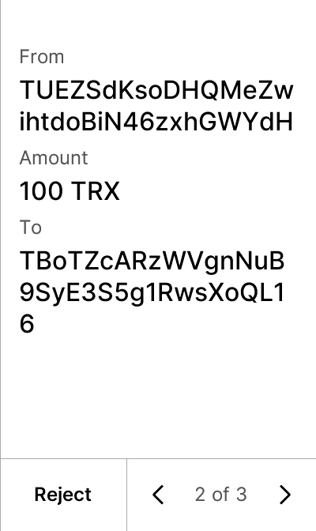


test_trx_send_asset_with_name
5 image(s)
test_trx_send_asset_with_name
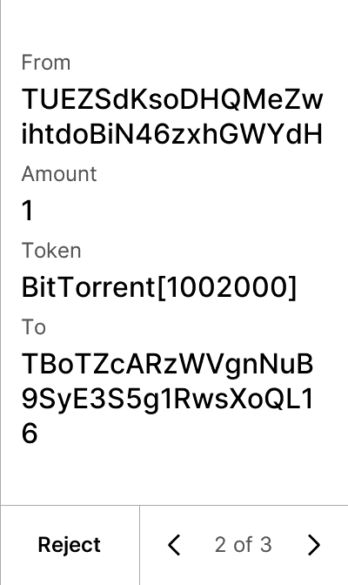


test_trx_send_asset_without_name
5 image(s)
test_trx_send_asset_without_name
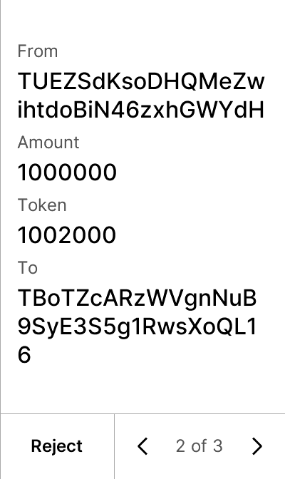


test_trx_send_display_hash
6 image(s)
test_trx_send_display_hash
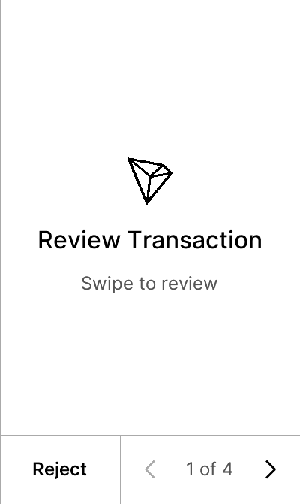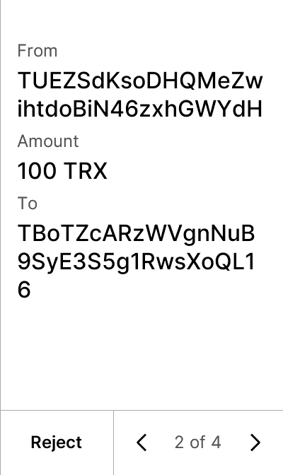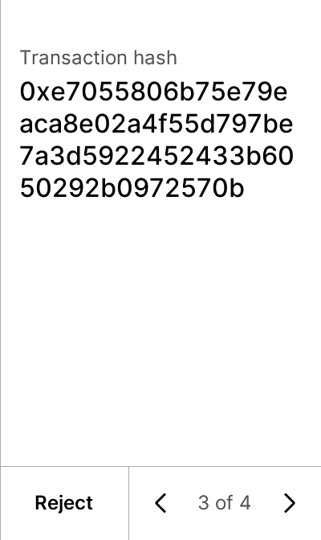
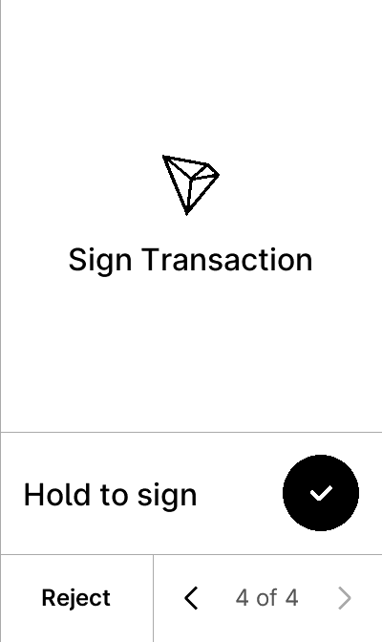

test_trx_send_permissioned
5 image(s)
test_trx_send_permissioned
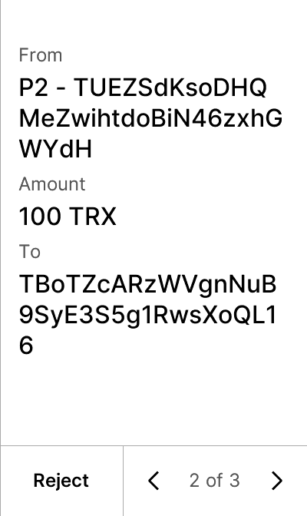


test_trx_send_with_data_field
6 image(s)
test_trx_send_with_data_field


warning
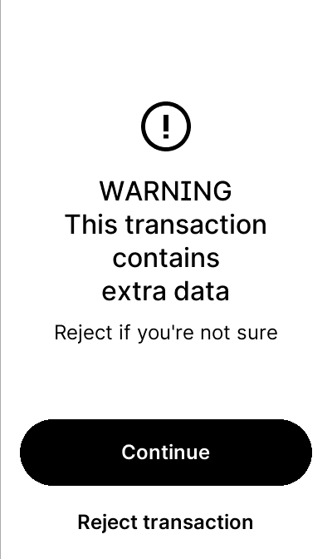

test_trx_send_wrong_path
5 image(s)
test_trx_send_wrong_path



test_trx_sign_hash
5 image(s)
test_trx_sign_hash
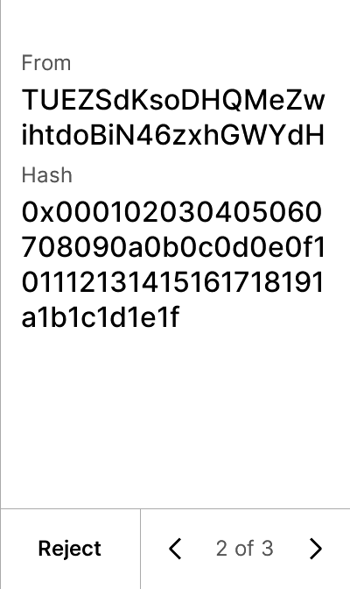


test_trx_sign_message
5 image(s)
test_trx_sign_message
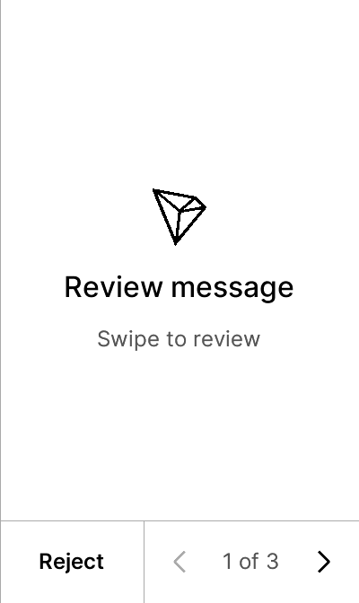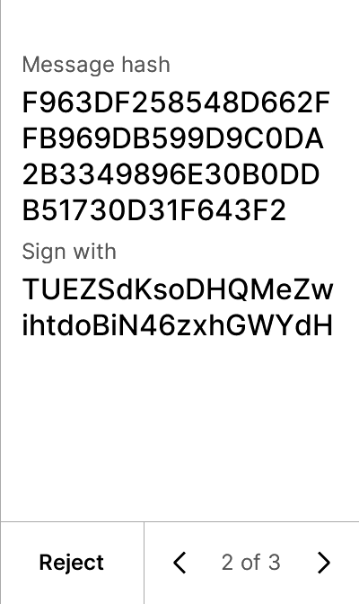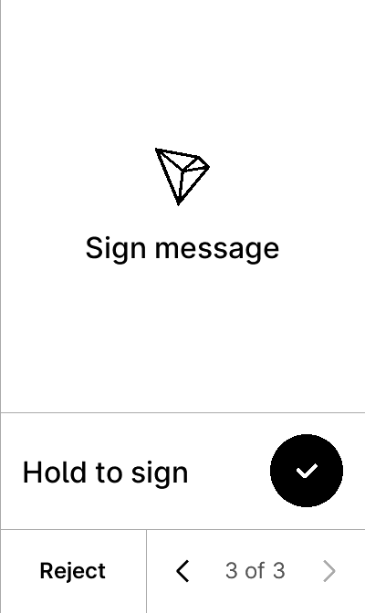


test_trx_sign_personal_message
5 image(s)
test_trx_sign_personal_message
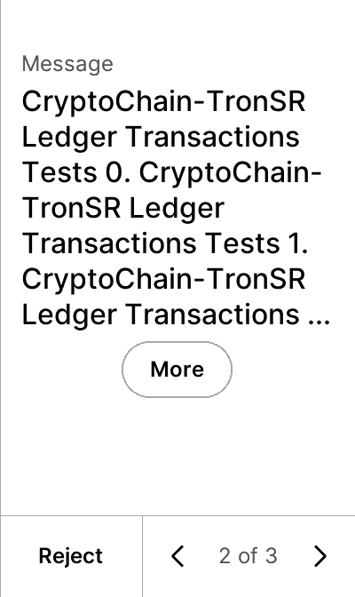


test_trx_trc20_approve
5 image(s)
test_trx_trc20_approve
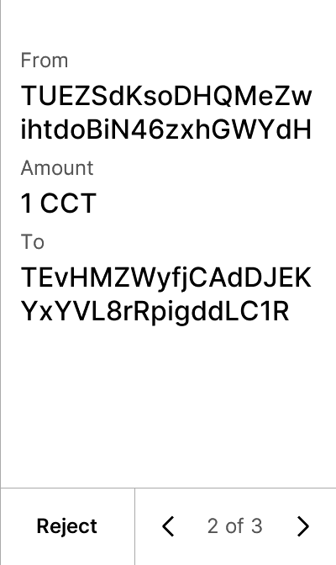


test_trx_trc20_send
5 image(s)
test_trx_trc20_send



test_trx_trc20_send_e20_amount
5 image(s)
test_trx_trc20_send_e20_amount
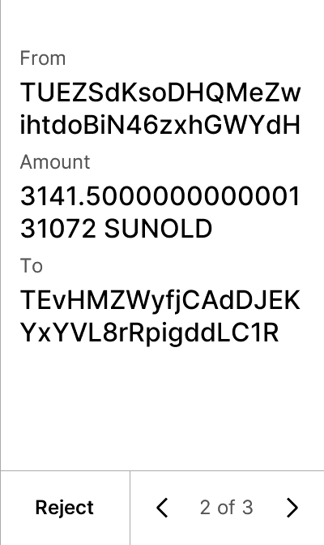


test_trx_trc20_send_zero_amount
5 image(s)
test_trx_trc20_send_zero_amount
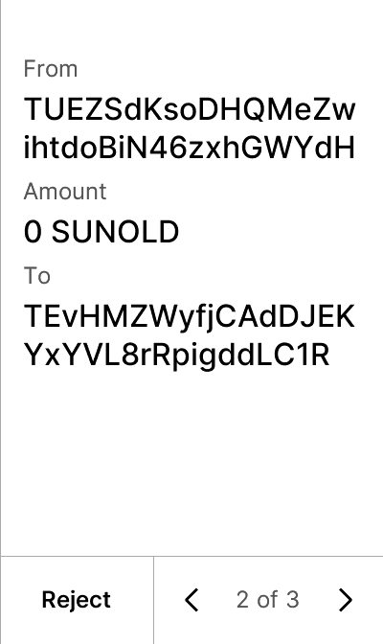


test_trx_undelegate_resource
5 image(s)
test_trx_undelegate_resource
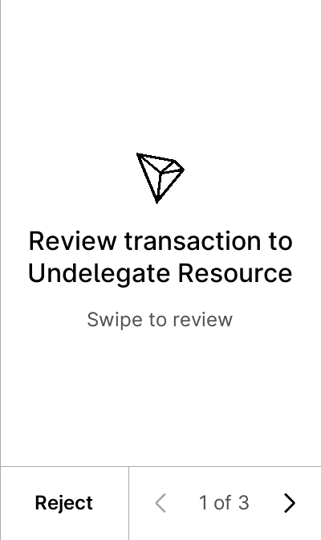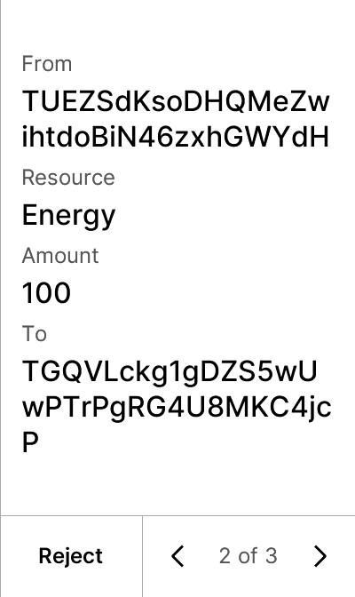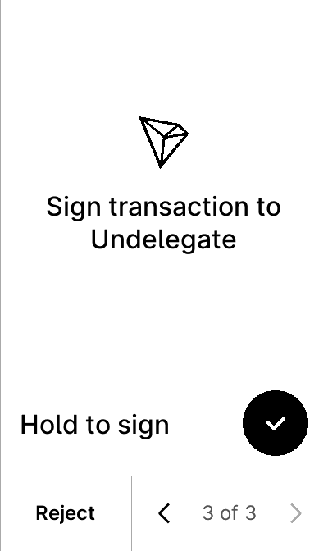


test_trx_unfreezeV2_balance
5 image(s)
test_trx_unfreezeV2_balance
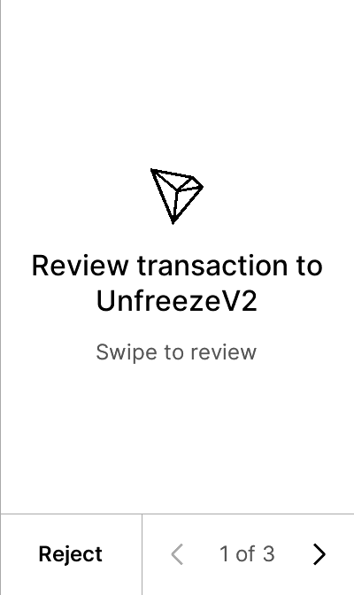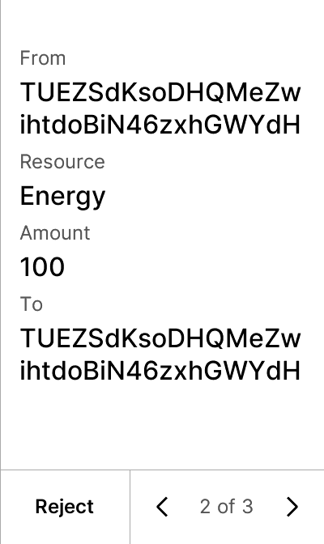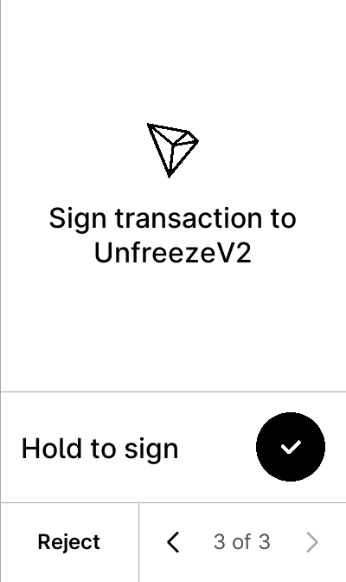


test_trx_unfreeze_balance_bw
5 image(s)
test_trx_unfreeze_balance_bw
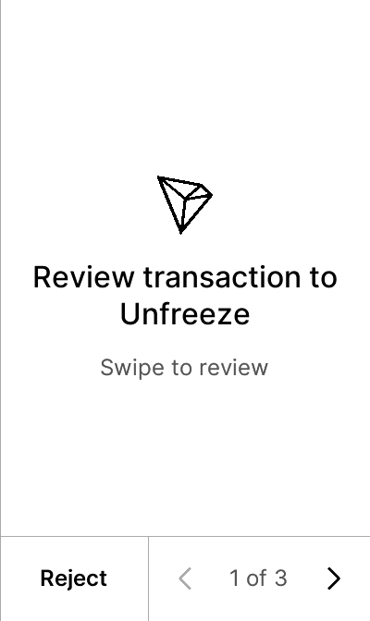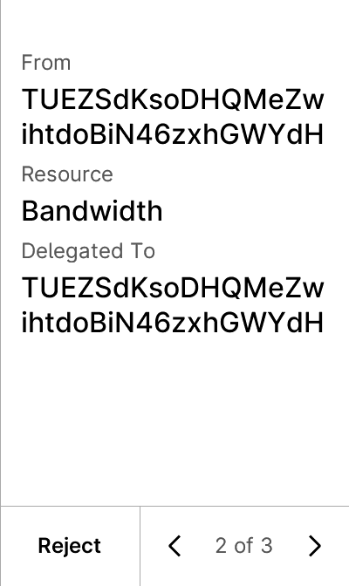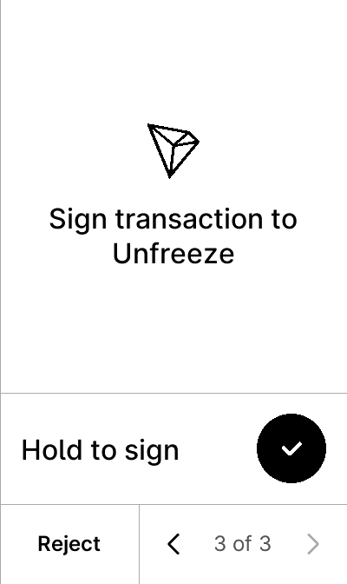


test_trx_unfreeze_balance_delegate_energy
5 image(s)
test_trx_unfreeze_balance_delegate_energy
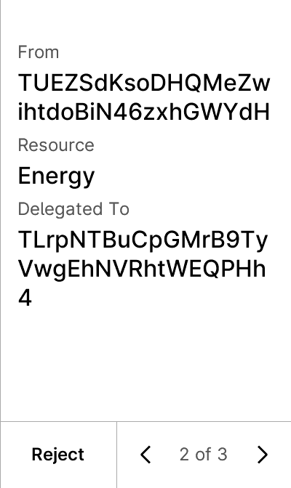


test_trx_unknown_trc20_send
7 image(s)
test_trx_unknown_trc20_send
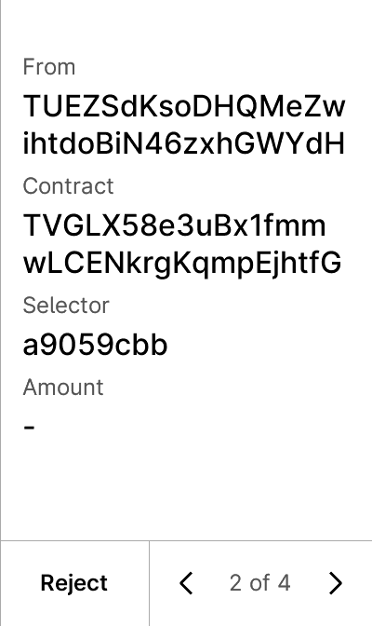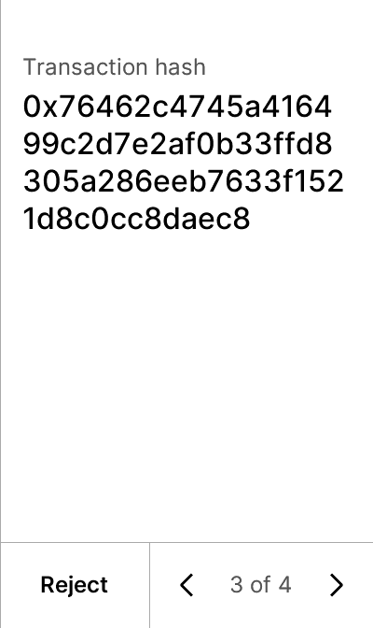

warning


test_trx_vote_witness
6 image(s)
test_trx_vote_witness
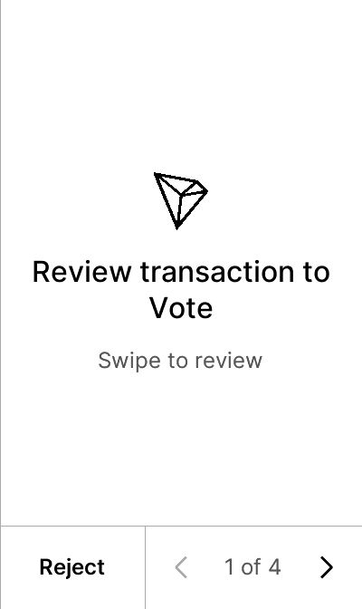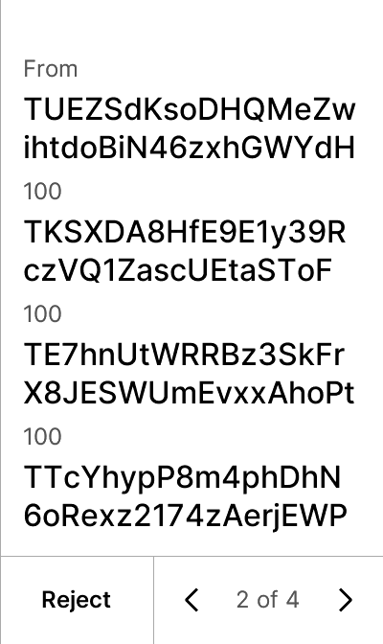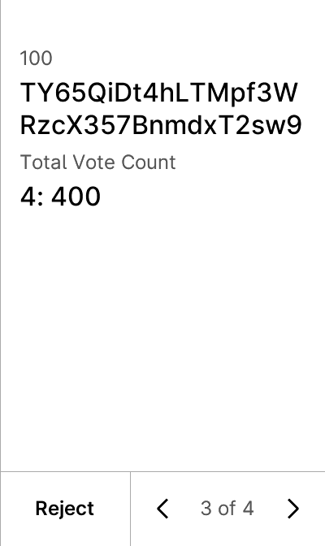
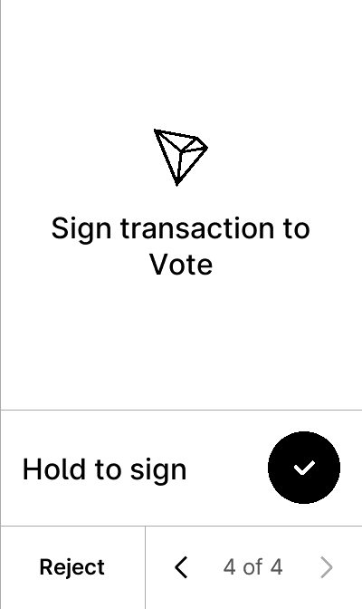

test_trx_withdraw_balance
5 image(s)
test_trx_withdraw_balance
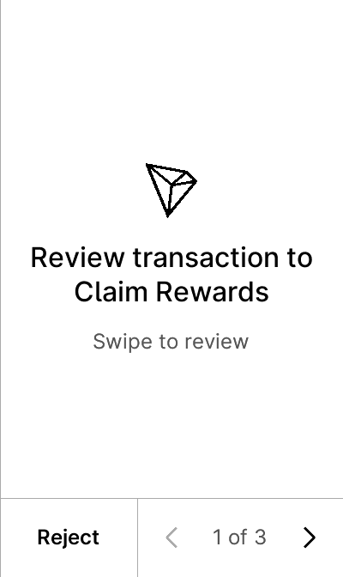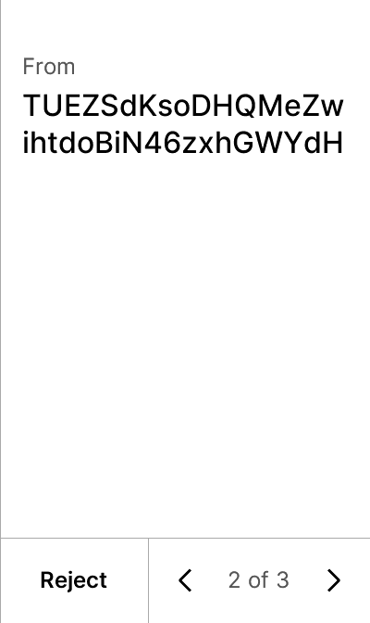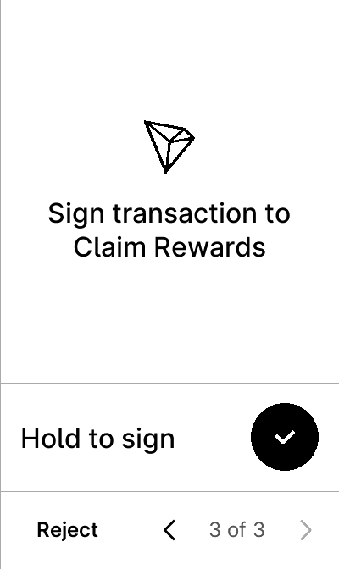


test_trx_withdraw_unfreeze
5 image(s)
test_trx_withdraw_unfreeze
