**Task1:** Calculate Q70 SBS travel times between the following Stop IDs:

* To calculate travel time between different stops for Q70 SBS I made SQL query that will give us the time taken by each bus and delay between each stop.

Some of my findings while I was working with data set are –

* For each bus Id there is one or more ‘gtfs_trip_id’ so that means one bus is used in different trips.
* To know if the bus is at stop or not, I didn’t rely on ‘at_stop_boolean’ flag because for some ‘gtfs_trip_id’, ‘at_stop_boolean’ flag not always tell you if the bus is at stop or not.
* For ‘stop_id’ 553332 the predicted time taken to reach is null because that’s our origin bus stop
* To get the starting time of bus from every bus stop I used ‘initial recorded time’ from the bus stop.
* To get the arrival time of buses between every bus stop I used the ‘next_predicted_arrival_time(x)’ corresponding to the last ‘recorded_at_time(rL)’ for. Then I used ‘next_predicted_arrival_time(x)’ column and ‘recorded_at_time(rI)’ at initial to calculate travel time.

Arrival time = x – rI (in minutes)

* To get the delay in time between every bus stop I used ‘next_predicted_time(pI)’ recorded at initial stage from column ‘record_at_time’ and ‘next_predicted_time(pL)’ from the last record of column ‘record_at_time’ corresponding to each bus stop.

Delay = pL – pI (in minutes)

* Below is the delay and time travel for trip_ id = 18522765 and vehicle_id = 7451

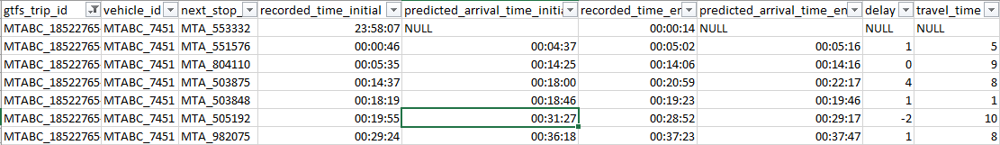

Figure 1: Travel details for trip_id 18522765

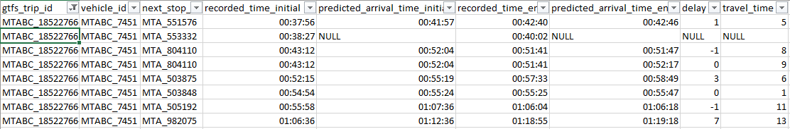

Figure 2: Travel details for trip_id 18522766

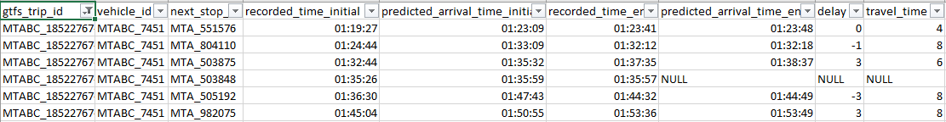

Figure 3: Travel details for trip_id 18522767