**Task2**: Visualize travel times and bus delays.

* To visualize travel time and delay between each stop I used trip_id column as a filter and x-axis is the bus stop_id and y-axis tells the delay and travel time for each stop_id

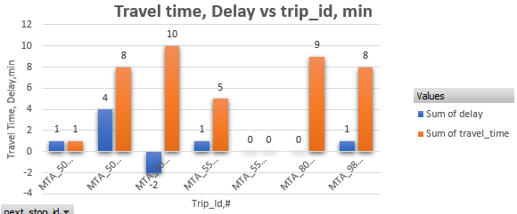

Figure 1: travel and Delay time for each trip_id 18522765 in minutes

* From figure 1 we can observe that delay for stop_id 505192 is negative means the bus reaches before time.
* For trip_id 18522765 the bus got longest travel time between stop 503848 and 505192 that is 10 mins and longest delay between stops 804110 and 503875 that is 4 mins
* To be more specific, I plot total delay and travel time for all trips between every bus stop

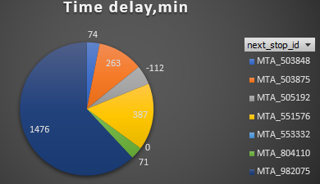 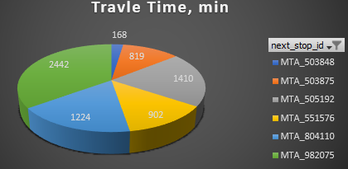

Figure 2: Delay Time for all trips for each bus stop in mins Figure 3: Travel Time for all trips for each bus stop

* From figure 2 we can say that most of the buses got delay reaching bus stop 982075 which is 1476 mins, So, there could be some of the possible reasons like there could be lot of rush between bus stop 505192 and 982075 after that buses took 2nd longest time to reach bus stop 551576. On the other hand, buses reach before time to bus stop 505192.
* Figure 3 tells us that the buses took longest time to travel to bus stop 982075 that is 2442 minutes followed by bus stop 505192 for which buses took 1410 minutes but the best observation is even though buses took second longest time to travel to bus stop 505192, most of them reached before time. There could ‘n’ number of reasons for that there is no traffic between 503848 and 505192 and driver think this is the best time to cover most of the delay which they had between previous bus stop.