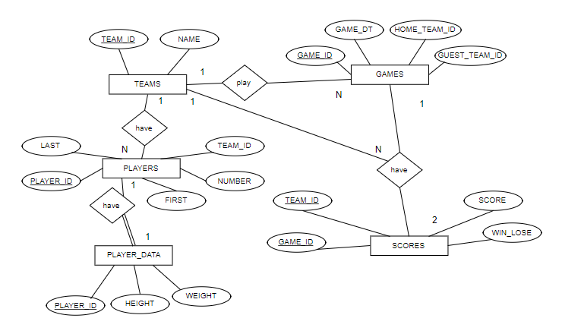

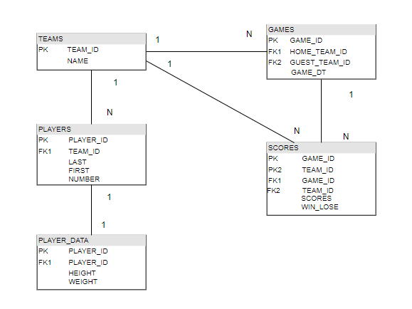

create table TEAMS (TEAM_ID integer, NAME varchar(20) , primary key (TEAM_ID))

create table PLAYER (PLAYER_ID integer, LAST varchar(2), FIRST varchar(20), TEAM_ID integer, NUMBER integer, primary key(PLAYER_ID), foreign key (TEAM_ID) references TEAMS(TEAM_ID))

create table PLAYER_DATA(PLAYER_ID integer, HEIGHT integer, WEIGHT integer, primary key(PLAYER_ID), foreign key(PLAYER_ID) references PLAYERS(PLAYER_ID) on delete cascade)

create table GAMES(GAME_ID integer, GAME_DT date , HOME_TEAM_ID integer, GUEST_TEAM_ID integer, primary key (GAME_ID), foreign key (HOME_TEAM_ID) references TEAMS(TEAM_ID), foreign key (GUEST_TEAM_ID) references TEAMS(TEAM_ID))

create table SCORES(GAME_ID integer, TEAM_ID integer, SCORE integer, WIN_LOSE varchar(4), primary key(GAME_ID,TEAM_ID), foreign key (TEAM_ID) references TEAMS(TEAM_ID) , foreign key (TEAM_ID) references GAMES(GUEST_TEAM_ID) ,foreign key (TEAM_ID) references GAMES(GUEST_TEAM_ID) , foreign key (HOME_TEAM_ID) references GAMES(TEAM_ID))

1)

SELECT * FROM TEAMS

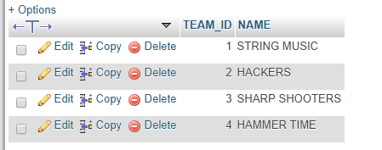

SELECT * FROM PLAYERS

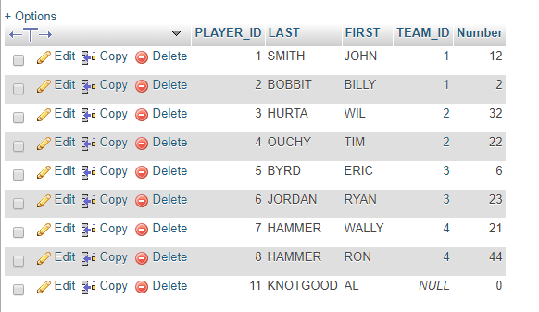

2) and 1) ?

SELECT * FROM PLAYER_DATA;

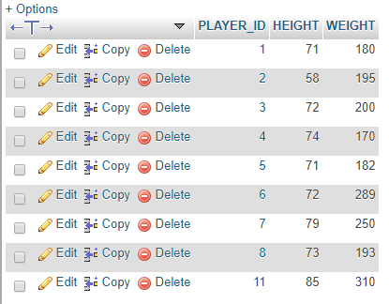

SELECT * FROM GAMES;

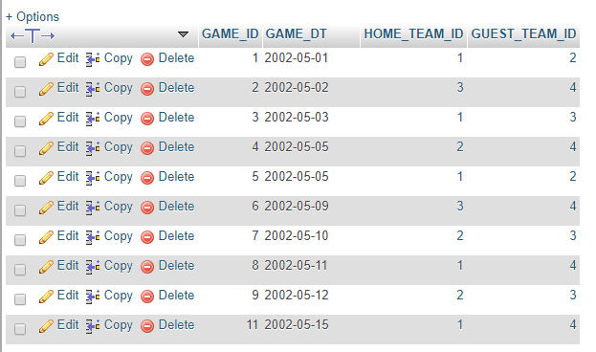

SELECT* FROM SCORES;

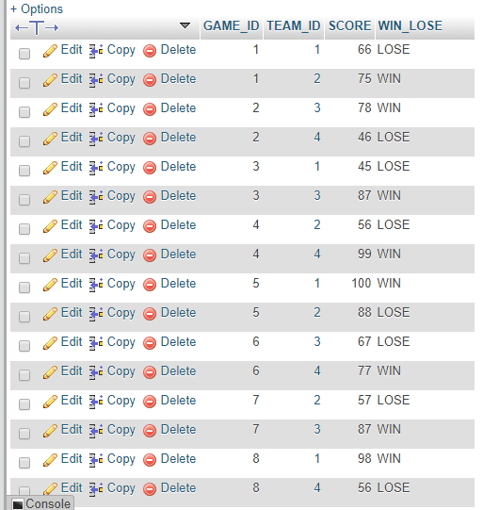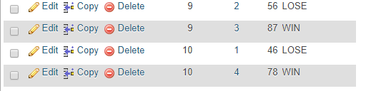

3)

[SELECT](http://loki.trentu.ca/phpMyAdmin/url.php?url=http://dev.mysql.com/doc/refman/5.5/en/select.html) [AVG](http://loki.trentu.ca/phpMyAdmin/url.php?url=http://dev.mysql.com/doc/refman/5.5/en/group-by-functions.html#function_avg)(HEIGHT) AS avgHEIGHT FROM PLAYER_DATA



4)

[SELECT](http://loki.trentu.ca/phpMyAdmin/url.php?url=http://dev.mysql.com/doc/refman/5.5/en/select.html) [AVG](http://loki.trentu.ca/phpMyAdmin/url.php?url=http://dev.mysql.com/doc/refman/5.5/en/group-by-functions.html#function_avg)(WEIGHT) AS avgWEIGHT FROM PLAYER_DATA



5)

CREATE VIEW PLAYER_LIST AS SELECT P.LAST AS NAME, P.NUMBER , PD.HEIGHT,PD.WEIGHT FROM PLAYER_DATA PD, PLAYERS P WHERE PD.PLAYER_ID = P.PLAYER_ID

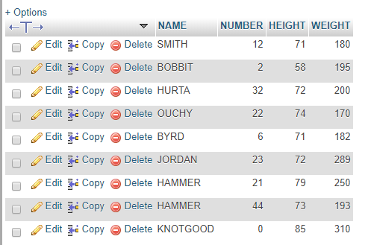

6)

CREATE VIEW ROOSTER AS SELECT T.NAME, P.LAST P.FIRST, P.NUMBER FROM PLAYERS P, TEAMS T WHERE P.TEAM_ID = T.TEAM_ID

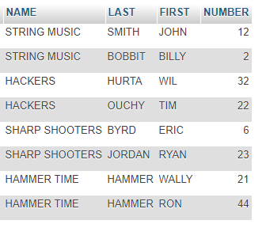

7)

create VIEW TOTAL_PIONTS as SELECT T1.NAME , sum(S1.SCORE) as Totalpoints from SCORES S1, TEAMS T1 where T1.TEAM_ID = S1.TEAM_ID group by T1.TEAM_ID;

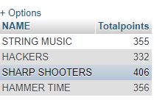

[select](http://loki.trentu.ca/phpMyAdmin/url.php?url=http://dev.mysql.com/doc/refman/5.5/en/select.html) NAME from TOTAL_PIONTS WHERE Totalpoints = ([select](http://loki.trentu.ca/phpMyAdmin/url.php?url=http://dev.mysql.com/doc/refman/5.5/en/select.html) [Max](http://loki.trentu.ca/phpMyAdmin/url.php?url=http://dev.mysql.com/doc/refman/5.5/en/group-by-functions.html#function_max)(Totalpoints) from TOTAL_PIONTS)



SELECT T1.NAME , sum(S1.SCORE) as Totalpoints from SCORES S1, TEAMS T1 where T1.TEAM_ID = S1.TEAM_ID group by T1.TEAM_ID order by Totalpoints DESC Limit 1



8)

[SELECT](http://loki.trentu.ca/phpMyAdmin/url.php?url=http://dev.mysql.com/doc/refman/5.5/en/select.html) T.NAME, S.SCORE FROM TEAMS T, SCORES S WHERE T.TEAM_ID = S.TEAM_ID [AND](http://loki.trentu.ca/phpMyAdmin/url.php?url=http://dev.mysql.com/doc/refman/5.5/en/logical-operators.html#operator_and) SCORE = ([SELECT](http://loki.trentu.ca/phpMyAdmin/url.php?url=http://dev.mysql.com/doc/refman/5.5/en/select.html) [MAX](http://loki.trentu.ca/phpMyAdmin/url.php?url=http://dev.mysql.com/doc/refman/5.5/en/group-by-functions.html#function_max)(SCORE) FROM SCORES)

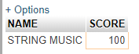

9)

[SELECT](http://loki.trentu.ca/phpMyAdmin/url.php?url=http://dev.mysql.com/doc/refman/5.5/en/select.html) [MAX](http://loki.trentu.ca/phpMyAdmin/url.php?url=http://dev.mysql.com/doc/refman/5.5/en/group-by-functions.html#function_max)(S1.SCORE + S2.SCORE) from SCORES S1, SCORES S2 where S1.GAME_ID = S2.GAME_ID [AND](http://loki.trentu.ca/phpMyAdmin/url.php?url=http://dev.mysql.com/doc/refman/5.5/en/logical-operators.html#operator_and) S1.TEAM_ID <> S2.TEAM_ID

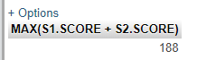

10)

[SELECT](http://loki.trentu.ca/phpMyAdmin/url.php?url=http://dev.mysql.com/doc/refman/5.5/en/select.html) [COUNT](http://loki.trentu.ca/phpMyAdmin/url.php?url=http://dev.mysql.com/doc/refman/5.5/en/group-by-functions.html#function_count)(*) FROM PLAYERS WHERE TEAM_ID [IS](http://loki.trentu.ca/phpMyAdmin/url.php?url=http://dev.mysql.com/doc/refman/5.5/en/comparison-operators.html#operator_is) NULL

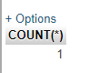

11)

[SELECT](http://loki.trentu.ca/phpMyAdmin/url.php?url=http://dev.mysql.com/doc/refman/5.5/en/select.html) [COUNT](http://loki.trentu.ca/phpMyAdmin/url.php?url=http://dev.mysql.com/doc/refman/5.5/en/group-by-functions.html#function_count)(*) FROM TEAMS

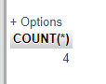

12)

[SELECT](http://loki.trentu.ca/phpMyAdmin/url.php?url=http://dev.mysql.com/doc/refman/5.5/en/select.html) [COUNT](http://loki.trentu.ca/phpMyAdmin/url.php?url=http://dev.mysql.com/doc/refman/5.5/en/group-by-functions.html#function_count)(*) FROM PLAYERS

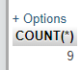

13)

[SELECT](http://loki.trentu.ca/phpMyAdmin/url.php?url=http://dev.mysql.com/doc/refman/5.5/en/select.html) [COUNT](http://loki.trentu.ca/phpMyAdmin/url.php?url=http://dev.mysql.com/doc/refman/5.5/en/group-by-functions.html#function_count)(*) FROM GAMES WHERE GAME_DT = '2002/05/05'

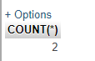

14)

[SELECT](http://loki.trentu.ca/phpMyAdmin/url.php?url=http://dev.mysql.com/doc/refman/5.5/en/select.html) P.FIRST,P.LAST FROM PLAYERS P, PLAYER_DATA PD WHERE PD.PLAYER_ID = P.PLAYER_ID [AND](http://loki.trentu.ca/phpMyAdmin/url.php?url=http://dev.mysql.com/doc/refman/5.5/en/logical-operators.html#operator_and) PD.PLAYER_ID = ([SELECT](http://loki.trentu.ca/phpMyAdmin/url.php?url=http://dev.mysql.com/doc/refman/5.5/en/select.html) PD1.PLAYER_ID FROM PLAYER_DATA PD1 where PD1.HEIGHT = ([SELECT](http://loki.trentu.ca/phpMyAdmin/url.php?url=http://dev.mysql.com/doc/refman/5.5/en/select.html)[MAX](http://loki.trentu.ca/phpMyAdmin/url.php?url=http://dev.mysql.com/doc/refman/5.5/en/group-by-functions.html#function_max)(PD2.HEIGHT) FROM PLAYER_DATA PD2))

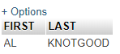

15) should delete based on player ID because two players could have same name

[UPDATE](http://loki.trentu.ca/phpMyAdmin/url.php?url=http://dev.mysql.com/doc/refman/5.5/en/update.html) PLAYERS [SET](http://loki.trentu.ca/phpMyAdmin/url.php?url=http://dev.mysql.com/doc/refman/5.5/en/set.html) TEAM_ID = 4 WHERE FIRST = 'AL' [AND](http://loki.trentu.ca/phpMyAdmin/url.php?url=http://dev.mysql.com/doc/refman/5.5/en/logical-operators.html#operator_and) LAST = 'KNOTGOOD'

[DELETE](http://loki.trentu.ca/phpMyAdmin/url.php?url=http://dev.mysql.com/doc/refman/5.5/en/delete.html) FROM PLAYERS WHERE FIRST = 'RON' [AND](http://loki.trentu.ca/phpMyAdmin/url.php?url=http://dev.mysql.com/doc/refman/5.5/en/logical-operators.html#operator_and) LAST = 'HAMMER'

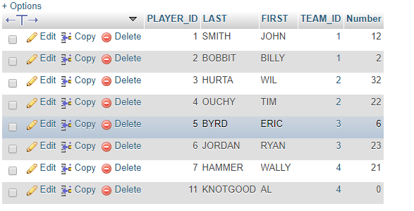

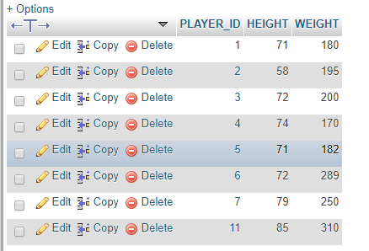

16)

[SELECT](http://loki.trentu.ca/phpMyAdmin/url.php?url=http://dev.mysql.com/doc/refman/5.5/en/select.html) G.GAME_ID, G.GAME_DT, T1.NAME AS HOME_TEAM, T2.NAME AS AWAY_TEAM FROM GAMES G, TEAMS T1, TEAMS T2 WHERE G.HOME_TEAM_ID = T1.TEAM_ID [AND](http://loki.trentu.ca/phpMyAdmin/url.php?url=http://dev.mysql.com/doc/refman/5.5/en/logical-operators.html#operator_and) G.GUEST_TEAM_ID = T2.TEAM_ID

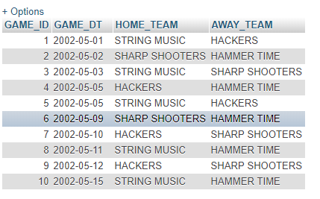

17)

[SELECT](http://loki.trentu.ca/phpMyAdmin/url.php?url=http://dev.mysql.com/doc/refman/5.5/en/select.html) T.NAME, [COUNT](http://loki.trentu.ca/phpMyAdmin/url.php?url=http://dev.mysql.com/doc/refman/5.5/en/group-by-functions.html#function_count)(*) AS numWINS FROM SCORES S, TEAMS T WHERE T.TEAM_ID = S.TEAM_ID [AND](http://loki.trentu.ca/phpMyAdmin/url.php?url=http://dev.mysql.com/doc/refman/5.5/en/logical-operators.html#operator_and) S.WIN_LOSE = 'WIN' GROUP BY T.NAME ORDER BY [COUNT](http://loki.trentu.ca/phpMyAdmin/url.php?url=http://dev.mysql.com/doc/refman/5.5/en/group-by-functions.html#function_count)(*) DESC LIMIT 1

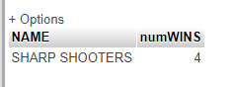

18)

[SELECT](http://loki.trentu.ca/phpMyAdmin/url.php?url=http://dev.mysql.com/doc/refman/5.5/en/select.html) T.NAME, [COUNT](http://loki.trentu.ca/phpMyAdmin/url.php?url=http://dev.mysql.com/doc/refman/5.5/en/group-by-functions.html#function_count)(*) AS numLOSSES FROM SCORES S, TEAMS T WHERE T.TEAM_ID = S.TEAM_ID [AND](http://loki.trentu.ca/phpMyAdmin/url.php?url=http://dev.mysql.com/doc/refman/5.5/en/logical-operators.html#operator_and) S.WIN_LOSE = 'LOSE' GROUP BY T.NAME ORDER BY [COUNT](http://loki.trentu.ca/phpMyAdmin/url.php?url=http://dev.mysql.com/doc/refman/5.5/en/group-by-functions.html#function_count)(*) DESC LIMIT 1

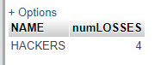

19)

SELECT T.NAME, AVG(S.SCORE) AS avgSCORE FROM SCORES S, TEAMS T WHERE T.TEAM_ID = S.TEAM_ID GROUP BY T.NAME ORDER BY avgSCORE DESC LIMIT 1

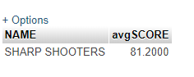

20)

[SELECT](http://loki.trentu.ca/phpMyAdmin/url.php?url=http://dev.mysql.com/doc/refman/5.5/en/select.html) CHART.NAME, CHART.WINS, CHART2.LOSSES FROM ( [SELECT](http://loki.trentu.ca/phpMyAdmin/url.php?url=http://dev.mysql.com/doc/refman/5.5/en/select.html) T.NAME, [COUNT](http://loki.trentu.ca/phpMyAdmin/url.php?url=http://dev.mysql.com/doc/refman/5.5/en/group-by-functions.html#function_count)(*) AS WINS FROM SCORES S, TEAMS T WHERE T.TEAM_ID = S.TEAM_ID [AND](http://loki.trentu.ca/phpMyAdmin/url.php?url=http://dev.mysql.com/doc/refman/5.5/en/logical-operators.html#operator_and) S.WIN_LOSE = 'WIN' GROUP BY T.NAMEORDER BY [COUNT](http://loki.trentu.ca/phpMyAdmin/url.php?url=http://dev.mysql.com/doc/refman/5.5/en/group-by-functions.html#function_count)(*) DESC ) AS CHART JOIN ( [SELECT](http://loki.trentu.ca/phpMyAdmin/url.php?url=http://dev.mysql.com/doc/refman/5.5/en/select.html) T.NAME, [COUNT](http://loki.trentu.ca/phpMyAdmin/url.php?url=http://dev.mysql.com/doc/refman/5.5/en/group-by-functions.html#function_count)(*) AS LOSSES FROM SCORES S, TEAMS T WHERE T.TEAM_ID = S.TEAM_ID [AND](http://loki.trentu.ca/phpMyAdmin/url.php?url=http://dev.mysql.com/doc/refman/5.5/en/logical-operators.html#operator_and) S.WIN_LOSE = 'LOSE' GROUP BY T.NAME ORDER BY[COUNT](http://loki.trentu.ca/phpMyAdmin/url.php?url=http://dev.mysql.com/doc/refman/5.5/en/group-by-functions.html#function_count)(*) ASC ) AS CHART2 WHERE CHART.NAME = CHART2.NAME

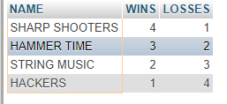

SELECT DISTINCT G.GAME_ID, G.GAME_DT, S1.SCORE AS HOME_TEAM, S2.SCORE AS AWAY_TEAM FROM GAMES G, SCORES S1, SCORES S2 WHERE (G.HOME_TEAM_ID = S1.TEAM_ID AND G.GAME_ID = S1.GAME_ID )AND (G.GUEST_TEAM_ID = S2.TEAM_ID AND G.GAME_ID = S2.GAME_ID)

