README.md

METR4810 Team 2
DO NOT PLUG IN USB-C ON THE PCB - this may damage the board. Use ST-LINK for programming and the USB-to-UART adapter for CLI communication.

How to use
After flashing and powering the PCB, choose either option:
• Run switch: switch PC11 / SW2 ON to start one two-cut run2 cycle; switch OFF to stop. No UART or computer connection is needed.
• UART CLI: connect through PuTTY to use run, stop, or control the motor, servo and stepper individually.
Both controls work together: an ON-to-OFF transition can stop a CLI-started run, and stop can stop a switch-started run. For switch-only use, complete steps 1-3 and skip the UART/PuTTY setup.

1. Clone the repository
Open a terminal in the folder where you want to save the project, then run:
git clone https://github.com/3jonah3/METR4810-Team2.git
cd METR4810-Team2
The project is now saved locally in METR4810-Team2.

2. Set up STM32CubeIDE
1. Download and install STM32CubeIDE for Eclipse.
2. Open CubeIDE and choose a workspace folder.
3. Select File -> Import -> General -> Existing Projects into Workspace.
4. Select the repository's METR4810_Team2_code folder and click Finish.
5. Click Build (hammer icon).
The project file to open/import in STM32CubeIDE is:
<your clone folder>\METR4810-Team2\METR4810_Team2_code\.project
Select the folder containing this .project when importing. Leave Copy projects into workspace unchecked.
Note: TBH, This is very simplifed there is likely a bit more setup to this, where you have to sort out your workspace, use google/AI for help You may also have to download stm32MX aswell...

3. Flash the PCB
1. Connect ST-LINK to the PCB's J24 header: SWDIO -> IO, SWCLK -> CLK, NRST -> RST. The programming header is missing a GND pin, so connect the black ST-LINK ground wire to GND on the spare GPIO header, as shown below. Power the PCB.
2. In CubeIDE, which can be opened by clicking on the .project file, once opened click Debug to flash.
3. If it pauses at main, click Resume (F8) to run the code.
PCB connection: GND was accidentally left out of the programming header during the PCB design. Connect the black ST-LINK ground wire to GND on the spare GPIO header, marked by the arrow below.
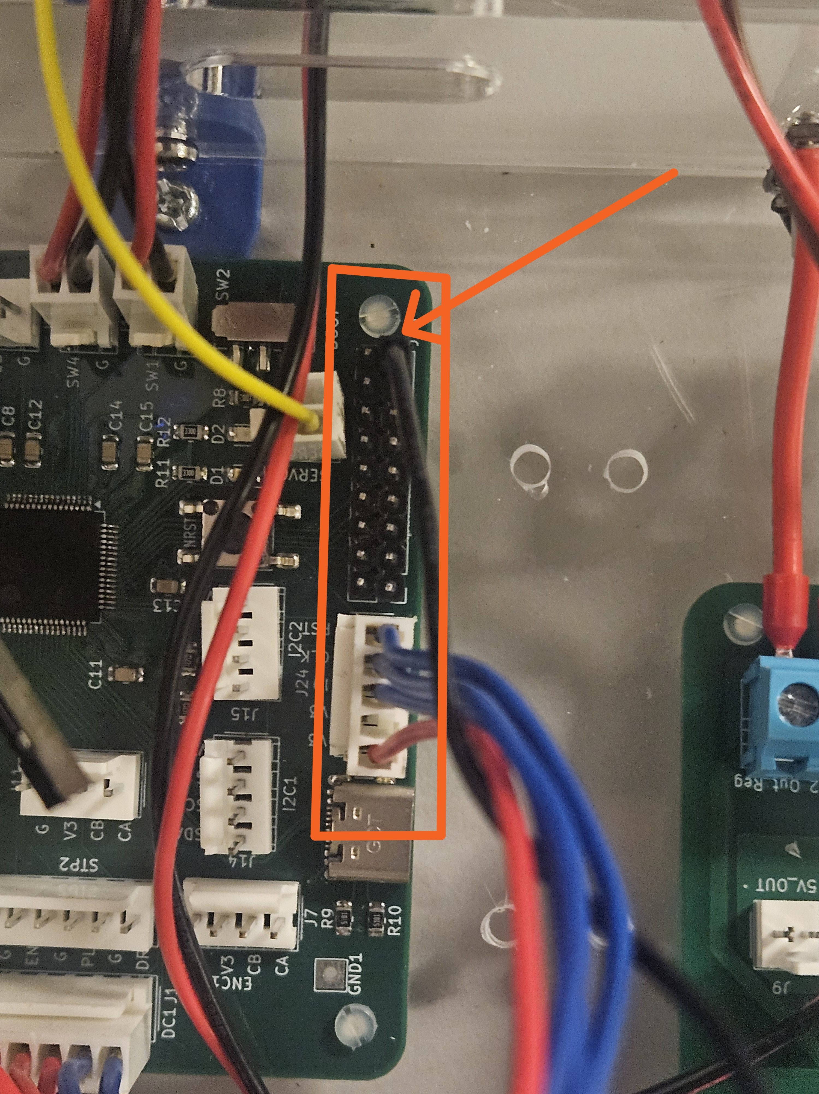
ST-LINK/V2 orientation: connect the plug as shown, with the red wire on the bottom row in this view.
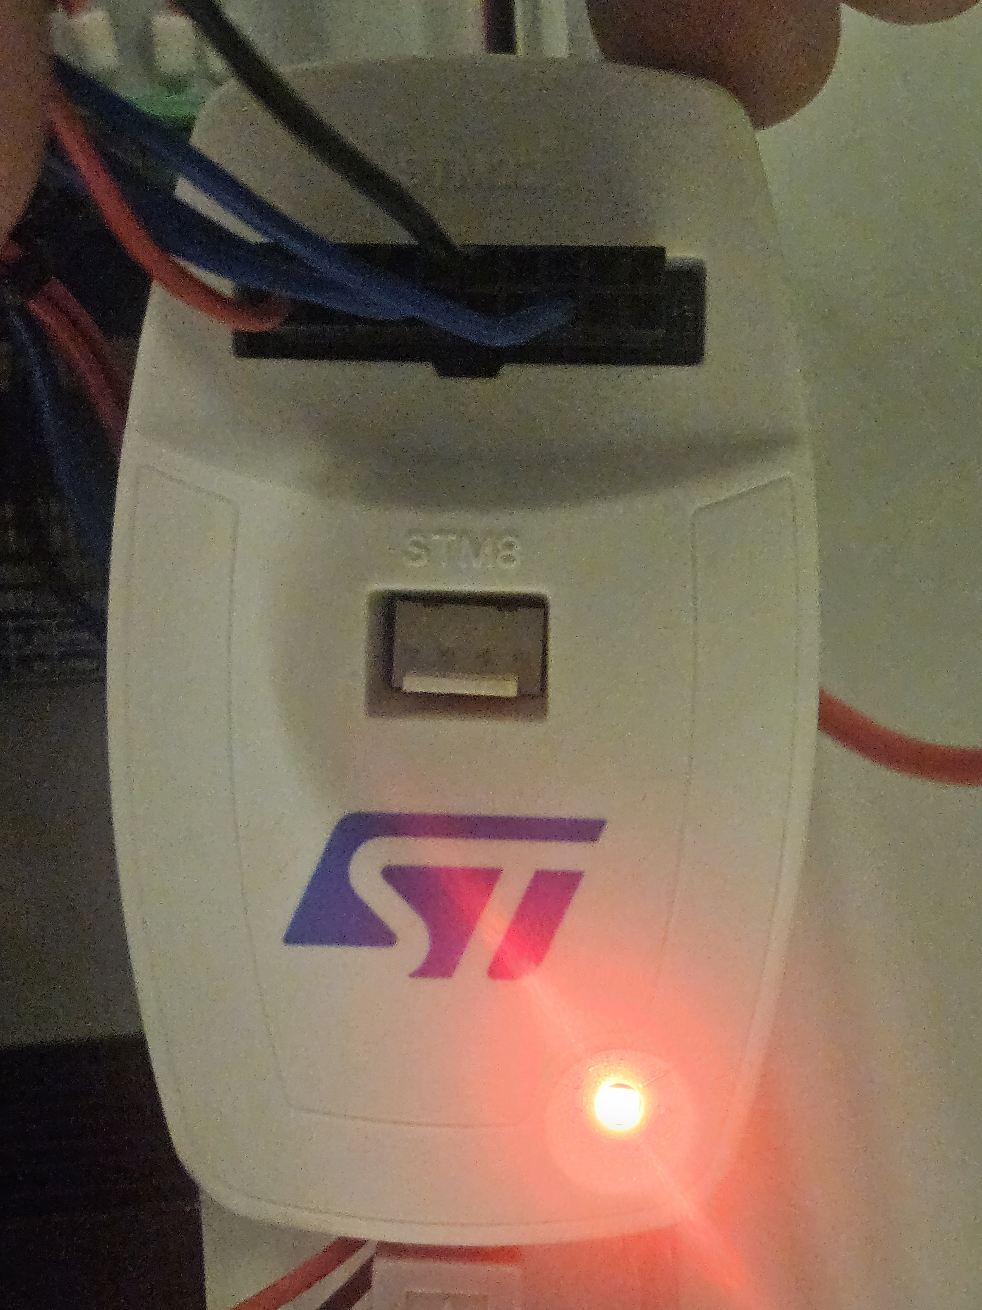

4. Connect UART
Set the USB-to-UART adapter to 3.3 V and connect it to J19 (UART1):
PCB J19 | USB-to-UART adapter
TX - pin 3 / PC4 | RXD
RX - pin 4 / PC5 | TXD
GND - pin 2 | GND

Cross TX and RX. Leave VCC, RTS and CTS disconnected. Power the PCB separately.
USB-to-UART adapter: only RXD, TXD and GND need to connect to the PCB, even though the photo shows leads on all six adapter pins.
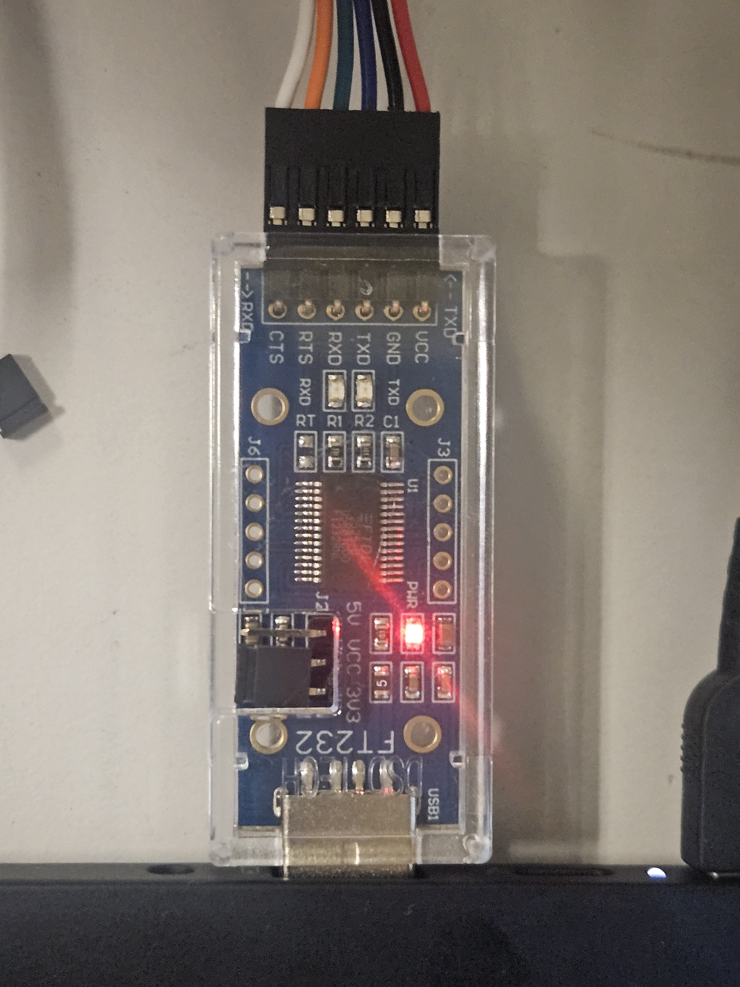
Plug the adapter into your computer. Find its COM number in Device Manager -> Ports (COM & LPT).

5. Set up PuTTY
Install PuTTY, then set:
Setting | Value
Connection type | Serial
Serial line | Your COM port, e.g. COM3
Speed | 115200
Data bits | 8
Stop bits | 1
Parity | None
Flow control | None

Under Session, select Serial, your COM port and 115200. COM3 is the example shown below.
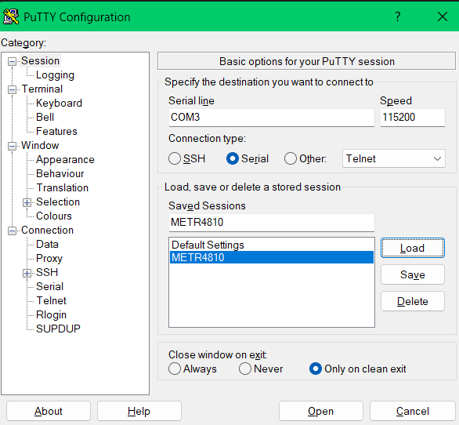
Data bits, stop bits, parity and flow control are under Connection -> Serial.
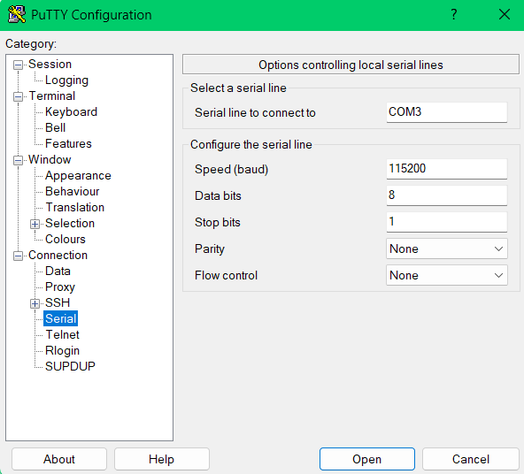
Under Terminal, set Local echo and Local line editing to Force on.
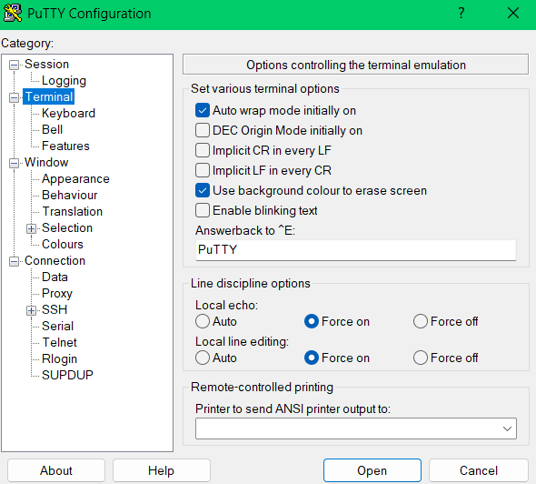
Click Open, then reset the PCB to see the welcome message and command list. Type ping and press Enter - it should reply OK PONG.

6. CLI commands
Type one command at a time and press Enter.

General
Command | Action
help | Show the command guide.
ping | Check the serial connection.
status | Show robot state and actuator status.
limits | Show switch states: 1 = pressed.
speed(750,500,2000) | Set straight, turning, and return stepper speeds in steps/s. Each must be 16-2000; configure while stopped.
speed2(750,500,2000,800,2000) | Set run2 speeds: straight1, curve1, retract1, curve2, return2. Stop first; each is 16-2000 steps/s.
run2 | Home, cut to 135 degrees, retract to 95,000 steps, cut to 145 degrees, then return to physical SW4. Both cuts end at 157,297 steps.
run | One cycle: home to SW4, drive out to 157,297 steps, return to physical SW4 and stop. The servo follows the schedule and the DC direction follows travel.
pause | Freeze a run where it is: the stepper and DC motor stop and the servo holds its angle. The run is kept; run and manual moves are refused until continue or stop.
continue | Resume a paused run from exactly where it stopped, on the same leg with the same drill duty.
stop | Stop the stepper and DC motor where they are and end the run; the servo holds its angle.

Servo
All servo commands use servo 2.
Command | Action
calibrate(110) | Example: save 110 degrees as straight. Accepts 0-135 for run; run2 requires 0-125. Stop all motion first; resets on power-up.
calibrate(status) | Show saved straight and true/path versus adjusted/command angles.
straight() | Move servo 2 to the current calibrated straight angle, or 90 degrees by default. Keeps the calibration.
servo(95) | Set angle; range 0-180 degrees. 95 degrees is the legacy driver centre; calibrated straight defaults to 90.
servo(1556u) | Set pulse width directly; range 500-2500 microseconds. 1556 us is the centre.
servo(arc) | Arc test: sweep the run's arc from 90 to 135 degrees over 4 s, hold 1 s, and sweep back over 4 s. Nothing else moves. It ends holding at 90 degrees; stop aborts it and the servo holds where it is.
servo(status) | Show nominal target angle and exact pulse width (not measured position).
servo() | Show help.

With the pod fitted, keep servo 2 within 1088-2024 us, which is the 95 degree arc start +/- 23.4 degrees of pod at the nominal scale. The keeper pocket only allows 23.5 degrees. This historical keeper allowance is not a firmware clamp: run2 reaches 145 degrees before calibration, and manual commands accept the full servo range. Check the fitted mechanism against the commanded range.

DC motor
Command | Action
motor(30) | Forward at 30% duty.
motor(-30) | Reverse at 30% duty. Range: -100 to 100.
motor(0) or motor(stop) | Stop the motor.
motor(status) | Show duty cycle.
motor() | Show help.

Stepper
Command | Action
stepper(20) | Move 20 steps toward SW4.
stepper(-20) | Move 20 steps toward SW1.
stepper(speed,100) | Set speed; range 16-2000 steps/second. Stop the stepper first.
stepper(auto) | Move continuously between SW1 and SW4.
stepper(stop) | Stop the stepper.
stepper(status) | Show speed, mode and remaining steps.
stepper() | Show help.

Counted moves allow up to 1,000,000 steps in either direction and stop early at a limit. Stop any current stepper movement before starting a new counted move.

Run feedback
While a run is active the CLI prints its progress without being asked:
Line | When
RUN STARTED: HOMING TO SW4 | A run starts from run, run2 or the PC11 switch.
RUN STARTED: SW4 PRESSED; BACKING OFF 1500 STEPS, THEN HOMING | A run starts with SW4 already pressed, for example after manually moving onto SW4.
TURN: OUTWARD LIMIT; ... | Normal counted outward reversal at 157,297 steps, without touching SW1.
RUN2 TURN: POSITION=...; ... | A run2 phase changes; the message identifies the next phase and target.
TURN: SW4; ... / TURN: SW1; ... | Physical switch events: SW4 after homing, or an earlier-than-planned SW1 hit.
PAUSED AT: ... STEPS (... MM FROM SW4) DURING OUT; ... | After pause. No DATA rows print while paused.
CONTINUING: OUT | After continue, followed straight away by a DATA row.
RUN COMPLETE: SW4 REACHED; POSITION=0 STEPS; ... | Return finished on physical SW4; servo holds calibrated straight.
SERVO ARC TEST DONE / SERVO ARC TEST STOPPED | A servo(arc) sweep finished, or was ended early by stop, a manual servo command, run or a fault.
DATA,... | Every 1000 ms (CSV, see below).
STOPPED AT: ... STEPS (... MM FROM SW4) DURING OUT; SERVO HOLDING ... US | The run is stopped early: stop, the switch or a fault.
FAULT: LIMIT FAULT LATCHED (SW1 AND SW4 PRESSED); ... | Once, when both limits read pressed together.
FAULT: LIMIT FAULT LATCHED (SW4 STILL PRESSED AFTER BACK-OFF); ... | Once, when SW4 has not released after the run-start back-off.

DATA rows are comma-separated, with a header row at the start of each run:
DATA,ms,leg,steps,mm,servo_us,pod_deg,dc,sw1,sw4
DATA,190512,OUT,95000,238.2,1500,0.0,-100,0,0
ms is time since reset. leg is BACKOFF, HOMING, OUT or RETURN; run2 uses CUT1, RETRACT1, CUT2 and RETURN2 after homing. steps and mm are the counted position from SW4 (398.87 steps/mm). servo_us is the commanded pulse, and pod_deg is the nominal pod-angle offset from the calibrated straight command (20 us per degree). dc is the drill duty, and sw1/sw4 are the limit switches (1 = pressed). All values are commanded, not measured.
Command | Action
telemetry(on) | Turn DATA rows on (default).
telemetry(250) | Print a row every 250 ms; range 100-10000.
telemetry(off) | Turn DATA rows off. The other lines still print.

To save a run, turn on PuTTY logging before starting it: Session -> Logging -> Printable output, then choose a file. The lines starting with DATA, open directly as CSV in Excel or MATLAB.

7. Limit switches and run switch
• Front limit switch -> SW1.
• Back limit switch -> SW4.
• Run switch -> SW2 / PC11 (not pictured).
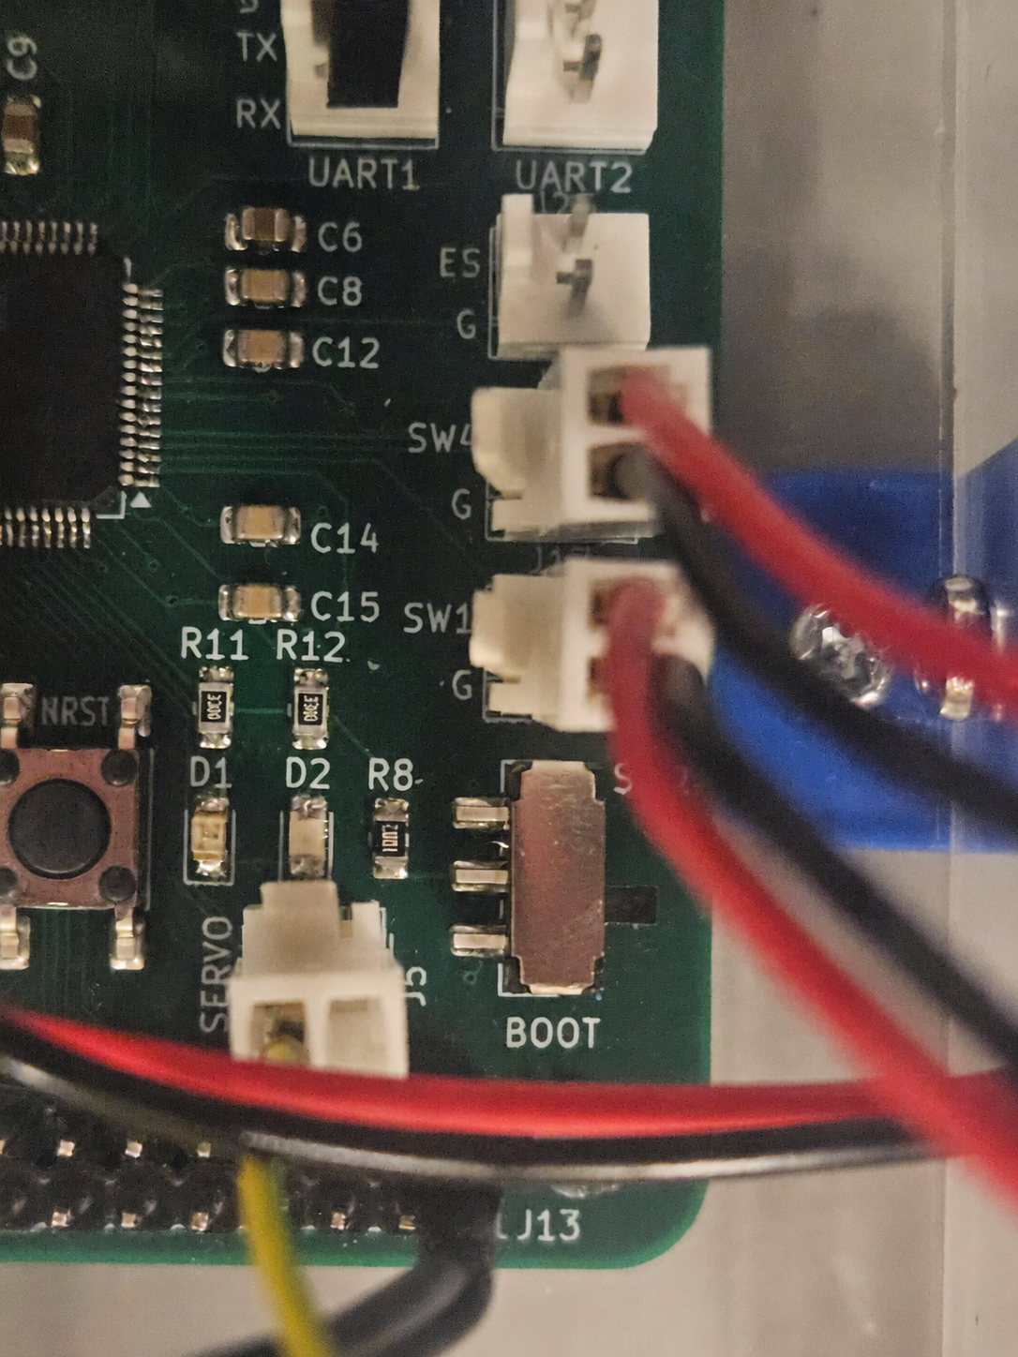
Switch PC11 / SW2 ON (contact closed to ground) to start one run2 cycle, and OFF (contact open) to stop the stepper and DC motor while the servo holds its angle. Both transitions use a 30 ms debounce. After completion or stop, switch OFF then ON to start another cycle. Leaving the switch ON never repeats the run; ON at reset requires OFF then ON first.
Homing and initial back-off always use 2,000 steps/s. Straight calibration above 125 blocks switch-started run2; status explains the invalid range.
This works without UART connected. The run and stop commands still work too. The switch is not a UART interlock: CLI commands still work while it is OFF.

8. Schematics and PCB routing
Click an image to view it at full size.

Control PCB schematic
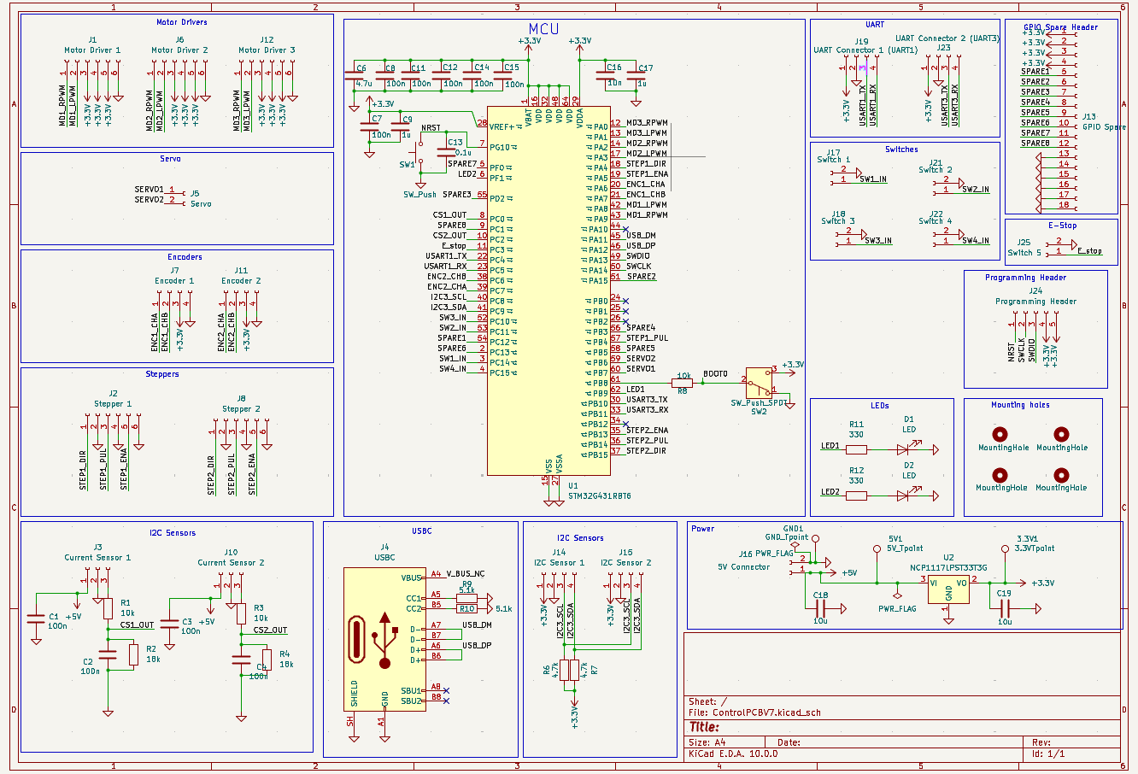

Control PCB routing
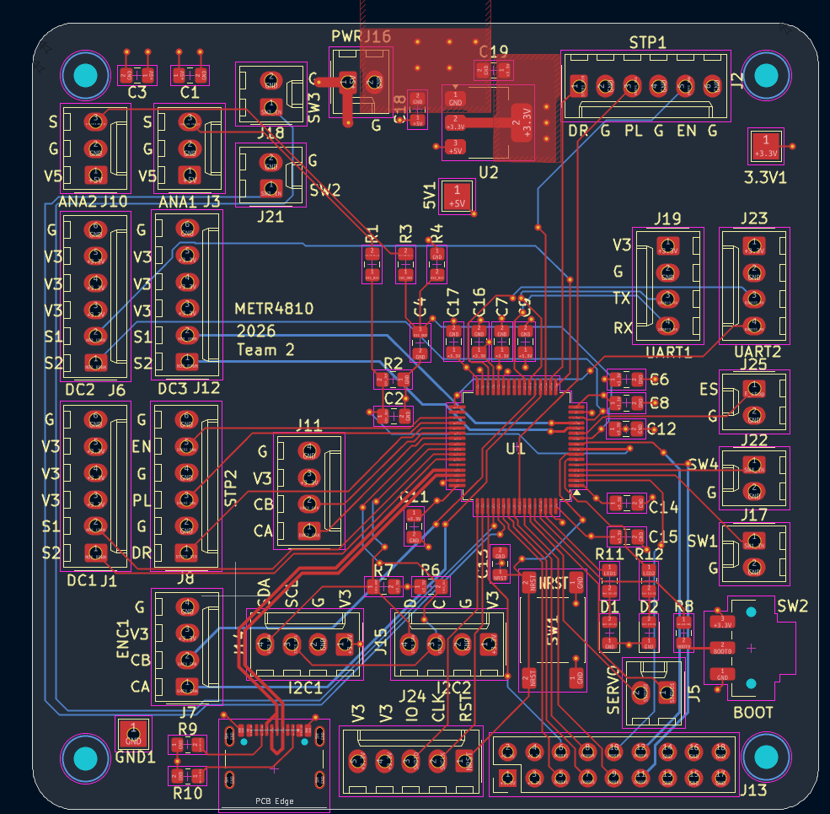

Power PCB schematic
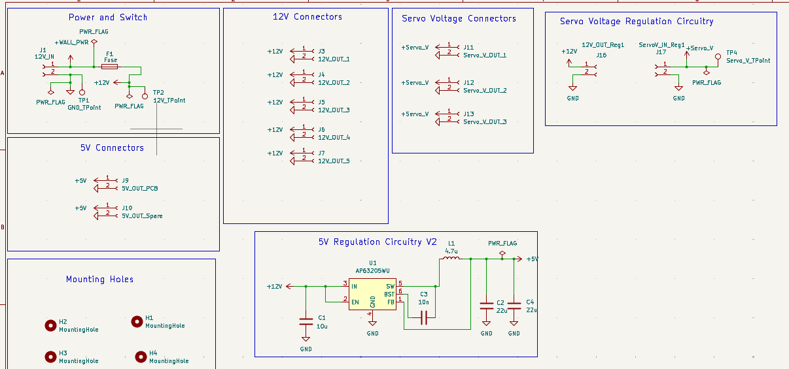

Power PCB routing
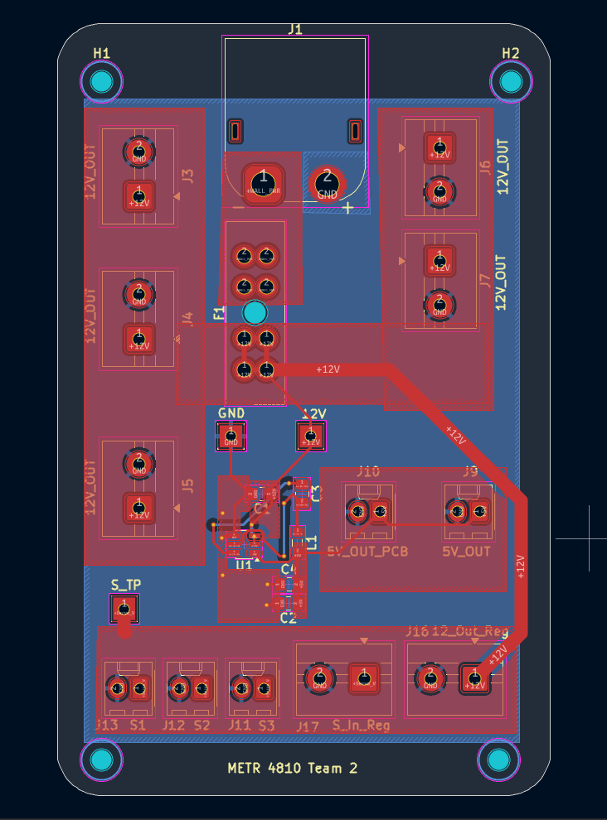

Important notes
• Do not plug a USB-C cable into the PCB; it may damage the board.
• Send stop before using individual actuator commands during run.
• During run, motor(stop), motor(0) and stepper(stop) stop the whole program.
• If both limit switches trigger together, or SW4 is still pressed after the run-start back-off, a fault latches. Correct the cause and reset the PCB to clear it.
• Closing PuTTY does not stop the robot.

If UART does not work
Check TX -> RX, RX -> TX, common GND, the COM port and PuTTY settings. Make sure CubeIDE has not paused the code.
PB9 flashes when receiving; PF1 flashes when transmitting.
For more detail, see SERIAL_CONTROL.md.

Modifying the code
1. Create a branch before editing; see CONTRIBUTING.md.
2. Change run phases, paths and speed defaults in Core/Src/robot_control.c; endpoint and homing constants are in Core/Inc/robot_control.h.
3. Change commands and terminal help in Core/Src/serial.c. Keep the README command tables in sync. These paths are inside METR4810_Team2_code/.
4. Keep generated-file edits inside USER CODE sections and leave Drivers/ alone.
5. Run the host tests and build before flashing:
./tools/test-firmware.ps1
./tools/test-firmware.ps1 -OvertravelSteps 1500
./tools/build-firmware.ps1
See the firmware maintenance guide for driver contracts, calibration, speed profiles and return diagnostics, and the path tables for steering values. Ask Jonah if unsure.

docs/firmware-maintenance.md

Firmware maintenance guide
For setup and everyday commands, see the README. These notes describe commanded motion; physical position and servo angle are not measured.

Code layout
Module inside METR4810_Team2_code/Core/ | Responsibility
Src/main.c user sections | Initialise drivers; service motion, CLI and LEDs in order.
Src/robot_control.c, Inc/robot_control.h | Run phases, calibration, speeds, limits and safety gates.
Src/serial.c, Inc/serial.h | Parse commands and queue responses without blocking.
Src/stepper.c | Count STEP pulses in TIM16 interrupts; stop counted moves in hardware.
Src/servo.c, Src/motor.c | Absolute servo PWM targets and signed drill duty.
Src/switch.c, Src/status_led.c | Raw switch reads and UART activity indicators.

Editing conventions
• Document public functions in headers: purpose, parameter units/ranges, returns, state changes and errors. Explain interrupt ownership and timing where relevant.
• Make readability edits by hand, following the existing layout and the style guide where helpful. Use consistent indentation and clear control bodies; no automatic formatter is required.
• Keep existing HAL callback names and public APIs. Do not force assignment-only restrictions onto embedded state or split a state machine just to meet a line limit.
• Preserve the existing shared-state reset expressions: this cleanup retains their original compiled reads/writes as well as their values.
• Explain intent and invariants in comments rather than obvious assignments.
• Edit only project-owned modules. In generated files edit only USER CODE sections, and leave vendor Drivers/ code untouched.
• Preserve command spelling, telemetry columns, timing and pulse accounting unless deliberately changing behaviour.

Verification
Run from the repository root:
./tools/test-firmware.ps1
./tools/test-firmware.ps1 -OvertravelSteps 1500
./tools/build-firmware.ps1
Host tests simulate parsing, state transitions, limits, pauses and timer pulses. They cannot establish physical foam clearance. For formatting/comment-only work, compare the generated HEX image before and after as well as running the tests.

Servo pulse widths in firmware
The servo mapping is 0 degrees = 500 us, 90 degrees = 1500 us, and 180 degrees = 2500 us at 50 Hz. The legacy driver centre is 95 degrees (1556 us): SERVO_CENTRE_ANGLE in servo.h. Both servos start there at power-up with their PWM off, while the run's arc starts separately at 90 degrees (1500 us) (DEMO_START_ANGLE in robot_control.h). The CLI controls servo 2 (PB6); servo(95) selects degrees and servo(1556u) selects microseconds. Send one command per line. stop keeps the servo PWM running so it holds its last angle. Switching the PWM off mid-pulse can throw the servo past its limit. Individual commands are rejected during autonomous run or a latched fault.
For C code using robot state and fault checks:
Robot_SetServo(2, 95); // Degrees; enables servo 2
Robot_SetServoPulseUs(2, 1556); // Microseconds; enables servo 2
Both functions return NULL on success or an error string. The low-level driver also provides servo(2, 95) and Servo_SetPulseUs(2, 1556); these return HAL status and require Servo_Start(2) to enable output after initialization. In C, 1556u is an unsigned integer, not a unit: use the separate pulse-width function. SERVO_ANGLE_US(angle) in servo.h converts an angle to its pulse width. Angles are nominal; confirm the mechanism can accommodate the commanded travel.

Single-cut sequence (run; PC11/SW2 starts run2)
1. Home to SW4 / PC15 with the DC motor off and servo 2 at 1500 us (90 degrees), the start of its arc. Zero is set where SW4 is first touched, after a 30 ms debounce.
• If SW4 is already pressed when the run starts (for example when manually placed on the home switch), the carriage first backs off 1500 steps toward SW1. SW4 must then read released; if it is still pressed 30 ms later, a limit fault latches instead of moving further. Otherwise the carriage homes back to first touch as normal.
2. Set position to zero and push outward toward SW1, with DC duty -100%.
3. At 157,297 steps, reverse the stepper and DC motor (+100%) and follow the servo schedule backwards on the return toward SW4. The counted outward endpoint controls normal reversal; SW1 remains a backup. Return travel continues until physical SW4 activates, even if the counted position reaches zero first.
4. When physical SW4 activates, the stepper stops immediately on detection. After 30 ms debounce confirms the switch, the DC motor stops and the run completes, holding the calibrated straight servo angle. A brief switch bounce resumes the return. There is no 5000-step return offset and no return overtravel. Send run for another single-cut cycle (switch OFF then ON starts run2); the next run backs off SW4 and homes again.
stop or switching the run switch OFF during a run stops the stepper and DC motor where they are and ends the run; the servo holds its angle. pause freezes the run the same way but keeps it, and continue resumes it. A pause during a switch debounce re-checks the switch for a fresh 30 ms on continue. A pause during the back-off or an overtravel finishes the remaining steps.
Set the three run speeds with one command while stopped:
speed(750,500,2000)
run
The arguments are straight, turning, return, in STEP pulses per second (each 16-2000). Homing and back-off always use 2000 steps/s for both programs, independently of speed settings. Outward travel switches to turning speed at 100,000 steps from SW4 first touch and keeps it to the outward reversal, including the 100-degree plateau. The entire return uses the third speed and stops on physical SW4. Limit overtravel shifts the reported transition position by the configured overtravel amount. Speed changes briefly stop and restart the pulse timer, preserving counted position; this is a discrete speed change, not an acceleration ramp.
status shows the active speed under STEPPER and all three settings under RUN SPEEDS. Changes are rejected during running, paused runs, or manual stepper movement. stepper(speed,n) remains available and sets all three speeds to n, as well as the manual move speed. Manual moves otherwise use the current selected speed. Defaults are 750/500/2000 (straight/turning/return); settings persist between runs but reset on power-up/reset.

Session straightness calibration
Use an absolute manual command such as servo(110) to find where the head is physically straight. With the stepper, drill and arc test stopped, enter calibrate(110). This saves 110 degrees as straight and commands servo 2 there. Any whole-degree value 0-135 is accepted; the upper limit leaves room for the full 45-degree sweep inside the servo's 0-180 command range.
straight() commands servo 2 to the saved straight position without changing calibration. It works like a manual servo command: refused during a run (including pause) or a latched fault, and ends an active servo arc test.
Calibration shifts homing, the entire outward/return path, the completion hold, and servo(arc) by straight - 90 degrees. For example, 100 produces a 100-145 degree sweep, and 110 produces 110-155. Step positions, speeds, and endpoints are unchanged. Manual servo(angle) and servo(pulseu) remain absolute so you can locate straight without compounding the offset. Calibration is optional, persists across stop/new runs, and resets to 90 on power-up/reset. calibrate(90) also restores the default.
status, calibrate(status), and servo/run/stop/pause/continue/calibration responses report TRUE (PATH) for the original nominal path angle and ADJUSTED (COMMAND) for the calibrated absolute servo command. Neither is a measured position. The reported run range also shows the adjusted limits. DATA retains its column layout: servo_us is the adjusted command, while pod_deg stays relative to the calibrated straight position. The table below lists original path angles; add the calibration offset for adjusted angles.

Servo steering schedule
The original run and first run2 cut hold straight through 100,000 steps, then follow a monotone cubic Hermite curve to 135 degrees at 157,297 steps. Cut 2 starts turning at 95,000 and ends at 145 degrees at the same endpoint. Calibration shifts angles without moving the step coordinates. See the complete path tables for anchors and samples.

Limit overtravel (dampened switches)
LIMIT_OVERTRAVEL_STEPS in Core/Inc/robot_control.h is 0, so the stepper uses first touch for homing at SW4 and reversal at SW1. Only once dampened switch mounts are fitted, set it to 1500 (about 3.8 mm). Each debounced SW1 press or SW4 homing press then drives up to 1500 more pulses before reversing. During an autonomous outward run, this is capped at the counted outward endpoint; the normal counted turnaround adds no overtravel. The zero point becomes the reversal point behind SW4, so the path evaluator subtracts the configured overtravel from the reported position to preserve the same physical steering path; status positions count from that reversal point. The run-start back-off grows to 1500 + 1500 steps so the carriage clears the overtravel zone before homing.
The host tests cover both settings, and the general parser and safety tests run in each. Test both before flashing an overtravel build: -DLIMIT_OVERTRAVEL_STEPS=0U and -DLIMIT_OVERTRAVEL_STEPS=1500U. On Windows, run ./tools/test-firmware.ps1 and ./tools/test-firmware.ps1 -OvertravelSteps 1500. On Linux, from the repository root:
gcc -std=c11 -DLIMIT_OVERTRAVEL_STEPS=1500U -Itests/host -IMETR4810_Team2_code/Core/Inc tests/host/test_control.c METR4810_Team2_code/Core/Src/{robot_control,serial,motor,stepper,servo,switch,status_led}.c -o test_control && ./test_control

Checking the return path
The drill polarity for the demo is now -100% outward toward SW1, +100% returning toward SW4. Initial homing keeps the DC motor off. Manual motor(duty) commands retain their signed-duty meaning.
The return uses a fixed reference captured at the actual outward turnaround: position = outward endpoint - pulses emitted on return. A counted outward reversal, or an early SW1 press, retraces the part of the schedule actually reached. Brief switch bounce pauses and resumes without changing the reference. Both directions use the same position-to-pulse curve, with their configured section speeds.
Each confirmed demo limit produces a serial line such as:
TURN: OUTWARD LIMIT; POSITION=157297; SERVO=2000 US; NEXT=SW4; DC=100%; RETURN TARGET=SW4
status shows OUTWARD END, RETURN PULSES, RETURN TARGET=SW4, and HOME ERROR. Return travel is continuous toward SW4, with no counted stopping endpoint. It passes the former 5000-step offset and, if necessary, the estimated zero until SW4 is detected. Pause/continue resumes toward that same switch. The stepper stops on switch detection; confirmation requires 30 ms, and the DC motor then stops as the run completes. False switch bounce resumes motion. No return overtravel is driven, even when homing overtravel is enabled.
At completion, HOME ERROR is outward pulses minus return pulses minus configured homing overtravel. Position is referenced to SW4 first touch: zero normally, or LIMIT_OVERTRAVEL_STEPS if homing placed zero behind the switch. The servo holds its calibrated straight command. The outward endpoint remains 157,297 steps from SW4 first touch.
These are counted command pulses, not encoder measurements. Missed steps can change the physical stopping position.
For a return mismatch, capture the outward TURN line and status shortly afterward while retracting. Compare the reported servo target to the observed mechanism before changing angle calibration or compensating for backlash.

Two-cut sequence: run2
run2 homes to SW4, then executes:
1. Cut 1: straight to 100,000 steps, then the existing smooth 90-135 degree path to 157,297 steps.
2. Retract along cut 1 to 95,000 steps (5,000 steps inside the straight section). No SW4 visit between cuts.
3. Cut 2: start turning immediately at 95,000, following a smooth 90-145 degree path to 157,297 steps.
4. Return along cut 2 to physical SW4, then stop at calibrated straight.
Both outward cuts turn before SW1. Positions above are measured from SW4 first touch; DATA adds LIMIT_OVERTRAVEL_STEPS if enabled. During counted run2 legs, an unexpected confirmed target limit stops the run and latches a fault; reset after correcting the cause. Final return and initial homing use physical SW4 as before.
speed2(750,500,2000,800,2000)
run2
The five arguments are straight1, curve1, retract1, curve2, return2, in steps/second (16-2000). Those are also the defaults. Homing/backoff always run at 2000 steps/s, independent of speed profiles. Cut 2 uses curve2 immediately; there is no straight2 argument. Set speeds while stopped; speed2 is independent of speed and stepper(speed,n). All speeds reset on power-up.
pause, continue, stop, motor(stop), stepper(stop), telemetry and run-switch OFF work with both programs. The maintained run-switch ON edge starts run2. With calibration above 125, switch-start is blocked just like CLI run2; status reports the invalid range. A running program cannot be replaced by the other without stopping first. Status and DATA identify CUT1, RETRACT1, CUT2 and RETURN2.
calibrate(A) shifts both cuts by A-90 degrees. For example, calibrate(110) gives straight 110, first endpoint 155 and second endpoint 165. run2 requires A in 0-125 so the larger sweep fits 0-180; the original run still supports calibration 0-135. Calibration remains optional and resets on power-up. straight() uses the saved straight angle while stopped. Status and command feedback show true/path and adjusted/command angles, plus both adjusted run ranges.
See the two-cut path table for cut 2 targets. Firmware builds and host simulations do not verify foam clearance or lost mechanical steps.

docs/foam-clearance-path.md

Foam-clearance steering path
Confirmed trial targets, 24 October 2026. Positions are DATA step counts with limit overtravel disabled. Angles are nominal servo angles, not pod angles.
Hold 90 degrees to 100,000 steps and 100 degrees from 105,000 to 115,000. Use a monotone cubic Hermite curve between anchors, with zero slope into/out of holds and at the final endpoint. Interior slopes use weighted harmonic means of adjacent secants. No overshoot; identical curve on return. Firmware evaluates the curve at the current counted position and rounds the pulse to whole microseconds. This table is a sample, not a linear lookup table.
Position (steps) | Servo angle (degrees) | Pulse (us)
0-100,000 | 90.00 | 1500
102,500 | 95.00 | 1556
105,000 | 100.00 | 1611
110,000 | 100.00 | 1611
115,000 | 100.00 | 1611
117,500 | 101.21 | 1625
120,000 | 104.06 | 1656
122,500 | 107.38 | 1693
125,000 | 110.00 | 1722
130,000 | 113.19 | 1758
135,000 | 116.00 | 1789
140,000 | 118.42 | 1816
145,000 | 120.45 | 1838
150,000 | 123.26 | 1870
155,000 | 128.00 | 1922
156,000 | 131.21 | 1958
156,500 | 133.28 | 1981
157,000 | 134.72 | 1997
157,297 | 135.00 | 2000

The 135-degree endpoint is the counted outward reversal at 157,297 steps, exactly 5000 steps before the observed SW1 hit at 162,297. The timer stops forward pulses at the endpoint even if main-loop processing is delayed, then the controller starts the return. A physical SW1 hit earlier still stops forward motion and reverses after debounce; autonomous overtravel is capped at the counted endpoint. With limit overtravel enabled, subtract LIMIT_OVERTRAVEL_STEPS from DATA position before evaluating this table. The straight section stays at 90 degrees through 100,000 steps.
This path is intended to improve foam clearance; the software checks cannot verify physical clearance.
The autonomous return continues to physical SW4, then completes after switch debounce and holds calibrated straight (90 degrees without calibration). The old 5000-step return offset is removed. Initial homing still uses SW4; outward reversal remains at 157,297 steps.
Calibration: this table lists TRUE/PATH angles. calibrate(A) adds A - 90 degrees to every angle for the ADJUSTED servo command. The accepted whole-degree range is 0-135. Defaults return on power-up/reset; positions and speeds do not change.

run2 second cut
After cut 1 reaches 135 degrees at 157,297 steps, it retraces the original curve to straight at 100,000, then retracts another 5,000 to 95,000 steps. Cut 2 starts turning from that position and smoothly reaches 145 degrees at 157,297 steps. Its final return retraces the second curve, reaches straight at 95,000, and continues to physical SW4.
Cut 2 stretches the original curve horizontally from the original 100,000-157,297 interval to 95,000-157,297. It expands the rounded pulse offset about straight by 611/500, rounding to microseconds. Holds and eased endpoints are retained. Positions below are rounded up to the first step reaching each mapped anchor; angles are approximate uncalibrated commands.
Cut 2 position from SW4 (steps) | Servo angle (degrees) | Pulse (us)
0-95,000 | 90.00 | 1500
97,719 | 96.12 | 1568
100,437 | 102.24 | 1636
111,309 | 102.24 | 1636
122,182 | 114.39 | 1771
133,055 | 121.77 | 1853
154,800 | 136.44 | 2016
155,887 | 140.40 | 2060
156,431 | 142.92 | 2088
156,975 | 144.63 | 2107
157,297 | 144.99 | 2111

Calibration for run2 must be 0-125 degrees; its adjusted second endpoint is straight + 55 degrees. The first cut remains unchanged. speed2(straight1,curve1,retract1,curve2,return2) defaults to speed2(750,500,2000,800,2000). Cut 2 uses curve2 from its start. Homing/backoff always use 2000 steps/s. With homing overtravel enabled, DATA positions add LIMIT_OVERTRAVEL_STEPS.

METR4810_Team2_code/SERIAL_CONTROL.md

USART1 robot control (diagnostic test)

Hardware and configuration
The serial interface is temporarily moved from USART3 (PB10/PB11) to the existing USART1 pins PC4/PC5 for connection troubleshooting. Motor, servo, switch, and LED pins are unchanged. PB10/PB11 no longer carry the command interface in this build.
Function | Existing connection | Configuration
USART1 TX | PC4, AF7 | Connect to adapter RX
USART1 RX | PC5, AF7 | Connect to adapter TX
STEP | PB4, TIM16 CH1 | 1 MHz timer, initially 500 steps/s
DIR | PA4 | LOW toward SW4; HIGH toward SW1
DC motor | PA8/PA9, TIM1 CH1/CH2 | Existing driver, 1 kHz PWM
Servo 1 | PB7, TIM4 CH2 | 50 Hz, 0–180 degrees (500–2500 us)
Servo 2 | PB6, TIM4 CH1 | 50 Hz, 0–180 degrees (500–2500 us)
SW1 / SW4 | PC14 / PC15 | Active LOW, internal pull-ups
Run/stop / SW2 | PC11 | Active LOW, internal pull-up
SW3 | PC10 | Active LOW, internal pull-up

Use a 3.3 V TTL UART adapter, a common GND, and the crossed TX/RX wiring above. Do not use an RS-232 voltage-level adapter. Power the board from its intended supply; leave the adapter's power pin disconnected unless the board's power design permits it. The existing USB peripheral is unrelated to this UART connection.
The USART1 pins PC4/PC5 were already assigned to AF7 but the peripheral was not initialized. This diagnostic build enables USART1; the original USART3 implementation had to enable its clock/interrupt and include the UART HAL driver. The .ioc now enables USART1 asynchronous 115200, 8 data bits, no parity, 1 stop bit, TX/RX, no flow control. USART1 IRQ priority is 2; TIM1_UP_TIM16 priority is 1 (lower number is higher priority). The shared timer handler services both TIM1 and TIM16; only manual TIM16 motion enables update interrupts. SysTick remains priority 15. Existing clocks are unchanged: SYSCLK/APB timers 16 MHz, timer prescalers 15, hence 1 MHz timer counters. Other preassigned but inactive peripheral pins remain untouched. PC3 is not used for run/stop; PC11/SW2 is the run/stop button.

Operation and safety rules
Power-up is IDLE: DC duty zero, STEP stopped, servo PWM disabled. There is no startup interlock: UART motion commands work immediately. PC11/SW2 is an active-LOW run/stop toggle, polled independently of UART. A press starts the same program as run; a press while RUNNING performs stop. Press and release each require 30 ms of stable input. Holding the button does not repeat. A button held during reset must be released and pressed again before it can start motion. UART and button controls share state: either can stop a run started by the other. From individual actuator operation (IDLE), a button press starts the full autonomous program.
run does one cycle. It homes to SW4 with the DC motor off, drives out to SW1 with DC at -100%, reverses at SW1 and returns with DC at +100%, then stops at SW4 and prints RUN COMPLETE. If SW4 is already pressed at the start, the carriage first backs off 1500 steps toward SW1; SW4 must then read released, or a fault latches. At each target press STEP stops immediately. After 30 ms a still-pressed switch counts and a false press resumes toward the same target. This debounce is nonblocking. The README describes the servo steering schedule and the run feedback.
stop cancels all stepper activity, sets DC duty to zero and enters STOPPED. The servo PWM keeps running at its last target, so the pod holds its angle: switching the PWM off mid-pulse can throw the servo past its limit. pause freezes a run the same way but keeps it, and continue resumes it on the same leg. The next accepted movement command can resume motion. Repeated RUN during RUNNING does not reset travel. Servo targets are commanded positions, not feedback.
Simultaneous SW1 and SW4 activation latches a fault in every operating mode and stops all motors. So does SW4 still reading pressed after the run-start back-off. Releasing the switches or sending STOP does not clear it. Correct the cause and reset. Both button and UART starts respect this latched fault. Manual motion stops early at its target limit; moving away from one pressed limit is allowed.
While RUNNING, individual movement and speed commands are rejected. Send STOP first. stepper(stop), motor(stop), and motor(0) during RUNNING stop the whole robot to cancel coordinated motion consistently. Outside RUNNING, individual stops affect only that actuator. Standalone commands leave the global state IDLE, so inspect the actuator status fields to determine movement; IDLE means no full autonomous program. stepper(auto) replaces a manual move with standalone limit-to-limit motion, leaving DC duty unchanged. A manual move requires the stepper to be stopped first.
Serial STOP is a software stop. For an emergency stop, use independent hardware to disable drive enables or interrupt actuator power appropriately for the mechanism, with a deliberate reset/re-enable procedure. UART, firmware polling, and PC11 are not a substitute for that hardware.

Commands
Quick example (with room for safe motion):
help
servo(95)
motor(30)
motor(0)
motor(-30)
stop
stepper(speed,100)
stepper(20)
stepper(status)
stop

Diagnostic LEDs
• LED1, PB9: lights for 150 ms after USART1 receives a byte from the PC. Further received bytes extend the light, including invalid commands. It is off at startup and while no data is arriving; it is no longer a heartbeat.
• LED2, PF1: lights for 150 ms after USART1 completes transmitting a buffer. Repeated transmissions extend the light. It should flash for the startup READY message after reset and for replies to PING. This indicates MCU transmission completion, not acknowledgement from the PC or proof of correct wiring.
Both LEDs are active HIGH and use the existing GPIO assignments. Timing uses HAL_GetTick without blocking delays. status_led.c/.h owns this behavior; the UART callback posts an event, and the main loop updates the LEDs.
PF1 should flash on reset for the startup message. Sending PING followed by Enter should light PB9 for reception and PF1 for the reply. If PB9 never lights, check adapter-TX-to-PC5, common ground, COM port, baud rate, and that firmware is running. If PF1 flashes but PuTTY stays blank, check PC4-to-adapter-RX and the PC settings.

Command reference
On reset the controller prints a welcome message, ASCII owl beneath "Welcome to METR4810 Team 2 CLI", and the complete lowercase command guide, including descriptions, ranges, examples and motion rules. Physical servo 2 (PB6/TIM4 CH1) is the only servo exposed by the CLI; servo 1 is never enabled by serial commands. servo() / motor() / stepper() display help without moving anything. The previous space-separated actuator commands have been replaced; use parentheses and a comma for stepper speed.
Commands are case-insensitive and accept CR, LF, or CRLF. Leading/trailing spaces and tabs around names and arguments are accepted, e.g. motor( -50 ). Extra parameters, malformed parentheses, and numeric suffixes are rejected.
Command | Result
ping | OK PONG
help | Command list
status | System state, stepper mode/target/speed/remaining count, DC duty, limits, fault, PC11 button state, dropped TX response count
limits | SW1–SW4; 1 means pressed
run / stop | One autonomous cycle (see above) / stop everything; the servo holds its angle
pause / continue | Freeze a run in place / resume it from where it stopped
telemetry(on) / telemetry(off) / telemetry(250) | CSV DATA rows during a run: on, off, or every N ms (100–10000)
stepper(200) / stepper(-200) | 200 pulses toward SW4 / SW1
stepper(speed,500) | Set nominal speed, 16–2000 steps/s; stepper must be stopped
stepper(auto) / stepper(stop) / stepper(status) | Standalone automatic travel / stop / inspect
servo(95) / servo(120) | Set physical servo 2 target and enable its PWM; 95 degrees is the centre
servo(arc) | Arc test: sweep servo 2 from 95 to 135 degrees and back (4 s out, 1 s hold, 4 s back); stop aborts
servo(status) | Last accepted servo 2 target; -1 means no commanded position
motor(50) / motor(-50) | Signed duty from -100 to +100%; negative reverses direction
motor(stop) / motor(status) | Stop / inspect DC motor

Manual counts are limited to ±1,000,000, excluding zero. TIM16 uses PWM2 one-pulse mode for manual motion: one rising edge per hardware cycle, ending LOW at overflow. Hardware stops the timer before the update interrupt rearms the next cycle. This prevents ISR latency from adding pulses. ISR latency adds a small gap between manual pulses, so actual speed is slightly below the configured nominal rate. Continuous automatic travel still uses the original PWM1 waveform. Integer timer division also quantizes speed. Counts describe electrical STEP pulses, not encoder-confirmed mechanical displacement; stalls, STOP, or limits can prevent completing a move.
Servo angles map 0–180 degrees onto 500–2500 microseconds, with rounding. The centre, where the pod is straight, is 95 degrees (1556 us), set by SERVO_CENTRE_ANGLE in servo.h; both servos start there at power-up with their PWM off. The run's arc starts at the centre and ends at 135 degrees (2000 us). With the pod fitted, keep servo 2 within 1088–2024 us: the keeper pocket allows only 23.5 degrees of pod at 20 us per degree. The autonomous run caps itself there; manual servo(...) commands do not.
RX uses a 256-byte ring; commands have at most 95 characters; TX uses an 8192-byte ring. No dynamic allocation is used by application modules. Callbacks only buffer bytes, complete TX, signal UART errors, or count/rearm pulses. Parsing and control run in the main loop. TX never blocks STOP processing. If responses saturate TX, whole response fragments can be dropped; STATUS reports the cumulative count. Send one command at a time and wait for its reply during normal use.
Overlong or non-ASCII/control-character input stops the robot and discards through the next terminator. UART overrun or receive-ring overflow also stops the robot, flushes pending input, and requires a fresh newline before retrying. Never execute the truncated suffix of a damaged command. PuTTY local editing avoids sending backspace control bytes; they are deliberately rejected by the firmware.

PuTTY acceptance test (physical board required)
1. Build/flash the firmware with actuator power initially disconnected. In Windows Device Manager find the USB adapter's COM number. In PuTTY select Serial, that COM port, 115200, 8 data bits, 1 stop bit, None parity, None flow control. For readable typing, set Terminal → Local echo and Local line editing to Force on. The firmware does not send a > prompt or echo typed characters.
2. With PC11 HIGH, reset. Expect the welcome/help and READY: IDLE; type help. Confirm IDLE, zero DC duty, stopped stepper, button RELEASED and no servo PWM. Verify UART movement works without first pressing PC11, then stop.
3. Disconnect UART and press PC11: the full autonomous program must run. Holding it must not toggle repeatedly. Release and press again: all motion must stop. Reset while holding it: remain idle until release and a fresh press. Also test UART run followed by button stop, and button run followed by UART stop.
4. In a clear, secured mechanism, send the sequence below. Verify one cycle: home to SW4, out to SW1 and back, then RUN COMPLETE. Also verify stop mid-run and a restart without reset.
run
status
stop
status
run
stop
5. Send STOP during travel, during the 30 ms limit debounce, and while holding either limit. Confirm no later autonomous restart. Try individual movement commands during run; expect rejection. Try motor(stop) and stepper(stop) during run; both must cancel the entire program. Start RUN with SW4 pressed: it must back off 1500 steps toward SW1, then home back to SW4 before heading out. Simulate a brief switch bounce; resume toward the original target. Pause and continue on each leg.
6. With the stepper stopped, set speed to 500, then issue stepper(1), stepper(200), stepper(-200) with sufficient free travel. Count rising edges on PB4 using a logic analyzer: exactly 1, 200, 200 unless interrupted by STOP or a limit. Repeat at 16 and 2000 steps/s, including simultaneous STATUS traffic. Confirm LOW idle, DIR setup time, clean first/last pulses, no extra edges after STOP, and no lost mechanical steps. STOP mid-move and verify REMAINING becomes zero.
7. Test motor(50), motor(-50), motor(100), motor(-100), motor(stop), and motor(status). Verify the physical direction and signed duty in status; use low duty initially with the mechanism clear. Test servo targets servo(95), servo(1700u) and servo(2000u) on physical servo 2, then STOP: the servo must keep holding. Measure 50 Hz and pulse widths of 1556, 1700 and 2000 microseconds. Verify initialization does not move either servo; with the pod fitted, stay within 1088–2024 us.
8. Test lowercase commands, CR-only, LF-only, and CRLF (one reply per command). Try stepper(speed,-100), servo(200), motor(101), motor(-101), servo(1,90), STEPPER, motor(50x), a huge integer, RUN extra, and UNKNOWN. Expect errors without starting movement. Paste more than 95 characters in one line; expect a stop/error, then verify PING works. Flood input to exercise RX/TX saturation; after receive overflow send an empty line, then PING. Inject UART framing errors if test equipment permits and check recovery without reset.
9. Activate SW1 and SW4 together while idle and while running. All motion must stop; STATUS must show a latched fault. Release both and attempt every movement command; none may run, including via PC11. Correct the cause and reset; verify IDLE, then confirm a fresh button press or UART run can start again.
Measure worst-case STOP-to-STEP-low latency under command traffic; no hard real-time latency is claimed from host tests. The only intentional motion-path delay remaining is the existing driver's 1 ms DIR setup (HAL tick rounding can make it slightly longer). Apart from the dual-limit fault and the SW4 check at run start, there is no homing timeout or broken-switch detection.

Files, building, regeneration, and validation
• Core/Src/serial.c, Core/Inc/serial.h: interrupt buffers, recovery, parser, replies.
• Core/Src/robot_control.c, Core/Inc/robot_control.h: modes, debounced run button, fault latch, nonblocking original travel sequence, individual-command policy.
• Core/Src/main.c: generated initialization plus protected calls to both modules.
• stepper.c/.h: retain continuous travel driver; add speed/count APIs and TIM16 one-pulse completion callback. servo.c/.h: retain conversion and pin mapping; separate initialization from PWM enabling and add stop. motor.c and switch.c are unchanged.
• .ioc, generated MSP/IRQ files and HAL configuration: USART1 and timer IRQ setup. Four UART/UARTEx HAL source/header files come unmodified from the installed STM32Cube G4 V1.6.3 package, matching this project's firmware package.
• tools/build-firmware.ps1: compile/link all firmware sources with ARM GCC; products go to METR4810_Team2_code/build/.
• tests/host/: actual application/driver sources exercised with a minimal HAL model. tools/test-firmware.ps1 runs these using installed MATLAB LCC64, or build on a host with a C compiler using the command below. These tests model callbacks and register writes; they do not emulate STM32 peripheral timing or electronics.
From the repository root in PowerShell:
./tools/build-firmware.ps1
./tools/test-firmware.ps1
Pass -ToolchainBin to the build script if ARM GCC is elsewhere, or -LccRoot to the test script. On a GCC-equipped host:
mkdir -p METR4810_Team2_code/build
gcc -std=c11 -Itests/host -IMETR4810_Team2_code/Core/Inc \
tests/host/test_control.c METR4810_Team2_code/Core/Src/{serial,robot_control,motor,stepper,servo,switch,status_led}.c \
-o METR4810_Team2_code/build/test_control
METR4810_Team2_code/build/test_control
In CubeIDE refresh the project and use Project → Clean then Build Project, so its managed build discovers new .c files. Do not rely on old Debug makefiles or ELF. The standalone build compiles and links with the installed GCC 14.3.rel1 and existing linker script.
Custom main.c calls are inside USER CODE blocks; HAL callbacks live in separate files. The .ioc has KeepUserCode enabled and owns peripheral/IRQ configuration. CubeMX regeneration was run on an isolated copy: the custom modules and main-loop hooks survived, and USART1 plus TIM1_UP_TIM16 handlers were generated correctly. The resulting generated initialization/IRQ files were incorporated into the project. After future regeneration, inspect the diff, rebuild, rerun host tests, and repeat at least the idle/button/RUN/STOP hardware tests. Do not move custom code outside USER CODE blocks or define duplicate HAL UART/timer callbacks.
Development validation: ARM firmware compile/link passes with -Wall -Wextra. The host regression suite passes with LIMIT_OVERTRAVEL_STEPS at 0 and at 1500. Physical wiring, electrical pulse accuracy, servo calibration, switch noise, direction, motor dynamics, and worst-case stop latency remain to be validated on the actual PCB.

CONTRIBUTING.md

Contributing

1. Make a new branch
Always make a new branch before changing code. Start with your current work saved and committed.
git switch main
git pull origin main
git switch -c your-branch-name
Replace your-branch-name with a name like fix-stepper. The -c creates the branch and switches to it.

2. Put code in the right place
These files are in METR4810_Team2_code/Core/Src/:
File | Purpose
main.c | Setup and main-loop calls.
robot_control.c | Run/run2, maintained switch control and stopping.
serial.c | CLI commands and help text.
motor.c, servo.c, stepper.c, switch.c | Hardware drivers.

In generated files like main.c, only add code between USER CODE BEGIN and USER CODE END. Otherwise, CubeMX can overwrite it. Leave vendor files in Drivers/ unchanged.

3. Write the autonomous routine
The autonomous run is the code used for the demo. The UART CLI is generally used for testing individual actuators and checking behavior.
Put the autonomous routine in robot_control.c:
• start_auto() starts the run from UART or the maintained switch (which selects run2).
• Robot_Update() runs the sequence. Put full-run actions under the ROBOT_RUNNING state.
• Robot_Stop() stops and cancels the sequence.
Avoid long delays or waiting loops so the stop command and switch keep working.

4. Test and share
Build in CubeIDE and test your changes, including starting and stopping. Update the README if commands or setup change.
git status
git add <changed-files>
git commit -m "Describe your changes"
git push -u origin your-branch-name
Replace <changed-files> with the files you changed. Open a pull request into main and briefly say what changed and what you tested.
For function contracts, formatting conventions and checks, see the firmware maintenance guide.

