CHAPTER 1
BACKGROUND
At the Gershenson Radiation Oncology Center, we currently have a Stereotactic Body RadioTherapy (SBRT) protocol for lung cancer patients. These plans are delivered on the Helical Tomotherapy (HT) machine though they can also be delivered using RapidArc (RA). The plans use a dose schedule of 12 Gy per fraction over 4 fractions. With these SBRT plans being delivered using IMRT, their higher doses, and their smaller margins, it is imperative to verify the dose delivery before delivering the plan to the patient.

The current protocol for the DQA of these SBRT cases uses the (standard) “cheese” phantom. Two point dose measurements are taken using Exradin A1SL ion chambers for absolute dose measurements and an EDR2 film is used for a relative dose distribution. The ion chambers are placed 5 mm above and 10 mm below the film plane at the center of the phantom. Plans are run twice for DQA; once at full dose for the ion chamber absolute dose measurements and then again at half dose for the relative dose distribution using the film.

However, the current protocol poses some challenges. EDR2 film saturates at ~7 Gy [1] which is too low when delivering the ~12 Gy for these SBRT cases. Hence the second delivery at half the dose so as not to saturate the EDR2 film. Secondly, a single delivery time may approach ~25 minutes thus the total time for the DQA may approach ~ 1 hr per patient. Thirdly, when scaling the plan, the TomoTherapy Treatment Planning System (TPS) does so by scaling the leaf open times (LOT). The machine only has a discrete set of LOTs that it can produce. It is uncertain how much this effect may introduce errors in the calculations and even more so for smaller LOTs [2]. Much more importantly, we end up performing DQA on a plan that will actually not be delivered to the patient.

CHAPTER 2
PURPOSE
This study's purpose is to construct and test a new phantom that meets the challenges posed by the current protocol. It should remain a manage-able size, reduce the dose to the film plane while still allowing performance of DQA on the unmodified plans so we can be confident in our verification of the dose delivery to the patient. Once constructed, the new phantom needs to be tested for the viability in perfomring the DQA protocol for SBRT plans.

CHAPTER 3
MATERIALs
Our new phantom has similar measurements compared to the (standard) “cheese” phantom, but is made of the high density material teflon. Figure 1 shows a picture of the new phantom. In this picture, a film has not been placed so that the two chambers can be seen. It is cylindrical in shape with a length of 10 cm and a diameter of 30 cm. It is cut in half along the diameter to allow placement of a film (EDR2 in this protocol's case). Two holes are drilled to the center to place ion chambers in (Exradin A1SL in this protocol's case); one 5 mm above and the other 10 mm below the film plane. With this design, the phantom's high density attentuates the dose to the film plane without having to modify the plan in any way. Additionally, the phantom remains a manage-able size. Finally, with the holes for ion chambers and the cut for the film, the procedure already in place can continue to be used while performing the DQA on the plan that is actually to be delivered to the patient.

CHAPTER 4
METHODS
With the phantom designed and built, it remains is to test it. An MVCT scan was used since a kVCT scan will suffer from high-density artifacts. However, the MVCT scan showed too much noise and it was uncertain what effect this non-uniformity would have on the dose calculations. A sample slice is shown in Figure 2. In order to remove this uncertainty, the phantom's scanned images were smoothed out and the effect this smoothing had on the DQA results was tested. Once calibrated, 6 sample patients were chosen and retrospectively replanned to be used for testing. DQAs were ran on the 6 sample patients using the smoothed phantom and compared with the performance to DQAs ran using the unsmoothed phantom. Further testing compared the performance of the teflon phantom to the (standard) “cheese” phantom for both plans expected to pass and plans expected to fail. This comparison was performed on both RA and HT modalities. This testing served to benchmark the new phantom with an already established DQA phantom for both modalities.

RIT v3.4 was used for all the film analysis. HT offers a built-in solution for film gamma analysis but RA does not. The built-in solution for HT only outputs a qualitative display for the gamma analysis results while RIT outputs results quantitatively as well. Furthermore, since testing the teflon phantom was done for both RA and HT and for consistency, RIT was chosen for the film analysis. Criteria for passing DQA were that: point doses were to be within 3% of the TPS values and over 90% of the points in the film gamma analysis were to be within 3% DTA and 3% dose difference.

A Matlab 2008b script was used to perform the image smoothing. The script consisted of replacing all the varying pixels of teflon in the phantom with an average value for teflon taken from a representative slice. The process used the following procedure:

- Average all the pixel values that varied greatly from their surroundings.
- Determine a cutoff value so that pixels above this are considered to be teflon using the representative slice.
- Determine the average and standard deviation of all values above this cutoff in the representative slice.
- Replace all values within 3.25 standard deviations of that average with the average over the whole phantom.
- Fix the outlying values that happened to be missed.

The representative slice was chosen to be one where the two chambers and film region were easily visible and the slice was relatively clean of apparent artifacts. Figure 2 shows a sample slice shown before and after the smoothing algorithm was applied. Before the smoothing, the noise is readily apparent. After applying the smoothing algorithm, the two chamber positions and film plane are clearly visible. The varying pixel values for the teflon have all be replaced and are now uniformly an average value.

Before the new phantom can be used, the calibration curves in the TPSs need to be extended due to the high density of the new phantom. The phantom scan was imported into both the Eclipse and TomoTherapy TPSs. Eclipse was used for the RA planning and TomoTherapy was used for HT planning. straightforward plan was created for both systems. The plan consisted of a single cylindrical target volume to which 2 Gy was to be delivered. The target volume was placed concentrically within the phantom with a length of 6 cm and a diameter of 9 cm. Both plans were delivered to determine the actual dose measured in the ion chambers. Calibration proceded by entering and testing the accepted densities of teflon; relative electron density in the case of Eclipse and mass density in case of TomoTherapy as these are the units the two systems use. Calibration values were changed and retested until the dose calculated by the treatment planning systems matched the actual measured dose. Once a satisfactory match was found (less than 1% error), the two calibration plans were replanned and redelivered to confirm the calibration values.

The first step in the testing of the new phantom is to determine the effect of the smoothing algorithm on the DQA results. DQAs were ran on the 6 sample previous patients using both the smoothed and unsmoothed phantoms on both RA and HT. To determine the effect of the smoothing on the DQA results, the point dose errors and gamma analysis pass rates from before and after the smoothing were compared.

As a proof of principle test, the isodose lines for a film of a random patient for each of the two phantoms were compared. Great agreement is expected when using the (standard) “cheese” phantom. This comparison shows if great agreement may be achieved with the new phantom as well.

Wth the effect of the smoothing tested, the new phantom was benchmarked against the (standard) “cheese” phantom. To begin the benchmarking, the teflon phantom was compared with the (standard) “cheese” phantom for plans expected to pass DQA. The 6 sample SBRT lung patients were replanned for 48 Gy to be delivered to 100% of the PTV. These plans were expected to pass as they were (essentially) just recalculations of plans that previously passed. DQA plans were created and ran for both teflon and (standard) “cheese” phantoms for both RA and HT delivery. Note that for the (standard) “cheese” phantom, DQA plans were created both at full dose and at half dose.

To finish off the benchmarking, the performance of the teflon and the (standard) “cheese” phantoms for plans expected to fail DQA was compared. This testing confirms that the new phantom can catch plans that should fail DQA just as the (standard) “cheese” phantom can and was only performed on the HT machine because of time limitations, RA was temporarily down at the time, and it was uncertain how to scale/modify plans using Eclipse but had options for HT. DQA plans for the 6 sample patients were created and ran. These plans were expected to fail because they are scaled down versions of those expected to pass. They are scaled down so that their mean LOT is reduced to below 100 ms. We tested by scaling only since it is a strightforward method for this testing.

CHAPTER 5
RESULTS
The first testing performed was to calibrate the new teflon phantom in the two treatment planning systems: Eclipse and TomoTherapy. Eclipse was used for RA planning and uses HU to relative electron density (r.e.d.) for its calibration while TomoTherapy uses HU to mass density for its calibration. Hence the differing units used for the two systems. The accepted value for the relative electron density is 1.867 [3] and the mass density of teflon is given as 2.2 g/cc [4]. Testing started by using these values but they turned out not to give an accurate calibration. Tweaking and retesting the values to get a match gave the results presented. Possible reasons for why the accepted values include differences in how my average HU for teflon was determined compared to theirs, using a MVCT scan as opposed to their kVCT scan, and the TPSs' ability to compensate for scatter.

The calibration values of teflon came out to be:
888 HU --> 1.803 r.e.d. for the Eclipse TPS
888 HU --> 1.964 g/cc for the TomoTherapy TPS

The same calibration was used for the usmoothed phantom as well as it calibrated an average value of the unsmoothed version.

The second testing performed was to determine the effect of the smoothing algorithm on the DQA results. Table 1 presents a tabular summary for the 6 patients comparing the effect of the smoothing on the DQA results for both treatment modalities.

For HT, the smoothing changed:
mean point dose error from 1.140% to 0.268%
std. of the point dose errors from 1.333% to 1.184%
mean gamma analysis pass rate from 94.450% to 96.817%
std. of the gamma analysis pass rates from 4.474% to 2.466%

For RA, the smoothing changed:
mean point dose error from 1.467% to 0.492%
std. of point dose errors from 1.282% to 1.414%
mean gamma analysis pass rate from 93.813% to 98.563%
std. of gamma analysis pass rates from 9.100% to 1.354%

As for why for RA, the std. of point dose errors increased, possible reasons include differences in how the two TPSs' dose calculation algorithms, how they handle noise and scatter, the points to average together for the chamber readings etc.. If the unsmoothed phantom was separately calibrated, there might be less improvement in the means, but similar variabilities would be expected and would still expect the smoothed phantom to perform better because of the removal of the noise and artifacts.

Overall, the smoothing lead to both better agreement with the TPSs and greater consistency. Since the smoothed version turned out to be better, from now on, the smoothed teflon phantom was used for comparison with the (standard) “cheese” phantom.

The third testing performed was a proof of principle test that compared the agreement of isodose lines for random patients for both phantoms. Figure 3 shows a sample comparison of isodose lines for a patient using the (standard) “cheese” phantom on HT. Isodose lines shown are 90%, 75%, 67%, 50%, and 30%. Solid lines denote TPS values while colored lines denote measured values. Great agreement when the (standard) “cheese” phantom was expect and that is just what was seen. Figure 4 shows the corresponding film gamma analysis. Points in red denote points that failed. The pass rate in this case was 99.14%. The expected excellent agreement was confirmed.

Next the same comparison was ran using the new phantom. Figure 5 shows a similar sample comparison of isodose lines for a patient using the teflon phantom on HT instead. Again, isodose lines shown are 90%, 75%, 67%, 50%, and 30% and solid lines denote TPS values while colored lines denote measured values. It was uncertain how well the isodose lines would end up agreeing with the measured film. They turn out match well! Figure 6 shows the corresponding gamma analysis. Points in red denote points that failed. The pass rate in this case was 98.23%. Excellent agreement is also confirmed when using the teflon phantom. This preliminary result would indicate that with image smoothing and proper calibration, the treatment planning system is just as capable of dose calculations as with a (standard) “cheese” phantom!

The fourth testing was to benchmark the new phantom. This begins with comparing the performance of the teflon phantom with the (standard) “cheese” phantom for plans expected to pass DQA. Both RA and HT modalities were compared.

Table 2 summarizes the performance on point dose errors. The table gives the mean and standard deviations of these errors for both teflon and cheese phantoms and for both RA and HT. For RA, both phantoms gave comparable results though the teflon phantom had an edge; 0.5% mean point dose error and 1.4% standard deviation for the teflon phantom versus 1.2% mean point dose error and 1.0% standard deviation for the (staandard) “cheese” phantom. For HT, both phantoms gave comparable results; 0.3% mean point dose error and 1.2% standard deviation for the teflon phantom versus 0.3% mean point dose error and 1.1% standard deviation for the (standard) “cheese” phantom.

Table 3 summarizes the performance on the corresponding film gamma analysis pass rates. The table gives the mean and standard deviation of these pass rates for both teflon and cheese phantoms and for both RA and HT. For RA, both phantoms gave comparable results though the cheese phantom had an edge; 99.38% mean pass rate with 0.76% standard deviation for the (standard) “cheese” phantom versus 98.56% mean pass rate and 1.35% standard deviation for the teflon phantom. For HT, both phantoms gave comparable results again though teflon was slighly less accurate but more consistent; 97.77% mean pass rate and 3.44% standard deviation for the (standard) “cheese” phantom versus 96.82% mean pass rate and 2.47% standard deviation for the teflon phantom. Note that the films analyzed for the (standard) “cheese” phantom were from the half-dose plans.

The benchmarking of the new phantom against the (standard) “cheese” phantom is completed by comparing their performance on catching plans made to fail DQA. Note that for this testing, plans were only delivered on the HT machine.

Table 4 summarizes the performance on point dose errors for this testing. The table gives the mean and standard deviations of these errors for both teflon and (standard) “cheese” phantoms for HT. For both phantoms, all point dose errors turned out to be greater than 3%. Thus all plans failed DQA, as expected.

Table 5 summarizes the performance on the corresponding film gamma analysis pass rates. The table gives the mean and standard deviation of these pass rates for both teflon and (standard) “cheese” phantoms for HT. The gamma analysis pass rates all turned out to be almost perfect. They were all 100% passing except one, for the (standard) “cheese” phantom, which was 99.8% passing. Possible causes for this surprising agreement include more stable output from the HT machine, the HT machine uniformly calculating the wrong dose (leaving the relative dose distribution unaffected), change in ROI size, etc.. Again, note: all the films analyzed for the (standard) “cheese” phantom were from the half dose plans. Possible causes for the one non-100% result include that: it was a cheese one, so the half-scaling may be involved. It was the last one ran so the machine may have started acting up, overheating, etc., an incorrect ROI was chosen in the analysis, etc..

CHAPTER 6
CONCLUSIONS
In conclusion, the new smoothed teflon phantom is a viable option for SBRT DQA. Both treatment planning systems can accurately calculate point doses even in the high density teflon if commissioned appropriately. Both treatment planning systems can accurately calculate dose distributions as well. The new smoothed teflon phantom's performance is comparable to the (standard) “cheese” phantom.

REFERENCES
[1] X. R. Zhu, P. A. Jursinic, D. F. Grimm, F. Lopez, J. J. Rownd and M. T. Gillin, "Evaluation of Kodak EDR2 film for dose verification of intensity modulated radiation therapy delivered by a static multileaf collimator," Med Phys 29, 1687-1692 (2002).

[2] Treatment Planning to Improve Delivery Accuracy And Patient Throughput in Helical Tomotherapy, D. C. Westerly et. al., Int. J. Rad. Onc. Biol. Phys. Vol. 74 No. 4 pp 1290-1297, 2009.

[3] Catphan 500 & 600 Manual. www.phantomlab.com/library/pdf/catphan500-600manual.pdf.

[4] NIST. http://physics.nist.gov/cgi-bin/Star/compos.pl?matno=227.
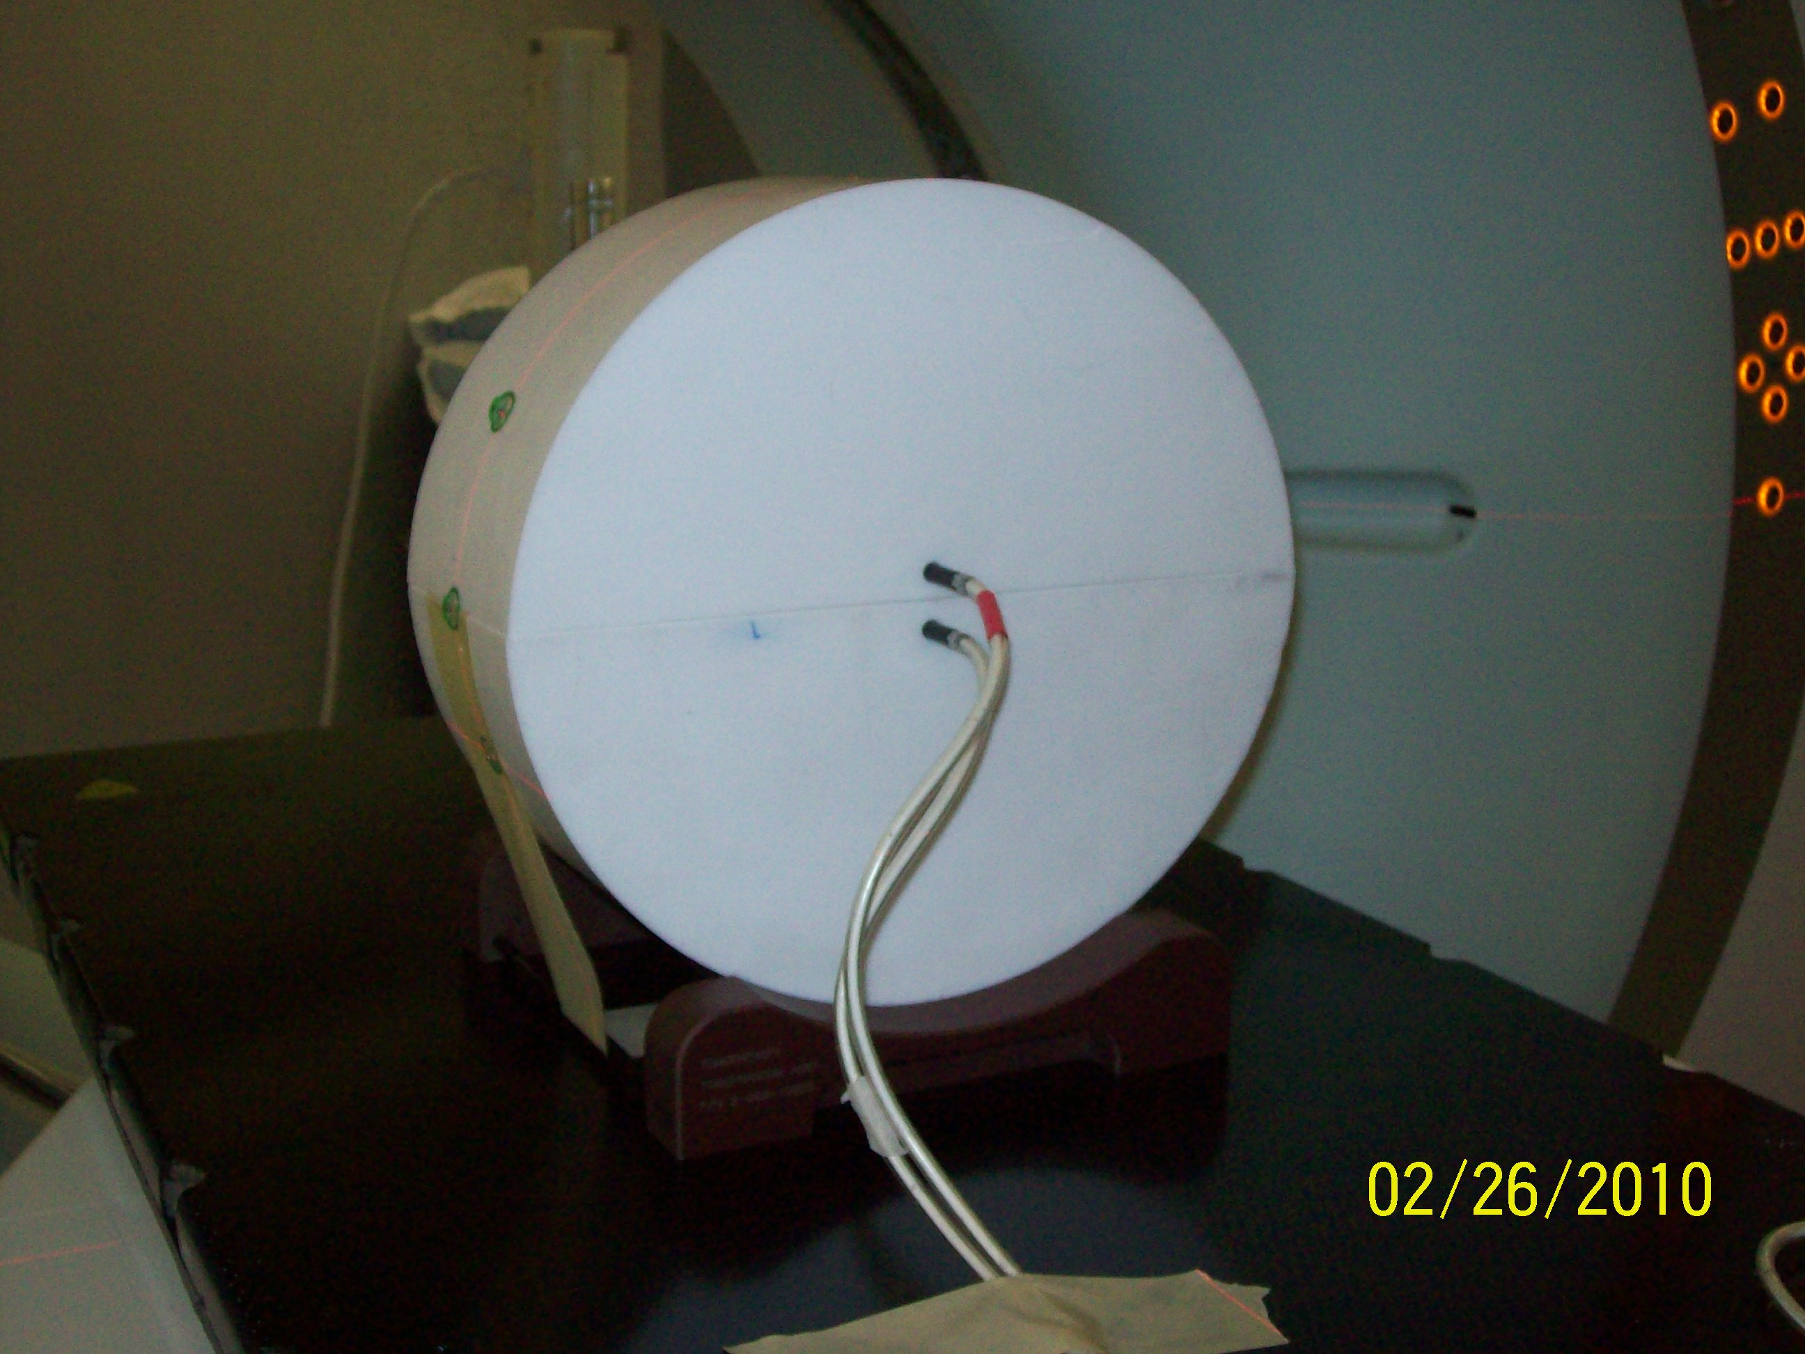
Figure 1. The new teflon phantom as it appears when setup for DQA without the film so as to show both chambers.

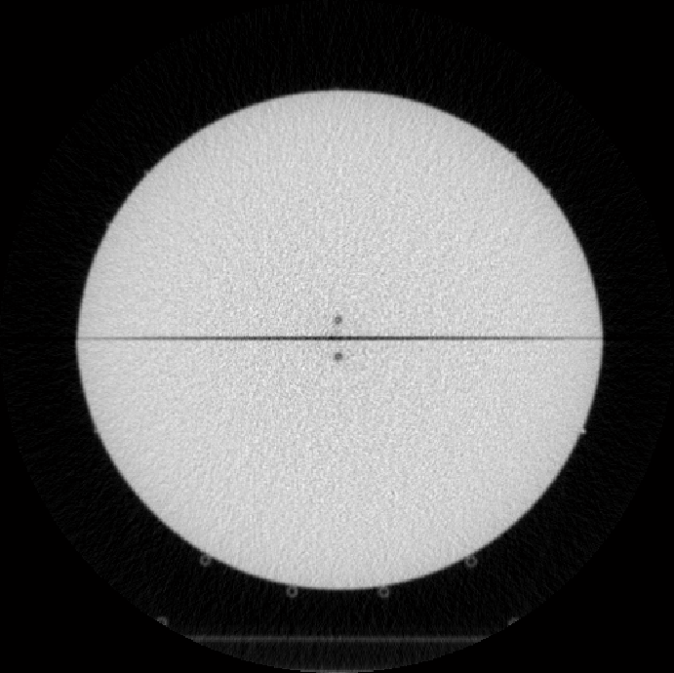
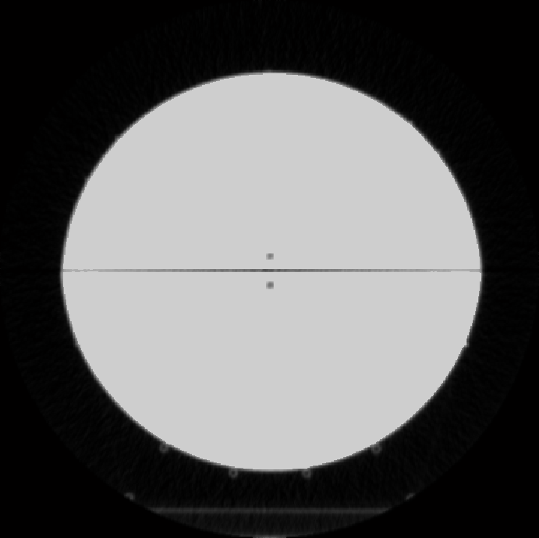
Figure 2. Comparison of a sample slice before (above) and after (below) applying the smoothing agorithm.

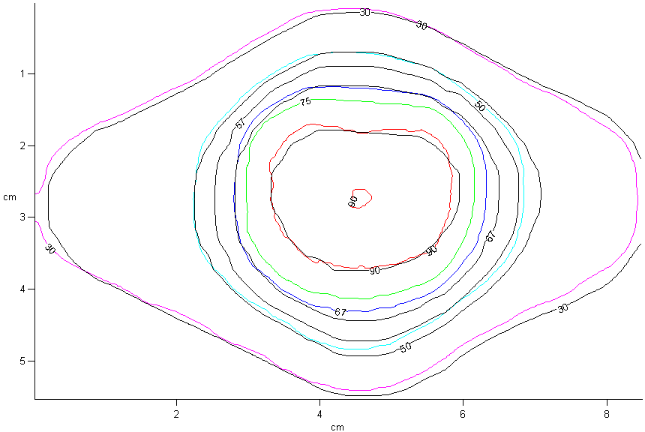
Figure 3. Sample isodose comparison for a random patient using the cheese phantom. Colored lines represent the measured data while solid lines represent TPS values.

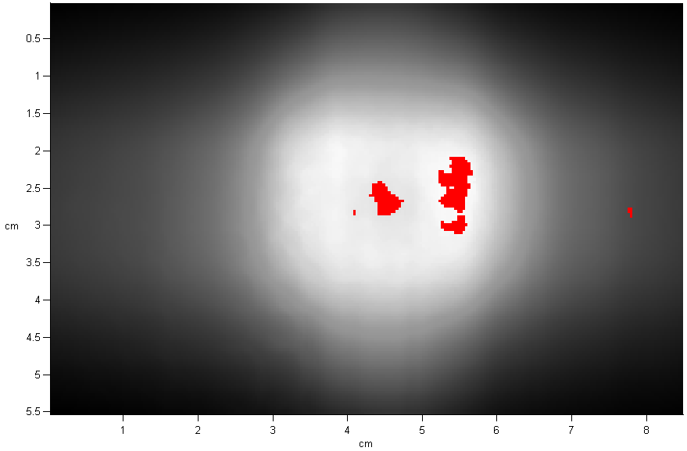
Figure 4. Film gamma analysis for the sample isodose comparison using the cheese phantom. Red points indicate points that failed the analysis. The pass rate in this case is 99.14%.

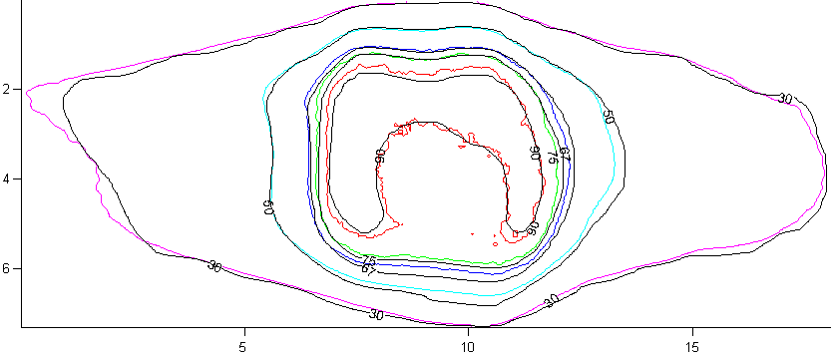
Figure 5. Sample isodose comparison for a random patient using the cheese phantom. Colored lines represent the measured data while solid lines represent TPS values.

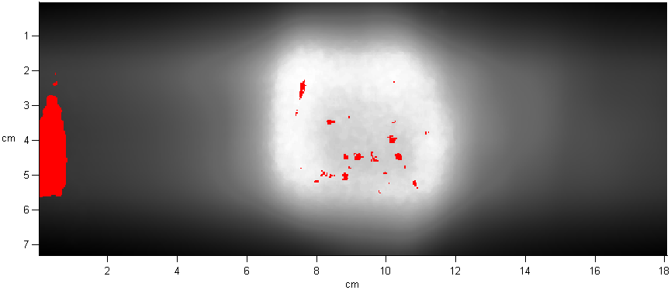
Figure 6. Film gamma analysis for the sample isodose comparison using the cheese phantom. Red points indicate points that failed the analysis. The pass rate in this case is 98.23%.

Tomotherapy
 | Before | After
Point Dose Diff μ (σ) | 1.140% (1.333%) | 0.268% (1.184%)
γ Pass Rate μ (σ) | 94.450% (4.474%) | 96.817% (2.466%)
Varian RapidArc
 | Before | After
Point Dose Diff μ (σ) | 1.467% (1.282%) | 0.492% (1.414%)
γ Pass Rate μ (σ) | 93.813% (9.100%) | 98.563% (1.354%)

Table 1. Summary of the effect of applying the smoothing algorithm to the point dose differences and the gamma pass rates over six patients for both HT and RA.

Passing Plans – Point Doses (Mx/TPS)
 | RA |  | HT
 | Teflon | Cheese | Teflon | Cheese
mean | 0.5% | 1.2% | 0.3% | 0.3%
stdev | 1.4% | 1.0% | 1.2% | 1.10%

Table 2. A summary of the performance of the new teflon and standard cheese phantom on the passing plans on point doses and for both RA and HT modalities.

Passing Plans – Gamma Analysis
 | RA |  | HT
 | Teflon | Cheese | Teflon | Cheese
mean | 98.56% | 99.38% | 96.32% | 97.77%
stdev | 1.35% | 0.76% | 2.47% | 3.44%

Table 3. A summary of the performance of the new teflon and standard cheese phantom on the passing plans on film gamma analysis and for both RA and HT modalities.

Failing Plans – Point Doses (Mx/TPS)
 | Teflon | Cheese
mean | 6.50% | 7.50%
stdev | 1.60% | 1.10%

Table 4. A summary of the performance of the new teflon and standard cheese phantom on the failing plans on point doses. Note: only delivered on HT.

Failing Plans – Gamma Analysis
 | Teflon | Cheese
mean | 100% | 99.97%
stdev | 0% | 0.8%

Table 5. A summary of the performance of the new teflon and standard cheese phantom on the failng plans on film gamma analysis. Note: Only delivered on HT.

