Pitches with minimum ripple effect:
- 0.430
- 0.287
- 0.215
- 0.172
- 0.143
- 0.123
- 0.096
- 0.086

Gantry Rotation Period
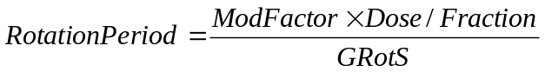

Total Treatment Time

To Decrease Treatment Time
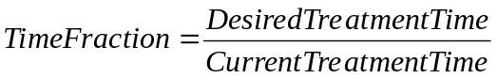
- Cancel optimization
- Set Modulation Factor to:
- Set pitch to:
