Applicability of Image Smoothing for Dose Calculation of High Density Phantoms in Patient Specific Delivery Quality Assurance

Motivation:
Delivery quality assurance (DQA) of stereotactic body radiotherapy (SBRT) intensity modulated radiation therapy (IMRT) treatments can be challenging due to the high dose per fraction prescribed to the target volume. For non-small cell peripheral lung tumors, a fractionation scheme of 12 Gy per fraction delivered in 4 fractions is commonly used. Currently, our center conducts DQA measurements using EDR2 film for dose plane measurement and two A1SL ion chambers for absolute point dose measurements within a cylindrical solid water phantom. Unfortunately, EDR2 film saturates at a dose of ~ 7 Gy much less than that prescribed for SBRT treatments¹. Previously, the solution of using a high density teflon phantom to attenuate the film plane dose to ~ 6 Gy was shown to be feasible². Use of high density phantoms poses its own challenges in the DQA process as artifacts are introduced in the scanned images of the phantom. Using megavoltage CT (MVCT) rather than kilovoltage CT (kVCT) to scan the phantom helps to mitigate these artifacts, but not completely. These image artifacts affect the dose calculation accuracy of patient treatment plans on the high density phantom. Smoothing the images can remove the presence of artifacts. The purpose of this study was to determine the appropriateness of such image manipulation in terms of performing DQA for SBRT cases.

Method and Materials:
At our center, SBRT plans can be delivered via Rapid Arc (RA) or Helical Tomotherapy (HT) systems. Rapid Arc plans are generated within the Varian Eclipse platform, while Helical Tomotherapy plans are generated within the Tomotherapy platform. Each treatment planning system (TPS) has its own way of creating verification plans for DQA. This teflon phantom DQA process was tested for implementation with both planning platforms.

A MVCT scan of the teflon phantom was taken using our Helical Tomotherapy system. Two image sets of the phantom: smoothed and unsmoothed, were imported into both the Varian and Tomotherapy treatment planning systems. Smoothing was performed using a Matlab R2008b script and consisted of homogenizing the varying pixel values of the teflon phantom to an average pixel value for teflon in the representative slice. The representative slice was chosen to be one that displayed the two chamber positions and the film plane clearly. The process proceeds as follows:

- Average all the pixel values that varied greatly from their surroundings.
- Within the representative slice, determine a cutoff value using aa binomial search that compares the values above.
- Determine the average and standard deviation of all values above the final cutoff value in the representative slice. This average value is considered to be the value for teflon.
- Replace all values in the phantom within 3.25 standard deviations of the teflon value with the teflon value as all are considered to be teflon.
- Replace all pixels with six or more corrected values among its neighbors. This fixes outlying values that happened to be missed.
- Replace slices at the beginning and the end that only include part of the phantom. This fixes the slant from the table sag.

Since teflon is a high density material, the correct CT calibration value to extend the calibration curves in both treatment planning systems needed to be determined. This was done by creating RA and HT plans for both images of the teflon phantom in each planning system. Plans were then delivered to the teflon phantom on each machine and measured point doses were compared to those calculated. If necessary, CT calibration values were altered until the calculated dose to the chambers matched the measured point doses.

Once calibrated, six SBRT lung patients previously treated on HT were re-planned for RA delivery. Therefore, each patient had 1 HT and 1 RA plan for delivery. DQA plans for each patient were generated on both the unsmoothed and smoothed teflon phantom images. Patient plans were then delivered to the teflon phantom on each machine. Both point dose measurements and film analysis were conducted. Results were compared to those calculated for both image sets. Film analysis was based on a gamma index (γ) with criteria of 3% dose difference, 3 mm distance to agreement (DTA) and 10% threshold.

We also tested catching of failing plans. These were conducted on HT. The plans for the six patients had their doses scaled down so that errors in mean leaf open times (LOT) became significant (<100 ms).^{[Add reference]} HT allows for scaling of the overall dose as part of the process for creating DQA plans. Scaling the dose in this manner is accomplished by scaling LOT by HT. Initially, all plans had a mean LOT of ~500 ms. Assuming that HT scales LOT with dose linearly, each plan was scaled to have a mean LOT of just under 100 ms. DQA was run for each of these plans to confirm their failure.

Results:
Fig. 1 and Fig. 2 show a sample slice from the scan of the phantom before and after applying the smoothing algorithm. As can be seen in the figures, the smoothing algorithm eliminates noise from the CT data set. Without smoothing, the MVCT pixel values in the phantom range from 1600 to 2294, while in the smoothed image the MVCT pixel value is set to the average value of 1905.

Fig. 3 and Fig. 4 show the results of the gamma comparison for a sample patient using the unsmoothed phantom and the smoothed phantom, respectively. The figures show the effect of the image noise on the agreement between calculated and measured dose planes. When the artifacts are removed from the image set, the calculated dose plane is much more representative of the actual delivered dose.

Table 1 presents the average point dose differences for the two chambers as well as the gamma index results for the six SBRT patients for both the smoothed and unsmoothed image sets. For both planning systems, use of the smoothed images improved agreement between calculated and measured point doses. The maximum improvement in point dose differences seen was a 1.17% for HT and 0.78% for RA. The improvement in the gamma (γ) pass rate was even greater for the smoothed images, with indices being 2.4% and 4.8% higher for HT and RA respectively. In general, the calculated point doses were less sensitive to the image artifacts than the calculated dose distribution.

[Add False Positive Testing Results and Figure/Table Reference(s)]

Conclusion:
Using an algorithm to smooth out the artifacts improves the treatment planning systems' ability to accurately calculate both point doses and dose distributions in our teflon phantom. The results indicate that DQA of SBRT plans using our high density phantom will be possible with further commissioning.

References:

- X. R. Zhu, P. A. Jursinic, D. F. Grimm, F. Lopez, J. J. Rownd and M. T. Gillin, "Evaluation of Kodak EDR2 film for dose verification of intensity modulated radiation therapy delivered by a static multileaf collimator," Med Phys 29, 1687-1692 (2002).
- D Worthy, M Snyder, and R Starin, “SU-GG-T-249: Delivery Quality Assurance for Stereotactic Body Radiotherapy (SBRT) Using a Teflon Cylindrical Phantom” Med. Phys. 37, 3242 (2010).

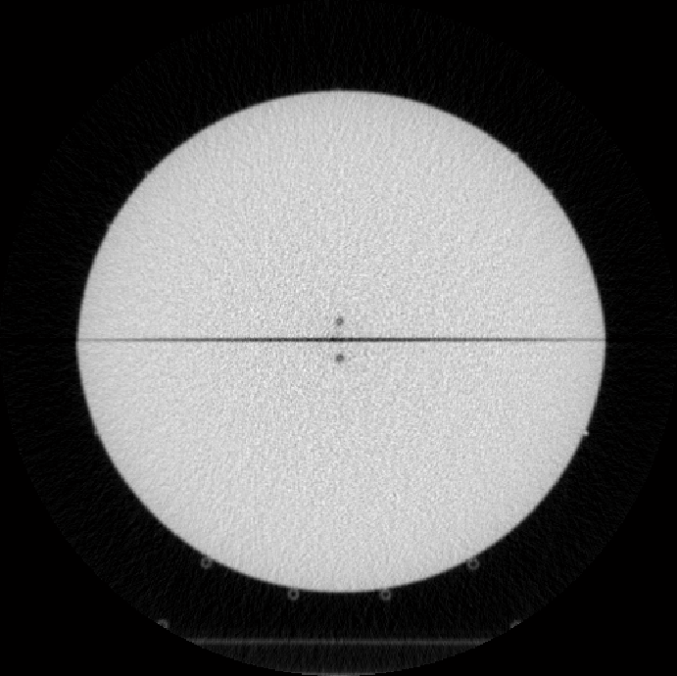
Fig. 1. Sample slice from the scanned phantom before applying the smoothing algorithm.

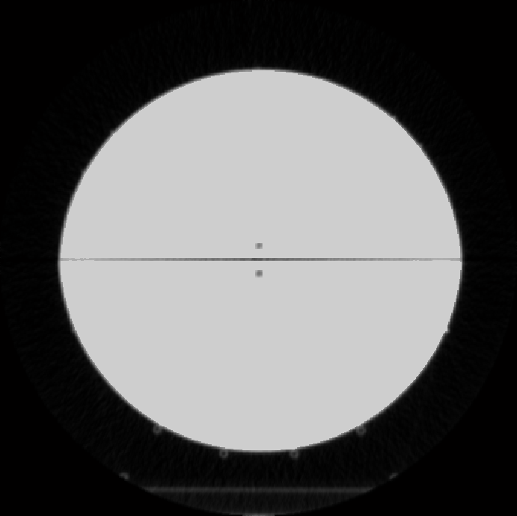
Fig. 2. Sample slice from the scanned phantom after applying the smoothing algorithm.

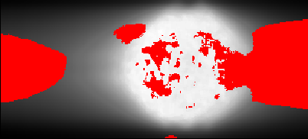

Fig. 3. Gamma comparison for a sample patient using the unsmoothed phantom. The red indicate points that failed the gamma comparison (γ >1).

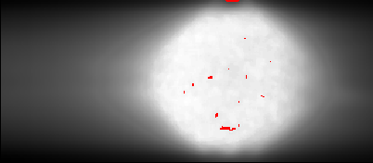

Fig. 4. Gamma comparison for a sample patient using the smoothed phantom. The red indicates points that failed the gamma comparison (γ >1).

[Add False Positive Testing Figure(s)]

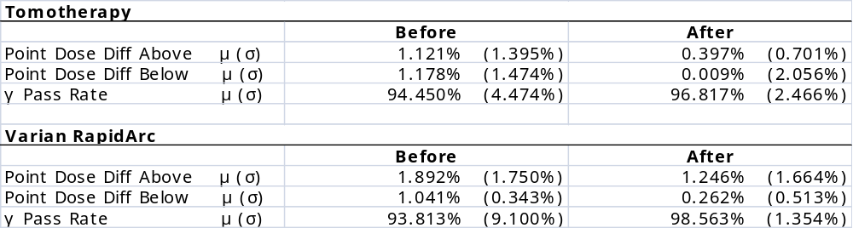

Table. 1. Summary of the effect of applying the smoothing algorithm to the point dose differences and the gamma pass rates over six patients for both HT and RA. μ and σ represent the mean and standard deviation in the listed quantity, respectively.

[Add False Positive Testing Table(s)]

Teflon Phantom
Patient | Mx [Gy] | TPS [Gy] | Mx/TPS | Pass/Fail
1 | 1.70869 | 1.67200 | 1.02210 | Pass
2 | 1.70869 | 1.79450 | 0.95220 | Fail
3 | 1.65457 | 1.82100 | 0.90861 | Fail
4 | 1.75250 | 1.80850 | 0.96904 | Fail
5^ | 1.67003 | 1.69800 | 0.98353 | Pass
5_ | 1.69580 | 1.77850 | 0.95350 | Fail
6 | 1.70096 | 1.80950 | 0.94002 | Fail
Cheese Phantom
Patient | Mx [Gy] | TPS [Gy] | Mx/TPS | Pass/Fail
1 | 0.76986 | 1.02367 | 0.75206 | Fail
2 | 0.63276 | 1.08933 | 0.58087 | Fail
3 | 0.93860 | 1.11300 | 0.84331 | Fail
4 | 1.30244 | 1.21100 | 1.07551 | Fail
5^ | 1.36571 | 1.10567 | 1.23519 | Fail
5_ | 1.32353 | 1.13733 | 1.16372 | Fail
6 | 1.07042 | 1.12500 | 0.95148 | Fail

Table 2. Summary of absolute point dose data for the failing plan testing. Patient 5 has two entries since the upper chamber passed for the cheese phantom so both chamber measurements were recorded to determine if both chamber measurements would fail the DQA and for comparison with the teflon phantom. Patient 1 only had enough room in the PTV for one chamber measurement.

