Improving Wheatley’s method by dynamic programming

Cheng Zhang and B. Montgomery Pettitt
Sealy Center for Structural Biology and Molecular Biophysics,
Department of Biochemistry and Molecular Biology,
The University of Texas Medical Branch
Galveston, TX 77555, USA

Abstract
An attempt of improving Wheatley’s method.

I. Introduction
Recently, Wheatley computed the 11th and 12th virial coefficients for the three-dimensional case¹.
We develop the method and its extensions in Sec. II. The results are presented in Sec. III. We conclude the article in Sec. IV.

II. Methods

II.A Background

II.B Expansion in graphs
Given a set of vertices, the Boltzmann weight 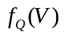 of a configuration 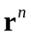 can be written as a sum over all graphs 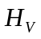 of the vertex set 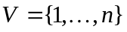:
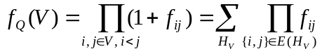, ()
where 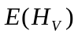 denotes the set of edges of . Note that we allow all possible graphs 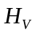 in the sum, and thus there are 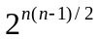 terms in total, for each pair 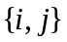 can carry a value of either 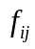 or 1. We will always assume a fixed configuration , and ignore the configuration dependence hereinafter.
Similarly, the total contribution from a configuration to the virial series can be written as a sum over the biconnected graphs of the vertices
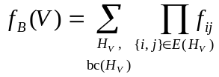, ()
where the 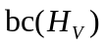 is a Boolean function that tests the biconnectivity of .
The direct evaluation Eq. () requires an enumeration of the graphs. In Wheatley’s method, however, we use the subsets of vertices to collect similar graphs and for each vertex subset, we only aim at the corresponding sum of graphs. In this way, the number of objects to handle is of order 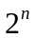, which is the number of possible partitions of the vertex set. This strategy proves to be helpful for 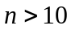¹.

II.C Wheatley’s method
We first define, in addition to Eqs. () and (), a sum over the connected diagrams
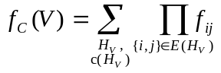, ()
which serves as a bridge between the Boltzmann weight the biconnected sum. For later convenience, we also extend the definitions in Eqs. (), () and () to an arbitrary subset of . Thus, we have values for each of 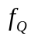, 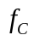, and 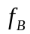.
The general strategy of Wheatley algorithm is first to deduce the values of 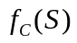 from the values of 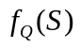 for 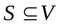, and then deduce 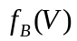 from the values of .
The first step is accomplished by the following recursion¹:
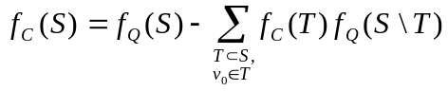, ()
where v₀ is the lowest vertex in S, and the sum is carried over proper subsets T of S containing v₀.
In the second step, we further define 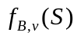 as the sum over connected subgraphs of vertices in the subset S without articulation point lower than v, and
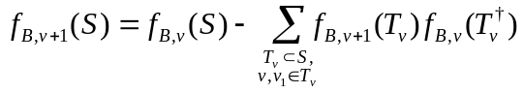. ()
where v₁ is the lowest vertex in 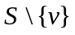, and 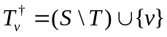. For efficiency, we compute and save the 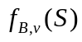 values in ascending order of v, or 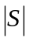 for the same-v cases.

II.D Connected sum
In the first step, we try to obtain the connected sum 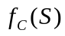 for each subset of the ground set 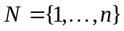. We observe that every graph composed of vertices in can be broken down into (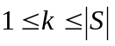) connected components. So,
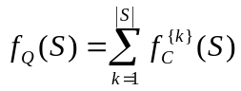, ()
where 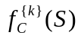 is defined as the sum of graphs of that are composed of disjoint connected components, and 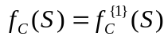. Formally, for an arbitrary function 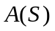, we define the sum over -partitions as
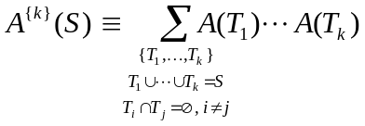, ()
where the sum is carried over all unordered -partitions 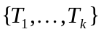 of the vertex set .
Equation () serves as a bridge between the values of and . At first glance, it is less manageable than the recursion furnished by Wheatley. It turns out that our formulas allows an easier and possibly more efficient implementation because we can now use an efficient algorithm of counting set partitions², which works better when applied to all subsets.
First, let us invert Equation () as
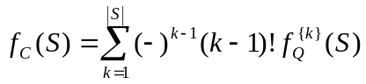, ()
where 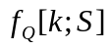 is the sum over k-partitions for the function 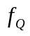, as defined in Eq. (). The remaining problem is to evaluate the sum the k-partitions in Eq. (), which can be done using the inclusion-exclusion principle².

II.E Sum over set partitions
Here we will review an algorithm² that computes the sum over set partitions Eq. () efficiently. To do so, we will first compute a simpler sum over ordered k-tuples:
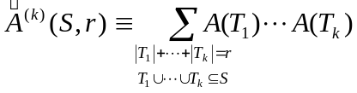. ()
This sum over tuples in Eq. () is simpler than the sum in Eq. () for two reasons: (a) the subsets 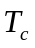 may share members; and (b) the union of the subsets 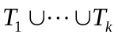 only needs to be contained in instead of being precisely . To recover Eq. (), we now compute the Möbius transform 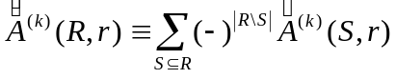 for fixed and ,
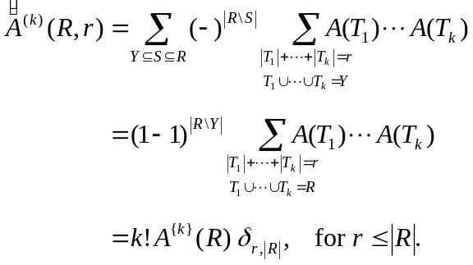 ()
Here, on the second line, we have carried out the sum over by using the binomial theorem, and the sum yields zero only if 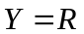. On the next line, we observe that in order for the union to cover , the sum 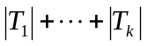 must be at least 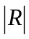, and if 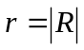, it is reduced to Eq. (), except for the factor 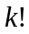 that accounts for the number of permutations of the subsets. In short, we have
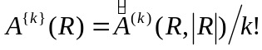.
Next we give a recursion to compute 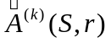²:
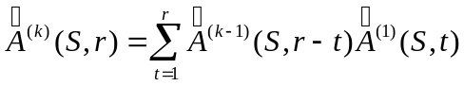, ()
which represents the process of appending a set of elements to the 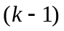-tuple. Using this recursion, we can compute efficiently once we have 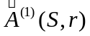.
Finally, is equal to the ranked zeta transform (or subset sum) of 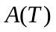:
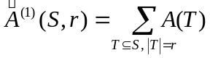, ()
which can be readily computed.

II.F Algorithm C
Here is an algorithm of computing the connected sum for all subsets
- For every subset , compute 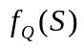.
- Compute the ranked zeta transform 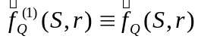 of 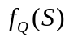, and make a copy of it. Set 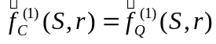.
- For each 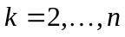, do step 4.
- For each subset , and (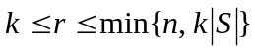), compute (in place) 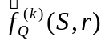
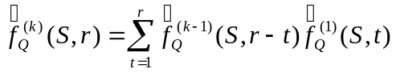,
and update (in place)
.
- For each , compute the Möbius transform 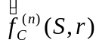 of 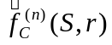, and set 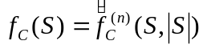.
Here and 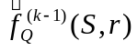 share the same memory space, and the same holds for 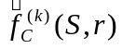 and 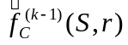.

II.G Removing articulated diagrams
We start with a reformulation. Let 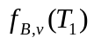 be the sum of diagrams with no articulation point lower than vertex , we have
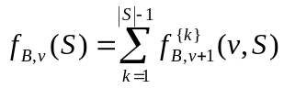. ()
where
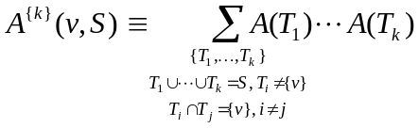, ()
Inverting Eq. (), we get
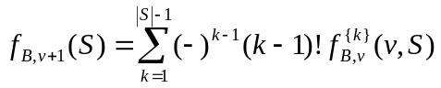. ()

III. Results

III.A Virial coefficients

IV. Summary and discussions

V. Acknowledgements
The authors gratefully acknowledge the financial support of the National Science Foundation (CHE-1152876) and the Robert A. Welch Foundation (H-0037).

Appendix A. Inversion of the partition sum
Here we show that Eq. () is the inversion of Eq. (). We write
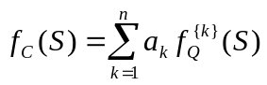, (A1)
and we will show that 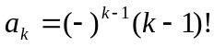.
First, by using Eq. () and (), we expand each -product of -partitions to the sum of a few 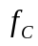-products of -partitions with 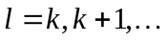. For example, . Thus, the right side of Eq. (1) can be written as a sum of -partitions of :
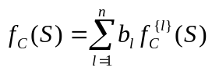,
where 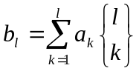, with 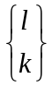 being the Stirling number of the second kind, or the number of ways of placing elements into groups. Obviously, we must have 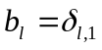, and
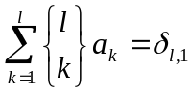. (A2)
By solving equations of (2), we can determine all values of 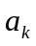.
Recall that the exponential generating function of the Sterling number of the second kind is given by
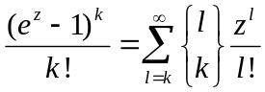.
Here, the coefficient before 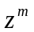in the power series of 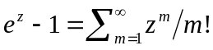 represents the number of ways of placing identical objects in a group, which is simply 1, divided by 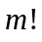. Then, with 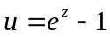, 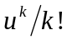 gives the exponential generating function of making such unordered groups, without restricting the total number of objects³. Multiplying both sides by 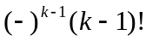 and summing over yields
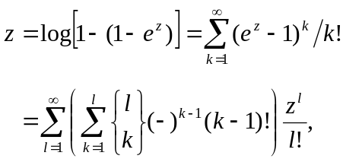
Comparing the coefficients of 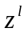, we get
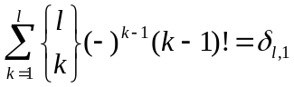.
Comparing with (2), we conclude that .

Appendix B. Zeta and Möbius transforms
The Möbius can be accomplished in 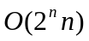 steps.

Figure captions
Figure 1. Figure description.

References
¹R. J. Wheatley, Phys. Rev. Lett. 110, 200601 (2013).
²A. Björklund, T. Husfeldt, and M. Koivisto, SIAM J. Comput. 39, 546 (2009).
³P. Flajolet, and R. Sedgewick, Analytic Combinatorics (Cambridge University Press, Cambridge, 2009).

