Improving Wheatley’s method by dynamic programming

Algorithm C.

Step C2. Ranked zeta transform.
- Initialize 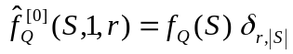.
- For 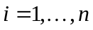, repeat step 3.
- For every subset such that 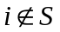, apply
.
The final result is 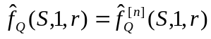.

Step C3.
- For each subset , do step 2.
- For each 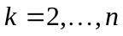, compute
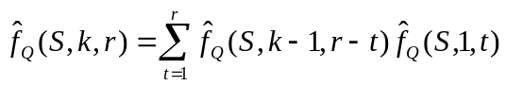.

Step C4.
For every subset , and every rank 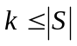, compute 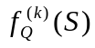 from 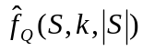
- For each 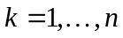, do steps 2-3.
- Set 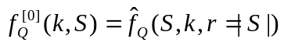.
- For each ,
.

Step C5.
Loop over every subset , apply
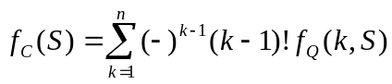.

Algorithm C (reduced memory).
- For every subset , compute 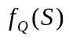, and set 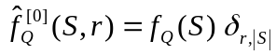, 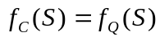.
- (Ranked zeta transform.) For , repeat step 3.
- For every subset such that , loop over 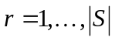, apply (in place)
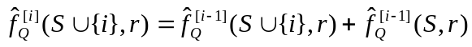.
- Set 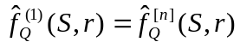, and make a copy of it.
- (Steps 3-5 in the main text.) For each , do steps 6-9.
- For each subset , compute, in place, 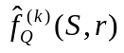 [with 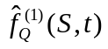 being the saved copy in step 4] by a loop over :
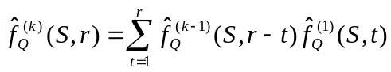.
- (Möbius transform.) Construct an array 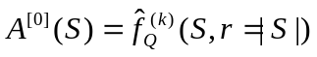. For , do step 8.
- For each subset ,
.
- For each subset , set 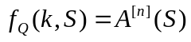, and modify
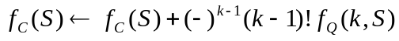.
From Eqs. (Error: Reference source not found) and (Error: Reference source not found), we have, by exchanging the order of two sums
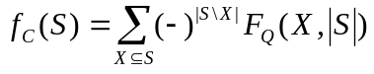,
where
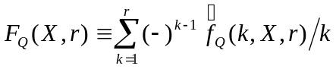.
The Möbius transform of 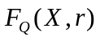 is
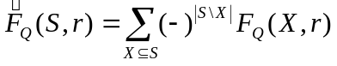.
We have
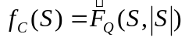.
Further,
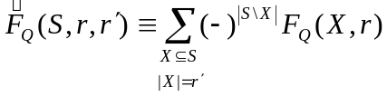.
So
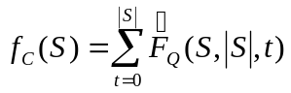.

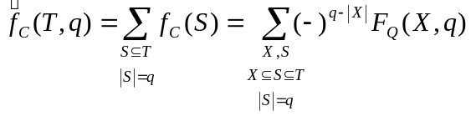
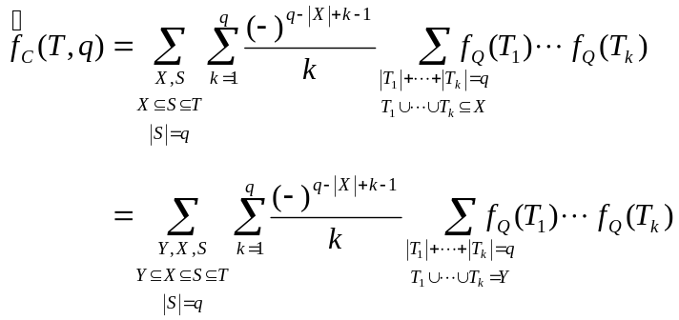
Now if 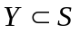, the sum over  gives 0 by the binomial theorem.
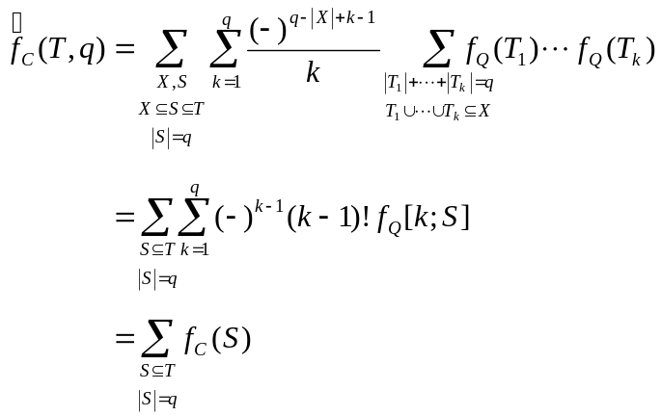

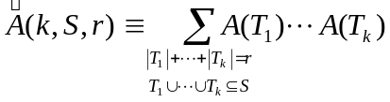
Using the inclusion-exclusion principle
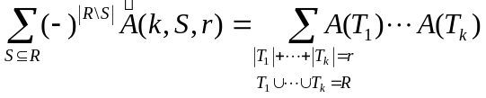
This expression obviously vanishes if 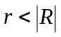, for 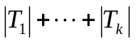 is at least 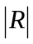for 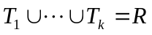 to be true; and it equals 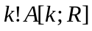 if 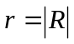.
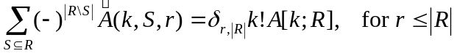.

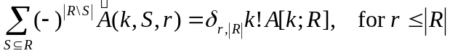
- For every subset , compute .
- For every subset and every 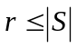, compute 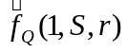 by Eq. (Error: Reference source not found) using the ranked zeta transform (Appendix Error: Reference source not found).
- For every subset , every , and every 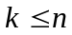, compute 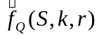 by Eq. (Error: Reference source not found).
- For every , every subset , and every , compute the Mobius transform 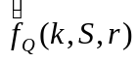 of 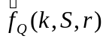. Set 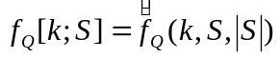 [Eq. (Error: Reference source not found)].
- For every subset , compute 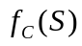 from 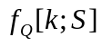 by the inversion Eq. (Error: Reference source not found).

