Erratum: “Computation of virial coefficients from integral equations” [J. Chem. Phys. 142, 214110 (2015)]

Cheng Zhang, Chun-Liang Lai, and B. Montgomery Pettitt
Sealy Center for Structural Biology and Molecular Biophysics,
Department of Biochemistry and Molecular Biology,
The University of Texas Medical Branch,
Galveston, TX 77555-0304, USA

There are a few errors in the published version of the paper¹. The unnumbered equation below Eq. (16) (on page 3) should instead appear as
.
Right above Eq. (17) (on page 3), the following sentence should be inserted before “Thus,”
‘Here, the superscript “ex” means the excess (non-ideal) part.’
Third, the following comment should be added to the caption of Fig. 1.
“For the 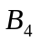-SC equation, the results were from the compressibility route; the virial-route results (not shown) were also worse than the results of the DSC equation.”
Next, there are two errors in Table III (on page 9). The top number for 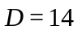 and 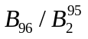, should appear as “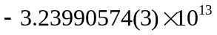,” and the top number for 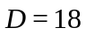 and 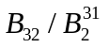, should appear as “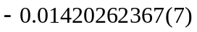.”
In the caption of Fig. 4 (on page 10), “sixth-dimensional” should be “six-dimensional.”
In Table IV (on page 10), the number for 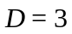 and 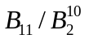 should appear as “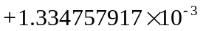.”
In the Conclusions (Sec. IV on page 11), the phrase “consider to incorporate” should be “consider incorporating.”
Finally, we have corrected a few mistakes in the supplementary material. None of the corrections affect the conclusions of the article.

1C. Zhang, C.-L. Lai, and B. M. Pettitt, J. Chem. Phys. 142, 214110 (2015).

