King Saud University

Collage of Computer Sciences

1436H/1437H - Term 2

Online Examination System

CSC 342 Project

(Phase 2)

|  |  |
| --- | --- |
| Student Name | ID |
| Abdulsalam Alfaisal | 433102180 |
| Abdullah Alshthri | 430105330 |
| Abdulaziz Saleh Al-Akouz | 433103063 |
| Ahmed alsudairi | 431100358 |

|  |  |  |
| --- | --- | --- |
| **Use Case Description** | | |
| **System:** online examination system | | **Student Group ID:** |
| **Use Case name:** register | | **UC ID:** 000 |
| **actor:**  faculty member ,student | | **Priority (H,M,L):** H |
| **Goal:** register in system's website | |  |
| * **Input:** user name , id , password and other info. | | |
| * **Steps:** | | |
| **Actor** | **System** | |
| **1. Actor enter** user name .Alt1  **3.** a Alt1  **5.** enter academic ID . Alt1  **7. enter email address. Alt1**  **9. enter captcha litters . Alt1**  **11. click submit button . Alt1** | 2. Sys check if the name chosen is available , display "available" . *EXP1  4. if password more than 8 litters display "ok" *EXP2 .  6. check if the ID belong to the institute. Display "verified ". *EXP3  8. if email format is correct , display "Correct".*EXP4  10. if captcha is correct , display "Correct" . *EXP5  12.system perform the required process to complete the registration (update data base ,send varication email , etc) | |
| **Exceptional flows:**  EXP1: user name already used*. Display "user name already used" Go to step 1 .*  EXP*2 : display" use more than 8 liters"*  *Go to step 3.*  EXP*3 :id not verified by institute display "id does not belong to the institute "go to step 5*  EXP4: email format not correct . display "email format not correct"  **Go to step 7**  EXP**5: captcha wrong . display "try again " update captcha , go to 9**  **Alternative flows:**  Alt1: actor can cancel Operation , exit use case. |  | |
| **Post-conditions:** *data base will be updated with user info ,* | | |
| * **Output:** confirmation and user information to client by email. | | |

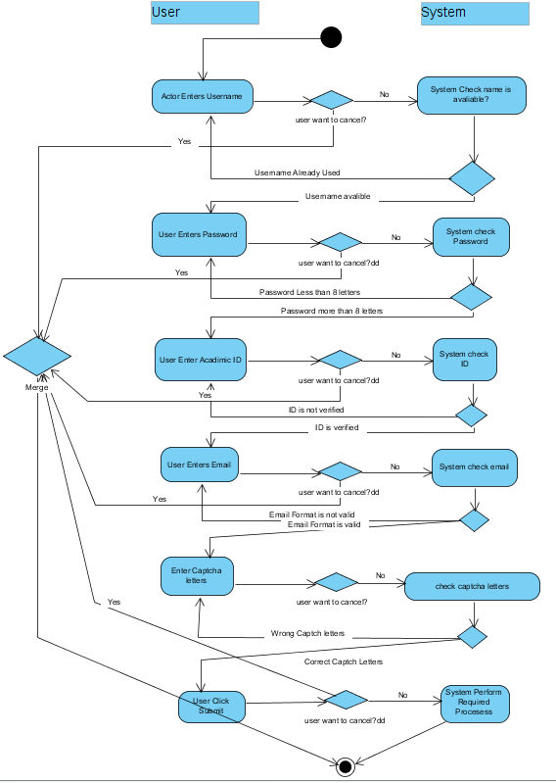

|  |  |  |
| --- | --- | --- |
| **Use Case Description** | | |
| **System:** online examination system | | **Student Group ID:** |
| **Use Case name:** Participate in Exam | | **UC ID:** 016 |
| **actor:** Student | | **Priority (H,M,L):** H |
| **Goal:**  Involve in the exam | | |
| **Pre-conditions:** Exam is avaliable | | |
| **Steps:** | | |
| **Actor** | **System** | |
| 1. student enter system interface. Alt1 2. student select a course. Alt1 3. select participate in exam Alt1 4. student click confirm Alt1 5. student start to solve the exam 6. student click on submit , or time is finished. Alt1 | 1.1 system display list of courses that the student joined.  3.1 system display exam info ( date,time ) EXP1  4.1 system Add you in the exam  4.2 student enter exam.  6.1 calculate and upload score | |
| **Exceptional flows:**  EXP1: Exam is not avaliable , go to step [2]  **Alternative flows:**  Alt1: actor can cancel Operation , exit use case. | | |
| **Post-conditions:** the Exam is involved | | |

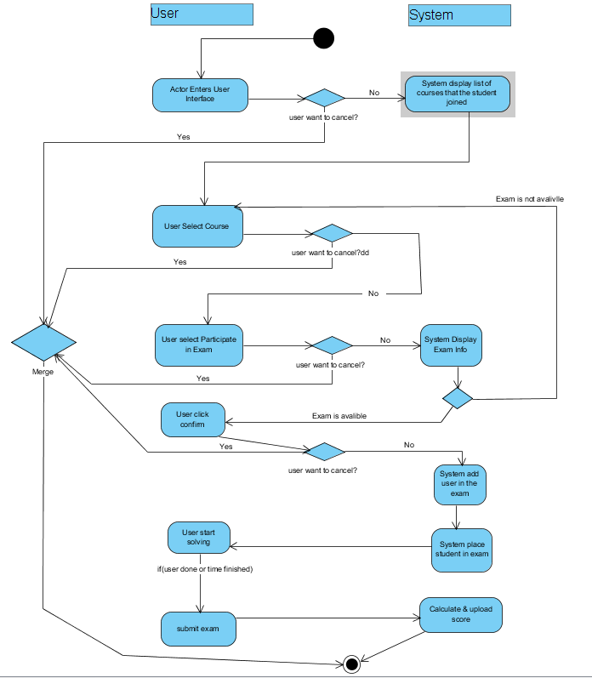

|  |  |  |
| --- | --- | --- |
| **Use Case Description** | | |
| **System:** online examination system | | **Student Group ID:** |
| **Use Case name:** register admin | | **UC ID:**  018 |
| **actor:**  admin | | **Priority (H,M,L):** H |
| **Goal:** register in system's website | |  |
| * **Input:** user name , id , password and other info. | | |
| * **Steps:** | | |
| **Actor** | **System** | |
| 1. Enter Ticket Number , given by an admin. *ALT1  **3. Actor enter** user name *alt1  **5.** enter password . *alt1  **7. enter email address. *alt1**  **9. enter captcha litters . *alt1**  **11. click submit button *alt1** | 2. check if Ticket Number is valid, if valid display “valid” , and proceed to next step. *Exp0  4. Sys check if the name chosen is available , display "available" . *EXP1  6. if password more than 8 litters display "ok" *EXP2 .  8. if email format is correct , display "Correct".*EXP3  10. if captcha is correct , display "Correct" . *EXP4  12.system perform the required process to complete the registration (update data base ,send varication email , etc) | |
| **Exceptional flows:**  **Exp0: Ticket No. is not valid , go to step 1**  EXP1: user name already used. Display "user name already used" Go to step 1 .  EXP2 : display" use more than 8 liters"  Go to step 3.  EXP3: email format not correct . display "email format not correct"  Go to step 5  EXP4: captcha wrong . display "try again " update captcha , go to 7  **Alternative flows:**  Alt1: actor can cancel Operation , exit use case. |  | |
| **Post-conditions:** *data base will be updated with user info ,* | | |
| * **Output:** confirmation and user information to client by email. | | |

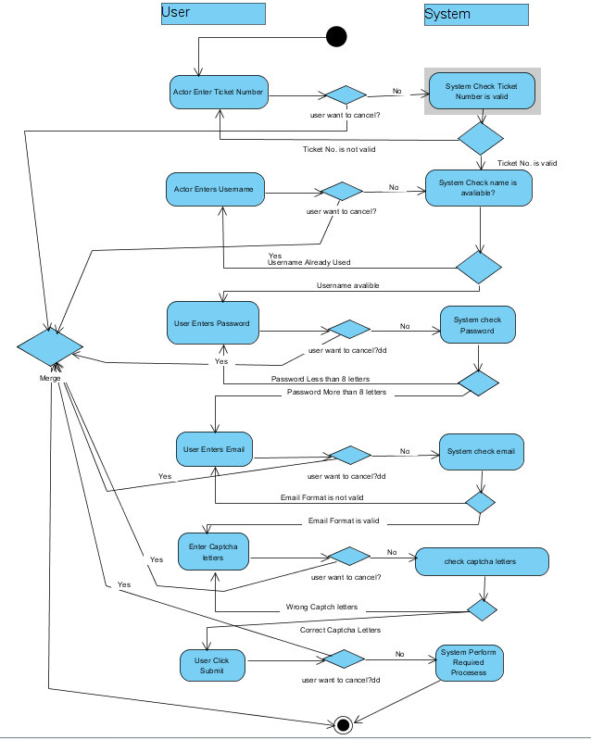

|  |  |  |
| --- | --- | --- |
| **Use Case Description** | | |
| **System:** online examination system | | **Student Group ID:** |
| **Use Case name** view exam information | | **UC ID:**  015 |
| **actor:** Student | | **Priority (H,M,L):** H |
| **Goal:**  to view exam info | | |
| **Pre-conditions:** Exam is avaliable | | |
| **Steps:** | | |
| **Actor** | **System** | |
| 1. student enter system interface. Alt1 2. student select a course. Alt1 3. student select a Exam. Alt1 4. student click on Back. Alt1 | 1.1 display courses that the student joined.  2.1 system display list of exams  . EXP1  3.1 system display exam info(Date,Time).  4.1 system back to system interface | |
| **Exceptional flows:**  EXP1: Exam is not avaliable , go to step [2]  **Alternative flows:**  Alt1: actor can cancel Operation , exit use case. | | |
| **Post-conditions:** exam info viewed | | |

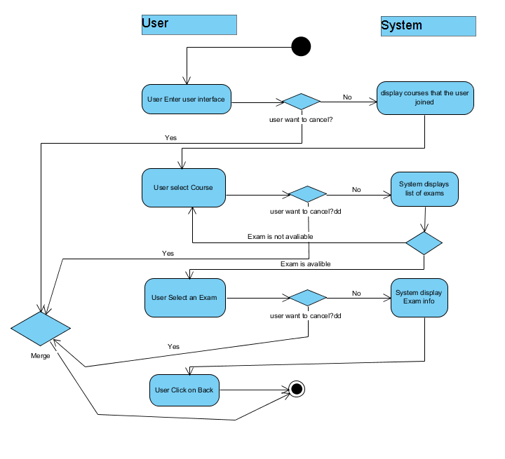

|  |  |  |
| --- | --- | --- |
| **Use Case Description** | | |
| **System: Online Examination System** | | **Student Group ID:** |
| **Use Case name:** Update Question | | **UC ID:** 09 |
| **Primary actor:** *Faculty Member* | | **Priority (H,M,L): M** |
| **Stakeholders:** | |  |
| **Goal: to update the question(s) of a specific exam.** | | |
| **Relationships**   * **Includes:** * **Extends:** | | |
| **Input: Exam Id, Updated question(s)** | | |
| **Pre-conditions:**   * **Logged in as a Faculty Member.** * **Exam available.** * **Question(s) ready.** | | |
| **Steps:** | | |
| **Actor** | **System** | |
| **1. actor enters Exam ID. *Alt1**  **4. actor select the question need to be updated. *Alt1**  **6. actor enter the updated question and choices. *Alt1** | **2. system checks the Exam ID and created by this actor, if found go to next step. *Exp1**  **3. display the questions of the exam, and ask actor to select the question need to be updated.**  **5. system ask actor to enter the updated question and choices.**  **7. system run the appropriate processes to update the question. If succeeded system displays “Succeeded”, then go to step 3. *Exp2**  **8. exit the use case.** | |
| **Exceptional flows:**  **Exp1: if exam is not found, display “exam not found”, then go to step 1.**  **Exp2: if an error accrued, display the error, then go to step 6.**  **Alternative Flows:**  **Alt1: actor can cancel the operation, go to step 8.** | | |
| **Post-conditions:** *update the question(s) of the specified exam.* | | |
| **Output: “succeeded” or “failed” message.** | | |

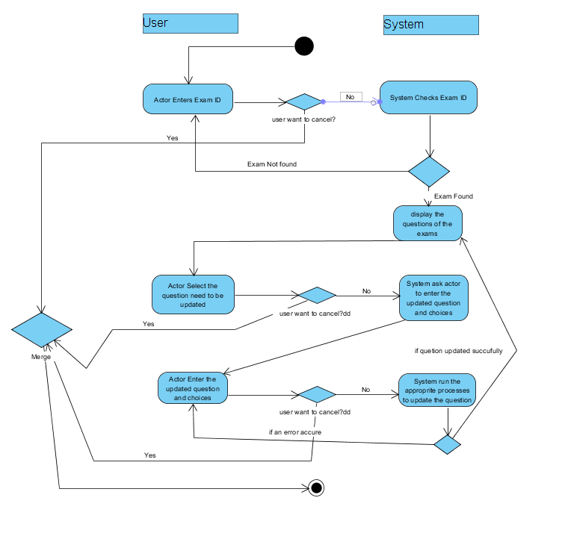

System Architecture Diagram:

