***Coin Detection and Image Stitching***

IMT2022059 – Pudi Kireeti

***Overview***

This project consists of two parts:

1. Coin Detection, Segmentation, and Counting
   * Detect coins using edge detection techniques
   * Segment individual coins using region-based segmentation
   * Count the total number of detected coins
2. Image Stitching for Panorama Creation
   * Detect key points in overlapping images
   * Use homography to align and stitch images into a panorama

The project is available on GitHub: [3kp-0502/vr_assignment1_IMT2022059](https://github.com/3kp-0502/vr_assignment1_IMT2022059)

***Part 1:***

***Coin Detection, Segmentation, and Counting***

This section detects, segments, and counts Indian coins in an image.

***Steps Involved:***

* **Edge Detection (Contours Method):**
  + **Convert the image to grayscale:** cv2.cvtColor(image, cv2.COLOR_BGR2GRAY) is used.
  + **Apply Gaussian Blur and Canny edge detection:** cv2.GaussianBlur and cv2.Canny are used.
  + **Find contours to detect coin boundaries**cv2.findContours is used.
  + **Outline detected coins in green:** cv2.drawContours with green color (0, 255, 0) is used.
* **Segmentation:**
  + **Filter valid coins based on area and circularity criteria:** The filter_valid_coins function does this.
  + **Create masks for each valid coin:** cv2.drawContours with thickness=cv2.FILLED is used to create masks.
  + **Extract individual coin segments using the masks:** cv2.bitwise_and is used with the masks.
* **Counting Coins:**
  + **The total number of detected coins is determined by counting valid contours:** len(valid_coins) gives the count.
  + **Display the final count in the terminal:** print(f"Final Coin Count: {len(valid_coins)}") is used.

***Requirements***

Install the required dependencies using:

pip install opencv-python numpy matplotlib

***How to Run***

Place your input image in the input_images/ folder and update the image path in 1.py.

Then run:

python 1.py

***Methods Used:***

* **Preprocessing:** Grayscale conversion and Gaussian blur to reduce noise
* **Edge Detection:** Canny edge detection with optimized thresholds for coin boundaries
* **Contour Detection:** Identifying closed shapes that represent coins
* **Filtering:** Using area and circularity metrics to eliminate non-coin objects
* **Segmentation:** Creating masks for each coin and extracting individual segments

***Example Inputs & Outputs:***

Original input:

Gray:

Blurred:

Edges:

Closed:

Detected coins:

Segmented coins:

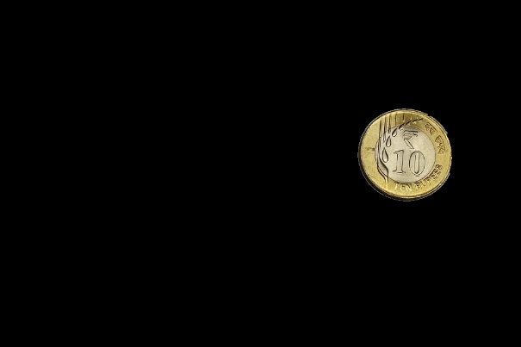

***Failed results:***

**1. Better Edge Preservation in Preprocessing**

* **Good Code:** Uses a **smaller Gaussian blur kernel (7,7)** to reduce noise while keeping fine edges intact.
* **Bad Code:** Uses a **larger Gaussian blur kernel (11,11)**, which **over-smooths** the image, leading to weaker edges and possible loss of small or faint coin boundaries.

**2. Improved Edge Detection Parameters**

* **Good Code:** Uses **lower Canny thresholds (20, 150)** to **detect faint edges** of coins.
* **Bad Code:** Uses **higher Canny thresholds (30, 150)**, which may cause **some faint edges to be ignored**, leading to missed coins.

**3. Better Morphological Operations for Contour Detection**

* **Good Code:** Uses a **smaller kernel (3x3)** for cv2.morphologyEx, which **preserves finer details** and retains accurate coin boundaries.
* **Bad Code:** Uses a **larger kernel (5x5)**, which may **merge** close objects, leading to inaccurate contours.

**4. More Realistic Coin Filtering Criteria**

* **Good Code:**
  + Area: **800 to 60,000**
  + Circularity: **> 0.6**
* **Bad Code:**
  + Area: **1,000 to 50,000**
  + Circularity: **> 0.7**
* 🔹 The **good code** allows detection of slightly **irregular or small coins**, while the **bad code** is too strict and may **filter out valid coins**.

**5. Better Contour Retention**

* **Good Code:** Uses **lower area and circularity thresholds**, helping **detect both small and large coins**.
* **Bad Code:** Uses **higher circularity (0.7)**, which may **reject slightly oval coins**.

**6. More Robust Display and Visualization**

* **Good Code:**
  + **Draws detected contours in green**.
  + **Uses 2x4 subplot arrangement** to display segmented coins properly.
* **Bad Code:**
  + Also uses 2x4 but **doesn’t optimize segmentation display** as effectively.

**7. Better Documentation and Code Readability**

* **Good Code:** Has **clearer comments and docstrings** explaining each function.
* **Bad Code:** Has **fewer explanations**, making it harder to understand

***Part 2:***

***Image Stitching***

This section stitches overlapping images into a single panorama.

***Steps Involved:***

* **Feature Detection & Matching:**
  + **Uses SIFT (Scale-Invariant Feature Transform) to extract keypoints:** cv2.SIFT_create() and sift.detectAndCompute() are used.
  + **Matches keypoints using FLANN (Fast Library for Approximate Nearest Neighbors):** cv2.FlannBasedMatcher() and flann.knnMatch() are used.
  + **Filters matches based on a ratio test to keep only good matches:** the code applies a ratio test (m.distance < 0.7 * n.distance).
* **Homography & Warping:**
  + **Computes the homography matrix using RANSAC algorithm:** cv2.findHomography(..., cv2.RANSAC, ...) is used.
  + **Warps the left image to align with the right image:** cv2.warpPerspective() is used.
  + **Creates a seamless panorama by combining the warped images:** the warped left image is combined with the right image.

***Requirements***

Install dependencies using:

pip install opencv-python numpy matplotlib

***How to Run***

Place overlapping images in the input_images/ folder and update the image path in 2.py.

Then run:

python 2.py

***Methods Used:***

* **Feature Detection:** SIFT algorithm to find distinctive keypoints
* **Matching: FLANN-based matcher with KD-tree for efficient matching:** The FLANN matcher with FLANN_INDEX_KDTREE is used.
* **Filtering:** Ratio test to eliminate poor matches
* **Homography:** RANSAC method to find the optimal transformation matrix
* **Warping:** Perspective transformation to align and combine images

***Example Inputs & Outputs***

Original overlapping images:

Keypoints:

Keypoints matching:

Final stitched image:

***Failed results:***

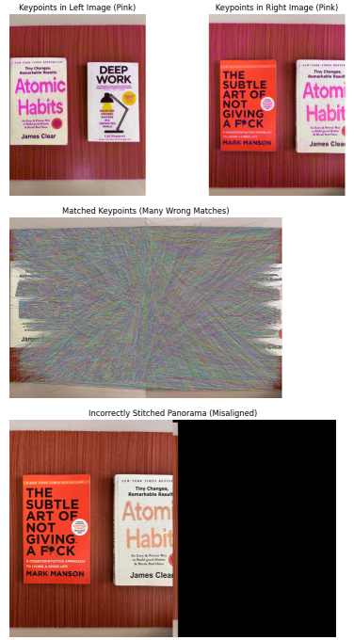

**1. Proper Keypoint Detection (SIFT)**

**Good Code:** Uses **SIFT** (cv2.SIFT_create()) to detect keypoints and compute descriptors in both images.  
**Bad Code:** Uses the same SIFT detector but visualizes keypoints in **pink** instead of a standard color (blue/green), which is just a visual issue.

🔹 **Why it's good:**

* SIFT is robust to scale and rotation changes.
* Helps find distinct features for matching.

**2. Correct Keypoint Matching (FLANN with Ratio Test)**

**Good Code:**

* Uses **FLANN-based matching** with correct settings (trees=5, checks=50).
* Applies **Lowe’s Ratio Test** (m.distance < 0.7 * n.distance) to filter **only good matches**.

**Bad Code:**

* Uses FLANN but **incorrectly sets trees=1 and checks=5**, which weakens feature matching.
* Keeps **all matches, even bad ones**, leading to incorrect alignments.

🔹 **Why it's good:**

* The **ratio test** removes **false matches** by ensuring the best match is significantly better than the second-best match.
* Using trees=5 and checks=50 improves **match accuracy**.

**3. Correct Homography Estimation**

**Good Code:**

* Finds **homography matrix (H)** using cv2.findHomography(src_pts, dst_pts, cv2.RANSAC, 5.0).
* Uses **RANSAC** to eliminate outliers in feature matches.

**Bad Code:**

* Uses a **fixed transformation matrix** (H = [[1, 0, 100], [0, 1, 50], [0, 0, 1]]), which is incorrect.
* The fixed matrix **does not align** images properly.

**Why it's good:**

* **Homography matrix (H)** correctly maps one image onto another.
* **RANSAC (Random Sample Consensus)** removes **incorrect feature matches**, improving accuracy.

**4. Proper Image Warping & Blending**

**Good Code:**

* Uses cv2.warpPerspective(left_img, H, (width * 2, height)) to **warp the left image correctly**.
* Places the **right image correctly** without incorrect overlapping.

**Bad Code:**

* Uses a **fixed H**, leading to **misalignment** and a **badly overlapped panorama**.

🔹 **Why it's good:**

* **Warping with a correct homography matrix** ensures proper **perspective alignment**.
* **Overlapping region is preserved correctly**, preventing distorted images.

***Folder Structure***vr_assignment1 _IMT2022059/

input_images/

coins.jpg

left.jpg

right.jpg

output_images/

blurred.jpg

closed.jpg

detected_coins.jpg

edges.jpg

gray.jpg

keypoints_left.jpg

keypoints_right.jpg

matches.jpg

panorama.jpg

segmented_coin_1.jpg

segmented_coin_2.jpg

segmented_coin_3.jpg

segmented_coin_4.jpg

segmented_coin_5.jpg

segmented_coin_6.jpg

segmented_coin_7.jpg

segmented_coin_8.jpg

1.py (Coin Detection & Segmentation)

2.py (Panorama Stitching)

Readme_final

***Results & Observations***

***Coin Detection & Segmentation***

* Successfully detected coin edges using Canny edge detection with optimized parameters
* Effectively filtered valid coins using area and circularity criteria
* Segmented individual coins using contour-based masks
* The algorithm correctly identified and counted the coins in the test image

***Image Stitching***

* SIFT keypoints were accurately detected in both input images
* FLANN-based matching successfully identified corresponding points between images
* Homography with RANSAC effectively handled perspective differences
* The final panorama seamlessly combined both images with smooth transitions