Static JavaScript Vulnerability Scanner
A lightweight, web-based static analysis tool that scans JavaScript source code for common security vulnerabilities including SQL Injection, Cross-Site Scripting (XSS), Command Injection, and Hardcoded Secrets.
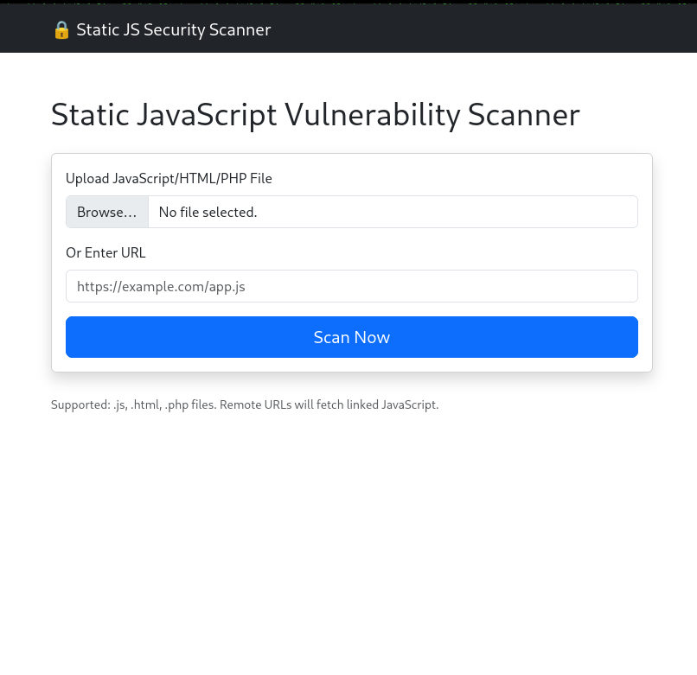

Features
- 🔍 Static Analysis – Scans JavaScript files without execution.
- 🌐 Remote URL Scanning – Fetches and analyzes JavaScript from live websites.
- 📁 File Upload – Supports .js, .html, and .php files.
- 🧩 Embedded Code Extraction – Extracts JavaScript from HTML <script> tags and PHP blocks.
- 🛡️ CWE Mapping – Each vulnerability is mapped to its Common Weakness Enumeration (CWE) ID.
- 📊 Detailed Reports – Provides line numbers, descriptions, and actionable remediation guidance.
- 🚀 Web Interface – Clean, responsive UI built with Bootstrap.

Vulnerabilities Detected
Vulnerability | CWE ID
SQL Injection | CWE-89
Cross-Site Scripting (XSS) | CWE-79
Command Injection | CWE-78
Hardcoded Secrets | CWE-798
Insecure eval() | CWE-95

Installation

Prerequisites
- Python 3.10 or higher
- Git

Setup
- Clone the repository
- git clone https://github.com/group16/static-js-security-scanner.git
cd static-js-security-scanner

