Capstone Project Review Report

Capstone Project Name: Teaching Code to Kids Through Robotics

Student Name: Andrew Johnson

Degree Program: BS-IT Software

Student Mentor Name: Tracy Tadrick


Student Signature _____________________ Date ______12/14/2015______

Mentor Signature _____________________ Date _____________________
Table of Contents
Capstone Project Summary 3
Review of Other Work 5
Project Rationale 8
Systems Analysis and Methodology 9
Goals and Objectives 11
Project Deliverables 13
Project Plan and Timelines 16
Project Development 17
Conclusion 23
Appendix A 26
References 30

Capstone Project Summary
According to recent Bureau of Labor Statistics data, roughly 100,000 jobs go unfilled in computing per year. (BLS, 2014) Yet according to a recent Gallup poll, only 1 in 4 K-12 schools teach Computer Science and programming. (Gallup, 2014) Computers touch every aspect of our lives, yet so few of us know how to program them or how they work. Small development boards featuring micro-controllers or a full computer environment offer a lot of processing power relative to their small size at a very affordable price. Therefore, these boards are a great candidate for school systems on a limited budget. Often these systems also allow input and output with the physical world through sensors attached to their pins. This opens up possibilities for teaching physical computing as well.
The purpose of this project is to teach kids about programming and physical computing through robotics. My capstone project helps solve the problem of students not knowing how to program computers. This project report details a pilot proof-of-concept program designed with educators in mind to bring programming and robotics to their classrooms. Robots have been designed and built that use a scalable chassis system. A modular building system was the best choice for this project– and I have used Lego Technic building elements to construct the chassis, and my own design of motors, sensors and development board. I used the Particle Photon micro-controller board in the Arduino family, which features an ARM Cortex 32 bit processor, capable of supporting on-board WiFi. This allows a lot of processing power on a very small form factor – about the size of 3 postage stamps. The Wifi allows communication with the robots wirelessly.
During the execution of the project, I first focused on building the chassis as this would take the longest and I believed it to be the most challenging. Second the electrical circuitry to wire the components together were built. During the project I was surprised that the chassis required less effort than the electronics. This is due to the modular nature of the chosen materials – Lego allows very simple refactoring. However, when building the circuitry I found that mistakes required more significant rework to remove components from the soldered board. Several times in the project I found very simple design to be most effective. Creating a system that did not permanently affix the components together was a little challenging, but in the end I was able to finish with only gluing one set of components. After the chassis and electronics were prototyped I inserted the Photon chip into the circuitry and started building the code. The first round of code went well as I was just creating temporary test “Hello World” code to get the system running and the basic functions of the motors tested. Once I had the system running, I transformed the temporary code into the basic movement code in the main file of the program. After I had that working, I attempted to refactor the code to use libraries for reuse. However due to an unplanned limitation, this was not possible so I rolled back to the original code base. Following the skeleton code, the testing phase began. For most times the robot performed according to specifications and the code was well debugged. Unfortunately, an issue was found where the motors did not power evenly on low power. I had attempted to make modifications in the code to account for this, but it did not work. This limitation was accepted as a risk and plans to handle the risk on the classroom presentation were made. The plan is to limit the time the robot runs to less than 2 hours and to bring a backup battery. Once testing was wrapped up the robot was presented to a small focus group and feedback was gathered. As discussed later, some redirection of the curriculum was required. At this stage, the project is classroom ready and the current scope will encompass my capstone report.
The project report deliverables include building instructions for the chassis, instructions to build the control circuits, sensors, motors and actuators. All of the project deliverables are posted via Github, an open source version control system. (Johnson, 2016) The major project deliverables have also been included in the appendix. The capstone project details a proof-of-concept system to take to elementary schools, only the first phase of the project. Second, working with an educator at a local elementary school, an event will demonstrate the system to her classroom allowing the students to get up close and personal with the robots and learn some principles of programming and robotics methodology. This report details the design, build and testing of a robot chassis, fundamental movement control code to be used to teach kids about robotics and programming.

Review of Other Work
STEM – Science, Technology, Engineering and Math emphasis programs have been well adopted into education curriculum at the K-12 level. While not all schools have STEM focused programs integrated into curriculum, there are many options to present these concepts to students. In addition, mainstream youth organizations such as the Boy Scouts of America and Girl Scouts of America have integrated STEM focused learning into their awards curriculum, camps, events and activities. STEM focus is very relevant to bringing Computer Science programs to K-12 schools because Computer Science encompasses all four STEM areas of focus. Scientists and engineers are working hard to build the next generation of faster, cheaper and smaller microprocessors; mathematicians are researching new algorithms, and technologists are building new frameworks and libraries to make coding easier, more powerful and reachable for all. Even the humble software developer that may not contribute to the community at large still uses all four STEM foci in their daily work.
Several studies have been made on STEM focuses programs in K-12 schools and have largely concluded that STEM integrated learning is leaving a positive effect in student's lives inside and outside the classrooms. The FIRST program is a STEM focused, competition based robotics program. Along with STEM, FIRST teaches good ethics and character integrity by overcoming challenges through team based competition. In one study, FIRST alumni were surveyed about their experiences with FIRST in K-12 school and their post-FIRST experiences in higher education and long-term careers (Brandeis University, 2005). Most respondents indicated that the program taught them communication skills, problem solving skills and professionalism. The study also found that students that participated in FIRST had a higher grade point average in high school, the mean of all responses being 3.5 GPA – a B+, and 84 percent of respondents had a B average or greater in high school.
Bootstrap is a K-12 software focused program to help students learn algebra by programming video games. Students apply the concepts they learn in mathematics by creating fun games, coding in syntax based programming language. The program teaches students to break down mathematic expressions using concentric circles. The circles represent parenthesis and aid in teaching expression operation and teach students to break problems into manageable segments. A study conducted by the ACM Technical Symposium on Computer Science Education found a significant improvement in mathematics test scores over control groups that participated in Bootstrap. (Schanzer et al, 2015) Educators also were surveyed on their experiences before and after integrating Bootstrap into their curriculum and found a positive correlation in teacher's perceptions about computer science after exposure to Bootstrap in their classrooms.
The only negative impact found in my research was for the Code.org program K-12 software program. Code.org is an online game-based program that teaches programming concepts to beginners without language specific syntax. Drag and drop picture-based “code” modules can be placed to move a character, create an animation or draw a picture. It could be argued that this pseudocode could be more confusing after students are introduced to language specific code in a text editor or IDE. In 2015 Code.org hired an independent evaluation firm to conduct a study on the effectiveness in their program (Code.org, 2015). The study found a negative correlation between exposure to Code.org's Course 1 curriculum and mathematics and science test scores. However, the study did not have a control group that was not exposed to the curriculum. In addition, the study scope was limited to a single school district, which is not statistically significant and not a representation of a true sample for the entire country. Due to these factors, it is my view that these negative findings are not significant or any cause for concern.
Outside the classrooms, independent youth organizations are integrating STEM into their programs. The Boy Scouts of America has introduced several STEM focused merit badges including Programming and Robotics. In addition, the BSA is piloting a program called STEM Scouts that integrates STEM focus further into their program. (BSA, 2015) STEM Scouts has a peer-reviewed scholarly journal, the Scientific Journal of the BSA that allows older scouts to submit scholarly papers for review, and if accepted, to be published in a journal. This allows young men (and young women in the Venture program) to gain experience in STEM and build clout as an expert before leaving high school. The Girl Scouts of America have also added many STEM badges to their program including a video game design badge and a web site design badge. (Girl Scouts of America, 2015) This will give young women opportunities to build valuable technical skills and enable them to thrive in the technology sector.
All of the programs feature curriculum that is simple for kids to understand, helps them break down problems into smaller segments and presents the material in a fun, relatable way. It is clear that this approach has been proven successful. This research has also made it clear that STEM focused learning is needed in the classroom, and that statistically significant analysis of STEM programs in classrooms has found them to be highly beneficial during K-12 school and well after students graduate. Since computer science encompasses all of STEM and computers are in every aspect of our lives, it is imperative that we allow America's students exposure to computer science early on.

Project Rationale
Many of the code learning programs discussed in the previous section feature moving an animated character through a maze or across an environment, and often include interacting with the environment in some way. Picking up an object, moving an object, destroying an object are some of the ways that kids are interacting with these virtual environments. As many modern systems interact with the real world, this project created a classroom program that builds on the fundamentals taught in these virtual code environments. Kids are used to moving virtual characters in a virtual world. To take the experience to the next level, my robotics program is designed to help kids to move a real robot in a real environment in their classroom. The basic movements of the robot such as turn left, turn right, forward and backwards were abstracted out in their own methods. This allows kids to control robots with real code syntax in the real world.
Since this approach does not sandbox the students to a virtual environment, students learn that small mistakes in their code have substantial effects in navigating the environment. If a student forgets to program the robot to turn right for instance, the robot could at best end up in the wrong place, or at worst could drive off the course onto the floor. To protect the investment, the course is set up directly on the floor of the classroom, and does not have permanent outer walls. I believe giving this extra latitude and not sandboxing the students creatively and technically creates a richer learning experience, as it allows them to make mistakes safely. Once a student learns why the robot failed and drove off the field or didn't end up where intended, instruction is given and the student learns for themselves to identify and fix the bugs in the code.
Finally, once the students gain proficiency in navigating the course, and have completed more challenging routes, the students are taught to optimize their code. Can a course be navigated successfully with fewer lines of code? Could loops or conditionals offer additional efficiency or code reuse? This fine tuning will teach the kids to think outside the box, collaborate to solve problems and help develop critical thinking skills.
By using simple programming syntax and controlling the robots in ways the students are familiar with, this project helps students learn problem solving skills and team collaboration. Having open discussions about their successes and failures teaches open communication and helps students be confident whether they succeed or make mistakes.

Systems Analysis and Methodology
The system methodology used in this project was the Agile methodology. I chose the Agile Methodology for the robot build and software programming due to its long term focus and planning while discovering and recovering from mistakes quickly. The Agile methodology was a good choice for this project as the fast iteration and protocol to break the work into small units was a good fit for physical and software prototyping. Agile focuses on only working on one small component of the whole at a time. This allowed fast iteration and low loss of productivity and waste when mistakes were encountered. The physical chassis was built first, with quickly reworked designs as challenges were encountered. The modular nature of Lego elements was a good fit as reworked mistakes did not cause waste. While careful planning was employed for the layout of the circuit board for the main microprocessor, a few mistakes required rework. Prototyping the circuitry on a temporary circuit board—sometimes called a breadboard, mistakes in circuitry and layout can be revised and addressed before they are committed to the permanent board. However, this does not always prevent issues with physical layout conflicts on the board. By quickly iterating through bugs and features in the system the project adapted quickly and stayed on target to completion. Once the chassis was fully prototyped and tested with basic movement code, the main program code was written. The lower level basic control of motors, actuators and sensors were to be placed in a software library and encapsulated in methods, however due to limitations in the compiler, the basic control code was placed in the main code body. This enabled simple method calls to control movement, as discussed in the last section. The final phase was to get the project to proof-of-concept with a small focus group of willing kids to test the system physically and the teaching curriculum. Feedback from this small focus group was used to fine tune the robotics system and classroom instruction for the next phase of the project. Special care was given to keep the concepts simple and easy to learn while still providing an exposure to software and real code syntax.
In the post-capstone phases of the project, the classroom curriculum will also follow the Agile methodology. Students will design a plan of robot movement on paper and then program the associated code with adult help. The robots will then run the course quickly as students watch the movement and find any bugs in their code. Then a quick review of the process will be drafted on the board as the students voice the bugs they found. Then the code will be reviewed on a projector and the students will point out the errors found. Code will be corrected and the robots run the course again. Once the robots complete the course successfully, the students will identify ways to improve the code and perhaps shorten or improve the robots movement through the course. If optimizations are found, they will be rapidly implemented again, following the same steps in this methodology until the robot performs at top efficiency. As time permits in the classroom, additional barriers in the course could be added and the students will go through the process again to try to build an efficient navigation model. A debrief discussion after the activity will challenge the students to identify what they learned about problem solving and how they can use this model to solve other problems. Following the Agile methodology helped to deliver the proof-of-concept phase of the project earlier than scheduled.

Goals and Objectives
The goal of the capstone project was to create a robot system proof-of-concept as described in previous sections. The first objective was to create the physical robot prototype. The second objective was to create scalable code to run on the robots and abstract the low-level programming to simple method calls in the main application. The third objective was to test and debug the prototype and then present it to a small focus group to gain feedback in improving the robot chassis, code and classroom presentation. Finally, the classroom presentation will be assembled and an event will be scheduled with the educator to present the material to her classroom after the capstone project is completed.
The physical robot chassis needed to be strong, light and adaptable. As mentioned, I selected Lego Technic elements for the construction. The chassis required constant rework until the final prototype was built, and Lego made this possible without waste. The physical chassis phase and the code phase were planned to run simultaneously after the basic design was prototyped and the circuit board was designed and built. However, due to shipping delays the final circuit design was pushed back. The Lego chassis development was able to be built with similar on hand parts, preventing delays in project delivery. As mentioned, the circuit board was constructed on a grid style prototyping board requiring no additional tooling and was made quickly and safely using a common soldering iron and widely available components. This reduced and simplified project scope and budget as iterations of design on a commercially printed circuit board are not needed, avoiding costly design and tooling. All of these actions contributed to meeting the objective of building a rigid robot chassis.
The second objective of the project was to implement a scalable code library to drive the robot movement. The Arduino language (based on the Wiring programming language) allows code to be encapsulated into libraries, which can then simply be imported to a sketch (Arduino programs are called “sketches”). Once the libraries are imported into the main sketch code, all of the code in the library is available to the main sketch code. However, a limitation that was not known was that existing object type libraries cannot be imported into new libraries using the Particle IDE. Instead, all the low level motor and sensor programming was placed in the main code body. Presenting these simple method calls on a projector to the kids is more understandable than trying to explain an entire block of code. This philosophy also aligns with the objectives of other STEM focused curriculum and programs geared to teach kids to code. Keeping the code as simple as possible meets this project objective, allowing students to be able to learn to code by using simple syntax-based method calls.
Third, debugging and testing the prototype was thorough to ensure the robots are as precise and accurate as possible in rotation and movement between grid squares. The power systems on the robot were tested and determined that the robots will run in a classroom setting for 1-2 hours. In addition to physical and software testing, the classroom event curriculum was developed and tested with a focus group of 3 students. It became very apparent during this phase that the code needs to be as simple as possible for a student to understand it. It was also found that a foundation of an online code program as discussed in the Review of Other Work section helped the students understand the code much easier. Refining the code and classroom presentation helped meet this objective through debugging and focus group testing.
The final project objective and deliverable – a classroom event is not in scope for the capstone report. As this is a proof-of-concept for the system, the event will be scheduled with the educator on a future date.
The goal of this project was to create a proof-of-concept robotics platform to help teach kids how to code through physical computing. As the chassis, code and other deliverables are built on time and well tested the goal was completed successfully. This allows me to take this project into schools to help teach kids about code and get them excited to pursue a career in computing, or at least to learn some code to help simplify their jobs through automations.

Project Deliverables
This project finishes with four deliverables – an open-sourced code repository on Github, detailed plans to build the robot chassis, the physical robot chassis prototype and a classroom event delivered to the key stakeholder. However, only the first 3 deliverables are in scope for the capstone report at the current phase of the project.
Open sourcing the code libraries on a version control system is important so that the framework of this classroom demonstration can be used again and adapted for other uses. This allows others to use the code easily, and when they fork the repository and publish, the community will benefit from the code being freely available. Github was chosen as the version control repository for the project. The project is licensed under a Creative Commons 2.0 non-commercial attribution license. This means that users of the project can use it for non-commercial use and must provide attribution to me as the owner of the project. This first deliverable is composed of the second and third objectives – writing the software and debugging and testing.
The second deliverable was the physical robot chassis. This scalable modular chassis provides efficient use for the current project scope, and a platform to add sensors and additional actuators as needed long term in future phases of the project. Should the robot need rework or new design, the modular nature of Lego Technic elements ensures that the chassis is well adaptive to changes, and can be rapidly be reworked without additional cost.
From a technical perspective, the robot chassis was made from Lego Technic elements and features tank treads driven by 2 9-gram continuous-rotation servo motors. These servo motors allow 360 degree movement of the motors in both directions. They also conveniently encapsulate power, direction and speed controls into a simple and easy to use product. This eliminated the need for gear motors and their corresponding H-Bridge circuitry to control direction and separate power controls. An H-Bridge circuit chip can be used to power a motor in both directions, and are often implemented in robotics projects that require motor control. Using servo motors greatly reduced the build time and costs on the physical circuitry of the prototypes. To control the robots, the Particle Photon development board was selected for the microprocessor. The small footprint and power requirements of this board make it ideal for robotics, and the WiFi features add scalability for cloud-based robot controls after proof-of-concept. As the elementary school's WiFi has stringent security requirements and I am not able to easily test the prototypes before the future classroom event, WiFi control of the robots is out of scope for this project. All necessary components to connect motors and sensors were designed and soldered to a custom prototyping circuit board and affixed atop the robot securely with locking plastic ties. The project proposal specified a 3d printed connector, but to ease in getting to proof-of-concept quickly, the motors were connected with the wheel axles using the provided plastic servo attachment horn combined with a strong epoxy and a Lego axle coupler. The system is powered by a NiMh battery at 6 volts. This feeds power both directly to the servos at 6 volts and through a power regulator to reduce the voltage to a safe level for the Photon microprocessor. Best practices and safety were observed to ensure quality of work on the robots during the build process. This ensured a quality product and safety.
The physical robot chassis will not be delivered permanently to the educator for direct use in the classroom at phase 2, as the post-capstone project scope is limited to a classroom event. I will retain possession of the prototyped robot chassis so I may take it to future classrooms, conventions and other events.
The third deliverable was a detailed plan of the chassis and circuitry. Step-by-step plan drawings were delivered and posted to Github along with the original plan files. Since this is an open source project, I have uploaded plan drawings of the Lego chassis in digital format for easy modification to the Github repository. This is in a file format that may be opened by Lego Digital Designer software, along with HTML instructions of the build step-by-step. In addition, a circuit diagram schematic has been provided so users of the program can build electronics from the same prototype methods as this project.
The final deliverable will be a classroom event for a group of 3rd and 4th grade students. The wooden course will be placed on the floor of the event with the students surrounding it. A code editor will be magnified and presented on a projector screen so the students can see the code in action. The chalk board will also be used to list bugs found in the student's algorithms. Each student will be given a sheet of paper with a replica of the grid, allowing them to plan the robot movements across the grid. When they discover bugs in the code, they can write them on the paper and then corrected in the code editor. This method will allow them to use multiple senses to learn. This deliverable is not delivered in the capstone report as yet. This will encompass phase 2 of the project, after the capstone report.
The key stakeholder will be receiving one of the four deliverables—the classroom event with her students. However, the system at large will benefit the global education community, robotics aficionados throughout the community on the Internet, and developers looking to adopt a local classroom to help bring STEM to their students.

Project Plan and Timelines
Building the physical robot chassis took the longest amount of time, so it ran concurrently with the coding phase. However, the coding phase needed an understanding of the basic electronic circuitry and motors, so the start of the coding phase was delayed until the robot chassis Lego components were complete. The chassis took 14 days to complete, even with shipping delays caused by the parts supplier. The coding phase completed in only 2 days since encapsulation in libraries was not necessary as discussed. The completed chassis was the first project milestone, followed by the initial prototyped code as the second milestone. Testing and debugging only took 4 days once the code and chassis were complete. Building the wooden grid board the robots will drive on took 3 days. This ran concurrently with the beginning phase of testing and debugging. Having clean, bug free code and precise robot movement was the third milestone. Once the code was debugged, the focus group testing phase began. An extra 2 days was allotted to make necessary adjustments but was not needed as all other phases completed early. Collecting feedback and fine tuning the classroom experience was the fourth milestone. The final phase entailed preparing all necessary documents, plans and publishing code to be ready for the classroom. As this phase is complete, I am now ready to set up a time with the educator to come visit her classroom and teach the students about robotics and programming as described. Becoming classroom ready was the last project milestone as the proof-of-concept is now complete.
Project Deliverable or Milestone | Duration | Planned Start Date | Planned End Date | Actual Start Date | Actual End Date
Physical Chassis | 14 | 12/07/15 | 12/21/15 | 12/07/15 | 12/21/15
Movement Code | 7 | 12/14/15 | 12/21/15 | 12/14/15 | 12/16/15
Build playing field | 3 | 12/17/15 | 12/20/15 | 12/07/15 | 12/10/15
Testing & Debugging | 7 | 12/17/15 | 12/24/15 | 12/21/15 | 12/25/15
Focus Group Testing | 2 | 12/24/15 | 12/26/15 | 12/25/15 | 12/26/15
Classroom Ready | 4 | 12/26/15 | 12/30/15 | 12/26/15 | 12/27/15

Project Development
The capstone project executed on time and successfully. The basic chassis and robot prototype are scalable to future project needs and the system is ready for classroom use. This is not to say it went off without any issues. Shipping delays, limitations in the compiler and physical chassis rework kept the project challenging. The circuitry took the longest to implement and was the most difficult. I was concerned that the weight of the robot once complete would be too much torque for the motors, but the motors have performed within specifications and are able to bear the weight of the chassis without any stress. The physical design of the chassis and electronics required the most rework, and the most mistakes to correct. I found the Agile methods used in this project helpful to keep the project on track. Since Agile focuses on only fixing one bug in the system or adding one feature at a time, mistakes in physical design and code did not propagate widely through the design. As I focused on getting a prototyped circuit board before writing the code, when wiring needed to be moved to a new pin on the micro-controller, the code was not affected. When the battery arrived from the supplier, I had originally planned to enclose it inside the center of the robot chassis; however, it did not fit without significant rework of the chassis. The motor box and wheel systems had lined up with very precise tolerances and rework would affect this. I decided instead to sandwich the battery between a blank circuit board and the main electronics circuit board. I used brass standoffs to space the boards, and used foam sheets to keep the battery from moving. This enabled the battery to be secured to the top with plastic locking ties very securely and did not permanently affix any of the components.
Encapsulating the movement code into libraries was a key project objective. Unfortunately due to limitations described below this was not possible. Instead, the movement code was simplified and placed below the main operating code. This also helped the code to be simple and easy to for the students to understand. A great deal of time was spent on debugging and testing to code to ensure that it performs properly and accurately. The code is well tested and debugged and I am confident that it will perform in the classroom well.
Project deliverables were completed successfully and on time. The tested code, chassis design instructions, circuit diagrams and completed prototype design photographs are included to show project progression. Appendix A, Figure 1 shows the movement code. In the loop() block the students can add their own method calls to the methods below to control the robot. This allows the students to engage with the code and gain a greater understanding while still using real syntax. I believe this approach to provide richer learning than dragging and dropping code blocks or sandboxing the students in safe environments. Appendix A, Figure 2 shows a screenshot of the build instructions. Full build instructions are available in the Github repository. As shown in the screenshot, the Lego Digital Designer software allows easy visualization of the model and clear instructions of the build. This format allows anyone to build the robot chassis, and includes a parts list at the end of the build instructions in the HTML document on Github. Appendix A, Figure 3.1 and Figure 3.2 show the circuit diagram simplified to a breadboard view and schematic view. As the project progresses, this will be refined into a commercially printed circuit board for easier soldering and connections. Appendix A, Figure 4.1 shows the tight tolerances achieved between the servo motor horn and the drive wheel axle. This photo shows the assembly prior to gluing. Appendix A, Figure 4.2 shows the completed robot build including chassis, motor and electronics. All items in the build have been affixed in a non-permanent fashion with the exception of the main drive wheel couplers which used glue. This allows scalability if the needs of the project should change the robot design. Therefore there is no waste in refactoring the design.

Problems Encountered
The following problems were encountered during the project, along with their accompanying solutions:
Orders for parts were backordered causing delays in the prototype design
  - The motors, battery and charger were backordered from the supplier causing a delay in the physical chassis build. The solution was to build the Lego chassis using 180 degree hobby servos of the same size, and test the code using the limited motion range servos until the 360 degree motion servo motors were able to be delivered. As seen in the project timeline, this delay did not delay the final delivery date of the project.
Physical design of the prototype required rework
  - The physical chassis design using Lego elements required nearly constant rework in every phase of the design and build. However, by using a modular building system, it allowed me to quickly iterate out of bad designs and come up with simple, mechanically rigid design that will scale easily for future projects. Some of the notable redesigns were the motor box, the tank tread and wheel system and placement of the battery and electronics. These are now among some of the best designed systems on the chassis. Taking the extra time to refactor the design was well worth the extra effort.
Connecting the wheel system to the motor system required rework
  - The project proposal specified a 3d printed connector would be made to connect the motor to the wheel axle. However, after several bad iterations of the connector, I decided to use household epoxy to glue the motor connector that comes with the motor kit and a Lego axle coupler. This solution allowed me to get to the completed prototype phase and rapidly revise and test the system. By sacrificing 2 inexpensive Lego elements on each robot chassis, this allowed me to quickly get the chassis built without a lot of redesign and waste with a 3d printer. I am so pleased with the tolerances on the glued connector, that I am putting it into production for now.
The Particle IDE did not allow other libraries to be imported in a new library
  - The servo control is handled by a community-supported software library that is able to be imported into the project and allows easy control of the motors. However, the Particle IDE does not allow other libraries to be imported and used in creation of new libraries. The biggest hurdle is that it does not allow object type imports, and only allows primitive type variable imports in new libraries. The solution is to encapsulate the motor control methods in the main program after the system standard setup() and loop() methods. As the goal of the project is to teach kids about code, I feel this change is beneficial to the project-- students can see the actual code running the core in the main file on their projector.
Left wheel powered stronger when battery was low
  - The left wheel powers stronger than the right wheel when power is low, causing the robot to veer right. Unfortunately this is a limitation of the electronics and only becomes apparent on low power. Brownouts in power can cause erratic behavior and there is not a solution that can be worked in the code to balance power. At this time, the solution is to limit usage of the robot in the classroom to 1-2 hours to prevent battery loss. Every effort has been made to conserve power. The battery selected is a 2200 milli Amp-hour 6v NiMH battery. 6 volts powers directly to the servo motors – the optimum voltage. 5 volts regulated is sent to the Particle Core and other electronics, limiting power loss.
Circuit design of prototype required rework
  - Despite best efforts to prototype the circuit on a temporary breadboard, the layout of the circuit required rework a few times. The solution was to reheat the solder, remove it and move the components to their new locations. Since there were only a few changes to the first iteration of the circuit board, I was able to rework the solder joints without causing significant damage to the board. Future versions of the board will be able to made, learning from mistakes on the first iteration.

Unanticipated Requirements
In the focus group phase, it became apparent for the need to simplify the code as much as possible. The students became easily confused when shown a code editor, but when the same syntax was presented on a board along with a basic explanation, the students were able to create code successfully. Hence, writing the code and stepping through the robot's predicted movement became essential to ensure the students success. Prior to the event, I will ensure that the students complete some online code activities as described in the Review of Other Work section. I believe that this foundation will help the kids grasp the concepts faster and will make the activity a greater success.

Reasons for Change
WiFi control of the robots was a pre-project objective, however since the school internet is secured strongly, getting WiFi access for a single day event was not feasible. Instead, cabled programming of the robots is to be implemented.
I had proposed encapsulating the basic movement code of the robot control to a separate library. This would have enabled the code to be simplified, clean and reusable. However, I had not considered that a library could not exist in a library with the Particle IDE. This is not a functional limitation in the Arduino language, it is specific to the Particle implementation of the microprocessor. Instead, I placed the movement code in methods below the main code body. I feel this change allows the students a more positive result because they will easily see the remainder of the operating code. Zooming in on the window to only show their main code and scrolling to view the motor control code will prevent the students from getting confused by too much syntax.
Some of the original planned electronic components were changed. I originally wanted a switching power regulator over a linear power regulator. The difference is that in a switching regulator, voltage is switched on and off very rapidly and then the gaps are smoothed with capacitors. Conversely, a linear regulator simply limits the power with a regulator chip designed for the purpose. The difference is that in a linear regulator the additional power lost between supply power and the regulated power is lost as heat on the heat sink. A switching power regulator does not lose energy aside from regular resistance. This would save power usage over a linear regulator. However, due to size limitations on the circuit board, I could not use a switching circuit and instead opted for a simple 3 pin linear regulator. The small amount of energy lost in this change is not significant at the low current levels of the project.

Actual and Potential Effects
My capstone project delivers a scalable robotics platform to help teach programming to K-12 students. In the focus group stage of my project, I found the students able to understand the concepts of basic programming using simple syntax. Controlling physical robots in the real world made the learning much deeper and allowed the focus group students to grasp the concepts at a much higher level. This leads me to believe that all ages can learn to code. Future expansions of this project include taking the system to conferences for live demonstrations and speaking engagements, a website to promote the system and additional upgrades and sensors to the basic platform. WiFi control of the robots in real time from a computer keyboard and a web application is a long term goal of this ongoing project.

Conclusion
My capstone project was a rewarding experience that helped me grow as a developer. The robot platform as designed and built is ready to enter the classroom. The capstone stage in the project is a success. The project finished early, provided all deliverables to the proposed specifications, and proved the concept of a small learning robot to teach young people about code. The following paragraphs in this section detail the project successes.
The robots were designed, built and tested on time and the project finished earlier than expected. This helped keep development costs low for the project as my time was used efficiently. When delays in shipping were encountered, the project timelines and priorities were modified to account for the delays out of my control. This action helped keep the project on pace and ensured project completion on time.
All deliverables in the project scope have been completed and scope did not suffer major scope creep. Scope was managed throughout the project to ensure that the capstone project completed on time and stayed under budget. However, this platform allows a lot of future features that can be added, providing a very scalable framework. Not adding too many features at once to the robots enabled this project to stay in scope and finish on time and under budget.
Waste was minimized to keep costs low and the project completed under the budget. As I am paying for the project personally, the budget was a concern. Each robot chassis was able to be completed for $100, and the budget did allow a backup chassis built completely to be made. This price is also within reach of educators on a budget that want to make a robot for their classrooms. Using Lego here was a key contributor to success. While Lego is expensive up front over other chassis building systems, the modular nature allows this project to develop from design to prototype rapidly and without any waste. Should the project need rework into a robotic arm for instance, the same Lego elements are used for the redesign and there are not additional costs.
The project deliverables meet quality and safety specifications and are fit for long-term use as an investment. I am proud of the workmanship I performed on the chassis, circuitry and in the code. Every effort was made through this project to do the best job possible with the available resources. The chassis is rigid, well designed and I was especially pleased with the motor box design. The tolerances in lining up the motor box and wheel axle are beautiful. The code is well tested and designed, ensuring top performance on the robotics.
Risks were identified during the project and steps were taken to resolve them. Since the motors do not function correctly on low battery power this poses a risk to the classroom experience. Because I want the students to learn by programming the robot through a course, it is critical that the motors drive at the same power. This risk was simply accepted as mitigation was not possible in the code. Additional steps to prevent problems from this risk are to only keep the robot moving when power is good – about 2 hours. As well, an extra charged battery will be taken to the events as a backup. Since these risks are well managed I do not deem them a threat to project success.
K-12 are in great need of STEM focused learning programs. Many programs are available, but many do not go beyond the basic and high level concepts. This project delivers additional detail in the field of computer science through a fun classroom robotics demonstration program. Through this proof-of-concept project, students receive an immersive workshop event to broaden and deepen their understanding of problem solving, teamwork, critical thinking and most importantly, fun through learning. It is my desire that this program helps students become interested in STEM related fields including computer science and robotics.

Appendix A
Figure 1 - Basic Motor Movement Code
void setup() {
Servo leftMotor;
Servo rightMotor;
leftMotor.attach(D0);
rightMotor.attach(D1);
}
void loop() {
//Robot control goes here
//call functions below to move robot
}
void motorForward() {
leftMotor.write(45);
rightMotor.write(135);
}
void motorReverse() {
leftMotor.write(135);
rightMotor.write(45);
}
void motorLeft() {
leftMotor.write(45);
rightMotor.write(45);
}
void motorRight() {
leftMotor.write(135);
rightMotor.write(135);
}
void motorStop() {
leftMotor.write(90);
rightMotor.write(90);
}
Figure 2 - Build Instruction Screenshot

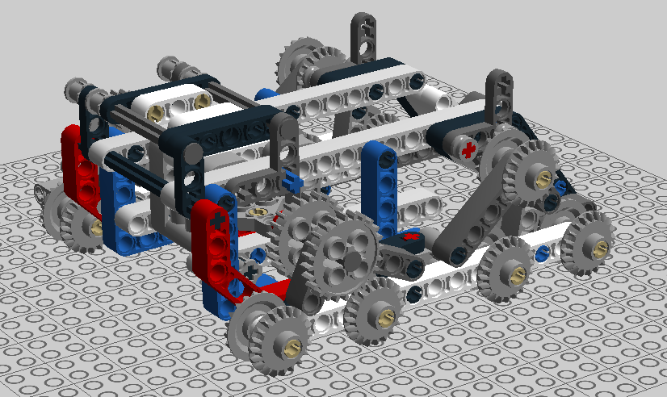
Figure 3.1 - Circuit Diagram – Breadboard View

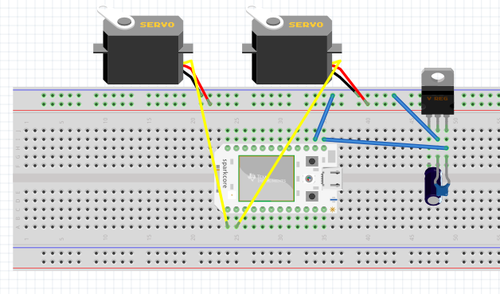
Figure 3.2 – Circuit Diagram – Schematic View
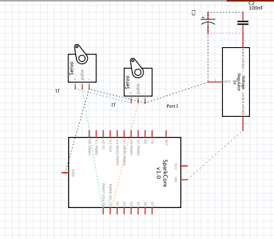

Figure 4.1 – Motor Wheel Axle Tolerance Photograph

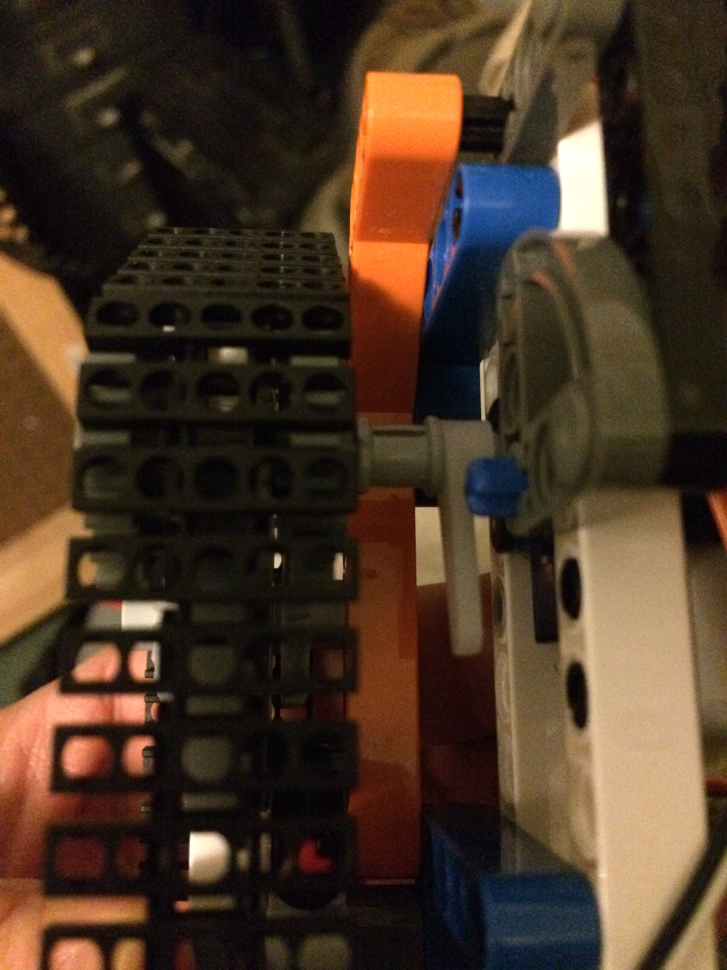
Figure 4.2 – Completed Robot Build Photograph
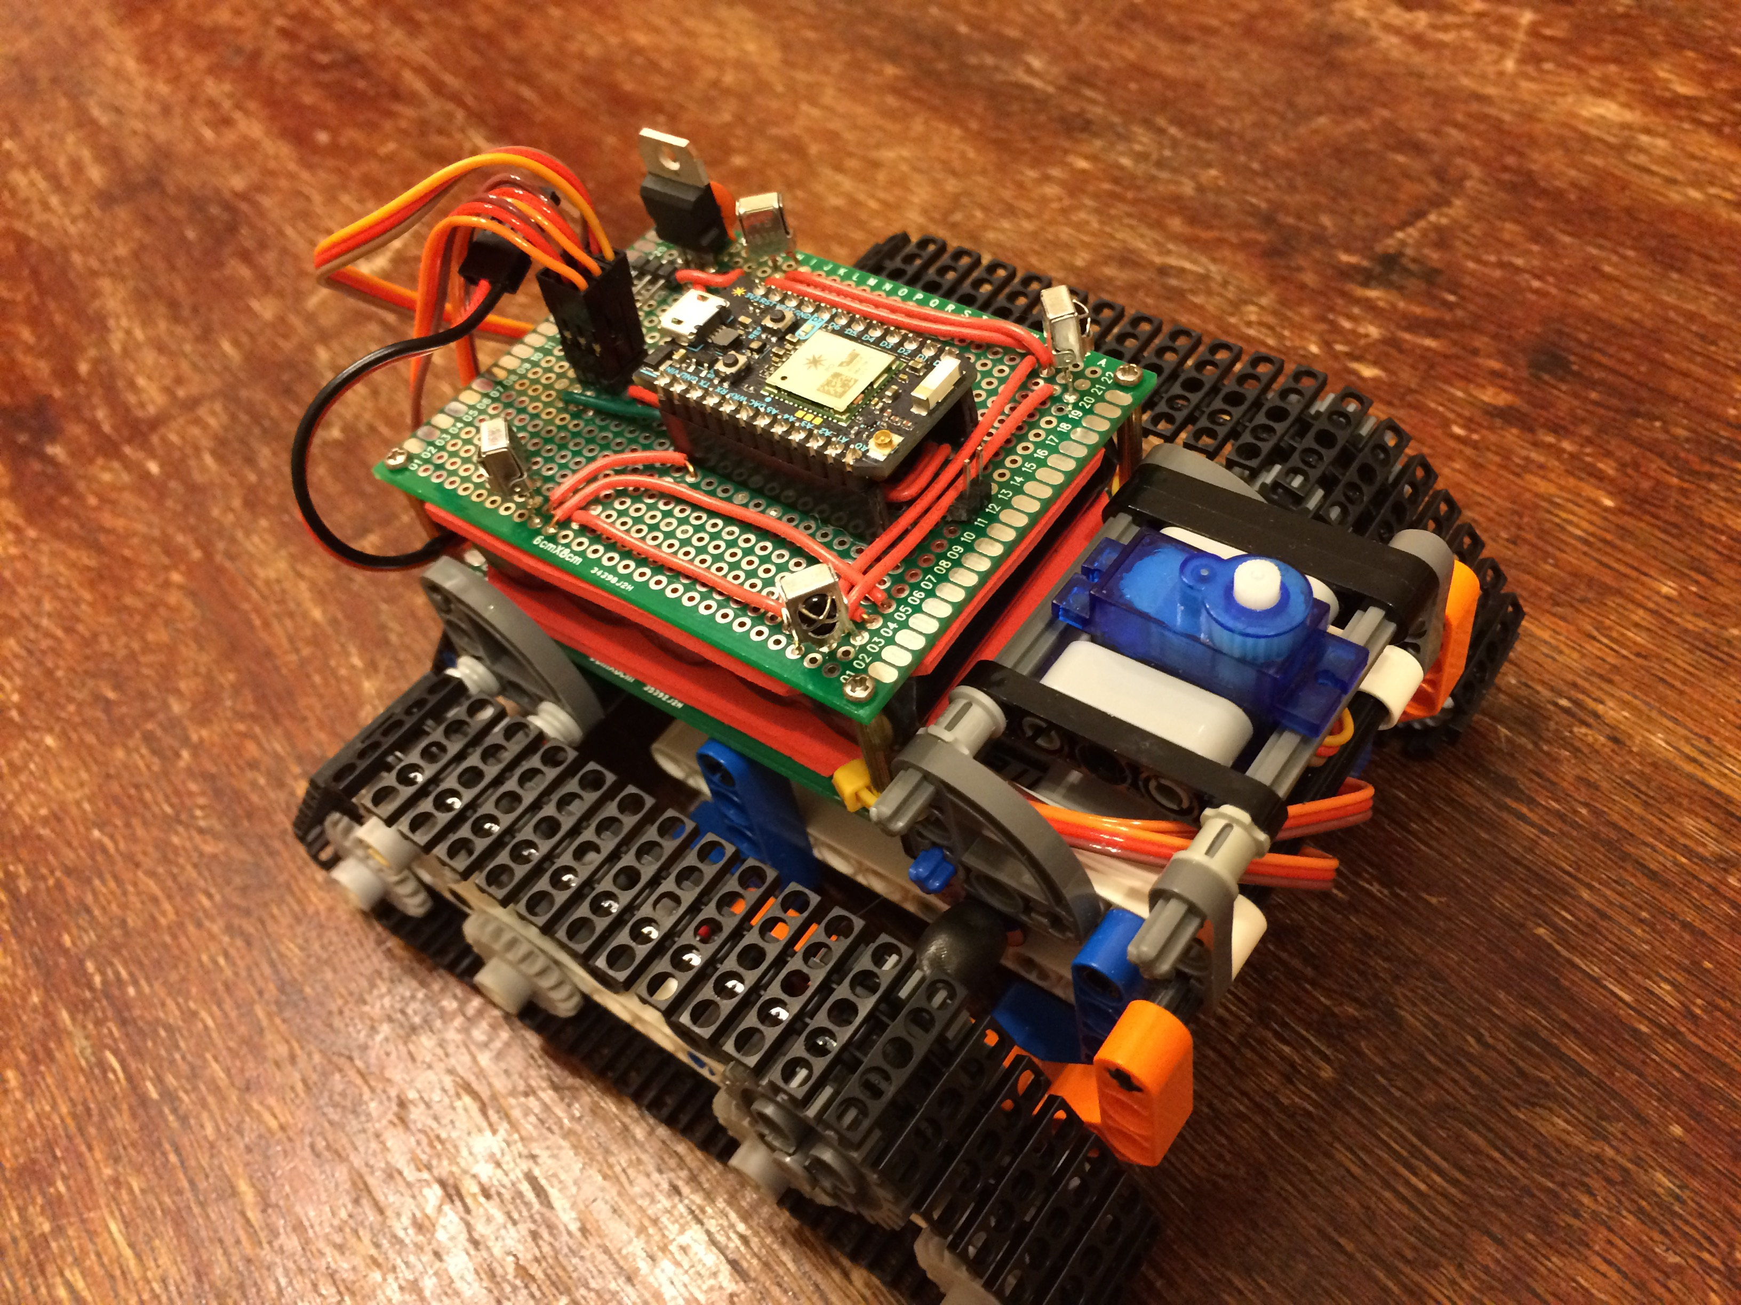

References
Employment by major occupational group. (n.d.). Retrieved December 15, 2015, from http://www.bls.gov/emp/ep_table_101.htm
Images of Computer Science: Perceptions Among Students, Parents and Educators in the U.S. (2014). Retrieved December 14, 2015, from http://csedu.gallup.com/home.aspx
More Than Robots: An Evaluation of The First Robotics Competition Participant and Institutional Impacts. (2002). Retrieved December 14, 2015, from http://www.firstinspires.org/
Schanzer, E., Fisler, K., Krishnamurthi, S., & Felleisen, M. (n.d.). Transferring Skills at Solving Word Problems from Computing to Algebra Through Bootstrap. Proceedings of the 46th ACM Technical Symposium on Computer Science Education - SIGCSE '15.
Boy Scouts of America (n.d.). Retrieved December 14, 2015, from https://stemscouts.org/stem- journal/
Girl Scouts and STEM. (n.d.). Retrieved December 14, 2015, from http://www.girlscouts.org/en/about-girl-scouts/girl-scouts-and-stem.html
Andrew Johnson, Capstone Project Robotics Code Repository. Retrieved January 3, 2016, from https://github.com/3leftturns/battleBots/

