**Firefox 1 (browsing weather, looking at interactive weather radar map):**

Average # messages per second: 62.1836734694

Max # messages per second: 388

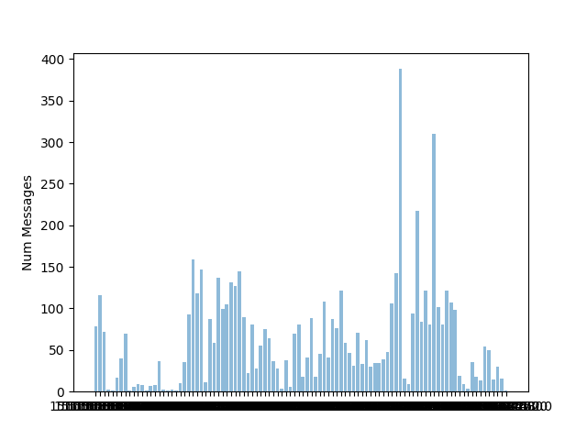

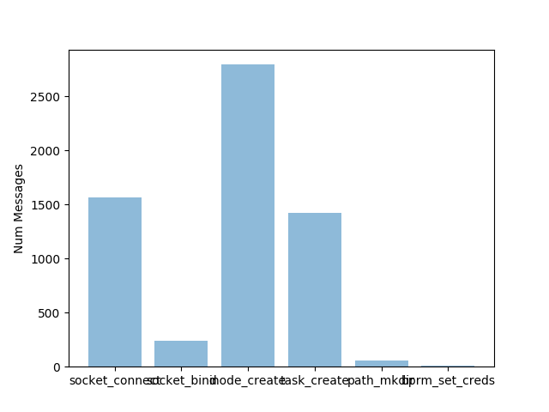

**Firefox 2 (various search engines plus youtube videos):**

Average # messages per second: 55.7518248175

Max # messages per second: 405

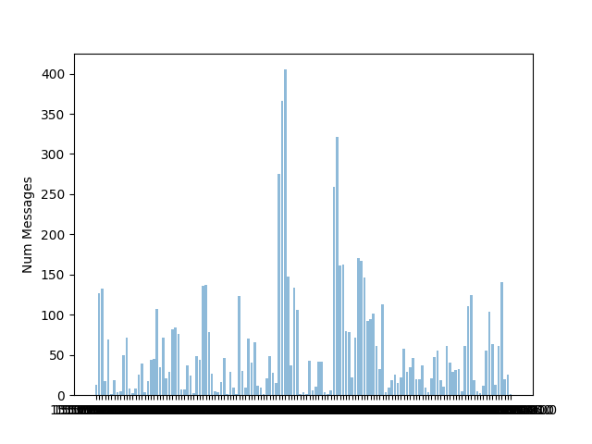

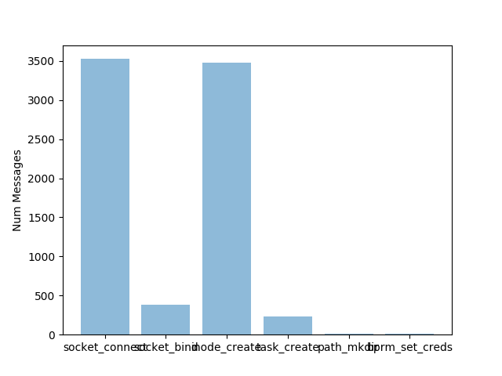

**Libreoffice Writer:**

Average # messages per second: 7.0

Max # messages per second: 46

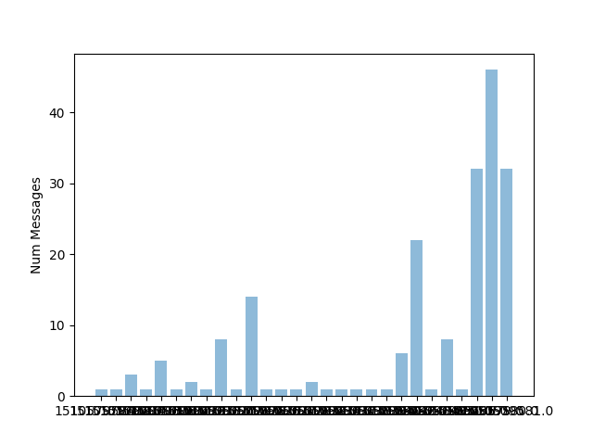

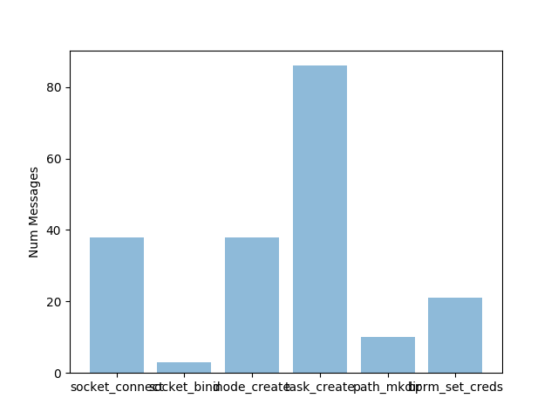

**Libreoffice Calc:**

Average # messages per second: 5.09756097561

Max # messages per second: 76

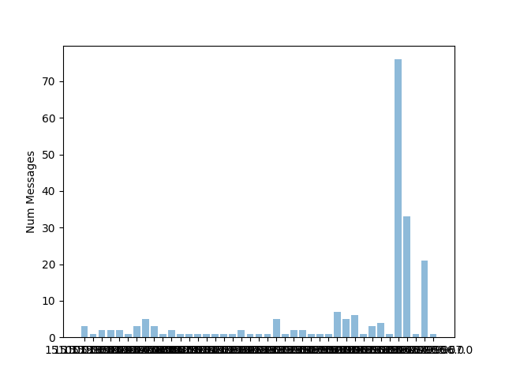

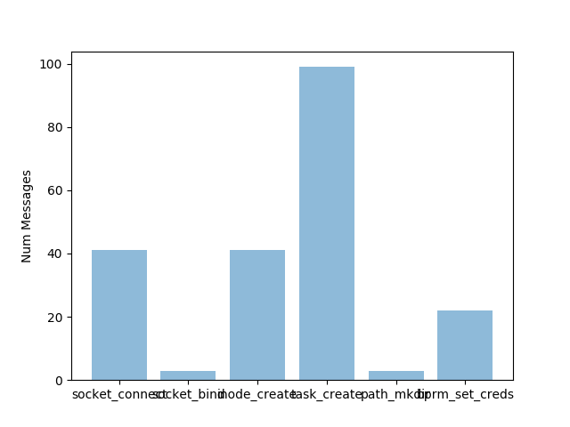

**Libreoffice Impress:**

Average # messages per second: 4.92727272727

Max # messages per second: 108

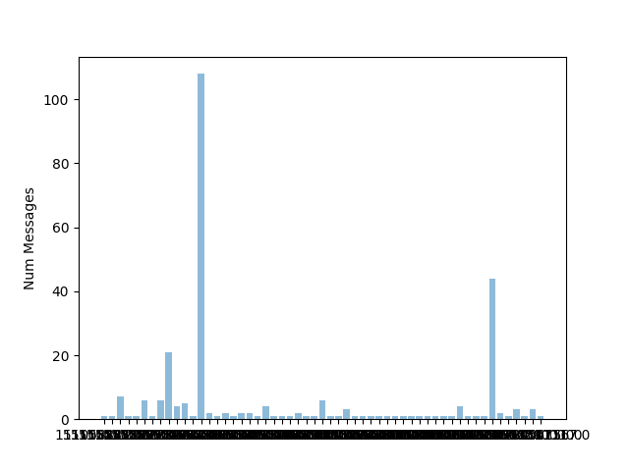

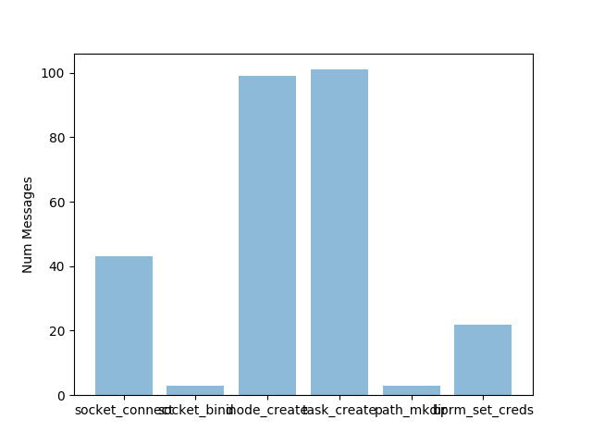

**Calculator:**

Average # messages per second: 5.125

Max # messages per second: 19

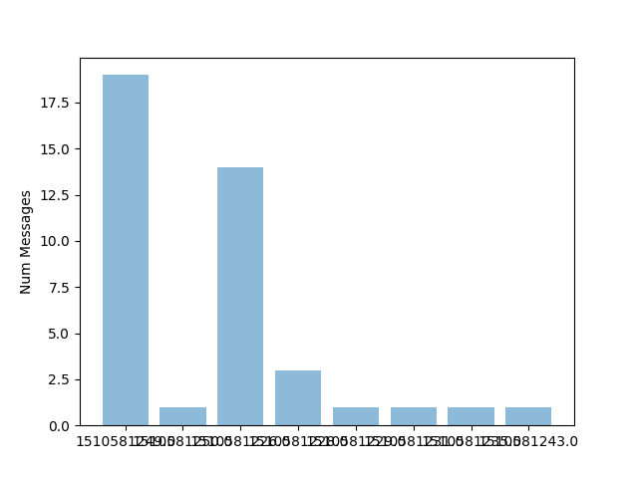

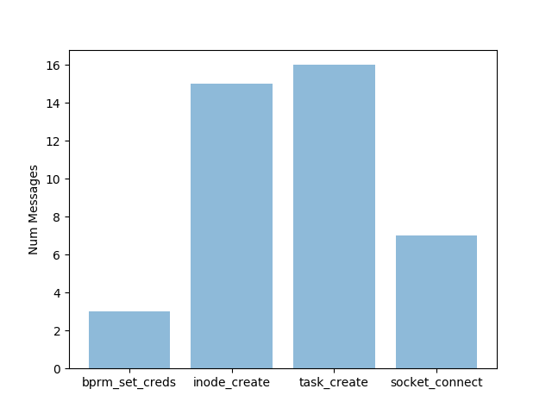

**Thunderbird:**

Average # messages per second: 6.91836734694

Max # messages per second: 53

