**Assessment Cover Sheet**

* Complete and attach this cover sheet to your assessment before submitting

**Assessment Title**

*Individual Project*

**Programme Title:**

*Bachelor of Information, Communication and Technology*

IT-7405

**Course No.:**

*Web-Development with Non-Relational Databases*

**Course Title:**

*Ali Hussain Khamis*

**Student Name:**

*202000483*

**Student ID:**

Sini Raj Pulari

**Tutor:**

**Date submitted:**

**Due Date:** Tuesday, 3 rd Jan 2022 by 11:55 p.m.

***By submitting this assessment for marking, either electronically or as hard copy, I confirm the following:***

* This assignment is **my own work**
* Any information used has been properly referenced.
* I understand that a copy of my work may be used for moderation.
* I have kept a copy of this assignment

Do not write below this line. For Polytechnic use only*.*

**Date of Marking:**

**Assessor:**

**Grade/Mark:**

**Comments:**

Contents

Business Motivation and Problem Statement 3

The main Functionalities are: 3

Additional Functionality: 3

Creating the No-SQL MongoDB Database and Data Modeling 3

Running the server 3

Creating Database and collection and Inserting 3

Querying 4

Update 9

Replace 10

Indexes 10

Delete 10

Query Diagnosis and Analysis 11

Query Planner Mode 11

Execution Stats Mode 11

All Plans Execution Mode 12

Django 13

Creating car view app 16

Creating Search Bar 20

Add Car 22

Admin 25

Login 27

Registration 29

Reflection 32

Figure 1 Running Server 5

Figure 2 Running Terminal 5

Figure 3 Creating Database 5

Figure 4 Inserting Multiple Data 6

Figure 5 Inserting One data 6

Figure 6 Retrieving All Data 6

Figure 7 Searching Database by Name 7

Figure 8 Searching by IN 8

Figure 9 Searching by AND 9

Figure 10 Searching by OR 10

Figure 11 Searching with OR and AND 10

Figure 12 Update Many 11

Figure 13 Update One 11

Figure 14 Replace One 12

Figure 15 Indexes 12

Figure 16 Delete One 12

Figure 17 Delete Many 12

Figure 18 Query Planner Mode 13

Figure 19Execution Stats Mode 13

Figure 20 All Plans Execution Mode 14

Figure 21 Virtual Environment 15

Figure 22 Django Project 15

Figure 23 Requirements 15

Figure 24 Command 16

Figure 25 Website 16

Figure 26 Database Connection 16

Figure 27 Base Files 17

Figure 28 Directory Path 17

Figure 29 Static 17

Figure 30 Migration 17

Figure 31 Images 18

Figure 32 Car Model 18

Figure 33 Car view 19

Figure 34 Creating Files 19

Figure 35 HTML Code 19

Figure 36 URL 20

Figure 37 car view to settings 20

Figure 38 Adding car view URL pattern 20

Figure 39 Inserting Data 21

Figure 40 First phase of website done 21

Figure 41 Search working 23

Figure 42 Add Car Form 24

Figure 43 Image Uploader Function 24

Figure 44 Add Car view 25

Figure 45 Add Car URL 25

Figure 46 Add Car in installed apps 26

Figure 47 URL Mapping 26

Figure 48 installing crispy 26

Figure 49 Add car page 26

Figure 50 Final Page 27

Figure 51 Super User 27

Figure 52 Admin Login 28

Figure 53 Admin Page 28

Figure 54 Code 28

Figure 55 Updated admin page 28

Figure 56 added users to the installed applications 29

Figure 57 Redirection Paths 29

Figure 58 Adding user URL Pattern 29

Figure 59 updated nav 30

Figure 60 Hello to the user logged in 30

Figure 61 Three pages 30

Figure 62 Page one 30

Figure 63 Page two 31

Figure 64 Page Three 31

Figure 65 Register view 32

Figure 66 URL code 33

Figure 67 register HTML page 33

Figure 68 Registration in nav bar 33

Figure 69 installed application register 34

Figure 70 register URL path 34

# Business Motivation and Problem Statement

Finding Transport is every important because it provide us with independence and freedom of mobility. But many people have a hard time to find the correct car that suits their needs or if it is within the budget. So, to tackle this dilemma, I decided to create a Car Sales website.

## The main Functionalities are:

* Add Car.
* Login
* Registration.

## Additional Functionality:

* Search Bar
* Change password

# Creating the No-SQL MongoDB Database and Data Modeling

## Running the server

First, I ran the mongod.exe which is the mongo dB server.



Figure Running Server

Secondly, I opened mongosh which is the terminal



Figure Running Terminal

## Creating Database and collection and Inserting

Use keyword to create the database



Figure Creating Database

Inserting into nonexistent collection will create the collection automatically

Figure Inserting Multiple Data

Another way of inserting is insert one

Figure Inserting One data

## Querying

Find all retrieves everything in the database

Figure Retrieving All Data

Finding with specific fields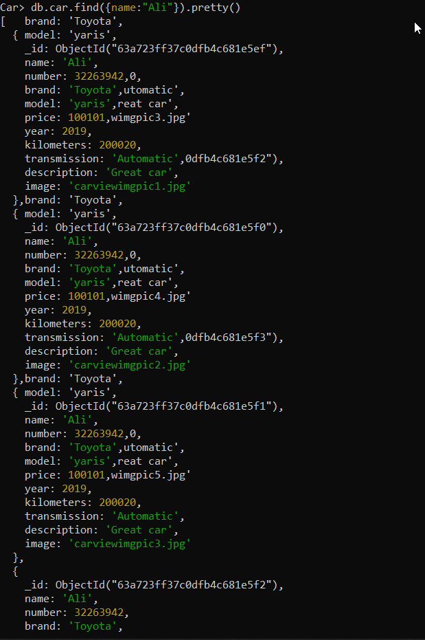

Figure Searching Database by Name

Search by in

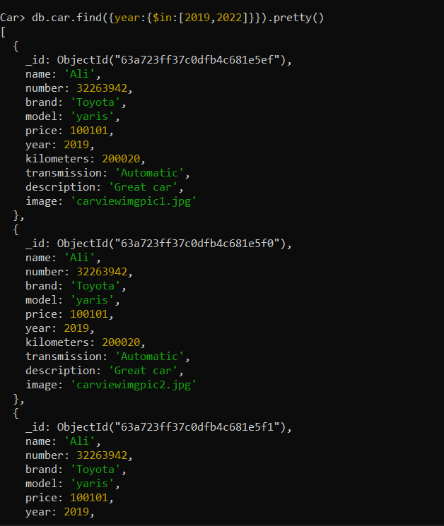

Figure Searching by IN

Searching with AND

Figure Searching by AND

Specify OR condition

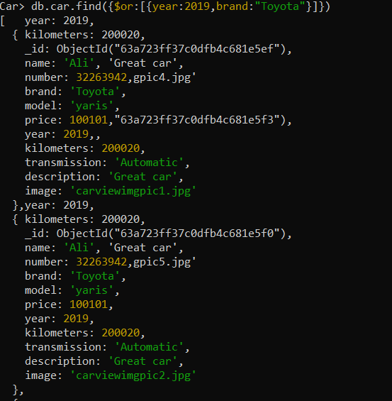

Figure Searching by OR

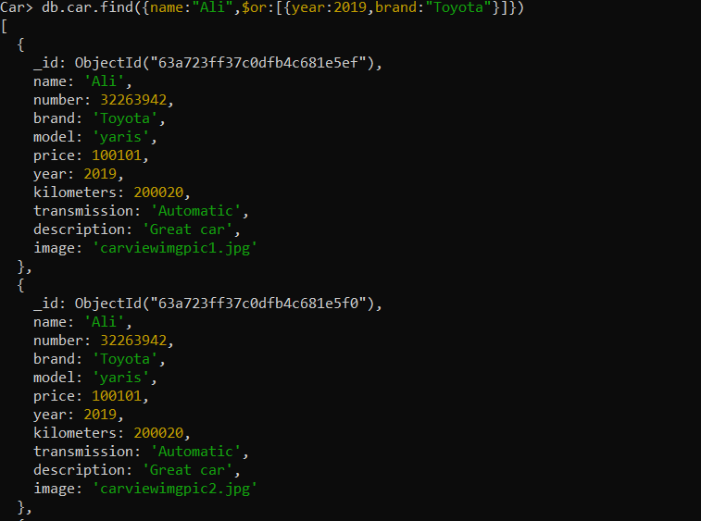Specify OR as well as AND condition

Figure Searching with OR and AND

## Update

Update Many

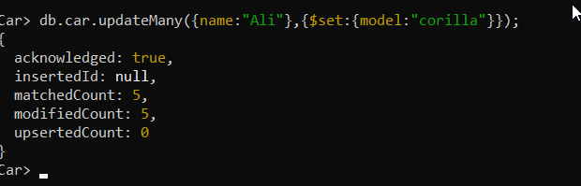

Figure Update Many

Update One

Figure Update One

## Replace

Figure Replace One

## Indexes

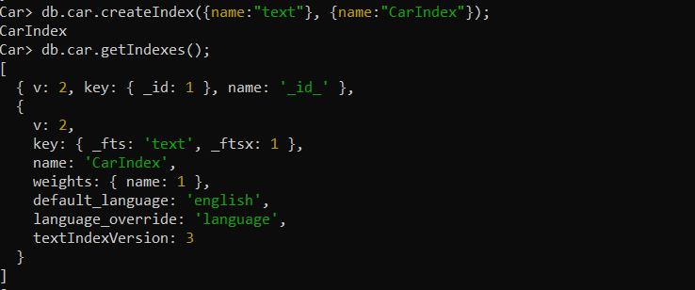

Figure Indexes

## Delete

Delete One

Figure Delete One

Delete Two



Figure Delete Many

## Query Diagnosis and Analysis

### Query Planner Mode

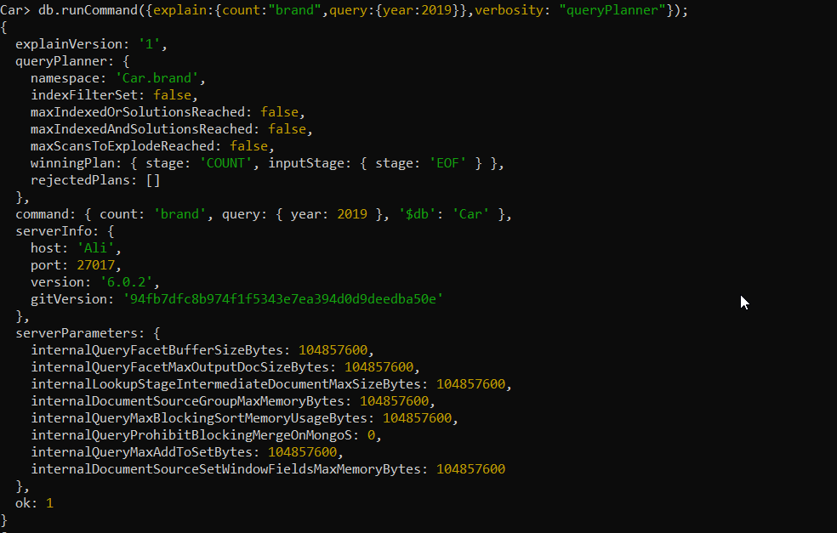

Figure Query Planner Mode

### Execution Stats Mode

Figure Execution Stats Mode

### All Plans Execution Mode

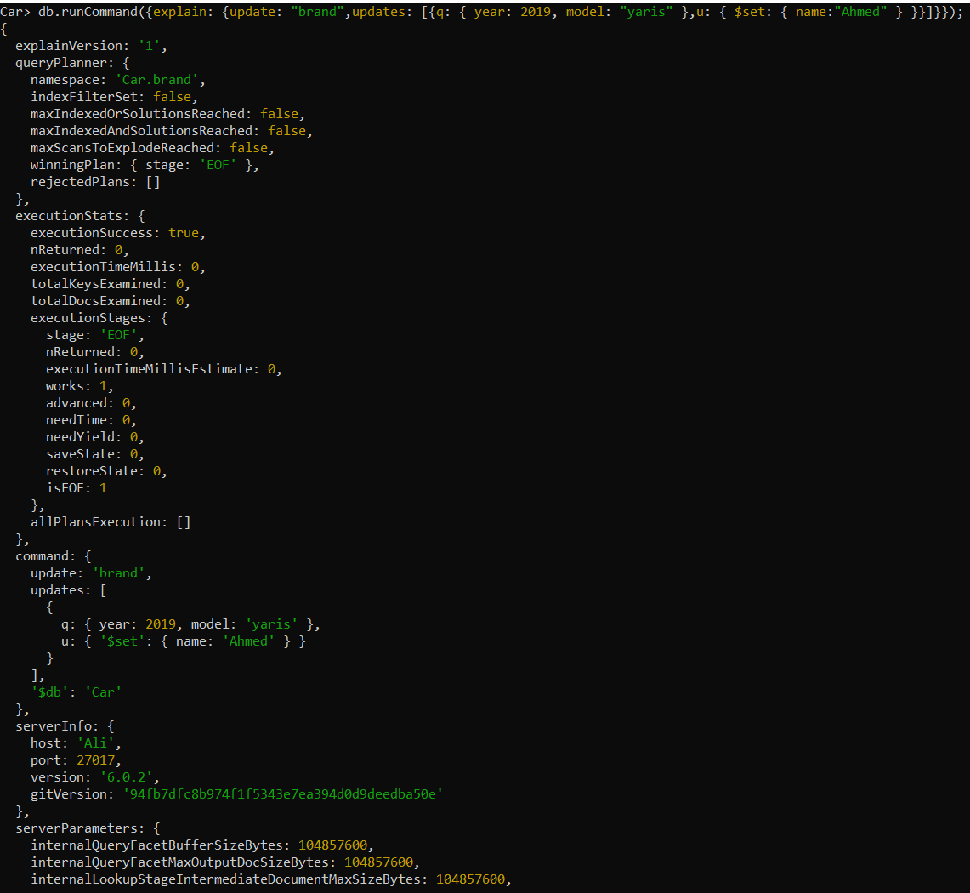

Figure All Plans Execution Mode

# Django

Creating a virtual environment

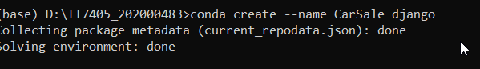

Figure Virtual Environment

Activated and created a Django project

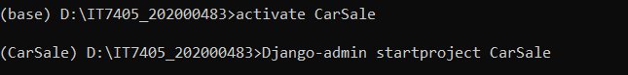

Figure Django Project

Downloaded the requirements

Figure Requirements

Running Server

Figure Command

Figure Website

Connect to Database

Figure Database Connection

In the main project I created a templates folder where I will store my base and navbar html and I added the directory path to the settings template and static URL.

Figure Base Files

Figure Directory Path

Figure Static

Migrating to the database

Figure Migration

## Creating car view app



Creating static folder for the images

Figure Images

Creating a car model

Figure Car Model

Created a view for car view

Figure Car view

Created a car view html page and URLs file

Figure Creating Files

Code html

Figure HTML Code

URL mapping

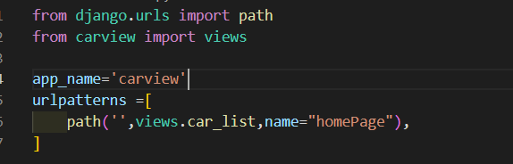

Figure URL

Adding car view to settings

Figure car view to settings

Imported include and added car view URLs to URL patterns

Figure Adding car view URL pattern

Populating database with python shell

Figure Inserting Data

Loading website

Figure First phase of website done

## Creating Search Bar

Creating Search bar view

Mapped search bar

Creating search bar html

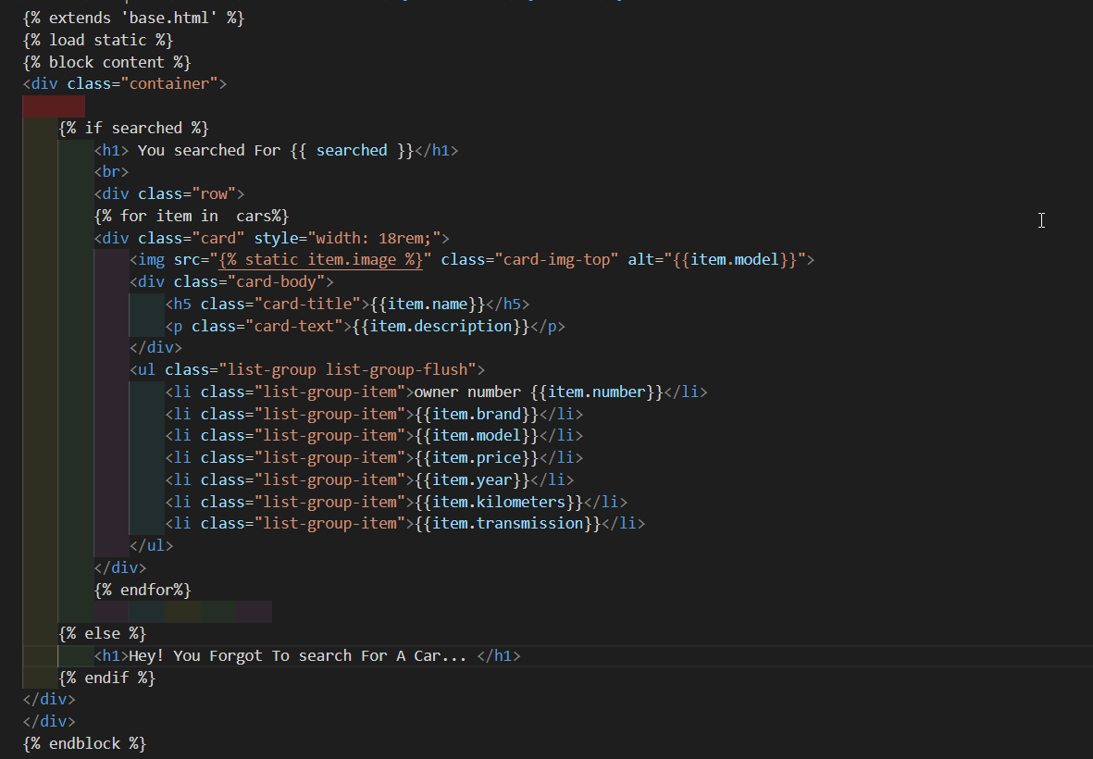

Added search bar for navigation

Website phase two done

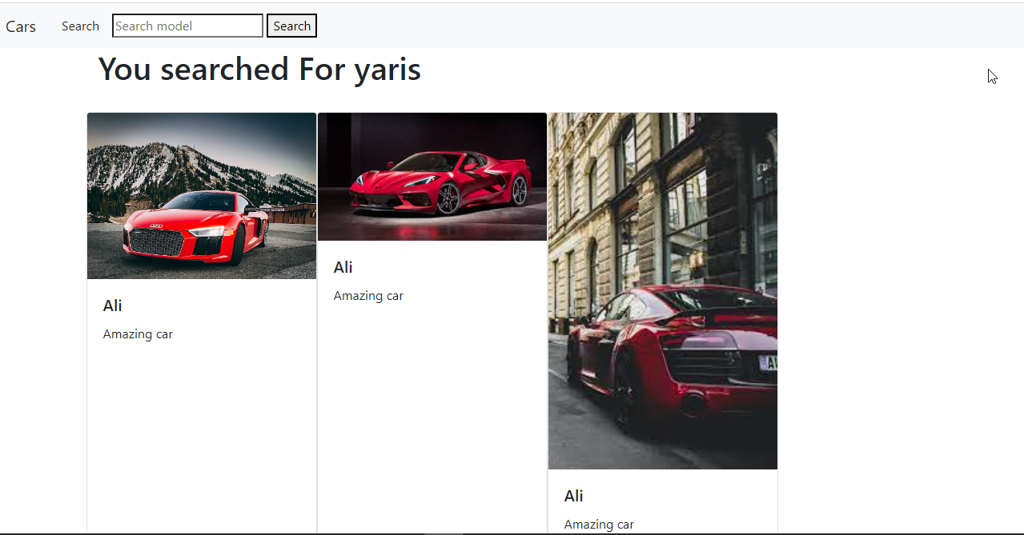

Figure Search working

## Add Car

Created forms file and created forms class

Figure Add Car Form

Create a function file and created a image uploader function

Figure Image Uploader Function

Add Car views

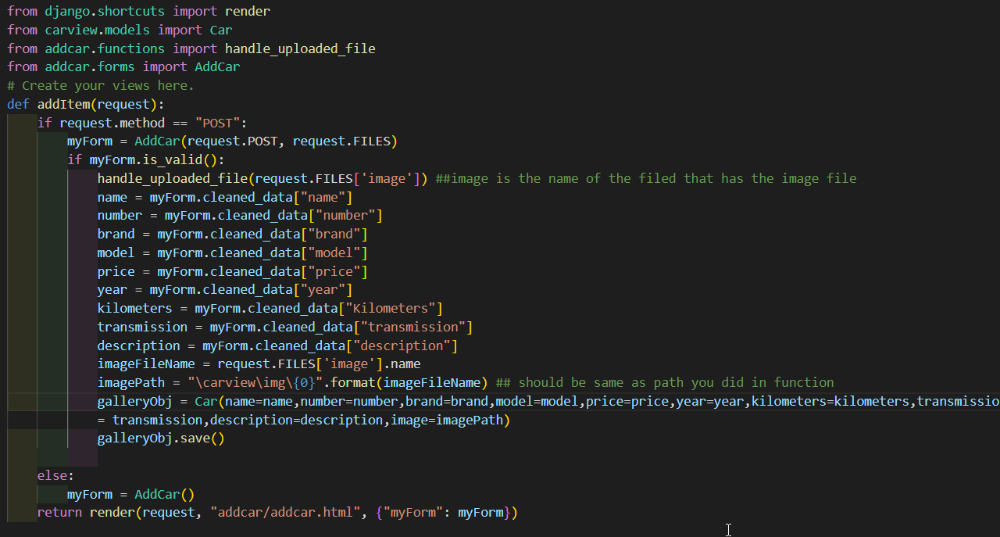

Figure Add Car view

Add Car URL

Figure Add Car URL

Add Car to settings and mapped in URLS pattern

Figure Add Car in installed apps

Figure URL Mapping

Installed crispy

Figure installing crispy

Add car page

Figure Add car page

Add car Page

Figure Final Page

I create a page for search because the buttons functions were overlapping.

## Admin

Creating a super user

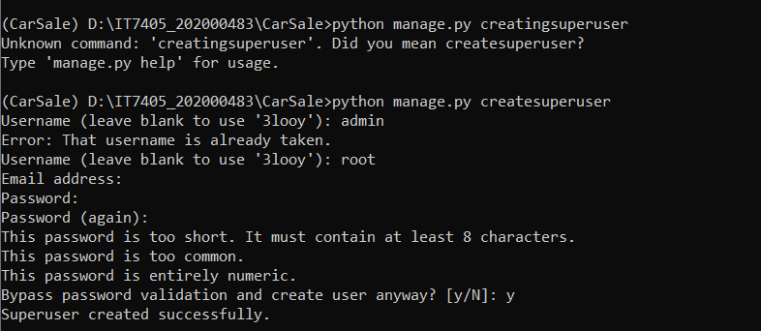

Figure Super User

Super user login and page

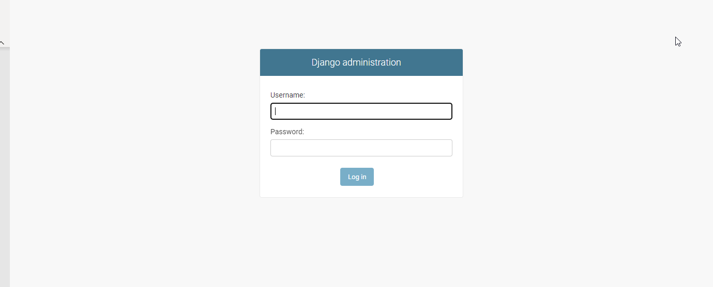

Figure Admin Login

User is root

Password is 1234

Figure Admin Page

Car Data management

Figure Code

Figure Updated admin page

## Login

Creating a user application

Settings

Figure added users to the installed applications

Figure Redirection Paths

URL patterns

Figure Adding user URL Pattern

Adding user pages which will be created soon to the navigation bar

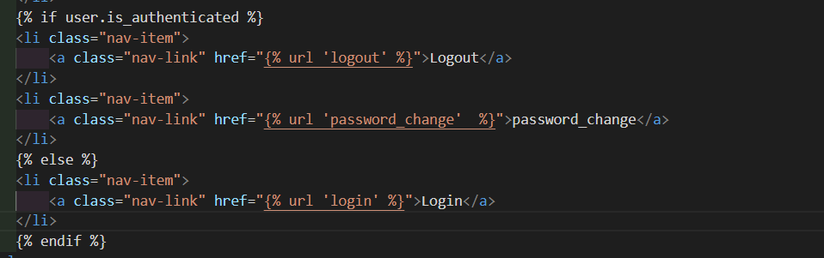

Figure updated nav

Designing the base

Figure Hello to the user logged in

HTML Pages

First, I created a Template folder inside it a sub folder registration which contain 3 different html pages

Figure Three pages

Figure Page one

Figure Page two

Figure Page Three

## Registration

Creating a register application

Figure 65 Register application

Register view

Figure Register view

Register URL and creating python url.py file

Figure URL code

Created a register html page

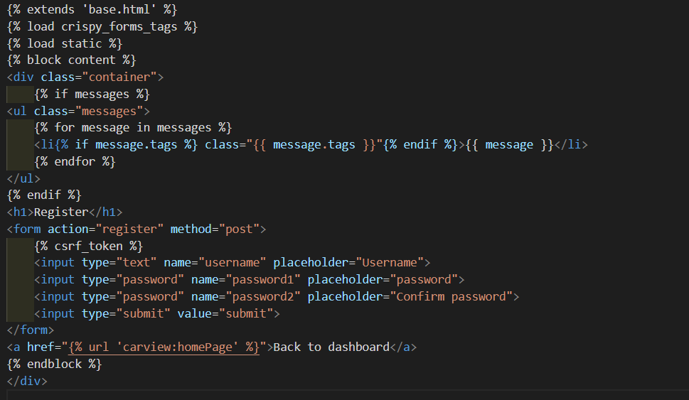

Figure register HTML page

Added registration to the nav bar

Figure Registration in nav bar

Add registration to settings and URLs pattern

Figure installed application register

Figure register URL path

# Reflection

In this project I learned a lot of valuable things. We started by finding a problem to create a solution for using Django framework and mongo dB as a database. I started the project by creating the database and running CRUD operations to populate it. After that I started working my website which include the following functions search, add, login, change password and register. Working on the project I faced a lot of challenges such as time manage due to working on multiple projects at the same time, which made me stress a lot. Furthermore, there are not a lot of documentations about Django and mongo dB working hand to hand together, so when ever I ran into a problem, I had to debug it which was very time consuming but improved my debugging skills. Designing the website was challenging because the focus of this course is backend not frontend, so learning boot strap and implementing it was very challenging. What I would do better is better organize my time and manage my stress levels by taking breaks, having walks. Finally, I learned a lot from this project that will help me in the long run.