Tab 1


TAMU-SPIRIT Oceaneous

Guidance Navigation and Control - Interface Control Document

Release Title | Release Date | Author(s)
GNC-ICD-01 | 2/14/2026 | Braden Batesole  Mihika Varshney

1 - Introduction

1.1 - Scope

1.1.1 - Abbreviations
GNC - Guidance Navigation and Control
ICD - Interface Control Document
Pi 5 - Raspberry Pi 5 microcontroller
NFC - Navigator Flight Controller

1.1.2 - Abstract
The ICD is a document that defines the ways in which GNC’s components interface with each other. We will utilize a combination of diagrams and text to describe the methodology of component assembly.

1.2 - Helpful Links
[1] - Oceanous RVM
[2] - Pi 5 Specifications Sheet
[3] -

2 - Components
This section outlines the different components GNC will utilize to complete its requirements, as seen in [1].

2.1 - Raspberry PI
2.2 - Blue Robotics Navigator Flight Controller
2.3 - System Architecture

2.1 - Raspberry Pi 5
Our Pi 5 houses a Broadcom BCM2712 2.4GHz quad-core 64-bit Arm Cortex-A76 CPU with 8 GB LPDDR4X-4267 SDRAM [2]. The processor and 8 GB of soldered ram allow us to interface with many of the components that we will see later on. The high ram amount is critical for constant camera uplink, as is required for camera use.
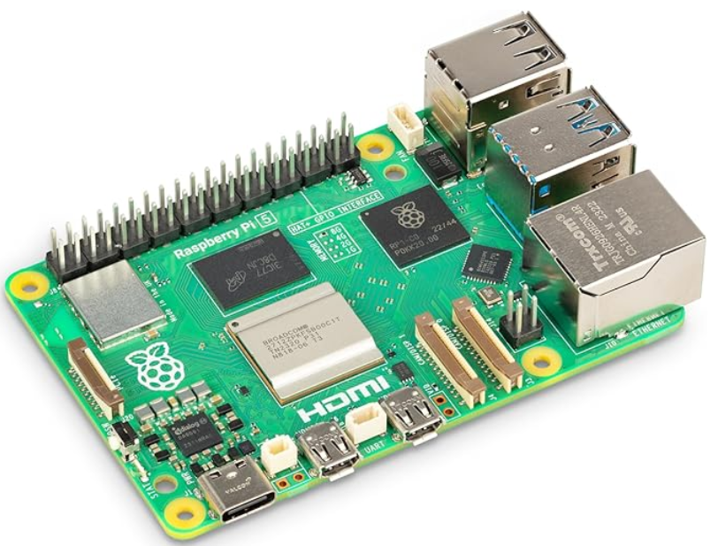
Figure 1 - A photo of a Pi 5 board.

2.2 - Blue Robotics Navigator Flight Controller
The NFC comes equipped with 6-axis IMU with accelerometers and gyroscopes for orientation, dual three-axis magnetometers for compass heading, and 16 servo PWM channel outputs for connecting to servos and motors.
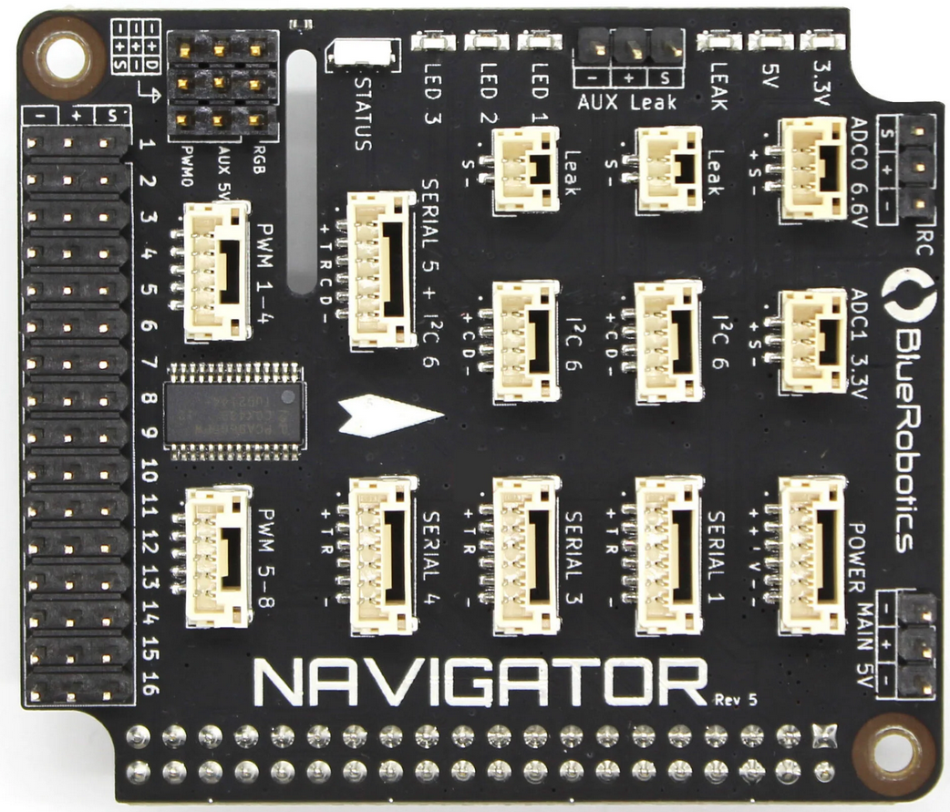
Figure 2 - A photo of the NFC.

2.3 - System Architecture
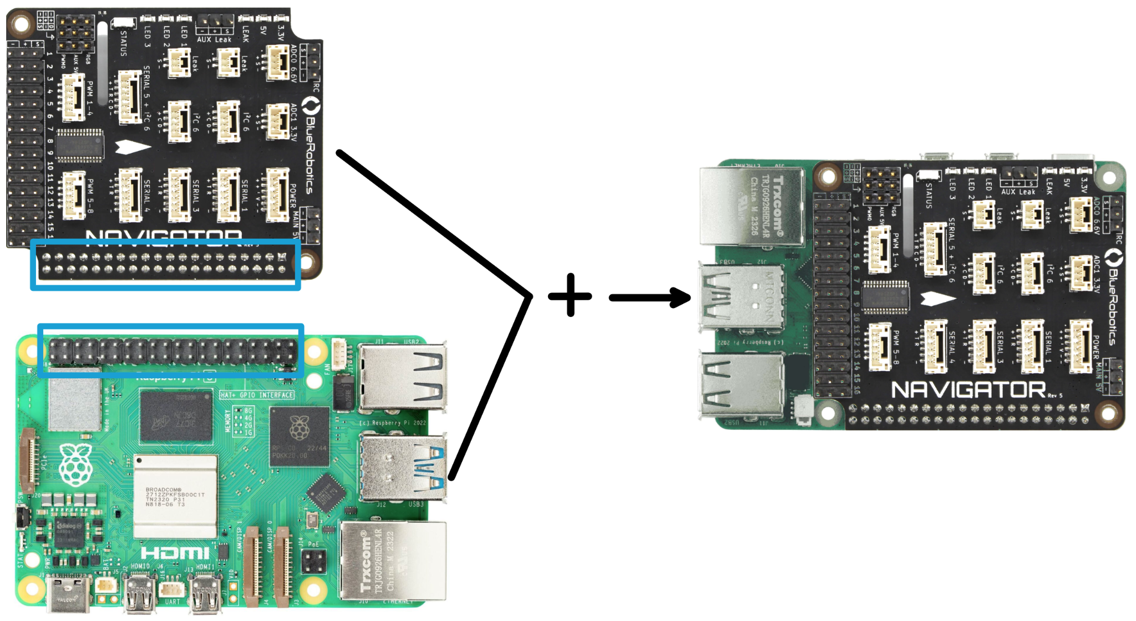
Figure 3: Pi 5 and NFC Configuration
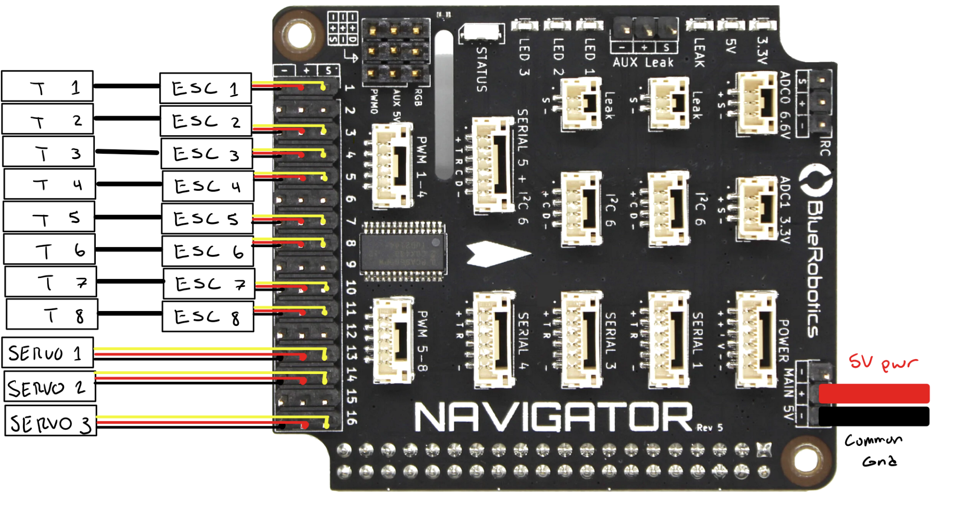
Figure 4: Thruster Configuration
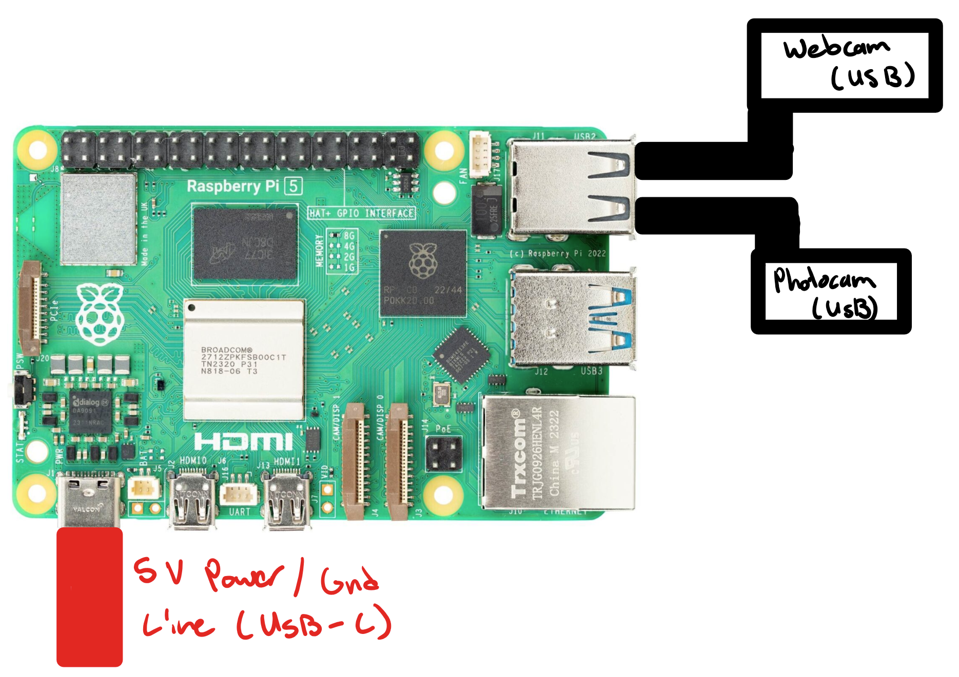
Figure 5: Camera configuration

3 - Communication Interfaces
This section outlines the communication for all components.

3.1 - Thruster Control Interfaces
3.2 - Camera Control

3.1 Thrusters
Thrusters connected from ESC to GPIO pins (1-16) on the NFC. Connect the ESC power to the battery. Use pin crimp housing to connect ESC wires to the NFC. as seen in Figure 4.

Black and Red Wires: Battery Wires
Yellow: Signal Wire

PWM Frequency: 50 Hz;
PWM Range: 1ms to roughly 2 ms
Update Rate:
Neutral Value:

Motor Direction Convention:

3.2 Cameras
Both onboard camera systems interface with the Pi 5 which runs BlueOS. BlueOS is used to encode and stream video that is then transmitted to the control station via an ethernet.

Videos are streamed via UDP (User Datagram Protocol) to minimize latency and prevent retransmission delays.

3.2.1 Camera Specifications

Brio 1080 Webcam
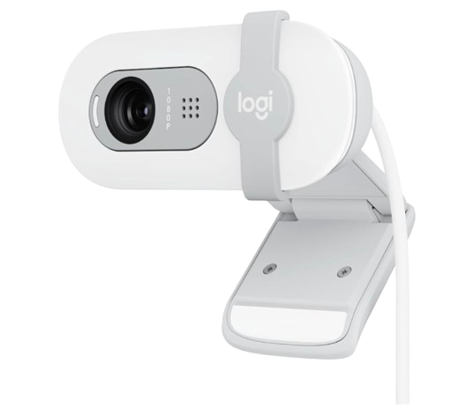
Resolution: 1080p
FPS: 30 fps
Compression:
Bandwidth usage:

ArduCam
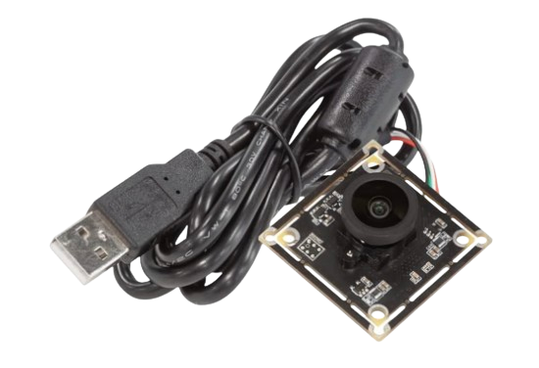
Resolution: 4k
FPS: 15 fps
Compression:
Bandwidth usage:

3.2.2 Failsafes
Potential camera failures and their methods of troubleshooting.

Camera Disconnect
Camera feed stops working, disconnect of cable from raspberry pi

Action:
Restart BlueOS
Bring ROV back to reconnect cables if disconnect
Switch to an ArduCam video feed in case Brio unable to reconnect

Excessive Bandwidth
Overloaded bandwidth

Action:
Reduce resolution to (e.g. 720p)
Reduce FPS to (3.g. 20 fps)

Tab 2
Cameras Configuration

Connect Raspberry Pi to a connection source - ideally through an ethernet connection

Connect camera through USB ports

Double check that camera has been recognized by computer
- Connected with the USB ports
- lsub in terminal to confirm RPI recognizes
- install ffmpeg to take images and videos
  - sudo apt install ffmpeg
- Download OpenCV to control the camera
- Each camera that gets added is listed as: /dev/video<n>

Taking images
ffmpeg -f v4l2 -video_size 1280x720 -i /dev/video0 -frames 1 out.jpg
- for taking video: A more advanced alternative is mjpeg-streamer, which enables you to stream the camera in a browser. You can find a detailed tutorial on how to set that up here.

